|  |  |
| --- | --- |
|  | **2010** |
|  |  |

|  |
| --- |
|  |
|  |

**Portal for Video On Demand Multimedia-Playback, Retrieval, access, and Management.Portal for Video On Demand Multimedia Playback, Retrieval, access, and Management.**

Table of Contents

1 Proposed Solution 3

1.1 Conceptual Architecture 3

1.2 Architecture Design Principals 3

1.3 Architecture Design Assumptions 3

1.4 Physical Architecture 4

1.4.1 Portal User Client Global Topology 4

1.4.2 Infrastructure Architecture 4

1.5 Software BOQ 8

# Proposed Solution

## Conceptual Architecture

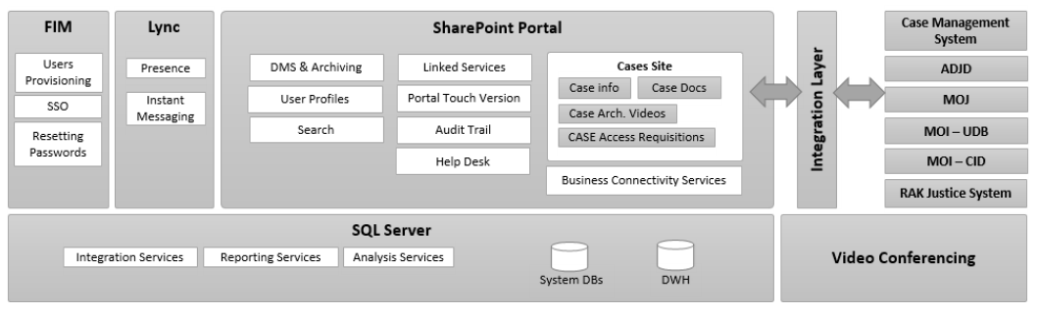

## Architecture Design Principals

The principles behind the architecture design are:

* Design information system architecture that meets all the business objects and stockholder's needs.
* Design architecture that maximizes the use of Portal User Client current infrastructure.
* Design a scalable architecture that provides Portal User Client an option to scale easily based on the actual load of the services deployed with either scale up or scale out option.
* Design a flexible architecture that allows Portal User Client to add and remove components with minimum effort in the future.
* Design platform to host/integrate with multiple corporate/line of business applications aimed for the persons accessing the services from any of Portal User Client locations
* Consider high availability design that will offer the best-fit option for Portal User Client current data Center strategy.
* Provide an environment plan that will give Portal User Client sufficient and stable environments to deploy high quality capabilities without impacting others sharing the environments

## Architecture Design Assumptions

The design will take into consideration the following assumptions and constrains

* The design will implement a High Availability solution with minimal downtime for the key components
* The design will take into consideration the future growth and scalability
* Fit / Accommodate all the network layers, firewalls, infrastructure design and security layers of the current Portal User Client data Center
* The management of the environment should be simple and centralized as much as possible.
* The proposed architecture is based on Microsoft Stack (**SQL Server, SharePoint and Windows Server)** that offer all the services that are necessary for the platform
* The design will best utilize the current environment (Windows Server, Exchange Server and the Hardware Firewall and Network Load Balancing)
* The customization solution is split in three parts:
  + Business components that leverage SharePoint capabilities and will be developed using the **.NET Framework, Workflow Foundations (WF)**.
  + Service Oriented Architecture will be developed using the **.Net Framework, Windows Communications Foundations (WCM).**
  + Web Interface components that are developed/customized in **AJAX/Silverlight** to manage the dynamic needs and **ASP.NET** to manage the static needs.
* All the data content of the solution will be managed through **SQL Server.** There are a number of different databases used by **SharePoint** such as Contents, Configuration and DBs related to the Services (Search, Profile…etc.) …etc. Nevertheless, still other databases and Line of Business application and core applications can be integrated into the SharePoint portals with minimal integration efforts using the readymade adaptors and interfaces.
* Technical management of the platform will be done by Portal User Client Tech with our assistance, definition and implementation of the standard procedures required to maintain and operate such architecture. We will also provide Portal User Client Tech with guidance on how to monitor such a platform.
* We will use **Visual Studio Team System** as our development tool and **Visual Studio Team Foundation Server** as the source code management tool and **Visual Studio Test Edition** to manage testing (unit, integration and load testing…etc.) of the platform

## Physical Architecture

This section will provide the different environments needed for Portal User Client solution.

### Portal User Client Global Topology

As per the current environment at Portal User Client **,** the main data Center at the head quarter office will be used to host the whole solution.

One of the main solution design principle is to be flexible to accommodate the network topology and zones inside the data Center. For example, isolating the database servers behind firewalls.

### Infrastructure Architecture

Portal User Client will have multiple different environments to provide its production environment. There will be also additional supplementary environments, which are used for quality assurance, testing and development purposes.

Portal User Client will have the following types of environments

* Production environment
* Testing environment
* Development environment

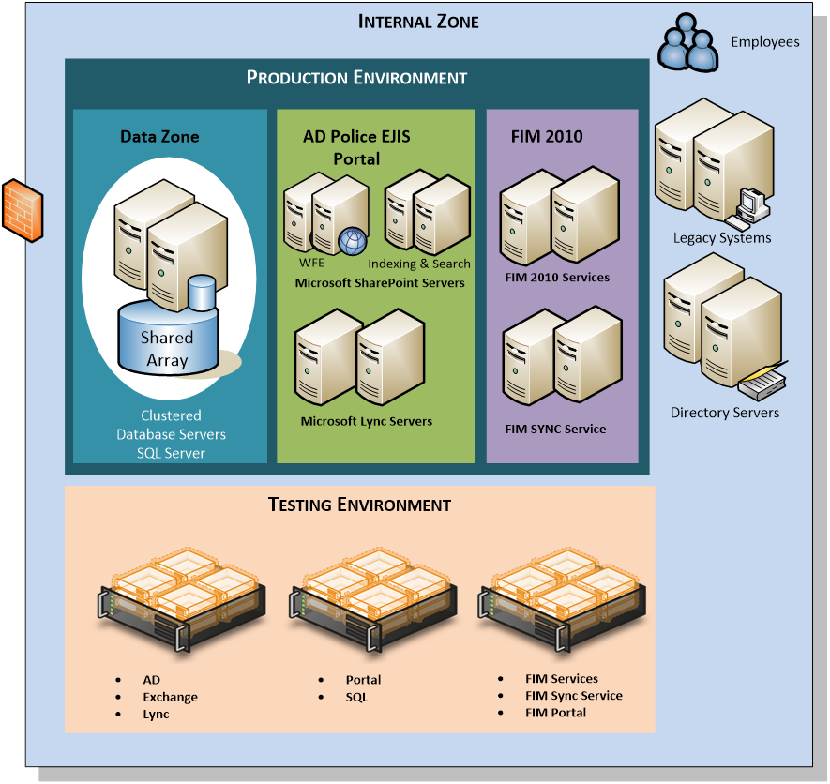

Figure 1 Physical Architecture - Production

All web front end servers and application servers can be virtualized using certified virtualization techniques, but for the production usage, it's recommended to have the actual SQL Server as physical servers. Since the portal services will be used also for publishing content and to provide miscellaneous collaboration sites, there will be considerable amount of read and write operations for the databases. To avoid issues with the SQL Server file I/O performance, the physical platform will increase the performance of the platform.

The design will utilize the SAN storage technology in Portal User Client data Centers so hard disk space can be easily increased when required. It's important to monitor the disk space usage on the servers and increase the amount of hard disk whenever it's required. This approach is also more cost efficient, so that in the first wave of the project, smaller space allocation can be used and it can be easily scaled if required depending on the overall services provided by the SharePoint farm. Initial storage requirements for the each server are declared later in this document.

If the web front end servers and application servers are provided from the virtualization environment, it's important to scale the virtualization platform such a way that if required, we can easily scale up or out the actual farm.

#### Hardware and Software recommendations

Following hardware recommendations apply for web front end and application servers.

|  |  |
| --- | --- |
| **Hardware component** | **Recommendation** |
| CPU | 64-bit, dual processor, four-core, 2.5 GHz minimum per core |
| Memory | 8 GB / 16 GB |
| Storage | 200 GB |

###### Software

* The 64-bit edition of Windows Server 2012.
* Web Server (IIS) role
* Application Server role
* Microsoft .NET Framework version 3.5 SP1
* Microsoft "Geneva" Framework (ADFS 2.0)
* Microsoft Sync Framework Runtime v1.0 (x64)
* Microsoft Filter Pack 2.0
* Microsoft Chart Controls for the Microsoft .NET Framework 3.5
* Windows PowerShell 2.0 CTP3
* SQL Server 2012 Native Client
* ADO.NET Data Services v1.5 CTP2

##### Database servers

###### Hardware

Following hardware recommendations apply for the database servers. Note that this database cluster can be shared between the multiple different environments.

|  |  |
| --- | --- |
| **Hardware component** | **Recommendation** |
| CPU | 64-bit, dual processor, four-core, 2.5 GHz minimum per core |
| Memory | 32 GB |
| Storage | 120Gb (OS Only) + SAN access |

###### Software

* The 64-bit edition of Microsoft SQL Server 2012.

##### Lync Servers Hardware Requirements

|  |  |
| --- | --- |
| CPU | 64-bit dual processor, hex-core, 2.26 gigahertz (GHz) or higher  Intel Itanium processors are not supported for Lync Server server roles. |
| Memory | 32 gigabytes (GB) |
| Disk | 8 or more 10,000 RPM hard disk drives with at least 72 GB free disk space.  Two of the disks should use RAID 1, and six should use RAID 10. - OR -  Solid state drives (SSDs) which provide performance similar to 8 10,000-RPM mechanical disk drives. |

##### FIM Hardware Requirements

The server or servers that host Microsoft® Forefront® Identity Manager (FIM) 2010 server components must meet the following minimum hardware requirements:

* + An x64-capable processor
  + 2 gigabytes (GB) of available hard disk space
  + 2 GB or more of RAM
  + A monitor with a resolution of 1024 × 768
  + A CD-ROM or DVD-ROM drive

The client computer that hosts the FIM 2010 client-side components must meet the following minimum hardware requirements:

* + 512 MB of RAM (1 GB recommended)
  + 500 MB of free hard disk space
  + A monitor that can display a resolution of 1024 × 768

##### Virtual Hosts Hardware Requirements

|  |  |
| --- | --- |
| CPU | 64-bit dual processor, hex-core, 2.26 gigahertz (GHz) or higher  Intel Itanium processors are not supported for Lync Server server roles. |
| Memory | 64 gigabytes (GB) |
| Disk | 8 or more 10,000 RPM hard disk drives with at least 350 GB free disk space.  Two of the disks should use RAID 1, and six should use RAID 10. - OR -  Solid state drives (SSDs) which provide performance similar to 8 10,000-RPM mechanical disk drives. |

## Costs:

|  |  |  |  |
| --- | --- | --- | --- |
| Item # | Item Description | License Per | QTY |
|  | SQL Server 2012 Enterprise Edition | Core | 8 |
|  | SharePoint Portal 2013 | Core | 6 |
|  | SharePoint User CALs | User | TBD |
|  | Windows 2012 Standard Edition x64 | Processor  (2 CPU Pack) | 30 |
|  | Microsoft Forefront Identity Management Server | Server | 4 |
|  | Microsoft Forefront Identity Management CALs | User | TBD |
|  | Microsoft Lync Server 2013 |  |  |
|  | Lync Standard CAL |  |  |
|  | Lync Enterprise CAL |  |  |