Workforce Management System – WFM

For Utilities and Manufacturing Sector.

Table of Contents

Covering Letter 5

1. Executive Summary 8

1.1 About Utilities Giant’s 8

1.2 Utilities Giant’s Project Objective 8

1.3 Utilities Giant’s –Current Scenario 8

2. Technical Solution Overview 10

2.1 WMS Solution 10

**OPTION - 1** 10

PHASE I: GoldSaxWorkManage Work Flow Management System (GoldSaxWorkManage Engine and GoldSaxWorkManage-Elive) 11

PHASE II: SAP Integration + Hardware Deployment 11

**OPTION - 2** 11

PHASE I: Work Flow Management System (Customized .NET Workforce Management System) 11

PHASE II: SAP Integration + Hardware Installations 11

3. Scope of Work - OPTION 1 11

3.1 WMS Solution 11

3.2 WMS –process snapshot 13

3.3 WMS Key Features 14

3.4 Utilities Giant’s –Current Software 15

3.5 Utilities Giant’s – Project Deliverables & Prerequisites 15

3.6 PHASE I - GoldSaxWorkManage Work Flow Management System 17

3.7 Organizational Scope 18

3.8 Functional Scope 20

3.9 Key and Work Allocation Automation System 24

3.10 Solutions Approach Using SOA 2.0 25

3.11 WMS Solution Architecture 27

3.12 Workforce Manager – Macro Architecture 28

3.13 PHASE II – SAP Integration & Hardware Deployment 35

4. Scope of Work – Option 2 37

4.1 Recommended Solution 37

4.1.1 Assumptions 38

4.1.2 Exclusions 39

4.2 Vehicle Tracking Solution 40

4.2.1 Assumptions 41

4.2.2 Exclusions 41

4.3 Asset Tracking and Protection using Day & Night Surveillance Camera 42

4.4 Technology Details 42

4.5 Pre-requisites for implementation 42

4.6 Implementation Methodology 43

4.7 Project Plan 46

4.8 Deliverables 46

4.9 Roles and Responsibility Matrix 49

4.10 Handling Scope Changes 52

4.11 GOLDSAXWORKMANAGE’ Training Approach 53

5. Project Methodology 55

5.1 Program Management Plan 55

5.2 Methodology 56

5.3 Application Development Methodology 56

5.4 Transition and Maintenance Methodology 57

5.5 Testing Methodology 58

5.6 Acceptance Criteria 60

5.7 Quality Assurance 60

5.8 Knowledge Transfer 62

6. Financial Investment & Effort Estimation 64

7.1 Option 1 64

7.2 Option 2 66

8. Comparative Analysis between the Options 67

9. Project Assumptions 67

10. ROI / Benefits 68

# Executive Summary

## About Utilities Giant’s

Utilities Giant’s Industries is a leading energy, water and marine group operating across six continents worldwide.

With facilities with 5,800 megawatts of gross power capacity and over seven million cubic metres of water per day in operation and under development, Utilities Giant’s is a trusted provider of essential energy and water solutions to both industrial and municipal customers. It is also a world leader in marine and offshore engineering as well as an established brand name in urban development.

## Utilities Giant’s Project Objective

The main objective of the project is to provide an efficient state of art workforce Management system. This should allow all the traceability and accountability of all work activities and management of assets.

## Utilities Giant’s –Current Scenario

1. **Challenges**

* Utilities Giant’s has been providing third party utilities, services and products such as steam, demineralized water and high grade industrial water (HGIW) to its customers on Sakra and Seraya, Jurong Island.
* The service corridor is a pipe rack network routed strategically throughout Jurong Island and is used to service customers by supplying feedstock supply and facilitating product transfer.
* With the expansion of services to Tembusu, there will be a need to improve operational efficiency while maintaining security and safety within its service corridors.

1. **Efficiency**

* Currently, manual processes are used to deploy, monitor and track contractor teams across the island as the number of teams and the area of deployment increases, a more structured system needs to be put in place.
* There will be a need to manage contractors and measure their performance. The processes to institutionalize include:
* Management and issuance of work permits and keys
* Checking in and out from site office to work areas
* Progress reporting of work statuses and locations of teams
* Enforcement and audits when required

1. **Security and Safety**

* Jurong land is a gazette protected place with general access control and Protection security
* However, the service corridors are still accessible by non-Utilities Giant’s staff and visitors
* Restrictions would have to be forced so that the service corridors have limited access only to authorized personnel.
* Currently Contractors withdraw keys from a pass office to gain access to the sections of the service corridor where they are authorized to work. However, there are several issues with this arrangement as described below:

1. Permits to Work (PTW) are not tied to the authorized person from the contractor team and in turn not tied to the keys which he is to be issued.
2. There is no sure way to know if a contractor team is at its correct work location or if they have ventured into other areas.
3. The pass-office needs to be manned for contractor teams to report back when they have completed their work, to return the PTW and their issued keys.
4. Contractor teams may finish work beyond their allocated time and hold on to their keys for longer than necessary and without Utilities Giant’s staffs' knowledge.
5. Access to the service corridors are controlled via access points along the corridor such as gates. There is a need to monitor the entry and exit so that only authorized personnel passes through
6. Considering the safety aspect, all personnel must have also left via that access point when work is done
7. As the service corridors carry products that are under high pressure or may be inflammable, any illegal works or works that are carried out in proximity by other parties should also be ideally monitored.

# Technical Solution Overview

We propose to deliver this project in 8months constituting 5months of Development and 2 months of Implementation.

Our deep industry knowledge and intense experience in implementing WMS and roll out will continuously enable us to confidently deliver the desired results to the client. We plan to depute a team which would bring in a blend of experience in Utilities with WMS expertise to ensure complete coverage of business needs as per the business blueprint and perform a disciplined roll out . Our proposed solution will help the client to attain:

* Contractors, Field Force and operational procedure streamlining & effectiveness.
* Real time access to information to ensure efficient, transparent decision making at the Operational levels.
* Improved operational efficiency via process re-engineering, improvement and automation.
* Supply chain and value chain optimization resulting in the reduction of inventory, consumable and logistic costs.
* Well-organized data-management to avoid duplication of effort and increase accuracy, timeliness and comprehensiveness of management information



## WMS Solution

GoldSaxWorkManage will provide the required solution to **Utilities Giant’s**  with **Two Options**; each option will have **Two Phases**. Both options vary in scope and functionalities so that Utilities Giant’s may make the best possible choice.

**OPTION - 1**

### PHASE I: GoldSaxWorkManage Work Flow Management System (GoldSaxWorkManage Engine and GoldSaxWorkManage-Elive)

### PHASE II: SAP Integration + Hardware Deployment

**OPTION - 2**

### PHASE I: Work Flow Management System (Customized .NET Workforce Management System)

### PHASE II: SAP Integration + Hardware Installations

# Scope of Work - OPTION 1

## WMS Solution

Currently, to automate the manual processes that are used to deploy, monitor and track contractor teams across the island, RFID Readers that can track RFID tags are issued to the team members and as the area of deployment increases, just an installation of RFID reader at the Service corridor would help track the location. The number of RFID tags issued to team members and contractors increase as the team size grows.

* To manage contractors and measure their performance, the following strategies are followed:
* Management and issuance of work permits and keys are fully automated using the vendor manager’s module from GoldSaxWorkManage-elive, issuance of work permit after the completion of the bidding process is done by the Contractor.
* Checking in and out from site office to work areas is automated by RFID readers scanning the RFID tags of contractors and the team members.
* To Report progress of work statuses and locations of team at the end of day using GoldSaxWorkManage-elive, the Contractor’s reporting module helps the Contractor to update to the system.
* Enforcements are made whenever needed through the enforcement policy programmed at the directory services and the respective user agents i.e. the supervisors, Vendor managers and other Authorities of Utilities Giant’s .
* Audits of Capital assets are done by processing the images obtained from High Resolution Surveillance cameras at the Utilities Giant’s ’s Service corridors.

**Security and Safety**

* To limit access to authorized personal, The Real time Data Aggregator of the GoldSaxWorkManage Engine at deeper bolts time stamps streams from RFID, GPS and Surveillance CAMS checks for pattern match and ensures that intrusion is detected at the Surveillance and not the RFID reader.
* Key management is auto mated. The security personal is intimated at his elive dashboard of the validity of the contractor just when he enters the RFID reader’s zone.
* To know if the Contractor and his team is at the right area, the Core engine matches the parsed data from RTDA to the parsed data at the work flow scheduler, from the SAP Plant Manager (PM) work order and the Contracting module and the Vendor management module. While there is a mismatch of the two parsed datum, with respective to the mismatch, the policy model at the active directory sends it to the asynchronous messaging server of the message structure and the user agents who are to be notified of the anomaly. While there is a match, the policy model at the active directory sends it to the asynchronous messaging server of the message structure and to the user agents to notify the progress.

## WMS –process snapshot

## WMS Key Features

The following are the basic functions required in this solution but not limited to the following list of functions:

* Automation of Key management and issuance.
* Secure access automation.
* Service Corridor security using Surveillance cam and RFID.
* Mobilizing Reporting, alerting and monitoring by GoldSaxWorkManage Elive which is an Application User Interface to be installed in IPAD, IOS, Android and Windows phone.
* Create auto response to alerts and reports and dashboard via rule automation for all user agents.
* View workforce Performance via Surveillance CAM.
* View authorized personal at the service corridor via Surveillance CAM.
* Track workforces’ position via RFID.
* Auto-creation of work schedule using the work order from SAP PM according to work scheduling policy via the Work-Flow Scheduler of the GoldSaxWorkManage Engine.
* End of the day reports for Contractors, Supervisors, Vendor Managers and Security personal.
* Periodical reports of Work progress by the contractor and supervisor.
* A live Dashboard constituting information-flow of work flow events to related users.
* Alerts on the Dashboard and pop up boxes.
* Asset Quality to be monitored continually.

**\*\* To facilitate the above, the following modules will be present in the system.**

|  |  |
| --- | --- |
| **Modules** | **Description** |
| GoldSaxWorkManage elive | The innovative Mobility Interface for users of IPAD, Windows Phone 7 and 8, Android, IOS |
| Dash Board | Real-time Asynchronous Flow of structured Information processed from the GoldSaxWorkManage Engine for end users of Utilities Giant’s |
| Daily Contractor’s reporting module | This includes daily report of workers as well as key return status, work schedule at service gate |
| Contracting Module | Contains Forms for Contracting and Bidding and Contractor Eligibiliity assessment |
| Rule Automation Module | This module allows sending auto report to contractor’s reporting module based on rules and also auto escalates issues raised at the dashboard to respective authorities |
| Administrative Module | This module provides Access rights, Role management, helps activating or disabling users, ensures work order display |
| Quality Assurance Module | This Module allows Quality assurance through 3D imaging |
| Auditor’s Module | This module enables auditors to make automated and remote assessment of the capital assets used for production |
| API | Allows 3rd party applications, devices to add further functionalities from the system to external applications |
| Security Access Point Management | Security personal at the gate of the service corridor get access to the dashboard service for them to make a decision on user authorization |

## Utilities Giant’s –Current Software

Utilities Giant’s currently uses SAP PM version is ECC6.

## Utilities Giant’s – Project Deliverables & Prerequisites

Implementation of a Real time SOA 2.0 using ServiceMix, JEE and User Interfacing using GXT - Phone Gap Framework is done.

**Technical requirements:**

|  |  |  |
| --- | --- | --- |
| **IBM WebSphere Real Time** | **Core Engine** |  |
| **Application Server** | **Jboss AS7** |  |
| **Work Flow manager** | **JBPM(Optional)** |  |
| **ServiceMix** | **Enterprise Service Bus** |  |
| **Core Engine** | **Esper Engine** |  |
| **Mobile User Interface** | **PhoneGap Framework** |  |
| **Distributed File System** | **Hadoop, Hbase** |  |
| **Persistance** | **IBM DB2** |  |
| **Load balancing Webserver** | **NGIX** |  |
| **Real Time Data Aggregator** | **Storm** |  |

**Key Deliverables:**

* GoldSaxWorkManage-elive
* GoldSaxWorkManage Engine

**Deliverable Options:**

* One - Time Licensing with Annual Maintenance Subscriptions.
* Source code, Supporting Documents with Annual Maintenance, L1, L2, and L3 Support Subscriptions.
* IEEE Standard Documentation and Source Code with Annual Maintenance, L1, L2, and L3 Support Subscriptions.

**Out of Project Scope:**

There are a few components which are out of this project’s scope. However the system is designed and developed with a view for reusability, extensibility and interoperability. We at GoldSaxWorkManage have the capabilities to make the further enhancements, however due to lack of information in hand about the management decision making policies; we let this further upon for future enhancements such as:

* Predictive Analytics
* Decision Support
* 3D Imaging for Quality assessment
* Real time Integration to Other existing Systems except SAP PM

**Prerequisite Hardware components:**

* RFID Tags, Readers and supporting software with API support installed at the service corridors and gateways.
* GPS Devices and supporting software with API support installed in vehicles at the service corridors.
* High Resolution Surveillance Cameras and supporting software with API support and IP broadcast installed at the service corridors and gateways.
* 3D imaging and Sensors at the spot of final produce for visual and kinesthetic quality measuring.
* System requirements

**Software prerequisite Options (any one of the mentioned):**

* Red Hat Enterprise MRG V1
* SUSE Linux Enterprise Real Time (SLERT) 10
* WebSphere Real Time is supported on the following though without the benefit of the RTSJ support.
* Red Hat Enterprise Linux AS Version 5.0 Update 4
* Red Hat Enterprise Linux AS Version
* SUSE Linux Enterprise Server Version
* IBM AIX V6.1
* IBM AIX V7.1.

## PHASE I - GoldSaxWorkManage Work Flow Management System

We have organized the Scope into the two following areas:

* Organizational Scope
* Functional Scope

## Organizational Scope

The milestones followed in our SDLC are elaborated below:

**Test Driven Development**

**Design**

**Requirement Gathering**

**Installation and Production**

**Training and Development**

**Integration and Integration Testing**

**Administration and Maintenance**

**Milestone 1:**

**Requirements Gathering:**

A team of Professionals at the client’s premises interact with the actors of the existing systems and processes to gather information which includes gathering, analyzing, validating, and specifying requirements. SRS acts as input to the design phase and includes functional, performance, software, hardware, and network requirements of the project including Use Cases and Test cases.

**Milestone 2:**

**Design:**

A team of Professionals from GoldSaxWorkManage’s premises work on translation of the requirements specified in the SRS into a logical structure which includes the Solution Architecture, Technical Architecture that can be implemented in the Development Phase.

**Milestone3:**

**Test Driven Development:**

A team of Professionals from GoldSaxWorkManage’s premises work on implementation of the design specified into executable programming language code. This will result in the source code modularly packaged for the software which is tested and mapped against the design document created in the design phase.

**Milestone 4:**

**Integration and Integration Testing:**

Modules and packages and dependencies are integrated to engines and functionality test of the system and integration testing are performed.

**Milestone 5:**

**Installation and Production:**

Setting up the Physical Infrastructure at the client’s Premises which include installation of the necessary hardware and the executable Software.

**Milestone 6:**

**Training and Development:**

Our teams work closely with the end – users of the system and train them accordingly for successful use of the system.

**Milestone 7:**

**Administration and Maintenance**

A team of Professionals from GoldSaxWorkManage’s premises with secured access to the Physical Infrastructure at the client, work on implementation of changes that software might undergo over a period of time, or implementation of new requirements after the software is deployed at the customer location. The maintenance phase also includes handling the residual errors that may exist in the software even after the testing phase, Day to day Clearance of logs, Cache, and Health Check on Running Systems.

## Functional Scope

|  |  |
| --- | --- |
| Following are the User Interfaces suggested to incorporate WMS at Utilities Giant’s :  **A Web Browser Based User Interface:**  For Users of desktop PC’s connected over the internet.  **GoldSaxWorkManage-elive:**  The innovative Mobility Interface for users of IPAD, Windows Phone 7 and 8, Android, IOS. |  |

Both interfaces for user based functionalities have the following Modular Utilities either in combination or in isolation with respect to the user type authentication, access restriction and privileges as charted by the Administrator:

**Dash Board:**

Real-time Asynchronous Flow of structured Information processed from the GoldSaxWorkManage Engine for end users of Utilities Giant’s will assist in the following:

* + - Tracking Work Force Tasks.
    - Tracking Resource Mobility (RFID MAPS, GPS MAPS).
    - View the Surveillance CAM (Subject to internet bandwidth and device Model).
    - Alerts Dash board (Alerts specific to the authenticated user).
    - Analytic Time Series Charts, Histograms, and Data representation Charts depending on the user’s need.

**Tracking Workforce Tasks**

**Vendor Managers**

**Contractors**

**Supervisors**

**Tracking Work Force tasks:**

Dash board’s functionality called Tracking WorkForce tasks are categorized as follows:

* Supervisors
* Contractors
* Vendor Managers

**Supervisors:**

Supervisors of Utilities Giant’s track progress of the work schedule as per the supervision policy laid out by Utilities Giant’s to its supervisors. In the Dashboard for the supervisor Messages are structured as follows:

* + Job Name
  + Job ID
  + Job Site
  + Contractor Name
  + Contractor ID
  + Status of work progress: Started/Ongoing/Completed/Incomplete

Example: The Job ID xhy238 named filtering at location Diman Islands contracted by Ms. Johann burg CID: 387rtyg is Ongoing.

**Contractors:**

Contractors of Utilities Giant’s track progress of the work schedule as per the Operations policy laid out by Utilities Giant’s to its Vendor Managers. In the Dashboard for the Contractor, Messages are structured as follows:

* + Job Name
  + Job ID
  + Job Site
  + Status of work progress: Started/Ongoing/Completed/Incomplete
  + Corrective action

Example: The Job ID xhy238 named filtering at location Diman Islands is Incomplete. Please report to the Supervisor with needful comments.

**Vendor Managers:**

Vendor Managers of Utilities Giant’s track progress of the work schedule as per the Vendor Management policy laid out by Utilities Giant’s to its Vendor Managers. In the Dashboard of the Vendor Manager, messages are structured as follows:

* + Job Name
  + Job ID
  + Job Site
  + Contractor Name
  + Contractor ID
  + Supervisor ID
  + Supervisor Name
  + Status of work progress: Started/Ongoing/Completed/Incomplete

Example: The Job ID xhy238 named filtering at location Diman Islands contracted by Ms. Johann burg CID: 387rtyg supervised by Ms. Dixon Dias ID: ghj234 is Incomplete. Report from Contractor to Supervisor is “It will be finished in 2 Hours”. Corrective action from supervisor to contractor is “We have time left for the next job ID:12767ty it is delayed because of incomplete Job ID: xhy238. Comments from Supervisor to Vendor Manager are Contractor ID has defaulted thrice causing a financial loss of $789876. I would rate him poor due to his inefficiency.

**Contractor’s Module:**

Daily Contractor’s reporting module:

This module will contain daily reports of all the employees as well as the following:

* Current work order progress with charts.
* Warning on Alerts generated and authorities’ intimation.
* Alerts on corrective measures to be taken from authorities.
* GPS map of related transport vehicles.
* RFID MAP of field force under his deployment.

Following report shall be produced based on the reporting policy.

* On Time Completion of work by Contractor.
* Key Return status.
* Work Schedule at Service gate.
* Work schedule – worker list by Employee.

**Contracting Module:**

* Forms for Contracting and Bidding.
* Contractor Eligibility assessment.

**Rule Automation Module:**

* Auto report to contractor’s reporting module based on rules.
* Auto escalates issues raised at the dashboard to respective authorities.

**Administration:**

This module helps the system administrator to manage the users of the system:

* Contractors
* Security Access Point Managers
* Supervisors and Auditors

**Features:**

* For Access rights
* Role management
* Activate or Disable users
* Work order Display

**Supervisor’s Module:**

Includes report of the status of work in progress as governed by the Policy of Supervision of the Company.

**Rule Automation:**

* Rule for corrective action to be taken.
* Rule for Risk mitigation and avoidance.
* Auto reporting and escalating issues.

**Quality Assurance Module:**

Reporting forms of the quality measures of the work completed as governed by the Policy of Quality of the Company.

**Auditors Module:**

Reporting forms of the Capital assets used in production its status for reusability of the work completed as governed by the Policy of Quality of the Company.

**Application Programming Interface (API):**

For integrating third party systems, Devices, Modules, Products and for allowing development of Custom based Interfaces from the existing WMS, R.P.C (Remote Procedure Calling), Web 2.0(Web Services) and CLI (Command line Interface for Mobile Devices and Desktops) is an additional feature of GoldSaxWorkManage engine.

**Security Access Point Management:**

The restructured work order of every contractor for the day will be displayed in this Interface along with needful information for security access decision making by the deputed security personal.

**Quality assurance Module:**

With 3D Cams installed in the service corridors at physical locations where periodical quality check is made, before dispatch or within stages of production, the statistical measure of quality parameters are reported at the dashboard of the quality inspector’s elive User Interface.



## Key and Work Allocation Automation System

oard

Key and Work Allocation Automation System

**Security Access Point**

**Contractor**

**GoldSaxWorkManage Engine**

**Download Work Order**

**Display work order for the day in dashboard**

**Verify work Order**

**Return Key**

**Issue Key**

Completed

**Accept Key**

**Track Job**

**Check work order in Contractor’s Dashboard.**

**Perform Job**

**End**

**End**

**yes**

**yes**

**yes**

**yes**

The above figure elaborates how interaction among workers, contractors and supervisors is cut down via Work Force Management System.

We look forward to work with the client on this exciting project. In response to your RFP, we feel there are three key factors that distinguish GoldSaxWorkManage from the others:

* Our Collaborative Business Style
* Our People and Approach
* Our Energy & Utilities Experience

The client needed a solution that would help in the implementation and efficient functioning of the entire WMS. Based on our study of the client Workforce Management processes, we plan to form a dedicated team as described below:

* WMS Requirement Analysts, System Designers, Technical Architects, and Software Developers
* WMS Implementation and Roll out team
* WMS Solution Support and Maintenance team

GoldSaxWorkManage and its technologically proficient team will provide the best possible solution meeting the client’s demands and requirements. The solution to meet the challenges of the client are planned to be met by GoldSaxWorkManage in the best possible ways described below:

* **Automated Key Issuance** System of the GoldSaxWorkManage Engine will make sure that work permits and keys are allocated to the contractors after issuing the work order.
* **Radio Frequency Identification** (RFID), Global Positioning System (GPS), Surveillance Cams installed at the client’s premises will ensure authentication of personnel entering and leaving.
* **Dash Board** Real-time Asynchronous Flow of structured Information processed from the GoldSaxWorkManage Engine for end users of The client will assist in the following:
  + - For The client Users to keep tracking progress and status of work done.
    - End Users of The client for tracking mobility (RFID MAPS, GPS MAPS).
    - Viewing the Surveillance CAM (Subject to internet bandwidth and device Model).
    - Analytic Time Series Charts, Histograms, and Data representation Charts depending on the user’s need

## Solutions Approach Using SOA 2.0

Our choice to SOA 2.0 paradigm contains four essential elements:

* + - Multiple low-level system events that separately do not appear to have any relationship, but through pattern detection by comparing these many events, some unusual or less obvious correlation becomes clear. Events are data from RFID, GPS and Surveillance CAM.
    - We need data enrichment by infusion of related information to each event to more clearly illustrate how the various events are related. This is achieved at the R.T.D.A (Real Time Data Aggregator) Level.
    - For a trigger condition which when not met, the business-level event (User Notification) is not created, but when the trigger condition is met, the higher-level business event is created. Trigger event is the mismatch in Work flow Schedule and Data from R.T.D.A. This happens at the Core engine.
    - A human or automated process is invoked when the trigger event is reached by means of alerts and advice.

**The Approach in detail:**

We compose SOA 2.0 messaging by orchestration from RTDA, WFM to the Core Engine into the Casual Vector Engine and choreography from the Casual vector Engine to the Asynchronous messaging Engine. In orchestration, the core engine takes control over the involved messages and coordinates the execution of different operations on the messages involved in the operation. The involved SOA 2.0 messages do not know (and do not need to know) that they are part of a composition or a higher business process. Only the Core Engine i.e. central coordinator of the orchestration knows this, so the orchestration is centralized with explicit definitions of operations and the order of invocation of SOA 2.0 messages. Choreography on the other hand does not rely on a central coordinator. Rather, each SOA 2.0 service involved in the choreography knows exactly when to execute its operations (based on defined trigger criteria) and whom to interact with. Choreography is a collaborative effort focused on exchange of messages. All participants of the choreography need to be aware of the business process, operations to execute, messages to exchange, and the timing of message exchanges.

A business-level trigger condition enables the SOA 2.0 architectured GoldSaxWorkManage Engine to establish real-time intelligence, Work Force/Field force, Contractor’s Management automation and establish operations policy loyalty among other features. Business objects model Operational-world entities from the Real time Data aggregator in the WFMS architecture such as RFID, GPS and Surveillance CAM. When the state of one of these objects changes and a monitoring agent notices this change is significant (when compared to the list of criteria to monitor), an event is created and passed to another monitoring agent i.e. the Core Engine to the Causal Vector Engine.

The detection of an actual Operational problem or inconsistency could allow Utilities Giant’s to reduce cost spent and time expended on manual monitoring. Automatic monitoring of events in operational Service Corridor activities as processes execute to see if any immediate action needs to be taken either inside or outside the enterprise. These monitoring agents continually test for specific business conditions and changes in business operations. If necessary, the agents alert End Users, make recommendations, send messages to other applications or invoke whole business processes when such conditions or changes occur.

## WMS Solution Architecture

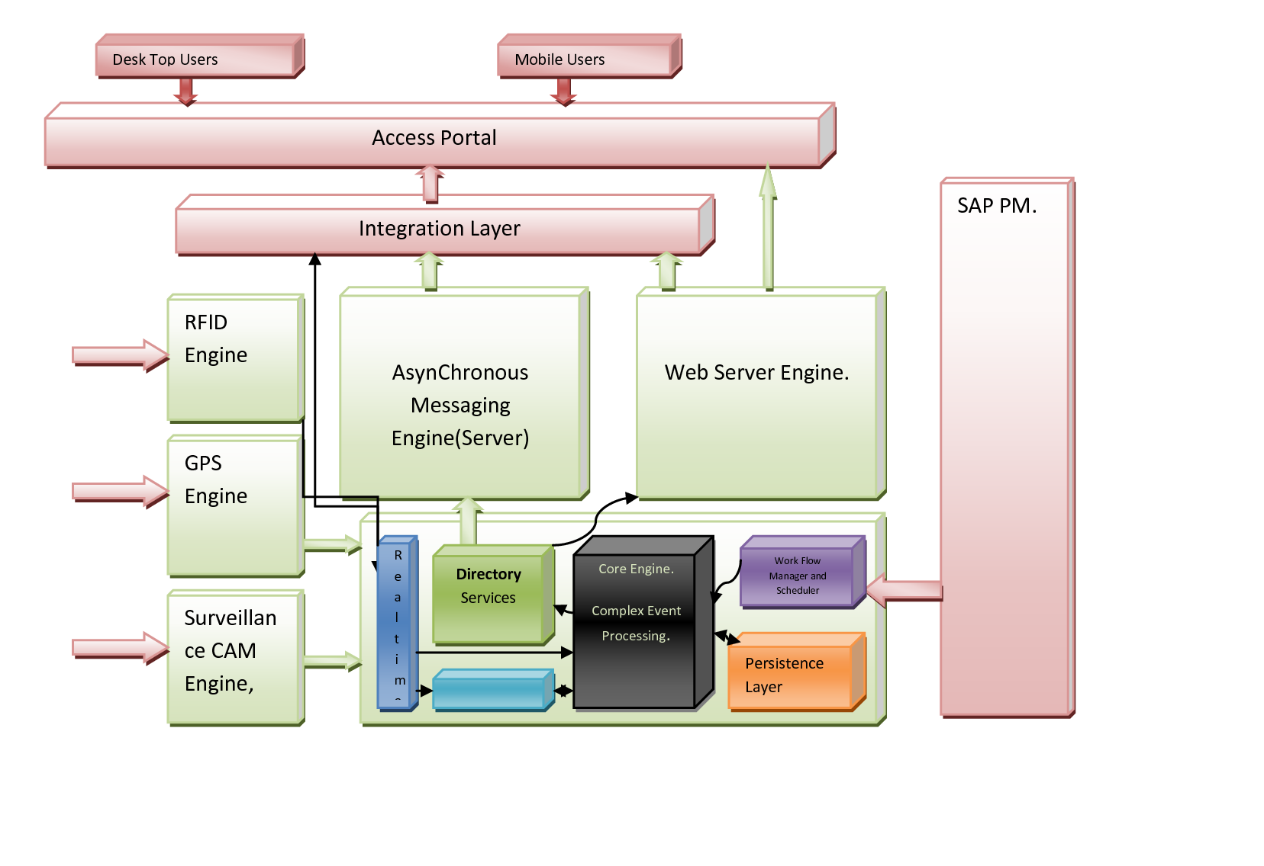

As per the figure above, Users of the System Access the System via the access Portal. Apart from user session management, The Access Portal according to the URL patterns Configuration routes the request to the Asynchronous messaging server for Dash Board Real-Time Informative Analytics and Web server as to the MVC(Model – View – Controller) Respectively.

Connecting components of the GoldSaxWorkManage Engine is our ESB implementations contain a facility, mediation flows which are part of the Service Mix enterprise service bus intercept. Mediation flows modify messages that are passed between existing services and clients that use those services. A mediation flow mediates or intervenes to provide functions, such as message logging, data transformation, and routing, the functions are implemented using the Interception Design Pattern from Service Mix.

As messages pass through the ESB, the ESB enriches the messages destined for a channel that is monitoring for a high-level business event. That is, for each message, the ESB may query the D.F.S to obtain additional information about some data entity within the message

## Workforce Manager – Macro Architecture

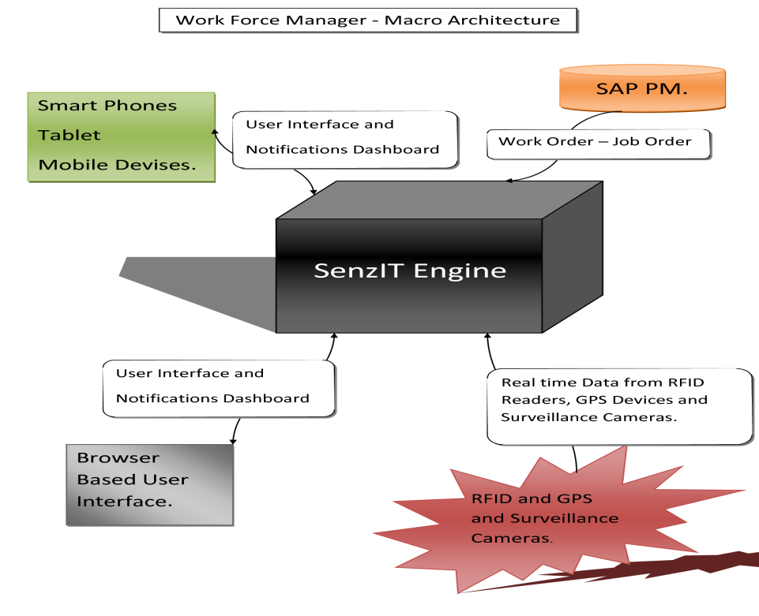

**Dash Board Services:**

Based upon the authentication, user privileges from the administrator determine the

Informative Analytics to be presented. This is configured at the Directory services.

The Directory services also provide authentication services.

**Forms and Data Services:**

Based upon the authentication, user privileges from the administrator determine the form and data to be presented. This is configured at the Directory services. The Directory services also provide authentication services.

**Byte Streaming:**

Based upon the authentication, user privileges from the administrator determine the Media content, RFID MAPs and GPS Maps to be presented. This is configured at the Directory services.

* + 1. **GoldSaxWorkManage Engine**

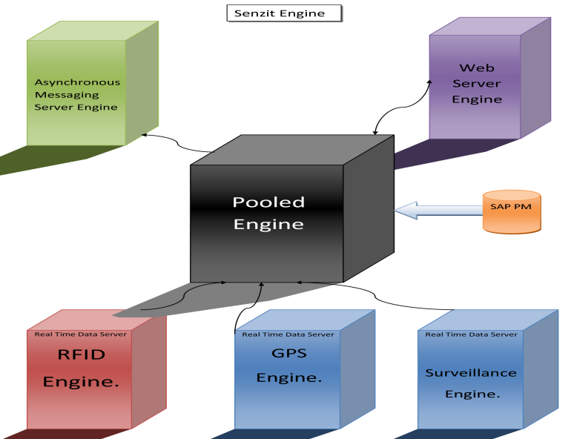

At the Heart of the WMS system is the GoldSaxWorkManage Engine which receives real-time data from RFID, GPS and Surveillance Cameras. RFID, GPS and Surveillance Cameras are placed in the Service corridor at the service field to monitor and retrieve data from Field force and assets. Periodical retrieval of work order from the SAP PM is also made. Responding to request from the access portal for Web user interface and Mobile devices offering Dashboard services Byte Streaming and Forms and data services.

* + 1. **Pooled Engine**

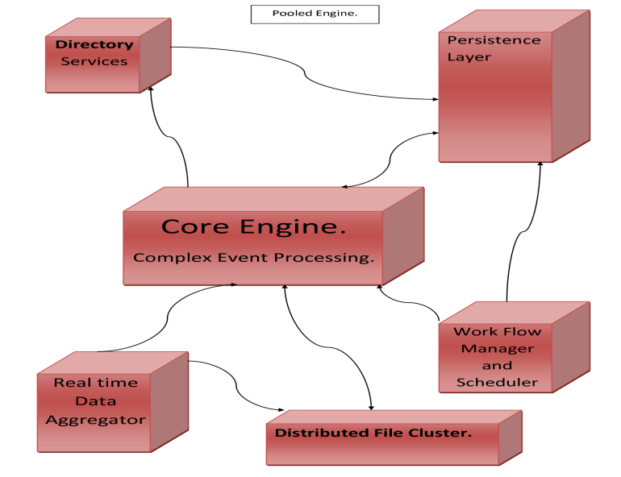

The heart of the GoldSaxWorkManage Engine is the pooled engine which retrieves data from the RFID Engine, GPS engine and Surveillance Engine into the Real time data Aggregator. Further the web server access the persistence layer of the Pooled engine and the Asynchronous messaging server engine access the pooled engine for Dashboard services and byte streaming.

* + 1. **Core Engine (Complex event processing):**

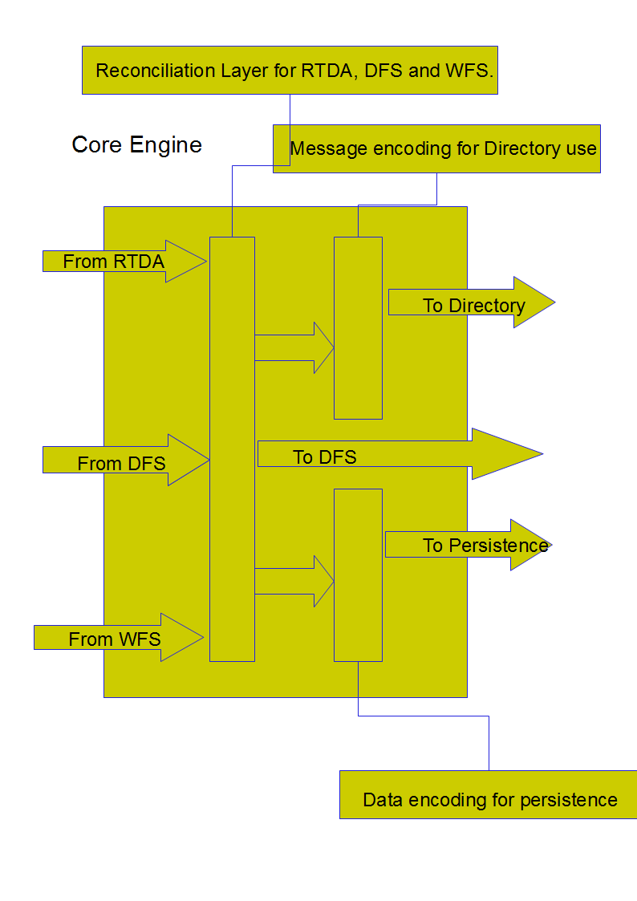

The C.E.P is an Esper Engine with synchronous data access from Real time Data Aggregator, Work Flow Manager and Scheduler, The persistence layer, and the distributed file cluster. Once the work Scheduler gets updated of the new work order from SAP PM, Synchronous access to the work flow schedule by The C.E.P which goes to a state of being unable to reconcile Task lists to data from R.T.D.A, responds to the discrepancy by searching the Active Directory for respective Stake holders as stated in the Policy and notifies them The frequency of notification is configured at the directory service with respect to the notification policy. The Notification is persisted.

* + 1. **Casual Vector Engine**

At the core of Complex event Processing, Using a Causal Vector Engine, the perception of causality can be enhanced under appropriate spatiotemporal conditions based on structural and temporal rules written into the engine. Perception of complex causal semantics, such as additive, mediated, and bidirectional causalities need to be coded so that the engine can distinguish between events that are related and those that only appear to be related but, in fact, are not.

The engine uses preponderant causal vector rate-of-change propagation to code the relationship among the events and establishes a partial order in which it validates the causality perceived between multiple occurrences. The engine plays and replays the event sequence in different temporal order to infer what could be related topological connections and compares these replays to rules preprogrammed by Work Flow Manager using JBPM. Multiple low-level system events are processed by the Causal Vector Engine and compared against these rules to trigger higher-level Business Events.

Core Engine does this through a Causality Vector Engine (CVE) choreographing messages to the active directory services layer which decide whom to notify about what and how which results in the Dashboard messages and alerts in real-time to End Users. Where streams of events need be observed as they occur, much User Interface GoldSaxWorkManageelive has several windows that list the same events in different contexts, so the End users associate Dashboard messages with Streaming data into RFID MAP, GPS MAP and Surveillance CAM’s Video.

The Dashboard Services window shows events in date-timestamp order; one or more other windows in various orders as the CVE works through the list of rules and creates implied relationships between the events. Various buttons and controls exist in the User Interface that enables the End Users to create relationships between events on-the-fly and define rules that respond to these relationships, for example auto reporting or escalating responses to alerts and events. Process analysts can infuse additional defining detail through JBPM attached to a rule or event context.

**Real Time Data Aggregator:**

In a RTDA Storm topology, there are two nodes:

* **Spout:** This gets an input stream to the Storm cluster from RFID, GPS and Surveillance CAM and then emits the data to the input stream of the cluster that will be processed by bolts.
* **Bolt:** This processes data taking it as an input a stream from a spout. Processing at the first bolts are filtering outliers and noise. After processing data, it stores it in a D.F.S as well pass it in a stream to other bolts for aggregation in a time stamped event format. This is passed to further bolts for formatting it to workflow Schedule reporting.

**Dataflow and Directory Services:**

An **Enterprise ServiceBus** (ESB) mediation flow is one of the component types in our Service Component Architecture (SCA). Like any SCA component, the program accesses a mediation flow through exports that it provides, and the mediation flow forwards messages to other external services via imports. Special kinds of imports and exports for JMS, called JMS bindings via Active MQ, enable Directory services to specify the binding configuration and use the data handling context object from the directory. The mediation flow consists of a series of mediation primitives that manipulate messages as they flow through the bus.

Our specified custom binding for both export and import, does then start to focus on the mediation flow component by the JMS Custom Binding Mediation Component where each operation on the flow component's interface is represented by a request and a response.

**Service Data Objects** (SDO) framework provides a unified framework for data from multiple data sources, such as Persistence, entity EJB components, XML data, Web services, the Service Component Architecture, JMS messages and JSPs.

Mediation flows are entirely independent of the bindings that are used in the imports and exports. In fact, the purpose of having a conversion into an SDO Data Object instance outside of the flow implementation is because mediation flows can then be built without knowledge of the protocol and format with which messages are sent to and from the mediation module format with which messag are sent to and from the mediation module are sent to and from the mediation module

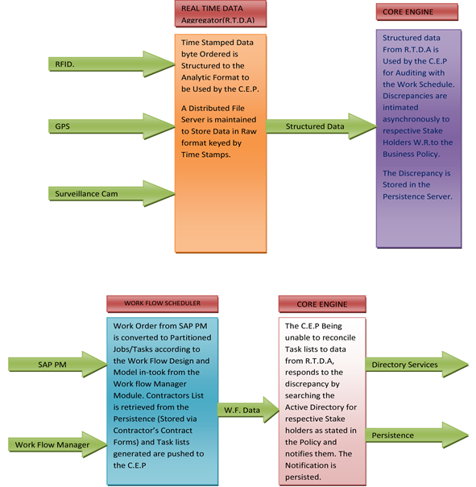

Periodically through synchronous access, structured data From R.T.D.A is used by the C.E.P for reconciliation with the Work Schedule. Anomaly is intimated asynchronously to respective Stake Holders and with respect to the Business Policy, remedial measures are suggested. The Anomaly is Stored in the Persistence Server.

**Quality Assurance:**

While historical data remains unavailable, inference of quality based on measure of benchmarking parametersof the entire population(i.e the final produce) as per the quality measurement policy is utilized. Visual parameters are retrieved through the 3D CAM and non visual parameters are measured via sensory devices and other digital devices needful to retrieve the quality parameters.

**Products for**

**Quality check**

**CORE-ENGINE**

**Surveillance**

**Engine**

**3D Camera**



## PHASE II – SAP Integration & Hardware Deployment

**Milestone – 8 Integration with SAP PM using SAP PI (Process Integration**

* To retrieve/download data from SAP PM.
* Work order CSV, XML or any SOAP Restful Message to be retrieved periodically by logging in and downloading.
* To parse and structure the data for the Work flow scheduler Engine.
* Work order to be merged with Contractors and vendor management data to arrive at a work schedule with at least.
* Work ID, Location ID, Contractor ID, Work Start time, Work Finish time.

**Milestone – 9 Testing & GO live of GoldSaxWorkManage WMS integrated with SAP PM.**

* Ensure consistency from data in SAP and GoldSaxWorkManage WFS&M Engine.
* Benchmark Testing
* Load Testing
* Verification Testing
* Go Live

**Milestone – 10 Hardware Deployments**

**Installation, erection and configuration of Hardware at the Service Corridors**

* RFID Readers.
* RFID Printers (to issue RFID Tags).
* High Resolution Surveillance CAMs.
* 3D CAMs for Quality Inspection.
* GPS Devices at Utilities Giant’s Vehicles for transit.
* Servers for Engines.
* Database Servers.
* Networking the Servers and Configuring the Hardware to O.S and to tune the Engines.
* Clustering the Servers for scalability.
* Installation of Softwares in Smart Devices.

**Assumptions:**

* The maintenance orders are created in SAP based on service corridors.
* The contractors in the vendor management system are not integrated with the maintenance orders in SAP.
* The RFID tags are carried inside the service corridor via the pass office only, by the workforce provided by the contractor.

# Scope of Work – Option 2

## Recommended Solution

**Workforce Management System ( WFMS)**

As option two - Workforce Management System (WFMS) - is proposed for managing the RFID keys that are used for tracking the workforce, the maintenance orders created in SAP will be read into WFMS based on a pre-defined periodicity. These orders are linked to the contractors, who provide the workforce, maintained in the WFMS. With this linkage, it becomes feasible to get information regarding which maintenance order (PTW) is issued against a particular contractor, what services are expected to be delivered by him, the delivery expectations and the workforce requirement. When the RFID keys are issued, they are issued against the maintenance order using WFMS. The WFMS application will also maintain the master data of the RFID keys available at the service corridor.

Passive RFID readers are installed at the pass office and various sections within the service corridor. The IN and OUT readings are polled by the reader and read by WFMS. The frequency of polling the readings can be decided by the client based on the tracking requirement.

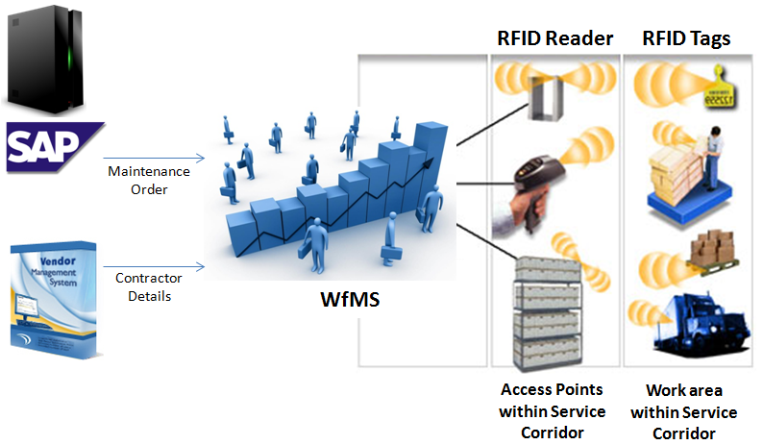

SAP will communicate with WFMS via the SAP PI. As an alternative, the Maintenance Order details can be downloaded using ABAP program as a sequential or XML file which can then be read by WMS. Only one of the mentioned interfaces will be implemented.

With the above mentioned linkages maintained in WFMS, various reports can be generated to analyze the workforce brought in by a contractor against a PTW and hence his performance can be measured. Other controls / reports planned in WFMS:

* Analyze whether a contract team is working in a designated location or not.
* Identify workforce/contractor who is yet to return the key/PTW.

WMS is also planned to work offline, in case it cannot to SAP due to a network failure.

The monitoring functions and the analysis reports can be accessed via android and windows based mobile devices as well.

## Assumptions

* The maintenance orders are created in SAP based on service corridors.
* The contractors in the vendor management system are not integrated with the maintenance orders in SAP.
* The RFID tags are carried inside the service corridor via the pass office only, by the workforce provided by the contractor.

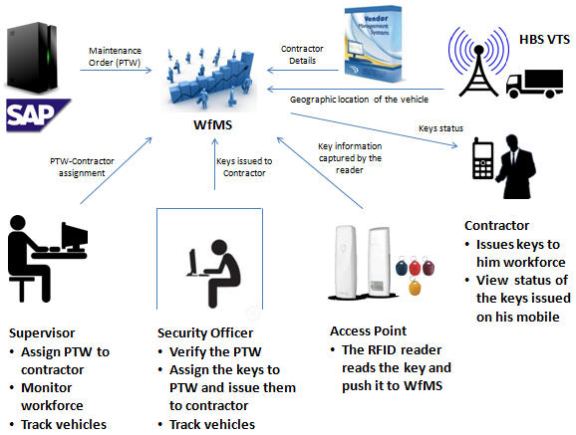

* Tracking and monitoring of visitors are outside the scope of the project.
* Locating the worker based on his real time coordinates is not in the scope of the project.
* Graphical display of work locations and the workforce working there is not in the scope of the project.
* No data is written back into SAP ECC.
* The client will provide the necessary assistance to develop interface with the VMS application.
* The mobile devices on which the monitoring functions are required to be accessed will be finalized with the client before starting the project.
* The WMS application has its own storage requirements and hence GOLDSAXWORKMANAGE proposes MS SQL Database. The client has to procure the licenses required.
* Access to client’s SAP development (ABAP development rights required), quality and production systems and the required documentation.
* The effort estimates that follows are for providing the solution to one service corridor only.

## Exclusions

* Supply of RFID readers and tags are outside the scope of the project and the client has to ensure that they are available in enough numbers before starting the project.
* The supplier of the RFID readers and tags has to ensure that data is polled onto a location readable by WMS.

## Vehicle Tracking Solution

For tracking the fleet that ferries materials in and out of the service corridor, GOLDSAXWORKMANAGE propose a readymade application from its product stable. GOLDSAXWORKMANAGE VTS is an advanced Web based GPS tracking solution that delivers state-of-the art services to assist your organization improve efficiency, prevent asset loss, increase security, optimize emergency and surveillance tasks. GOLDSAXWORKMANAGE VTS services are accessible online from any computer with a standard browser and an Internet connection. You can login to GOLDSAXWORKMANAGE VTS secure servers to manage your assets, track your devices and change account parameters.

GOLDSAXWORKMANAGE VTS makes automated location finding an easy task with professional GPS tracking and tracing devices, GPS enabled PDA/mobile phones and wireless or cellular devices. GOLDSAXWORKMANAGE VTS can be used to track vehicles, static and moving objects and mobile work force. In addition to these, advanced tracking features improve employee productivity and safety.

Tracking functionality includes real-time tracking of multiple vehicles, on screen route history viewing, vehicle history reporting and data exports in PDF, KML and CSV formats for further processing. GOLDSAXWORKMANAGE VTS supports a large number of hardware devices with facilities to add additional sensors and enhanced telemetric solutions. On selected devices the configuration parameters and tracking commands can be sent over-the-air (OTA).

**Key Features of GOLDSAXWORKMANAGE VTS**

* Modular, Scalable and Resilient design
* Highly Available (HA) and Fault-Tolerant (FT)
* Security and access logs
* Built on open source technologies and standards
* Over-the-air (OTA) configuration of devices
* Multiple databases, Web servers, Operating Systems
* Time zones, languages and multi-lingual maps
* Modular administration with multiple roles
* Real-time tracking with server push technology
* Playback with start, stop, rewind and fast forward
* Supports multiple devices with multiple sensors and telematics
* CDMA/GSM/GPRS/SMS network
* Devices with Internal battery and high quantity
* GPS data storage
* Vehicle Geo-fencing
* Route optimization
* Add custom locations and Points Of Interest
* Custom map support
* Alerts and messages to ensure safety and Security
* Reports in multiple formats
* Trouble ticket management

**Functionality proposed for implementation at client site**



For the project under discussion, GOLDSAXWORKMANAGE proposes to implement the most essential vehicle tracking and monitoring functions which include:

* Real-time tracking and playback of vehicle movements
* Geo-fencing to provide alerts when the vehicle moves into restricted area

## Assumptions

* The digitised map of the area where the service corridors are located to help track vehicle movements will have to be provided by the client. There is an option to use Google maps; the decision has to be taken by the client.
* The GPS enabled devices, to be attached to the vehicles, have to be purchased and made available before starting the projects by the client.
* The client shall provide assistance for fixing the devices to the vehicle. The vehicles have to be made available to the project team as per an agreed schedule.
* The cost for purchase SMS packages and licensing requirements for the usage of GPS devices will have to be arranged by the client.
* The effort estimate is for installing a maximum of 100 GPS devices to vehicles.

## Exclusions

Apart from tracking the vehicle movements; other functions like monitoring fuel usage, over speeding, parking for longer durations etc. will not be part of the scope of the project.

## Asset Tracking and Protection using Day & Night Surveillance Camera

There are many remote facilities that lack off-site observation or security measures within the service corridor. The assets can be closely monitored to ensure that they remain functional and productive at all times and there is not unauthorized movement of these assets.

Considering the purchase of evaluation of the surveillance cameras, identification of the location where it has to be placed, the purchasing time required etc.; the gestation time required to complete this task will be longer. Hence GOLDSAXWORKMANAGE proposes to have this function implementation as a second phase. This proposal does not cover the implementation aspects of the asset tracking and protection using surveillance camera.

## Technology Details

* The WMS application shall be developed using Microsoft .NET framework 4.5 with C# Technology and ASP.NET for the web based interface. MS SQL database will be used for storing the application specific details.
* SAP ECC and WMS will communicate via SAP PI. RFC function modules may be required to be written in SAP to extract the data required for WMS.
* GOLDSAXWORKMANAGE VTS is built on open source technology and standards. It uses PHP, PostgreSQL, OpenLayers, JQuery CakekPHP and Java.

## Pre-requisites for implementation

The client will have to arrange the required hardware and software for installing the applications discussed above. The proposed configurations are as follows:

For WMS Main Server

* Processor: Intel Xeon E3-1275 V2 @ 3.50GHz
* RAM: 1600 MHz, 2 x 8GB Memory
* Hard Disk: 2 x 1 TB SATA
* Integrated RAID 01

Backup Server

* Processor: Intel Core i3-3240 @ 3.40GHz
* RAM: 1600 Mhz, 1 x 8GB memory
* Hard Disk: 1 x 1 TB SATA
* Database: SQL Server 2008 R2 - 2 licenses
* Operating system: either Ubuntu/Linux operating system or Windows NT

For GOLDSAXWORKMANAGE Vehicle Tracking Solution

Main Server

* Processor: Intel Xeon E3-1275 V2 @ 3.50GHz.
* RAM: 1600 MHz, 2 x 8GB Memory
* Hard Disk: 2 x 1 TB SATA
* Integrated RAID 01
* Network card: 2 Nos.

Backup Server

* Processor: Intel Core i3-3240 @ 3.40GHz
* RAM: 1600 Mhz, 1 x 8GB memory
* Hard Disk: 1 x 1 TB SATA
* Database: PostgreSQL
* Operating system: Ubuntu/Linux
* GPS devices, RFID Keys, RFID Readers, mobile devices in required numbers.
* Development and testing environment (entry level servers) shall also be provided by the client.

## Implementation Methodology

GOLDSAXWORKMANAGE proposes SAP Solution Manager Based Implementation approach.

GOLDSAXWORKMANAGE proposes a five phase approach comprising of Project Preparation 🡪 Business Blueprint🡪 Realization 🡪 Final Preparation Go-Live 🡪 Support (Hypercare) for execution of this project.

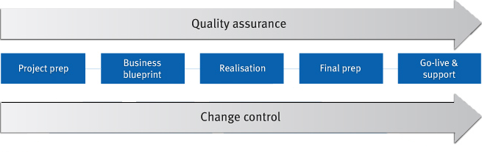

**Project Preparation - Project formally initiated and planning commenced**

The purpose of the Project Preparation Phase is to initiate a SAP Implementation project. As the project’s start-up phase, this phase will primarily involve addressing project logistical concerns such as facilities, infrastructure and culminates with the Project kick-off meeting.

**Business Blueprint - Requirement Analysis and Design**

The objective of this phase is to analyze the entire Data requirement for implementation. Subsequent to the analysis phase, based on the requirements, detailed design documents of the “to-be” state are produced. This phase culminates with the sign-off of the Requirements Documents and the Design Documents. Requirement document and Design document will be reused wherever applicable.

**Realization - Build, Unit Test and Integration Test**

Project Realization acts as project's development and configuration phase. Users begin to see the fruits of the design phase in this stage of the project. In this phase Installation/configuration of SAP and its components in the recommended scenario will be done. Enhancements will be done to achieve custom functionality (if any). All testing (Unit, Integration, Regression and User Acceptance Testing) to validate the Build as well as User training is conducted in this phase to validate the build. The phase ends with a Quality Assurance review of the testing results and a formal decision to Go Live.

**Final Preparation and Go-live - End users are trained & Solution confirmed for cutover**

The objective of this phase is to complete the final preparation prepare the data require for final cutover, plan and schedule the cutover activities and finalize readiness to go live. This phase also serves to resolve all crucial open issues. The phase culminates with final Go-live.

**Support (Hypercare) - Operability of Solution deployed ensured**

The objective of this phase is to move from a pre-production environment to live production operation.

Project Activities as per ASAP methodology

The high-level project activities as per ASAP methodology that will be followed for SAP implementation is given below:

**Milestone 1: Project Preparation**

* Defining Project goals and objectives
* Preparing the Project organization and standards
* Finalizing the scope of SAP implementation
* Defining SAP implementation strategy
* Defining the overall Project schedule and implementation sequence
* Establishing the Project organization and committees
* Preparing the Project charter
* Identifying and Assigning resources
* Technical requirements planning for development servers
* PCs for the Project team
* Prepare executive kick-off meeting

**Milestone 2: Business Blueprint**

* Define the Baseline scope
* Refine the overall Project schedule and implementation sequence
* Develop System Environment - Install Quality Assurance System
* Define Business Organization Structure
* Business Process Definition / Documentation and sign-off
* List Reports, Lay-out, Enhancements, Conversions, etc.
* Quality check Blueprint phase
* Data Migration and Cut Over strategy
* Training Plan

**Milestone 3: Realization**

* Organizational Change Management
* Configuration and Confirmation
* Final Configuration and confirmation
* Technical System Management, Install Training Systems
* Create Reports, Forms
* Establish Authorization Concept
* Final Integration Test
* End User Documentation and Training Material
* Quality Check Realization phase

**Milestone 4: Final Preparation**

* Project Management Final Preparation for go-live
* End User Training
* Installation and commissioning of Production server
* Detailed Project Planning
* Data Migration and Cut Over
* Establish Internal Help Desk
* Quality Check Final Preparation Phase

**Milestone 5: Go Live and Support**

* Production Support & Post Go-Live Activities

## Project Plan

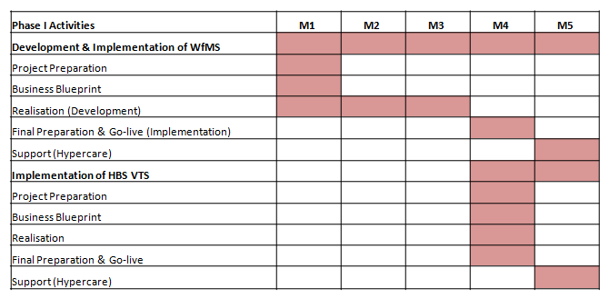

* Onsite effort will be there during the project preparation phase, for final preparation phase and the support phase (Hypercare) of the project.
* The Scrum framework shall be used with a 2 weeks sprint with continuous deployment during the development phase of WfMS

## Deliverables

**Project Preparation**

The goal of this phase is to review the detail project plan, procedures and staffing based on the detailed scope discussions and agreements of the pre-implementation phases and to finalise development, quality and production environments and the new processes after introduction of WfMS and VTS.

| **Deliverables** | **Primary Responsibility** | **Secondary Responsibility** |
| --- | --- | --- |
| Development Environment and QA Environment Installed and Ready for Realization Phase | Client | GOLDSAXWORKMANAGE |
| Project plan, schedule, scope, charter and Detailed Staff assignments finalized to Client agreed scope | GOLDSAXWORKMANAGE | Client |
| Project Environment Established | GOLDSAXWORKMANAGE | Client |
| Project Kick off meeting conducted | Client | GOLDSAXWORKMANAGE |

**Business Blueprint**

The Business Blueprint phase will address the additional functionalities of the Organization which are not included in the Global Design template and are specific to the organization. The additional requirements for Developments, Modifications and reporting will also be finalized during this stage.

| **Deliverables** | **Primary Responsibility** | **Secondary Responsibility** |
| --- | --- | --- |
| Requirement Gathering | Client | GOLDSAXWORKMANAGE |
| Signed Off Blueprint document | Client | GOLDSAXWORKMANAGE |
| Development of Functional Specification Documents for the identified objects | GOLDSAXWORKMANAGE | Client |
| Providing Approved Functional Design and Detailed Process Design for review | Client | GOLDSAXWORKMANAGE |
| Developing the Hand-off Mechanism and Acceptance criteria | GOLDSAXWORKMANAGE | Client |
| Install and configure the technical environment | GOLDSAXWORKMANAGE | Client |
| Gap Analysis report | GOLDSAXWORKMANAGE | Client |
| Data migration plan and templates | GOLDSAXWORKMANAGE | Client |
| Training strategy | GOLDSAXWORKMANAGE | Client |
| Cutover strategy | GOLDSAXWORKMANAGE | Client |

**Realization**

| **Deliverables** | **Primary Responsibility** | **Secondary Responsibility** |
| --- | --- | --- |
| Initial settings and organizational structure finalized in system | GOLDSAXWORKMANAGE & Client | - |
| Business Transactions Unit Tested with Converted Data | GOLDSAXWORKMANAGE & Client | - |
| Conversions Tested and Errors Cleared | GOLDSAXWORKMANAGE & Client | - |
| Built Production Environments | Client | GOLDSAXWORKMANAGE |
| Confirmed Integration Test Plans | GOLDSAXWORKMANAGE & Client |  |
| Integration Test Completed | Client | GOLDSAXWORKMANAGE |
| Confirmed End User Training Plans | Client | GOLDSAXWORKMANAGE |

**Final Preparation**

| **Deliverables** | **Primary Responsibility** | **Secondary Responsibility** |
| --- | --- | --- |
| UAT sign-off | Client | GOLDSAXWORKMANAGE |
| End-Users Trained | Client | GOLDSAXWORKMANAGE |
| Productive system ready (Configuration transported and Legacy Data Converted) | Client | GOLDSAXWORKMANAGE |
| Data uploaded and verified | Client | GOLDSAXWORKMANAGE |
| Help Desk in Place | Client | GOLDSAXWORKMANAGE |

**Hypercare**

| **Deliverables** | **Primary Responsibility** |
| --- | --- |
| Live Productive System | GOLDSAXWORKMANAGE & Client |
| Support transitioned to Client | GOLDSAXWORKMANAGE & Client |
| Project closed | GOLDSAXWORKMANAGE & Client |

Document generation, dissemination, storage and ultimate disposition/ distribution of the same are critical activity in project. GOLDSAXWORKMANAGE’s plan covers all the aspects of documentation. During the project lifecycles, there are many documents generated. The same can be categorized as:

* Standards, Procedures & Guides
* Plans & Reports
* Knowledge Management
* Quality Documents

The table below provides plan detailing out types of documents generated during various phases of the project and dissemination of the same:

| **Category** | **Document** | **Generation** | **Dissemination** | **Responsibility** |
| --- | --- | --- | --- | --- |
| Standards | Project Charter | Project Preparation | Business Blueprint | Client/GOLDSAXWORKMANAGE |
| Project Governance Standards | Project Preparation | Business Blueprint | Client/GOLDSAXWORKMANAGE |
|  | | | | |
| Procedure and Guides | Preliminary Check and Update Guide | Project Preparation | Business Blueprint | GOLDSAXWORKMANAGE |
| Prepare Guide for installation | Project Preparation | Business Blueprint | GOLDSAXWORKMANAGE |
|  | | | | |
| Plans | Project Plan | Project Preparation | Business Blueprint | Client/GOLDSAXWORKMANAGE |
| Cutover Plan | Realization | Cutover | Client/GOLDSAXWORKMANAGE |
| KT Plan | Blueprint | Realization | GOLDSAXWORKMANAGE |
| Communication Plan | Project Preparation | Business Blueprint | Client/GOLDSAXWORKMANAGE |
| Integration Test Plan | Blueprint | Realization | GOLDSAXWORKMANAGE |
| UAT | Blueprint | Realization | Client/GOLDSAXWORKMANAGE |
|  | | | | |
| Reports | Project Status Report | All Phases | Weekly | GOLDSAXWORKMANAGE |
| Test result documents | Realization | Cutover | GOLDSAXWORKMANAGE |
|  | | | | |
| Knowledge Management | Blueprint document | Blueprint | Realization | Client/GOLDSAXWORKMANAGE |
| Custom development request document | Blueprint | Realization | Client/GOLDSAXWORKMANAGE |
| Basis/DB handover document | Realization | Cutover | GOLDSAXWORKMANAGE |
| System administration documents | Realization | Cutover | GOLDSAXWORKMANAGE |
| Configuration document | Realization | Cutover | GOLDSAXWORKMANAGE |
| Test problem Report and Resolution | Realization | Cutover | GOLDSAXWORKMANAGE |
| Interface documents (Development Request) | Realization | Cutover | GOLDSAXWORKMANAGE |
| Technical specification document | Realization | Cutover | GOLDSAXWORKMANAGE |
| Functional specification document | Realization | Cutover | GOLDSAXWORKMANAGE |
| Quality Documents | Code Review documents | Realization | Cutover | GOLDSAXWORKMANAGE |
| Living Document | Issue Logs | All Phases | Project Closure | Client/GOLDSAXWORKMANAGE |
| Risk Monitoring and Review log | All Phases | Project Closure | Client/GOLDSAXWORKMANAGE |

Template and standards for the all above document types are available as a part of GOLDSAXWORKMANAGE’s Quality Management System (QMS). These templates will be used for project documentation.

## Roles and Responsibility Matrix

Roles and Responsibilities for activities under services provided:

The table shown below provides an overview of Primary and Secondary responsibilities of Project Teams from Client and GOLDSAXWORKMANAGE for various activities.

The organization identified for an Activity in any project phase in the table below as “Primary” is responsible for actively leading, directing, and driving the specified activity within such phase.

The organization identified for an Activity in any project phase in the table below as “Assist” indicates that such organization may be called upon to provide inputs to the specified activity.

| **Project Phase** | **GOLDSAXWORKMANAGE** | **Client** |
| --- | --- | --- |
| **Project Preparation** | | |
| Project Charter preparation | Assist | Primary |
| Project Organization | Primary | Primary |
| Detail Project Plan | Primary | Assist |
| Kick-off | Primary | Primary |
| **Business Blueprinting** | | |
| Requirement Gathering | Primary | Primary |
| Development of Functional Specification Documents for the identified objects | Primary | Assist |
| Providing Approved Functional Design and Detailed Process Design for review | Assist | Primary |
| Developing the Hand-off Mechanism and Acceptance criteria | Primary | Primary |
| Install and configure the technical environment | Primary | Assist |
| **Realization** | | |
| Development of Technical Specifications for the identified objects | Primary | Assist |
| Configuration and Development | Primary | Assist |
| Conducting Unit Testing | Primary | Assist |
| Business scenario test case preparation | Assist | Primary |
| Conducting Integration testing | Primary | Primary |
| Investigate and fix Process Configurations based on System Integration Testing results | Primary | Assist |
| Preparing training document | Primary | Assist |
| Conduct the training for the key users | Primary | Assist |
| Conduct training for End users | Assist | Primary |
| Conducting User Acceptance Testing | Assist | Primary |
| Acceptance Sign-off | Assist | Primary |
| **Go live preparation and Go-live** | | |
| Preparing Cutover Strategy | Primary | Assist |
| Preparing Data for Final Cutover | Assist | Primary |
| Go-No Go decision | Assist | Primary |
| Final Data Loading | Primary | Assist |
| Client Sign-off | Assist | Primary |
| **Hyper care** | | |
| Define and Setup Support Model | Assist | Primary |
| Post Production Issue Resolution for Configuration and RICEFW Objects | Primary | Assist |
| Knowledge Transition to process team | Primary | Assist |

**Project Activities and Responsibilities:**

|  |  |  |
| --- | --- | --- |
| **Activity** | **Client Core Team** | **GOLDSAXWORKMANAGE Consultants** |
| Requirement Specification | X | X |
| Gap Analysis | X | X |
| System Configuration |  | X |
| Technical -Specifications | X |  |
| Configuration and Development |  | X |
| Prototyping |  | X |
| Unit Testing | X | X |
| Integration Testing | X | X |
| User Acceptance Testing | X | X |
| Technical Documentation |  | X |
| End User Training | X |  |
| Master Data Preparation | X |  |
| Master Data Loading | X | X |
| Post Go Live Support | X | X |

## Handling Scope Changes

Any requirement or development that takes more than 15 days will be considered as a change request and will be handled as per the process for handling change requests. Client will send a change request to GOLDSAXWORKMANAGE and GOLDSAXWORKMANAGE will estimate the effort, seek approval from Client. GOLDSAXWORKMANAGE will execute the change request on approval from Client at a man-day rate which will be based on the scope of work to handled Onsite or offsite

**Scope change procedure**

GOLDSAXWORKMANAGE has a well-defined scope change control process to manage changes pertaining to application services or individual components and to co-ordinate the changes across all the impacted components.

A Change Control Board (CCB) is proposed, consisting of the Project Coordinator, or any other senior representative of either Client or GOLDSAXWORKMANAGE. The CCB is formed before commencement of the engagement.

Fig: Change Control Procedure

**Change Identification and**

**Categorization (Customer)**

**Open a Change**

**Request**

**(CR/PR Log)**

**Change Review (CCB)**

**Change Log (PL)**

Specifications

Efforts

Span

Allocation

**Customer Approval**

**Execute the**

**Change**

**Customer**

**Acceptance**

**Close CR**

**Yes**

**No**

**Major**

**Change?**

Additional features

Changes in existing specification

Changes in approved assumptions

Changes in version of the software used

Criticality

Scope

Impact on the system

Estimated effort for implementation

Cost

Efforts

Span

A typical change management process is depicted below:

* All change requests (CR) are logged in CR Log and reviewed by the Change Control Board (CCB) for feasibility and impact
* For high impact CR, effort estimation and plan is approved by customer before implementation
* Version control of impacted entities is managed by quality leader

The primary task of the CCB is to analyze the Change Requests for feasibility and impact. Based on the analysis, the Change Request is either accepted or rejected.

Change Management involves the following:

* Request for Change: A request for application change or correction could be raised using the Problem tracking system or the User could inform via email. All the application change requests are transferred to the Change Request log (CR Log).
* Change Request Analysis: The CCB analyzes the feasibility and the impact of the requested change. Based on this analysis the change is either accepted or rejected
* Effort Estimation and Planning: Once the change is accepted, a detailed impact analysis, effort estimation and resource planning are done. The details of which are updated against the Change Request in the CR log.
* Identification of Impacted Configuration Item: The impacted entities are checked out from the Configuration Library and locked in consultation with the Configuration Librarian.
* Incorporate the Changes: The changes are incorporated into the code through the process of Designing, Design review, Coding and Code Review.
* Verification and Testing: The extent of testing is based on the size of the change request and the impact of the changes on the application. The types of testing carried out for verification purpose are Unit Testing, Integration Testing and Functional Testing and Regression Testing. All the bugs reported during the testing phases are tracked to closure.
* Release and Implementation: Once the changes are tested and verified, the person responsible plans and releases the changes into production. The release schedule is prepared in conjunction with the release schedule of all other impacted components.
* User Acceptance: After the changes are released to the production environment, an acceptance is obtained from the user and the status is updated accordingly against the Change Request. GOLDSAXWORKMANAGE has a well-defined scope change control process to manage changes pertaining to application services or individual components and to co-ordinate the changes across all the impacted components.

## GOLDSAXWORKMANAGE’ Training Approach

GOLDSAXWORKMANAGE understands that effective Training is a critical task in the SAP implementation project at Client. Hence we have identified certain objectives for the training programs to be conducted including:

* Prepare selected users for their roles in user acceptance test
* Prepare selected users for their roles in conversion of the new SAP system
* Equip users with the necessary knowledge and skills to use the new SAP system
* Encourage users’ acceptance and support for the new SAP system
* Facilitate continuing training programs for existing and new users of the system

The training approach for Client has been developed with reference to certain key principles of training including:

* User training will focus on describing how the SAP system should be used to support the business operations. User training materials would be developed that will support this objective
* A ‘Train-the-Trainer’ approach will be deployed. The user project team members will be identified and prepared for training development to become training instructors
* Training will be designed to provide terminal users with hands-on exposure.

A Training Team will be formed in the Project Preparation Phase (Design Phase) of the SAP Implementation Project. This team will be responsible for the following:

* Planning user training programs
* Developing user materials
* Coordinating user training

**Plan-the-Training**

During the early part of Project Preparation phase, detailed training plans will be developed. The key steps would include:

* Confirm the user group - The impact of user procedure definition will be taken into account as jobs may change significantly from the old to the new system
* Define training curriculum - Each user group is profiled to give a list of training required, level of training required and when required for the group
* Develop course descriptions - Each course is defined in terms of learning objectives, content, target audience and instructional approach
* Define training resource requirement - An overall training schedule is prepared together with equipment, facility and instructor personnel requirements

**Develop Training Courseware**

The following materials would be developed for each customized training course:

* Visual aids or equivalent (for instructor)
* Instructor’s guide (for instructor)
* Participant’s guide (for participants)
* Training Database

Each ‘Participant’s Guide’ will be organized by topics. Each topic covers a logical section of the course. Such an organization will enable ease of continuing maintenance of the training materials.

The ‘Participant’s Reference’ will include outputs from other implementation tasks such as user manual procedures, input forms, terminal operating instructions, report samples, etc.

**Conduct Training**

The majority of the training programs conducted will be instructor-led classroom courses. Where applicable, each course shall have a good mix of theory and hands-on exercises. Because SAP is an online real-time system, great emphasis will be given to terminal practice.

The approach will be decentralized training under which the project team will train a group of core users who will then conduct courses for other users in the organization. This approach will speed up the training process and help to develop in-depth skills within operating units. Trainings will be conducted at the Client location in Australia.

# Project Methodology

## Program Management Plan

**Proactive Program Management:**

GOLDSAXWORKMANAGE understands the complexity of the parallel tracks of development and release. GOLDSAXWORKMANAGE will ensure that there is seamless integration between various teams and stakeholders through customized Conflict Management, Communication and Escalation procedures, Change and Release Management and frequent reporting tools. GOLDSAXWORKMANAGE will:

* Schedule a Steering Committee meeting with UTILITIES GIANT’S to establish the Project objectives, and define oversight
* Work to gather documentation related to existing IT engagement policies, procedures and artifacts which GOLDSAXWORKMANAGE will leverage
* Schedule periodic status meetings with UTILITIES GIANT’S project manager to review progress and address open issues

**Service Enablers:**

GOLDSAXWORKMANAGE will bring to this engagement a synergy of all experience and best practices gained over implementation of projects with similar scope, size and purpose. Our various technology and domain practices will provide sufficient overview to help deliver the services within schedule, budget and scope. Our standard processes, customizable methodologies, audit and review processes help drive delivery excellence through our PMO.

**Solution Accelerators and Enhancements:**

GOLDSAXWORKMANAGE believes that our approach to accelerate the solution delivery a in providing solution enhancements is a key differentiator among vendors focusing on only execution of defined requirements. Throughout this proposal GOLDSAXWORKMANAGE has defined various solution accelerators and solution enhancements.

## Methodology

The success of GoldSaxWorkManage’s solutions and the level of excellence that we deliver can be attributed to the efficiency of in-house methodologies and processes. GoldSaxWorkManage is equipped with numerous methodologies which are very crucial for executing engagements at the highest levels of delivery standards and customer delight. The following diagram illustrates implementation of our methodologies in the proposed SDLC for the Workforce Management System.

## Application Development Methodology

Our application Development methodology for software engineering can be tailored to meet specific project needs and mapped to specific project execution models. GoldSaxWorkManage ensures that quality is tracked and measured throughout the project lifecycle.

**Continuous Integration**

Continuous Integration is a software development practice where members of a team integrate their work frequently; usually each person, both onsite and offsite, integrates at least weekly - often leading to multiple integrations per month. Each integration is verified by an automated build (including test) to detect integration errors as quickly as possible. GoldSaxWorkManagehas found that this approach leads to significant reduction in global integration problems. It allows a team to develop cohesive software more rapidly.

**Shared Global Codebase**

A single, shared global code repository is used by both onsite and offsite developers. The single stream of development greatly decreases the difficulty of integrating between multiple locations. GoldSaxWorkManageleverages configuration management tools that provide concurrent capability to share code across locations in a seamless manner. Configuration Management process and strategy is aligned to the nature of the engagement and the lifecycle of the same component across different releases.

**Test First Development/Test Driven Development**

GoldSaxWorkManage developers focus on repeatedly writing test cases first and then implementing only the code necessary to pass the test. The goal of this approach is to achieve rapid feedback; it can provide great value to building software better and faster. By focusing on the test cases first, one must imagine how the functionality will be used by clients (in this case, the test cases). It allows a programmer to focus on the task at hand and often the first goal is to make the test pass. Another advantage is that test-driven development, when used properly, ensures that all written code is covered by a test. The early and frequent nature of the tests helps to catch defects early in the development cycle, preventing them from becoming endemic and expensive problems. By eliminating defects earlier than normal, usually one can avoid lengthy and tedious future debugging tasks.

**Incremental Design**

GoldSaxWorkManage developers endeavor to take a "simple is best" approach to designing software. Systems are designed to take into account only those requirements that are currently under development and they do not waste inordinate amounts of time accounting for every possible design decision that may be made in the future. This does not mean that comprehensive design is accomplished. It is the focus on creating the most elegantly simple design possible that satisfies known requirements rather than focusing on designing for requirements that may or may not produce significant business benefit. The system is designed incrementally as more is learned and existing design elements and the design and code evolve as the project progresses, resulting in the simplest code possible to solve high priority business problems.

**Release Management**

Our release management process is a robust, repeatable one to manage software releases, with support to multiple applications going into each release. Our processes include robust induction plan for new members in the team and ensure strict compliance to change management processes with all changes audited.

## Transition and Maintenance Methodology

GoldSaxWorkManagehas developed and provides customized roadmap to Managed Services Model with Operational Excellence as a key differentiator to our Government clients. GoldSaxWorkManage brings vast experience in Application Management Services, having supported mission-critical applications for Federal Agencies in around the globe.

In anticipation of GoldSaxWorkManage working with UTILITIES GIANT’S for the Operational Maintenance and Support initiative of the System, we have illustrated our methodology for overall Application Management & Support and creation of a roadmap to Managed Services model, in the following figure:

**Governance & Program**

**Service Delivery**

**Initiation**

**SLA Definition**

**Process Tailoring**

**Knowledge Acquisition**

Planning

**Cut Over**

**Service Enablers**

## Testing Methodology

GoldSaxWorkManage’s Testing methodology is a full lifecycle testing methodology for performing independent software system verification and validation. Our test experts can plug in to any project at any point, whether there is only a need to take on a certain stage or set of activities, or to be responsible for the management and execution of the entire test effort.

GoldSaxWorkManage applies these elements flexibly and as suited to various engagements depending on the type of software development methodology in place (Waterfall, Rapid, Spiral, or other).

The Following diagram describes the five phase of the methodology

## Acceptance Criteria

GoldSaxWorkManage will mutually agree with UTILITIES GIANT’S on the acceptance criteria before signing the SOW. GoldSaxWorkManage will agree to the terms stated above for all defects as defined below:

GoldSaxWorkManage defect- GoldSaxWorkManage is responsible for all defects/issues arising from non-conformance to the specifications, or traced to an omission in the System Requirements Specification based on the base-line requirements document. GoldSaxWorkManage will work with UTILITIES GIANT’S in prioritizing the reported defects and help identify the release schedule for the defects.

**Enhancement**

A new requirement or change to the current software specification, which is not in the controlling baseline requirements or specification. GoldSaxWorkManage will work with UTILITIES GIANT’S in analyzing the impact of the proposed enhancements on the scope and schedule and in identifying the target release for these changes.

## Quality Assurance

Having quality centric approach through all the phases of the project can ensure quality of the deliverable. We engage testers from the very beginning of the project in order to ensure high quality deliverables. This methodology has been described in life cycle of a defect is shown in the diagram below:

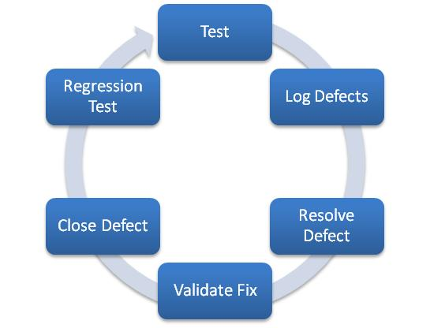

GoldSaxWorkManage will also collaborate with UTILITIES GIANT’S in performing load and performance tests and stress tests. In addition to the traditional quality assurance process of application validation, raising and resolving bugs and regression testing, as part of our effort in producing high quality artifacts, we use the following techniques right from the beginning of the engagement:

**Acceptance Criteria**

Functional specification document is an artifact produced during the requirements analysis phase. For every functional specification, the key acceptance criteria are identified upfront and provided in the functional specifications document, which are reviewed by business users and signed-off. In addition, key success factors for each of the functional modules are specified in this document. The developers verify that these acceptance criteria are met, hence laying the foundation for a quality deliverable.

**Coding standards**

Coding guidelines and standards are established upfront at the beginning of the project. All the team members in the project use same development tools and the IDE’s project “preferences” to maintain code consistency. These guidelines are formulated after consulting with our client’s IT organization. Every developer is briefed about these standards during the project on-boarding session to produce a higher quality product with minimal supervision.

**Code reviews**

We propose to organize joint code review sessions with our counterparts at UTILITIES GIANT’S to ensure that every developer in the team meets coding guidelines and standards. Typically led by technical Utilities Giant’s , these sessions identify issues with error handling, code optimizations, potential performance issues and conformity with the coding standards.

**Continuous Integration**

We would have a continuous integration during the course of the development to ensure that we deliver a quality product by fixing the bug and error dynamically.

**Documentation**

Documentation is an integral part of our development process. In addition to writing self-documenting code, we emphasize on adding detailed comments in the code to describe the functional details of the code. Although these functional comments should not be the basis for understanding the code, we do strive to keep the code consistent with the in-line comments.

**Design Artifacts**

As part of the design process, we produce the class diagrams, component diagrams, deployment diagrams etc. using UML tools. We document all our design decisions, code review meeting minutes and all other relevant project information. We can use a different tool of choice based on our customer’s preferences if required.

**Release Notes**

As part of our release process, we create detailed release notes with the following details with every release:

* Release number and date
* New features in the release
* Update to existing features
* Defects fixed in the release
* Known issues

This release note is published and provided to the teams performing quality assurance and user acceptance testing.

**Deployment Scripts**

With every release, we provide deployment scripts, which elucidate detailed instructions to release engineers and other resources involved with deployment process. These deployment scripts are walked through and reviewed by all the stakeholders. Before major releases and production releases, mock deployments are performed to validate these instructions.

**Sunset Meetings**

After every release of the application, a formal review / sunset (postmortem) meeting is organized to capture the following details (depending on the relevancy to the nature of the release):

* Were the business goals addressed?
* Best practices that worked well
* Scope for improvement
* Satisfaction of business/product managers
* Quality of deliverable

The outcomes of this meeting are published and shared with other teams. This will help in leveraging the efficiencies in the tools and processes across the teams, hence multiplying the effectiveness of our processes.

## Knowledge Transfer

At the end of the development phase, GoldSaxWorkManage will deploy an resource to take the applications/portals that are deployed through the journey into support/maintenance. The Transition manager will plan and execute all necessary steps to setup a support model. Following are the key activities that will be executed:

* Establish Toll gate checks to validate that applications are ready for Business As Usual (BAU) support
* Knowledge Transfer which will include a business overview of all applications and respective interfaces and integration to other applications in the client environment
* Process Training for the teams in Support & maintenance
* Setup parameters for customer satisfaction survey for service
* Monitor & evaluate the support during the Guarantee period and advise if any changes are necessary to the Delivery model

At the start of the development phase, GoldSaxWorkManage in collaboration with UTILITIES GIANT’S , will setup a success criterion for the Project. This will form the criterion to be evaluated at the end of warranty support. The success criterion will broadly fall under following parameters:

* Status of application documentations
* Assess if all necessary documents are in place and, customer sign-offs are in place
* Testing/UAT statuses
* Whether testing has been completed and user approvals in place
* Ensure Test strategies & plans are available for future references
* New team’s knowledge to support the applications
* Ensure all necessary KT is completed for Technical as well as processes
* Ensure key business users are informed about the new support teams and necessary contact points

Transition Manager will review the above mentioned criterion with the Development Project manager and will create an action plan to bring any open items to closure. This plan is managed during the Transition Phase. At the end of Warranty Period, all actions are expected to be closed and applications & integration are ready to move into a support mode. If all action items are closed and considered “supportable”, development teams who will no longer continue into service will be released. If otherwise, all required team members from the Project will be retained until the criterion is accepted.

# Comparative Analysis between the Options

|  |  |
| --- | --- |
| GoldSaxWorkManage WMS | Senz WFMS |
| This is designed on a Real time SOA "SOA.2" a Real time engine with low latency connected via Enterprise Service bus the different components that form the GoldSaxWorkManage Engine. | This follows the Client Server Architecture wherein for every response; a request needs to be made. |
| In Real Time, the system generates messages to the Elive Dashboard based upon Parsed metadata match in the Core- Engine. | Various reports can be generated to analyse the workforce brought in by a contractor against a PTW and hence his performance can be measured. |
| Auto generate reports based on rule automation feature and messages of the work in progress, | Analyse whether a contract team is working in a designated location or not. |
| Complete real time tracking of Work Backlog, lag in progress, lack of field force to complete the work | Identify workforce/contractor who is yet to return the key/PTW. |
| This is a highly available system which should have access to all devices and data 24/7. In case of an outage or network failure, | WFMS is also planned to work offline, in case it cannot to SAP due to a network failure. |
| Monitoring and Analysis Reports, Charts, Video Monitors, Dashboards are available in Elive and Browser based U.I | The monitoring functions and the analysis reports can be accessed via android and windows based mobile devices as well. |
| Unauthorized intrusion is immediately traced and the respective parties are messaged. | Tracking and monitoring of visitors are outside the scope of the project. |
| A worker, team member can be tracked via RFID and zoomed in via the surveillance CAM for Monitoring, Behaviourial pattern recognition etc. | Locating the worker based on his real time coordinates is not in the scope of the project. |
| A Graphical display of work locations is available based on Service Corridor, down to fields and also the work area | Graphical display of work locations and the workforce working there is not in the scope of the project. |
| Quality measure of the Products is done at respective phases via the 3D Cam | No scope for quality measure |
| The system is partially automated for even usual tasks like reporting. | No automation |

|  |  |  |
| --- | --- | --- |
| Feature Comparison | Option 1 | Option 2 |
| Automation of Key management and issuance. | Yes | Yes |
| Secure access automation. |  |  |
| Service Corridor security using Surveillance cam and RFID. | Yes | No |
| Mobilizing Reporting, alerting and monitoring which is an Application User Interface to be installed in IPAD, IOS, Android and Windows phone. | Yes | Yes |
| Create auto response to alerts and reports and dashboard via rule automation for all user agents. | Yes | No - Manual |
| View workforce Performance via Surveillance CAM. | Yes | No |
| View authorized personal at the service corridor via Surveillance CAM. | Yes | No |
| Track workforces’ position via RFID. | Yes | No |
| Auto-creation of work schedule using the work order from SAP PM according to work scheduling policy via the Work-Flow Scheduler. | Yes | Yes |
| End of the day reports for Contractors, Supervisors, Vendor Managers and Security personal. | Yes | Yes |
| Periodical reports of Work progress by the contractor and supervisor. | Yes | Yes |
| A live Dashboard constituting information-flow of work flow events to related users. | Yes | No |
| Alerts on the Dashboard and pop up boxes. | Yes | No |
| Asset Quality to be monitored continually. | Yes | No |
| Quality inspection | Yes | No |

# Project Assumptions

Below are the assumptions based on which the estimate has been prepared:-

* All relevant stakeholders shall review the deliverables and the deliverables would be revised incorporating the comments from stakeholders. Utilities Giant’s shall validate the revised deliverables and on conformance shall approve the same.
* Scenarios that require stakeholder buy-ins shall be facilitated by the Utilities Giant’s . Utilities Giant’s shall take an active role in resolving any disagreements from the stakeholders.
* Utilities Giant’s will ensure that any dependencies for the success of this project are provided on time.
* Detailed Requirement Engineering will be accomplished and would be mutually agreed and signed off.
* Project kick off starts after the singing off the Detailed Requirement engineering document
* Detailed Requirement Engineering Document stage can be considered as a “ZERO’th” stage of the project.
* Onsite support and availability of team from the client should be facilitated on time
* Test Criteria & Acceptance testing will be concluded along with Requirement   
  Freezing. Client holds the responsibility for the same.
* Software tools, licenses, hardware if required will be discussed and concluded along with Requirement Freezing.
* Detailed Requirement Engineering Document will be amended to the master agreement, to ensure that any estimate changes are factored in the Estimation Document.

Onsite Infrastructure availability including Hardware and software specifications and prerequisites, office space, laptop, iPad, Android Tab, Internet connectivity, conference rooms, projectors etc. would be provided by Utilities Giant’s as per requirement.

** This document is prepared with limited information on the specifics of operational policy of the client. Therefore, deviation in aspect with respect to the client’s exact requirements would be eliminated once the necessary documents are furnished to GoldSaxWorkManage.

# ROI / Benefits

The client Industries is a leading energy, water and marine group operating across six continents worldwide. Managing their work force is indeed a real challenge and to help them achieve this, we, the ‘GoldSaxWorkManageians’ are putting in rigorous efforts to bring in the best possible solution to benefit not only the higher officials but also the common workers.

* + Display of non-conformity in work schedule by the contractor – Field force
  + Alerts on corrective action as per the supervision policy
  + Display of consequence of back log – what if analysis
  + Display of Risk Monitoring of the backlog in work progress

A daily report tracking system will help in making reports of the contractor’s work schedule based on the reporting policy.

* + - On Time Completion of work by Contractor
    - Key Return status will be automated
    - Work Schedule will be available at the Service gate

With the motive of bringing down redundancy in the work schedule of the client, GoldSaxWorkManage has come up with attractive ideas that inevitably include the following advantages:

* Reduced cost
* Reduction of redundant tasks
* Increased automation and reduction in manual labour

The GoldSaxWorkManage’sproject team would be governed by common project management principles and governance approach and based on the timelines there would be an overlap. They would observe separate timelines and have separate set of resources. The resources would come with appropriate skills required in the respective phases of the project. Thus, GoldSaxWorkManage is hoping that it has provided the best possible solution to simplify the Work force management task of the client.