DESKMATE
An ESP32-Based Interactive Desk Companion
PROJECT REPORT
Embedded Systems • Ultrasonic Sensing • OLED Interface
Prepared by: ______________________________
UID / Roll No.: ____________________________
Department / Institution: ___________________
Submission Date: __________________________

Abstract
DeskMate is a compact ESP32-based interactive desk companion that responds to the presence of a nearby object or person. It combines an HC-SR04 ultrasonic distance sensor with a 0.96-inch, 128×64 I²C OLED display. The sensor measures distance, the ESP32 processes the measurement, and the OLED changes its visual output when a target comes within an approximate 30 cm threshold. The currently implemented build focuses on proximity detection and a happy facial expression. A Wi-Fi-synchronised digital clock was considered, but it has NOT been integrated into this version.
The project demonstrates microcontroller programming, ultrasonic ranging, I²C communication, signal conditioning, and basic embedded graphics. It is an educational prototype, not a person-identification or safety device.

1. Introduction
A desk companion is a small electronic device intended to provide an interactive response in a workspace. DeskMate adds basic environmental awareness by detecting nearby objects and displaying an expression. It uses ultrasonic ranging rather than a camera. The ESP32 triggers the sensor, measures the echo pulse duration, calculates distance, evaluates the reading against a threshold, and updates the OLED.

2. Problem Statement
Static desktop gadgets do not respond to a user's presence. DeskMate explores a low-cost solution that detects proximity and gives immediate visual feedback using commonly available electronic components.

3. Objectives
- Build a prototype using an ESP32 DevKit V1.
- Measure distance using an HC-SR04 ultrasonic sensor.
- Display facial graphics on a 128×64 I²C OLED.
- Trigger a visual response at approximately 30 cm.
- Reduce the HC-SR04 5 V ECHO signal before it reaches the 3.3 V ESP32 GPIO.
- Document the design, implementation, testing, and future improvements.

4. System Overview
The system has three main blocks: sensing (HC-SR04), processing (ESP32), and output (OLED). The sensor communicates through TRIG and ECHO signals. The OLED uses the I²C bus. All modules share a common ground.
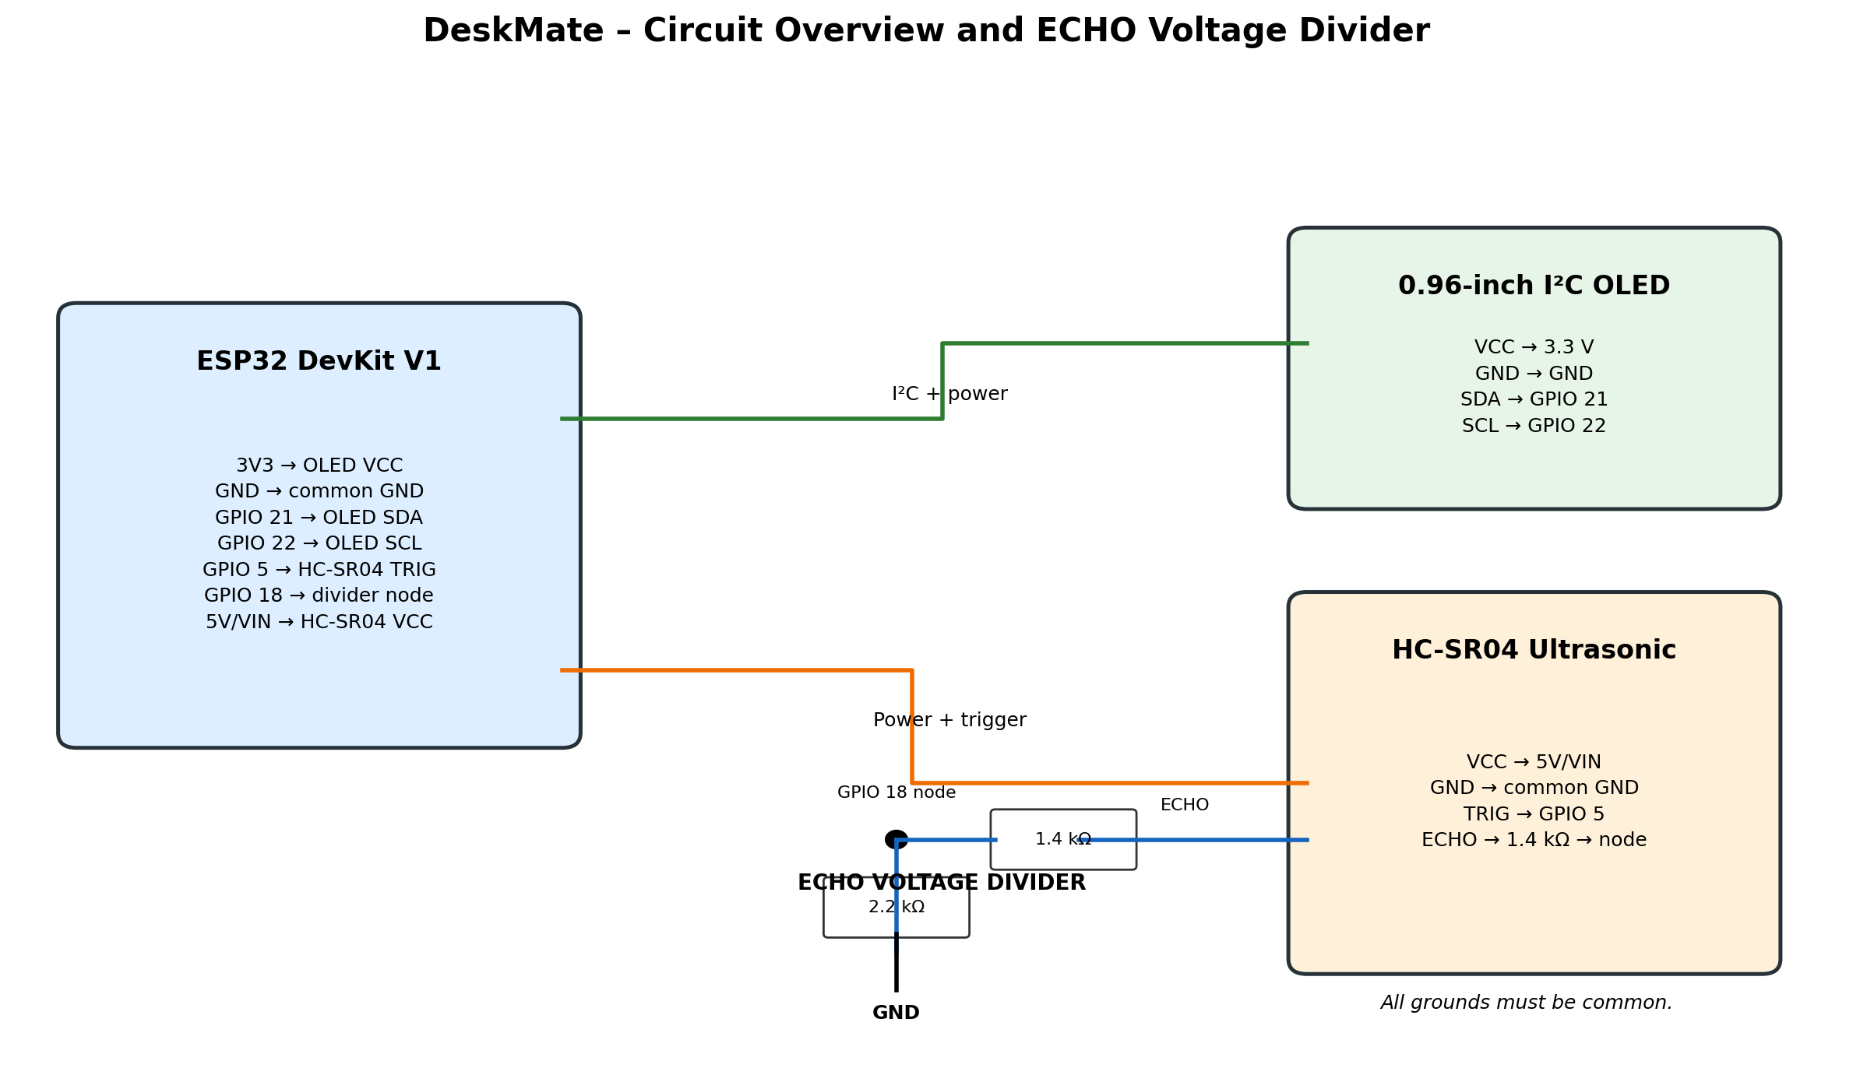
Figure 1. DeskMate circuit overview. The ECHO divider is shown separately for clarity.

5. Hardware Components
Component | Function | Details
ESP32 DevKit V1 | Main controller | Reads sensor timing and controls the OLED; 3.3 V GPIO logic.
HC-SR04 | Distance sensor | Ultrasonic ranging using TRIG and ECHO; powered from 5 V.
0.96-inch OLED | Visual output | 128×64 I²C display; commonly address 0x3C.
1.4 kΩ resistor | Divider upper resistor | Between ECHO and divider junction.
2.2 kΩ resistor | Divider lower resistor | Between divider junction and common GND.
Breadboard and jumpers | Prototyping | Temporary connections without soldering.

6. Working Principle

6.1 Ultrasonic ranging
The ESP32 sends a short HIGH pulse to TRIG (typically at least 10 microseconds). The HC-SR04 emits an ultrasonic burst and raises ECHO for a duration corresponding to the sound's round-trip travel time. The ESP32 measures this pulse duration.
Distance (cm) ≈ Echo time (µs) × 0.0343 ÷ 2
The factor 0.0343 cm/µs approximates the speed of sound at room temperature. Division by two accounts for the outward and return journey. Readings vary with temperature, target angle, surface, and sensor alignment.

6.2 OLED display and I²C
The OLED is controlled over I²C using SDA and SCL. The Adafruit SSD1306 library manages the display buffer and screen updates. Adafruit GFX supplies drawing functions for pixels, lines, circles, and text.

6.3 Proximity response
The firmware compares measured distance with an approximate 30 cm threshold. When a valid reading is within that range, the OLED shows the happy-face response. When the target moves away, the display returns to its non-proximity state. The exact animation and transition timing depend on the uploaded sketch.

7. Circuit Connections
Module pin | Connection | Purpose
OLED VCC | ESP32 3V3 | OLED supply
OLED GND | ESP32 GND | Ground reference
OLED SDA | GPIO 21 | I²C data
OLED SCL | GPIO 22 | I²C clock
HC-SR04 VCC | ESP32 5V / VIN | Sensor supply
HC-SR04 GND | Common GND | Ground reference
HC-SR04 TRIG | GPIO 5 | Trigger signal
HC-SR04 ECHO | 1.4 kΩ → junction → GPIO 18 | Echo input through divider

7.1 ECHO voltage divider
The HC-SR04 ECHO output can reach approximately 5 V. ESP32 GPIO inputs use 3.3 V logic and are not 5 V tolerant. Therefore, do not connect raw ECHO directly to GPIO 18. Connect ECHO to the 1.4 kΩ resistor; connect its other end to a junction. Connect that junction to GPIO 18 and to one end of the 2.2 kΩ resistor. Connect the other end of the 2.2 kΩ resistor to common GND.
Vout = Vin × R₂ / (R₁ + R₂)
For R₁ = 1.4 kΩ, R₂ = 2.2 kΩ and Vin = 5 V: Vout = 5 × 2.2 / (1.4 + 2.2) ≈ 3.06 V. This reduces the ECHO level to a value suitable for the ESP32 input under nominal conditions. The lower resistor must connect to common GND.

8. Software and Development Environment
- Arduino IDE – writing, compiling, and uploading firmware.
- ESP32 Arduino core – board support and GPIO/timing functions.
- Wire library – I²C communication.
- Adafruit GFX – graphics primitives.
- Adafruit SSD1306 – SSD1306 OLED control.
- pulseIn() or equivalent pulse-timing function – measuring ECHO duration.
Typical pin configuration: TRIG GPIO 5, ECHO GPIO 18, OLED SDA GPIO 21, OLED SCL GPIO 22, OLED address 0x3C. The actual uploaded sketch is the final authority if configuration changes.

9. Program Logic / Algorithm
- Initialise serial communication and configure TRIG and ECHO pins.
- Initialise I²C and the OLED display.
- Send a short trigger pulse to the HC-SR04.
- Measure the HIGH duration of the ECHO signal.
- Convert echo duration into distance in centimetres.
- Compare the distance with the approximate 30 cm threshold.
- If the target is near, draw the happy expression; otherwise draw the default screen.
- Repeat the measurement and display update continuously.

10. Testing and Observations
During prototype verification, OLED operation was confirmed and the ultrasonic sensor produced live distance readings. The OLED also responded to proximity during the test. This demonstrates that the basic sensor-to-controller-to-display path was functioning.
Test | Expected result | Reported status
OLED initialisation | Display turns on and renders graphics | OLED operation confirmed.
Ultrasonic sensing | Distance changes as target moves | Live readings confirmed.
Proximity response | Display reacts when target is near | Successfully tested.
Digital clock mode | Clock appears when idle | Not integrated in current build.

For a formal laboratory record, measure several known distances with a ruler and record both the reference distance and sensor reading. No accuracy figures are claimed here because a calibrated measurement dataset was not supplied.

11. Applications
- Interactive desktop gadget or workspace decoration.
- Educational demonstration of ultrasonic sensing and embedded interfaces.
- Beginner project for learning ESP32 GPIO, I²C, and sensor integration.
- Foundation for proximity-triggered reminders or status indicators.

12. Limitations
- The sensor measures distance to reflective objects; it does not identify a person.
- Soft, angled, narrow, or irregular targets can produce weak or inconsistent echoes.
- Temperature and sensor alignment can affect readings.
- Readings near the threshold may cause rapid switching unless filtering or hysteresis is used.
- The current build provides a basic proximity-driven visual response.
- The Wi-Fi digital clock has not been integrated.

13. Future Scope
- Integrate an NTP-synchronised digital clock over Wi-Fi, configured for IST.
- Add more expressions such as idle, sleepy, surprised, and thinking.
- Use averaging, filtering, and hysteresis for stable transitions.
- Add a buzzer or RGB LED for optional feedback.
- Design a compact enclosure or custom PCB.
- Allow the proximity threshold to be configured.

14. Safety and Build Considerations
- Never connect HC-SR04 ECHO directly to an ESP32 GPIO; use the divider.
- GPIO 18 must connect to the divider junction, not raw ECHO.
- All modules must share a common ground.
- Use 5V/VIN for the HC-SR04 and 3V3 for the OLED as in this prototype.
- Disconnect USB power before changing wiring to avoid accidental shorts.

15. Conclusion
DeskMate demonstrates how an ESP32, an ultrasonic distance sensor, and an OLED can be combined to create a simple interactive embedded device. The ESP32 measures the HC-SR04 echo pulse, estimates distance, and updates the OLED based on proximity. Live sensing and the display response were tested successfully. A Wi-Fi digital clock remains a future enhancement and is not claimed as a completed feature.

16. References
- Espressif Systems – ESP32 Series Datasheet and Technical Reference Manual.
- HC-SR04 Ultrasonic Ranging Module documentation.
- Adafruit – GFX Library documentation.
- Adafruit – SSD1306 Library documentation.
- Arduino – Wire library, digital I/O, and pulseIn() reference.

Appendix A – Quick Pin Reference
ESP32 pin | Connected device
3V3 | OLED VCC
5V / VIN | HC-SR04 VCC
GND | OLED and HC-SR04 common ground
GPIO 21 | OLED SDA
GPIO 22 | OLED SCL
GPIO 5 | HC-SR04 TRIG
GPIO 18 | ECHO divider junction

Before submission, fill in the student details and add photographs of the actual assembled prototype and screenshots of the final firmware/output if required by the course rubric.

