**This program shows a list of processes at a given time**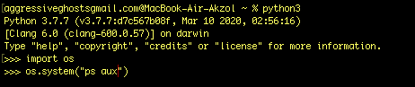

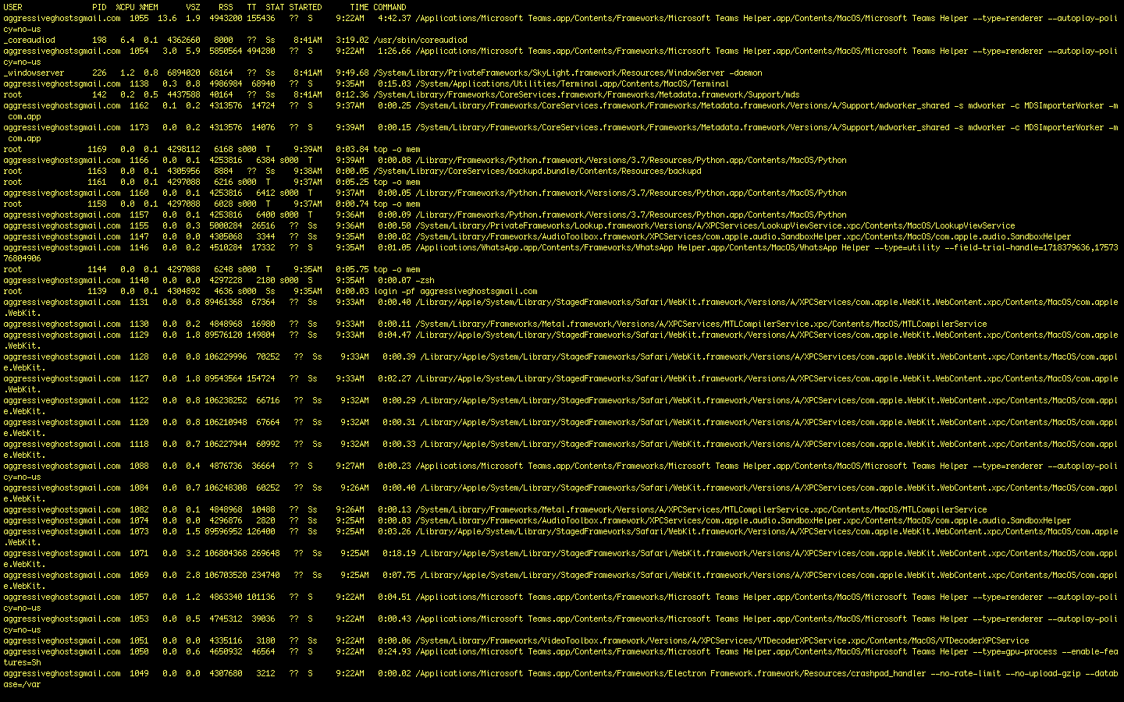

**This program shows list of processes on real time**