Twitter Sentiment Analysis
NLP Project 1.4

Course Project Report
Natural Language Processing
Dataset: TweetSentiment.csv
Tasks 1-3
Code: tasks1_2_simple.py and task3_simple.py
Outputs: outputs/tasks1_2 and outputs/task3

ABSTRACT
This report summarizes Tasks 1-3 for a Twitter sentiment dataset. Task 1 explores class balance, length, vocabulary, and frequent words/bigrams. Task 2 applies the simplified preprocessing pipeline, including lowercasing, URL and mention replacement, tokenization, punctuation handling, and custom stop-word removal.
Task 3 compares BoW and TF-IDF representations with Multinomial Naive Bayes and a feed-forward neural network. The latest outputs show BoW + FFNN as the best multiclass model with macro F1 = 0.6768, and TF-IDF + FFNN as the best binary model with macro F1 = 0.8644.
The main difficulty is the neutral class, which overlaps with positive and negative tweets.

REPORT SCOPE
Task 1: EDA; Task 2: preprocessing; Task 3: BoW/TF-IDF classification.
KEYWORDS
Twitter sentiment analysis, preprocessing, stop-word removal, bag-of-words, TF-IDF, Naive Bayes, FFNN
Data and outputs:
All metrics and figures are generated from outputs/tasks1_2 and outputs/task3 after the latest custom stop-word update.
1 Dataset and Exploratory Analysis
The dataset contains 27,480 tweets labelled as negative, neutral, or positive. Neutral is the largest class with 11,117 tweets (40.45%), followed by positive with 8,582 tweets (31.23%) and negative with 7,781 tweets (28.32%).

The corpus vocabulary contains about 25,251 unique tokens. The EDA code computes character length, token count, class distribution, vocabulary size, top words, and top bigrams before Task 2 preprocessing.

The raw top words are mainly high-frequency function words. Frequent bigrams include negation patterns such as 'don t' and 'can t', which motivated preserving negation cues.
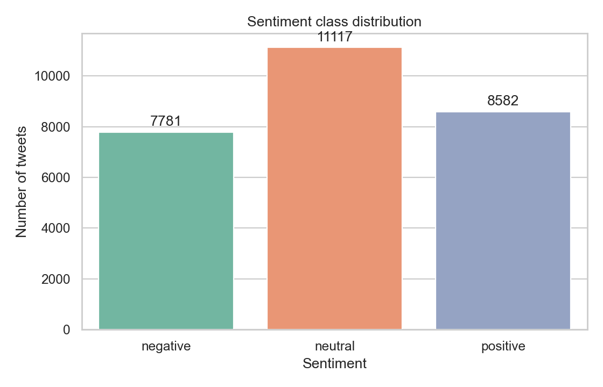
Figure 1. Sentiment class distribution.
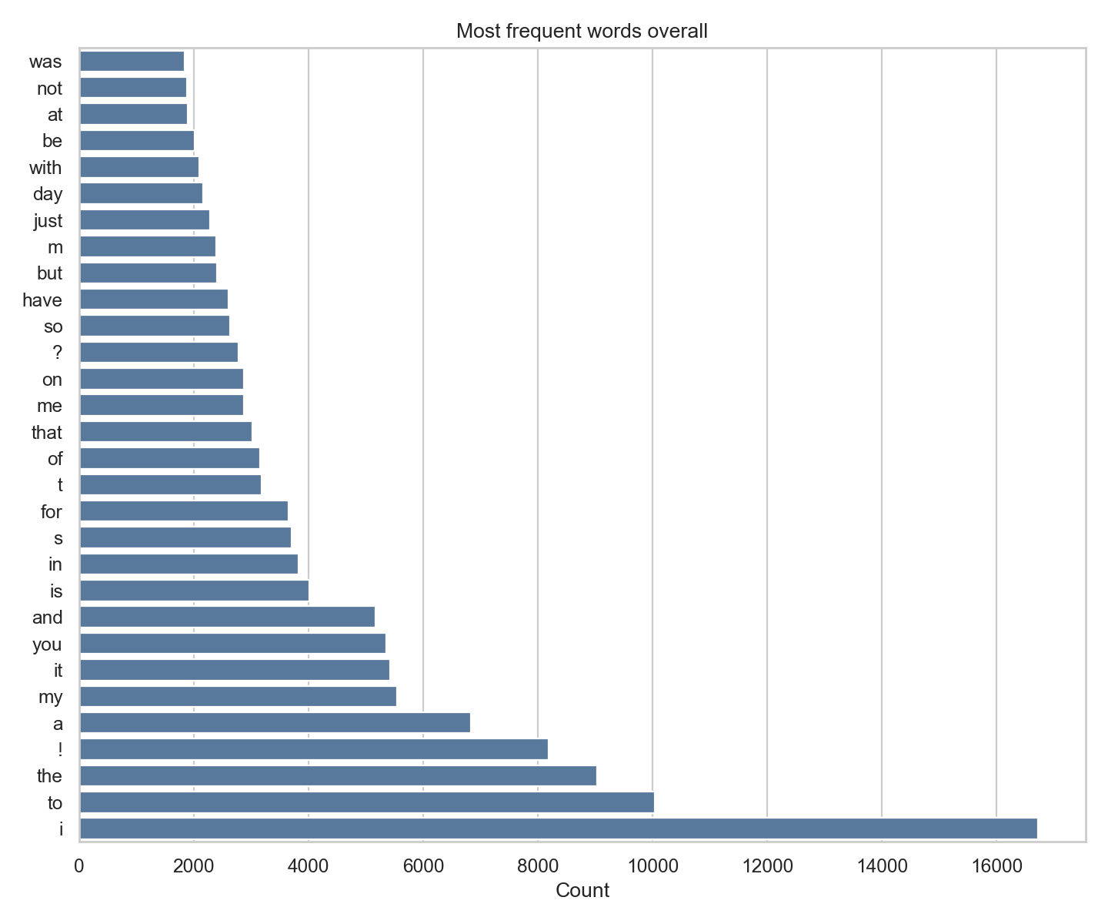
Figure 2. Most frequent raw words before preprocessing.
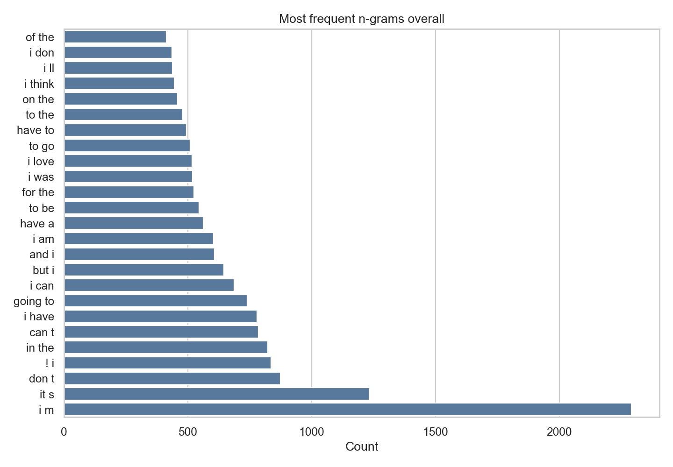
Figure 3. Most frequent raw bigrams before preprocessing.
The most frequent raw words include 'i', 'to', 'the', 'a', and 'my'. These words dominate the raw counts but usually carry limited sentiment information by themselves.
The frequent raw bigrams show both common phrase fragments and negation forms. For sentiment analysis, this means stop-word removal should be selective rather than automatic.
2 Preprocessing Choices
The simplified preprocessing pipeline writes processed_text to preprocessed_tweets.csv. The latest preprocessing reduces mean token count from 14.03 to 9.77, and mean character length from 68.35 to 51.94.
- Applied: lowercasing, whitespace normalization, HTML unescaping, and regex tokenization.
- Applied: URLs are replaced by URL and mentions by USER; hashtags are kept as words after removing #.
- Applied: punctuation is removed except ! and ?, because these marks can express emotion or emphasis.
- Applied: custom stop-word removal from corpus top words, while keeping negation-related cues.
Removed stop words: a, and, at, be, but, for, have, i, in, is, it, just, m, me, my, of, on, s, so, that, the, to, was, with, you.
- Kept for sentiment: !, ?, not, t.
- Not applied: stemming and lemmatization, because the current BoW/TF-IDF baselines can use surface forms directly.
- Not applied: number conversion or number removal, because numbers may carry dates, time, quantity, or emphasis.
- Not applied: non-ASCII removal and elongated-word normalization, to avoid deleting expressive tweet content.
- Overall, the preprocessing choices aim to reduce noise while preserving sentiment cues.
3 Classification Method. Task 3 uses the latest preprocessed_tweets.csv with a stratified 80/20 train-test split and random seed 42. Multiclass uses negative, neutral, and positive; binary removes neutral tweets.
BoW uses unigram counts. TF-IDF uses unigrams and bigrams with IDF weighting. The models are Multinomial Naive Bayes and an FFNN with one hidden layer of size 128, ReLU activation, Adam, batch size 128, and 25 epochs.
4 Results
The best multiclass model is BoW + FFNN with accuracy = 0.6747 and macro F1 = 0.6768. The best binary model is TF-IDF + FFNN with accuracy = 0.8650 and macro F1 = 0.8644. The representation choice has a modest effect compared with the binary/multiclass setup.
Set | Rep. | Model | Acc. | F1
Multi. | BoW | NB | 0.6497 | 0.6515
Multi. | BoW | FFNN | 0.6747 | 0.6768
Multi. | TF-IDF | NB | 0.6225 | 0.6065
Multi. | TF-IDF | FFNN | 0.6557 | 0.6580
Binary | BoW | NB | 0.8558 | 0.8555
Binary | BoW | FFNN | 0.8647 | 0.8642
Binary | TF-IDF | NB | 0.8604 | 0.8600
Binary | TF-IDF | FFNN | 0.8650 | 0.8644
Table 1. Latest classification results from metrics_summary.csv.
5 Confusion Matrix and Error Analysis
For the best multiclass model, many errors involve the neutral class: 448 negative tweets and 356 positive tweets are predicted as neutral, while 388 neutral tweets are predicted as negative and 392 as positive.
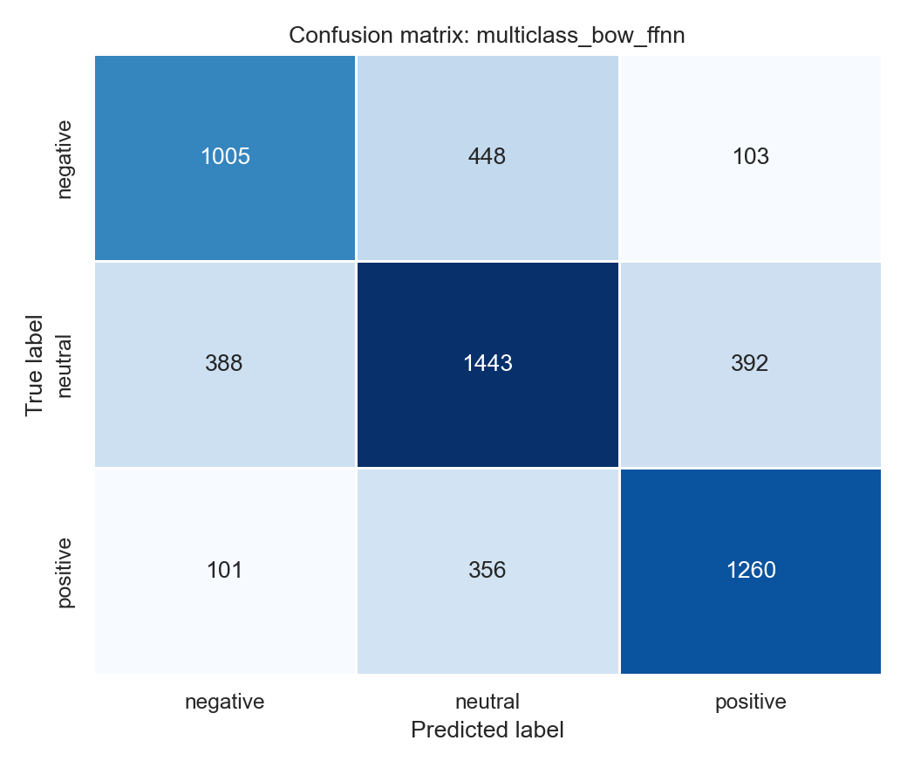
Figure 4. Confusion matrix for the best multiclass model: BoW + FFNN.
The Naive Bayes multiclass matrix is included to show the same evaluation type for the classical baseline. It has a similar neutral-class error pattern.
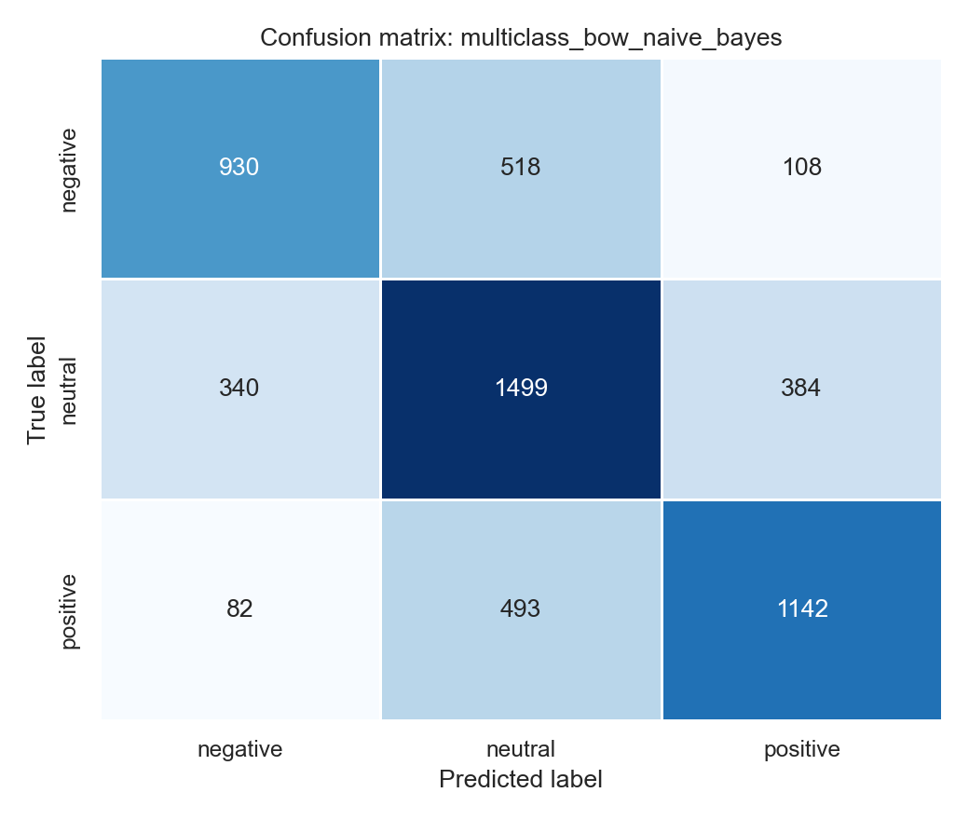
Figure 5. Confusion matrix for the multiclass Naive Bayes baseline: BoW + Naive Bayes.
Binary classification is easier because neutral examples are removed. In the best binary model, 244 negative tweets are predicted as positive and 198 positive tweets are predicted as negative.
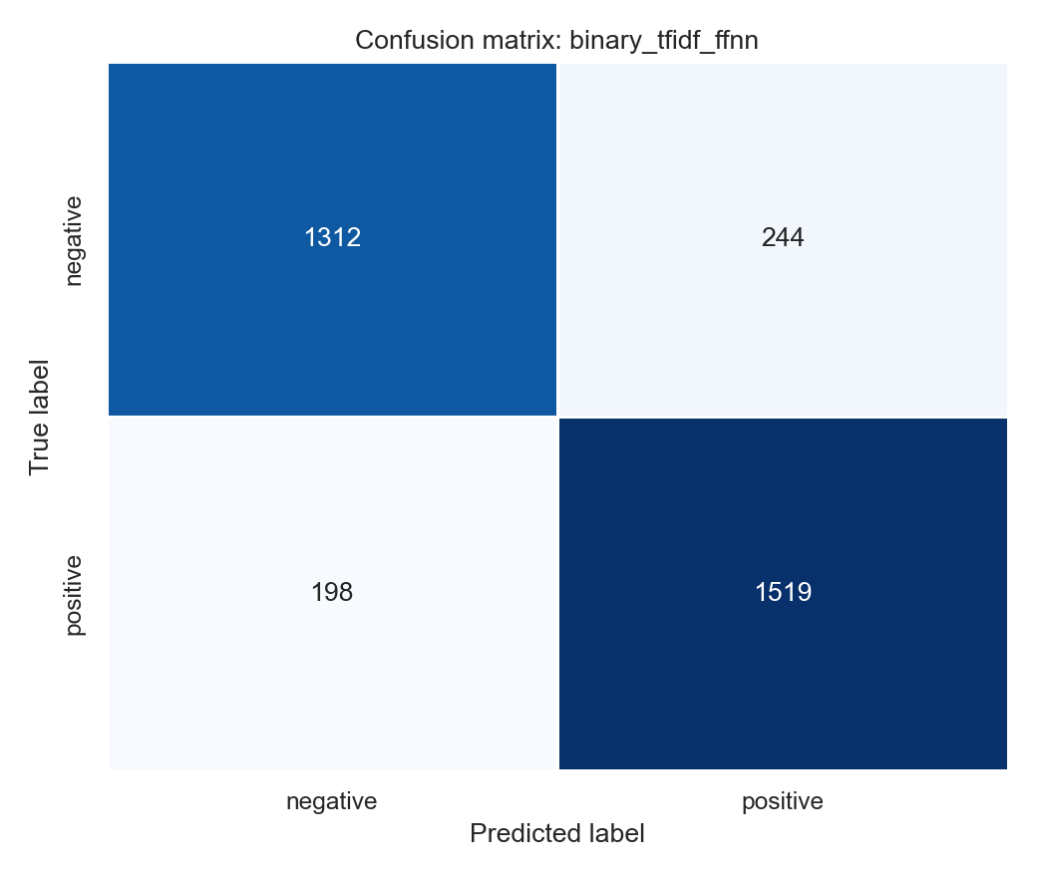
Figure 6. Confusion matrix for the best binary model: TF-IDF + FFNN.
6 Conclusion. The latest simplified code now includes custom stop-word removal based on top words while keeping negation cues. BoW + FFNN is best for multiclass sentiment classification, while TF-IDF + FFNN is best for binary sentiment classification.

