EX:NO:12 | Developing a game activity using Pygame like bouncing ball
Date: | Developing a game activity using Pygame like bouncing ball

Aim:
To implement bouncing ball game using Pygame.

Algorithm:
Step: 1
Step2:

Step3:

Step4:

Step5:

Program:
import pygame
# initialize pygame
pygame.init()

# define width of screen
width = 1000
# define height of screen
height = 600
screen_res = (width, height)

pygame.display.set_caption("GFG Bouncing game")
screen = pygame.display.set_mode(screen_res)

# define colors
red = (255, 0, 0)
black = (0, 0, 0)

# define ball
ball_obj = pygame.draw.circle(
surface=screen, color=red, center=[100, 100], radius=40)
# define speed of ball
# speed = [X direction speed, Y direction speed]
speed = [1, 1]

# game loop
while True:
# event loop
for event in pygame.event.get():
# check if a user wants to exit the game or not
if event.type == pygame.QUIT:
exit()

# fill black color on screen
screen.fill(black)

# move the ball
# Let center of the ball is (100,100) and the speed is (1,1)
ball_obj = ball_obj.move(speed)
# Now center of the ball is (101,101)
# In this way our wall will move

# if ball goes out of screen then change direction of movement
if ball_obj.left <= 0 or ball_obj.right >= width:
speed[0] = -speed[0]
if ball_obj.top <= 0 or ball_obj.bottom >= height:
speed[1] = -speed[1]

# draw ball at new centers that are obtained after moving ball_obj
pygame.draw.circle(surface=screen, color=red,
center=ball_obj.center, radius=40)

# update screen
pygame.display.flip()

Output:

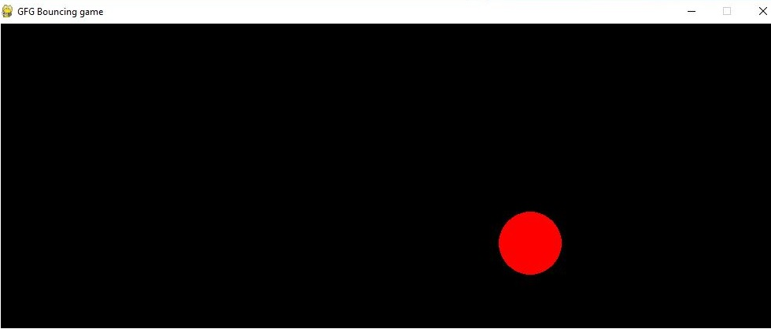

Result:

