**On the Chicken & Egg Problem in Transportation Electrification**

**Has this paper been already published in a peer-reviewed journal?** No

**Key Words:** vehicle electrification; charging stations; causal inference

**1. Introduction**

Vehicle electrification is widely regarded as a critical tool for climate change mitigation in the transportation sector (Musti & Kockelman, 2011). While the United States is seeing an increasing share of electric sales, the pace of adoption remains well below the necessary level to mitigate climate change impacts. One barrier to widespread adoption is the lack of charging infrastructure (Sullivan & Taylor, 2021). Section 2 defines the vehicle and charging station problem and summarizes the existing literature. Data sources are given in section 3. Section 4 provides our preliminary analysis based on available data at the time of submission[1]. Section 5 gives initial conclusions and outlines the proposed modeling strategy.

**2. The Electric Vehicle and Charging Station Problem**

Electric vehicle ownership is often referenced as exhibiting a “chicken and egg” behavior arising from the supply and demand relationship. Individual demand for electric vehicles is influenced by the available supply of charging points. Consumers are unwilling to purchase vehicles due to range anxiety and a perceived lack of charging stations. Suppliers are not incentivized to provide charging stations unless there is sufficient demand to warrant their cost. There is a clear role for public policy in such situations. The government deems electric vehicles as a solution to a public ill (i.e., climate change) and can incentivize either suppliers by providing installation subsidies or consumers by installing charging stations. While the problem has been recognized in the literature (Melliger et al., 2018), empirical analysis is minimal.

An important consideration to the analysis is how electric mobility system may differ from one based on fossil fuels. In the conventional private mobility model, the individual owns the vehicle and purchases fuel from centralized and privately owned refueling stations. In contrast, electric vehicles may be charged in the home using previously existing infrastructure. The presence of charging points in the home begs the questions 1) if (or to what extent) out-of-home charging stations are required for travel? and 2) to what extent is range anxiety a perception versus a reality?

According to the Bureau of Transportation Statistics, 98% of trips made in the US are less than 50 miles (Vehicle Technology Office, 2022). Given that most battery-electric vehicles (BEVs) have a range greater than 200 miles (Elfalan, 2021), it is feasible to make most trips on a single charge. However, long-distance trips (over 50 miles) comprise 30% of total vehicle-miles traveled (VMT) (Aultman-Hall, 2018). There is clearly a need for out-of-home charging stations to accommodate these trips. Even if most trips can be accommodated by in-home charging, the vehicle purchase decision will be influenced by consideration of these longer trips that require charging stations (Silvia & Krause, 2016). Additionally, Wolbertus et al. (2018)find that there is still a demand for charging stations in places where public daytime charging is the only option, such as at the workplace.

**3. Data Sources**

We use a combination of open-source and purchased data in our analysis. The two key input datasets are charging station locations provided by the Alternative Fuel Data Center (AFDC) and electric vehicle registrations provided by Experian Inc. The vehicle registration dataset comprises a 10-year panel at 2-year increments (i.e., 2012, 2014, 2016, 2018, 2020). Total vehicle registrations are recorded by county for the United States.

This initial analysis is based on the charging station data and EV sales by state for the period 2013 to 2020 as the county-level registrations were not made available in time for publication. EV sales and market share data is provided by EVAdoption, and state population data by the U.S. Census Bureau.

**4. Analysis**

As an initial analysis, we explore the relationship between demographics and charging station locations by mapping the proportion of black residents and station counts by census tract for four representative metropolitan areas: Chicago, Detroit, Omaha, and San Francisco. We hypothesize that charging stations are disproportionately located in non-black communities. Our hypothesis is borne out through our graphical results. Predominantly black south Chicago has few stations, while there are clusters of stations in several predominately non-black suburban communities. Similarly, charging stations in Detroit are concentrated downtown and in white non-black communities. There are few charging stations in the Omaha area, but those that exist are concentrated in downtown and predominantly non-black southern communities. San Francisco has the highest per capita rate of charging stations among the examined regions. Again, the spatial distribution exhibits clustering that appears to align with non-black communities rather than being equitably distributed across the region.

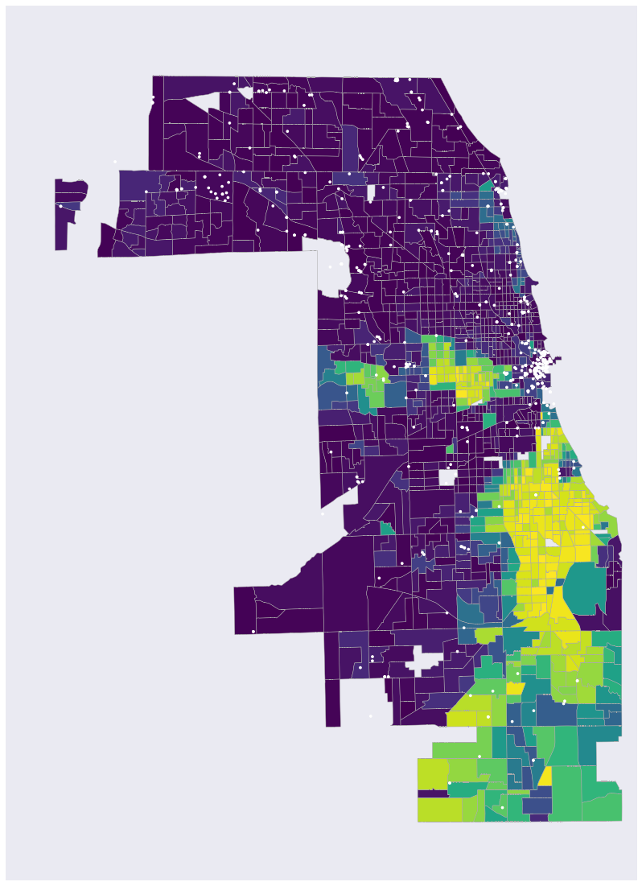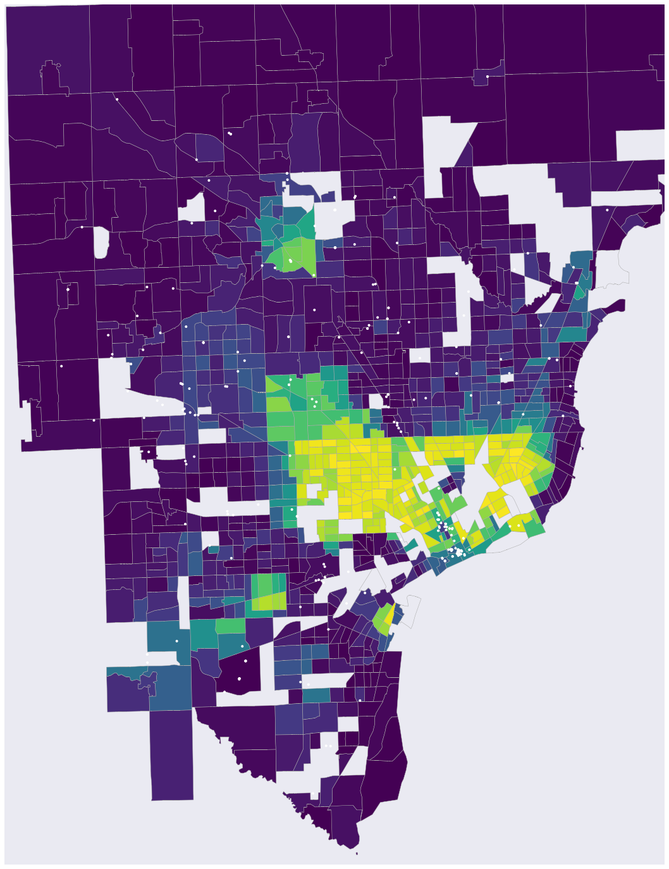

1. Chicago, IL (b) Detroit, MI

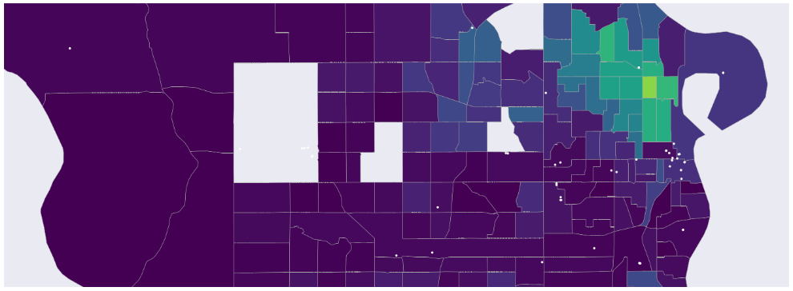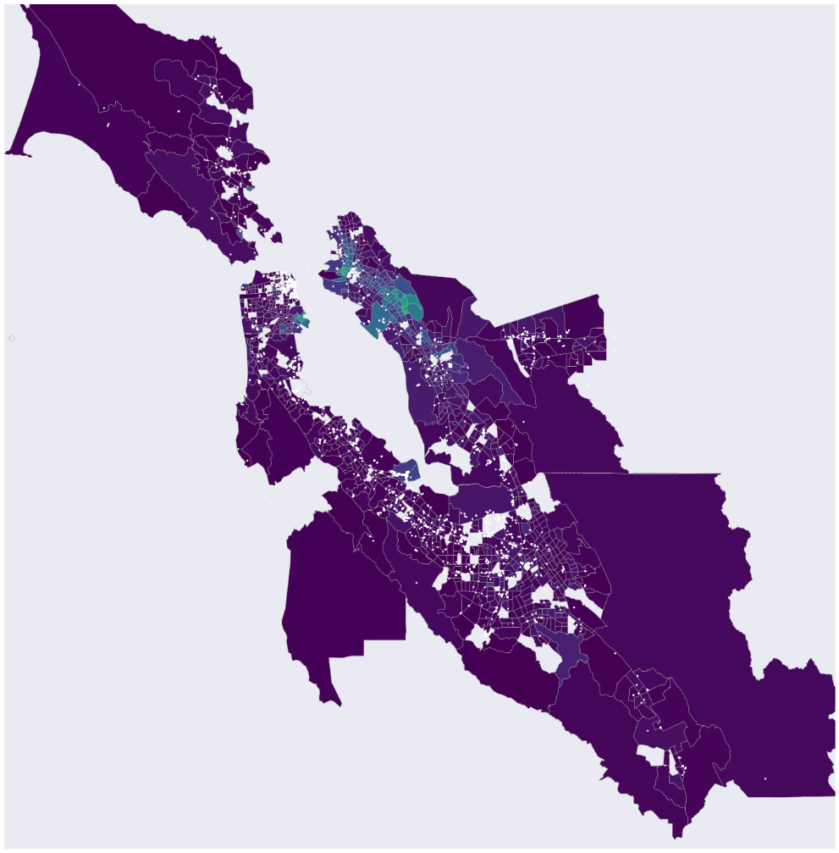

(c) Omaha, NE (d) San Francisco, CA



**Figure 1 Percent Black and Charging Station Locations for Four Representative US Cities (as of 2020)**

A second analysis based on charging station and plug-in electric vehicle (PEV, or summation of battery-electric and plug-in hybrid electric) sales data is summarized in Figure 2. Here, we plot per capita charging stations by state against PEV market share. Overall, there is a trend of increasing market share as a function of increasing charging station penetration. This trend fits our overall research hypothesis that charging stations encourage PEV adoption. Three exemplar states are highlighted in the plot. Texas fits the general trend, whereas California and Vermont are outliers. Vermont has the highest charging station penetration rate, but its PEV adoption is in the middle-high range. California has the highest PEV adoption despite a relatively low number of per capita charging stations. This result leads to several questions to be pursued in subsequent analysis. It may be the case that other policies implemented in California are driving PEV adoption. There may also be a non-linear scaling effect at play. The higher population of California relative to Vermont may mean that charging station needs are met by a decreasing rate of additional charging stations. That is, there is a critical mass of charging stations that satisfies demand without requiring a linear increase as PEV adoption rises.

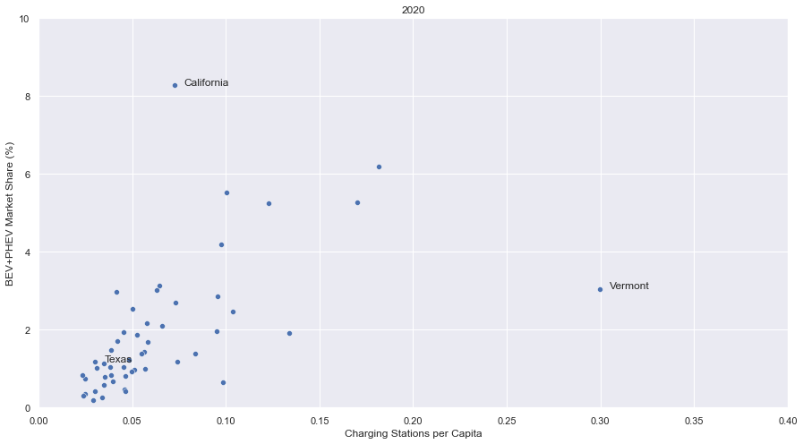

**Figure 2 Charging Stations and PEV (BEV+PHEV) Market Share by State (as of 2020)**

**5. Discussion and Conclusions**

The results presented herein are preliminary and do not consider a key dataset – vehicle registrations. We will expand our analysis to a more robust inferential study in the coming months. Our causal question is what effect public charging stations have on electric vehicle registrations at the county-level. The treatment variable is continuous over the study period. We propose three causal identification approaches. The first approach is a difference-in-differences approach that is identified off state-level investments in charging stations by year. The second approach is generalized propensity score matching using federal election results, state-level greenhouse gas (GHG) emissions factors, and demographic characteristics (e.g., racial composition, median income, and population density) as inputs to the propensity score.

The final causal inference approach, Granger causality, differs in that it focuses on the temporal phasing of charging station installations and PEV registration, whereas the other two approaches rely on Rubin’s potential outcome assumption (Reich et al., 2021). Granger causality relies on the assumption that past treatment knowledge reduces predictive uncertainty. It is a form of time series causal inference that would fit the current context well.

**References**

Aultman-Hall, L. (2018). *Incorporating long-distance travel into transportation planning in the United States*. https://escholarship.org/uc/item/0ft8b3b5

Elfalan, J. (2021, February 9). *Electric Car Range and Consumption*. Edmonds. https://www.edmunds.com/car-news/electric-car-range-and-consumption-epa-vs-edmunds.html

Melliger, M. A., van Vliet, O. P. R., & Liimatainen, H. (2018). Anxiety vs reality – Sufficiency of battery electric vehicle range in Switzerland and Finland. *Transportation Research Part D: Transport and Environment*, *65*, 101–115. https://doi.org/10.1016/J.TRD.2018.08.011

Musti, S., & Kockelman, K. M. (2011). Evolution of the household vehicle fleet: Anticipating fleet composition, PHEV adoption and GHG emissions in Austin, Texas. *Transportation Research Part A: Policy and Practice*, *45*(8), 707–720. https://doi.org/10.1016/J.TRA.2011.04.011

Reich, B. J., Yang, S., Guan, Y., Giffin, A. B., Miller, M. J., & Rappold, A. (2021). A Review of Spatial Causal Inference Methods for Environmental and Epidemiological Applications. *International Statistical Review*, *89*(3), 605–634. https://doi.org/10.1111/insr.12452

Silvia, C., & Krause, R. M. (2016). Assessing the impact of policy interventions on the adoption of plug-in electric vehicles: An agent-based model. *Energy Policy*, *96*, 105–118. https://doi.org/10.1016/J.ENPOL.2016.05.039

Sullivan, B., & Taylor, H. (2021, August 24). *The U.S. EV charging network isn’t ready for your family road trip, let alone the expected wave of new cars*. CNBC. https://www.cnbc.com/2021/08/24/cnbc-road-test-the-us-ev-charging-network-isnt-ready-for-your-family-road-trip-let-alone-the-expected-wave-of-new-cars.html

Vehicle Technology Office. (2022). *More than Half of all Daily Trips Were Less than Three Miles in 2021*. Department of Energy. https://www.energy.gov/eere/vehicles/articles/fotw-1230-march-21-2022-more-half-all-daily-trips-were-less-three-miles-2021

Wolbertus, R., Kroesen, M., van den Hoed, R., & Chorus, C. G. (2018). Policy effects on charging behaviour of electric vehicle owners and on purchase intentions of prospective owners: Natural and stated choice experiments. *Transportation Research Part D: Transport and Environment*, *62*, 283–297. https://doi.org/10.1016/J.TRD.2018.03.012

1. Vehicle registration data from Experian was not available at the time of submission to BTR.