School of Computer Science
Faculty of Science and Engineering
University Of Nottingham
Malaysia


Software Engineering Group Project COMP2019 G52GRP| Group 6

- Development of a mobile-based non-invasive skin assessment system
for personalized skincare and health monitoring -

- COMP2019 Final Group Report | 28th April 2026 -

Name: | Student ID: | Course: | Role:
Yining Cui | 20610427 | Computer Science with AI
Yew Hang Lau | 20711819 | Computer Science with AI | Group Leader
Mahmoud Yasser Sallam | 20574289 | Computer Science with AI
Yung Tung Wong | 20618167 | Computer Science with AI
Zhen Zhang | 20701305 | Computer Science
Zheng Qiwen | 20712310 | Computer Science with AI

GROUP SIX’S SUPERVISION IS LED BY DR. NABIL EL IOINI AND THE
PROJECT LIAISON & INDUSTRY SUPERVISOR IS DR. HERMAWAN NUGROHO.

Abstract & Acknowledgement

We would like to thank Dr. Ir. Hermawan Nugroho and Dr. Nabil El Ioini for their roles as our Project Client and Project Supervisor throughout the course of this academic year, their words of encouragement and wisdom through the myriads of meetings that we had were vastly meaningful and appreciated.
We would like to express our gratitude to the following lecturers & students for their support, insight, and guidance throughout the course of this project, we would not have been able to get where we did without their support:
- Dr. Tissa Chandesa
- Dr. Iman Liao
- Dr. Tomas Maul

Contents
Introduction & Project Description 5
1.1 Introduction 5
1.2 Project Background & Problem Statement 5
1.3 Purpose & Project Scope 6
Background Research 7
2.1 Similar Systems 7
2.1.1 DERM 7
2.1.2 Model Dermatol 7
2.1.3 SkinVision 8
2.2 Literature Review 8
2.2.1 Skin Cancer, Melanoma & ABCDE Rule 8
2.2.2 Prior usage of AI in skin cancer diagnosis 8
2.2.3 Preceding Work Review 9
2.2.4 Data Preprocessing 10
2.2.5 Class Imbalance 10
2.2.6 Skin Type Scale & Nonlinearity 10
User Requirements & Requirement Specifications 11
3.1 Functional System Requirements 11
3.2 Non-Functional System Requirements 12
3.3 Functional User Requirements 12
3.4 Non-Functional User Requirements 12
Tech Stack & Development Decisions 13
4.1 Coding Languages 13
4.1.1. Dart 13
4.1.2. Python 13
4.2 Coding Languages 13
4.2.1. Firebase 13
4.2.2. PythonAnywhere 13
4.2.3. GitHub 14
4.3 Datasets Details 14
Software Development & Outcome 15
5.1 Model Development 15
5.1.1 V0.1 | Scaffolding & Testing 15
5.1.2 V0.2 | Multimodal Implementation 15
5.1.3 V0.3 | Modularization & Tuning 19
5.1.4 V0.4 | Clinical Dataset Implementation 21
5.2. Application Development 23
5.2.1. [INSERT TEXT HERE] 23
Challenges & Obstacles 24
6.1 Dataset Sourcing & Exploratory Data Analysis [EDA] 24
6.2 Hyperspectral Analysis with Dermoscopic Images 25
6.3 Class Imbalance and Training Stability 25
6.4 Dermoscopic vs. Clinical Models 25
6.5 GPU utilization for Model Training 26
Project Management & Time Plan 27
7.1 Past Events 27
7.2 Current Events 27
7.3 Future & Planned Events 27
References 28
Appendix 30

Chapter 1

Introduction & Project Description

1.1 Introduction
“In Malaysia, there exists roughly 52,000 of newly reported cancer case in the year 2022, and that approximately 32,000 patients died of cancer in the same year. Out of the 52,000 new cases, 181 cases were of melanoma, and that 88 patients died of melanoma in that same year.” – Excerpt from the Project Description.
Dr. Ir. Hermawan Nugroho is the project’s client and is currently an Assistant Professor within the Department of Electrical and Electronics Engineering, his research focuses on five fields but can be summarized as Image & Signal Processing and AI applications in unmanned vehicles.
The project’s client has graciously provided us with a final year dissertation conducted by one of his previous students, Chong Jia Luo, titled “Lightweight Deep Learning Network for Skin Cancer Classification” where Mr. Chong utilized MobileNet, a Convolutional Neural Network backbone model to achieve lightweight skin cancer classification. This project works towards continuing the development of that project with the goal of improving its accuracy, generalizability and efficiency.

1.2 Project Background & Problem Statement
Skin cancer is one of the most common types of cancer, especially within Western countries such as United States and Germany. The higher incidence of skin cancer in Western countries may be due to genetic factors such as skin pigmentation or culture factors such as sun tanning culture. Study has shown that people with a lighter skin tone is more likely to get cancer due to the lack of eumelanin, a type of melanin that help with creating photoprotection against ultraviolet light. Aside from that, research also found that sun tanning by using sunbeds increases the risk of skin cancer due to the skin exposure towards the high intensity of ultraviolet radiation [18].
In contrast, countries in South-East Asia and Africa have a lower incidence of skin cancer, due to the average residents having relative darker skin tone compared to average residents in Western country [19]. A darker skin tone indicates the existence of eumelanin in the epidermal layer of the skin, which help to create photoprotection against ultraviolet light. There are also cultural differences that needs to be considered, for example, Malaysians, especially Muslim women, have a more modest dressing style due to their culture belief [20], in which the clothing typically covers the majority of the body part, indirectly creating a protective layer towards ultraviolet light for the skin.
The more concealing culture among Malaysian serves as a double edge sword in the matter of skin cancer. On one side, the dressing culture of covering majority of the skin helps to reduce the skin exposure towards ultraviolet light thus indirectly reducing the risk of skin cancer. On the contrary, because of culture belief (of not exposing body part) among Malay women, they are also less likely to seek medical attention when encountered with skin related issue. In which Dr. Hermawan stated: “For skin cancer case among Malaysian, particularly Malay women [due to cultural belief], they don’t share their skin to opposite gender [doctor for diagnosis].” Dr. Hermawan expressed his concerned regarding the accessibility of skin assessment system towards people in different ethnic groups and thus proposed the development of a mobile-based non-invasive skin assessment system to address this issue.

1.3 Purpose & Project Scope
The primary objective of this project is to develop a mobile application that will assist its users in monitoring their skin condition and detect early symptoms of skin cancer; effectively acting as a ‘diagnostic triage’ tool.
Furthermore, we aim to refer stakeholders to medical professionals for medical and dermatological advice when applicable or when the need arises.
Our project scope directs us to utilize Python and PyTorch in combination with various external modules to create the classification model and then utilize Flutter as the frontend as to achieve the goal of analysing the possibility of skin cancer from a photograph that is taken or uploaded from a user’s personal mobile phone, provided that it is supported by the application.
The system will then categorize and measure the photograph to determine the likelihood of skin cancer being present through characteristics such as bulky papules & ulcerations. If the likelihood of skin cancer is high, then the user will be suggested to visit their nearest dermatologist or hospital for further action and confirmation.
Provided is a summary list of the project’s capabilities and functionalities:
- Uploading or taking images using the application for Skin Cancer classification and inference.
- The application will then make gauge the available information to infer the possibility of the user having skin cancer.
- The application will provide referrals to medical practitioners and dermatologists if cause-of-concern is found. [IMPROVE HERE/BASE OFF IGR]

Chapter 2

Background Research

2.1 Similar Systems
Various systems already exist that aim to address and incorporate AI-assisted skin cancer detection, each of them with their own distinct and unique approaches and limitations which have informed the project’s design decisions.

DERM
DERM is an AI skin cancer detection system which facilitates the assessment of skin lesions and assists secondary medical institutions by reducing the need for urgent suspected skin cancer appointments [8]. The main drawback pertains to the clinical workflow and standardized equipment (dermoscopes) used in this process, where the skin lesion images are captured by healthcare professionals rather than by the patients themselves [8].

Model Dermatol
Model Dermatol, published by Iderma, is a free AI skin disease analysis application that analyse user submitted skin photograph and search for relevant medical documents about the potential skin disease based on the provided photo. The application claims to be able to provide relevant info on more than 180 types of skin disease to help the user understand their potential skin problems.
The procedure of using the application is as follow:
- The User enters some personal information (gender and year of birth) and their skin information (onset, itching, pain).
- The User takes or uploads a photo regarding their skin surface.
- The application then analyses the provided photo and gives a score between 0 and 100 to indicate the risk of user having a skin disease.
Model Dermatol does not provide a specific prediction regarding what type of skin disease the user might have. Instead, it provides a risk score to suggest the likelihood of the user suffer from a certain skin disease. The application then provides a list of information that were fetched from the websites: Wikipedia and PubMed to the user. This information includes images and description of different types of skin disease, and they serve as an indicator of what are the possible skin diseases the user might have, based on the provided photo.

SkinVision
SkinVision is another consumer application that categorizes skin lesions into three sections: Low Risk, High Risk, & In-Review, where High Risk and In Review images are forwarded to SkinVision’s board of dermatologists for further assessment [9]. They use 3 modified pre-trained ResNET-50 CNNs trained on 200,000+ dermatologists-labelled images across a variety of skin types, ages and genders, this serves as the largest setback as we do not have access to their proprietary dataset in addition to the fact that their app follows a subscription-service payment plan including an option to pay for a single image inference [9][10].
Our project aims to distinguish itself by incorporating various features, including a multimodal approach via incorporating patient metadata alongside image classification and prioritizing accessibility through smartphone-based input while lowering the prerequisites needed to access care via ethically and voluntarily collecting skin lesion samples from users.

Literature Review

Skin Cancer, Melanoma & ABCDE Rule
There are various types of skin cancers, with more common ones consisting of Basal Cell Carcinoma (BCC) and Squamous Cell Carcinoma (SCC), while Melanoma is a rarer and much deadlier form that develops from melanocytes and may appears as a mole.
The bodily distribution of melanoma can be different among people with different skin pigmentation. For people with a lighter skin tone, melanoma typically appears at the area such as the head, neck, trunk, and limbs; as for people with a darker skin tone, melanoma usually appears at area such as the palms of the hands, soles of the feet, and mucous membrane. Diagnosis of melanoma on a macroscopic level often follow the “ABCDE” rule, that is, searching for the following features on mole:
- Asymmetry – The shape of one half does not match the other half.
- Border – The border of the mole is irregular.
- Colour – The colour of the mole is uneven.
- Diameter – The size of the mole is larger than 6 millimetres.
- Evolving – The mole has increased in its size over the past few weeks or months.

Prior usage of AI in skin cancer diagnosis
The current research in AI usage in skin cancer diagnosis highlights a disproportionate performance disparity between specialized medical AI applications and general-purpose LLMs. And meanwhile models such as GPT-4 have advanced multimodal functionalities, recent studies show that they are not suitable for clinical dermatology as of now. A study published in JAAD found that while ChatGPT Vision managed to identify broad features, it hallucinated symptoms and markers or missed subtle irregularities [14]. Meanwhile comparative research papers found that consumer-purpose LLMs such as ChatGPT-4 Omni consistently underperform when matched against specialized dermatological algorithms [15]. These findings imply that the reliance on LLM’s is insufficient for a reliable diagnosis, justifying the development of a dedicated, domain-specific application.
A main concern that arises is the issue when comparing accuracy results in controlled environments versus real-life conditions, where AI models have feasibly attained high accuracy rates, often exceeding 90% in controlled studies but have seen significant accuracy drops when applied to user-generated smartphone images [12]. This decline in performance can be attributed to the gap that exists between standardized, controlled images and irregular, blurry or dimly lit images which are more commonly seen in photos taken by patients, this emphasizes the necessity for data pre-processing and the ability to handle lower-quality input data more effectively than models that solely rely on academic models.
And in spite of the current obstacles, automated algorithms have demonstrated considerable potential. A notable study published in Nature by Esteva et al., showcased that a Deep Convolutional Neural Network (DCNN) trained on ~130,000 images using GoogleNet’s Inception V3’s backbone achieved classification performance on par with board-certified dermatologists. This study employed transfer learning, pre-training on more than 1 million images from ImageNet before fine-tuning on dermatological data. This established the precedent needed to allow us to proceed with the transfer learning approach [5].

Preceding Work Review
Chong Jia Luo’s dissertation on lightweight deep learning networks for skin cancer classification explored the use of a modified MobileNetV1 architecture with the dropout layer removed and the final layer replaced with a dense layer using SoftMax activation for multi-class classification. Additionally, the dissertation mentions the concept of Generative Adversarial Networks (GANs) as a teacher-student network to generate and classify images simultaneously, though this approach carries risks of introducing artifacts, inaccurate labelling, and increased complexity [1]. However while conducting the literature review for the “Introduction to Image Processing” COMP2032 coursework, the paper on White Blood Cell (WBC) segmentation and classification by Mohamad Abou Ali, Fadi and Ignacio detailed the usage of a model called the “Segment Anything Model” that was utilized to segment WBC’s from Red Blood Cells (RBC) and compartmentalize them to create entirely distinct, composite images [16].
The skin cancer classification model is trained by feeding the model with lesion dataset, that is, dataset created from a list of images of skin lesion. There are two distinctive group for images of skin lesion: clinical image and dermoscopic image. Where clinical image is the image of skin lesion taken by a camera in close distance, while dermoscopic image is the image of skin lesion taken by using a dermoscope to zoom in the skin lesion. The skin lesion dataset that is being used to train the model in this preceding work is a set of dermoscopic image, specifically the ISIC 2018 dataset. This is due to the lack of clinical image dataset at the time when this preceding work was being done. However, it is ideal that in future work, the dataset that is chosen to train the skin cancer model would be clinical image dataset, as model trained with dermoscopic image can only give an accurate prediction if its input is also of type dermoscopic image. The idea of building a mobile-based skin assessment system is to increase the accessibility of skin assessment to the general public, and it needs to be considered that the general consumer would not have a personal dermoscope to take a dermoscopic image for the skin cancer classification model.

Data Pre-processing
Data pre-processing is another area where research has been conducted, Swapno et al. developed a skin cancer pre-processing pipeline that standardizes image sizes, unifies colour space information across different datasets and employed adaptive filters and morphological operations to remove hair from images, minimizing the impact of artifacts on analysis. Various of these pre-processing steps were employed in our iteration of the project and ranged from image resizing, pixel value normalization, data augmentation and contrast modification as they were all informed by paper [3].

Class Imbalance
Class imbalance has shown to be a very prominent issue in skin cancer datasets, especially with melanoma consisting of an extraordinarily minor subset of all skin cancer cases and moles (melanocytic nevi) overwhelming most of the sampled images. Research has shown that without mitigation, models tend to overfit to majority classes which adversely affects the minority classes [1][2]. The literature however proposes several strategies to address this, including inverse frequency class weighting, where the weight assigned to each class is inversely proportional to its frequency in the dataset in addition to deliberately increasing the malignant class weightage on top of that [2]. This philosophy was employed as a false negative classification of any malignant lesion carries significantly greater consequences than a false positive.

Skin Type Scale & Nonlinearity
The Fitzpatrick Skin Type scale is a scale that classifies skin colour from Type I to Type VI (Lightest to Darkest); however, it carries an issue where it was never calibrated for darker skin tones as it was developed by Thomas Fitzpatrick in 1975 for white-skinned patients to guide UV and sun exposure responses [17], and while other metrics exist such as the Monk Skin Tone, in order for them to be utilized effectively, dataset annotations need to include them in addition to, or over the Fitzpatrick scale.
Chapter 3

User Requirements & Requirement Specifications
This chapter covers the User and System requirements, ensuring the existence of a foundation that will allow us to measure the goals as we progress through the academic year, the requirements have been separated into 4 distinct groups, those being: [IMPROVE AND RESOLVE HERE/BASE OFF IGR]
- Functional System Requirements [FSR]: The requirements that dictate the actions and behaviour performed by the application and system.
- Non-Functional System Requirements [NFSR]: The requirements that dictate the performance goals, security measures and protocols that are to be followed.
- Functional User Requirements [FUR]: The requirements that dictate the actions that the end-user must be able to perform with the application at their own prerogative.
- Non-Functional User Requirements [NFUR]: The requirements that dictate the user experience and expectations to be taken into consideration.

3.1 Functional System Requirements
FSR-1. The system shall request and handle permissions from the user for the device’s camera, file storage & location services upon first use.
FSR-2. The system shall validate user credentials before granting access.
FSR-3. The system shall synchronise data across multiple devices periodically.
FSR-4. The system shall validate uploaded images to ensure they are in supported formats, and they are of sufficient resolution to ensure proper analysis.
FSR-5. The system shall securely transmit the image data from the application to the CNN.
FSR-6. The CNN shall process and categorize the image based on identified markers.
FSR-7. The system shall generate a percentage score based on the likelihood of skin cancer being present.
FSR-8. The system shall use the device’s location to locate and display a list of the nearest relevant hospitals and dermatology clinics in case a high-risk result takes place.

3.2 Non-Functional System Requirements
NFSR-1. The CNN model shall preferably achieve a minimum prediction & categorization accuracy of 60%.
NFSR-2. The CNN model shall be maintainable and support updates to allow for improved accuracies in the future.
NFSR-3. The system shall return the analysis results within X seconds under standard conditions.
NFSR-4. The application shall be built using Flutter, allowing for deployability and support on Android, iOS, and more.
NFSR-5. The backend & CNN model shall be implemented in Python.
NFSR-6. The system shall encrypt all sensitive data using [X Method/Encryption Algo].

3.3 Functional User Requirements
FUR-1. The user shall be able to register and log in using their phone number and password.
FUR-2. The user shall be able to reset their password from the login page.
FUR-3. The user shall be able to capture a new photo of a skin lesion using the in-app camera or select an existing photo from their gallery.
FUR-4. The user shall be able to submit the photo for analysis to determine the risk of skin cancer.
FUR-5. The user shall be able to view a result summary that clearly indicates whether the skin condition is likely benign or malignant.
FUR-6. The user shall be able to view a history of their photographs with the time, date, and the risk of cancer shown per log.
FUR-7. The user shall be provided with a recommendation to visit a doctor if the analysis indicates a high risk.
FUR-8. The user shall be able to see recommendations for skincare products based on their skin analysis. [Extended Functionality]
FUR-9. The user shall be able to visually compare past and present photos of their skin condition to track changes. [Extended Functionality]

3.4 Non-Functional User Requirements
NFUR-1. The application shall have a clean, and intuitive user interface with consistent navigations that allow for the ease of retracing steps.
NFUR-2. The application shall be accessible on Android & iOS.
NFUR-3. The application shall support offline mode for core functionality.
NFUR-4. The application shall inform the user that the analysis is not a definitive medical diagnosis.
Chapter 4

Tech Stack & Development Decisions
The following section will cover the key implementation decisions of this project, such as framework used for the application development and services used.

4.1 Coding Languages

4.1.1. Dart
Dart was a primary coding language as Flutter was selected as the primary framework used for this project, Dart programming language powers Flutter and is the primary programming language used for developing the application’s logic and function.

4.1.2. Python
Python is chosen as this project’s primary language for writing the back-end functionality such as training the AI model and creating API. The following libraries were employed:
- PyTorch: Creation and training of models, chosen over TensorFlow due to native GPU-acceleration support in windows.
- TIMM: Sourcing backbone models for transfer learning.
- NumPy, Pandas: Both were used for array operations and data manipulation.
- TensorBoard: Consolidation of model run information and visual charts.
- Scikit-Learn: Stratification splitting of datasets to avoid further class imbalance.
- Matplotlib: Graph and diagram creation.

4.2 Coding Languages

4.2.1. Firebase
Firebase is a back end as a service product that provides services such as cloud storage and authentication solution. It is chosen as this project’s back-end service, specifically used for authentication solution and authentication solution only. The reason of choosing Firebase as the service provider is that Flutter provides a library to support the implementation of Firebase API such as registering new user and verifying email address.

4.2.2. PythonAnywhere
PythonAnywhere is a web hosting service based on the Python programming language, and it will be used as this project’s hosting service provider. The reason of choosing PythonAnywhere is that it provides quick and easy solution to host Python related program. It also provides the developers a free plan with limited usage quota to try out the service and it is ideal for testing project prototype. Since the AI model of skin cancer prediction may be heavy and require a lot of processing power, it will not be ideal to run the program directly on the user’s mobile device; instead it shall be run on a server and that the application should send an API request to the server to request for the skin cancer prediction.

4.2.3. GitHub
GitHub is a version control system that utilizes Git at its base to help developers track the changes that has been made to a codebase. It was chosen as the team’s collaborative tool.

4.3 Datasets Details
For the purposes of this project, we have used and acquired six (6) datasets to varying degrees of implementation:
- HAM10000: The “Humans Against Machines” dataset is a 10,015 dermoscopic dataset that consists of 7 classes and more than 50% of the images contained within have been confirmed through histopathology, this dataset was as one of the main training pool datasets for V0.3.
- ISIC2019: The 2019 “International Skin Imaging Collaboration” challenge contains the next dermoscopic training dataset for V0.3, which consists of unique images for the 2019 challenge and contains images from previous challenges (2017-2018), ISIC2019 has 8 classes with the newest addition being Squamous Cell Carcinoma (SCC).
- PH²: The Pedro Hispano² dataset is another dermoscopic image dataset acquired at the Dermatology Service of Hospital Pedro Hispano, Matosinhos, Portugal. It consists of 160 melanocytic nevi images and 40 melanoma images and used as the first external test dataset across all versions.
- PAD-UFES-20: This dataset comprises approximately 2300 images captured using smartphone cameras over 6 classes, over 58% of the image samples are proven via a biopsy and was used as an external test set for V0.3 and a training set for V0.4.
- MRA-MIDAS: The Multi-Modal Image Dataset for AI-based Skin Cancer is provided by the Melanoma Research Alliance and is based on 3830 total images acquired from 1290 unique lesions taken using smartphones and dermoscopes, some issues were found with this dataset and were brought up with the Stanford AIMI team, where one of our members maintained an correspondence with them, however no response was received from their end after submission of the list of notable dataset issues, these issues were later amended and was dataset was used as one of the training sets for V0.4.
- Fitzpatrick 17k Dataset: The Fitzpatrick 17k dataset was gratefully provided to us by Assistant Professor Matt Groh, however after manually reviewing it, we decided against using it as manual extraction of feasible images would have been time-consuming and not worth the effort which would have been better allocated elsewhere.

Chapter 5

Software Development & Outcome

Model Development
This section details the implementation and work done specifically on the skin cancer classification model, including prototyping & scaffolding, testing, revisions and overhauls.

V0.1 | Scaffolding & Testing
An initial prototype was initially planned to be built using the TensorFlow & Keras libraries in a single Jupyter notebook which was based on just the MRA-MIDAS dataset with a simple image-only pipeline; where images went through preprocessing stuff, including resizing and colour space standardization to RGB, however this version was scrapped after running into numerous issues while attempting to set up GPU acceleration discussed in Chapter 6.5.

V0.2 | Multimodal Implementation
Version 0.2 represented a complete architectural overhaul, switching from TensorFlow to PyTorch which was inspired by [21] and incorporated numerous changes over V0.1 including:
- Automated pathing for various environments, including Kaggle, Google Colab, Windows & more.
- Multi-dataset implementation using HAM10000, ISIC2019, PH², PAD-UFES-20.
- Transfer Learning implementation using TIMM with EfficientNet-B_{X} (where X represents the version of EfficientNet used, B0-B7)
- Stratified dataset splitting with inverse class frequency modification to combat class imbalance.
- Checkpoint-based training resumption
- Parameter & Hyperparameter data classes to maintain a single source of truth.
- Tensorboard incorporation for live data visualization and consolidation.
For the initial iterations of V0.2, an EfficientNet-B0 backbone (pretrained on ImageNet and is initially frozen for the first 5 epochs) was used and would produce 1,280 image features while a separate metadata MLP branch processed all the clinical metadata; such as the age, sex and localization, through two Fully-Connected layers with ReLU activation and dropout set at 30%. The image and metadata feature vectors were concatenated and ran through a SoftMax conversion layer to produce a probability distribution between [0...1] for the 8 pre-mapped classes.
For this version, dataset usage expanded from one dataset to four: HAM10000 and ISIC2019 were used for training, testing & validation while PH² and PAD-UFES-20 were held out exclusively as external test sets. A unified 8-class scheme that explicitly mapped labels was employed to resolve the varying naming conventions used by each dataset. This was also performed for the localization metadata for the same reason.
The model was trained for 25 epochs with the backbone model being frozen for the first five epochs as to not disrupt the initial weights of EfficientNet/ImageNet too drastically, in addition to that a batch size of 32, learning rate of 0.001 on an AdamW optimizer, and early-stopping detection with a patience level 7 was employed, the early-stopping detection would halt the model’s training if it had not improved within the past 7 epochs consecutively and inverse-frequency class weighting was applied via CrossEntropyLoss.
The augmentation operations that were included consist of rotation flips (±20°), brightness, contrast and saturation jitters, random horizontal and vertical flips, affine translations, random cropping and normalization to the ImageNet normalization constants, these steps were employed thanks to the literature review conducted.
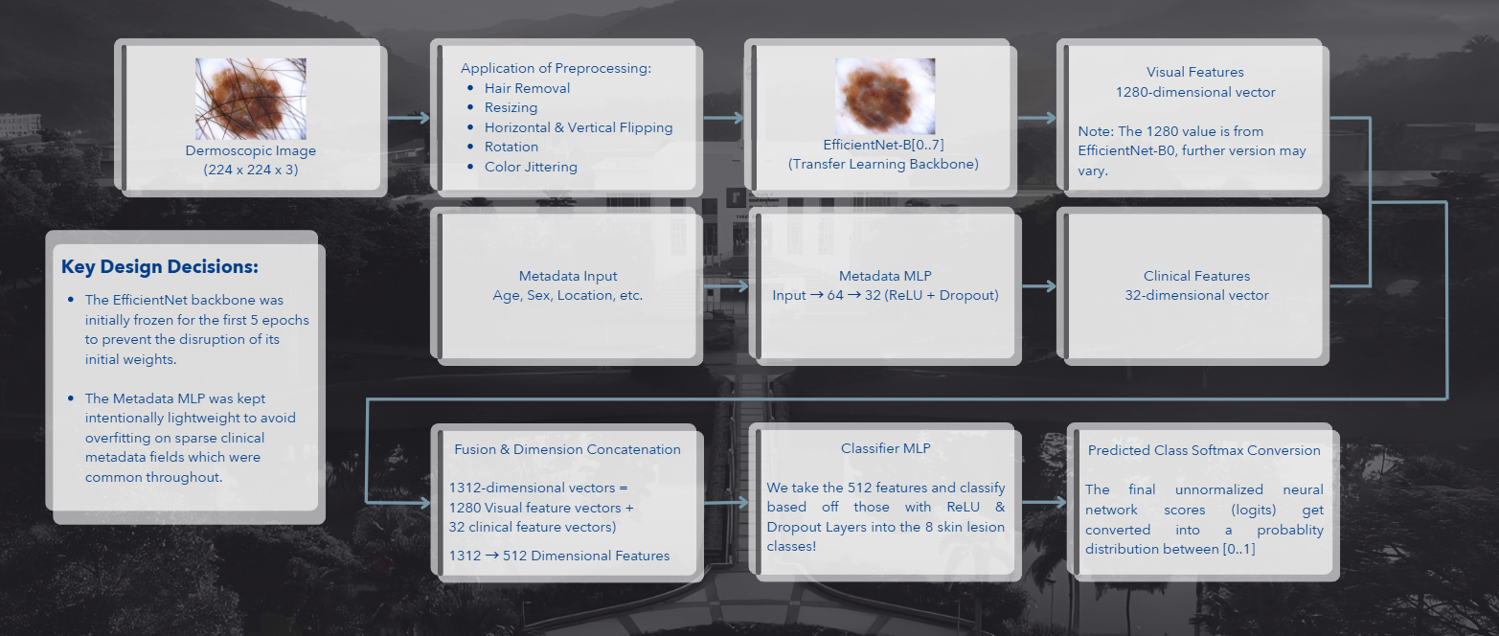
Figure X. Model Architecture snippet from SEGP Presentation
The results from V0.2 achieved accuracy results ranging between 81.3%, 86% and 24.8% among all three (3) test sets while the balanced accuracy and F1 scores fluctuated with a variance of ±8.36% (as shown in Fig. X.). Per-class analysis indicates strong performance across the board with most classes, with slight dips for Melanoma (MEL), Actinic Keratosis (AK) and Squamous Cell Carcinoma (SCC), all with recall metrics at 71%, 56%, 67% respectively, however after referencing back to the literature review, the lowered recall metrics for AK & SCC, especially when comparing them against each other makes sense as AK is a pre-cursor/pre-malignant skin lesion which has the potential to mutate in SCC, while MEL’s lower recall can be attributed to the fact that the model may find difficulties when comparing it against Melanocytic Nevi (Moles, NV) due to their visual similarities.
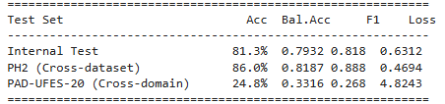
Figure X. V0.2 Overview of Evaluation Results

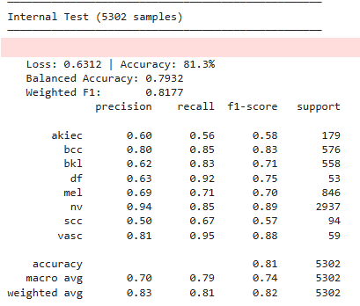
Figure X. V0.2 Internal Test Results
Upon looking at the external test sets, generalizability for the PH² dataset performs strongly with an accuracy of 86%, it is of note that the dataset only contains melanoma and nevus classes, and the model’s ability to generalize across unseen dermoscopic images. However, the results from the PAD-UFES-20 dataset highlighted a severe domain gap where the accuracy dropped to 24.8% accuracy with Fig. X. highlighting the confusion matrix visualization of the various misclassifications.
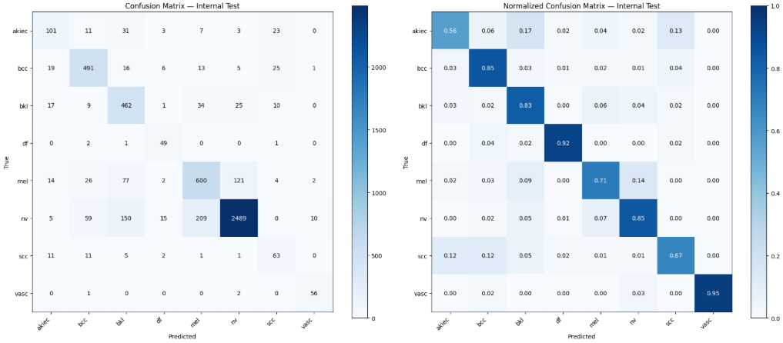
Figure X. V0.2 Internal Test Confusion Matrix
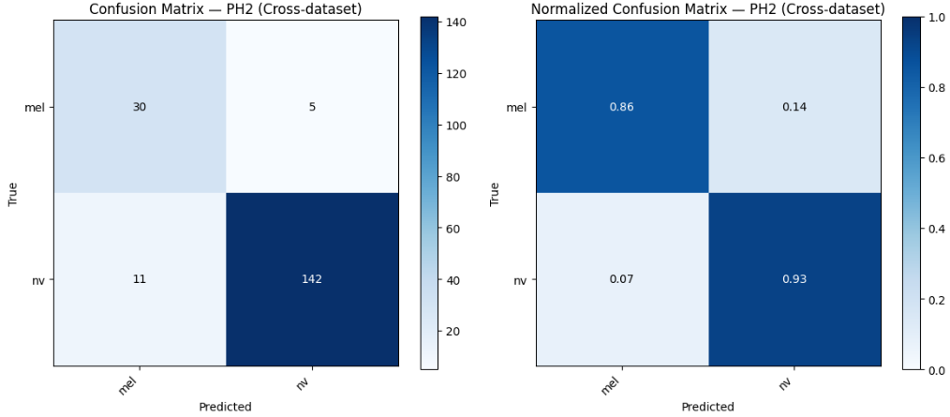
Figure X. V0.2 PH² Confusion Matrix
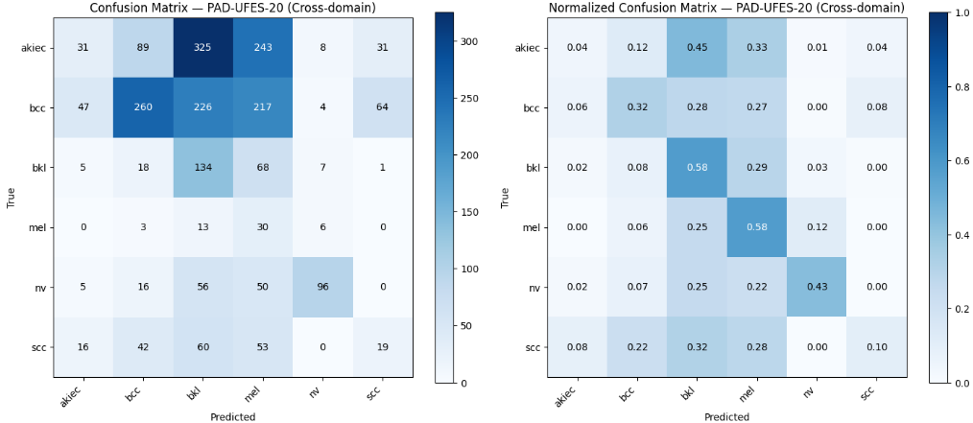
Figure X. V0.2 PAD-UFES-20 Confusion Matrix
Additionally, the validation loss as shown in Fig. X. reveals an overfitting gap which diverges and grows starting from approximately epoch 7 and continues to plateau as the training loss continues to decrease. This motivated several of our architectural changes in V0.3, however the overfitting issue has remained prevalent as will be shown later.
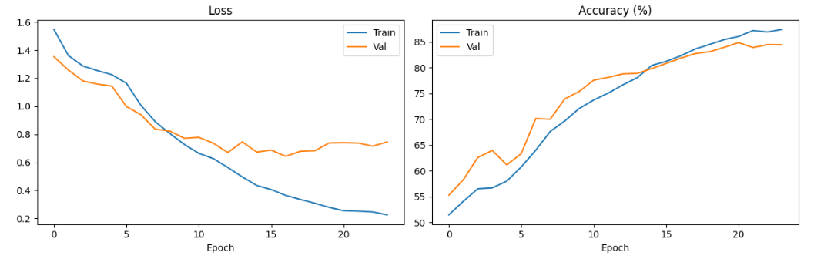
Figure X. V0.2 Training Curves

V0.3 | Modularization & Tuning
The third version included refactoring the Jupyter notebook into a Python package with dedicated modules to streamline and cut down on the bulk of the orchestration pipeline. Key improvements also include:
- Addition of Batch normalization layers, 4-step gradient accumulation and gradient clipping to improve gradient flow and training stability, especially after decreasing the batch size from 32 to 8.
- Epochs were increased to 35, early stopping patience was extended to 10 and augmentation step ratios were increased to be more prominent.
- Experimentation with larger image sizes and various iterations of EfficientNet models were performed.
According to Fig. X., V0.3’s accuracy improved for the internal test set and the PAD-UFES-20 from 81.3% & 24.8% to 83.3% & 33.8% respectively, while the PH² test set decreases down to 81% from 86%. Per-class analysis from the confusion matrices (Fig. X-X) shows that the model performed similarly to V0.2, with the same notes on AK and SCC being mistaken for each other on the Internal test set, however the MEL recall improved to 85% from 71%.
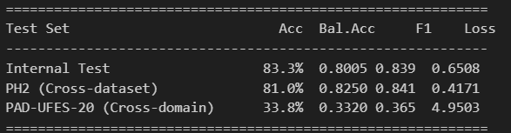
Figure X. V0.3 Overview of Evaluation Results
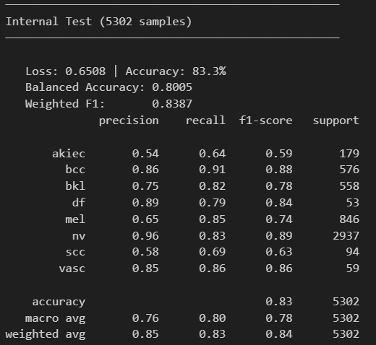
Figure X. V0.3 Internal Test Results
As for the external test sets, it remained relatively consistent as V0.2, with minor setbacks for PH²’s NV recall and marginal improvements in PAD-UFES-20, however it remains well below a reasonable level to use in a clinical or general-setting given its base accuracy is at 33.8%, this highlights the generalizability issues with using dermoscopic models against clinical images.
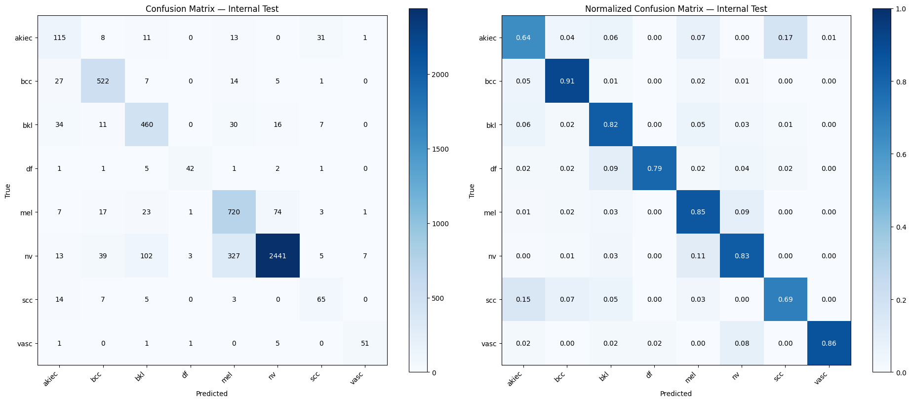
Figure X. V0.3 Internal Test Confusion Matrix
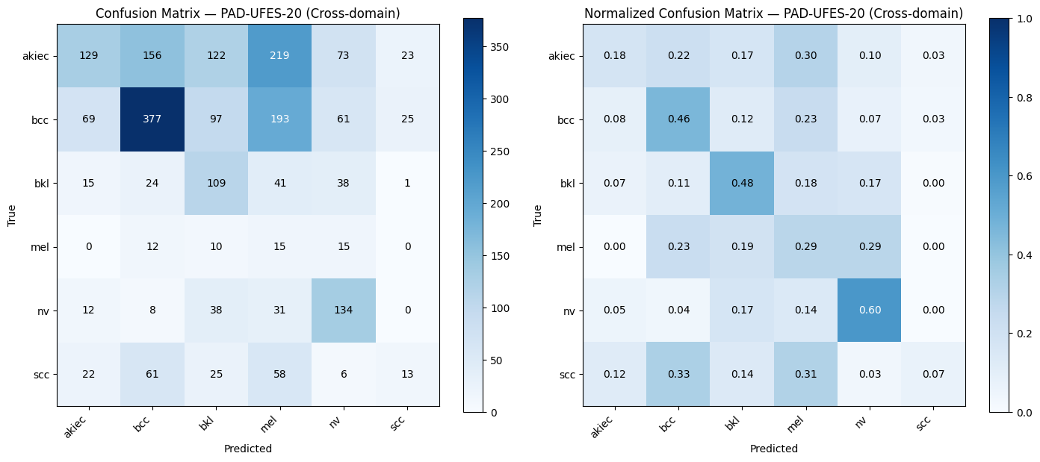
Figure X. V0.3 PAD-UFES-20 Confusion Matrix
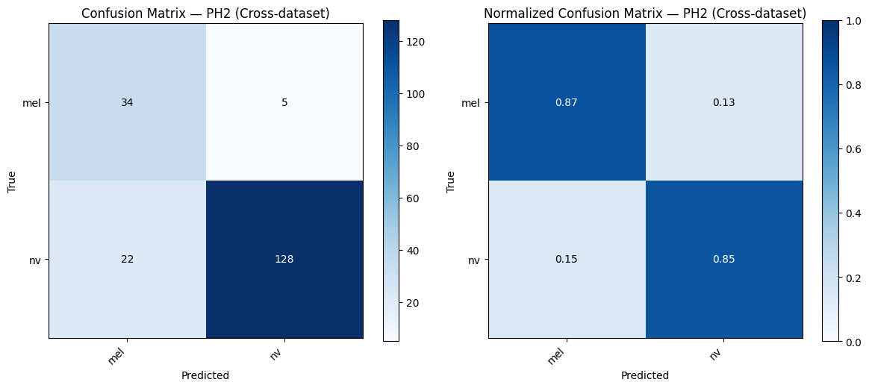
Figure X. V0.3 PH² Confusion Matrix
As shown in the training curves, the overfitting issue remains prevalent and should be further investigated in future works.
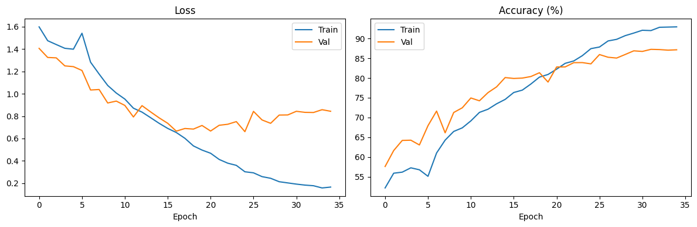
Figure X. V0.3 Training Curves

V0.4 | Clinical Dataset Implementation
The fourth iteration involved changing from the dermoscopic datasets as the training sets to using the clinical ones (PAD-UFES-20 and MRA-MIDAS) while retaining PH2 as an external test set, this required altering the mappings for both the localization and classification labels significantly in addition to cleaning the metadata excel sheet for the MRA-MIDAS dataset.
Furthermore, an additional feature was included where any missing pictures that were mentioned in the metadata sheets but didn’t exist in its respective dataset folder was flagged and its file name was stored in a log to inform the user of the issue.
V0.4 implemented a different, 3-class scheme (benign, malignant, and uncertain) as we shifted to using clinical datasets for training. While testing against the internal test set, V0.4 achieved 73.3%, 56.1 & 74.5% in regard to accuracy, balanced accuracy and weighted F1-scores. These scores are not to be compared to V0.3 as we have significantly altered the scope of the training data, switching from dermoscopic photos from HAM10000 & ISIC2019 to smartphone-grade photos from PAD-UFES-20 and MRA-MIDAS.
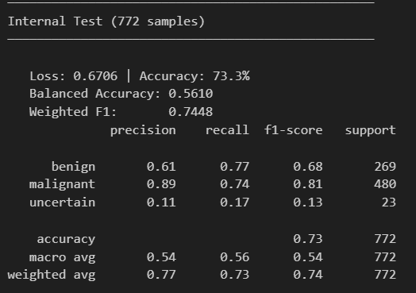
Figure X. V0.4 Internal Test Results
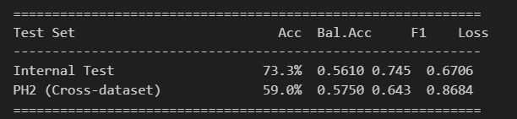
Figure X. V0.4 Overview of Evaluation Results

As shown in Fig. X. We opted for one external test set as the images would only be used against other smartphone grade cameras and opted for PH² to test its ability to detect MEL, the results were expected, with a drastic accuracy dip to 59%, however the Balanced Accuracy and F1-Scores were at 57.5% and 64.3% respectively. This confirmed that image modality (clinical vs. dermoscopic) to be the primary issue rather than another variable such as the classification scheme.
The confusion matrices below illustrate the per-class prediction distributions across both test sets.
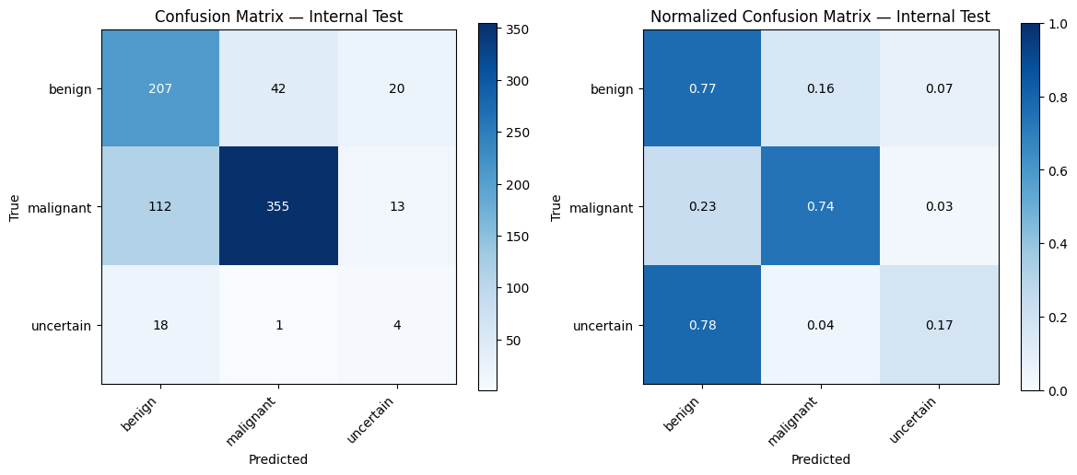
Figure X. V0.4 Internal Test Confusion Matrix
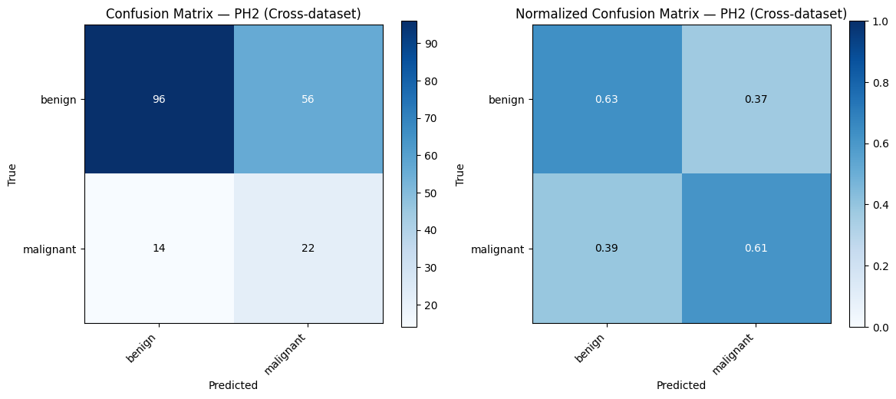
Figure X. V0.4 PH² Confusion Matrix
Overfitting remains to be an issue, and should be investigated in future works by comparing it against baseline CNN or ViT models to determine its cause as shown in Fig. X.
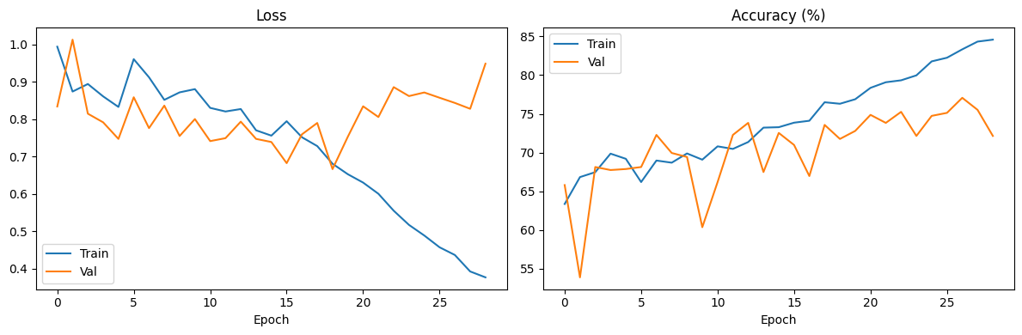
Figure X. V0.4 Training Curves

5.2. Application Development

5.2.1. [INSERT TEXT HERE]
Chapter 6

Challenges & Obstacles

6.1 Dataset Sourcing & Exploratory Data Analysis [EDA]
One of the largest challenges faced during the development of the model included sourcing a training dataset that adequately represented the Malaysian population as the majority of publicly available dermoscopic and clinical datasets, including both HAM10000 and ISIC2019 are heavily biased towards the first and second (lighter) Fitzpatrick skin types while Malaysian predominantly lean towards having darker skin tones meaning that lesion characters have the potential to vary drastically and poses a direct risk to classification accuracy. Furthermore, communicating with hospitals, academic, and medical institutions were met with lukewarm to no response when requesting support in requisitioning datasets or image samples.
Another issue related to datasets, were the issues found in the MRA-MIDAS dataset as shown in Fig X. however further attempts were made to resolve the inaccuracies in the dataset by manually analysing it, this allowed us to pre-process it leading to its implementation as one of the training sets for V0.4.
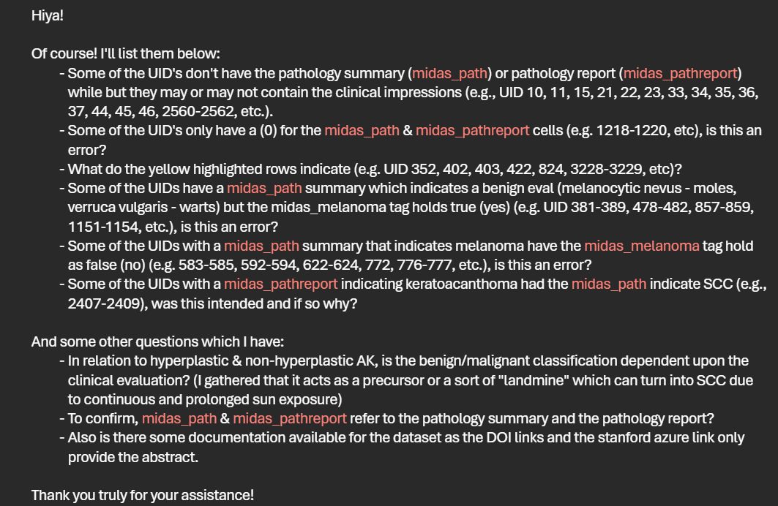
Figure X. Snippet of email correspondence with Stanford AIMI.
Furthermore, each dataset used different label conventions and metadata schemas, for example, HAM10000 utilizes lowercase abbreviations such as “akiec” & “bcc” for Actinic Keratosis and Basal Cell Carcinoma while ISIC2019 used “AK” & “BCC”, this necessitated the implementation of a unified class scheme to resolve the difference and explicitly label the mappings for each source accordingly. This was the case as well for body-site localization metadata which varied across datasets, HAM10000 had originally recorded the “scalp”, “face” and “ear” as separate instances whereas the ISIC2019 dataset grouped them under “head/neck”, this was resolved via the same method of employing category localization mapping to ensure consistent features were fed to the model during training.

6.2 Hyperspectral Analysis with Dermoscopic Images
The initial scope of the project envisioned the utilization of hyperspectral imaging and reconstruction techniques to analyse melanin concentration and skin composition non-invasively. If implemented correctly, theoretically it would promise richer spectral information than standard smartphone grade photographs and would improve differentiation between benign and malignant lesions. However, this approach was abandoned for various reasons.
Firstly, hyperspectral imaging hardware is prohibitively expensive so we would not have any baseline comparisons against other skin cancer lesions, and the publicly available dermoscopic and clinical datasets contain conventional colour space images. Therefore, building or privately sourcing a hyperspectral skin lesion dataset or attempting to employ hyperspectral reconstruction at scale or with verification metrics was beyond the resources available for this project.

6.3 Class Imbalance and Training Stability
For a decent majority of the datasets encountered, they exhibited severe class imbalance where moles would contribute to a large percentage of the samples which rarer conditions accounted for less than a few percentage points each. This would prove detrimental if unaccounted for, and was thus addressed by implementing inverse-frequency class weighing in the loss function, with an additional 1.35x malignant boost multiplier applied to the malignant classes, this approach prioritized recall for malignant conditions while sacrificing our false positive rate for benign classes which was a safer approach for the purposes of this application and project.

6.4 Dermoscopic vs. Clinical Models
While working on various iterations of the skin cancer classification models, it was found consistently that regardless of how dermoscopic datasets were modified, augmented or altered, their generalization and accuracy metrics when compared against clinical and smartphone grade photographic datasets would take a steep decline, this was a severe setback as the largest datasets that were publicly available were the dermoscopic ones, notably the HAM10000 and ISIC2019 which were used in various iterations of the model.

6.5 GPU utilization for Model Training
Setting up the environment to allow for training the model using a dedicated graphics card in order to take advantage of the much faster training speeds provided by CUDA cores and parallel operations proved to be much harder than expected, as various methods were attempted including using “Windows Subsystem for Linux 2”, “Docker”, and installing a virtual machine in Linux in order to leverage GPU-accelerated TensorFlow operations as support for Windows GPU-acceleration was dropped back in 2.11 or around November, 2022. This served as a factor for switching to PyTorch as it provided the ability to perform said operations natively on windows where they have allowed us to train models and test various iterations and modifications rapidly.

Chapter 7

Project Management & Time Plan

7.1 Past Events

7.2 Current Events

7.3 Future & Planned Events
Chapter 8

References
Model Creation Literature Review
- C. J. Luo, "Lightweight Deep Learning Network for Skin Cancer Classification," University of Nottingham Malaysia (UNMC), May. 2020, [Online]. Available: Lightweight Deep Learning Network for Skin Cancer Classification.pdf [Accessed Feb. 16, 2026].
- Z. Yu, C. Xin, Y. Yu, J. Xia, and L. Han, “AI dermatology: Reviewing the frontiers of skin cancer detection technologies,” Intelligent Oncology, vol. 1, no. 2, pp. 89–104, Mar. 2025, doi: 10.1016/j.intonc.2025.03.002.
- S. M. R. Swapno, S. M. N. Nobel, P. K. Meena, V. P. Meena, J. Bahadur, and A. Appaji, “Accelerated and precise skin cancer detection through an enhanced machine learning pipeline for improved diagnostic accuracy,” Results in Engineering, vol. 25, p. 104168, Jan. 2025, doi: 10.1016/j.rineng.2025.104168.
- R. R, V. P, and N. K, “Advanced Deep Learning Strategies for Skin Lesion Segmentation using R2U-Net,” 2024 International Conference on Communication, Computing, Smart Materials and Devices (ICCCSMD), pp. 1–6, Dec. 2024, doi: 10.1109/icccsmd63546.2024.11015162.
- A. Esteva et al., “Dermatologist-level classification of skin cancer with deep neural networks,” Nature, vol. 542, no. 7639, pp. 115–118, Jan. 2017, doi: 10.1038/nature21056.
- A. S. Chiou et al., “Multimodal image Dataset for AI-Based Skin Cancer (MIDAS) benchmarking,” NEJM AI, vol. 2, no. 6, May 2025, doi: 10.1056/aidbp2400732.
- N. R. Kurtansky et al., “The SLICE-3D dataset: 400,000 skin lesion image crops extracted from 3D TBP for skin cancer detection,” Scientific Data, vol. 11, no. 1, p. 884, Aug. 2024, doi: 10.1038/s41597-024-03743-w.

Interim Report & Lit Review Research
- L. Thomas et al., "Real-world post-deployment performance of a novel machine learning-based digital health technology for skin lesion assessment and suggestions for post-market surveillance," Front. Med., vol. 10, p. 1264846, Oct. 2023, doi: 10.3389/fmed.2023.1264846.
- SkinVision, "The SkinVision Algorithm," SkinVision. [Online]. Available: https://www.skinvision.com/clinical-research/how-the-algorithm-works. [Accessed: Apr. 21, 2026].
- SkinVision, "Getting Started," SkinVision. [Online]. Available: https://www.skinvision.com/getting-started#pricing-and-plans [Accessed: Apr. 21, 2026].
- Center for Artificial Intelligence in Medicine & Imaging | Stanford University, "MRA-MIDAS: Multimodal Image Dataset for AI-based Skin Cancer," Stanford University, Stanford, https://doi.org/10.71718/15nz-jv40. 2025.
- G. Brancaccio, A. Balato, J. Malvehy, S. Puig, G. Argenziano, and H. Kittler, "Artificial intelligence in skin cancer diagnosis: A reality check," J. Invest. Dermatol., Feb. 2023, doi: 10.1016/j.jid.2023.10.004.
- N. S. A. Mahmoud, "Early automated detection system for skin cancer diagnosis using artificial intelligent techniques.," 28 April 2024, https://doi.org/10.1038/s41598-024-59783-0.
- N. e. a. Shifai, "Can ChatGPT vision diagnose melanoma? An exploratory diagnostic accuracy study," 18 January 2024, https://doi.org/10.1016/j.jaad.2023.12.062.
- S. S. Sattler et al., "Evaluating the diagnostic accuracy of ChatGPT-4 Omni and ChatGPT-4 Turbo in identifying melanoma: Comparative study," JMIR Dermatol., vol. 8, p. e67551, Mar. 2025, doi: 10.2196/67551.
- M. Abou Ali, F. Dornaika, and I. Arganda-Carreras, ‘Blood Cell Revolution: Unveiling 11 Distinct Types with “Naturalize” Augmentation’, Algorithms, vol. 16, no. 12, 2023.
- P. Goon, C. Banfield, O. Bello, and N. J. Levell, "Skin cancers in skin types IV-VI: Does the Fitzpatrick scale give a false sense of security?" Skin Health Dis., vol. 1, no. 3, p. e40, Jun. 2021, doi: 10.1002/ski2.40.
- C. Dessinioti and A. J. Stratigos, "An epidemiological update on indoor tanning and the risk of skin cancers," Curr. Oncol., vol. 29, no. 11, pp. 8886–8903, Nov. 2022, doi: 10.3390/curroncol29110699.
- M. Wang, X. Gao, and L. Zhang, "Recent global patterns in skin cancer incidence, mortality, and prevalence," Chin. Med. J. (Engl.), vol. 138, no. 2, pp. 185–192, Jan. 2025, doi: 10.1097/CM9.0000000000003416.
- Z. Kamarulzaman, and N. Shaari, “A Review of Modest Fashion Perspectives in the Malaysian Fashion Industry,” IJAD, vol. 7, no. 2, pp. 32-45, Aug. 2023, [Online]. Available: 97513.pdf. [Accessed: Apr. 21, 2026].
- M. H. Hamim, “Public Notebooks,” Kaggle. [Online]. Available: https://www.kaggle.com/mahmudulhasanhamim/code. [Accessed : Feb. 18, 2026]

Chapter 9

Appendix
Appendix:
- Project_Description.pdf
- Design.pdf [UI]

