Michael Walton
Homework 3
11/19/2024
Game: Grab Em
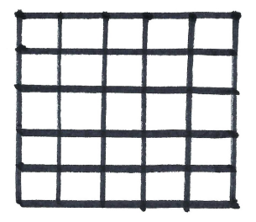
Fig 1. Fig 2. Fig 3.
Normal game play 5 turns in 8 turns in, player surrounds empty tile 8 turns in, player earns 1 bonus tile
How to Play:
The program will start with rendering a page to choose the size of the board by picking 1 thru 20 which represents 1x1 and 20x20 respectively. Then the players will choose the number of players 1 thru 4. Then finally each player will choose their color for the board. All player colors default to red, so selection must be made or red will win by default as all tile selections will be red. Next the players will click on Start Game and a new page renders with the size of the board chosen on the last screen. At the top of the page It will show which player’s turn it is. Players take a turn by using the mouse and clicking on a tile within the board. After the first player has taken their turn it will now show that it is player 2’s turn at the top of the screen above the board, and so on depending on the number of players each taking their turn in sequence. Player one will always be first then player two, three, and four.
Object of Game:
The object of the game is to claim as many tiles as possible before the board fills up. Statistically the player who goes first will always be the player who wins or the game will result in some kind of tie, depending on the number of players (Fig 1.). That is why there is a way to claim bonus tiles on the board to even out the odds of winning. When a player surrounds empty tiles on all sides by their own colored tiles(Fig 2.), the game automatically awards that player the empty tiles thus increasing their tile count(Fig 3.). The game becomes more interesting as players utilize the larger board sizes as much more strategy comes into play. The smaller board sizes are intended for utilizing for quick lessons on practicing strategy or playing with children. Tile count is purposely not displayed to increase mental tension and anxiety about who is winning until the finish.

Data Storage:
The board size(boardSize), number of players(numPlayers), and current player(currentPlayer) are all integers stored in separate web-based Flask session dictionaries.
The players colors(playerColors) is a list of strings stored in a web-based Flask session dictionary.
The board map(boardMap) is a 2D Array(nested list) stored in a web-based Flask session dictionary. Every cell in the list contains either “None” for an empty cell or the color of the player who claimed the cell ex. “red” for a cell that has been selected by a player.
The tile counts(tileCounts) is a web-based dictionary stored as a Flask session dictionary.

