Software Requirements Specification

Market Analysis Software
for "ProfitRUs"

Concordia University
COMP 354
Fall 2016

Prepared by

Prepared by Alexandre Philbert
Kenneth-Gerard Serrano
Vince Ortona
Yiran (Bernie) Shen
Table of Contents
Introduction 3
Purpose 3
Audience 3
Project Scope 3
Cost Estimation 4
Design 5
Architectural Style 5
External Libraries 5
Domain Model 5
Class Diagram 6
Use Cases 7
Case 1: User logs in 7
Case 2: User logs out 9
Case 3: User chooses stock 10
Case 4: Select Time Window 14
Future Iterations 17
Iteration #1 17
Iteration #2 17
Iteration #2 17

Introduction

Purpose
The purpose of the software is to allow users to analyze stock data. The software will provide indications when stocks are best to buy according to their “moving averages“.

There are four parts of this document: Overall Description; System Features; External Interface Requirements and Other Nonfunctional Requirements.
- Overall description mainly concentrates on the introduction of whole system architecture;
- System features have detail description of the system functional requirements, which is the key of this document;
- External interface requirements describe the user interface, hardware interfaces, software interfaces and communications interfaces;
- Nonfunctional requirements describe the details of other requirements, just like performance, safety, security and software quality attributes requirements.

Audience
Project managers could preview the function of products by this document, which could be the basement of system design and project management.
Developer reads SRS document carefully and understand the system functions. Writing User Guidance according to this document.
Designer analyzes the requirements and provides the design of system and database.
Tester designs test cases and test the functionality and non-functionality part of system according to this document.
User could have an insight of the performance and functionality of software according to this document .Then discusses the details with developers.
Marketing staff could have better comprehension of software according to this document.
Other staff uses this document as reference of performance and quality of the system.

Project Scope
Academic project for a Software Engineering course. This software is not intended to be sold or used in a commercial setting.

Cost Estimation
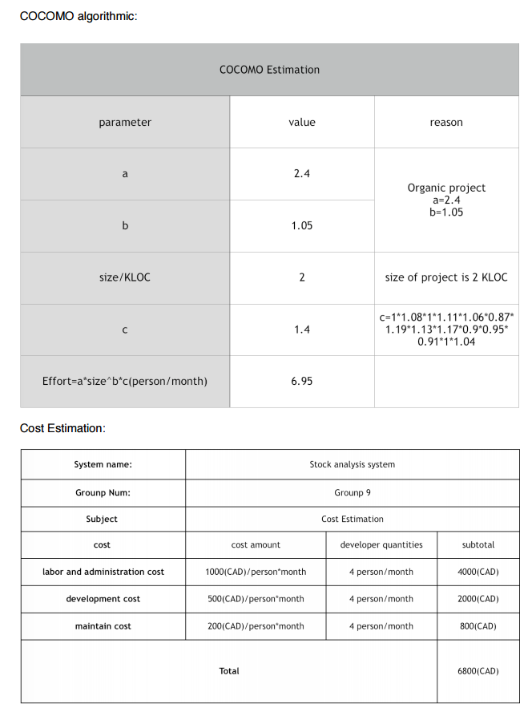

Design

Architectural Style
The architectural styles we chose for this project would be a mix of blackboard style, layered style, repository style and event-base style.

The reason why we chose blackboard and repository style is because there is multiple users that will be viewing and manipulating the data of the application. Including in the Repository style would be the database that includes the data from the graph of the selected stock, since the application mostly relies on it, which would be a disadvantage of that style.

The reason we chose the layered style would be because the application is itself a UI and that the data, which is the data from the selected stock, is separated from the UI. For the last style we chose, which would be the Event style is because there is many buttons that is included in the UI application, which will execute different kinds of functions.

External Libraries
JavaFX (UI) and Yahoo Finance API (Data).

Domain Model
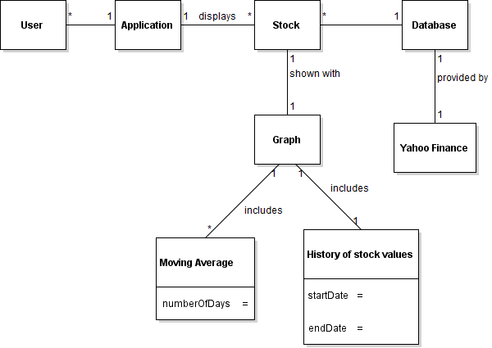

Class Diagram
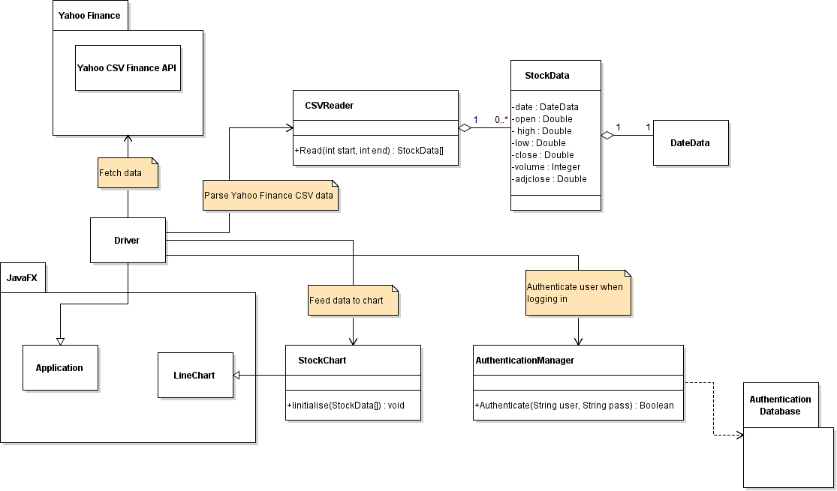

Use Cases

Case 1: User logs in

System Sequence Diagram
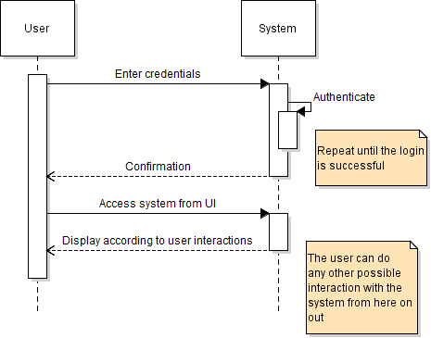

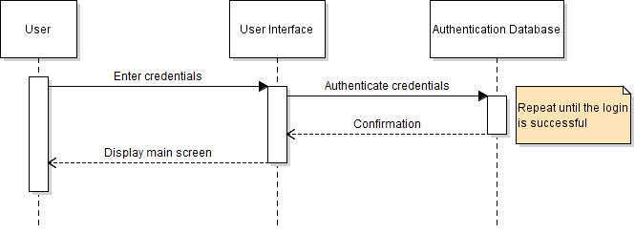
Sequence Diagram

Collaboration Diagram
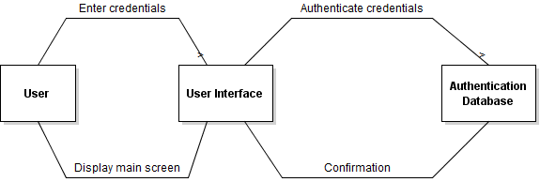

Scenario
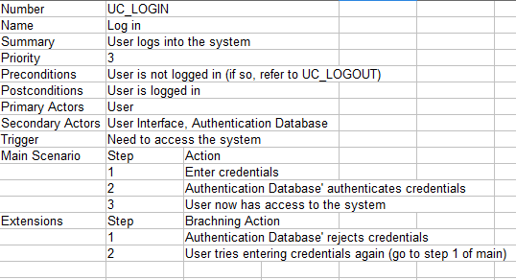

Case 2: User logs out

System Sequence Diagram
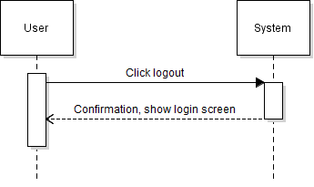

Sequence Diagram
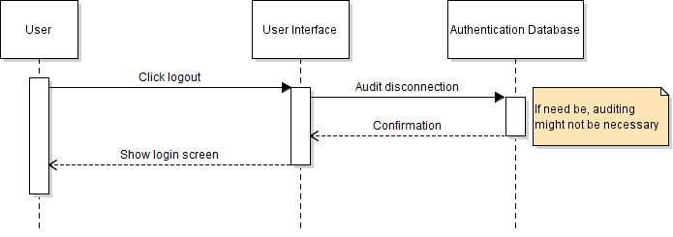

Collaboration Diagram
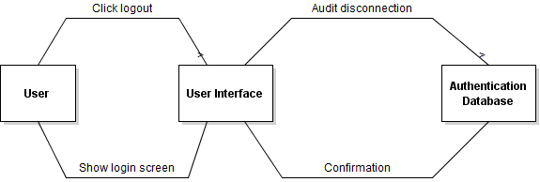

Scenario
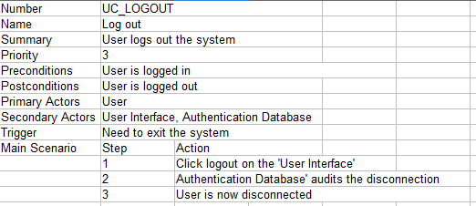

Case 3: User chooses stock

System Sequence Diagram
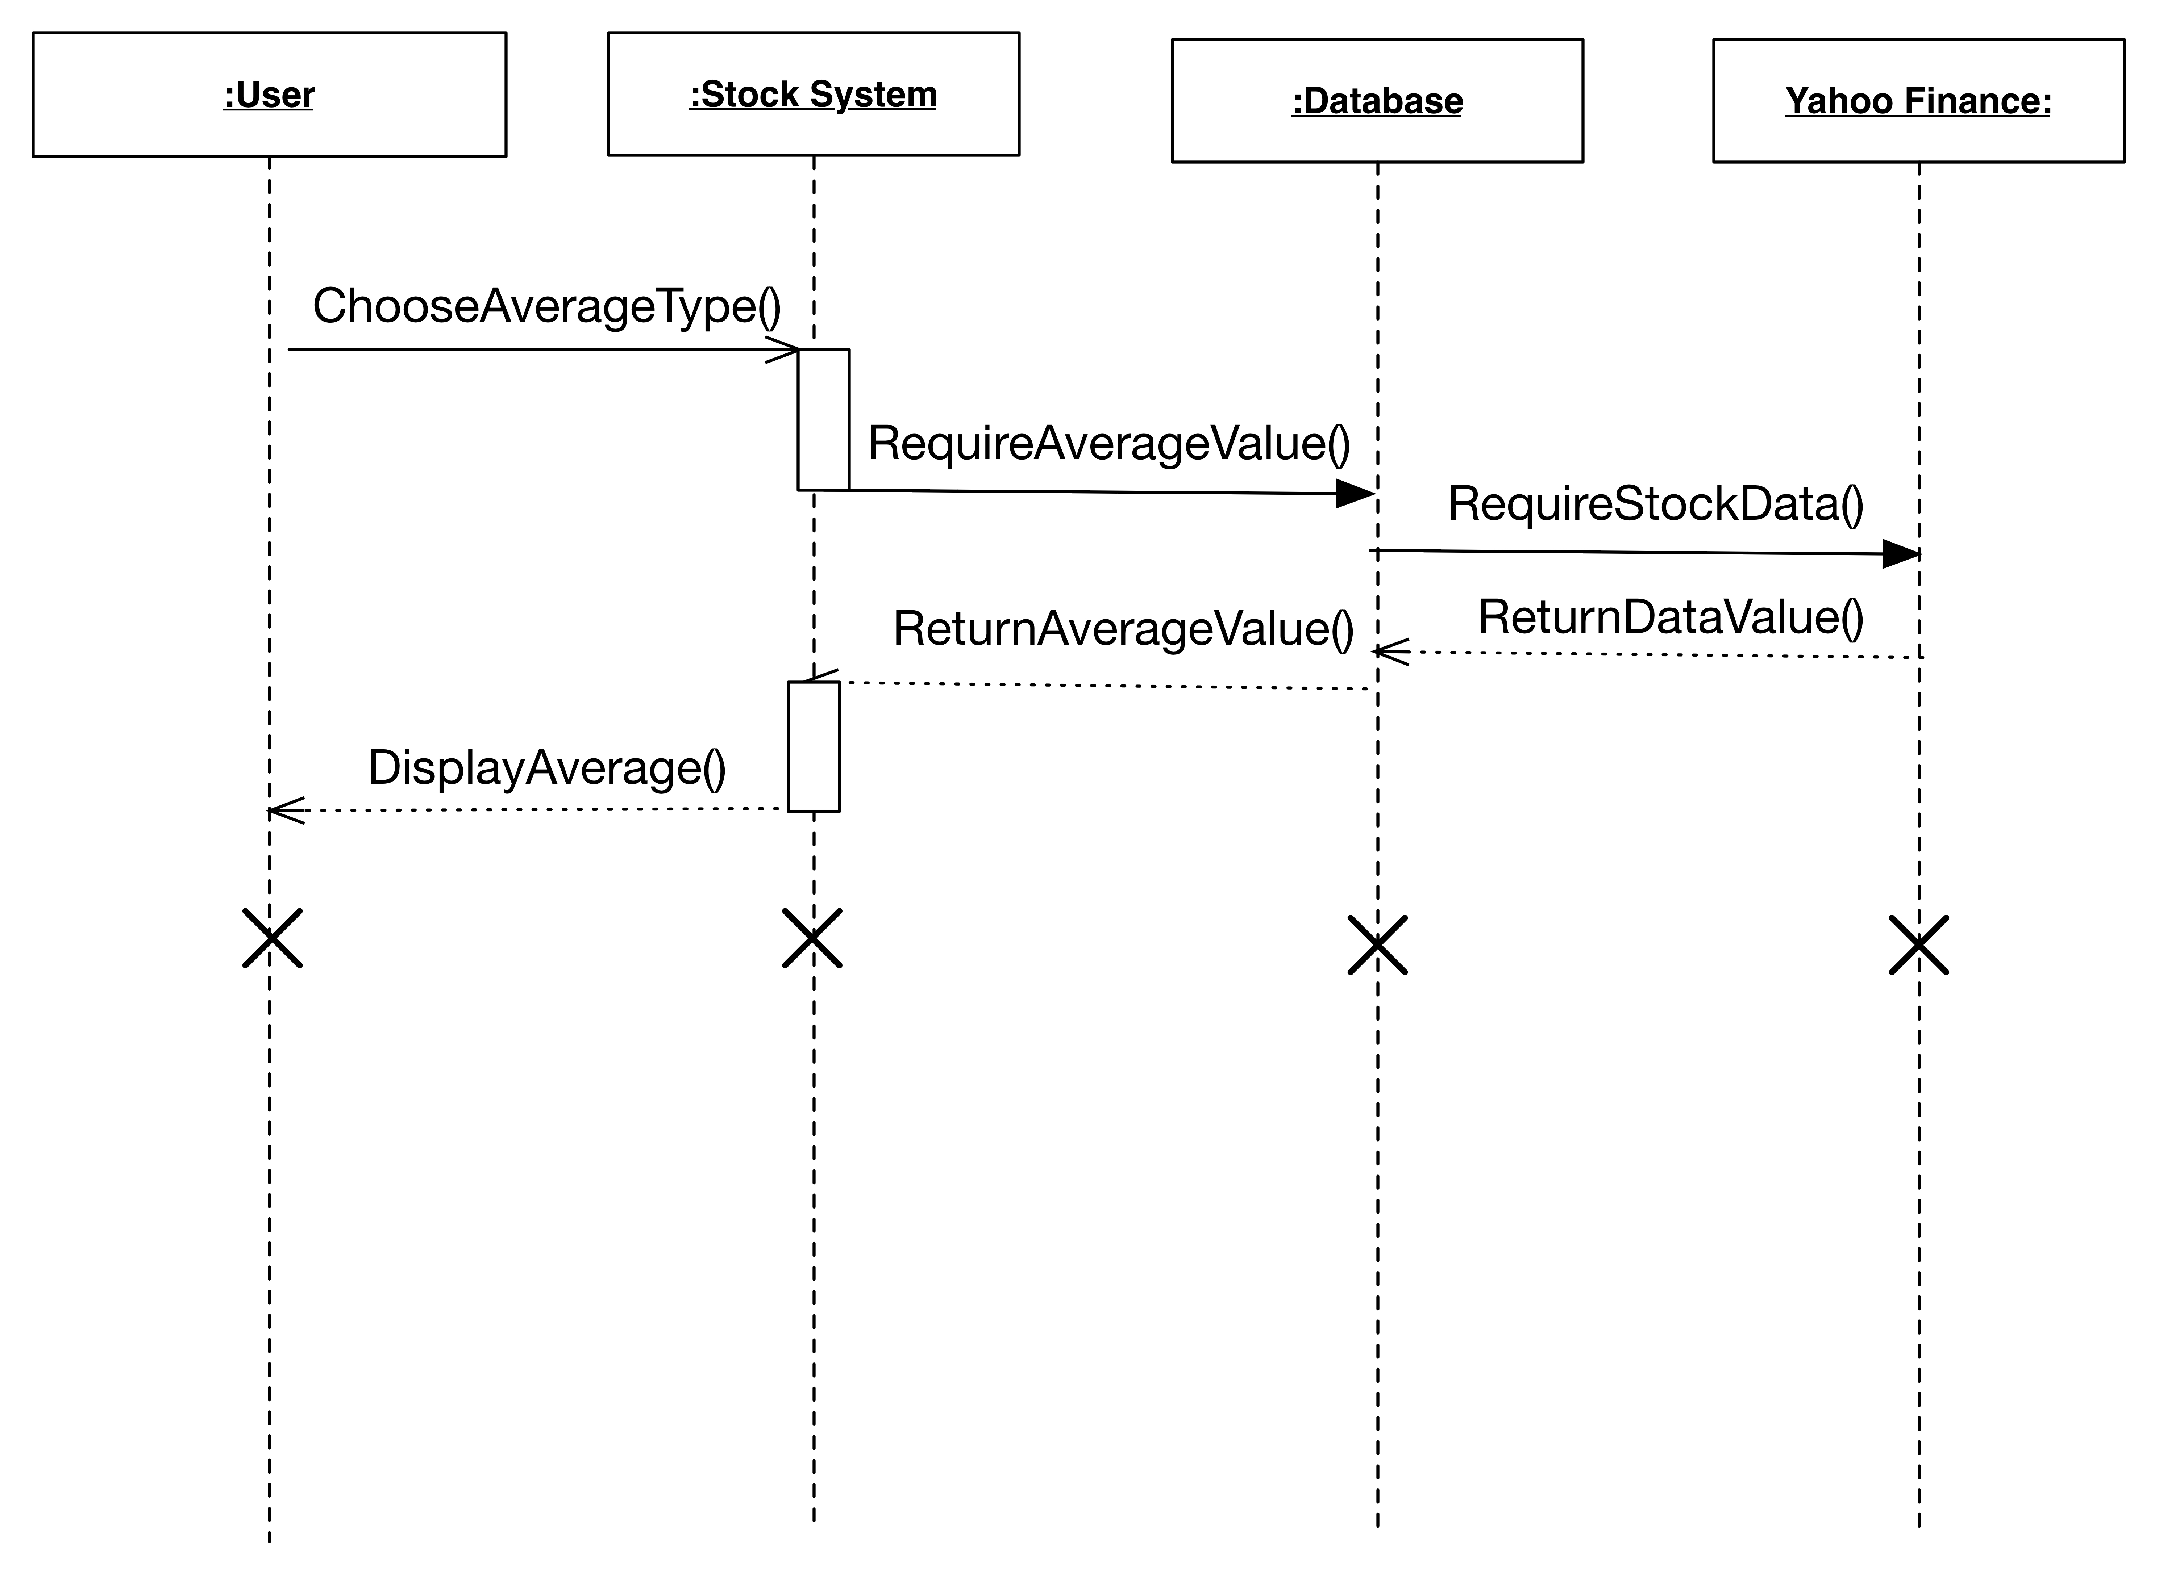

Sequence Diagram
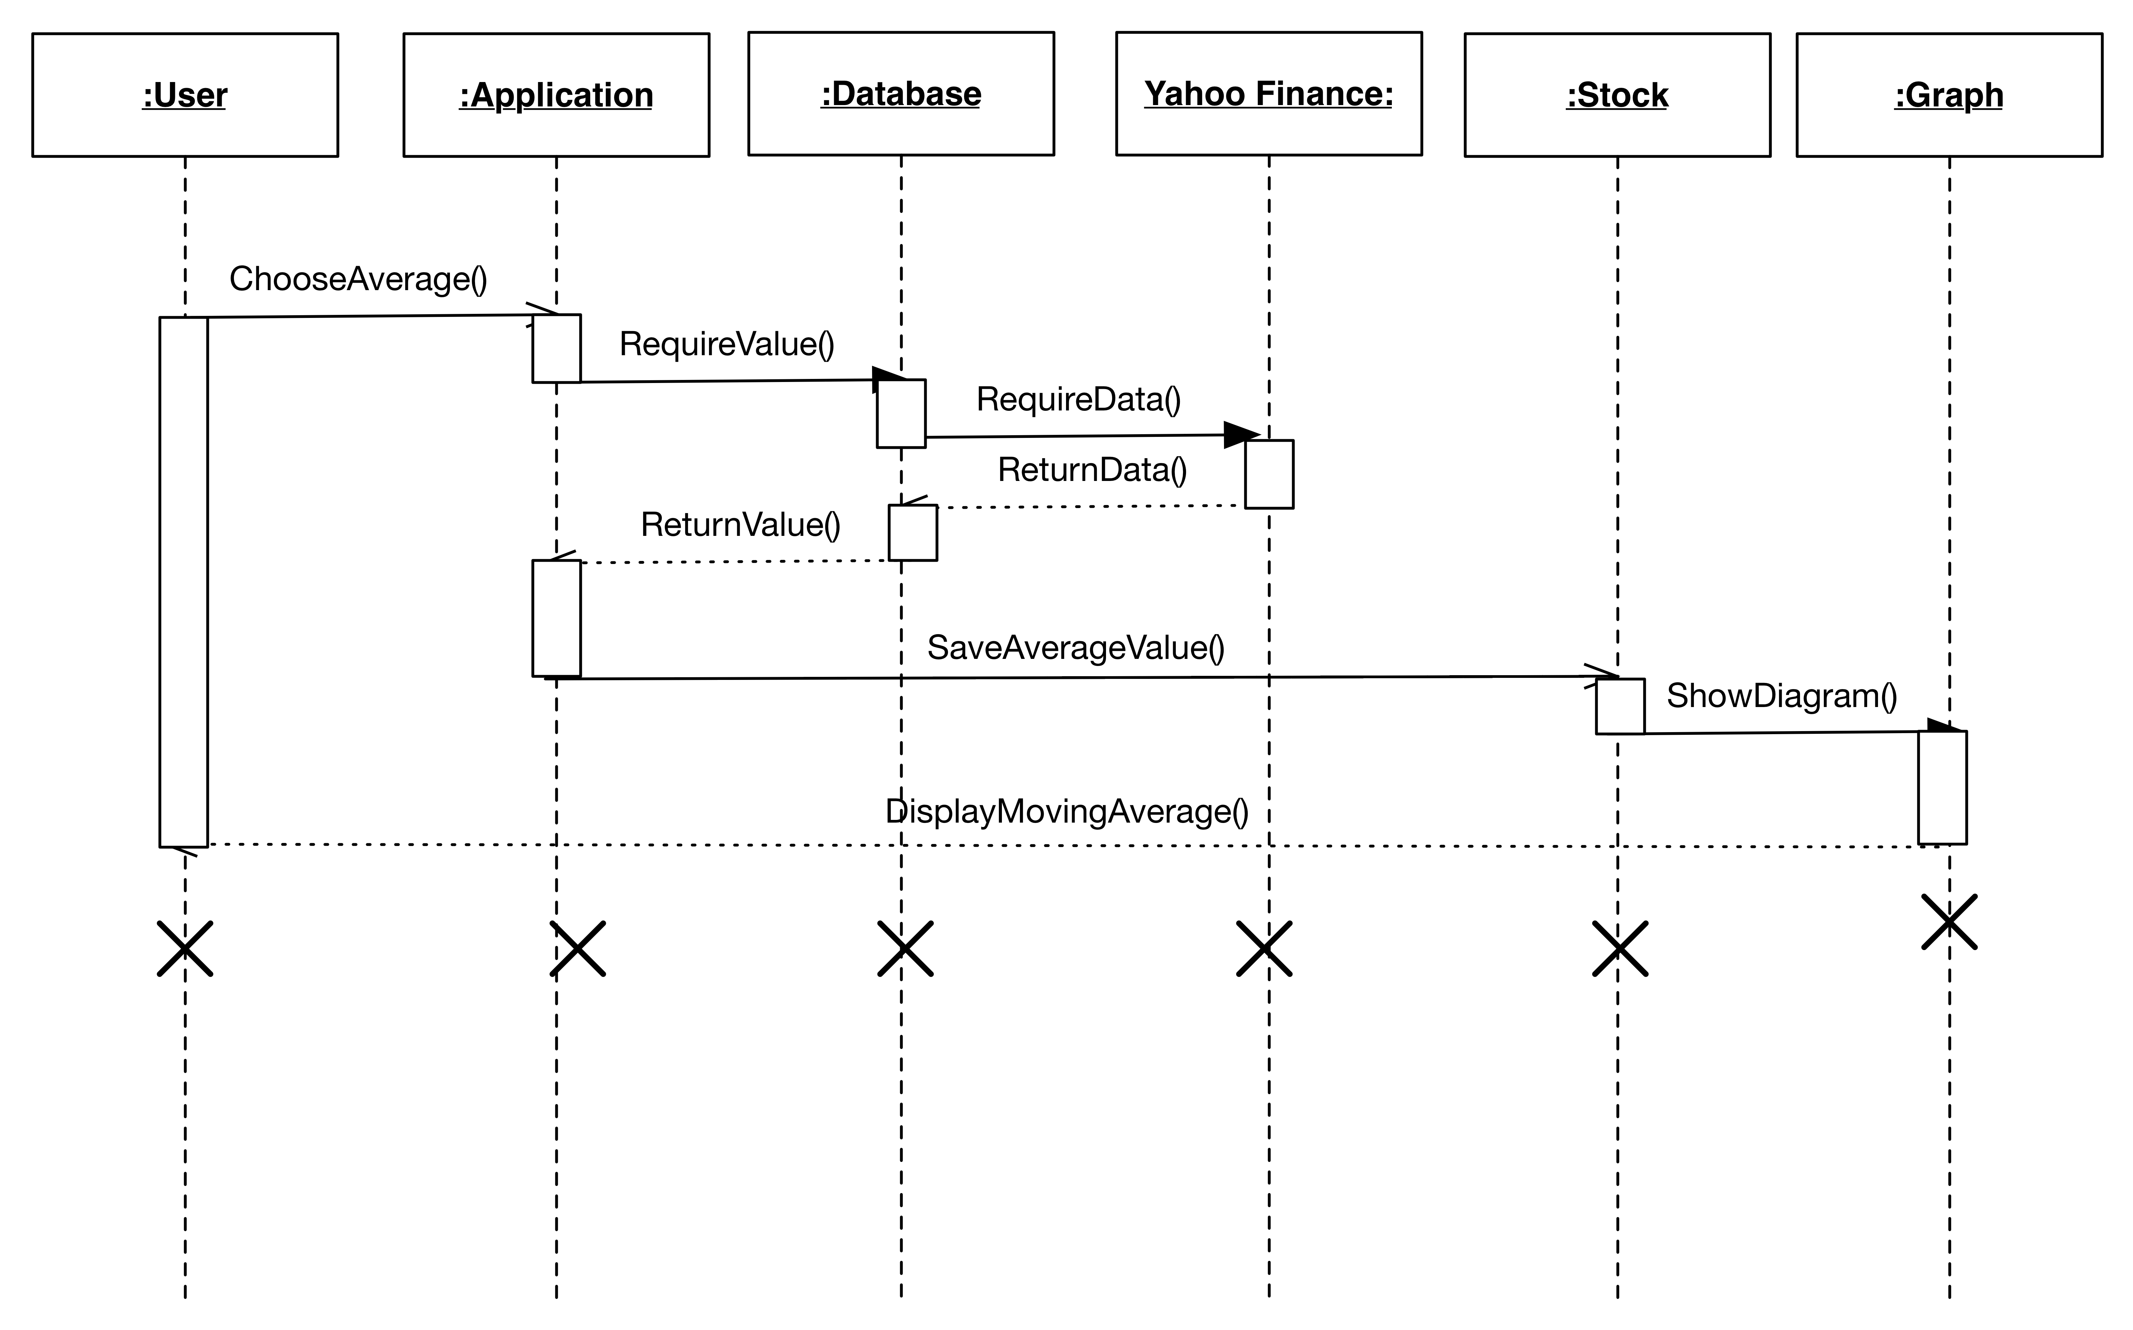

Collaboration Diagram
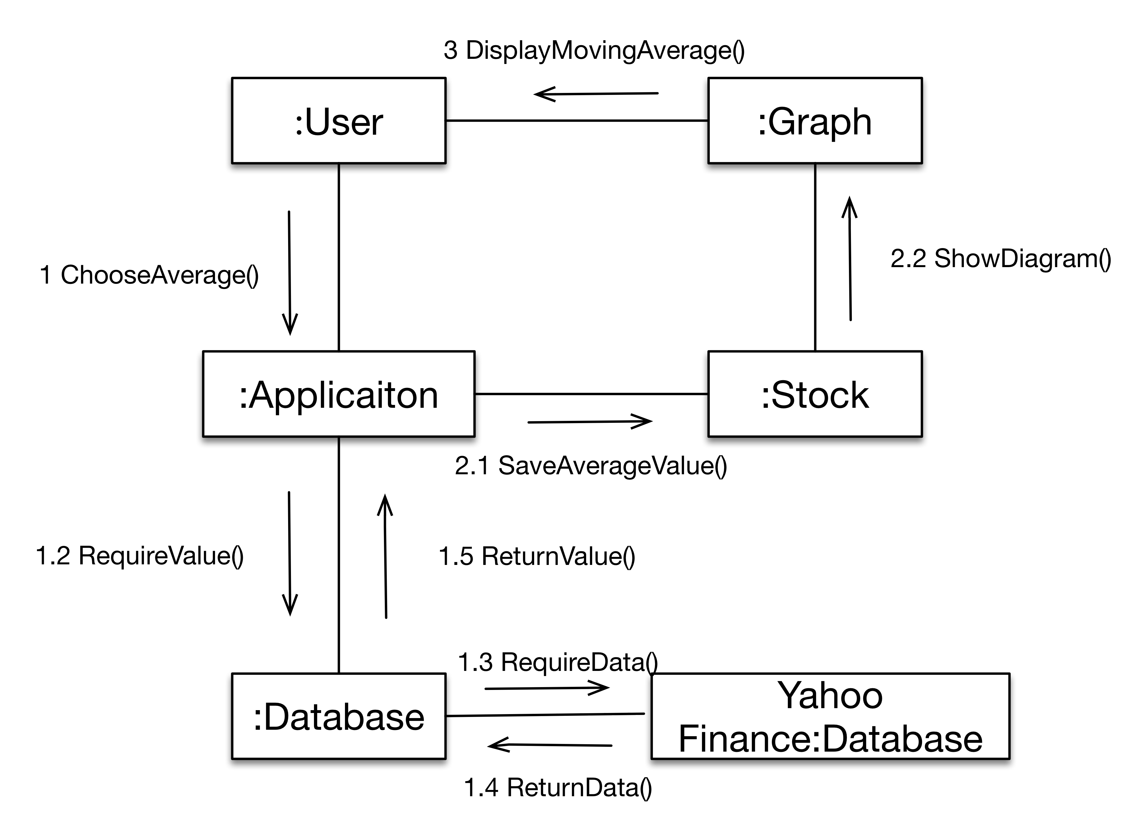

Scenario
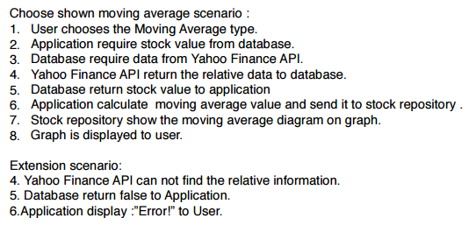
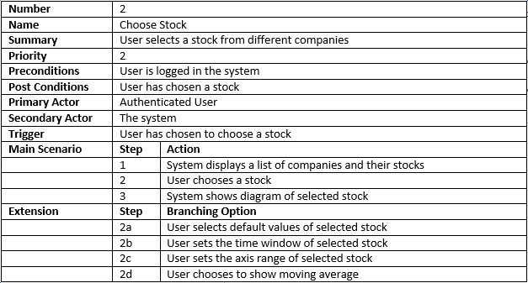

Case 4: Select Time Window

System Sequence Diagram
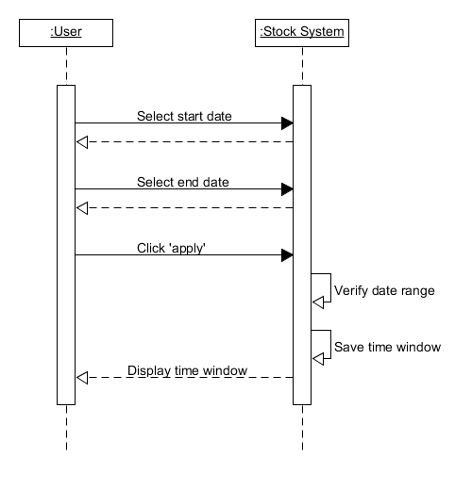

Sequence Diagram
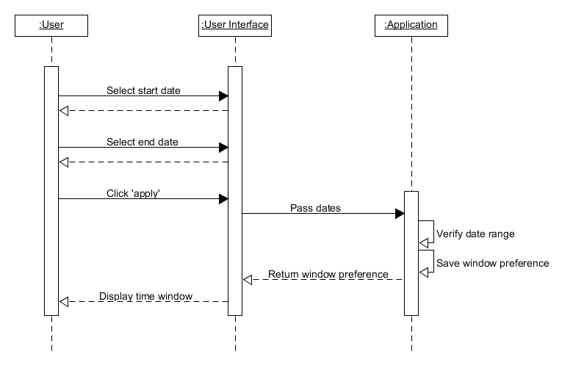

Collaboration Diagram
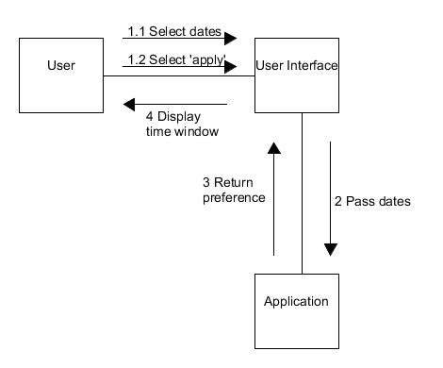

Scenario

Number | SET_TIME
Name | Set Time Window
Summary | User sets a time window for the stock's data
Priority | 3
Preconditions | User is logged in
Postconditions | Time window preference is saved
Primary Actors | User
Secondary Actors | User Interface
Trigger | User clicks “Time window” button
Main Scenario | Step | Action
 | 1 | User selects start date
 | 2 | User selects end date
 | 3 | User clicks “Apply” button
 | 4 | Time window range is displayed
Exception | 2.1 | User selecting end date earlier that start
 | 3.1 | User clicks “Apply” button
 | 4.1 | Error message sent: “End date cannot be earlier than start date”

Future Iterations

Iteration #1
- Read stock market data from .csv file
- Display data in a graph

Iteration #2
- Calculate moving averages
- Make graph parameterable (from a user standpoint)
  - Year, month, etc.
- Show 'Buy & Sell' indicators on the graph

Iteration #2
- Show one or many moving averages on the graph
- Get data from Yahoo Finance API instead of the sample data
  - Choose from a list of stocks
- User authentication

