**Practical - 1**

**Define a simple services like Converting Rs into Dollar and Call it from different platform like JAVA and .NET**

1]

create

a

new

project

and

create

a

new

webservice

2]

now

right

click

on

the

code

and

click

on

insert

code

>

add

new

web

service

operation

3]

after

give

name

to

operation

**FtoC**

and

add

one

parameter

**a**

of

double

data

type

and

click

ok

the

code

will

auto

generate

.

4]

now

do

the

following

changes

in

that

auto

generated

code:

Now

deploy

the

model.

5]

After

deploying

the

model

just

right

click

on

your

web

service

and

click

on

test

web

service

.

and

you

will

get

redirected

to

a

browser

page

where

you

can

check

that

your

web

service

is

working

or

not.

Creating

java

Client

using

jsp

5]

now

right

click

on

web

pages

>

new

>

jsp

.

and

give

name

as

input

jsp.

Again

right

click

on

web

pages

>

new

>

jsp

.

and

give

name

as

output

jsp.

6]

In

input.jsp

write

the

following

code

:

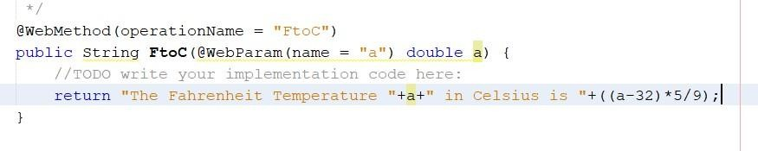

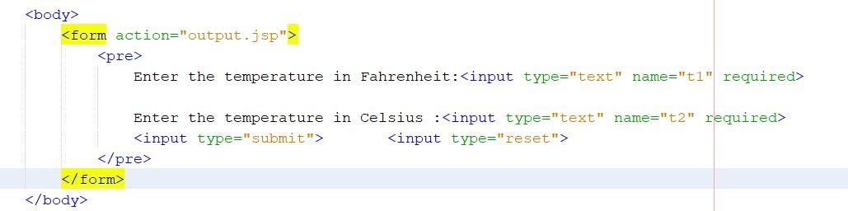

7] create a Web service client and give package name as “Client”. After creating web service client go to web service references and drag and drop the operations in output.jsp in body tag as shown

below:

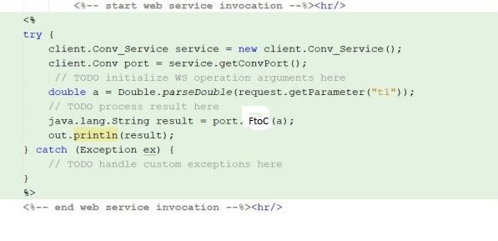

8]

now

deploy

the

model

again

and

run

the

input.jsp

file

you

will

get

redirected

to

the

browser

page

as

shown:

After

submitting

you

will

get

the

following

output:

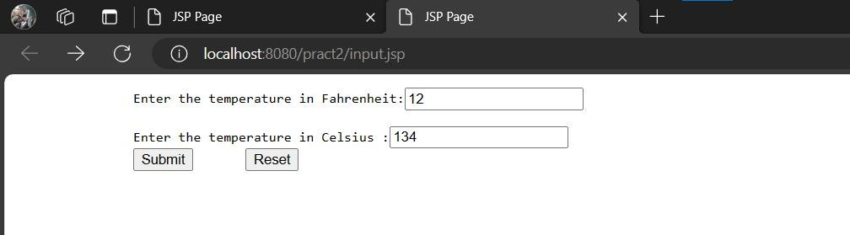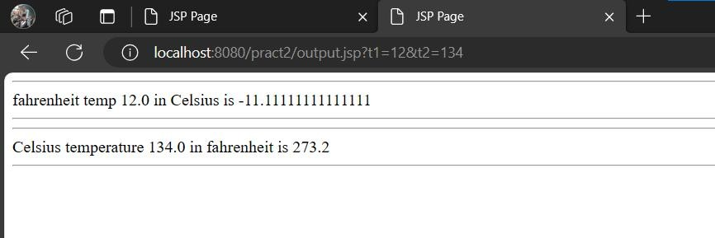

Python

Client

1]

Deploy

the

web

service

and

write

the

following

code

:

***Code***

***:***

from

zeep

import

Client

wsdl_url='http://localhost:8080/Practical_2/TempConverter?wsdl'

client=Client(wsdl_url)

#call

the

method

on

the

webservice

d=float(input("Enter

temperaure

in

Fahrenheit

:

"

))

result

=

client.service.FtoC(d)

print(result)

**2] replace your_wsdl_url with the url which was copied at the time of web service client creation .**

## In step no.16 . and replace the operation_name with your method or operation name. and pass parameter to it

**3] final code should look like following:**

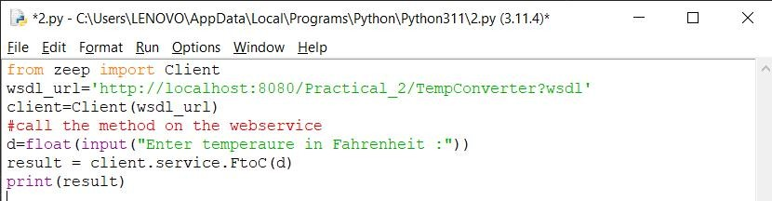

**4]**

**after**

**running**

**the**

**above**

**code**

**you**

**should**

**get**

**the**

**following**

**output:**

