**Practical - 4**

**Develop application to consume Google’s search / Google’s Map RESTful Web service.**

* Develop application to consume Google’s search / Google’s Map RESTful Web service.
* 1.First of all we need to create an Java Web Application with any name, let it be GoogleMap here using Netbeans IDE.
* 2.The code inside the input.jsp will be similar to this input.jsp Input.jsp

<%@page contentType="text/html" pageEncoding="UTF-8"%>

<!DOCTYPE html>

<html>

<head>

<meta http-equiv="Content-Type" content="text/html; charset=UTF-8">

<title>JSP Page</title>

</head>

<body>

<form action="index.jsp">

<pre>

Enter latitude:<input type="text" name="t1" />

Enter longitude:<input type="text" name="t2" />

<input type="submit" value="Show" /> </pre>

</form>

</body>

</html>

3. Before running ~~t~~he application we need the Google API key. The steps are shown here: - Visit Google APIs Console (https:~~/~~/console.developers.google.com, you have to login with your Google account).

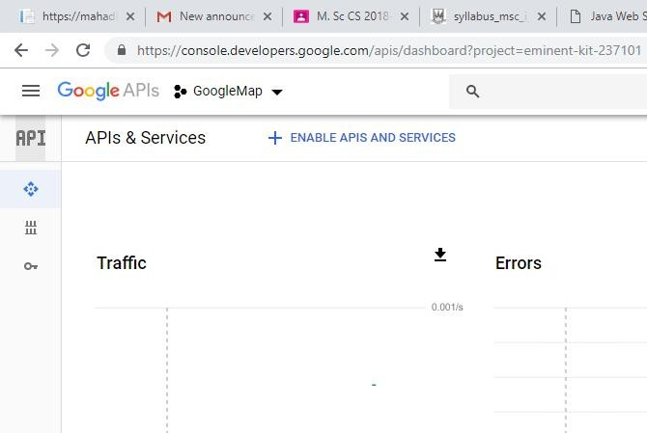

-

Create

a

new

API

Project.

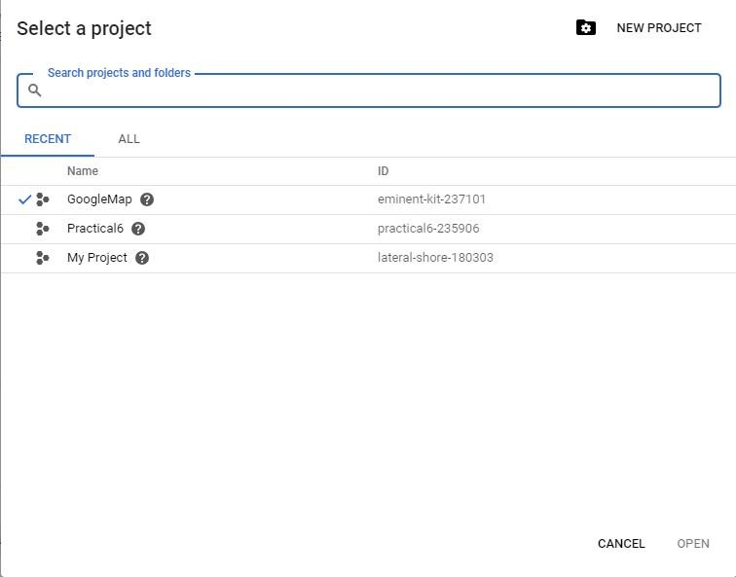

-

Enter

the

name

to

your

project.

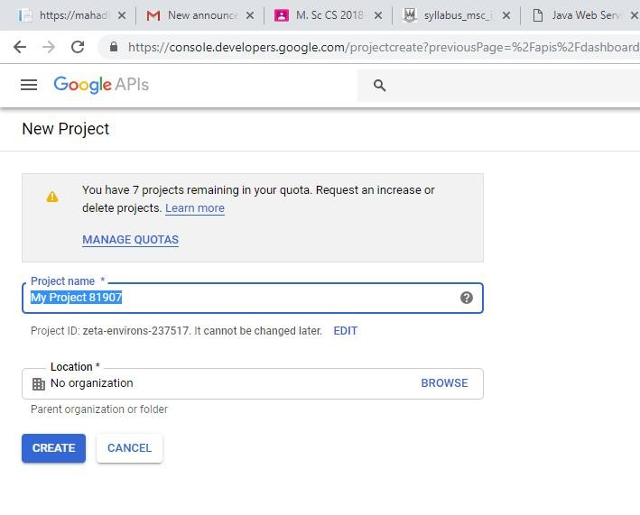

- Enable the Google Maps API V3.

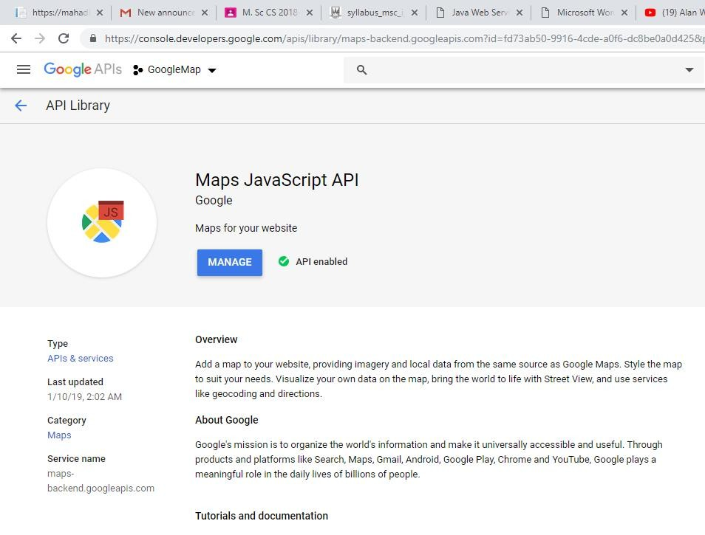

4.

Create

another

file

index.jsp

**Index.jsp**

<%@page contentType="text/html" pageEncoding="UTF-8"%>

<!DOCTYPE html>

<html>

<head>

<meta charset="UTF-8">

<title>Google Maps</title>

<style>

#map {

height: 400px;

width: 100%;

}

</style>

</head>

<body>

<%

double lati = Double.parseDouble(request.getParameter("t1"));

double longi = Double.parseDouble(request.getParameter("t2"));

%>

<h3>Google Maps</h3>

<div id="map"></div>

<script lang="javascript">

function initMap() {

var info = { lat: <%= lati %>, lng: <%= longi %> };

var map = new google.maps.Map(document.getElementById('map'), {

zoom: 4,

center: info

});

var marker = new google.maps.Marker({

position: info,

map: map

});

}

</script>

<script async defer src="https://maps.googleapis.com/maps/api/js?key=YOUR_API_KEY&callback=initMap"></script>

</body>

</html>

**Output**

**:-**

