**Practical - 5**

**Installation and Configuration of virtualization using KVM.**

# Steps to install Virtualization using KVM

To create a virtual machine first we need to ensure that virtualization is enabled on our system. It is mandatory to create virtual machines. There are multiple ways to check if virtualization is enabled,

# $ egrep -c ‘(vmx|svm)’ /proc/cpuinfo

The above command /proc/cpuinfo gives information about the processor. The output of the command will be a number. The output number 1 or more than that represents that virtualization is enabled, output 0 says you need to enable virtualization on your system.

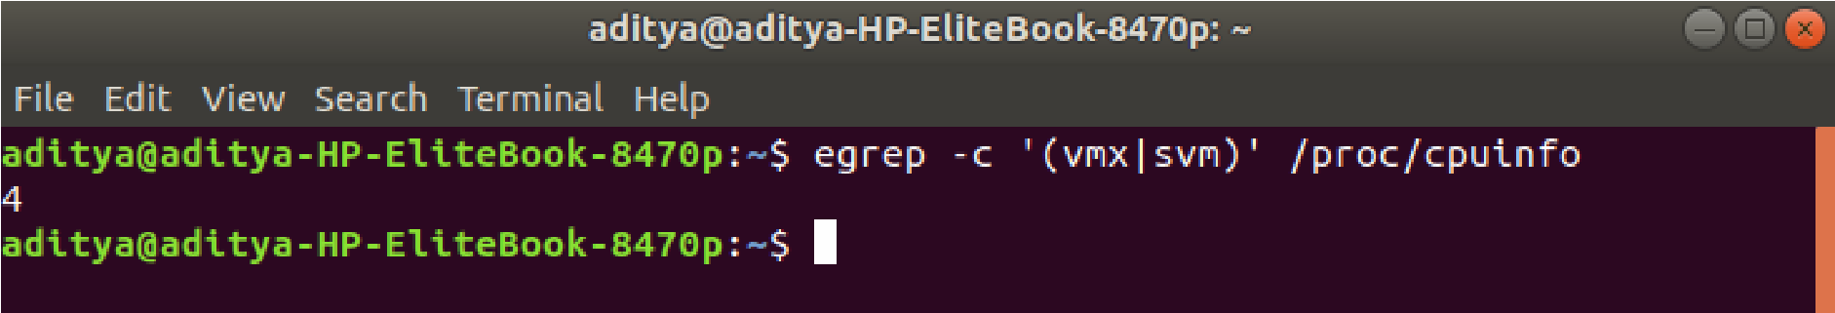

# Virtualization Inability $ lscpu | grep Virtualization

This command is used to check which type of virtualization your processor supports. If the system contains a CPU with Intel VT support, the above command will provide the following output

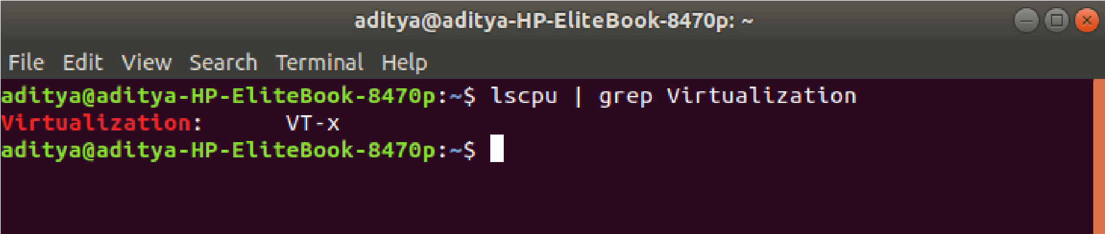

# Virtualization Type

Installing KVM on Ubuntu

$ sudo apt-get install virt-manager

Now we know our system is capable of creating and running virtual machines, it’s time to install tools which will create our virtual machines. To install KVM and other KVM dependencies such as virt-manager, bridge-utils enter command:

# $ sudo apt -y install bridge-utils cpu-checker libvirt-clients libvirt-daemon qemu qemu-kvm

1. bridge-utils: The bridge-utils package contains a utility needed to create and manage bridge devices. This is useful in setting up networks for a hosted virtual machine (VM).
2. cpu-checker: Outputs the specifications of CPU
3. libvirt-clients: a toolkit to manage virtualization platforms/clients and hypervisors
4. qemu: A program that can run the operating system of the machine on different machines
5. qemu-kvm: Runs process using KVM module

All dependencies are installed now run command its time to check if KVM ins installed successfully: *$ sudo kvm-ok*

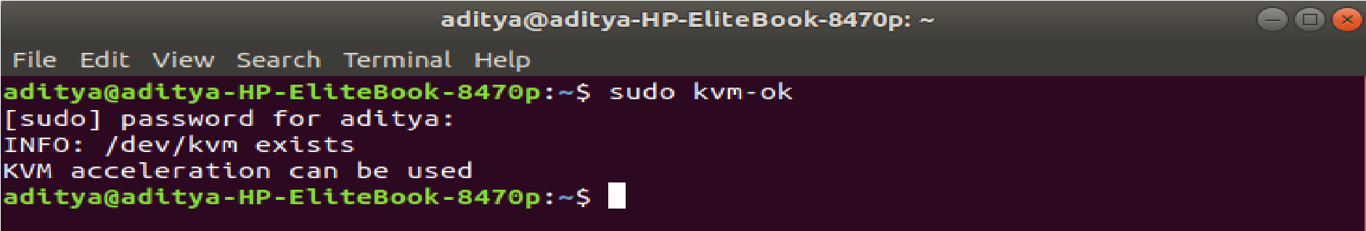

# Check if KVM is Installed properly

Also, we need to confirm if the virtualization daemon – libvritd-daemon – is running, to do so enter the command.

# $ sudo systemctl status libvirtd

If the output is not active: running you need to start daemon thread

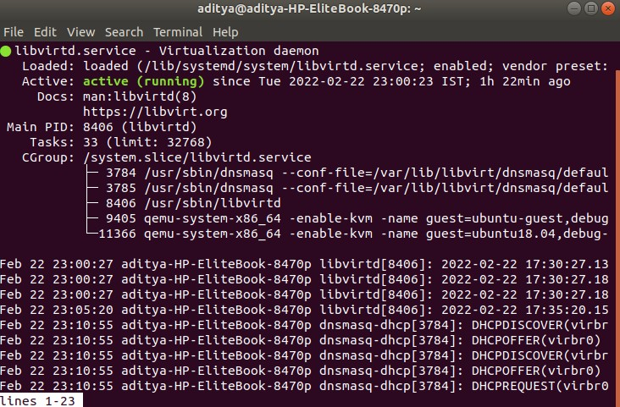

If the daemon thread is not running enter the following command to start the thread,

# $ sudo systemctl enable –now libvirtd

Adding a user to KVM

In this part, we are going to create a user for KVM. To prevent root user from using KVM and root user is only available when root user is a part of libvirt/libvirtd group. To add a new user to KVM, use the following command,

# sudo adduser [username] libvirtd

[username] enter the username of your choice if the output is

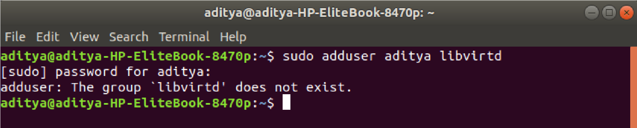

# Adding User to KVM

If your KVM is already a member of the non-root user and serves the same purpose as libvirtd group then you don’t need to add yourself to the group.

Creating Virtual Machine

There are two ways to create a virtual maclsne

1. Using the command line
2. Using the graphical interface

● **Create a Virtual Machine via Command Line**

virt-install is a command which is used to create virtual machines in Linux, following is the command which creates a VM.

# sudo virt-install –name=ubuntu-guest –os-variant=ubuntu20.04 –vcpu=2 –ram=2048 –graphics none –location=[local path to iso file] –network bridge:vibr0

The above command creates a Ubuntu virtual machine with version 20.04 and the name ubuntu-guest.

1. Name: specify the name of the virtual machine being created
2. vcpu: Number of virtual CPUs to configure for the guest.
3. Ram: Memory to allocate for guest instance in megabytes. According to your machine, you can specify the given memory of the VM.
4. Graphics spice: If no graphics option is specified, “virt-install” will default to ‘–graphics vnc’ if the display environment variable is set, otherwise ‘–graphics none’ is used.
5. Location: location of iso file on which virtual machine will be built. It can be the path to an ISO image, or to a CDROM device. It can also be a URL from which to fetch/access a minimal boot ISO image.
6. Network-bridge: Connect the guest to the host network, Connect to a bridge device in the host called “BRIDGE”.

**Create a Virtual machine using a graphical interface**

If you are not much familiar with the command line don’t worry there’s another way to create a virtual machine using a tool called virt-manager you can easily create virtual machines.

Steps to create VM using virt-manager,

**Step 1:** Launch virt-manager

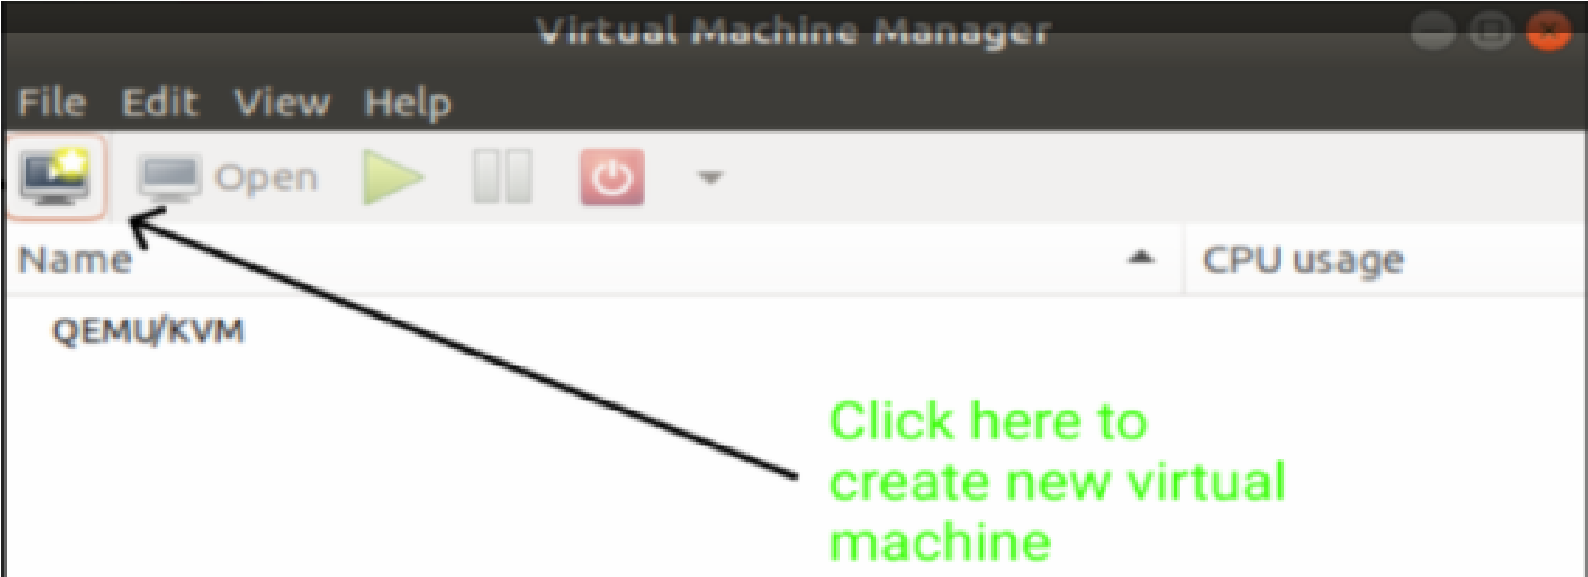

**Step 2:** Choose installation media it can be an iso file of OS, you can install from the network or can be a disk copy

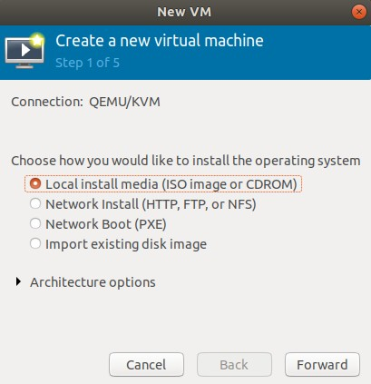

**Step 3:** Enter the path/URL of your file click next

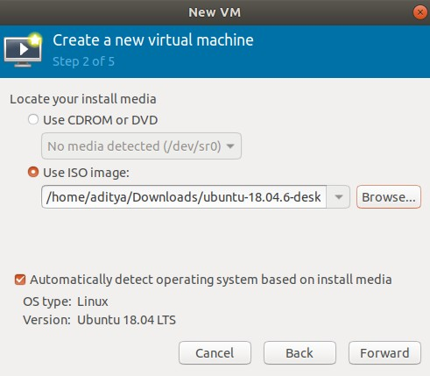

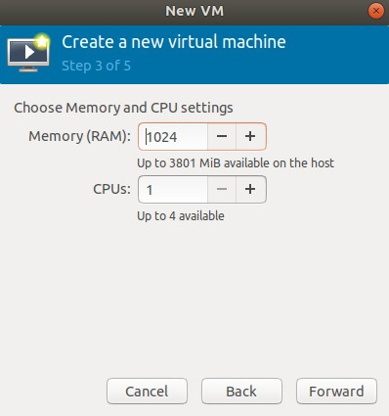**Step 4:** Enter memory and CPU requirements

**Step 5:** Enter required disk space

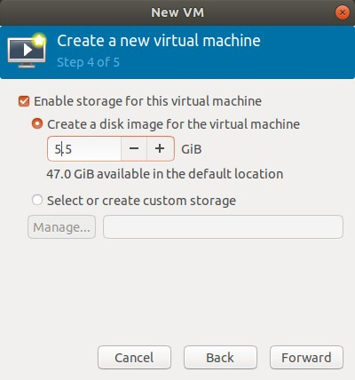

**Step 6**: Enter the name of VM and check specifications and hit the finish

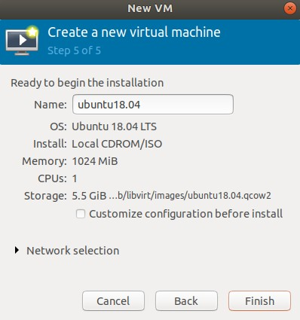

Now the installations should be completed and the virtual machine should start running.

**Conclusion:** Hence we have successfully installed and Configured virtualization using KVM.