**Practical - 7**

**Implement FOSS-Cloud Functionality VSI (Virtual Server Infrastructure) Infrastructure as a Service (IaaS), Creating Virtual Machine or Storage**

**Steps:**

1. Start VMWARE workstation player 15 → select Open virtual machine then→ Browse a foss cloud iso file→ then select Operating System: Other Version: Other, Name: FOSS.

2. Then click on edit virtual machine and select Processor: 2 or 3, Memory: expand to 165 GM.

3. Once the foss Cloud is launched select “Foss-Cloud installer :default boot options” and press Enter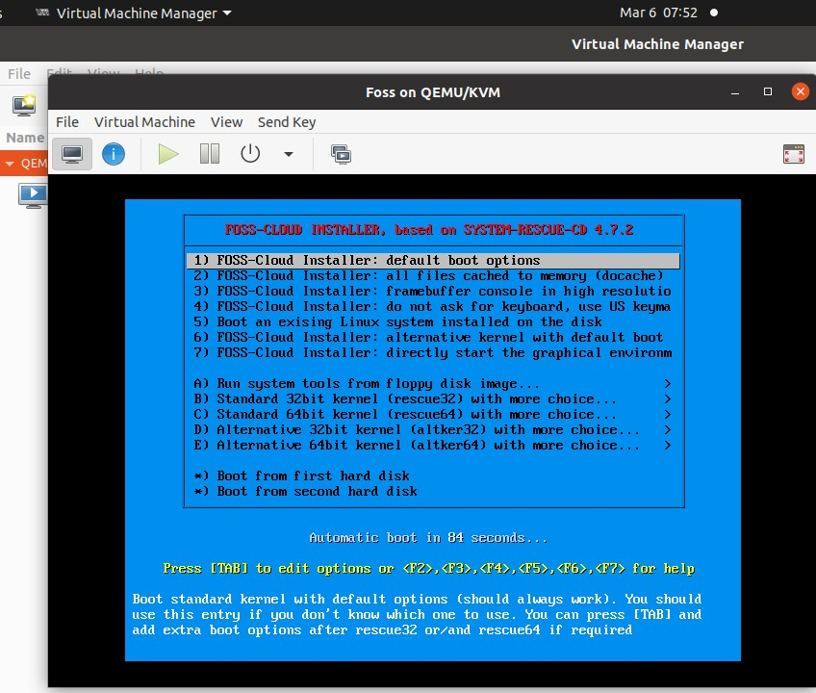

4.Reboot your system and select foss cloud

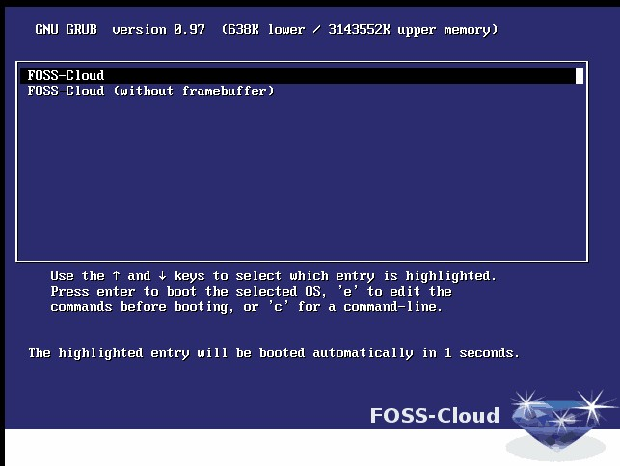

5.Types yes to start the installation

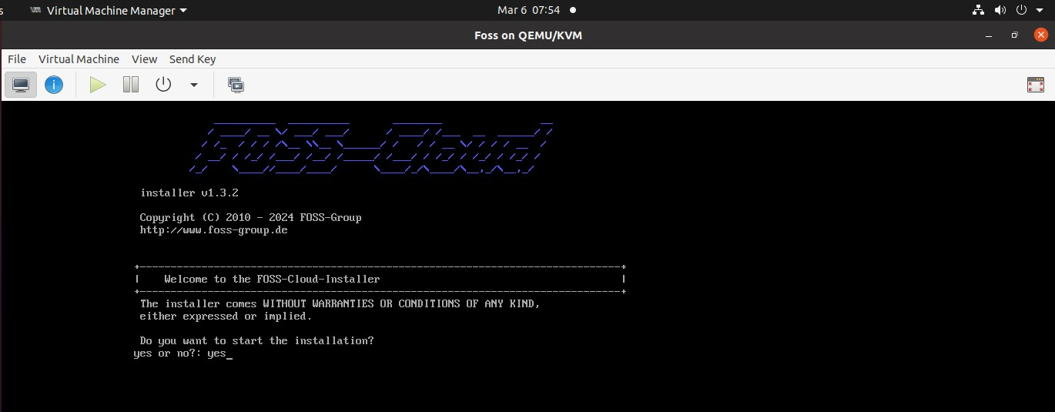

6.Select “Demo System” and press Enter

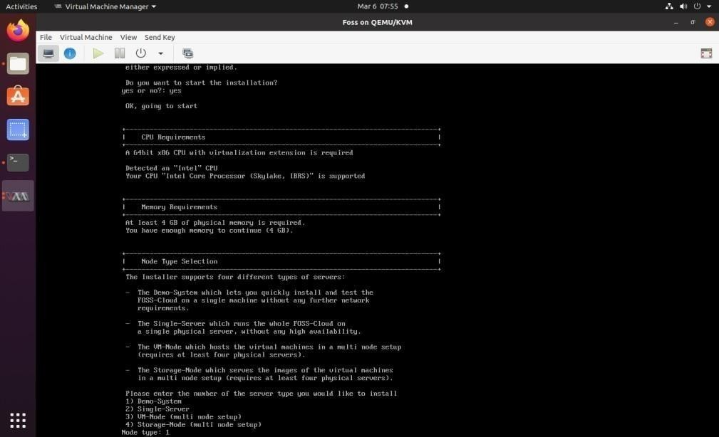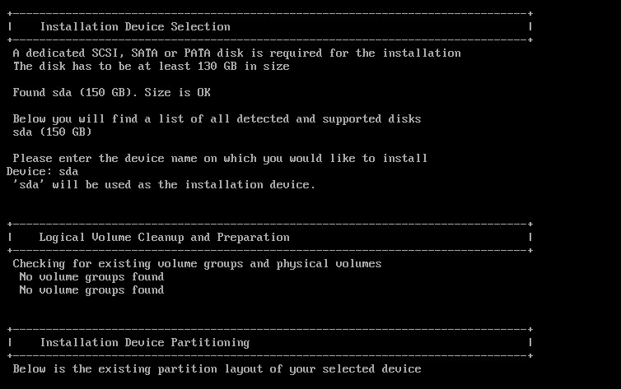

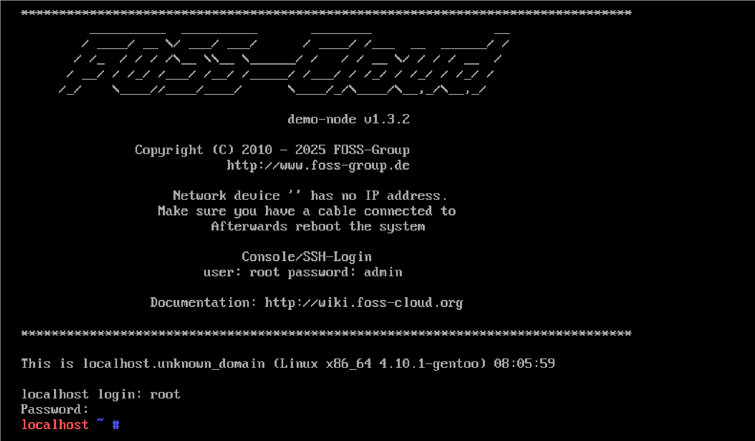

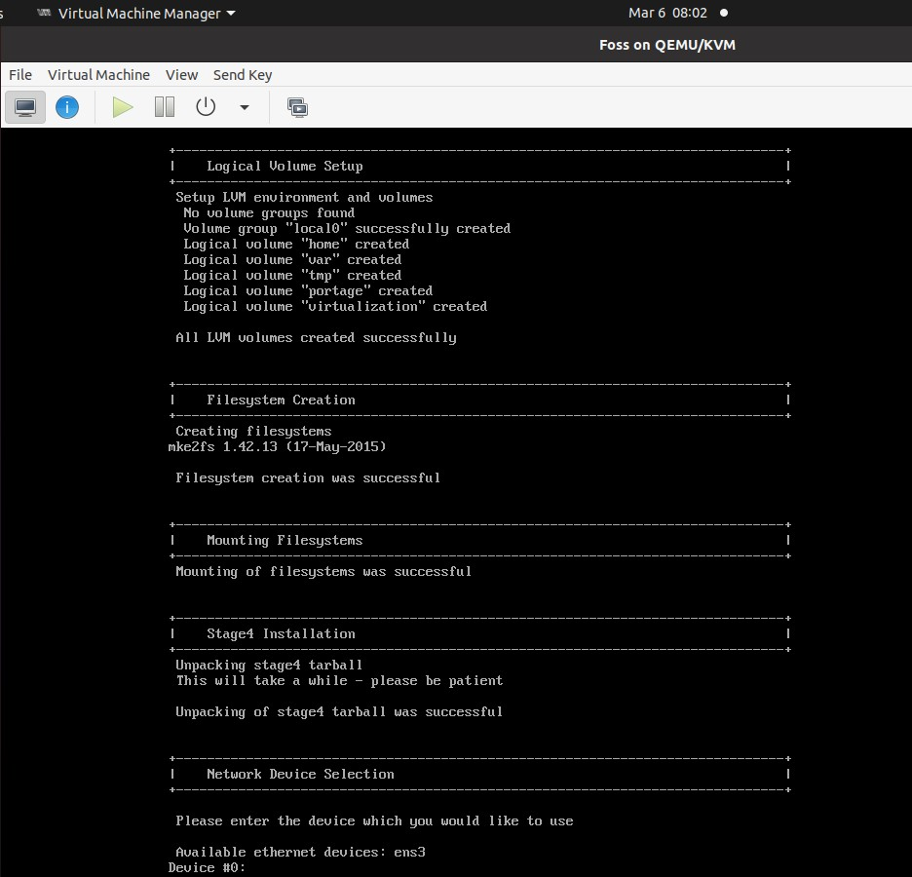

7.Enter

the

Device

name

as

“sda”

and

press

enter

8.Put credential of foss cloud and start foss cloud

9. Then Execute below mention command:- Fc-node-configuration –n demo-system –password admin

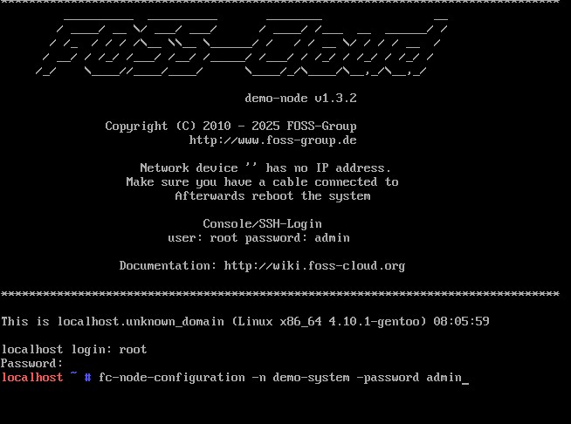

10.Then type ifconfig command to get the ip address

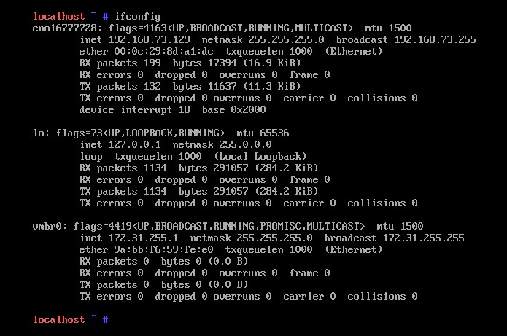

11.Then go to any web browser in windows OS and type the IP Address → FOSS cloud web page will open and you will find login details.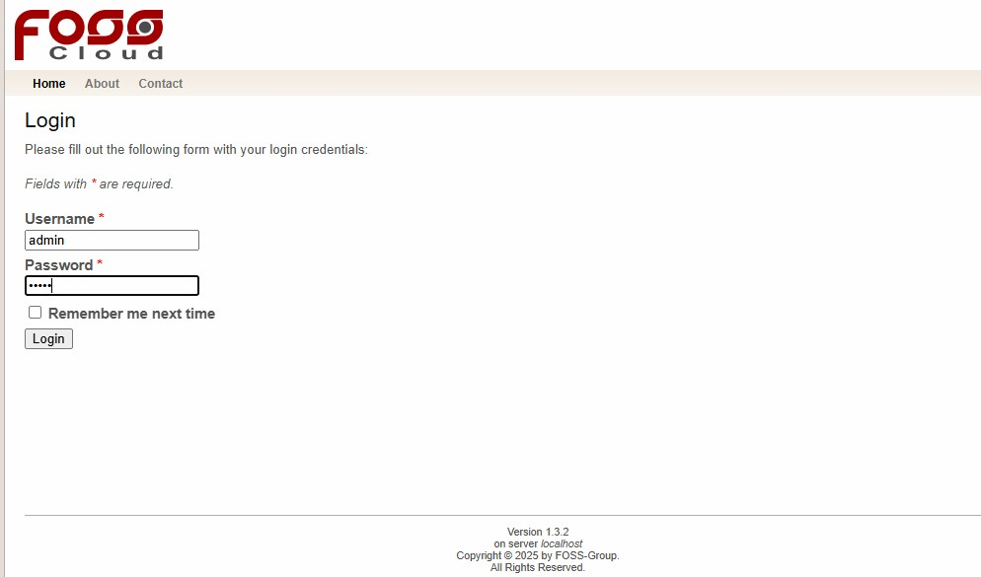

12. After putting the login details you will get the below mention page

