**Practical - 9**

**Using AWS Flow Framework develop application that includes a simple workflow. Workflow calls an activity to print hello world to the console. It must define the basic usage of AWS Flow Framework, including defining contracts, implementation of activities and workflow coordination logic and worker programs to host them.**

**Step 1: Open Terminal and Update and Upgrade your system by command sudo apt-get update && sudo apt-get upgrade**

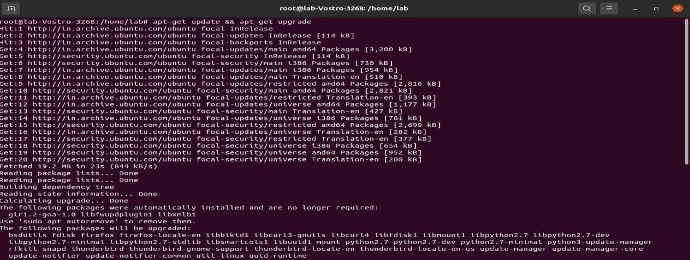

**Step 2: Download awscliv2.zip with command**

**curl "https://awscli.amazonaws.com/awscli-exe-linux-x86_64.zip" -o "awscliv2.zip"**

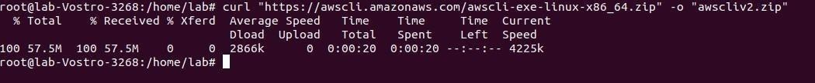

**Step 3: Download awscliv2.sig file with command curl -o awscliv2.sig https://awscli.amazonaws.com/awscli-exe-linux-x86_64.zip.sig**

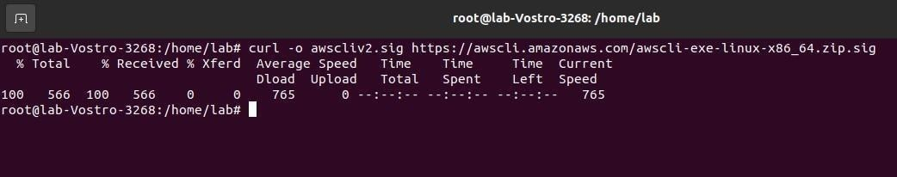

**Step 4: unzip awscliv2.zip with command unzip awscliv2.zip**

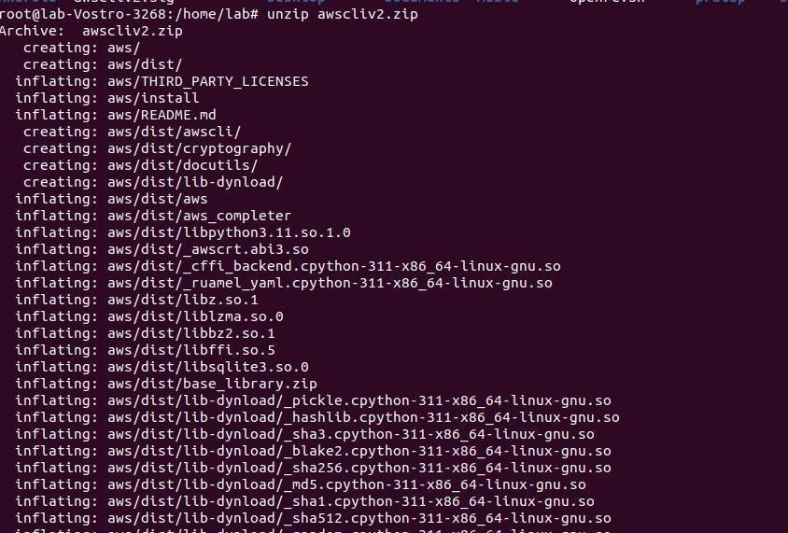

**Step 5: Run command sudo ./aws/install**



**Step 6: Type command pip3 install aws-sam-cli**

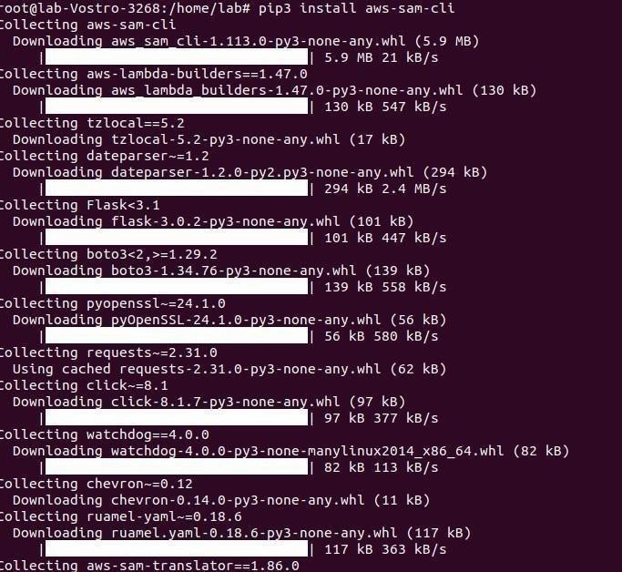

**Step 7: Type command sam init in terminal to launch Sam**

**CLISelect 1st option to use AWS Quick Ttart Templates**

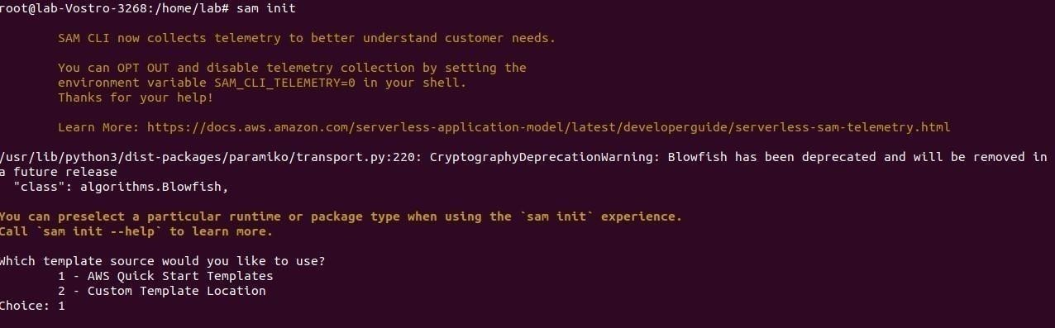

**Step 8: Select Template no.1 Hello World Example**

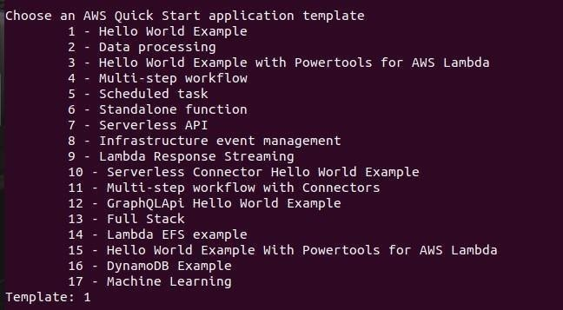

**Step 9: Type “N” if it ask to use most popular runtime and package type**

**Open new terminal by pressing ctrl+shift+T and check for python version by command python –version**

**Select the option according to your python version in my case its option 19- python 3.11**

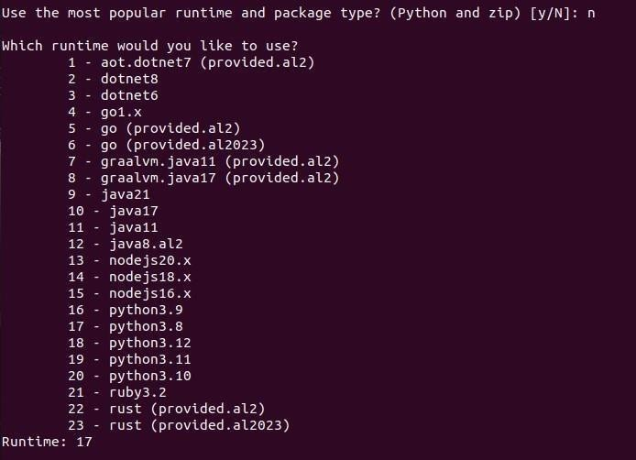

**Step 10: Select package type as Zip**

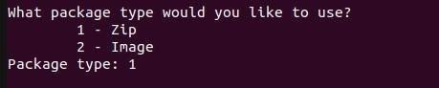

**Step 11: Now choose Yes option everytime it ask .**

**Give project name as per your preference in my case its sam-app-test**

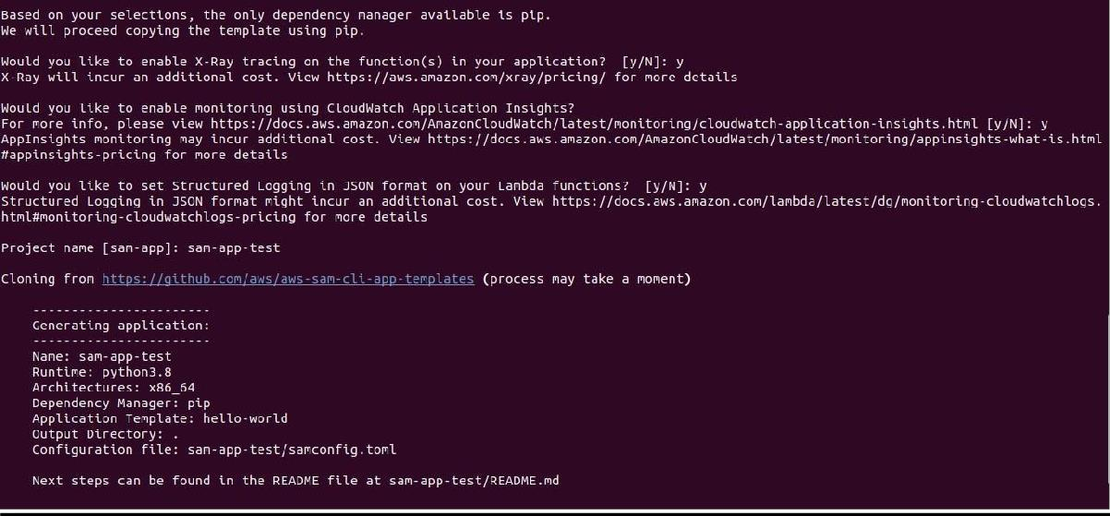

**Step 12: Now one folder will be created by your provided project name go into that folder by command cd (folder name)**

**After entering the project folder we will invoke the HelloWorldFunction by using commandsam local invoke „HelloWorldFunction‟**

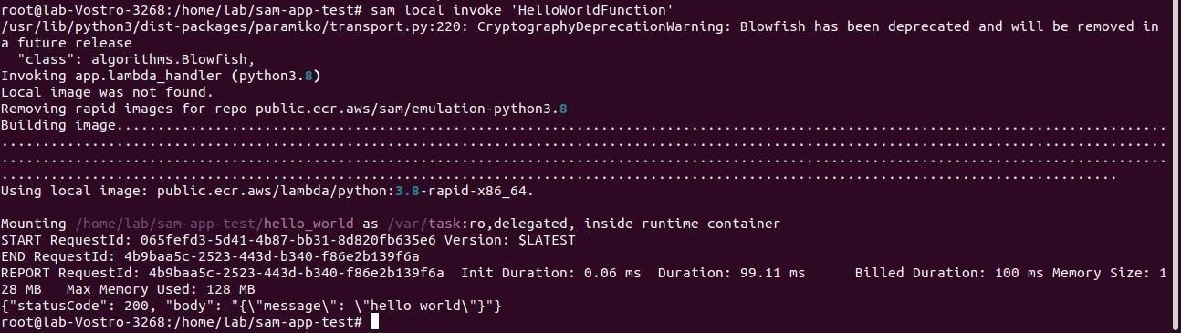

**It should give you StatusCode:200**

**Use command sudo snap install docker if docker error occurs.**

**Step 13: Type command sam local start-api this will give you URL open it in any browser.**

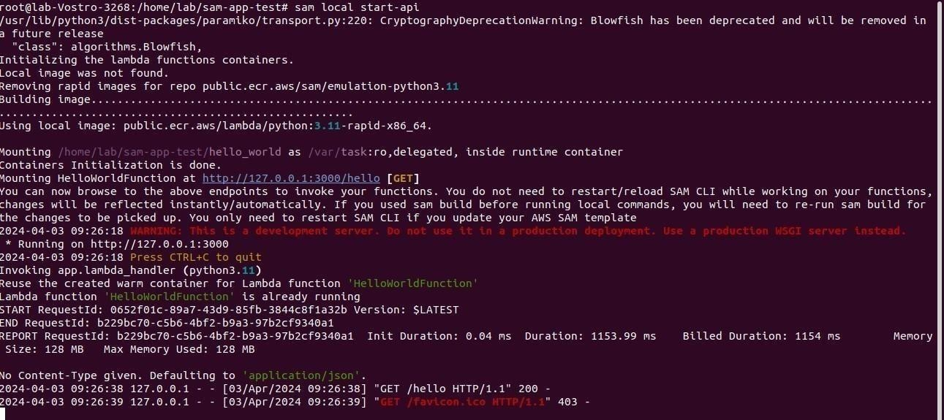

**Output:**

