Output
Below are the outputs generated from modifying the input datasets and functional code changes. Some columns are temporary values or copied from pre-existing GHI datasets.
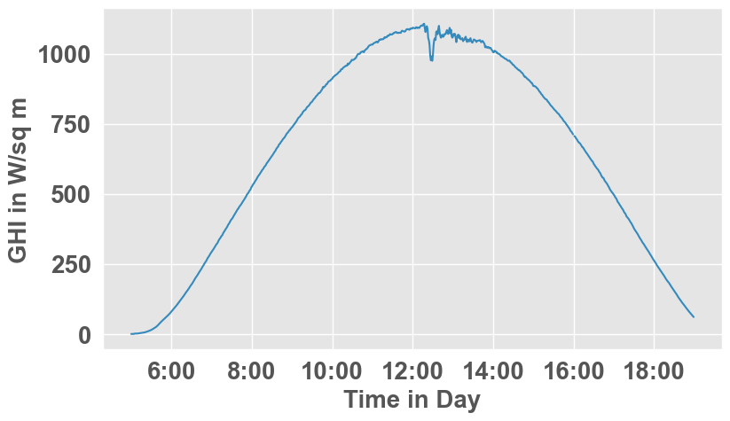

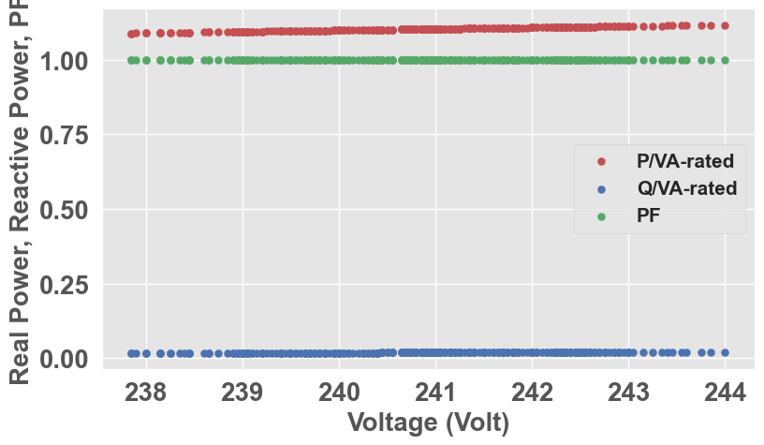
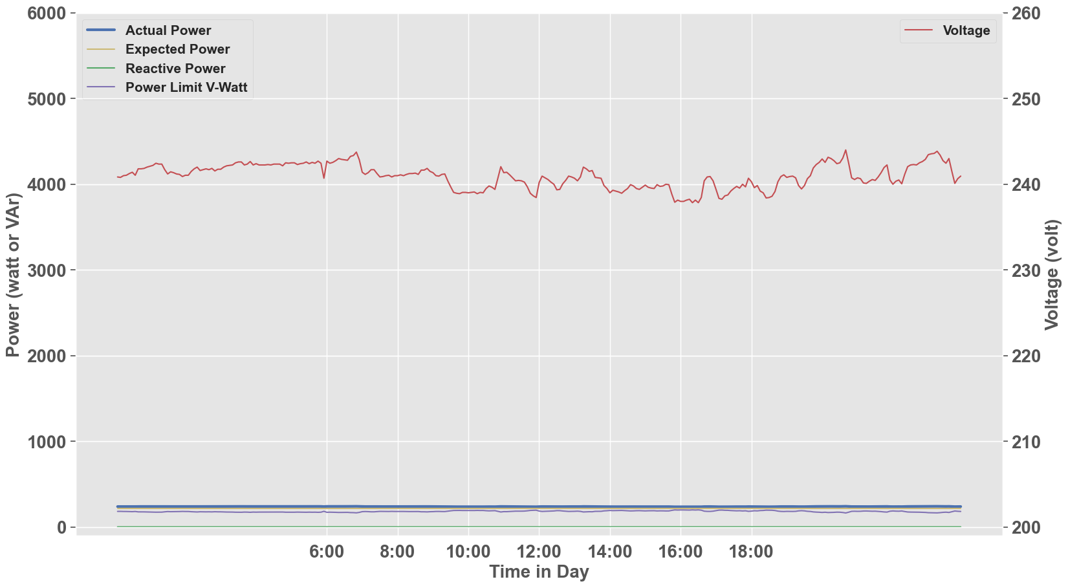

Changes to Input Dataset

details_site_id.csv
- added sample ac_cap_w, dc_cap_w to the end as 'inverter_ac_rating_kw'*1000 and 'subarray_dc_rating_kw'*1000 respectively
- changed 'edp_site_id' to 'site_id'

EDP data -> data_sample_1.csv
- Selected only ‘pv_site_net’ data points.
- changed 'edp_site_id' to 'site_id'
- added 'c_id', identical to 'site_id'
- Added 'reactive power' which is a replica of 'power' for now
- Added 'energy' to be 'real_energy'*1000
- Added 'duration' to be 300 (5 mins)
- Added 'voltage' to 'voltage'

ghi_sample_1
- Re-used existing ghi_sample_1.csv from sample datasets
- Changed timestamp and year to be 2023 to align with our current data points

Issues
- Code is sensitive to the format of timestamps, will break if ALL input datasets don’t leverage static datetime formats. See polyfit Line 102-104

timestamp = timestamp_complete
timestamp = timestamp.strftime('%Y-%m-%d %H:%M:%S')
timestamp = self.get_datetime_list(timestamp)

Error Stack trace
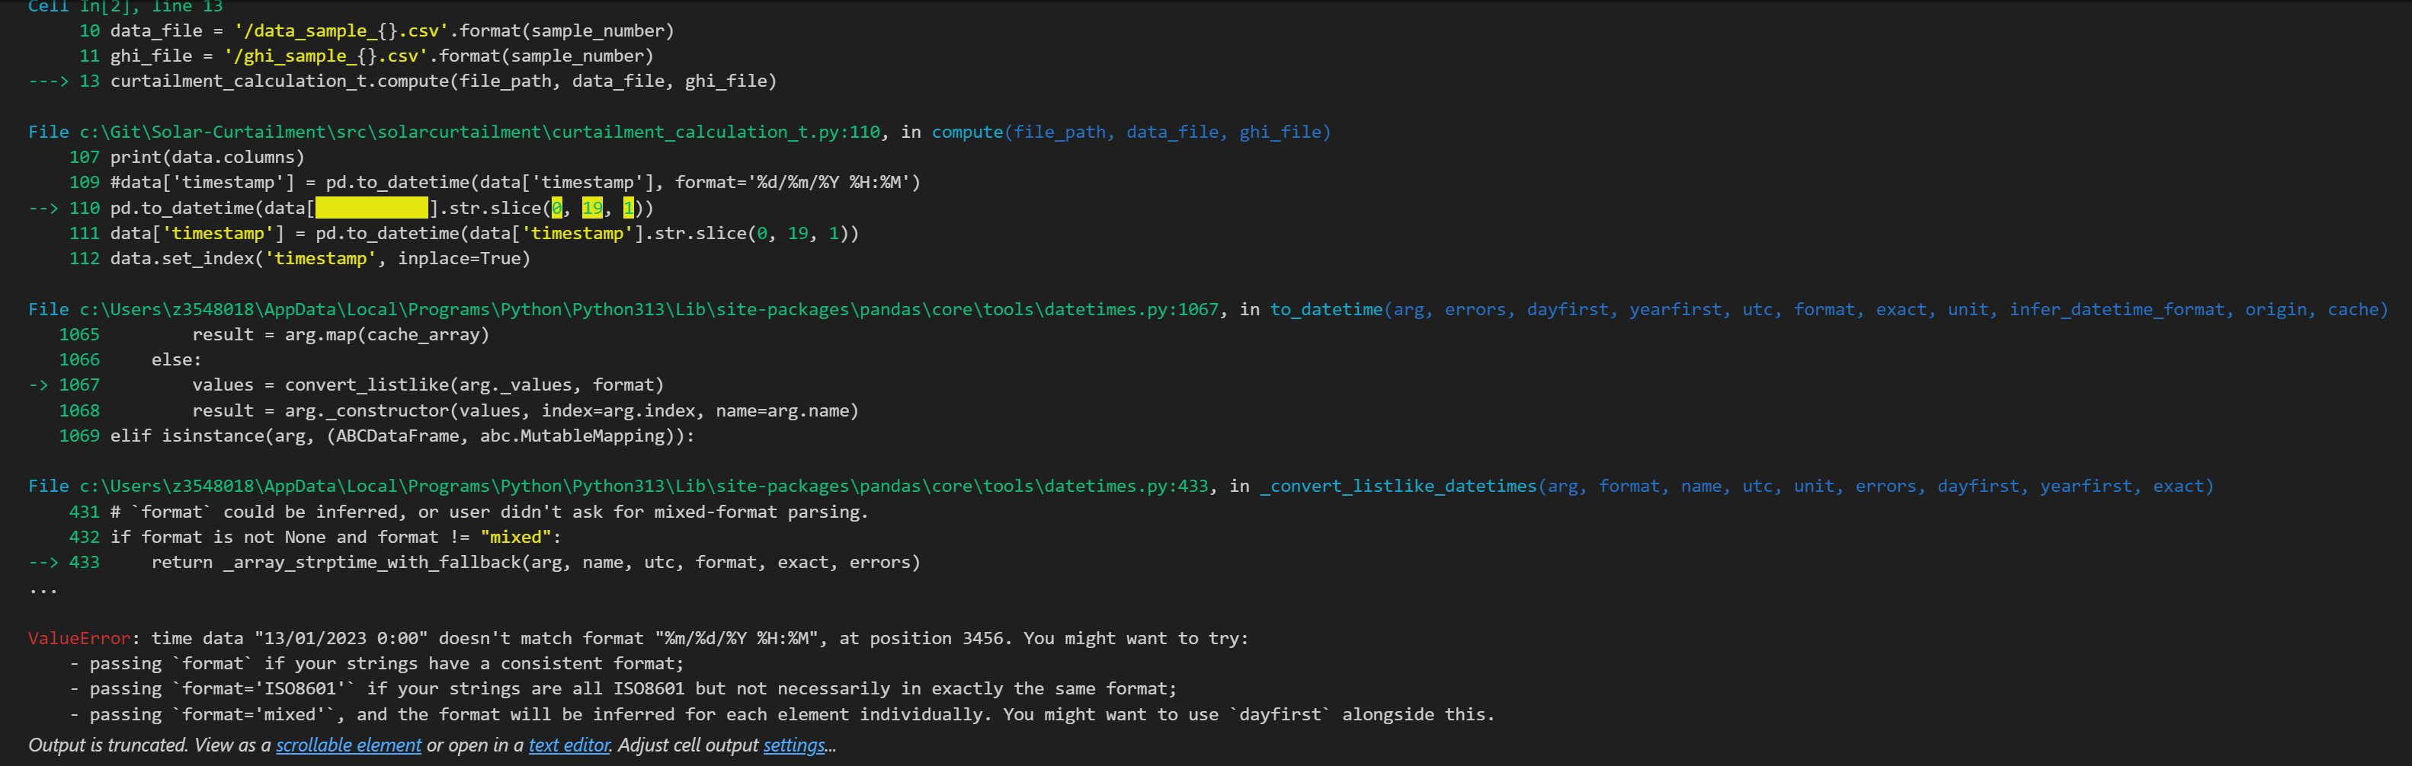
Functional Code changes: curtailment_calculation line 109 - 112
data['timestamp'] = pd.to_datetime(data['timestamp'], format='%d/%m/%Y %H:%M')
#pd.to_datetime(data['timestamp'].str.slice(0, 19, 1))
#data['timestamp'] = pd.to_datetime(data['timestamp'].str.slice(0, 19, 1))
data.set_index('timestamp', inplace=True)

- Code utilises timestamp as an indexing mechanism – Timestamps will need to be unique or this will cause conflicts within the code. This is especially problematic with EDP data with different circuit types – see polyfit 198-202

for i in range(1, n):
print("time array[i]")
print(time_array[i])
g = abs(math.degrees(math.atan((power_array[i] - power_array[i - 1]) / (
self.get_single_date_time(time_array[i]) - self.get_single_date_time(time_array[i - 1])))))

Error Stack trace
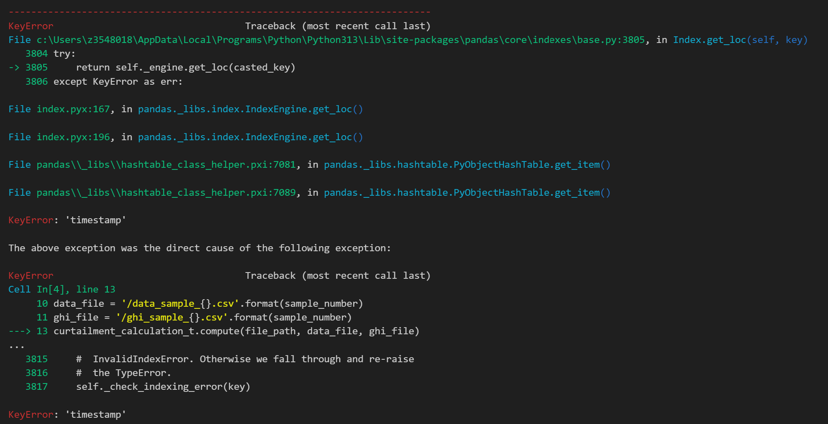

- Code creates duplicate columns and renames existing ones. This will cause issues and dependencies on naming conventions of input data sets. This is a repeated pattern throughout the code where arrays and lists are rewritten or completely reparsed with new values into existing columns. Code becomes hard to manage and understand when values of dataframes keep changing – vvar_curt line 285
circuit_day_data.rename(columns = {'timestamp':'ts'}, inplace = False)
circuit_day_data['ts'] = circuit_day_data['timestamp']

Code Changes: vwatt_curt lines 241-245
suspect_data.loc[buffer_high_filter, 'power_limit_upper'] = suspect_data['power_limit_vw'] + BUFFER_HIGH_VAL
suspect_data.loc[buffer_high_filter, 'power_limit_lower'] = suspect_data['power_limit_vw'] - BUFFER_HIGH_VAL

suspect_data.loc[buffer_low_filter, 'power_limit_upper'] = suspect_data['power_limit_vw'] + BUFFER_LOW_VAL
suspect_data.loc[buffer_low_filter, 'power_limit_lower'] = suspect_data['power_limit_vw'] - BUFFER_LOW_VAL

- Code has certain thresholds it checks and will notably break if input datasets do not meet this threshold. See vvar_curt line 299-300 we had to change power from 300 to 100
Stack Error
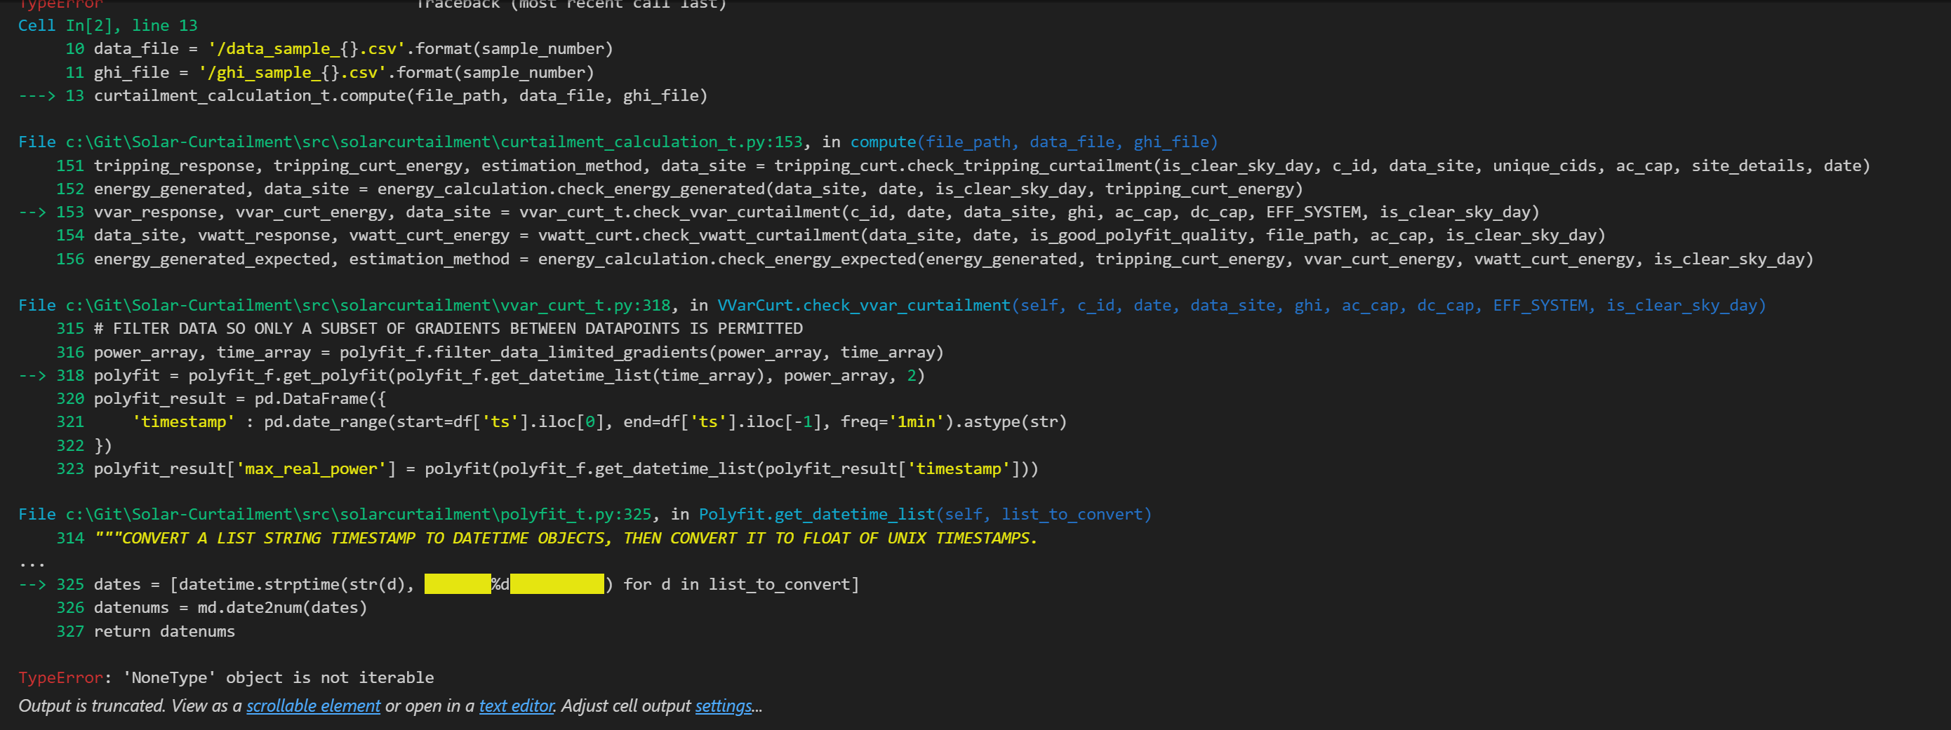
Code changes: vvar_curt line 300
# Set from 300 to 100
df = df.loc[df['power'] > 100]
- Thresholds and limits are embedded within individual functions. This makes it difficult to track, identify and debug – will need to move variables to centralized/defined areas to pass into functions. See variables in vwatt_curt, vvar_curt and polyfit

#step 4. If the percentage from the previous step is higher than certain limit, we say it shows VWatt response.
PERCENTAGE_THRESHOLD = 84
COUNT_THRESHOLD = 30 #Tim uses 150 for a month data, where a month usually consist of around 5 clear sky days.

- Classes and functions are interlocked and dependent on each other. There have been stack traces going as far as curtailment calculation -> vvar_curt function -> polyfit function -> vwatt_curt function
Stack Trace Error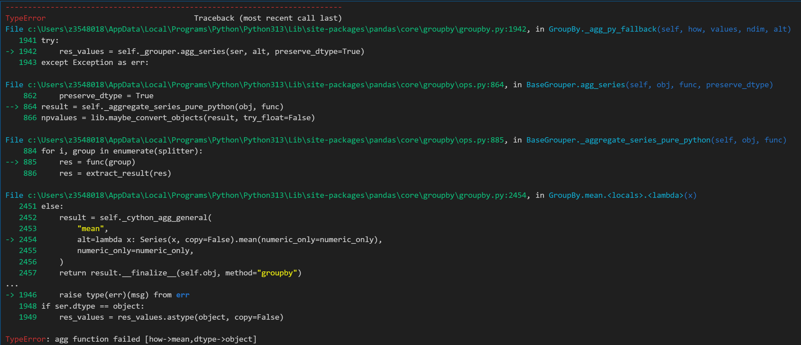

Proposed Rework/Rebuild Strategy
Currently the Solar Curtailment code is monolithic with intertwined functions that are dependent on each other. Variables are hardcoded in various places and unknown of their intent.
- Separate ALL data processing tasks before the functions are executed – Decouple data processing and functionality of the code. This will also decouple the complexity of the code
- Refactor operational tasks to the Juypter workbook itself rather than inline in-line functions. This will provide us with a platform to individually execute and debug each step along the way and allow us to understand the outputs of each step
- Keep the functions as purely computational/logical calculations. Reduce the complexity of each monolithic function and break inputs/outputs into Juypter tasks.
- Generate outputs/graphs where possible as we complete each task. This may reveal interesting trends/outliers as well as help in debugging and triaging processes.
