**Team name:**

Invincible

**Team members:**

Junkai Huang

Junnan Chen

Yuan Gao

**Scope**

Based on geographic information and latest job data published online, this data mashup application is designed to show job distribution in different cities and industries of Australia and United Kingdom. With further processing raw data, the application will also demonstrate the relationship between industry and occupations as well as the relationship between industry and intensity of work (weekly work hours). Through comparison, users can get an overall and intuitive understanding in labor force markets of these two countries. Moreover, it provides a series of interactive operation for users to focus on what he/she is interested in.

**Resources**

Datasets

[UK job datasets(from reed.uk)](https://www.kaggle.com/jobspikr/50000-job-board-record-from-reed-uk/data)

[Australia job dataset(from seek.au)](https://data.world/promptcloud/30000-job-postings-from-seek-australia)

[Mean weekly work hours of UK and AU](http://www.ilo.org/ilostat/faces/oracle/webcenter/portalapp/pagehierarchy/Page27.jspx;ILOSTATCOOKIE=lexdKxYC_OJPp5edWhD6BIvFl4AE_-xXJCaZjb03vgKBS5HwEsl5!2060453922?indicator=HOW_XEES_SEX_OCU_NB&subject=HOW&datasetCode=A&collectionCode=YI&_adf.ctrl-state=11yzna3e_83&_afrLoop=344782896298508&_afrWindowMode=0&_afrWindowId=null#!%40%40%3Findicator%3DHOW_XEES_SEX_OCU_NB%26_afrWindowId%3Dnull%26subject%3DHOW%26_afrLoop%3D344782896298508%26datasetCode%3DA%26collectionCode%3DYI%26_afrWindowMode%3D0%26_adf.ctrl-state%3Dzz742t9az_4)

APIs

Visualization API: Echarts

<https://ecomfe.github.io/echarts-doc/public/en/index.html>

Data Collection API: Reed APIs

<https://www.reed.co.uk/developers/Jobseeker>

Map API: Google Maps

<https://cloud.google.com/maps-platform/>

Code Repository

GitHub

<https://github.com/UNSWCOMP9321>

**Design architecture and components**

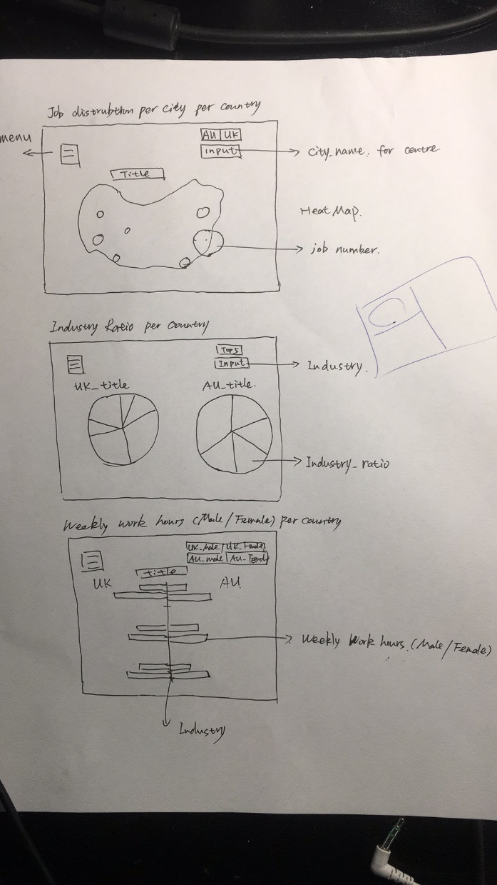

Heat Map: A heat map is used to show the number of occupation in different regions and the main industry in this area.

Pie chart: Pie charts represents the industry ratio due to job numbers in the two countries.

Bar chart: A bar chart shows the different weekly work hours in some major subjects of United Kingdom and Australia.

**Framework**

FrontEnd: Vue + JQuery

BackEnd: Flask

Database: MySQL

FrontEnd requests Json from BackEnd and BackEnd querys data from Database

**Teamwork**

Junkai Huang: Frontend framework and frontend development

Junnan Chen: Database related, data clean and supported functions

Yuan Gao: Backend development, routers and apis

After above work is done, all are put into frontend developing.