Tests
Bots:
See ‘test_bots.py’. To execute from root, enter the command `python -m pytest .\tests\test_bots.py`.

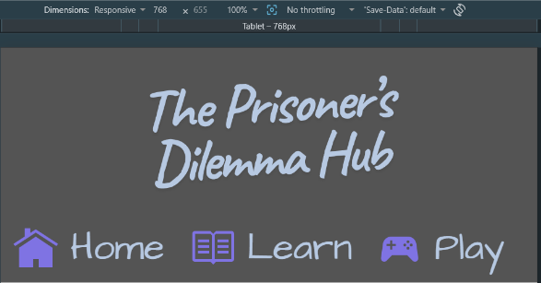
Version 1:
Testcase | Result | Screenshot
Header/Footer:
Header has 4 links – 3 nav links and the logo which lead to the correct pages.  Header displays correctly on all devices.  Footer has 4 main links – 3 nav and the logo leading to the correct pages. Has an additional 9 links under Navigation and Resources which work correctly.  Footer displays correctly on all devices.  Learn page content displays correctly on all devices.  Play content displays correctly on all pages.  Tables display correct scores.  Correct explanations are given. Strategies are revealed on games completion.  Home content displays correctly on all devices. | Passes  Passes  Everything else works but the logo in the footer does not link to the home page.  Links under the navigation are misaligned to the left, otherwise pass.  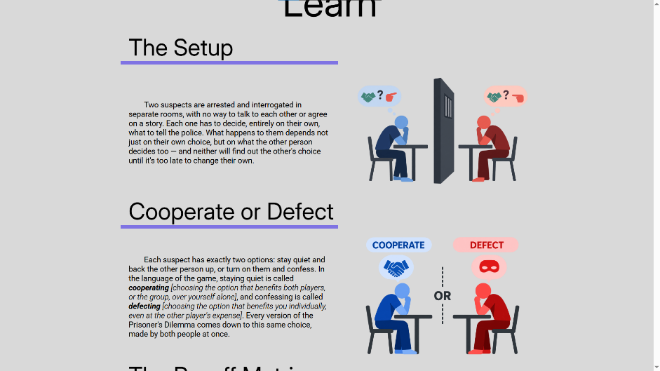  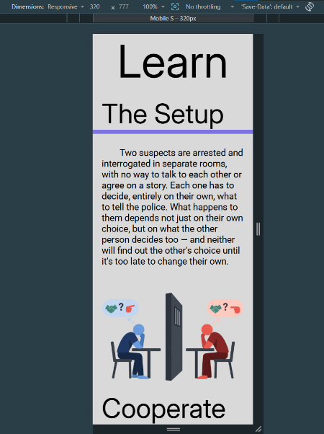  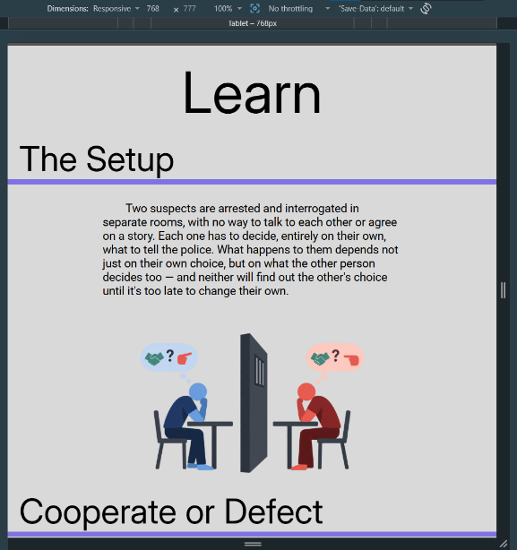  Passes  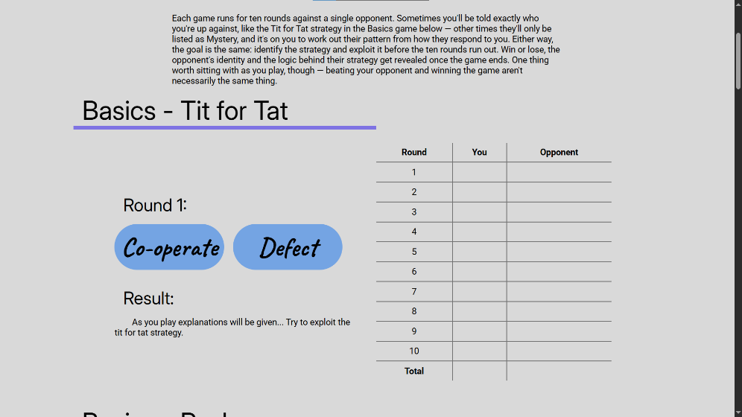  Passes on laptop, fails tablet and phone.  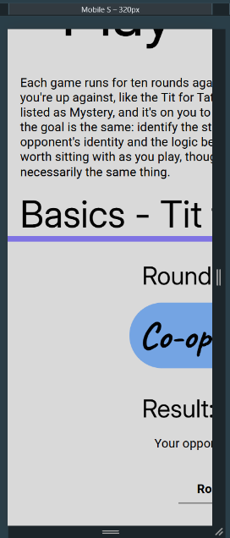  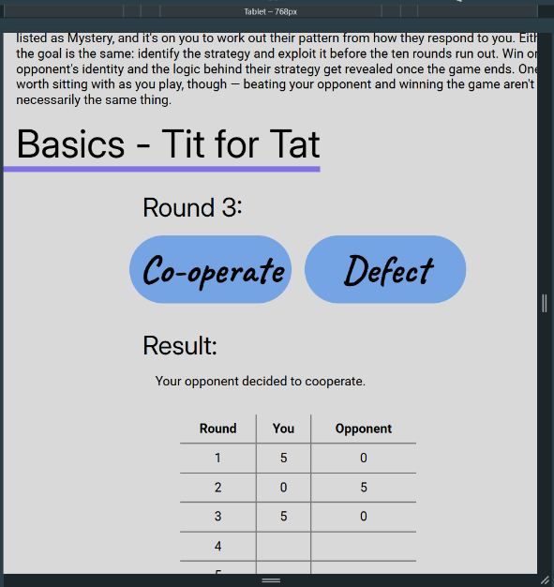  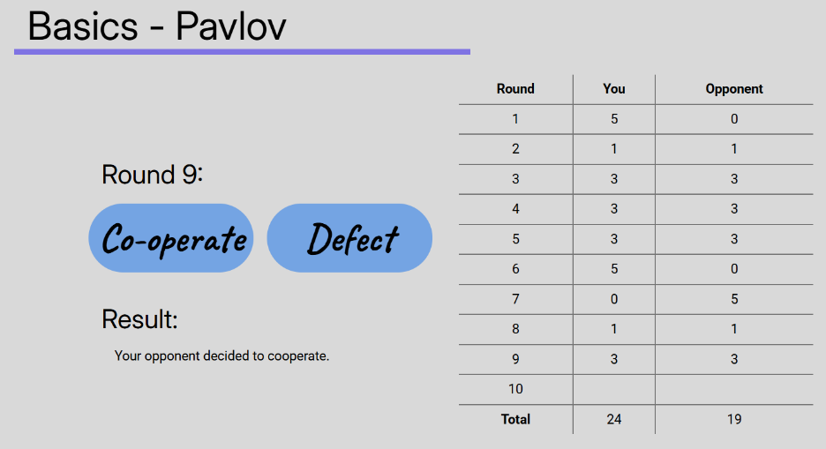  Pass  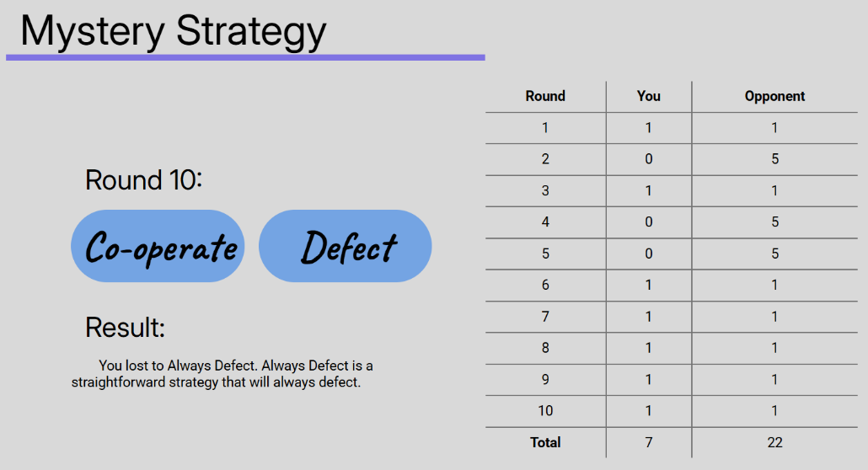  Pass  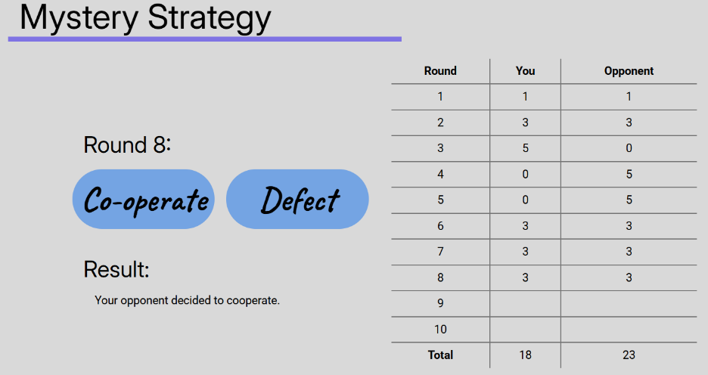  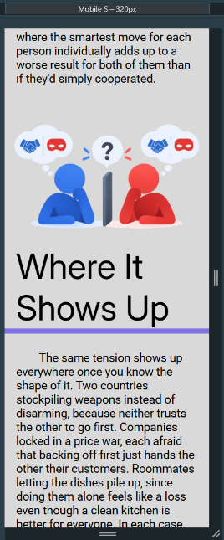  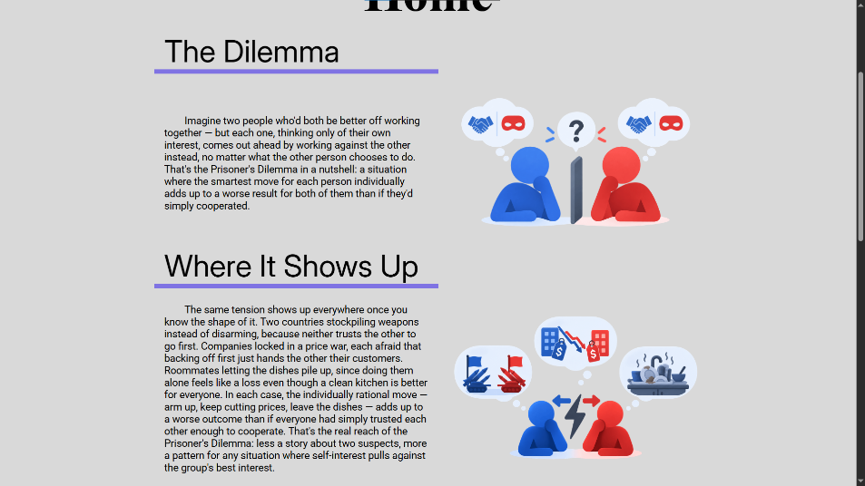  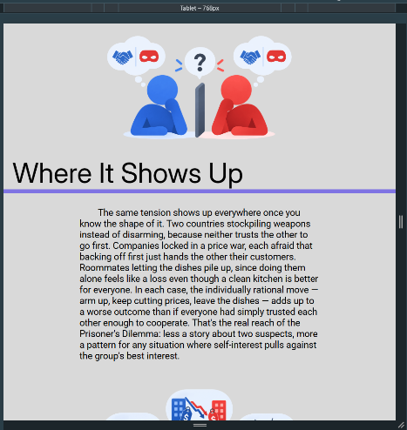  Pass | 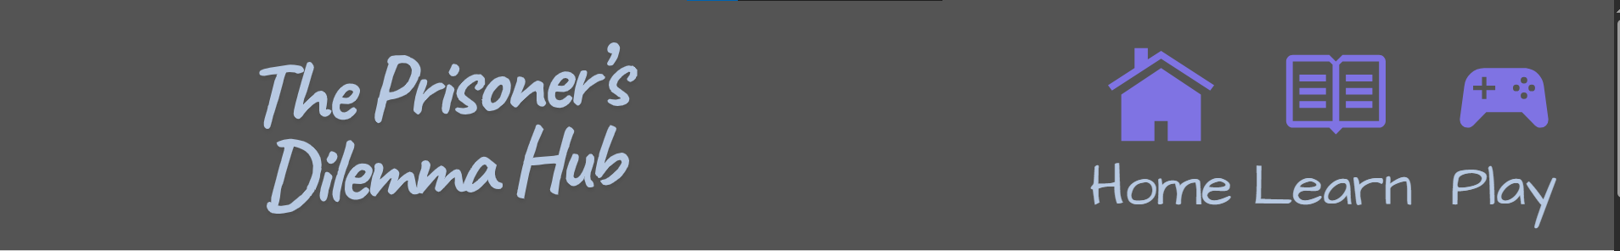  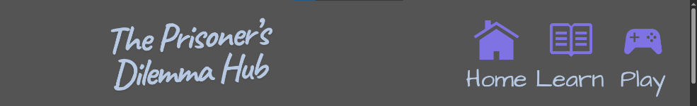  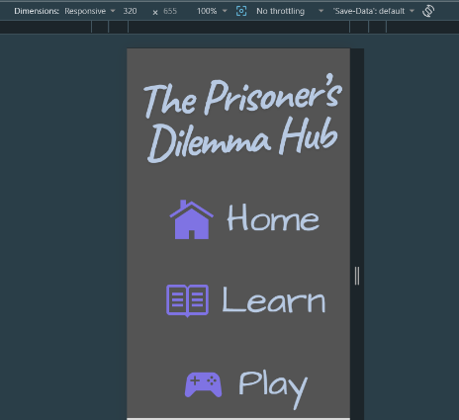  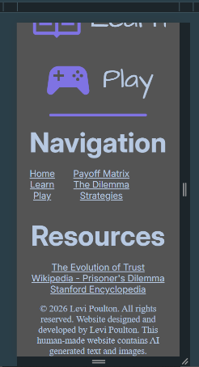  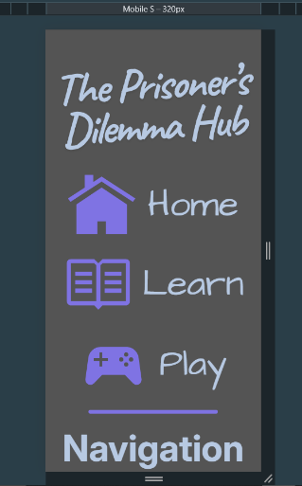  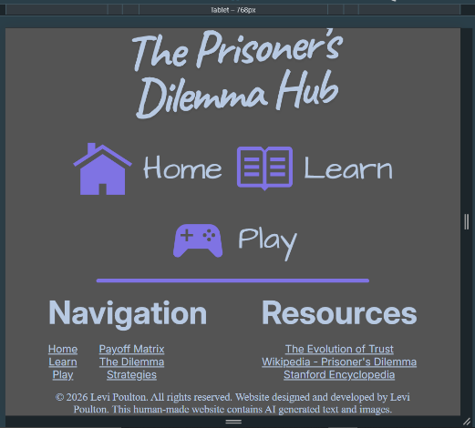  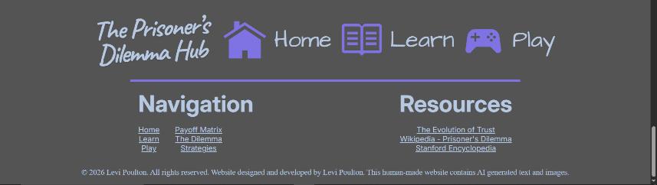
Solutions to Version 1 Fails:
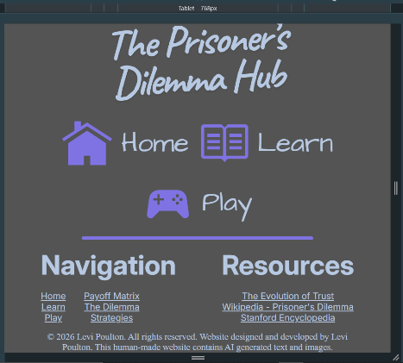
Misaligned links:
Before:
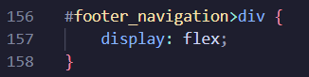

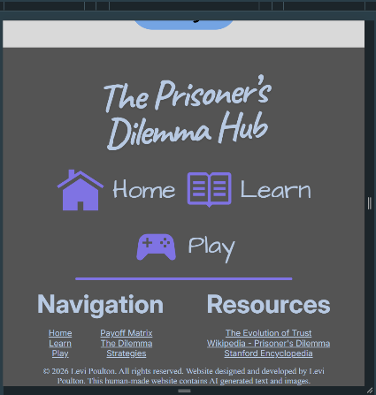
After:
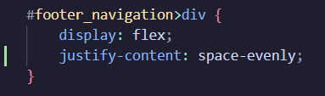

Footer logo link to home:
Before:
No link.
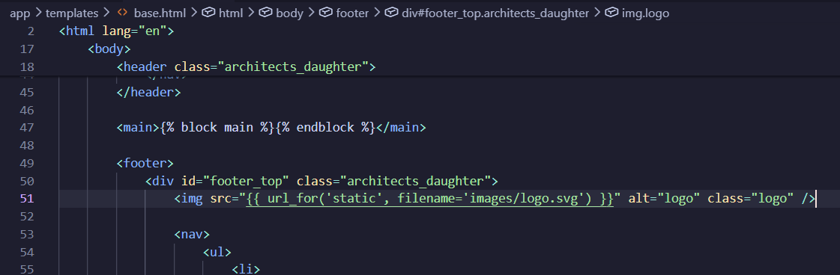
After:
Link works.
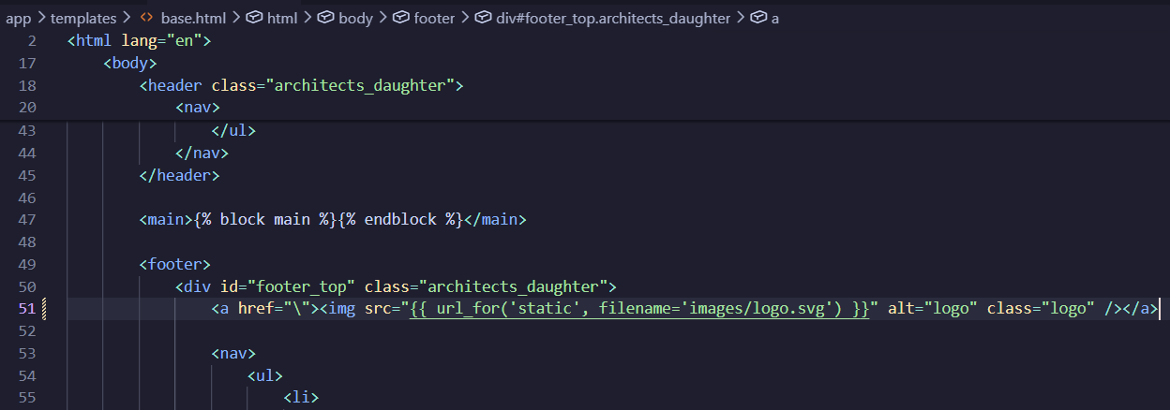

Content extending out of the play page on tablet and mobile:
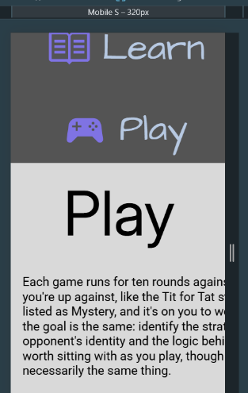
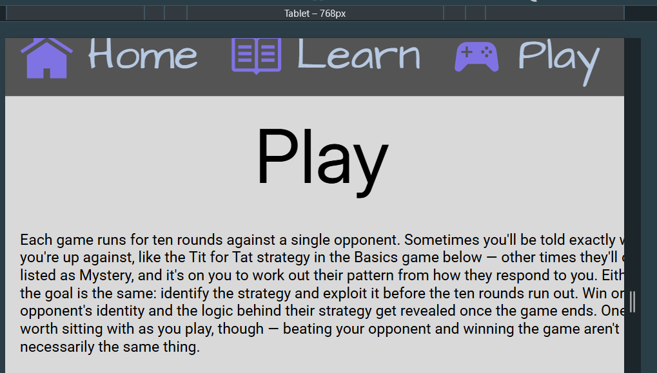
Before:
Width: 80ch; extends beyond small screens.
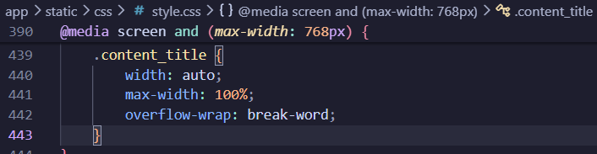

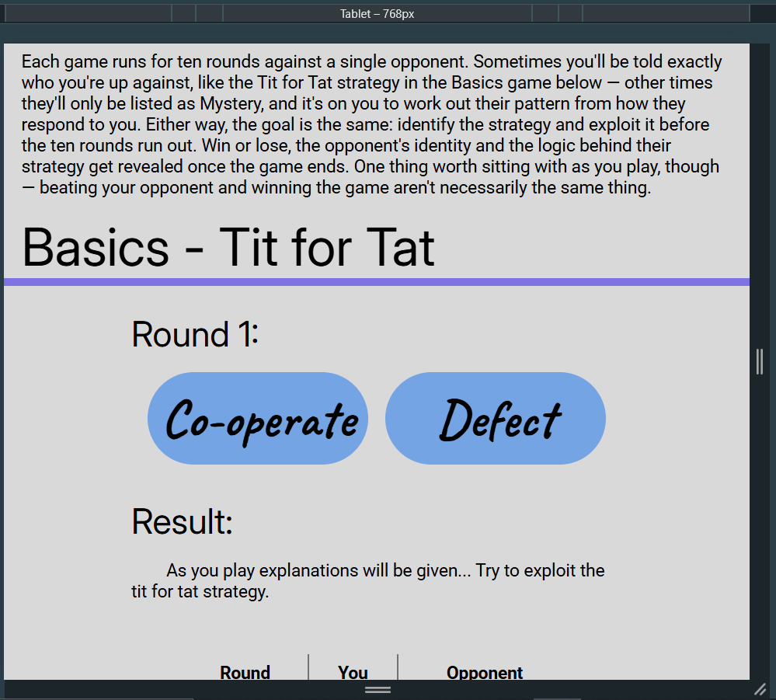
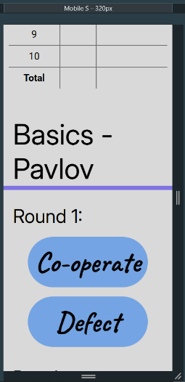
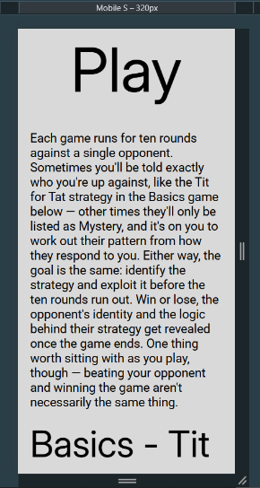
After:
