Trialling
Round 1:
Link to google forms survey: https://docs.google.com/forms/d/1SAPNeLwljfPPA6gYitBjd64ENY4TeYmP5xnpQxEFGjw/edit#responses
In the first round of trialling, I asked 4 male and female English-speaking students (aged 16-20) across New Zealand their preferences on 4 elements I wanted to trial. The 4 elements were text indents vs no indents, a line break between play explanations vs no line break, smaller or larger images and smaller or larger headings on mobile devices.
Indents
The results of this test were completely equal. 2 of the surveyors saying they preferred it with and 2 without. I decided to use my own discretion because, in every case when I later asked the surveyors to rate how important it was to them, the surveyors claimed that although they had their definitive preferences it was nothing significant enough for it to affect their usage of the website. My original design did not include text indents but during the development process I added them because I wanted to make it as easy as possible to find the start of a paragraph. I decided therefore to keep the text indents as they can help users to quickly and easily find the start of a paragraph facilitating an easier environment for students to read the information required to learn about the Prisoner’s Dilemma.
Line Break
The overall preference of this trial was to have a line break. 3 surveyors agreed the line break was better than having no line break because it allowed them to easier separate the information. The 1 surveyor who disagreed said, when later asked, that it was a personal preference. From the result of the survey, I decided to listen to the end users’ considerations and add the line break to my website. Below is the before and after of what this change looks like. To make this change I added “<br />” between the sentences.
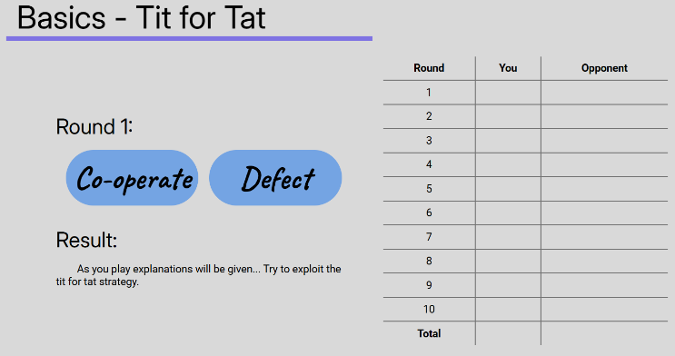
Original Version 1: Changed:
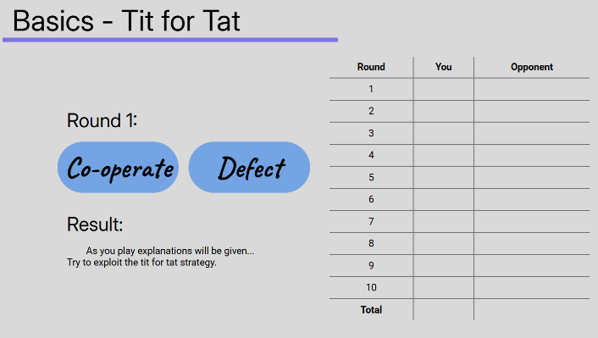

Image Sizes
The overall preference of this trial was to use larger image sizes. In this question there was 3 options: smaller images, larger images and somewhere in between. 2 of the surveyors wanted larger images, 1 surveyor wanted smaller images and the other surveyor picked somewhere in between. When later asked where in between they would like they said slightly smaller than the larger images. From these results I’ve decided to listen to the end users’ considerations and increase the image sizes (which were originally the small option) on non-mobile devices to the larger size I depicted in the tests. This change will make it easier for users to see the graphs and images and thereby learn. Below is the before and after of what this change looks like. I altered the image height by changing it from 300px to 400px.
Before: After:
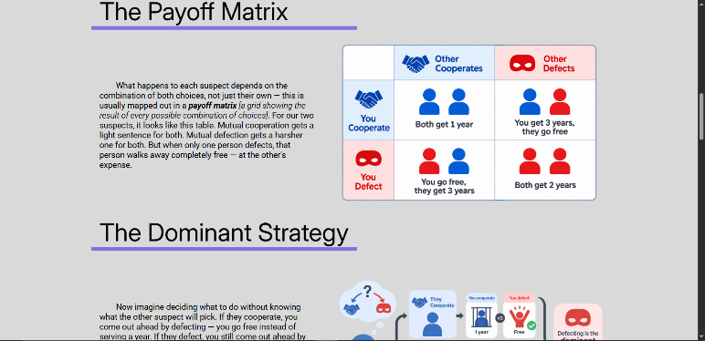
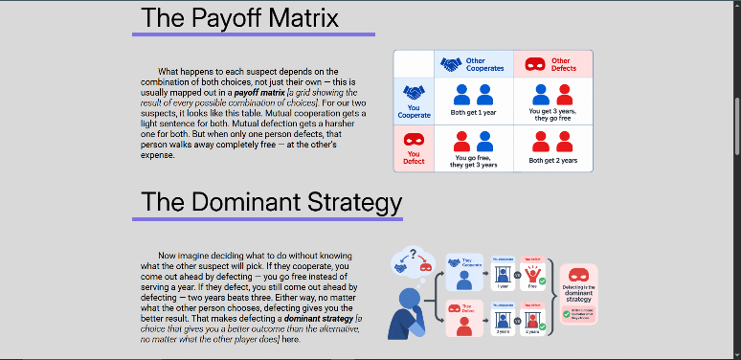

Mobile Header Sizes
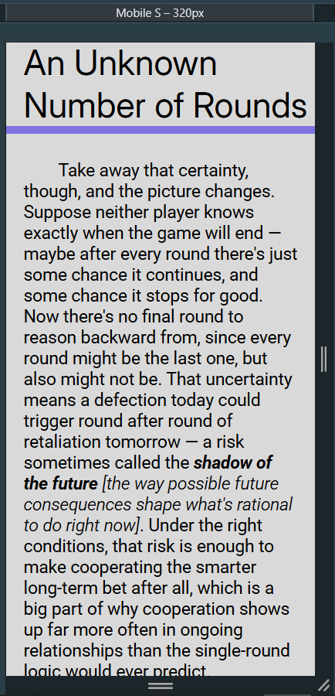
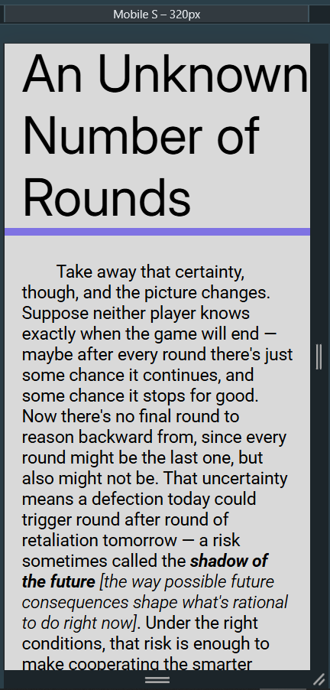
This was the only result to have a unanimous decision amongst all surveyors, which I also entirely agree with. This question asked the surveyors if they preferred larger or smaller headings on small devices. Everyone unequivocally wanted smaller headings because of the less space they took up which allowed a much easier reading experience on a small device. From these results I’ve decided to decrease the font size of the headings to make the website more accessible on phones and tablets. Below is the before and after of this change on a small phone (this change also effected larger phones and tablets). I decreased the font size of h1 and h3 elements by 1rem (currently 18px) and the font size of h4 elements by .5rem (which currently would be 9px).
Before: After:

Other Feedback
There was 2 other pieces of feedback from the surveyors. Larger font sizes for the “Result:” and “Round [X]:” titles on the play page and a larger font size for the main text. Each of those was from 1 individual so I will add them into the next round of trialling to see whether they are a personalised opinion or accurate representations of the end users’ considerations.

