Activity 1. [Calculate how many more years we can continue using this way of counting. Explain what you did to calculate it]

292.471.153 more years.

Long max value = 9.223.372.036.854.775.807 ms

9.223.372.036.854.775.807 ms = 292.471.208 years

We substract the 55 years that already happened

292.471.208 - 55 = 292.471.153

Activity 2. [Why does the measured time sometimes come out as 0?]

Because of the time taken for executing the program is less tha 1 ms

Activity 3. [From what size of problem (n) do we start to get reliable times?]

200000

Activity 4. [What happens with time if the problem size is multiplied by 2?]

Time nearly duplicates:

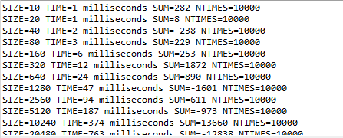

Activity 5. [What happens with time if the problem size is multiplied by a value k other than 2? (try it, for example, for k=3 and k=4 and check the times obtained)

K=3

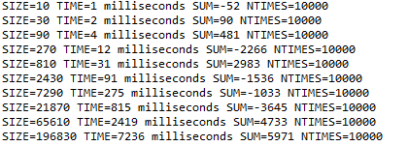

K=5

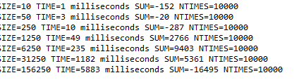

Activity 6. [Tables MAXIMUM)

CPU1: 12th Gen Intel(R) Core(TM) i5-12400 2.50 GHz

RAM1: 16,0 GB

| **Size** | **T(max)** | **T(sum)** |
| --- | --- | --- |

|  |  |  |
| --- | --- | --- |
| 10000 | 0.058 | 0.0377 |

|  |  |  |
| --- | --- | --- |
| 20000 | 0.113 | 0.0743 |

|  |  |  |
| --- | --- | --- |
| 40000 | 0.220 | 0.1482 |

|  |  |  |
| --- | --- | --- |
| 80000 | 0.445 | 0.2927 |

|  |  |  |
| --- | --- | --- |
| 160000 | 0.890 | 0.5873 |

|  |  |  |
| --- | --- | --- |
| 320000 | 1.769 | 1.1747 |

|  |  |  |
| --- | --- | --- |
| 640000 | 3.566 | 2.3510 |

|  |  |  |
| --- | --- | --- |
| 1280000 | 7.095 | 4.7113 |

|  |  |  |
| --- | --- | --- |
| 2560000 | 14.125 | 9.4374 |

Activity 7. [Tables MATCHES)

CPU1: 12th Gen Intel(R) Core(TM) i5-12400 2.50 GHz

RAM1: 16,0 GB

| **Sum** | **T(matches2)** | **T(matches1)** |
| --- | --- | --- |

|  |  |  |
| --- | --- | --- |
| 10000 | 0.06 | 511 |

|  |  |  |
| --- | --- | --- |
| 20000 | 0.1 | 2026 |

|  |  |  |
| --- | --- | --- |
| 40000 | 0.21 | 8065 |

|  |  |  |
| --- | --- | --- |
| 80000 | 0.42 | 32244 |

|  |  |  |
| --- | --- | --- |
| 160000 | 0.85 | 130349 |

|  |  |  |
| --- | --- | --- |
| 320000 | 1.67 | - |

|  |  |  |
| --- | --- | --- |
| 640000 | 3.35 | - |

|  |  |  |
| --- | --- | --- |
| 1280000 | 6.7 | - |

|  |  |  |
| --- | --- | --- |
| 2560000 | 13.4 | - |

|  |  |  |
| --- | --- | --- |
| 5120000 | 27.05 | - |

|  |  |  |
| --- | --- | --- |
| 10240000 | 54 | - |

|  |  |  |
| --- | --- | --- |
| 20480000 | 110 | - |

|  |  |  |
| --- | --- | --- |
| 40960000 | 218 | - |

T(Sum) is linear O(2n)

T(Max) is linear O(2n)

T(matches1) is linear O(4n)

T(matches2) is linear O(2n)