Kieran Deane-Alder
Medsci736 Final Report

Abstract (157 words)

Metabolomics is the analysis of all metabolites produced by a cell, tissue, organ, or even whole organism (the 'metabolome'). As an emerging science, is explicitly concerned with the analyis of large datasets. The instrumentation used to isolate and identify metabolites – gas (GC-MS) or liquid chromatography (LC-MS) mass spectrometry – produces relative, rather than absolute, measurements. This necessitates the use of specialised software, including custom R scripts, for normalising data and drawing appropriate statistical inferences.

It is also critical to employ good experimental practice in metabolomics. If equipment noise is to be corrected for, samples must ordinarily be randomised so that assumptions about the distribution in the statistical models used for these corrections are met. Unfortunately, randomisation is sometimes overlooked in experimental design. Thus, NoRAND was created.

NOvel R script for the Analysis of Non-randomised Data (NoRAND) attempts to "rescue" data obtained for samples that were not randomised. It compares the output of three correctional models to allow the user to make informed decisions about the quality of the data. NoRAND is available from its official GitHub repository, https://github.com/kdea020/metabolomics-project.

Keywords:
Metabolomics, parametric testing, sampling errors, linear regression

How to cite: Deane-Alder, K. (2016). NoRAND: Novel R script for the Analysis of Non-randomised Data. Journal of Open Research Software. Issue(Volume), pp. DOI.

1) OVERVIEW

Introduction

Data randomisation is a critical component of experiments in biology and medical science. Sufficient randomisation means that non-biological sources of variance are more prone to follow a distribution separate to the effect the experiment is trying to measure (). Undesirable effects (i.e. those caused by alterations in equipment sensitivity) that occur in a normal distribution can often be corrected for without removing real biological variance. These effects – such as batch effects and machine drift – are reducible sources of error with appropriate experimental design. Error that can not be reduced in such a fashion may still be corrected for by data processing and statistically informed correction procedures.

Metabolomics .

NoRAND
NoRAND comes with a set of example data to demonstrate the use and purpose of the program. This dataset is anonymised for subject names and includes a panel of 47 compounds. The data were obtained by GC-MS analysis of hair samples and have been normalised to biomass and D4-Alanine, an internal standard.

This dataset has a few serious issues that NoRAND attempts to correct: first and formost, the samples were not randomised (i.e. measured or obtained in a random order). In this particular dataset, all controls were run first, followed by all cases. As such, any variance introduced by equipment or experimental procedure could cause a greater (or lesser) difference in means between controls and cases by

Furthermore, there was

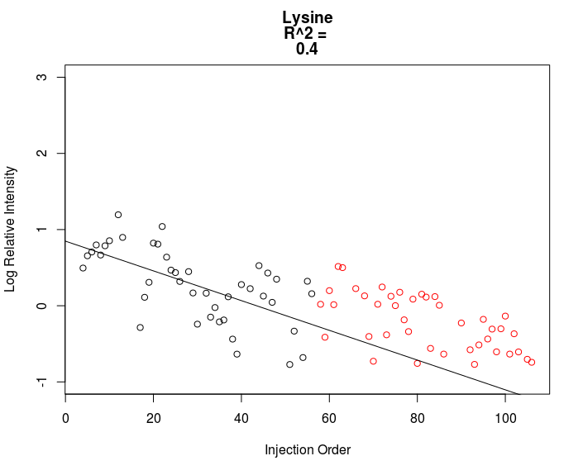

Figure 1: Lysine observations from example data, sorted by run order, and plotted on log-scale with regression line visible (uncorrected). Black hollow circles are controls; red hollow circles are cases. Produced as standard output by NoRAND.
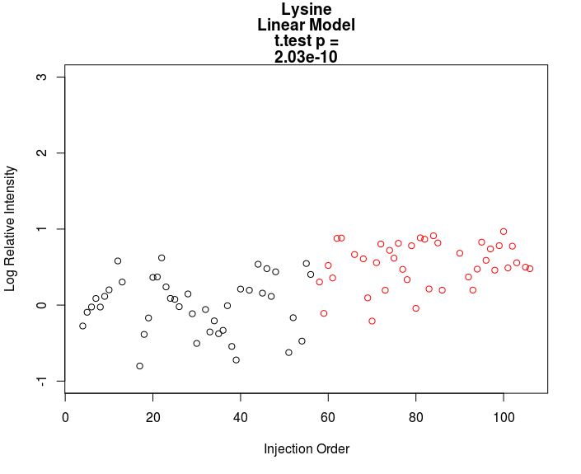

Figure 2: Linear regression (least-squares) model correction of lysine. Black hollow circles are controls; red hollow circles are cases. Produced as standard output by NoRAND.

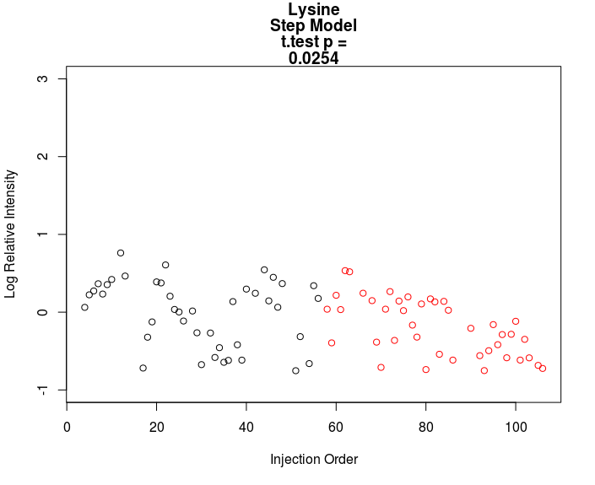

Figure 3: "Break" model correction of lysine observations. Differences in means between controls and cases now non-significant at the 1% level (compared to linear correction in figure 2, above). Break determined to be at sample 36 and set as such in NoRAND. Black hollow circles are controls; red hollow circles are cases. Produced as standard output by NoRAND.

Figures 1-3 (above)

Statistical methods

Linear regression
The linear regression model in NoRAND employs R's default base linear model function, lm(). This performs a simple least-squares linear regression, following the equation

Y = B₀ + B₁X + e,

where Y and X are the cartesian coordinates of points following the line, B₀ is the y-intercept of the line, B₁ is the slope and e is a normally distributed disturbance term. The least-squares regression method minimizes the sum of the residuals found from the form e = Y_{observed} – Y_{predicted}.

As drift in sample readings over time generally follows a linear trend in one direction, this is appropriate for estimating its effect (Wilkinson and Rogers, 1973).

Stairstep method
The stairstep model splits the dataset into two "batches" and attempts correct for a potential batch effect when a significant break between measurements has occurred. It takes the residuals of the average difference between measurements before and after the pre-defined "break", and subtracts from the "after" data to crudely eliminate the effect. The assumption is that in such cases the effect of the break is significant enough that removing it will not necessarily eliminate real biological variation – merely reduce noise.

The stairstep method for correction requires the user to modify a function in order to manually specify where a break in measurements might have occured. Instructions on how to do this can be found in the README.md file in the NoRAND GitHub repository.

Covariate model
The covariate model attempts to remove the influence of equipment drift and run-order by using whether the sample was a case, or control, as a confounder variable alongside the aforementioned linear regression. After performing a linear regression, it also uses whether a measurement came from a case or control as a primary variable when determining residuals. Compared to the linear model alone, this will reduce the significance level of case/control differences and while it offers a more complex modeling of experimental variance should be interpreted with care.

P-value reporting
The p-values reported in NoRAND's final model summary are generated by a two-tailed t-test of differences in means between cases and controls, after correction for each model. NoRAND uses the standard base t.test() function, as part of the linear model function, in R 3.3.1 with default parameters.

Q-value reporting
The q-value produced by NoRAND uses the BioConductor qvalue package, employing a version of the Benjamini-Hochberg correction to estimate the false discovery rate (Benjamini and Hochberg, 1995). This is intended to enable users to make inferences about the quality of the p-values reported by each of the three correctional models. The function can be adjusted to produce other q-values by other methods (instructions for this may be found in the README file accompanying NoRAND).

Implementation and architecture
NoRAND consists of several R scripts, each of which contains themed functions. These handle user input and file selection, produce plots of the data, and output interpretive statistics for each of the three correctional models. The user sources a single file using a simple command-line interface (running from shell or an integrated development environment such as RStudio), and then a series of prompts guides them through locating and importing necessary data files, and then selecting and plotting compound(s) of interest. NoRAND also displays and exports interpretive statistics to aid interpretation of the data analysis.

Data Import Handling

User selects
example data
User selects their own dataset with GUI

NoRAND performs data processing and determines compound names and sample run order.
Log transformation is also performed here.

User chooses the compound they wish to plot

NoRAND creates three correctional models and plots corrections

Display and export of interpretive statistics

Figure 1: NoRAND workflow.

NoRAND uses a linear workflow (figure 1, above) that begins with file selection. After this, the data is imported into columns (samples) and rows (observations of relative abundance for each compound, per sample) in matrices and data frames as necessary. Data frames are highly useful data containers, unique to R, which can store additional attributes (such as column and row names) without altering the size and arrangement of the data inside. Notably, NoRAND requires the user to import two files (in .CSV format) into the program. The first contains metabolite relative abundance, per sample, in columns and rows as described above. The second file contains the order in which each sample was run during the experiment. This allows for analysis of the contribution of run order and batch effects to observed variance, outlined in the statistical methods section below. More information on the precise files and formats required by NoRAND are available in the README file in the official github repository.

The next step for user input is choosing the compound

Metabolomics studies have a tendency to generate large datasets , as they usually examine extensive panels of metabolites and aim for the large sample sizes needed for statistically powerful clinical study. CSV files are very simple structurally and R's read.csv() function is well-optimised. As such, the computational efficiency of NoRAND is quite good. On a modern laptop (Intel Skylake architecture) the example dataset (~4,000 values) is imported, processed, plotted and analysed in less than 100ms. The performance should scale well with large datasets, making this script suitable for timely use.

Critically, NoRAND is designed to operate on normalised metabolomics data and and does not perform normalisation itself. Despite this, NoRAND has been tested with raw datasets and produced results comparable in quality to those from normalised data; however, this use is not recommended.

Quality control
The R functions were made under R version 3.3.1 ("Bug In Your Hair"), and the scripts built using RStudio in Ubuntu 16.04 (kernel 4.4.0-36-generic). NoRAND has been verified to load and run correctly on Mac OSX (ver. 10.x.x or above), Windows 7/8/10, and Ubuntu 16.04 (kernel 4.4.0-36-generic). Other operating systems and linux distributions have not been tested, but are highly likely to work as long as R version 3.3.0 or later is correctly installed.

NoRAND also includes a series of tests in the file TESTING.R that run automatically with the program. These test the input and output for all novel functions and will report descriptive error messages if these do not match the expected output. Correct functioning of NoRAND may be verified by running the script with the provided example data.

2) AVAILABILITY

Operating system
R scripts: Windows 7/8/10, Mac (OSX ver. 10.x.x or above), Linux (kernel 4.4.0-36-generic).

Programming language
C and R (R functions).

Additional system requirements
None.

Dependencies
The R scripts require installation of R version 3.3.0 or later (http://cran.r-project.org/).
TESTING.R requires a package for testing functions, testthat, kindly created by H. Wickham. (https://github.com/hadley/testthat).
The statistical functions are dependent on the BioConductor qvalue package for R, in order to report q-values (https://bioconductor.org/packages/release/bioc/html/qvalue.html).
Instructions for installing these packages are available in the README in the official NoRAND Github repository (https://github.com/kdea020/metabolomics-project)

Software location

Archive

Name
NoRAND R scripts: GitHub

Persistent identifier
NoRAND R scripts: https://github.com/kdea020/metabolomics-project

License
CC-BY-4.0

Publisher
Kieran Deane-Alder

Date published
27/10/16

Language
English.

3) REUSE POTENTIAL
While NoRAND was designed to analyse data obtained from metabolomics studies using GC-MS instrumentation, it should also function appropriately without alteration for LC-MS data. Additionally, the statistical models employed are relatively simple and make few assumptions about the nature of the data. Therefore, NoRAND could foreseeably be easily modified to analyse other large datasets, such as those obtained from proteomics studies. Thus, NoRAND has reuse potential beyond metabolomics.

Competing interests
The author declares that he has no competing interests.

References

in Harvard – square brackets

[2] Wilkinson, G.N., Rogers, C.E., 1973. Symbolic descriptions of factorial models for analysis of variance. Appl. Stat. 22, 392–399.

[3]

- Use template from J. Open. Res. Software
- You are sole author for purposes of submission.

Go to the journal and have a look at a paper similar to mine.

Overview section
- Allows you to place software in context of field.
- Why write the code to do the analysis?
- Lit review and comparison of other approaches to solve the problem.
- Why is my approach better?

Describe software in plain English, with examples of input and output.
What happens when you vary functions? Walk the user through how the software works.
(Like a Knitr notebook).
Describe, at each step, what you would do to test that the code is working correctly.

Re-use potential? "Who can use this code?" And what elements in the code would need to be changed to achieve re-use?

Will also need separate documentation (and licensing details).

Final assignment consists of:
- Paper
- Functioning software (on GitHub)
- Tests (must link to them in the paper)
- Comprehensive documentation on the use of the software

