(1) Overview

MorphoMANOVA: Multivariate Analysis Of Variance (MANOVA) analysis of landmarks derived from insect wings.

Paper Authors
1. Birrell, N. W.

Paper Author Roles and Affiliations
1. Developer, School of Biological Sciences, University of Auckland

Abstract
Geometric morphometrics has been touted as being a powerful method to analyse variation between wing venation landmarks of different insect species, giving a deeper insight into taxonomic relationships. The current method of analysis is to look at a scatter plot of principal components and visually distinguish if there is a difference between different species. The next step logical step would be to use a MANOVA analysis to provide a statistical determination of whether or not there is a difference between landmarks. This is done through the use of the R programming language and R studio.

Keywords
Geometric Morphometrics; Statistical Analysis; MANOVA; Wing Venation; Taxonomy, R, R Studio.

Introduction
Traditional morphometrics focuses on the statistical analysis of variables, usually corresponding to lengths and widths of anatomical structures [1]. The drawback of using these measurements is that the overall form of a structure is not used in the analysis, reducing the amount of information that is able to be used. Geometric morphometrics overcomes this by removing linear measurements through procrustes superimposition, instead focussing on shapes formed between analogous landmarks. This allows a researcher to look at how a landmark (a coordinate of an anatomical point of interest) has moved relative to other landmarks between specimens [1;2].

Geometric morphometrics has become popular in the study of insect taxonomy through the analysis of wing venation. After performing a geometric morphometric analysis of insect wing landmarks using procrustes superimposition, a table of principle components is produced which can be presented as a scatter plot (refer Figure 1.). Currently, it is possible to look at the scatter plot and say that a particular cluster of data points looks different to another cluster and therefore may be a separate species, however, this is purely based on a visual “hunch” that they look different. A sensible next step is to perform a MANOVA on the procrustean coordinates to state statistically that there is or is not a difference.

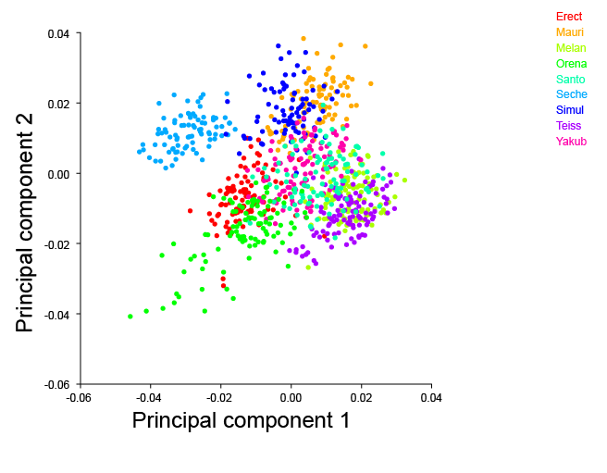
Figure 1: A scatter plot showing relative positions of landmarks based on the first two principle components by subgroups. The subgroup ''seche" appears as a distinct cluster. A multivariate statistical analysis however would be useful to confirm a difference. Image generated from openly available data [3] using MorphoJ software [4]
A MANOVA is a multivariate analysis of variance, used when there are two or more dependent variables, which compares multivariate sample means. There are four assumptions that must be checked when performing a MANOVA, these are (1) absence of multivariate outliers, (2) linearity, (3) absence of multicollinearity and, (4) equality of covariance matrices [5].

The software discussed is intended to perform a statistical analysis on landmark data produced from a morphometric programme such as MorphoJ [4].

Implementation and architecture
The MorphoMANOVA project was implemented using R. Originally Python had been the intended platform however it was found to be lacking in multivariate analyses which were key to this project. R version 3.3.1 was used as the statistical functionality of this programming language is both versatile and powerful.

The R script, morphoManova.R, is designed to be run using Rstudio which offers a graphical user interface (GUI) that is accessible to the average R user. It is assumed that the user of this software would have some statistical knowledge as this would be necessary to have produced the raw data in the first place during the geometric morphometric analysis.

The first annotations in the code request that the user ensures that the first column in their data file contains the independent variable and the second column onwards contains the dependent variables.

When the first line of code is run, a file browser opens, allowing the user to navigate and select the data file they wish to perform the analysis on. This reads the file into a data frame, morpho.df.

The next set of code then checks the data meets the assumptions, firstly that there are no outliers and secondly that the data is normally distributed. In the future it is planned to add a test for the third and fourth assumptions, that there is equality of covariance matrices and, that there is absence of multicollinearity. If any of these tests fail, then a MANOVA test would not be suitable and the user would need to look at another option. Unfortunately, it is not within the scope of this programme to suggest to the user an alternative statistical approach and it would be recommended that they consult with a statistician for assistance.

It should be noted that it was at this stage that I discovered the original geometric morphometric data did not meet the test for normality and therefore a MANOVA could not be applied. This was due to the original data that was intended to be used was directly from a principle component analysis. This means that a multivariate analysis had already been applied and we would therefore be carrying out a multivariate test on a multivariate test which is ultimately pointless. To show that the MANOVA function still works however, I produced a set of randomly generated normal data for use as an example. This is shown in the file normal_morpho.csv

If all of the tests of assumptions are met, then the next step is for the user to run the MANOVA function on their data. The ‘’summary(morphoManova)’’ function will produce an output and advise the significance codes of the p-value. In the case of normal_morpho.csv, the output is shown in figure 2.

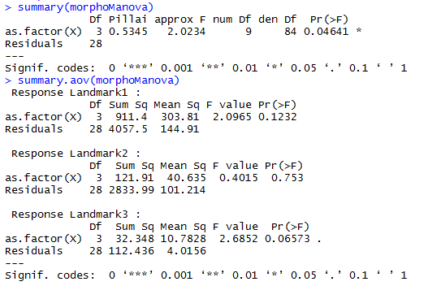
Figure 2: An example of the MANOVA output and breakdown

Quality control
Unfortunately, due to the last minute realisation that R would need to be used, the test driven development techniques that I had created for the original Python programme were unable to be applied to R. Whilst it should be possible to implement test driven development in R in the future, in this instance some simple checks of assumptions were added to ensure data was suitable for a MANOVA.

Quality control for the data going into the script is currently based on the user confirming that the first column is an independent variable and the remaining columns are dependent variables. The data is then checked against 4 assumptions. If these tests show that any of the assumptions are not met then this means that the data is not suitable for MANOVA analysis. A future feature would be to provide a failure message if a P-value is above or below a certain threshold so that a user clearly knows that a test has not been met.

(2) Availability

Operating system
The code will work on any operating system that is able to utilise R, R Studio and has the appropriate packages installed (refer dependencies).

This has been tested on:
Ubuntu 16.04
Windows 10 64bit

Programming language
R version 3.3.1

It has also been tested on R version 3.3.0 and found to still work as expected.

Additional system requirements
N/A

Dependencies
R Studio v0.99.903
R Packages:
mvnormtest v0.1-9
vegan v2.4-1

List of contributors

Greg Holwell | Product Owner,  University of Auckland
Zeeshan Sarwar | Scrum Master & Mentor, University of Auckland
Andre Bellve | R mentor,  University of Auckland

Software location:
Archive (for data)
Name: figshare
Persistent identifier: https://dx.doi.org/10.6084/m9.figshare.4083276.v2 & https://dx.doi.org/10.6084/m9.figshare.4109781
Licence: CC0 & CC-BY
Publisher: Neil Birrell
Date published: 27/10/16

Code repository (for code)
Name: GitHub etc.
Name: UOA-MEDSCI-736/nbir012-diptera-morpho
Identifier: https://github.com/UOA-MEDSCI-736/nbir012-diptera-morpho
Licence: The Unlicence
Date published: 27/10/16

Language
English

(3) Reuse potential
The MANOVA function presented here has limited reuse potential. It is possible to increase reuse potential by soft-coding the dependent variables in the MANOVA. This had been attempted but the functionality is currently not working as expected and was not included in the function.

Acknowledgements
Fabiana Kubke for putting together the fantastic course which sets a standard for what teaching should be like at university, all the tutors for their assistance and interest in our development, Sanjid Rahman and Kieran Deane-Alder for bouncing ideas off around my last minute realisation that I needed to use R and not python. Zeeshan Sarwar for assisting with the learning of R, which whilst not used is great for my personal development. Andre Bellve for pointing out that my data was not suitable for a MANOVA and pointing out some errors in my R code.

Funding statement
University of Auckland Vice Chancellor’s Strategic Funding 2015

Competing interests
The author declares that there are no competing interests.

References

[1] Klingenberg, C.P., 2011. MorphoJ: an integrated software package for geometric morphometrics. Mol. Ecol. Resour. 11, 353–357. doi:10.1111/j.1755-0998.2010.02924.x
[2] Slice, D.E., 2007. Geometric morphometrics. Annu Rev Anthr. 36, 261–281.
[3] Gidaszewski, N.A., Baylac, M., Klingenberg, C.P., 2009. Evolution of sexual dimorphism of wing shape in the Drosophila melanogaster subgroup. BMC Evol. Biol. 9, 110. doi:10.1186/1471-2148-9-110
[4] Rohlf, F.J., Marcus, L.F., 1993. A Revolution in Morphometrics. Trends Ecol. Evol. 8, 129–132. doi:10.1016/0169-5347(93)90024-J
[5] Finch, H., 2005. Comparison of the Performance of Nonparametric and Parametric MANOVA Test Statistics when Assumptions Are Violated. Methodology 1, 27–38. doi:10.1027/1614-1881.1.1.27

Copyright Notice
Authors who publish with this journal agree to the following terms:

Authors retain copyright with the work simultaneously licensed under a Creative Commons Attribution License that allows others to share the work with an acknowledgement of the work's authorship and initial publication in this journal.

Authors are able to enter into separate, additional contractual arrangements for the non-exclusive distribution of the journal's published version of the work (e.g., post it to an institutional repository or publish it in a book), with an acknowledgement of its initial publication in this journal.

By submitting this paper you agree to the terms of this Copyright Notice, which will apply to this submission if and when it is published by this journal.

