VideoChat Tutorial
Videochat

Videochat Recorder

- First select the VideoChat recorder on the LTI tool
.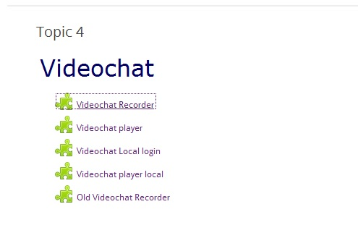
- Now on the next sc:reen you must select and confirm the webcam use.
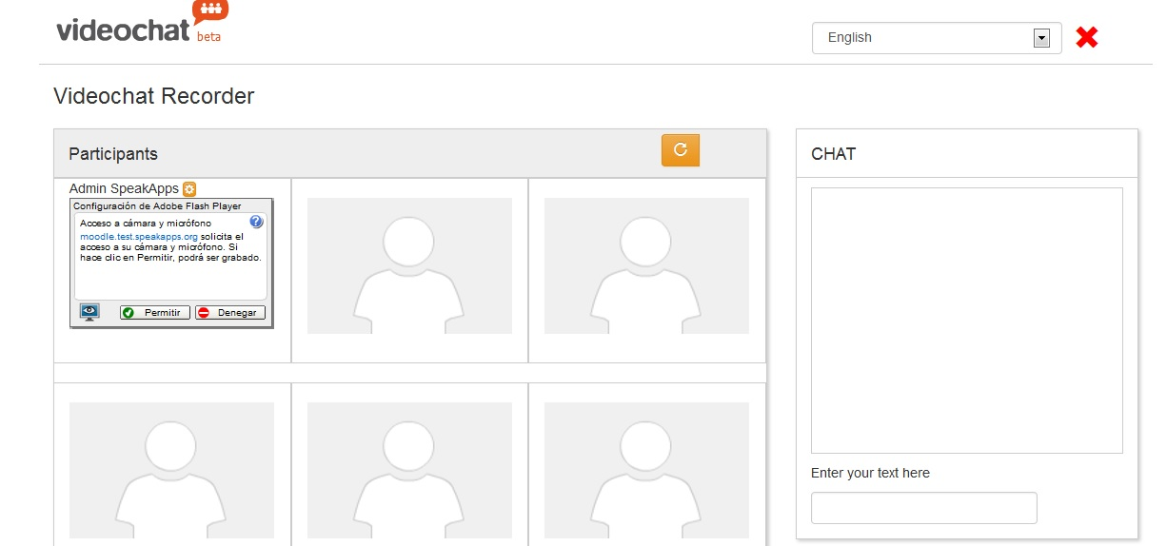

- And now you can start the session. Let's take a look:
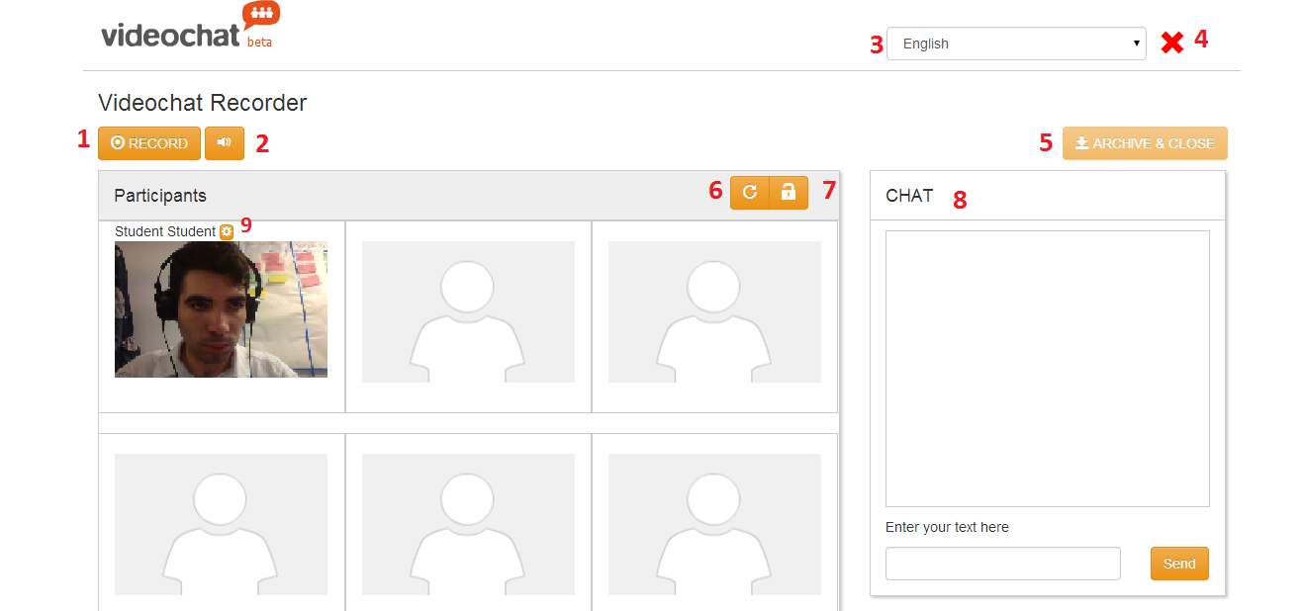
  - Start or stop the recording session.
  - Mute the current user.
  - Change the language of the user interface. This option refresh the page, so you probably need to confirm again the use of the camera like on the step 2.
  - Quit the session and return to the session browser.
  - Save the current recording and close the session.
  - Refresh the page. Note that you'll left the session and join again automatically.
  - Lock or unlock the session, preventing to enter new users.
  - Chat window.
  - Open the flash settings, where you can adjust the volume of the microphone, choose the camera or allow or deny the camera, between other options.

2 Videochat Player
- First of all, you need to select a session to play:
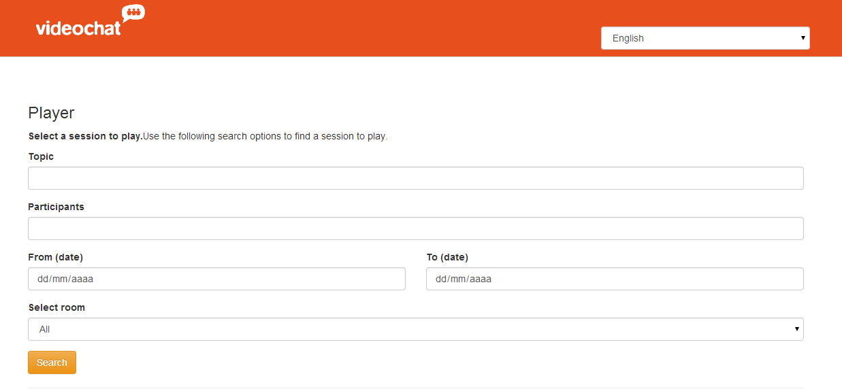
There are some filters to help you to find a session, like the topic description, an username, the date when it was recorded or the room where it was recorded.

Once you've chosen the criteria, after clicking Search the results will be shown just below:
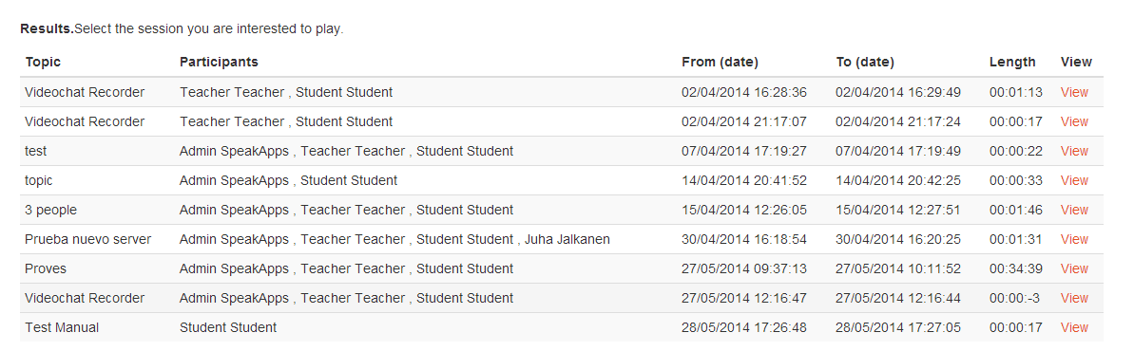
(By default, the results will show all the sessions sorted by date of recording).

- Let's take a look to the videochat player page:

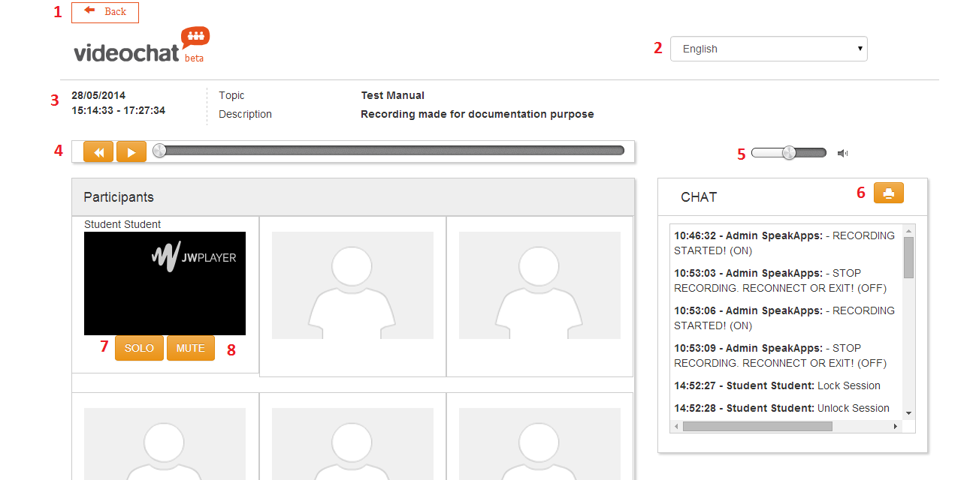
- Go back to the session browser.
- Change the language of the user interface.
- Information about the session, like the time and date where it was recorded, the topic and the description.
- Player controls to play, pause and rewind the video session.
- Volume control.
- Print all the chat.
- Mute the audio streams from the other users of the recording.
- Mute just this user audio.

