# BACKSTAGE Software Platform

URL: <https://mc3-demo.mit.edu/relate/RDB/touchstone/assessments/>

* If you need an account, please contact [cjshaw@mit.edu](mailto:cjshaw@mit.edu) or [zchen22@mit.edu](mailto:zchen22@mit.edu).

## GOALS

**Backstage** allows MIT faculty, TAs, and MITx fellows to re-use digital content from multiple sources. Versioning of problems and courses enables tracking of content usage, eliminating the lack of traceability with copy-and-paste.

## OVERVIEW

**Backstage** accepts as input either an edX class from a GitHub repository (*.zip file), or a Studio export (*.tar.gz file). It parses and captures images, content, problems, policies, chapters, sequentials, and verticals into a database. It assigns each of these items a unique ID, which allows for versioning and traceability.

Using a **Backstage** interface, users can edit an uploaded class or create one from scratch. Editing a course involves re-arranging items in different order, adding new content / assessments, or linking items to learning objectives.

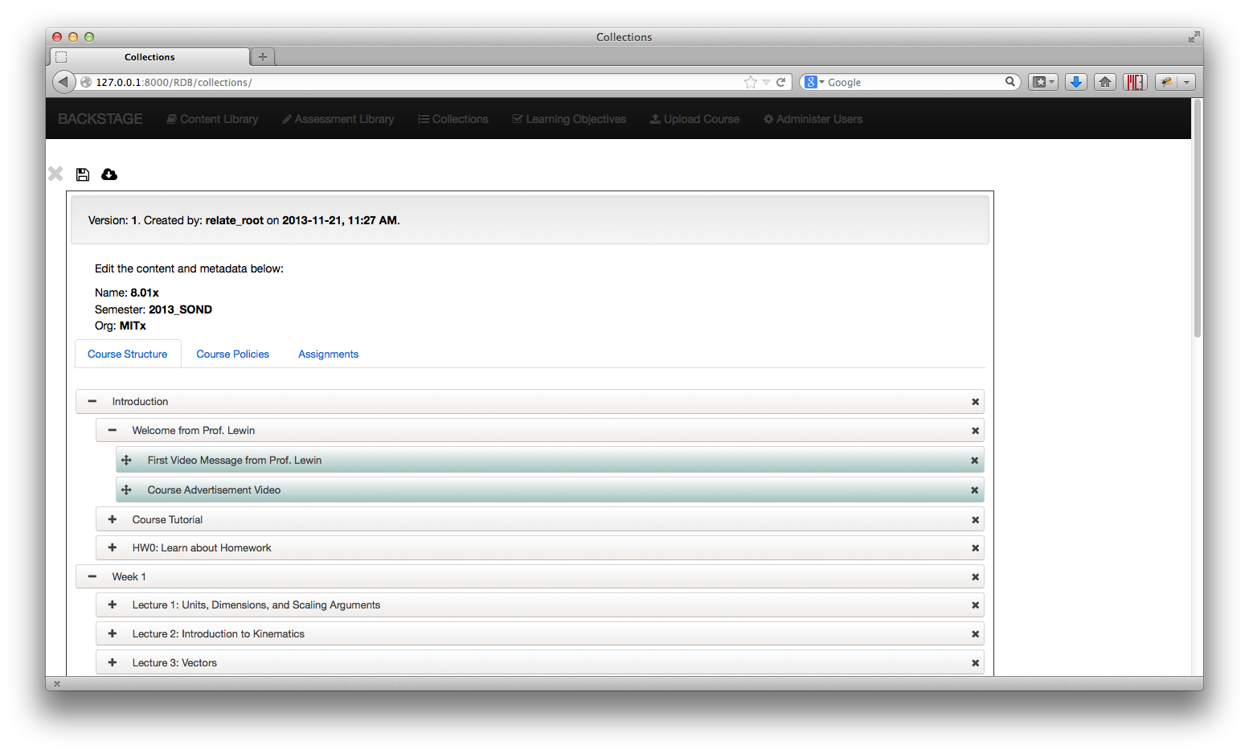

Figure 1. Editing a course structure in Backstage

**Backstage** also offers a library, where users can preview and edit individual problems or content from multiple classes. Users can also diff two items or download multiple items in a zip file.

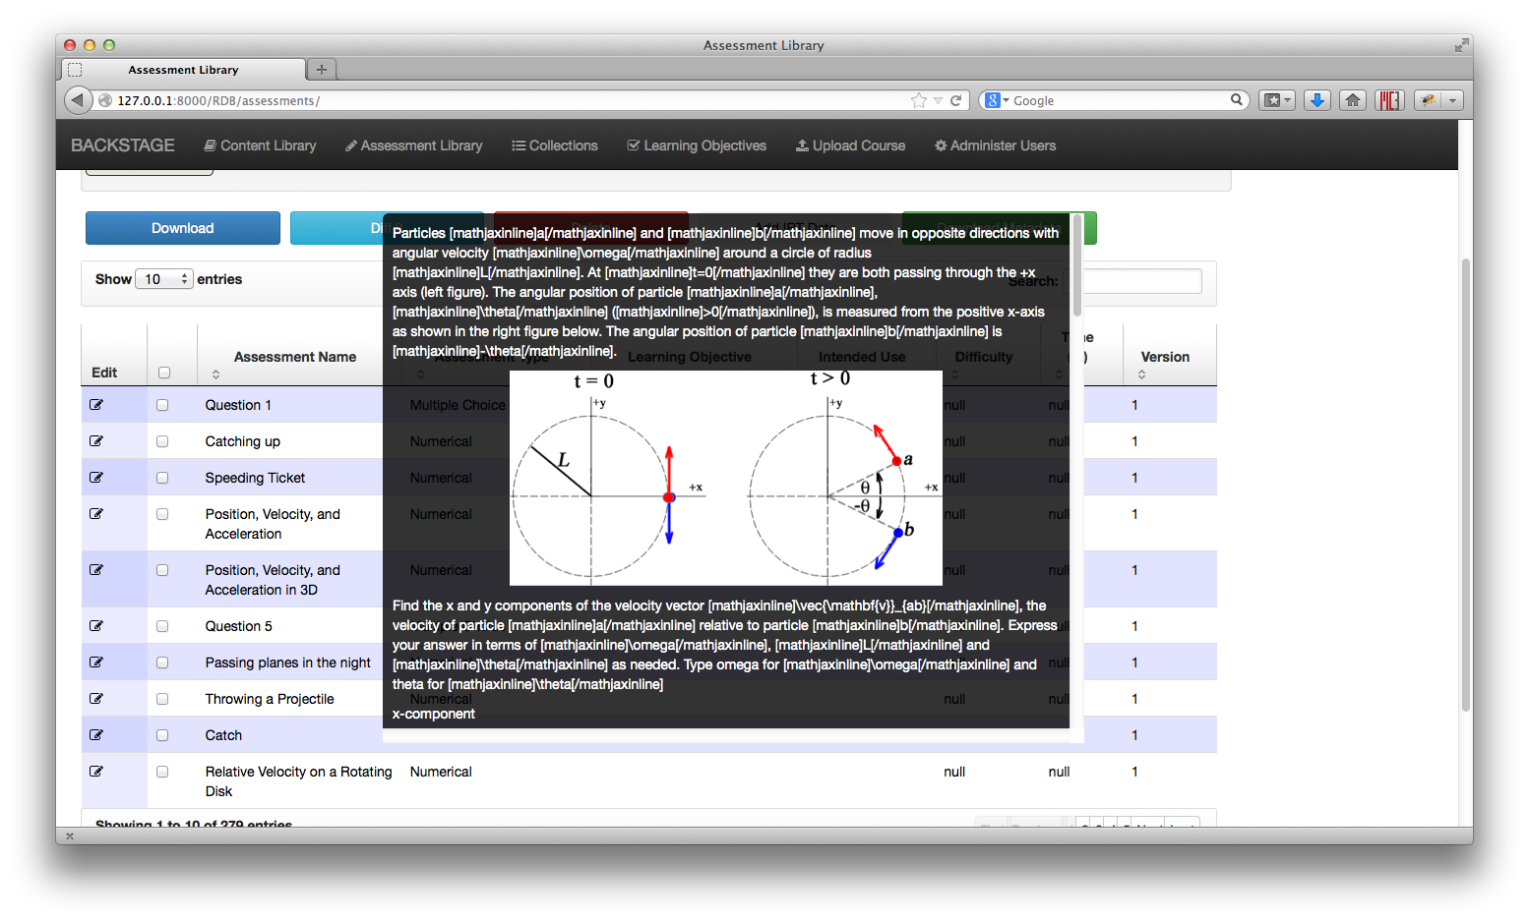

Figure 2. Assessment Library’s Live Preview

## BENEFITS FOR FACULTY, TAS, AND MITX FELLOWS

**Backstage** reduces the workload required to create MITx / edX classes. Second-run classes can easily update individual class components, while first-run classes can pick-and-choose items from multiple sources.

Educational researchers can use the platform to create different versions of classes for different groups of students. Traceability and analytic metadata of individual problems reduce the effort required to correlate student performance and assessment context (i.e. was Problem A before or after Problem B?).

## SOFTWARE FEATURES

The **Backstage** platform currently has basic input / output compatibility with edX, and supports the following features:

* *Classes*
  + Ability to re-arrange the order of edX class content.
  + Extract Studio “Draft” content and use in a regular class.
  + Import / Export edX-compatible classes (*.zip or *.tar.gz files).
  + Maintain version history of resources and classes.
  + Update an existing class with a new upload.
* *Content / Assessment Resources*
  + Create learning objectives and link them to assessments.
  + Diff raw text of two resources.
  + Download resources in bulk, with embedded images.
  + Live preview, with images and videos, of class content and assessments.
  + Search for resources across multiple classes.

*NOTE: Depending on your OS and what program you use to unzip downloaded files, you may need to change directory and file permissions to 755 before putting the unzipped files into an edX / Vagrant directory.

## FUTURE VISION

We plan to make the **Backstage** platform a more fully-featured and user-friendly authoring environment. Some of the features on our roadmap appear below:

* Bulk upload of analytic metadata for assessments.
* Capture additional static content like book chapters and PDF files.
* Direct “save-to-GitHub” feature, in lieu of downloading a zip file.
* Easy-to-use, form-based assessment and content creation.
* Improve handling of static content to isolate individual classes.
* Integrate with the [MIT Core Concept Catalog](http://mc3.mit.edu) (MC3).
* Multi-editor support of content (i.e. Google Docs live editing).
* Use content from multiple classes when constructing a class.