Feature Test:

|  |  |  |  |
| --- | --- | --- | --- |
| Case | Format | Encryption | Result |
| 1 | JSON | YES | Success |
| 2 | JSON | NO | Success |
| 3 | BINARY | YES | Success |
| 4 | BINARY | NO | Success |
| 5 | XML | YES | Success |
| 6 | XML | NO | Success |

Case 1:

Client:

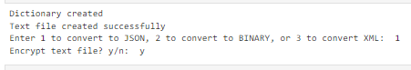

Server:

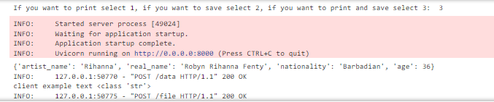

Case 2:

Client:



Server:

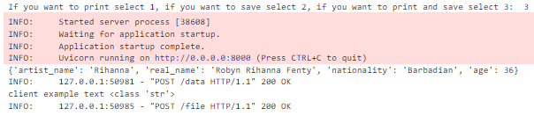

Case 3:

Client:

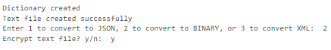

Server:

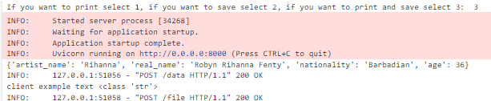

Case 4:

Client:



Server:

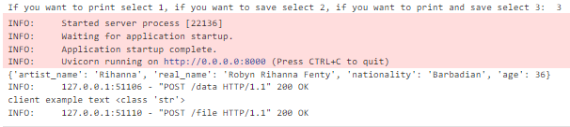

Case 5:

Client:



Server:

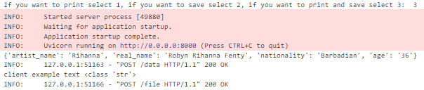

Case 6:

Client:



Server:

