SEM Project: Latent Growth Curve Modeling of REV Training Data

Krista DeStasio

11/16/2017

# Plots

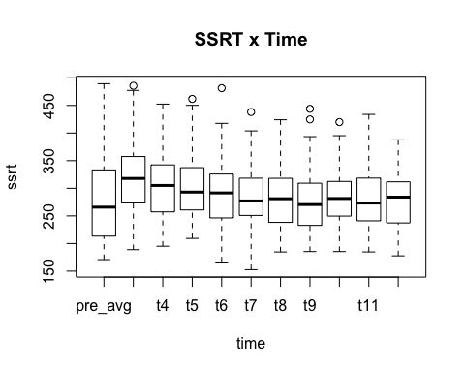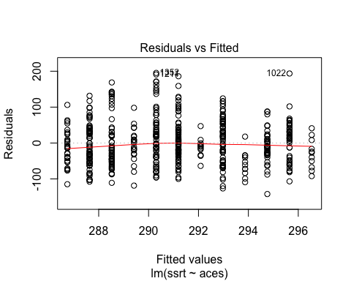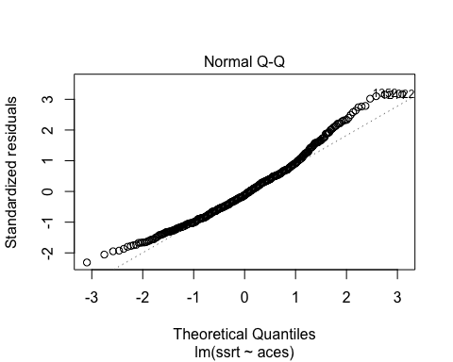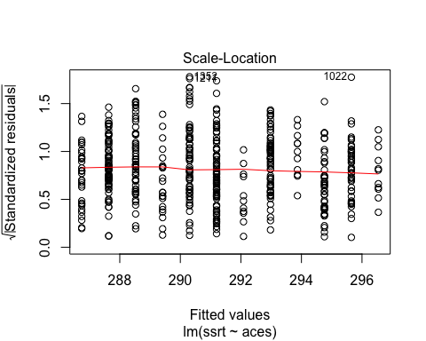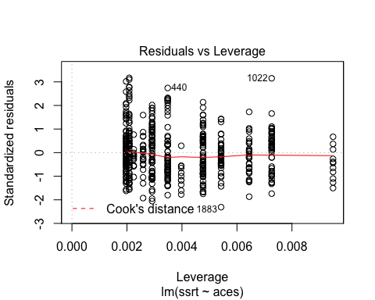

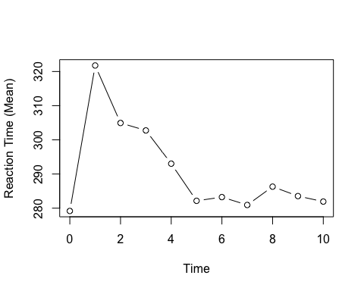

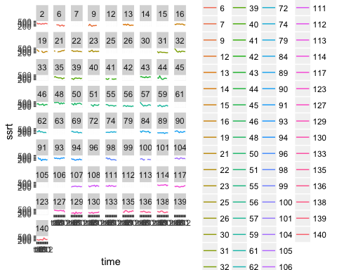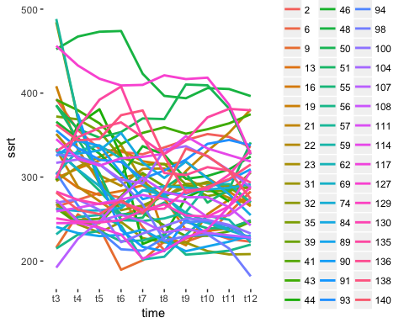

# Descriptives

## vars n mean sd median trimmed mad min max  
## id* 1 48 37.42 21.07 36.00 37.50 25.20 1.00 73.00  
## aces 2 48 8.79 3.19 9.00 8.70 4.45 4.00 15.00  
## ssrt_pre_avg 3 40 279.18 80.34 265.82 271.62 91.51 170.76 489.28  
## ssrt_t10 4 48 286.30 50.60 281.49 284.01 45.80 185.43 419.83  
## ssrt_t11 5 47 283.54 59.09 273.29 278.52 58.50 184.73 433.79  
## ssrt_t12 6 46 281.93 49.70 283.98 280.16 59.50 177.62 387.61  
## ssrt_t3 7 47 321.76 69.07 317.80 318.26 63.43 188.83 485.57  
## ssrt_t4 8 46 304.93 61.93 305.09 302.73 67.13 195.10 452.46  
## ssrt_t5 9 47 302.75 59.37 293.11 297.01 62.24 209.22 461.80  
## ssrt_t6 10 47 293.03 65.83 291.61 289.72 58.27 166.48 481.27  
## ssrt_t7 11 47 282.15 57.35 277.08 281.11 59.10 152.62 438.05  
## ssrt_t8 12 47 283.24 55.64 281.09 279.84 57.67 184.68 424.05  
## ssrt_t9 13 48 280.93 58.26 270.50 275.22 55.86 185.46 443.87  
## range skew kurtosis se  
## id* 72.00 0.00 -1.19 3.04  
## aces 11.00 0.24 -1.13 0.46  
## ssrt_pre_avg 318.52 0.67 -0.37 12.70  
## ssrt_t10 234.40 0.44 -0.26 7.30  
## ssrt_t11 249.06 0.81 0.06 8.62  
## ssrt_t12 209.99 0.21 -0.62 7.33  
## ssrt_t3 296.74 0.42 -0.05 10.07  
## ssrt_t4 257.36 0.33 -0.66 9.13  
## ssrt_t5 252.58 0.82 0.13 8.66  
## ssrt_t6 314.79 0.53 0.14 9.60  
## ssrt_t7 285.43 0.19 0.19 8.37  
## ssrt_t8 239.37 0.48 -0.39 8.12  
## ssrt_t9 258.41 0.86 0.22 8.41

# Models

## No predictors

### Basic change model

## lavaan (0.5-23.1097) converged normally after 270 iterations  
##   
## Number of observations 48  
##   
## Number of missing patterns 9  
##   
## Estimator ML  
## Minimum Function Test Statistic 48.706  
## Degrees of freedom 42  
## P-value (Chi-square) 0.221  
##   
## Parameter Estimates:  
##   
## Information Observed  
## Standard Errors Standard  
##   
## Latent Variables:  
## Estimate Std.Err z-value P(>|z|)  
## intercept =~   
## ssrt_t3 1.000   
## ssrt_t4 1.000   
## ssrt_t5 1.000   
## ssrt_t6 1.000   
## ssrt_t7 1.000   
## ssrt_t8 1.000   
## ssrt_t9 1.000   
## ssrt_t10 1.000   
## ssrt_t11 1.000   
## ssrt_t12 1.000   
## slope =~   
## ssrt_t3 0.000   
## ssrt_t4 1.000   
## ssrt_t5 1.737 0.590 2.943 0.003  
## ssrt_t6 2.309 0.830 2.781 0.005  
## ssrt_t7 2.568 0.950 2.703 0.007  
## ssrt_t8 2.610 0.942 2.769 0.006  
## ssrt_t9 2.891 1.100 2.629 0.009  
## ssrt_t10 2.523 0.965 2.614 0.009  
## ssrt_t11 2.596 0.960 2.704 0.007  
## ssrt_t12 2.947 1.118 2.635 0.008  
##   
## Covariances:  
## Estimate Std.Err z-value P(>|z|)  
## intercept ~~   
## slope -767.017 540.131 -1.420 0.156  
##   
## Intercepts:  
## Estimate Std.Err z-value P(>|z|)  
## .ssrt_t3 0.000   
## .ssrt_t4 0.000   
## .ssrt_t5 0.000   
## .ssrt_t6 0.000   
## .ssrt_t7 0.000   
## .ssrt_t8 0.000   
## .ssrt_t9 0.000   
## .ssrt_t10 0.000   
## .ssrt_t11 0.000   
## .ssrt_t12 0.000   
## intercept 322.217 9.768 32.987 0.000  
## slope -14.459 6.492 -2.227 0.026  
##   
## Variances:  
## Estimate Std.Err z-value P(>|z|)  
## .ssrt_t3 551.118 634.643 0.868 0.385  
## .ssrt_t4 1407.287 372.113 3.782 0.000  
## .ssrt_t5 1778.940 403.672 4.407 0.000  
## .ssrt_t6 1739.418 382.648 4.546 0.000  
## .ssrt_t7 1584.446 353.225 4.486 0.000  
## .ssrt_t8 1125.866 261.781 4.301 0.000  
## .ssrt_t9 782.939 199.880 3.917 0.000  
## .ssrt_t10 611.375 153.207 3.991 0.000  
## .ssrt_t11 754.384 185.473 4.067 0.000  
## .ssrt_t12 976.884 245.231 3.984 0.000  
## intercept 3950.390 1149.989 3.435 0.001  
## slope 307.206 298.547 1.029 0.303

## npar fmin chisq   
## 23.000 0.507 48.706   
## df pvalue baseline.chisq   
## 42.000 0.221 377.499   
## baseline.df baseline.pvalue cfi   
## 45.000 0.000 0.980   
## tli nnfi rfi   
## 0.978 0.978 0.862   
## nfi pnfi ifi   
## 0.871 0.813 0.980   
## rni logl unrestricted.logl   
## 0.980 -2409.091 -2384.738   
## aic bic ntotal   
## 4864.182 4907.220 48.000   
## bic2 rmsea rmsea.ci.lower   
## 4835.063 0.058 0.000   
## rmsea.ci.upper rmsea.pvalue rmr   
## 0.118 0.408 369.688   
## rmr_nomean srmr srmr_bentler   
## 369.688 0.110 0.110   
## srmr_bentler_nomean srmr_bollen srmr_bollen_nomean   
## 0.117 0.153 0.056   
## srmr_mplus srmr_mplus_nomean cn_05   
## 0.163 0.083 58.282   
## cn_01 gfi agfi   
## 66.247 0.982 0.972   
## pgfi mfi ecvi   
## 0.634 0.933 NA

### Linear model

## lavaan (0.5-23.1097) converged normally after 220 iterations  
##   
## Number of observations 48  
##   
## Number of missing patterns 9  
##   
## Estimator ML  
## Minimum Function Test Statistic 70.397  
## Degrees of freedom 50  
## P-value (Chi-square) 0.030  
##   
## Parameter Estimates:  
##   
## Information Observed  
## Standard Errors Standard  
##   
## Latent Variables:  
## Estimate Std.Err z-value P(>|z|)  
## intercept =~   
## ssrt_t3 1.000   
## ssrt_t4 1.000   
## ssrt_t5 1.000   
## ssrt_t6 1.000   
## ssrt_t7 1.000   
## ssrt_t8 1.000   
## ssrt_t9 1.000   
## ssrt_t10 1.000   
## ssrt_t11 1.000   
## ssrt_t12 1.000   
## linear_slope =~   
## ssrt_t3 0.000   
## ssrt_t4 1.000   
## ssrt_t5 2.000   
## ssrt_t6 3.000   
## ssrt_t7 4.000   
## ssrt_t8 5.000   
## ssrt_t9 6.000   
## ssrt_t10 7.000   
## ssrt_t11 8.000   
## ssrt_t12 9.000   
##   
## Covariances:  
## Estimate Std.Err z-value P(>|z|)  
## intercept ~~   
## linear_slope -86.443 54.387 -1.589 0.112  
##   
## Intercepts:  
## Estimate Std.Err z-value P(>|z|)  
## .ssrt_t3 0.000   
## .ssrt_t4 0.000   
## .ssrt_t5 0.000   
## .ssrt_t6 0.000   
## .ssrt_t7 0.000   
## .ssrt_t8 0.000   
## .ssrt_t9 0.000   
## .ssrt_t10 0.000   
## .ssrt_t11 0.000   
## .ssrt_t12 0.000   
## intercept 306.467 8.105 37.811 0.000  
## linear_slope -3.287 0.827 -3.977 0.000  
##   
## Variances:  
## Estimate Std.Err z-value P(>|z|)  
## .ssrt_t3 2073.039 538.673 3.848 0.000  
## .ssrt_t4 1663.538 433.014 3.842 0.000  
## .ssrt_t5 1586.001 375.659 4.222 0.000  
## .ssrt_t6 1647.436 379.086 4.346 0.000  
## .ssrt_t7 1646.718 370.110 4.449 0.000  
## .ssrt_t8 1181.559 270.079 4.375 0.000  
## .ssrt_t9 915.657 213.357 4.292 0.000  
## .ssrt_t10 624.373 160.895 3.881 0.000  
## .ssrt_t11 732.380 196.438 3.728 0.000  
## .ssrt_t12 858.347 245.488 3.496 0.000  
## intercept 2487.359 634.225 3.922 0.000  
## linear_slope 15.519 6.872 2.258 0.024

## npar fmin chisq   
## 15.000 0.733 70.397   
## df pvalue baseline.chisq   
## 50.000 0.030 377.499   
## baseline.df baseline.pvalue cfi   
## 45.000 0.000 0.939   
## tli nnfi rfi   
## 0.945 0.945 0.832   
## nfi pnfi ifi   
## 0.814 0.904 0.938   
## rni logl unrestricted.logl   
## 0.939 -2419.937 -2384.738   
## aic bic ntotal   
## 4869.873 4897.941 48.000   
## bic2 rmsea rmsea.ci.lower   
## 4850.883 0.092 0.030   
## rmsea.ci.upper rmsea.pvalue rmr   
## 0.139 0.104 374.284   
## rmr_nomean srmr srmr_bentler   
## 374.284 0.116 0.116   
## srmr_bentler_nomean srmr_bollen srmr_bollen_nomean   
## 0.115 0.152 0.064   
## srmr_mplus srmr_mplus_nomean cn_05   
## 0.161 0.086 47.028   
## cn_01 gfi agfi   
## 52.925 0.974 0.966   
## pgfi mfi ecvi   
## 0.749 0.809 NA

### Model comparison basic v. linear

## Chi Square Difference Test  
##   
## Df AIC BIC Chisq Chisq diff Df diff Pr(>Chisq)   
## modelbasic_fit 42 4864.2 4907.2 48.706   
## modellinear_fit 50 4869.9 4897.9 70.397 21.691 8 0.005521 **  
## ---  
## Signif. codes: 0 '***' 0.001 '**' 0.01 '*' 0.05 '.' 0.1 ' ' 1

### Quadratic model

The model with linear and quadratic slope components fits the data significantly better than a saturated model

## lavaan (0.5-23.1097) converged normally after 325 iterations  
##   
## Number of observations 48  
##   
## Number of missing patterns 9  
##   
## Estimator ML  
## Minimum Function Test Statistic 54.048  
## Degrees of freedom 46  
## P-value (Chi-square) 0.194  
##   
## Parameter Estimates:  
##   
## Information Observed  
## Standard Errors Standard  
##   
## Latent Variables:  
## Estimate Std.Err z-value P(>|z|)  
## intercept =~   
## ssrt_t3 1.000   
## ssrt_t4 1.000   
## ssrt_t5 1.000   
## ssrt_t6 1.000   
## ssrt_t7 1.000   
## ssrt_t8 1.000   
## ssrt_t9 1.000   
## ssrt_t10 1.000   
## ssrt_t11 1.000   
## ssrt_t12 1.000   
## linear_slope =~   
## ssrt_t3 0.000   
## ssrt_t4 1.000   
## ssrt_t5 2.000   
## ssrt_t6 3.000   
## ssrt_t7 4.000   
## ssrt_t8 5.000   
## ssrt_t9 6.000   
## ssrt_t10 7.000   
## ssrt_t11 8.000   
## ssrt_t12 9.000   
## quadratic_slope =~   
## ssrt_t3 0.000   
## ssrt_t4 1.000   
## ssrt_t5 4.000   
## ssrt_t6 9.000   
## ssrt_t7 16.000   
## ssrt_t8 25.000   
## ssrt_t9 36.000   
## ssrt_t10 49.000   
## ssrt_t11 64.000   
## ssrt_t12 81.000   
##   
## Covariances:  
## Estimate Std.Err z-value P(>|z|)  
## intercept ~~   
## linear_slope -303.117 214.851 -1.411 0.158  
## quadratic_slop 17.645 19.495 0.905 0.365  
## linear_slope ~~   
## quadratic_slop -11.867 6.989 -1.698 0.089  
##   
## Intercepts:  
## Estimate Std.Err z-value P(>|z|)  
## .ssrt_t3 0.000   
## .ssrt_t4 0.000   
## .ssrt_t5 0.000   
## .ssrt_t6 0.000   
## .ssrt_t7 0.000   
## .ssrt_t8 0.000   
## .ssrt_t9 0.000   
## .ssrt_t10 0.000   
## .ssrt_t11 0.000   
## .ssrt_t12 0.000   
## intercept 318.791 8.911 35.776 0.000  
## linear_slope -11.002 2.685 -4.097 0.000  
## quadratic_slop 0.801 0.260 3.076 0.002  
##   
## Variances:  
## Estimate Std.Err z-value P(>|z|)  
## .ssrt_t3 1264.285 482.660 2.619 0.009  
## .ssrt_t4 1361.505 378.409 3.598 0.000  
## .ssrt_t5 1643.324 384.606 4.273 0.000  
## .ssrt_t6 1589.675 373.567 4.255 0.000  
## .ssrt_t7 1520.665 351.386 4.328 0.000  
## .ssrt_t8 1083.949 261.465 4.146 0.000  
## .ssrt_t9 801.245 201.466 3.977 0.000  
## .ssrt_t10 633.217 165.289 3.831 0.000  
## .ssrt_t11 747.837 199.039 3.757 0.000  
## .ssrt_t12 780.305 298.822 2.611 0.009  
## intercept 2959.303 831.730 3.558 0.000  
## linear_slope 147.025 75.949 1.936 0.053  
## quadratic_slop 1.078 0.686 1.570 0.116

## npar fmin chisq   
## 19.000 0.563 54.048   
## df pvalue baseline.chisq   
## 46.000 0.194 377.499   
## baseline.df baseline.pvalue cfi   
## 45.000 0.000 0.976   
## tli nnfi rfi   
## 0.976 0.976 0.860   
## nfi pnfi ifi   
## 0.857 0.876 0.976   
## rni logl unrestricted.logl   
## 0.976 -2411.762 -2384.738   
## aic bic ntotal   
## 4861.525 4897.077 48.000   
## bic2 rmsea rmsea.ci.lower   
## 4837.470 0.060 0.000   
## rmsea.ci.upper rmsea.pvalue rmr   
## 0.118 0.382 366.962   
## rmr_nomean srmr srmr_bentler   
## 366.962 0.105 0.105   
## srmr_bentler_nomean srmr_bollen srmr_bollen_nomean   
## 0.111 0.136 0.060   
## srmr_mplus srmr_mplus_nomean cn_05   
## 0.145 0.081 56.799   
## cn_01 gfi agfi   
## 64.234 0.981 0.973   
## pgfi mfi ecvi   
## 0.694 0.920 NA

### Model comparison, basic, linear, and quadratic

## Chi Square Difference Test  
##   
## Df AIC BIC Chisq Chisq diff Df diff Pr(>Chisq)   
## modelbasic_fit 42 4864.2 4907.2 48.706   
## modelquad_fit 46 4861.5 4897.1 54.048 5.3425 4 0.253922   
## modellinear_fit 50 4869.9 4897.9 70.397 16.3488 4 0.002585 **  
## ---  
## Signif. codes: 0 '***' 0.001 '**' 0.01 '*' 0.05 '.' 0.1 ' ' 1

## Cubic model

## lavaan (0.5-23.1097) converged normally after 318 iterations  
##   
## Number of observations 48  
##   
## Number of missing patterns 9  
##   
## Estimator ML  
## Minimum Function Test Statistic 56.847  
## Degrees of freedom 46  
## P-value (Chi-square) 0.131  
##   
## Parameter Estimates:  
##   
## Information Observed  
## Standard Errors Standard  
##   
## Latent Variables:  
## Estimate Std.Err z-value P(>|z|)  
## intercept =~   
## ssrt_t3 1.000   
## ssrt_t4 1.000   
## ssrt_t5 1.000   
## ssrt_t6 1.000   
## ssrt_t7 1.000   
## ssrt_t8 1.000   
## ssrt_t9 1.000   
## ssrt_t10 1.000   
## ssrt_t11 1.000   
## ssrt_t12 1.000   
## linear_slope =~   
## ssrt_t3 0.000   
## ssrt_t4 1.000   
## ssrt_t5 2.000   
## ssrt_t6 3.000   
## ssrt_t7 4.000   
## ssrt_t8 5.000   
## ssrt_t9 6.000   
## ssrt_t10 7.000   
## ssrt_t11 8.000   
## ssrt_t12 9.000   
## cubic_slope =~   
## ssrt_t3 0.000   
## ssrt_t4 1.000   
## ssrt_t5 8.000   
## ssrt_t6 27.000   
## ssrt_t7 64.000   
## ssrt_t8 125.000   
## ssrt_t9 216.000   
## ssrt_t10 343.000   
## ssrt_t11 512.000   
## ssrt_t12 729.000   
##   
## Covariances:  
## Estimate Std.Err z-value P(>|z|)  
## intercept ~~   
## linear_slope -149.410 129.262 -1.156 0.248  
## cubic_slope 0.357 1.203 0.297 0.766  
## linear_slope ~~   
## cubic_slope -0.426 0.296 -1.438 0.150  
##   
## Intercepts:  
## Estimate Std.Err z-value P(>|z|)  
## .ssrt_t3 0.000   
## .ssrt_t4 0.000   
## .ssrt_t5 0.000   
## .ssrt_t6 0.000   
## .ssrt_t7 0.000   
## .ssrt_t8 0.000   
## .ssrt_t9 0.000   
## .ssrt_t10 0.000   
## .ssrt_t11 0.000   
## .ssrt_t12 0.000   
## intercept 315.772 8.507 37.118 0.000  
## linear_slope -7.498 1.754 -4.275 0.000  
## cubic_slope 0.050 0.018 2.772 0.006  
##   
## Variances:  
## Estimate Std.Err z-value P(>|z|)  
## .ssrt_t3 1543.951 498.081 3.100 0.002  
## .ssrt_t4 1421.669 406.183 3.500 0.000  
## .ssrt_t5 1604.194 379.373 4.229 0.000  
## .ssrt_t6 1614.349 375.926 4.294 0.000  
## .ssrt_t7 1548.768 355.062 4.362 0.000  
## .ssrt_t8 1097.282 263.405 4.166 0.000  
## .ssrt_t9 795.090 202.150 3.933 0.000  
## .ssrt_t10 631.847 167.215 3.779 0.000  
## .ssrt_t11 762.050 200.566 3.799 0.000  
## .ssrt_t12 723.824 323.655 2.236 0.025  
## intercept 2624.817 740.034 3.547 0.000  
## linear_slope 59.224 32.176 1.841 0.066  
## cubic_slope 0.004 0.003 1.323 0.186

## npar fmin chisq   
## 19.000 0.592 56.847   
## df pvalue baseline.chisq   
## 46.000 0.131 377.499   
## baseline.df baseline.pvalue cfi   
## 45.000 0.000 0.967   
## tli nnfi rfi   
## 0.968 0.968 0.853   
## nfi pnfi ifi   
## 0.849 0.868 0.967   
## rni logl unrestricted.logl   
## 0.967 -2413.162 -2384.738   
## aic bic ntotal   
## 4864.323 4899.876 48.000   
## bic2 rmsea rmsea.ci.lower   
## 4840.269 0.070 0.000   
## rmsea.ci.upper rmsea.pvalue rmr   
## 0.124 0.291 363.439   
## rmr_nomean srmr srmr_bentler   
## 363.439 0.103 0.103   
## srmr_bentler_nomean srmr_bollen srmr_bollen_nomean   
## 0.108 0.129 0.061   
## srmr_mplus srmr_mplus_nomean cn_05   
## 0.138 0.080 54.052   
## cn_01 gfi agfi   
## 61.121 0.980 0.972   
## pgfi mfi ecvi   
## 0.694 0.893 NA

### Model comparison, basic, linear, quadratic, cubic

## Chi Square Difference Test  
##   
## Df AIC BIC Chisq Chisq diff Df diff Pr(>Chisq)   
## modelbasic_fit 42 4864.2 4907.2 48.706   
## modelquad_fit 46 4861.5 4897.1 54.048 5.3425 4 0.253922   
## modelcubic_fit 46 4864.3 4899.9 56.847 2.7987 0 < 2.2e-16 ***  
## modellinear_fit 50 4869.9 4897.9 70.397 13.5501 4 0.008878 **   
## ---  
## Signif. codes: 0 '***' 0.001 '**' 0.01 '*' 0.05 '.' 0.1 ' ' 1

### Conclusion

The linear model is a worse fit than the all other models based on the chi square difference test and AIC. The quadratic model fits better based on the AIC, though the chi square difference test is agnostic.

# Model with predictors

## Quadratic slope with scan SSRT as predictor

## lavaan (0.5-23.1097) converged normally after 198 iterations  
##   
## Number of observations 48  
##   
## Number of missing patterns 12  
##   
## Estimator ML  
## Minimum Function Test Statistic 59.852  
## Degrees of freedom 53  
## P-value (Chi-square) 0.241  
##   
## Parameter Estimates:  
##   
## Information Observed  
## Standard Errors Standard  
##   
## Latent Variables:  
## Estimate Std.Err z-value P(>|z|)  
## intercept =~   
## ssrt_t3 1.000   
## ssrt_t4 1.000   
## ssrt_t5 1.000   
## ssrt_t6 1.000   
## ssrt_t7 1.000   
## ssrt_t8 1.000   
## ssrt_t9 1.000   
## ssrt_t10 1.000   
## ssrt_t11 1.000   
## ssrt_t12 1.000   
## linear_slope =~   
## ssrt_t3 0.000   
## ssrt_t4 1.000   
## ssrt_t5 2.000   
## ssrt_t6 3.000   
## ssrt_t7 4.000   
## ssrt_t8 5.000   
## ssrt_t9 6.000   
## ssrt_t10 7.000   
## ssrt_t11 8.000   
## ssrt_t12 9.000   
## quadratic_slope =~   
## ssrt_t3 0.000   
## ssrt_t4 1.000   
## ssrt_t5 4.000   
## ssrt_t6 9.000   
## ssrt_t7 16.000   
## ssrt_t8 25.000   
## ssrt_t9 36.000   
## ssrt_t10 49.000   
## ssrt_t11 64.000   
## ssrt_t12 81.000   
##   
## Regressions:  
## Estimate Std.Err z-value P(>|z|)  
## intercept ~   
## ssrt_pre_avg 0.431 0.100 4.312 0.000  
## linear_slope ~   
## ssrt_pre_avg -0.030 0.037 -0.793 0.428  
## quadratic_slope ~   
## ssrt_pre_avg 0.000 0.004 0.076 0.939  
##   
## Covariances:  
## Estimate Std.Err z-value P(>|z|)  
## .intercept ~~   
## .linear_slope -197.681 191.634 -1.032 0.302  
## .quadratic_slop 14.688 17.257 0.851 0.395  
## .linear_slope ~~   
## .quadratic_slop -11.043 6.917 -1.597 0.110  
##   
## Intercepts:  
## Estimate Std.Err z-value P(>|z|)  
## .ssrt_t3 0.000   
## .ssrt_t4 0.000   
## .ssrt_t5 0.000   
## .ssrt_t6 0.000   
## .ssrt_t7 0.000   
## .ssrt_t8 0.000   
## .ssrt_t9 0.000   
## .ssrt_t10 0.000   
## .ssrt_t11 0.000   
## .ssrt_t12 0.000   
## .intercept 196.371 29.682 6.616 0.000  
## .linear_slope -2.466 10.946 -0.225 0.822  
## .quadratic_slop 0.710 1.062 0.669 0.503  
##   
## Variances:  
## Estimate Std.Err z-value P(>|z|)  
## .ssrt_t3 1405.965 500.093 2.811 0.005  
## .ssrt_t4 1338.265 372.171 3.596 0.000  
## .ssrt_t5 1553.271 362.604 4.284 0.000  
## .ssrt_t6 1650.427 385.871 4.277 0.000  
## .ssrt_t7 1507.899 347.306 4.342 0.000  
## .ssrt_t8 1093.221 262.237 4.169 0.000  
## .ssrt_t9 799.337 200.760 3.982 0.000  
## .ssrt_t10 628.485 164.647 3.817 0.000  
## .ssrt_t11 756.705 200.342 3.777 0.000  
## .ssrt_t12 777.161 297.849 2.609 0.009  
## .intercept 1722.078 642.851 2.679 0.007  
## .linear_slope 132.736 74.512 1.781 0.075  
## .quadratic_slop 1.009 0.684 1.475 0.140

## npar fmin chisq   
## 22.000 0.623 59.852   
## df pvalue baseline.chisq   
## 53.000 0.241 401.910   
## baseline.df baseline.pvalue cfi   
## 55.000 0.000 0.980   
## tli nnfi rfi   
## 0.980 0.980 0.845   
## nfi pnfi ifi   
## 0.851 0.820 0.980   
## rni logl unrestricted.logl   
## 0.980 -2634.162 -2604.236   
## aic bic ntotal   
## 5312.325 5353.491 48.000   
## bic2 rmsea rmsea.ci.lower   
## 5284.472 0.052 0.000   
## rmsea.ci.upper rmsea.pvalue rmr   
## 0.109 0.458 347.607   
## rmr_nomean srmr srmr_bentler   
## 347.607 0.097 0.097   
## srmr_bentler_nomean srmr_bollen srmr_bollen_nomean   
## 0.102 0.123 0.061   
## srmr_mplus srmr_mplus_nomean cn_05   
## 0.130 0.077 57.935   
## cn_01 gfi agfi   
## 65.033 0.978 0.968   
## pgfi mfi ecvi   
## 0.673 0.931 NA

### Model comparison with and without scan as predictor

## Chi Square Difference Test  
##   
## Df AIC BIC Chisq Chisq diff Df diff Pr(>Chisq)  
## modelquad_fit 46 4861.5 4897.1 54.048   
## modelscan_fit 53 5312.3 5353.5 59.852 5.8038 7 0.5628

## Quadratic slope with early adversity as predictor

## lavaan (0.5-23.1097) converged normally after 233 iterations  
##   
## Number of observations 48  
##   
## Number of missing patterns 9  
##   
## Estimator ML  
## Minimum Function Test Statistic 60.842  
## Degrees of freedom 53  
## P-value (Chi-square) 0.214  
##   
## Parameter Estimates:  
##   
## Information Observed  
## Standard Errors Standard  
##   
## Latent Variables:  
## Estimate Std.Err z-value P(>|z|)  
## intercept =~   
## ssrt_t3 1.000   
## ssrt_t4 1.000   
## ssrt_t5 1.000   
## ssrt_t6 1.000   
## ssrt_t7 1.000   
## ssrt_t8 1.000   
## ssrt_t9 1.000   
## ssrt_t10 1.000   
## ssrt_t11 1.000   
## ssrt_t12 1.000   
## linear_slope =~   
## ssrt_t3 0.000   
## ssrt_t4 1.000   
## ssrt_t5 2.000   
## ssrt_t6 3.000   
## ssrt_t7 4.000   
## ssrt_t8 5.000   
## ssrt_t9 6.000   
## ssrt_t10 7.000   
## ssrt_t11 8.000   
## ssrt_t12 9.000   
## quadratic_slope =~   
## ssrt_t3 0.000   
## ssrt_t4 1.000   
## ssrt_t5 4.000   
## ssrt_t6 9.000   
## ssrt_t7 16.000   
## ssrt_t8 25.000   
## ssrt_t9 36.000   
## ssrt_t10 49.000   
## ssrt_t11 64.000   
## ssrt_t12 81.000   
##   
## Regressions:  
## Estimate Std.Err z-value P(>|z|)  
## intercept ~   
## aces 2.732 2.800 0.976 0.329  
## linear_slope ~   
## aces -0.853 0.846 -1.008 0.314  
## quadratic_slope ~   
## aces 0.082 0.082 1.003 0.316  
##   
## Covariances:  
## Estimate Std.Err z-value P(>|z|)  
## .intercept ~~   
## .linear_slope -262.524 211.204 -1.243 0.214  
## .quadratic_slop 13.562 19.145 0.708 0.479  
## .linear_slope ~~   
## .quadratic_slop -11.055 6.843 -1.616 0.106  
##   
## Intercepts:  
## Estimate Std.Err z-value P(>|z|)  
## .ssrt_t3 0.000   
## .ssrt_t4 0.000   
## .ssrt_t5 0.000   
## .ssrt_t6 0.000   
## .ssrt_t7 0.000   
## .ssrt_t8 0.000   
## .ssrt_t9 0.000   
## .ssrt_t10 0.000   
## .ssrt_t11 0.000   
## .ssrt_t12 0.000   
## .intercept 294.626 26.214 11.239 0.000  
## .linear_slope -3.430 7.948 -0.432 0.666  
## .quadratic_slop 0.071 0.769 0.092 0.927  
##   
## Variances:  
## Estimate Std.Err z-value P(>|z|)  
## .ssrt_t3 1353.017 505.283 2.678 0.007  
## .ssrt_t4 1344.943 378.900 3.550 0.000  
## .ssrt_t5 1638.294 384.598 4.260 0.000  
## .ssrt_t6 1590.644 374.929 4.243 0.000  
## .ssrt_t7 1512.010 349.891 4.321 0.000  
## .ssrt_t8 1088.094 262.285 4.149 0.000  
## .ssrt_t9 800.094 200.988 3.981 0.000  
## .ssrt_t10 632.414 164.838 3.837 0.000  
## .ssrt_t11 761.959 202.126 3.770 0.000  
## .ssrt_t12 720.793 295.139 2.442 0.015  
## .intercept 2833.519 816.153 3.472 0.001  
## .linear_slope 137.545 74.614 1.843 0.065  
## .quadratic_slop 1.016 0.673 1.511 0.131

## npar fmin chisq   
## 22.000 0.634 60.842   
## df pvalue baseline.chisq   
## 53.000 0.214 385.713   
## baseline.df baseline.pvalue cfi   
## 55.000 0.000 0.976   
## tli nnfi rfi   
## 0.975 0.975 0.836   
## nfi pnfi ifi   
## 0.842 0.812 0.976   
## rni logl unrestricted.logl   
## 0.976 -2534.319 -2503.898   
## aic bic ntotal   
## 5112.638 5153.804 48.000   
## bic2 rmsea rmsea.ci.lower   
## 5084.785 0.056 0.000   
## rmsea.ci.upper rmsea.pvalue rmr   
## 0.111 0.424 331.786   
## rmr_nomean srmr srmr_bentler   
## 331.786 0.097 0.097   
## srmr_bentler_nomean srmr_bollen srmr_bollen_nomean   
## 0.101 0.124 0.059   
## srmr_mplus srmr_mplus_nomean cn_05   
## 0.132 0.076 57.009   
## cn_01 gfi agfi   
## 63.991 0.981 0.973   
## pgfi mfi ecvi   
## 0.675 0.922 NA

### Model comparison with and without EA as predictor

## Chi Square Difference Test  
##   
## Df AIC BIC Chisq Chisq diff Df diff Pr(>Chisq)  
## modelquad_fit 46 4861.5 4897.1 54.048   
## modelaces_fit 53 5112.6 5153.8 60.842 6.7938 7 0.4507

## Conclusions

Inclusion of scores on the early adversity questionare as a predictor does not significantly improve model fit. Nor does inclusion of scan sst scores as a predictor improve model fit over the quadratic model.

# What does the final model look like?

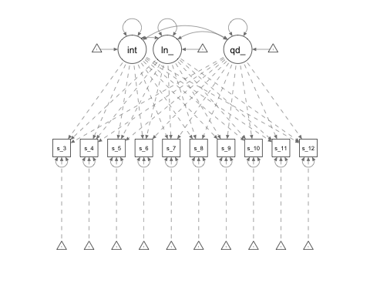

# Playing

# Step-wise modeling

To test the single group growth curve, I used a step-wise proceedure, starting with the most constrained model and iteratively freeing up parameters to see which model best fits the data. The first model is an intercept only model in which each timepoint is equally weighted so that they are all averaged together.

## lavaan (0.5-23.1097) converged normally after 40 iterations  
##   
## Number of observations 48  
##   
## Number of missing patterns 9  
##   
## Estimator ML  
## Minimum Function Test Statistic 408.924  
## Degrees of freedom 63  
## P-value (Chi-square) 0.000  
##   
## Parameter Estimates:  
##   
## Information Observed  
## Standard Errors Standard  
##   
## Latent Variables:  
## Estimate Std.Err z-value P(>|z|)  
## i =~   
## ssrt_t3 1.000   
## ssrt_t4 1.000   
## ssrt_t5 1.000   
## ssrt_t6 1.000   
## ssrt_t7 1.000   
## ssrt_t8 1.000   
## ssrt_t9 1.000   
## ssrt_t10 1.000   
## ssrt_t11 1.000   
## ssrt_t12 1.000   
##   
## Intercepts:  
## Estimate Std.Err z-value P(>|z|)  
## .ssrt_t3 0.000   
## .ssrt_t4 0.000   
## .ssrt_t5 0.000   
## .ssrt_t6 0.000   
## .ssrt_t7 0.000   
## .ssrt_t8 0.000   
## .ssrt_t9 0.000   
## .ssrt_t10 0.000   
## .ssrt_t11 0.000   
## .ssrt_t12 0.000   
## i 292.016 2.756 105.972 0.000  
##   
## Variances:  
## Estimate Std.Err z-value P(>|z|)  
## i 0.000   
## .ssrt_t3 (r) 3568.844 232.806 15.330 0.000  
## .ssrt_t4 (r) 3568.844 232.806 15.330 0.000  
## .ssrt_t5 (r) 3568.844 232.806 15.330 0.000  
## .ssrt_t6 (r) 3568.844 232.806 15.330 0.000  
## .ssrt_t7 (r) 3568.844 232.806 15.330 0.000  
## .ssrt_t8 (r) 3568.844 232.806 15.330 0.000  
## .ssrt_t9 (r) 3568.844 232.806 15.330 0.000  
## .ssrt_t10 (r) 3568.844 232.806 15.330 0.000  
## .ssrt_t11 (r) 3568.844 232.806 15.330 0.000  
## .ssrt_t12 (r) 3568.844 232.806 15.330 0.000

## npar fmin chisq   
## 2.000 4.260 408.924   
## df pvalue baseline.chisq   
## 63.000 0.000 377.499   
## baseline.df baseline.pvalue cfi   
## 45.000 0.000 0.000   
## tli nnfi rfi   
## 0.257 0.257 0.226   
## nfi pnfi ifi   
## -0.083 -0.117 -0.100   
## rni logl unrestricted.logl   
## -0.040 -2589.200 -2384.738   
## aic bic ntotal   
## 5182.401 5186.143 48.000   
## bic2 rmsea rmsea.ci.lower   
## 5179.869 0.338 0.307   
## rmsea.ci.upper rmsea.pvalue rmr   
## 0.370 0.000 1865.536   
## rmr_nomean srmr srmr_bentler   
## 1865.536 0.519 0.519   
## srmr_bentler_nomean srmr_bollen srmr_bollen_nomean   
## 0.556 0.530 0.547   
## srmr_mplus srmr_mplus_nomean cn_05   
## 0.538 0.556 10.687   
## cn_01 gfi agfi   
## 11.800 0.940 0.938   
## pgfi mfi ecvi   
## 0.911 0.027 NA

In this model, the intercept average is set to zero and residual variances are set equal to each other. As expected, this model has poor fit ($df_{M}=63$, $χ^{2}=408.92$, *p*=0.0, $RMSEA=.34$, *AIC*=5182.40). The average SSRT at the intercept (training session 1) is 292.02 with variance of 59.74 ms.

The second model is still an intercept only model with equal residual variance, but the intercept is allowed to vary. This model still fits poorly ($df_{M}=62$, $χ^{2}=146.89$, *p*<.001, *RMSEA*=0.17, *AIC*=4922.36), though significantly better than the fixed intercept model ($χ_{diff}^{2}=262.04$, *p*<.001; $AIC_{diff}=260.04$. The model intercept is still essentailly unchanged (291.60 ms) and there is significant variance around the intercept (39.60 ms, *p*<.001), which suggests that participants start off with very different inhibitory control abilities as measured by SST SSRT.

## lavaan (0.5-23.1097) converged normally after 72 iterations  
##   
## Number of observations 48  
##   
## Number of missing patterns 9  
##   
## Estimator ML  
## Minimum Function Test Statistic 146.883  
## Degrees of freedom 62  
## P-value (Chi-square) 0.000  
##   
## Parameter Estimates:  
##   
## Information Observed  
## Standard Errors Standard  
##   
## Latent Variables:  
## Estimate Std.Err z-value P(>|z|)  
## i =~   
## ssrt_t3 1.000   
## ssrt_t4 1.000   
## ssrt_t5 1.000   
## ssrt_t6 1.000   
## ssrt_t7 1.000   
## ssrt_t8 1.000   
## ssrt_t9 1.000   
## ssrt_t10 1.000   
## ssrt_t11 1.000   
## ssrt_t12 1.000   
##   
## Intercepts:  
## Estimate Std.Err z-value P(>|z|)  
## .ssrt_t3 0.000   
## .ssrt_t4 0.000   
## .ssrt_t5 0.000   
## .ssrt_t6 0.000   
## .ssrt_t7 0.000   
## .ssrt_t8 0.000   
## .ssrt_t9 0.000   
## .ssrt_t10 0.000   
## .ssrt_t11 0.000   
## .ssrt_t12 0.000   
## i 291.596 6.684 43.628 0.000  
##   
## Variances:  
## Estimate Std.Err z-value P(>|z|)  
## .ssrt_t3 (r) 1568.045 107.940 14.527 0.000  
## .ssrt_t4 (r) 1568.045 107.940 14.527 0.000  
## .ssrt_t5 (r) 1568.045 107.940 14.527 0.000  
## .ssrt_t6 (r) 1568.045 107.940 14.527 0.000  
## .ssrt_t7 (r) 1568.045 107.940 14.527 0.000  
## .ssrt_t8 (r) 1568.045 107.940 14.527 0.000  
## .ssrt_t9 (r) 1568.045 107.940 14.527 0.000  
## .ssrt_t10 (r) 1568.045 107.940 14.527 0.000  
## .ssrt_t11 (r) 1568.045 107.940 14.527 0.000  
## .ssrt_t12 (r) 1568.045 107.940 14.527 0.000  
## i 1983.812 437.496 4.534 0.000

## npar fmin chisq   
## 3.000 1.530 146.883   
## df pvalue baseline.chisq   
## 62.000 0.000 377.499   
## baseline.df baseline.pvalue cfi   
## 45.000 0.000 0.745   
## tli nnfi rfi   
## 0.815 0.815 0.718   
## nfi pnfi ifi   
## 0.611 0.842 0.731   
## rni logl unrestricted.logl   
## 0.745 -2458.180 -2384.738   
## aic bic ntotal   
## 4922.359 4927.973 48.000   
## bic2 rmsea rmsea.ci.lower   
## 4918.561 0.169 0.134   
## rmsea.ci.upper rmsea.pvalue rmr   
## 0.204 0.000 466.981   
## rmr_nomean srmr srmr_bentler   
## 466.981 0.160 0.160   
## srmr_bentler_nomean srmr_bollen srmr_bollen_nomean   
## 0.148 0.190 0.099   
## srmr_mplus srmr_mplus_nomean cn_05   
## 0.211 0.141 27.595   
## cn_01 gfi agfi   
## 30.673 0.944 0.942   
## pgfi mfi ecvi   
## 0.901 0.413 NA

## Chi Square Difference Test  
##   
## Df AIC BIC Chisq Chisq diff Df diff Pr(>Chisq)   
## model2_fit 62 4922.4 4928.0 146.88   
## model1_fit 63 5182.4 5186.1 408.92 262.04 1 < 2.2e-16 ***  
## ---  
## Signif. codes: 0 '***' 0.001 '**' 0.01 '*' 0.05 '.' 0.1 ' ' 1

The third model is a random effects slope model with fixed residuals that still allows the intercept and slope to vary, but fixes the slope intercept to zero. This model also does not fit the data well ($df_{M}=61$, $χ^{2}=122.99$, *p*<.001; *RMSEA*=.15) though it is a slight improvement over the previous model ($AIC_{diff}=21.89$, $chi_{diff}^{2}=23.89$). Although the intercept variance has decreased to 17.38 ms, both the intercept and slope have significant variance (*p*<.001 and *p*<.01).

## lavaan (0.5-23.1097) converged normally after 79 iterations  
##   
## Number of observations 48  
##   
## Number of missing patterns 9  
##   
## Estimator ML  
## Minimum Function Test Statistic 122.994  
## Degrees of freedom 61  
## P-value (Chi-square) 0.000  
##   
## Parameter Estimates:  
##   
## Information Observed  
## Standard Errors Standard  
##   
## Latent Variables:  
## Estimate Std.Err z-value P(>|z|)  
## i =~   
## ssrt_t3 1.000   
## ssrt_t4 1.000   
## ssrt_t5 1.000   
## ssrt_t6 1.000   
## ssrt_t7 1.000   
## ssrt_t8 1.000   
## ssrt_t9 1.000   
## ssrt_10 1.000   
## ssrt_11 1.000   
## ssrt_12 1.000   
## s =~   
## ssrt_t4 (s_31) 1.000   
## ssrt_t5 2.000   
## ssrt_t6 3.000   
## ssrt_t7 4.000   
## ssrt_t8 5.000   
## ssrt_t9 6.000   
## ssrt_10 7.000   
## ssrt_11 8.000   
## ssrt_12 9.000   
##   
## Regressions:  
## Estimate Std.Err z-value P(>|z|)  
## s ~   
## i 0.000   
##   
## Intercepts:  
## Estimate Std.Err z-value P(>|z|)  
## .s 0.000   
## .ssrt_t3 0.000   
## .ssrt_t4 0.000   
## .ssrt_t5 0.000   
## .ssrt_t6 0.000   
## .ssrt_t7 0.000   
## .ssrt_t8 0.000   
## .ssrt_t9 0.000   
## .ssrt_t10 0.000   
## .ssrt_t11 0.000   
## .ssrt_t12 0.000   
## i 302.041 7.477 40.398 0.000  
##   
## Variances:  
## Estimate Std.Err z-value P(>|z|)  
## .ssrt_t3 (r) 1306.976 97.625 13.388 0.000  
## .ssrt_t4 (r) 1306.976 97.625 13.388 0.000  
## .ssrt_t5 (r) 1306.976 97.625 13.388 0.000  
## .ssrt_t6 (r) 1306.976 97.625 13.388 0.000  
## .ssrt_t7 (r) 1306.976 97.625 13.388 0.000  
## .ssrt_t8 (r) 1306.976 97.625 13.388 0.000  
## .ssrt_t9 (r) 1306.976 97.625 13.388 0.000  
## .ssrt_t10 (r) 1306.976 97.625 13.388 0.000  
## .ssrt_t11 (r) 1306.976 97.625 13.388 0.000  
## .ssrt_t12 (r) 1306.976 97.625 13.388 0.000  
## i 2237.102 529.793 4.223 0.000  
## .s 24.767 8.419 2.942 0.003

## npar fmin chisq   
## 4.000 1.281 122.994   
## df pvalue baseline.chisq   
## 61.000 0.000 377.499   
## baseline.df baseline.pvalue cfi   
## 45.000 0.000 0.814   
## tli nnfi rfi   
## 0.862 0.862 0.760   
## nfi pnfi ifi   
## 0.674 0.914 0.804   
## rni logl unrestricted.logl   
## 0.814 -2446.235 -2384.738   
## aic bic ntotal   
## 4900.470 4907.955 48.000   
## bic2 rmsea rmsea.ci.lower   
## 4895.406 0.146 0.108   
## rmsea.ci.upper rmsea.pvalue rmr   
## 0.183 0.000 1070.924   
## rmr_nomean srmr srmr_bentler   
## 1070.924 0.371 0.371   
## srmr_bentler_nomean srmr_bollen srmr_bollen_nomean   
## 0.382 0.308 0.081   
## srmr_mplus srmr_mplus_nomean cn_05   
## 0.380 0.255 32.312   
## cn_01 gfi agfi   
## 35.964 0.951 0.948   
## pgfi mfi ecvi   
## 0.893 0.524 NA

When the slopes were allowed to vary and the slope could covary with the intercept, the model fit improved ($df_{M}=59$, $χ^{2}=95.12$, $χ^{2}$*p*=.002; *RMSEA*=.11, *p*.015; *CFI*=.89) compared to the second model ($χ_{diff}^{2}=51.77$; $CFI_{diff}$ =.15), though it is still not a good fit. Based on this model, SSRTs change by 17.72 ms across training points. The covariance between the slope (-3.84) and intercept (308.88) is significant (-112.68, *p*=.037), indicating that there is an interaction such that participants who started with higher SSRTs at training session 1 improve less across training sessions as compared to those with lower initial training SSRTs.

**Interpretation** = regression to the mean. The people who already had pretty good IC don’t have as much room for improvement. The slope is pretty insignificant though, so it may not mean much.

## lavaan (0.5-23.1097) converged normally after 94 iterations  
##   
## Number of observations 48  
##   
## Number of missing patterns 9  
##   
## Estimator ML  
## Minimum Function Test Statistic 95.117  
## Degrees of freedom 59  
## P-value (Chi-square) 0.002  
##   
## Parameter Estimates:  
##   
## Information Observed  
## Standard Errors Standard  
##   
## Latent Variables:  
## Estimate Std.Err z-value P(>|z|)  
## i =~   
## ssrt_t3 1.000   
## ssrt_t4 1.000   
## ssrt_t5 1.000   
## ssrt_t6 1.000   
## ssrt_t7 1.000   
## ssrt_t8 1.000   
## ssrt_t9 1.000   
## ssrt_10 1.000   
## ssrt_11 1.000   
## ssrt_12 1.000   
## s =~   
## ssrt_t4 (s_31) 1.000   
## ssrt_t5 2.000   
## ssrt_t6 3.000   
## ssrt_t7 4.000   
## ssrt_t8 5.000   
## ssrt_t9 6.000   
## ssrt_10 7.000   
## ssrt_11 8.000   
## ssrt_12 9.000   
##   
## Covariances:  
## Estimate Std.Err z-value P(>|z|)  
## i ~~   
## s -112.681 53.896 -2.091 0.037  
##   
## Intercepts:  
## Estimate Std.Err z-value P(>|z|)  
## .ssrt_t3 0.000   
## .ssrt_t4 0.000   
## .ssrt_t5 0.000   
## .ssrt_t6 0.000   
## .ssrt_t7 0.000   
## .ssrt_t8 0.000   
## .ssrt_t9 0.000   
## .ssrt_t10 0.000   
## .ssrt_t11 0.000   
## .ssrt_t12 0.000   
## i 308.882 8.057 38.338 0.000  
## s -3.836 0.838 -4.576 0.000  
##   
## Variances:  
## Estimate Std.Err z-value P(>|z|)  
## .ssrt_t3 (r) 1277.035 93.395 13.673 0.000  
## .ssrt_t4 (r) 1277.035 93.395 13.673 0.000  
## .ssrt_t5 (r) 1277.035 93.395 13.673 0.000  
## .ssrt_t6 (r) 1277.035 93.395 13.673 0.000  
## .ssrt_t7 (r) 1277.035 93.395 13.673 0.000  
## .ssrt_t8 (r) 1277.035 93.395 13.673 0.000  
## .ssrt_t9 (r) 1277.035 93.395 13.673 0.000  
## .ssrt_t10 (r) 1277.035 93.395 13.673 0.000  
## .ssrt_t11 (r) 1277.035 93.395 13.673 0.000  
## .ssrt_t12 (r) 1277.035 93.395 13.673 0.000  
## i 2659.565 634.599 4.191 0.000  
## s 17.716 7.013 2.526 0.012

## npar fmin chisq   
## 6.000 0.991 95.117   
## df pvalue baseline.chisq   
## 59.000 0.002 377.499   
## baseline.df baseline.pvalue cfi   
## 45.000 0.000 0.891   
## tli nnfi rfi   
## 0.917 0.917 0.808   
## nfi pnfi ifi   
## 0.748 0.981 0.887   
## rni logl unrestricted.logl   
## 0.891 -2432.297 -2384.738   
## aic bic ntotal   
## 4876.594 4887.821 48.000   
## bic2 rmsea rmsea.ci.lower   
## 4868.997 0.113 0.069   
## rmsea.ci.upper rmsea.pvalue rmr   
## 0.154 0.015 402.684   
## rmr_nomean srmr srmr_bentler   
## 402.684 0.125 0.125   
## srmr_bentler_nomean srmr_bollen srmr_bollen_nomean   
## 0.125 0.197 0.089   
## srmr_mplus srmr_mplus_nomean cn_05   
## 0.209 0.117 40.327   
## cn_01 gfi agfi   
## 44.987 0.966 0.962   
## pgfi mfi ecvi   
## 0.876 0.686 NA