5MMCS001W – 3D Interactive Media Development Group Report
Joseph Calabro W1635359, Byron Serrano W1657638, Fatimah Firdous W1587978

Concept and Design:
Our goal for this project is to create a 3D interactive toy shop, this will be done through the use of 3D models with animation in Unity. The problem with a lot of online stores is that you can’t fully see what it is your buying until you’ve received the item. This project aims to fix that problem by providing an environment where the user can view and interact with different models/toys so that they have a full understanding of what the product actually is. This will be achieved through an application that guides the user through the toy shop while explaining how they can easily interact with the product making for a safe and user-friendly experience.
The project will be designed in such a way that the user will be able to travel to and from various parts of the toy shop but in a linier way using waypoints, this is so the experience flows well and doesn’t give the user a lot to think about. The application will start on the outside of the shop, the user will be given a welcome message with instructions on how to proceed. Clicking on the front doors of the shop will open them and move the camera into the shop and onto the next way point. The user will now be at the front desk. Buttons each labelled with a toy designer (a member of our group) will be displayed. Clicking on one of these buttons will move the camera to the next way point, the shelf. At the shelf the user will be able to select a toy (3D model) created by the selected designer from a list. They will then be able to interact with that given model. The user will be able to rotate the model and toggle various things such as, animation, wireframes and shader effects. At any point the user can click on a button at the bottom of the screen to go back to the previous waypoint.
When coming up with this idea we based the way the user could interact with models off the game Overwatch. In Overwatch the player can choose between multiple characters to play as. Each character can be customised with different cosmetics one of which is skins (Changes the characters appearance). When selecting a skin for a character the user has a list of different skins to choose from and can rotate the characters model to view the changes. For our project we aim to capture this simple and easy to use design but give it more interactions so that it is not as simple as just rotating a model.

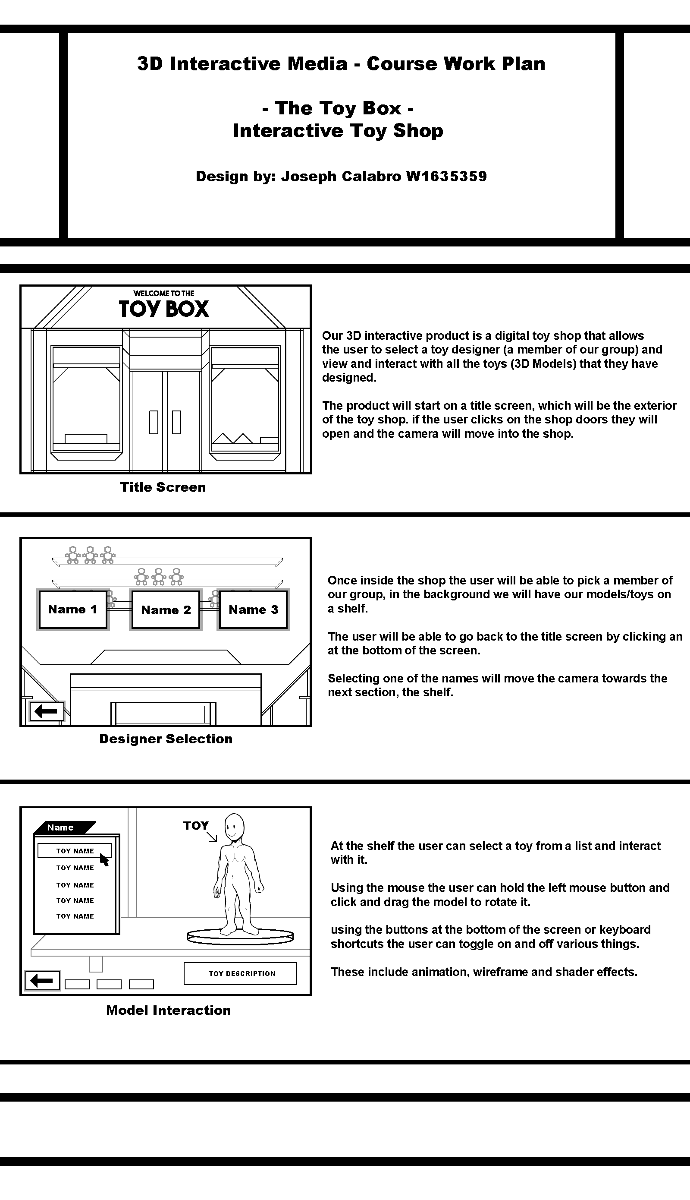
Design Diagrams: Storyboard

Above you can see a storyboard showcasing a rough design of the described concept.
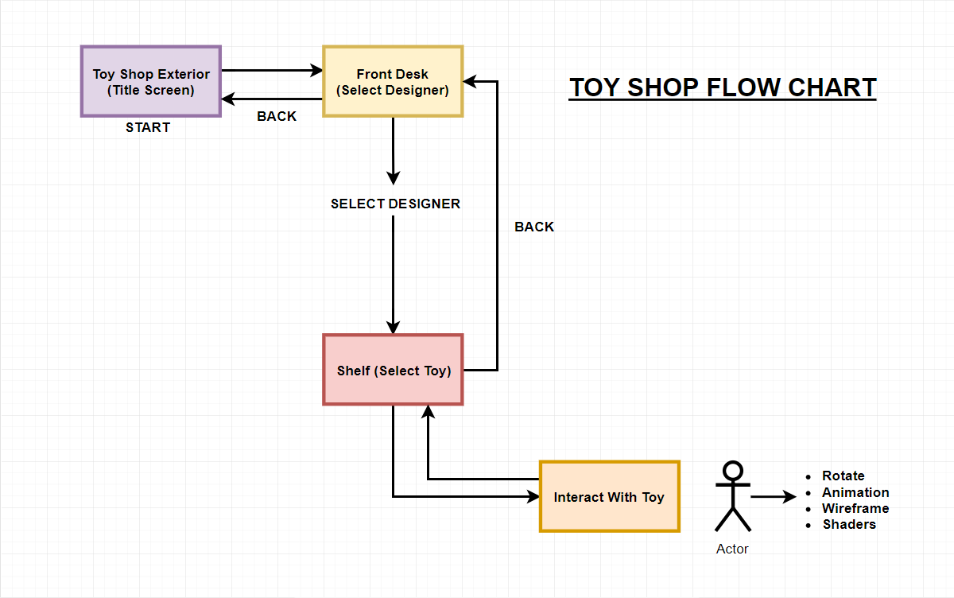
Design Diagrams: Flow Chart

Above you can see a flow chart which shows step by step the designed navigation throughout the toy shop. The user will be able to move to each waypoint in the toy shop as described.
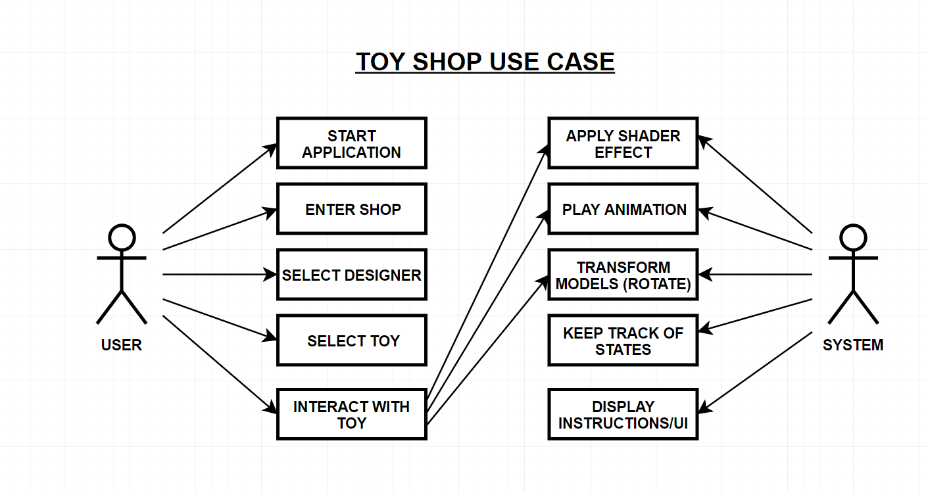
Design Diagrams: Use Case

Above you can see a use case diagram showing the different actions the user and system will take in the application.
Project Methodology
Our group work flow will follow the waterfall project methodology. This means we will give each other tasks based on the progress that has been made. This work flow is the safest as it creates a step by step allocation of tasks making for a steady progression, allowing us to improve and advance from our current position in the project.
Commercial Analysis
A lot 3D interactive media tends to be similar in that the user is given a 3D scene or environment to explore and interact with. The majority of which usually being for education or model showcasing for portfolios. Our 3D interactive product leans more towards the showcasing type, as we are going to create an application that is essentially used to look and interact with our created models. However, we are presenting our application as a service where the user can view and interact with products from various companies, giving it more commercial viability.
Online products tend to be viewed through pictures and videos, while some companies provide an embedded 3D viewer which allows the user to view some products in 3D, this is not the norm and sometimes isn’t perfect. Our 3D interactive product aims to make viewing products in 3D a lot better. On a grander scope our interactive application would allow the user to select from a vast range of companies and allow for all their products to be viewable in a 3D in an interactive way. Such an application is yet to exist making it something that could potentially be useful in today’s modern society.
It could also be said that this application is something that isn’t necessary as other 3D viewing applications exists, and companies that would like to show off their products in 3D could just embed existing applications such as Sketch Fab, or better yet design their own embedded 3D viewer.
Our application could be the first designed specifically for commercial products. Offering partnerships with various companies, having an assortment of 3D interactable products all under one application that could also be embedded on product pages for simplicity and ease of use.
Navigation Framework
Our navigation framework will make use of both mouse and keyboard inputs. However, the primary source of input will be the mouse. Each section of the shop (The entrance, front desk and shelf) will be a separate waypoint that the camera will move to depending on the current global state of the application. Each camera will have subtle movement relative to mouse position, creating a satisfying and interactive feel even when the user isn’t directly interacting with a model.
On the opening screen the user will be given instructions and visual clues on how to progress. For example, the front doors of the shop could glow with a particle effect to indicate that it is clickable. Once clicked on the user will move to the front desk where they can click on displayed buttons to progress or go back. Clicking on one of our group member’s names will move the camera to the next waypoint at the shelf where they will be able interactive with a range of models that they can choose from. While at the shelf the user can click on buttons at the bottom of the screen or their keyboard shortcuts to interact with the model. Left clicking and dragging on a model with allow the user to rotate it so that it can be viewed from any angle. There will be a button to reset its position.
To move back to a previous waypoint the user can click the back button which will be at the bottom left corner of the screen.
Animations
We will aim to have an animation for each model that the user can interact with. These animations will be triggered when the user clicks on the animation button or its keyboard counterpart. If an animation can loop like our Lego mini-figure walk cycle, then it will play continuously until stopped by the user, otherwise the user will have to play the animation again after it has ended. We will also try to include some narrative environmental animations that help make the toy shop more believable, for example we could have a toy trainset that’s constantly moving via scripted movement around the shop in the background. Or a jack-in-the-box that occasionally animates in the background. Anything that will help enhance the visuals of our application will be closely considered alongside what we have done and how much time we have left. Environmental animations aren’t the focus of the project and so if time is short we may have to discard some of our ideas to focus on the functionality of the application.
Lighting, Shaders and Texturing
Making our application visually appealing is essential so that it grabs people’s attention. We will be trying to create a warm looking toy shop on a winter night, so using warm hues for lighting will be important. Using a mix of yellows, reds and oranges with varying levels of saturation to subtly light the scene will help make the environment look warm and inviting. To contrast this, the exterior of the shop will make use of colder hues such as blue and purple for lighting.
To enhance the realism of the models and textures we will make use of a variety of shaders. Lego figures are made of plastic, so our models of Lego figures will need to make use of glossy shaders to make them look as if they are made from plastic. A lot of the background models can make use of Unity’s default diffuse shader with textures to make them appear as if made from another material, as background models won’t be entirely visible most of the time, so we can afford to be more CPU efficient. Some models may need shaders specific to them for example a model of a cartoon/anime character will probably look much better with flat-colour/toon/cel-shading shaders.
UI Efficacy
The goal of a UI (User Interface) is to be easily accessible so that navigating through an application is a thoughtless process. A UI needs to be easily distinguishable from background material and needs to give the user feedback. This can all be achieved through simple designs, good colour choices and animations such as hover effects.
The UI for our 3D interactive application will make use of buttons each with glow hover effects so that the user is aware of what they are selecting. We will make sure the colours chosen for UI elements contrast background elements so that it is easy for the user to understand what they can interact with. We will also try to make the UI fit the theme of the toy shop so that there is no direct disconnect between UI and the theme of the application. Getting the right balance and design for the UI will be important so ensure there is no clash between the UI, background elements and the theme of the application.

