INSPECTION+

**DRONE HEALTH CHECK**

REPAIR, MAINTENANCE & SERVICING

{drone\_name}

Service Date: {date}

Technician: {technician} Approved by: {supervisor}

**UK Head Office**



Unit 6 The Old Flour Mill, Queen Street, Emsworth, Hampshire, PO10 7BT



**Drone Information**

**Owner: {company}**

**Aircraft Model: {aircraft\_model}**

**Manufacturer:** {**manufacturer**}

**Aircraft Type: {aircraft\_type}**

**Serial No**: **{serial\_no}**

|  |  |  |
| --- | --- | --- |
| **image_1** | **{image_1}** |  |
| **{image_1}** | **{{image_1}}** |  |

**01 | Inspection**

**1.1 | Function Inspection**

**Obstacle avoidance system:** Check obstacle avoidance system functions correctly.

**Image transmission system:** Check photo and video capturing and image transmission stability.

**Propulsion system:** Check propulsion system.

**Notes: {function\_inspection\_notes}**

✔

✔

✔

**1.2 | Visual Inspection**

**Sensors:** Inspection of sensors for damages and scratches.

**Aircraft:** Inspection of propellors, legs, antenna, and drone body (for cracks).

**Notes: {visual\_inspection\_notes}**

✔

✔

✔

✔

✔

**Battery & Battery compartment:** Check whether the Battery or Battery compartment damaged.

**Gimbal and Camera:** Check whether the gimbal and camera are damaged.

**Motor and Aircraft Arm:** Check whether the motor or aircraft arm is damaged, and check whether the motor can rotate smoothly or whether the aircraft arms can be folded and unfolded smoothly.

**Remote Controller & Accessories:** Check whether the remote controller or other accessories damaged.

✔

**2 | Maintenance Record**

**2.1 | Clean**

**Aircraft Body**

✔

**Notes: {deep\_clean\_notes}**

✔

**Antenna**

**Battery compartment**

✔

✔

**Motor**

✔

**Gimbal**

**2.2 | Calibration**

**IMU Calibration**

✔

**Notes: {calibration\_notes}**

**Vision sensor calibration**

✔

✔

**Compass Calibration**

✔

**RC Calibration**

**2.3 | Firmware update**

**Remote controller firmware update**

**Notes: {firmware\_update}**

✔

✔

**Aircraft firmware update**

✔

**Battery and Battery compartment Firmware Update**

**2.4 | Additional Repairs**

✔

**Check:** Additional repairs (pre-authorised)

✔

**Notes: {additional\_repairs\_notes}**

**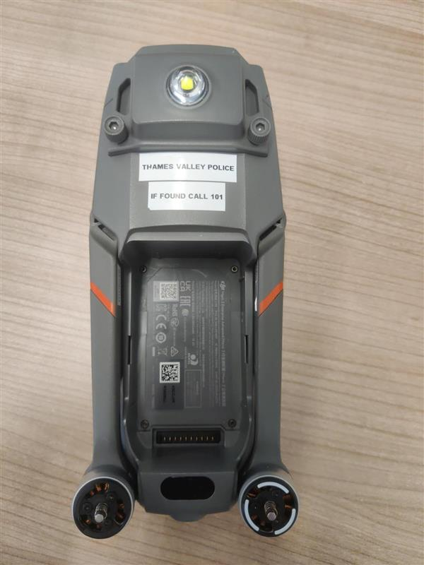**

**3 | Battery**

**3.1 | Battery health**

**Notes:** None

Once the drone is back in your hands, please can you check all the settings and please do your own due diligence before flight.

**Mr B. Coleman**

Technical Manager

****

Questions?

Let’s talk about it!

If you have any questions or queries about your report, call our team of experts on **01243 370 296** or

send your questions to [**sales@ired.co.uk**](mailto:sales@ired.co.uk)

**Disclaimer**



The information contained in this report is believed to be accurate at the time and date of issue, but no representation or warranty is given - express



or implied - as to its accuracy, completeness or correctness.