
DATA STRUCTURE AND ALGORITHMS
Classroom: Estructura de Datos SDA


6 de enero de 2026
carlos.herrera@upa.edu.mx

https://github.com/ISC-UPA/2026-1-TIID4-SDA

Contenido
1. S01_W01 2
1.1. Referencias 2
1.2. Technological Requirements 2
1.3. Variables de Entorno 2
1.3.1. Java 2
1.3.2. Python 2
2. S02 3

S01_W01

Referencias
https://www.w3schools.com/dsa/index.php
Book: Introduction to Algorithms, Fourth Edition, The MIT Press, 2022

Technological Requirements
Python https://www.python.org/downloads/windows/
https://graphviz.org/download/
o
Windows Package Manager provides Graphviz Windows packages.
C:\> winget install graphviz

Java JDK https://www.oracle.com/java/technologies/downloads/

VS Code https://code.visualstudio.com/Download
Extensions: Extension Pack for Java
Extensions: Python Extension Pack

Variables de Entorno

Java
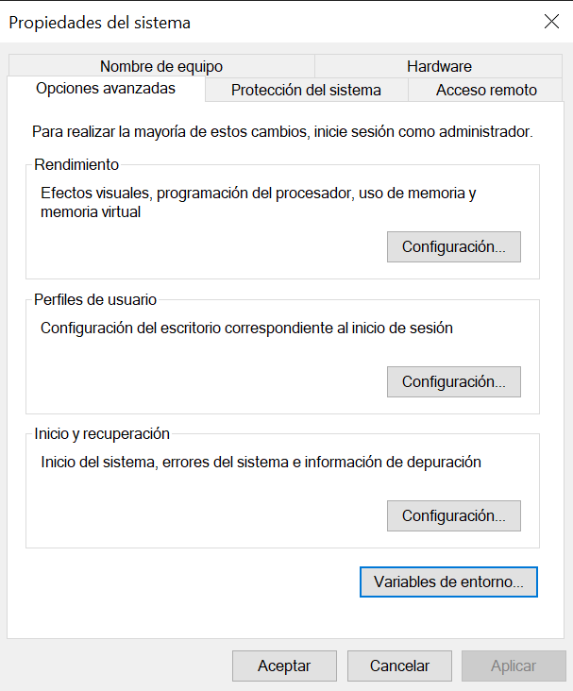 | 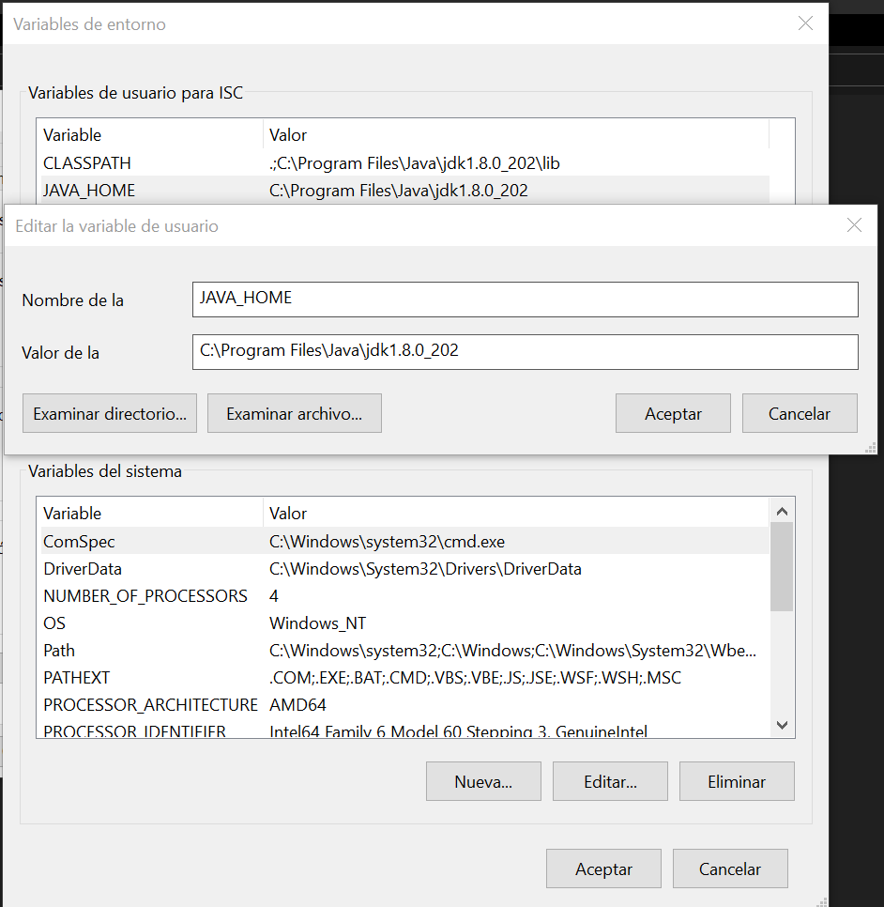

Panel de control -> Sistema -> Configuracion avanzada del sistema
Opciones avanzadas -> Variables de entorno -> Variables de Usuario
JAVA_HOME  C:\Program Files\Java\jdk1.8.0_202 | PATH  %JAVA_HOME%\BIN
CLASSPATH  . ; %JAVA_HOME%\LIB | Probar Instalación desde CMD  C:\>java -version (correr)  C:\>javac -version (compilar)

Python
GRAPHVIZ_DOT  C:\Apps\Graphviz-13.1.2-win64\bin\dot.exe | PATH  C:\Apps\Python313\  C:\Apps\Python313\Scripts\  C:\Apps\Graphviz-13.1.2-win64\bin

S02

