Refactoring the Java Card Framework
Geraud Campion – geraud@seas
Michael O’Connor – mpo@seas

Faculty Advisor: Steve Zdancewic
With the Help of: Alwyn Goodloe

Abstract
Our project involves Smart Cards. Smart Cards (SC) have a small CPU and a limited amount of memory; they interact with a terminal specifically programmed to interact with a SC. SC and Terminal programs are devleoped in Java, however SCs use a language that is subset of Java, for this project we assumed that it was a strict subset, referred to as Java Card language (JCL), and they have to be programmed around receiving data from the terminal they are being used with. So not only are Smart Card programs limited by the language restraints, master-slave interaction they have with the terminal is another limitation. Our project hopes to alleviate the master-slave portion of this problem. We will modify a Java compiler to allow SC code that can request the terminal to do work for it.
Our project will take in a Java program with both Terminal code and SC code written in the same file. The code will make use of Java annotations to determine what resources (methods and fields) are card resources and what resources are terminal resources. The program will then translate the card and terminal code to allow the SC program to send a request to the terminal, and wait for a response. The crux of this translation is that it allows the SC and terminal programs to maintain their states while this unintended request is processed

Related Work

- The Current State of Smart Cards
Smart Card technology has been a part of the industry since 1978. Originally, Smart Cards were little more than a RAM, but they have evolved to include small CPUs capable of running a subset of Java. Programming in Java Card is similar to writing semi-assembly Java code. This has been an impediment to the development of even the most basic applications for Smart Cards. Still, Smart Cards have survived and have gone a long way, encouraging much development and research. This is in part due to its use in Europe where Smart Cards are very prevalent today, with applications ranging from payphones to banking and even cell phones.
Smart Cards have many purposes. People use them for identification, keys, bankcards, even military dog tags. As Smart Card technology has progressed over the years, researchers have dedicated their largest focus on security and more advanced applications. One of the most recent large studies was done by the 7th IFIP WG 8.8/11.2 International Conference of Tarragona, Spain in April 2006. The Conference addressed quite a few topics about Smart Card applications. Most of the topics were about security-based matter including cryptography, internet authentication, certification, and access control.

- The Advantage of a Translator
The final goal of this project is to create a translator that allows developers to create SC programs in a strictly Java environment. It is the goal of many programmers to write more advanced SC programs. In order to do this more easily, the actual framework must improve. The finished translator project will give programmers the ability to create programs in which the terminal and the card can make arbitrary calls to each other without giving the impression that the communication works in a master-slave relationship. There are a few advantages to this. Namely, it will be much easier for SC developers to create programs without the need to know the intricacies of Card-Terminal communication. Another advantage is that normal Java programs will more likely be SC compatible with little or no modification. Exceptions are also a tedious part of Java Card Programming. The translator automates the generation of these exceptions.
Since shipping work off to the terminal is much easier, now just a method call away to the programmer instead of a rigorous translation, the richer language set and added power of the terminal are available to make his SC code more robust. It does this by inserting the necessary error checking and translation automatically, which gives the programmer more time to spend developing a richer product. A secondary advantage is having the SC and terminal code in the same file. This greatly alleviates the debug time that we learned about in writing our own SC and terminal project, since there is no need to move between folders and projects to see what method to call, or what parameters to pass, etc.

- Previous Research for a Translator
Peng Li and Steve Zdancewic from The University of Pennsylvania have recently studied Java Card technology, especially with card-to-terminal control flow. Their work provides a great model for the kind of work that this project will be tackling. It explains the host-card relationship and optimization, a focus of this project.
This paper outlines a way to allow the card to call the terminal. It uses a concurrent thread or ‘trampoline’ model to break the master-slave model that currently is used by the SC. The translation they outlined was the basis for our translation, though we needed to modify things slightly for a few reasons. The paper shows how to translate a SC program, not a terminal program. It creates a scheduler and modified SC programs that are meant to take the place of the SC program that was initially created. It also gave us the idea to create a Battleship program, which we used last semester to learn SC programming, and use as the example program that our code translates.

- Important Resources
We have used a few important resources. The first source we used was “How to Write a Java Card Applet: A Developer’s guide”, by Zhiquen Chen. This is an in-depth guide to writing a basic money transaction Java Card program, called “Wallet”. This was useful because the simplest way to learn a new programming language is with a hands-on example. The second source was the Java Card API by Sun Microsystems. This is obviously an important source as it assisted us when we started to create our own Java Card program. Another helpful resource was C. Ortiz’s “An Introduction to Java Card Technology - Part 1”. This site presented very good diagrams and explanations of the Java Card command and response APDUs. This document also defined possible Class and Instruction Values. Our fourth source was the Java Card Developer Forum hosted by Sun Microsystems. The people in this forum were very helpful in answering very specific questions, especially problems that were not addressed elsewhere and coding problems that did not return errors.
Later in our project, we used Steve Zdancewic and Peng Li’s paper on “Advanced Control Flow in Java Card Programming.” Since this is the basis of our project, it constitutes as a main resource of our project for obvious reasons. The next important resource is the Ocaml website: <caml.inria.fr>. This is important because we will be developing the translator on top of Java compiler written in Ocaml. This leads to the last important resource, Stephen Tse’ Java compiler. This compiler can be found at <http://www.cis.upenn.edu/~stse/javac/>.

Technical Approach

- The Creation of a Java Card Program
  - Setup
We had started on a “Hello World” Java Card program. This was simple and we learned that each Java Card program requires a “install” and “process” method. The “install” method registers an applet, or Java Card application. The “process” method is called every time the terminal sends a command to the card. This method usually consists of a large switch statement, which selects another private method, depending on the APDU instruction.
Our next step involved following the tutorial, “How to Write a Java Card Applet: A Developer’s guide”, by Zhiquen Chen. This tutorial gave us a better grasp on how to write a more in-depth Java Card program. We then started on our program, which is a Battleship game in which the card plays against the terminal. The game is played on an n x n – sized board with n ships of size 1. For simplicity, we chose to use a board of size 5 x 5. The goal of this program is to prevent the card and terminal from cheating. For our purposes, this means 5 things:
1. The card should never see the terminal’s original setup.
2. The terminal should never see the card’s original setup,
3. The terminal should not be able to move its ships after starting.
4. The card should not able to move its ships after starting.
5. The card or terminal should not go out of turn.
To solve problems 1-4, we used MD5 hashing; to solve problem 5, we used states. We discovered soon enough that our task would be slightly difficult because Java Card only allows Boolean, Byte, and Short types.

  - The Application Protocol Data Unit
In order to understand the control flow of our program, it would be easier to understand the Command and Response APDUs first. Figure 1 shows the possible formats of the Command APDU that the terminal sends to the card. The APDU consists of a Class (CLA), an Instruction (INS), two Parameters (P1, P2), the length of the data field (Lc), a Data Field, and the Response Length (Le).
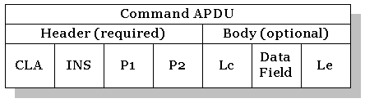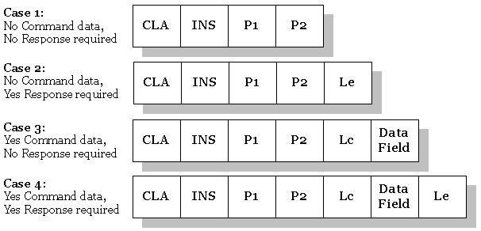
Figure 1: Possible Formats of the Command APDU, from Ortiz, C. Enrique.

The card, in turn, sends a response APDU back to the terminal. The response format is given in Figure 2. There is a Data Field, and two status words (SW1, SW2).
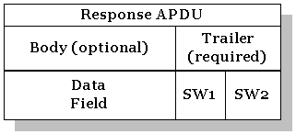
Figure 2: Format of the Response APDU, from Ortiz, C. Enrique.

  - Implementation
In our implementation, the card has four states and four methods. The first method is “Init Boards”. This function takes a “size” (5) as an input parameter and creates five game boards. It first creates a 5 x 5 board called “cardHasShip”. It randomly places 5 ships on this board. This function also takes as input “numHashBytes”; we use 8 bytes for hashing. It then creates a 5 x 5 x 8 board called “cardBeforeHash”. 25 random 8-byte numbers are created and placed in this board. A third 5 x 5 x 8 board, “cardAfterHash”, is created by taking each of the 25 “cardHasShip” Booleans and each of the 25 “cardBeforeHash” numbers and passing them through a MD5 hashing function. The function XORs the Boolean (as 0 or 1) with the first random byte out of the 8 bytes, it then passes the resulting 8 bytes through the MD5 hashing function and stores the first 8 bytes of the result in the corresponding element of “cardAfterHash”. The “Init Boards” returns “cardAfterHash” as a response. The function also takes as input, a 5 x 5 x 8 “termAfterHash” board in the data field of the APDU. This is saved and another 5 x 5 board, “termHasShip” is initialized to nulls.
The second card method is called “Attack Card Cell”. This method takes as input the terminal’s attack guess. This guess must be between 0 and 24, or an error is returned. In response, it sends the “cardHasShip” Boolean for that location and “cardBeforeHash” for that location. These two values allow the terminal to rehash and check the result to see that it matches “cardAfterHash” for that location and make sure the card is not cheating.
Because the terminal can only send commands and the card can only send responses to these commands, there are two methods required for attacking the terminal. The third card method is called “Attack Terminal Cell”. This method takes as input a guess (to allow user input). If the guess is out of the range of possible cells, i.e. -1 or 200, the card assumes that it should make a random guess and it sends this guess as a response.
The fourth method is called “Attack Terminal Cell Response”. This takes as input the “termHasShip” Boolean and the “termBeforeHash” for the requested location in the previous method, “Attack Terminal Cell”. The card then rehashes the two values and checks the result to see that it matches “termAfterHash” for the location, to make sure the terminal is not cheating. The card checks to see if there are five hits in “termHasShip” and returns a Boolean response to the terminal, declaring whether or not it has won yet. The APDU for the four described methods is given in Figure 3.
Name |  | INIT BOARDS | ATTACK CARD CELL | ATTACK TERM CELL | ATTACK TERM CELL RESPONSE
Command | CLA | B0 | B0 | B0 | B0
Command | INS | 30 | 40 | 50 | 60
Command | P1 | 5 size | 0 <= P1 < 25 attack cell | if (0 <= P1 < 25) attack cell, else attacks random cell | 0
Command | P2 | 8 numHashBytes | 0 | 0 | 0
Command | Lc | C8/200 | -1 | -1 | 9
Command | Data Field | termAfterHash = 200 bytes | null | null | (termBeforeHash, boolean)=9 bytes
Command | Le | -1 | -1 | -1 | -1
Response | Data Field | cardAfterHash = 200 bytes | (cardBeforeHash, boolean)=9 bytes | AttackCell= 1 byte | card Has Won boolean = 1 byte
Response | SW1 | -- | -- | -- | --
Response | SW2 | -- | -- | -- | --
Figure 3: APDU layout for the 4 card methods.

The four states that keep the terminal from going out of turn are as follows: “waiting for: attack card cell”, “waiting for: attack terminal cell”, “waiting for: attack terminal cell response”, and “card won”. For simplicity, we have the terminal attack first, so the state upon initializing the boards is “waiting for: attack card cell”. After the terminal calls “Attack card cell”, the card’s state is “waiting for: attack terminal cell”. After the terminal calls “Attack terminal cell”, the card’s state is “waiting for: attack terminal cell response”. After the terminal calls “Attack terminal cell response”, the card’s state is either “waiting for: attack card cell” or “card won”, depending on whether or not the card has won (or error if the card has reason to believe the terminal has tried to cheat). Once the card is in a win state, it refuses any other method calls except re-initialization. By mid-November, we had completed writing a Battleship game for both the terminal and card.

- The Creation of the Ocaml-based Java Translator

  - Preparation
After writing the Battleship code, we had to learn Ocaml in order to use Stephen Tse’ Java Compiler. This was a big step, considering neither of us had ever written in a functional programming style. This involved reading through O’Reilly’s Objective Caml manual that can be found at the reference Ocaml website. Later on with the project, we did have trouble with the language, in terms of debugging and writing it. Many times, the compiler does not return very descriptive errors. However, after writing a lot of Ocaml code, we did not have as severe language problems.
After learning some functional programming, we had a very large and robust Ocaml program to examine. Using Stephen’s Java compiler, whose module dependencies are diagramed in Figure 4, we recursively read through lists (i.e. bdylist_flat), appended and concatenated lists, returned tuples of arbitrary type, and read a lot of Ocaml code. After reading through the Ocaml code of the compiler, primarily jtyped.ml, we were better suited to write our own code that used type-inferencing and became more adept at reading through code and modifying our own code to take advantage of the language.
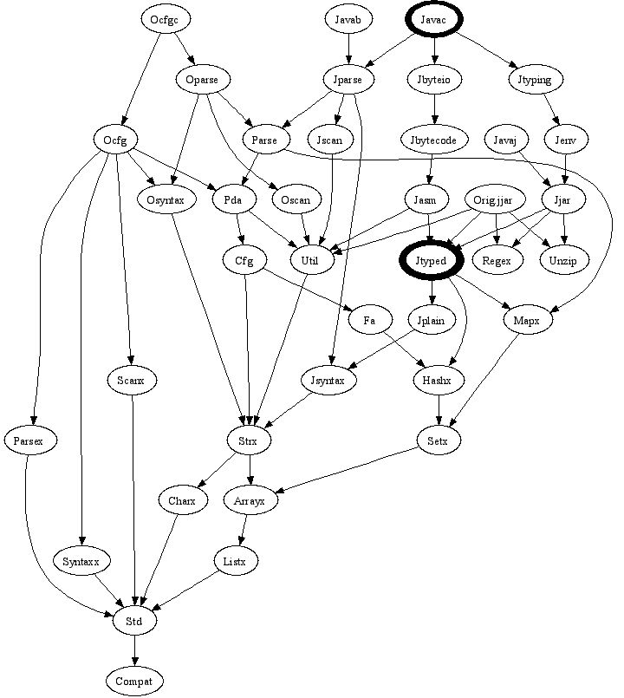
To translate a program, we split our project into four parts: Flatten (Jflat.ml), Split (Jsplit.ml), Check (Jcheck.ml), and Translate (Jtrans.ml and genFiles.ml). The reason these four parts were split up was due to the different aspects of the Syntax Tree (ST) they worked with/modified, and where we wrote our changes. Flatten dealt with the base aspects of the ST and reworked the ST for the code to be compiled. Split worked at the method declaration level, as did Check, however check went to the expression level of the tree. Translate again dealt with the base aspects of the ST, however it wrote out changes to a separate java file, which would end being the final Card language code, and the final Terminal code.
Figure 4: Java Compiler Module Dependency Tree
Flatten:
Flatten is the first piece of translator to go over the inputted code. For us it was meant to accomplish multiple things; 1) have us learn the structure of the compiler and Typed Syntax Tree (TST), 2) to alter the TST of the code to be translated, 3) and get us accustomed to programming in OCaml. The purpose of Flatten is to check if any expressions, other than assignment, had method calls in as part of that expression. For example: 5 + foo(), foo( goo() ), if( boo() ), etc. To do this we checked the TST of the compiled code. The TST was split into different levels: ctask: list of cunits; cunit: package, import list, or decl list; decl: class, interface, annotation, or enumeration decleration; body: method decleration, field init, etc; stmt: a statement (i.e. while (true) { }); and exp: an expression (i.e. 5 + 10).
For this piece of the translator, we dealt mostly with the stmt and exp level of the TST. To check the statements we have a method flt_stmt that returns a list of statements, which could contain new code and modified statement or the stmt that we were checking. For each statement, we checked to see if any of the exps that it contained had a method call in it, the method exp_flt or elist_flat is the initial check for this. Either we then created a statement list that contained the stmt unchanged or a block of code that contained stripped out method calls and the modified stmt. The code that stripped out the method calls and modified the exps that were part of the stmt was the method flt_exp.
flt_exp and elist_flat called the method elist_flat_fin, which returned a pair of types; stmt list and exp, to check a given expression to see if it is a method call (or invoke). Taking note of how variables may not be of type void, if a method was of type void we knew it could not be used in an assignment or as an expression other than of type: foo( ) not g( foo( ) ). Using this, if we found an exp of type invoke (expst1) of type non-void T1, we would check its parameter list, expst1, for ‘bad’ exps with elist_flat_fin. This would return a pair (s1, e), we then concatenate to the s1 a new stmt that creates a new variable of type T1, and next a new exp to load the value of the variable. The return value is the pair of these two values. If the exp was not of type invoke (expst1) of type non-void T1, we would just check its exp list (if there was one) and returned the value of what this check returned.
PROGRAM.java
SUPPLIED COMPILER
Jflat.ml
Jcheck.ml
Jsplit.ml
Jtrans.ml
genFiles.ml
Typed Syntax Tree
TermMeths.txt
CardMeths.txt
BadMeths.txt
Card.java
Term.java
Figure 5: Translation Module Dependency Tree.

After writing this code, we had a very large and robust Ocaml program under our belt. We did have trouble with the language, in terms of debugging and writing it, later on with the project but after this was complete, we did not have as sever language problems. In this program we recursively read through lists (i.e. bdylist_flat), appended and concatenated lists, returned tuples of arbitrary type, and read a lot of Ocaml code. Reading through the Ocaml code of the compiler, primarily jtyped.ml, we were better suited to write our own code that used type inferenceing and became more adept at reading through code and modifying our own code to take advantage of the language.
The major problem we worked through in this part of the project was the decision of what to return for the functions elist_flat, elist_flat_fin, and flt_exp. The difficulty was to determine the best way to maintain our modified stmt lists and exps as we traversed down the syntax tree and across exp lists for each exp. Using Ocaml was actually a benefit in this context, since it deals with tuples and lists natively. In this way, we were able to return two different types as a tuple. Reading down the syntax tree as well as reading across an exp list, was all another minor issue since we were working recursively. We fixed this by having helper functions, like exp_list_flat as a helper function for flt_exp. Another problem we encountered with this part of the project was learning Ocaml, this was our first big Ocaml program and we had a rough learning process with errors and debugging.
    - Performing Scheduler Creation
A large part of building the Java Card Translator involves creating a Scheduler. The Scheduler controls the flow of the Java program so that the code on the card will run in the right order when it is translated. The Scheduler keeps a stack of frames. These frames hold the states, which are used by different blocks of code. The Scheduler also keeps the current state of the Java program. It contains a “goto” function to change this state. The main part of the Scheduler is a while loop that contains a switch depending on the current state. The switch contains a long list of the possible states, and depending on the current state, goes to function that that state points to.
This function is one of a list of functions in another component of the Scheduler. Each line of code from the original code annotated for the card may be translated into a new block, or function that is added to the Scheduler. This translation happens in seven different cases. The seven block translations take care of entering frames, leaving frames, going to the next state, and exceptions for the trampoline-style code.
genFiles.ml creates the Scheduler java files, using input template java files and the programmer’s files. For each function annotated for the card, an entry function and an exit function is created in the outputted Scheduler files. The blocks are then added to the Scheduler if the corresponding input line needs to be translated. At the same time, a case is added to the Scheduler’s switch statement.

    - Performing Paper translation
To perform the translation that the paper defined we had preliminary steps to do first. First, we had to determine which methods were for the card, which were for the terminal, or which should have been on both (Jsplit.ml), next to determine which card methods called terminal methods both directly and indirectly (Jcheck.ml), finally we did the actual translation of the card methods (Jtrans.ml). The only card methods to be translated were ones that directly or indirectly called card methods, no other card methods were translated.
To determine which methods should be on the card, terminal, or both we had to use Java implemented annotations. They work as class, method, field, interface, etc. annotations. They are just the ‘@’ symbol before a method or field name: @CARD/@TERM public int foo (). If no annotation was present then the method is meant for both the card and terminal. Using this, Jsplit.ml goes through the TST until the body level. At the body level, we check the modification list, which holds things such as public/private, static, annotations, synchronized, etc., to see if it contains an annotation for ‘CARD’ or ‘TERM.’ Depending on what the annotation is the method name gets stored in CardMeth.txt, TermMeth.txt, or both.
foo
goo
bar
h
getname
getage
getpin
h
Once Jsplit completes, we then check to see which methods on the card are ‘bad’ or not. A bad method is a card method that calls a terminal method or card method that calls a card method that calls a terminal method directly or indirectly. Jcheck does this check, using the following algorithm: check each method in the CardMeth.txt file to see if in the method it calls a terminal method or a bad method. It checks this by going through the TermMeth.txt and the BadMeth.txt. If the method exists in one of those two files put the current method into BadMeth.txt, unless the method name is already there. Do this for all methods on the card until no names are added to the BadMeth.txt for a whole iteration through the CardMeth.txt file. When this program finally stops, there is a text file of methods from the card that need to be translated.
Fig.6:methods in red to be translated. Methods on left on card, right on terminal
Finally, with the list of ‘bad’ methods, we have the pieces necessary to perform the translation of the card code. We traverse through the TST to the body level, and check to see if that method name is in our bad method file, if it is we perform a translation on the method, if not, the method is left alone. We go through the whole TST in this way.
When we actually perform the translation, we move down to the stmt and exp levels of the TST. As part of the translation the method is broken into statement blocks, these statements are different from the stmts in jtyped.ml, these are branches, loops, try-catch blocks, returns, throws, assignment and others. When one of these statements is reached its current state, the next state (line of code) it will go to, and current exception state are bundled up and sent to a scheduler method. These are sent to the scheduler as strings, which we get from using the show methods found in jtyped.ml (provided with the supplied compiler). The expressions are bundled up in the state of the statement blocks; they are not explicitly ‘translated’ like the statements. After everything was sent through the scheduler, we had two split programs.
One problem we had with this portion of the project was that the paper’s translation algorithm viewed statements and expressions differently than our supplied compiler. This made it difficult, especially with regard to method invokes which the paper viewed as a statement and the compiler viewed as an expression, since the paper expected a different degree of freedom to move about statements that we did not always get being at a lower level of the TST. Finding a good algorithm to do the check with was also a minor issue, however we used a straightforward way to search for both direct and indirect terminal calls. Writing to a file, while returning from a function was also an issue when writing the Ocaml code for Jcheck. Simply finding a good way to recursively look through a input file and to return true or false depending on that search was difficult, couple that with assigning global values and our inexperience with Ocaml, and this part of the project was the most challenging from a code writing perspective.
Conclusion:
This year we accomplished a variety of things over the course of our project. We initially created a SC and Terminal project, and learned the problems with the master-slave model that the we tried to alleviate wit the second phase of our project. For this part of our project we learned a new programming language and worked on creating a robust test file that we could use on the second half of project, as well as gain insight as to why the translation we were going to do was important. Our first roadblock, was actually getting to create this program, since we were not able to get the required licenses initially and that put us a few weeks behind schedule at the start.
The second half of our project was actually creating a translation of a SC program. Here were learned Ocaml, and functional programming, which was a great challenge for us. Not only did we have problems reading example Ocaml code, due to the type inferencing, it took time to adjust from thinking of writing in Object Oriented Programming languages to a functional one. After we got over this hurdle, we had to dissect and learn the compiler and environment that we were going to build off. It took time to delve into the intracicies of the very large code base we were given and to figure how exactly we wanted to place our project in it.
After these steps we were finally able to work on our translator, which proved more difficult than we initially thought. From first having to create the Jflat program, with help from our advisors, we encountered many problems with programming for the first time in Ocaml. Also trying to determine the best ways in which to flatten a given statement or expression were ambiguous thanks to the Java being such a full language. Once we moved on we were able to implement the papers translation of SC code, however we did not translate the terminal code. In the end, we created a program that takes in an annotated Java program, creates two separate programs from this one which is fully translated to break the master-slave model that it was previously tied to.
A part of our project that we would change would have been to start the actual translation of our code, at the end of first semester. This would have given us more time with Ocaml, and would have given us a firm stepping stone to get off to at the beginning of this semester. Also, we would have chosen a different language to program our project in, having the large base of code work with in Ocaml greatly influenced our decision, but many of the programs we could have completed in much less time without being held back by our lack of time with functional programming and Ocaml.

References:
Chen, Zhiquen. “How to Write a Java Card Applet: A Developer’s guide”. Java World. 01 Jul. 1999. 28 Nov. 2006 <http://www.javaworld.com/javaworld/jw-07-1999/jw-07-javacard.html>.
Developer Forums: Consumer and Commerce - Java Card. 2006. Sun Microsystems. 28 Nov. 2006 <http://forum.java.sun.com/forum.jspa?forumID=23>.
Domingo-Ferrer, Josep, Joachim Posegga, and Daniel Schreckling. Smart Card Research and Advanced Applications. Berlin: Springer, 2006.
Hendry, Mike. Smart Card Security and Applications Second Edition. Boston, London: Artech House, 2001.
Java Card Documentation. 2006. Sun Microsystems. 24 Sept. 2006 <http://java.sun.com/products/javacard/reference/docs/index.html>
Java CardTM 2.1 Platform API Specification. Final Revision 1.0. Sun Microsystems. 28 Nov. 2006 <http://java.sun.com/products/javacard/htmldoc>.
Java World. 2006. JavaWorld. 24 Sept. 2006 <http://www.javaworld.com/>
Li, Peng, and Steve Zdancewic. “Advanced Control Flow in Java Card Programming.” Steve Zdancewic. 24 Sept. 2006 <http://www.cis.upenn.edu/~stevez/papers/LZ04a.pdf>.
Ort, Ed. “Writing a Java Card Applet”. Sun Developer Network. Release 2.1.1 Jan. 2001. 24 Sept. 2006 <http://developers.sun.com/techtopics/mobility/javacard/articles/intro/>.
Ortiz, C. Enrique. “An Introduction to Java Card Technology - Part 1”. Sun Developer Network. 29 May 2003. 28 Nov. 2006 <http://developers.sun.com/techtopics/mobility/javacard/articles/javacard1>
Rankl, Wolfgang, and Wolfgang Effing. Smart Card Handbook Third Edition. West Sussex: Wiley, 2003.
Svigals, Jerome. Smart Cards: The Ultimate Personal Computer. New York: Macmillan Publishing Company, 1985.

