Quadratic Reciprocity
By:
Geraud Campion
Michael O’Connor
Meng Tran
Lilly Yeh

Quadratic reciprocity is, at its most basic, the question; if p and q are distinct odd primes and q is a quadratic residue of p, is a also a quadratic residue of q? This question was answered by Euler in the mid 1700’s by examining numerical evidence. However he was unable to prove that his answer was correct. The law of Quadratic Reciprocity in its modern form: , was formulated by Legendre in 1785. While Legendre himself published several proofs of this theorem, he was unable to find a complete proof.
The first man to prove the Law of Quadratic reciprocity was Gauss. He found the first proof in 1796 at the age of 18. Looking for an approach that could be generalized to higher powers, Gauss ended up finding up finding at least six different proofs.
To this day, there are still mathematicians finding and publishing new and different proofs of the Law of Quadratic Reciprocity, making it the most popular theorem to prove. In the year 2000 Franz Lemmermeyer compiled a list of the 192 proofs that had been found at that time. The list includes the name(s) of the prover(s). The year it was proven and the method of the proof. At the moment there are a total of 214 known proofs of the Law of Quadratic Reciprocity. The last one is proved by Dulce and Spears in the year of 2004 using the group theory.
Murray Gerstenhaber’s proof of Quadratic Reciprocity is an extremely concise and elegant proof. It is the 153rd proof, and was published in April of 1963 in The American Mathematical Monthly, Vol. 97, No. 2. His proof is based off Kubota’s proof, which is the 148th proof of Quadratic Reciprocity. It is an algebraic proof that factors the Jacobi symbol, and uses roots of unity. This proof is dependent on “Gauss’s Lemma.”
Let m be an odd positive integer and M be a set of ½ (m-1) integers such that the set {0,M,-M} create a complete residue set mod m. Let n be another odd positive integer such that (n,m) = 1, then for any a in M, there is an a’ in M such that 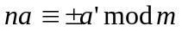. If we let n and m be primes, p and q, then (p/q)=1 if p is a quadratic residue or non-residue mod m.
The proof is as follows, let ζ be a primitive m^{th} root of unit; a complex number ζ be a primitive m^{th} root of unity, where m is a positive integer, if ζ^{m} = 1. If m is the least integer for which ζ^{m} = 1, then ζ is called a primitive m^{th} root. Then 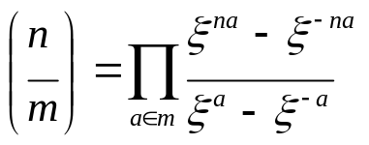, the numerator and denominator are equal in everything but their sign. The sign of them will be positive or negative according to 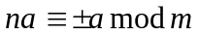for any a’ in M. Now let η be a primitive n^{th} root of unity. Since n is odd , we can have in χ, 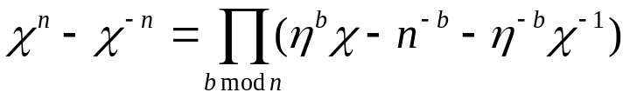. We can then factor the numerator of the Jacobi symbol, and then cancel the denominator to obtain 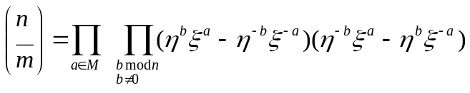. Let N be a half-system of residues mod N. We can rewrite the product as; 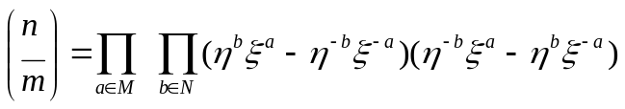. If we multiply this out; 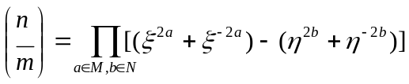. The product obviously has ½(m-1)*½(n-1) factors, if we switch m and n changes the sign of each. Therefore, 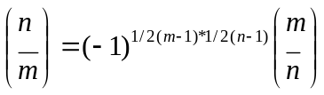, which is the law of Quadratic reciprocity.
The second proof was done by Sey Y. Kim in 2004. It is proof number 212 out of the 214 currently known proofs. This proof uses permutations rather than the geometric techniques of Gauss and Eisenstein. The proof is as follows:

First, define a set Φ by
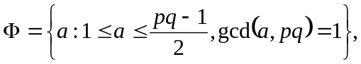
and then set 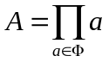.
Lemma 1. 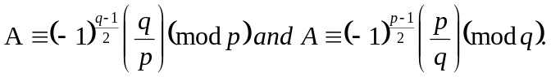
-Proof. Set
Plainly, T is a subset of S. Since
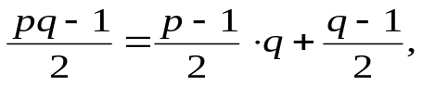
it follows easily that Φ = S-T. Hence, by Euler’s criterion,
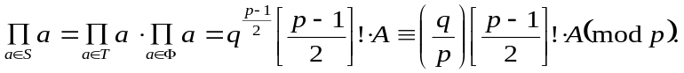
On the other hand, because
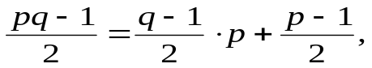
we have
where we have used Wilson’s theorem: (p-1)!≡-1(mod p). We infer that
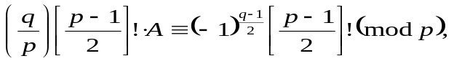
whence A≡(-1)^{(q-1)/2}(q/p)(mod p). The other statement in Lemma 1 follows by symmetry.

From Lemma 1 it follows immediately that (-1)^{(q-1)/2}(q/p)= (-1)^{(p-1)/2}(p/q) iff A≡1 or -1 (mod pq).
Lemma 2.
-Proof. We set d=pq. By the CRT, the congruence X²≡1(mod d) has precisely four solutions, say X≡1,-1,N,-N(mod d). The congruence X²≡-1(mod d) has a solution X≡I(mod d) iff p≡q≡1(mod4), in which case there are precisely four solutions, namely, X≡I,-I,NI,-NI(mod d).
Now for each a in Φ there exist unique a’ in Φ and δ_{a} in {-1,1} s.t. a*a’≡δ_{a} (mod d). (The correspondence a->a’ is a permutation of Φ.) Writing
we remark that
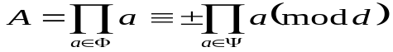
If p≡q≡1(mod4), we have
whereas otherwise it is the case that
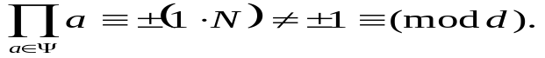
The lemma follows immediately.
Proof of Theorem. Combining Lemmas 1 and 2, we conclude that
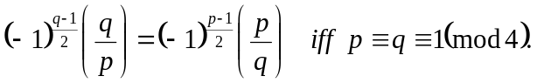
The theorem now follows by considering the four cases (p,q)≡(1,1),(1,-1),(-1,1),(-1,-1)(mod 4). Or, in formulas, since p≡q≡1(mod 4) iff (-1) ^{[(p+1)/2][(q+1)/2]} = -1:
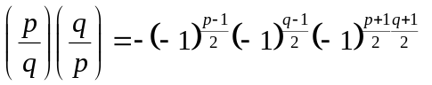
But
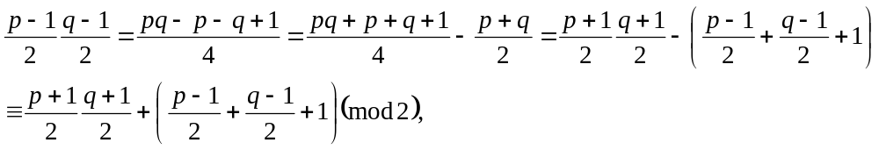
showing that 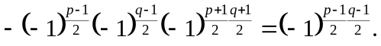
The differences in both of these proofs are clear. S. Y. Kim’s proof is an elementary proof which uses only real numbers to prove it. He also uses permutations and Euler’s criterion which can be found on page 404 of our textbook (Rosen). M. Gerstenhaber’s proof is an algebraic proof based on Kubota’s (147th, 148th) proof which uses Gauss’s Lemma. There are many other ways of proving quadratic reciprocity including: cyclotomy (used by Mathieu (31), Teege(114), etc.), induction (used by Bang(78), Kronecker(39), etc.), and group theory (used only by Duke and Spears (214)).
It is important that there are a wide variety of proofs because it exposes the different types of techniques that exist. These different techniques can be used to prove other theories and conjectures. It also allows for a wide range of understanding the law of quadratic reciprocity. A person who is familiar with Gauss’s Lemma can understand this law better when proved using Gauss’s Lemma instead of cyclotomy.
The law of quadratic reciprocity is mainly used to evaluate Legendre symbols.
The formula is fast, but evaluating Legendre symbols also involve prime factorization. Factoring primes is still currently inefficient. One of the fastest algorithms that is used is the quadratic sieve algorithm which was covered in Wednesdays presentation.
The formula is fast, but evaluating Legendre symbols also involve prime factorization. Factoring primes is still currently inefficient. One of the fastest algorithms that are used is the quadratic sieve algorithm which was covered in Wednesday’s presentation.

