**TIPI Analysis Program Instructions and Functionality**

1) Please ensure that the latest Java SDK is installed on your computer, and install the latest version of JavaFX. Please follow the instructions on this site to add the JavaFX packages to your build path: https://openjfx.io/openjfx-docs/#install-java.

2) Under Run Configurations > Arguments, disable the checkbox next to "“Use the -XstartOnFirstThread argument when launching with SWT”

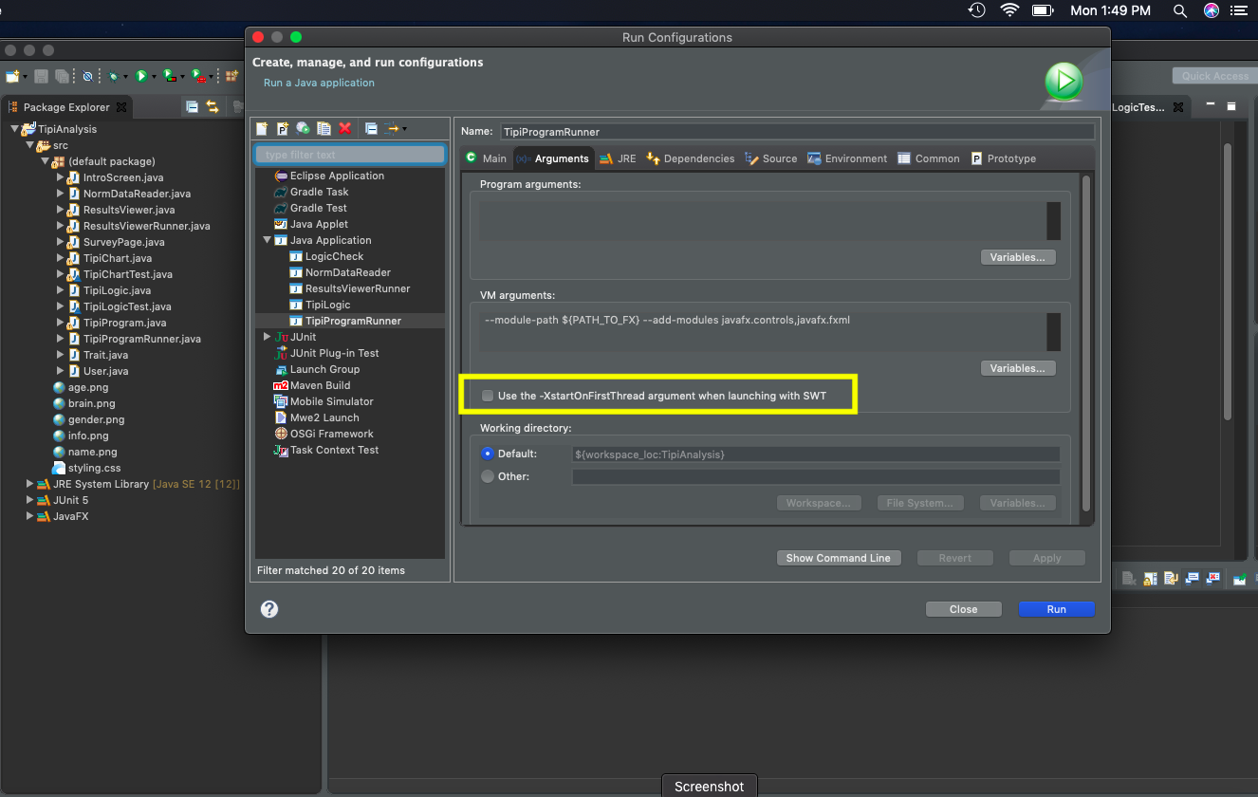

3) Pull all files from the GitHub repository at https://github.com/UPenn-CIT599/final-project-tipianalysis, and create a new Java project in Eclipse. Please ensure that all files pulled from GitHub are added to the project.

4) Run the "TipiProgramRunner.java" class to initiate the program.

5) When the program appears, read the description, then, enter your name, sex (Male or Female), and age into the appropriate fields, and click “Continue to Survey” when finished. (Please note, the Tipi Analyzer program cannot be used by anyone under the age of 16.)

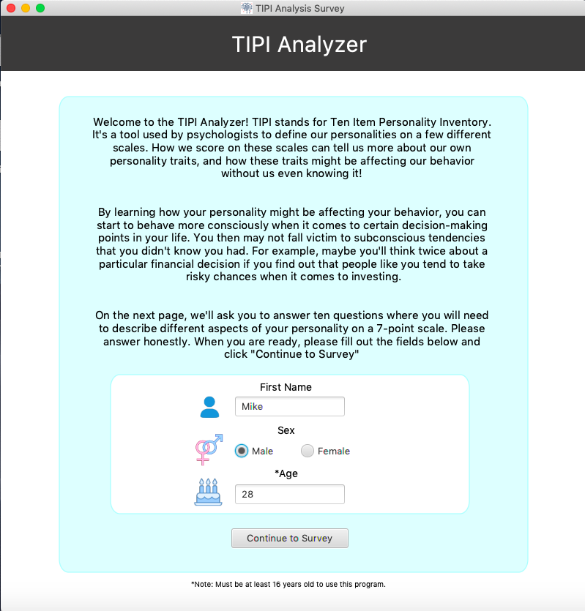

6) Please read the instructions on the survey page, and answer each trait honestly given the possible choices. Click “Save and Continue to Results” when you are finished with your selections. (Note: The program will not allow you to continue if you try to save your results without making a selection for each trait.)

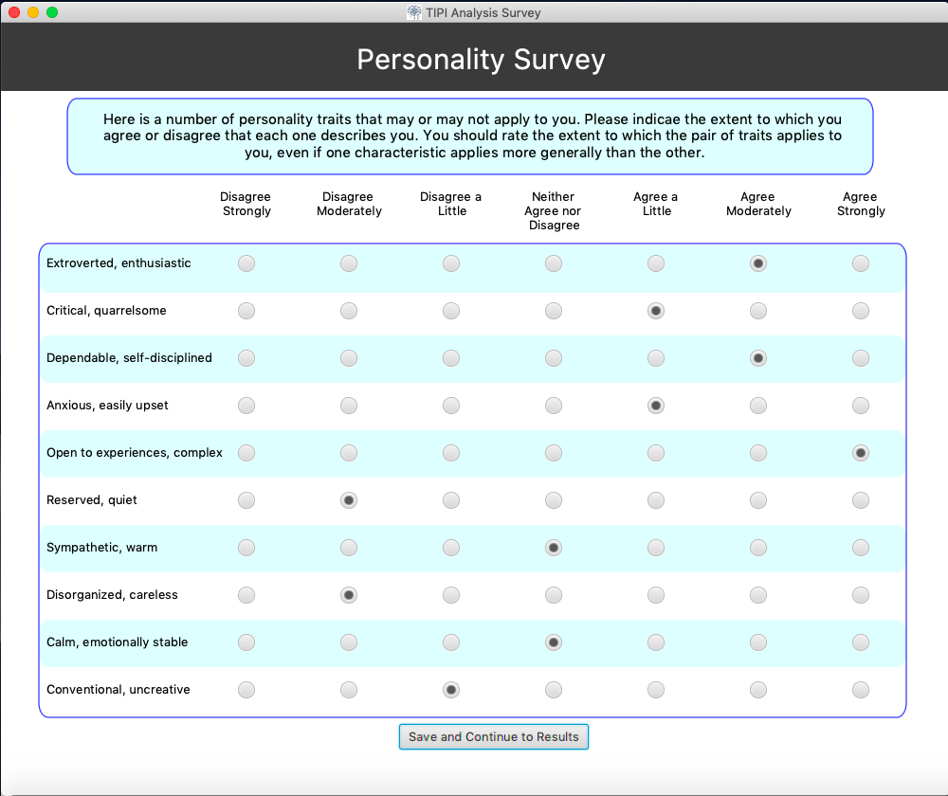

7) The next screen displays your final scores for each of the “Big 5 Personality Traits” as well as a comparison to the mean score’s obtained from the TIPI research website for others who have taken the survey in your peer group (based on age and sex). It will also list a general profile of how close you are to your peer group for each trait, using “High”, “Low”, or “Average” as the descriptions.

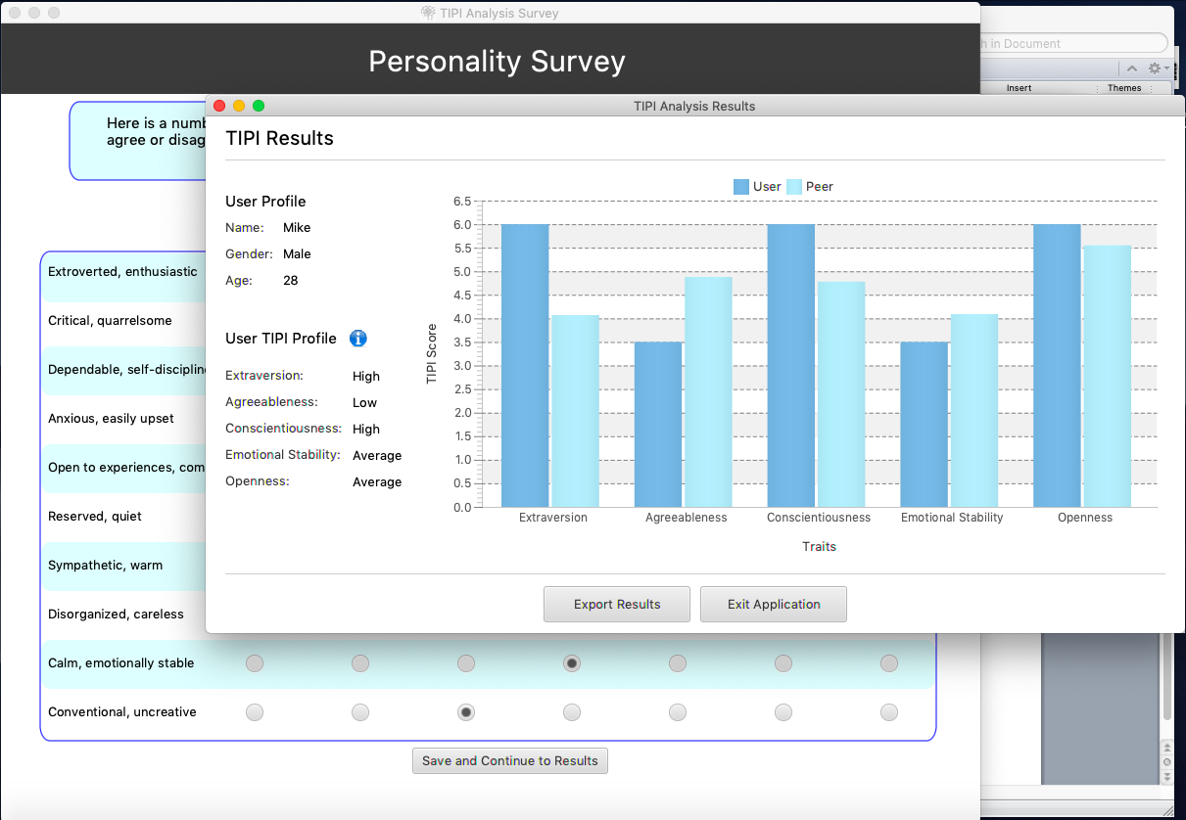

7a) Click on the info button next to the “User TIPI Profile” heading to get a more detailed breakdown of each trait and a description of what a higher or lower score in each trait means.

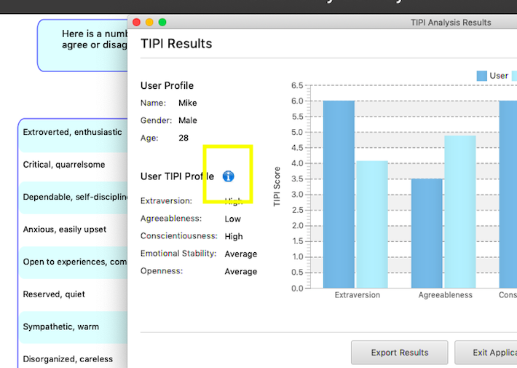

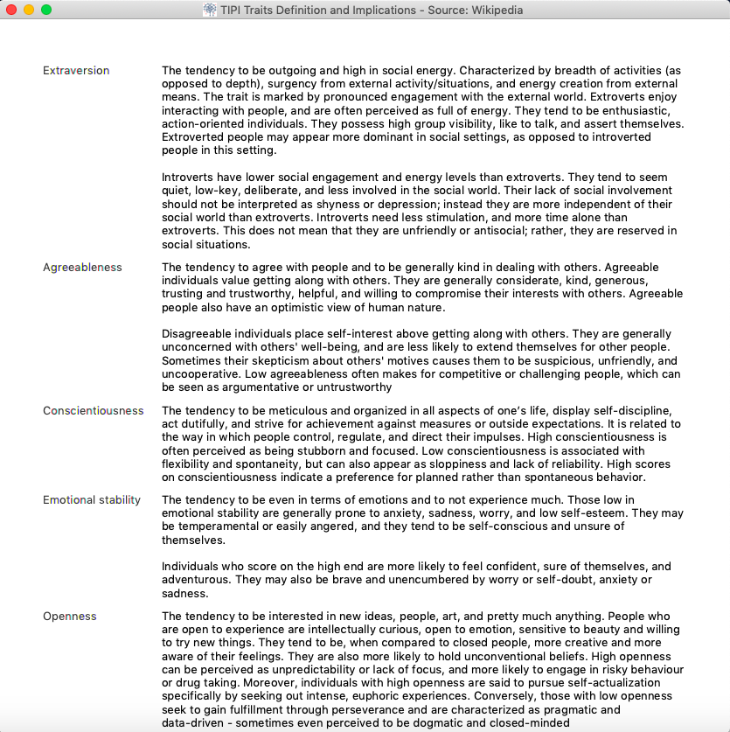

8) Click the “Export Results” button to print and/or save your results as a .PDF file.

9) Lastly, click the “Exit Application” button to close all windows of the application and end the program.