OK – so Neben 16 Figure 8 predicts a pitchfork of ~1e-3 on ~50 m baselines, maybe a little higher on the short ones. Nithya’s harder to read, but 1e-3 between k=0 and pitchfork seems reasonable.That’s reasonably in line with what we see, but not with Zac’s sims. Hmm.

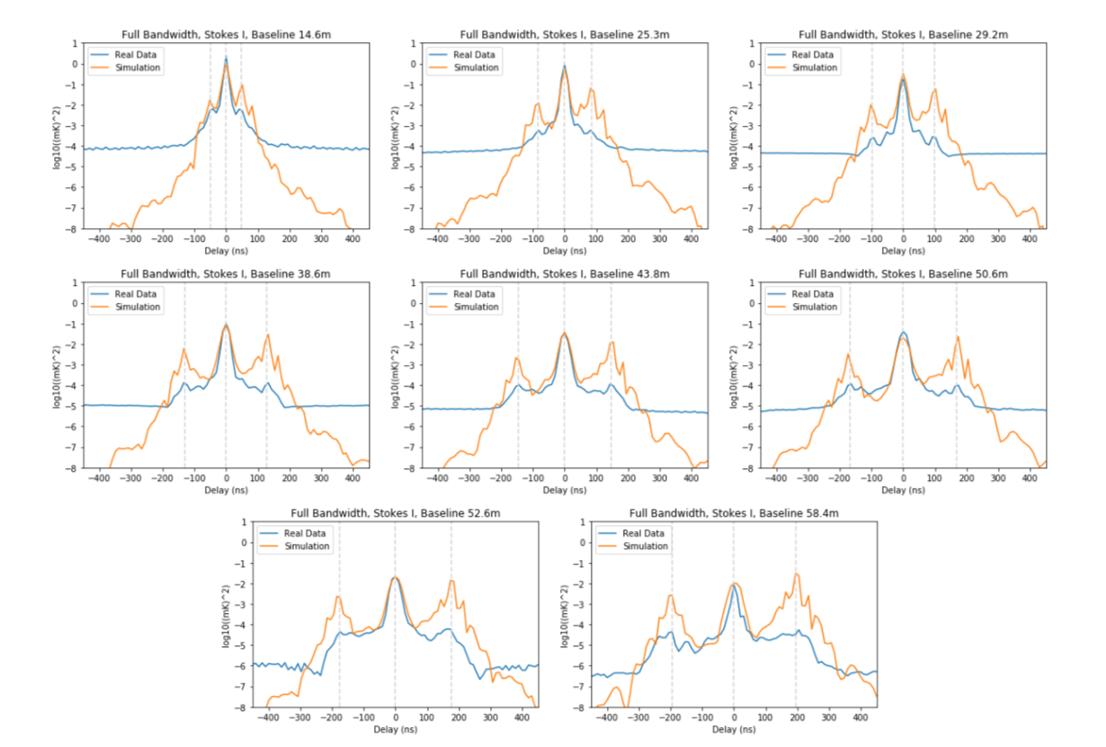

CAVC CS4D 3W5U ACAA

Figure 2: (for us) add antenna numbers (Paul L)

Double check table 1 / make consistent w/ Section 3 (James)

Write up calibration method: (James)

Now Figure 4 (gains): clean up spikes (Paul L)

Now Figure 5: stick with dirty images (b/c that’s what we used for calibration and the deconvolution doesn’t do the wrong thing: we didn’t CLEAN b/c CASA can’t do the right thing.) (Tasha)

Figure 6: let’s leave it alone

Figure 7 and 8: Paul C has correct versions? (Paul C)

Figure 9: James to remake this weekend

Noise checks

Generate an appropriate Tsys for use in estimating the noise level

Spectral images of GLEAM sources (do we know where they are? … do they overlap with these high RA fields?)

Calibration checks

In order to explain why our calibration is different, we need to explain why Saul’s equation 11 was wrong, and we should provide a more correct answer. Even better would be the answer we give relative to Saul’s explains the difference in the k=0 peak in the power spectra. (Not sure about the peak in the his Figure 4, but ideally that too.)

The way to do this is to take the GSM, project it int

Started on this with HERA19_GC_Calibration.ipynb

Get the difference between simulated and real images. Looks like an offset of ~1 degree (sidereal vs. solar time? Other error?)

What do the channel maps of the GC look like?

Multi-channel Images from which the GC calibration spectra were derived are here:

/data4/paper/HERA19Golden/Simulation/SIMS

/data4/paper/HERA19Golden/RawData/2457548/2457548_Calibration

/data4/paper/HERA19Golden/CalibratedData/2457548/mult_spec_chan_1024_gc.2457548.uvcRP.abscal.image.fits