Interview Question

1. Personal background and fitness habits:

- How many times a week do you usually go to the gym?

- What types of workouts or classes do you participate in?

- What types of workouts or classes do you participate in? Do you usually exercise with others or alone?

2. Existing social dating habits:

- Have you made new friends at the gym?

- What fitness-related dating or social apps have you used? How has your experience been?

- What are your main concerns when considering making friends with people at the gym?

- Would you like to get involved in social activities such as organising fitness groups, challenges, events or discussion topics?

3. Functionality and interface requirements:

- When considering an app for fitness dating and recording self-data, what features are most important to you?

- What kind of matching mechanism do you expect?

- What are your suggestions or expectations in terms of user interface and experience?

- What do you think are the biggest challenges you might encounter when using such an app?

4. Security and privacy:

- What security and privacy concerns do you have when using dating apps?

- What features would you like the app to provide to increase your security and privacy?

5. Other feedback:

- What other expectations or suggestions do you have for a fitness dating app?

- What obstacles or challenges do you think would prevent you from using such an app?

**Interview (1)**

1. Personal background and fitness habits:

***- How many times a week do you usually go to the gym?***

I usually go to the gym about 3 or 4 times a week.

***- What types of workouts or classes do you participate in?***

I mostly do strength training and cardio.

***- What types of workouts or classes do you participate in? Do you usually exercise with others or alone?***

I prefer to exercise with friends because we can motivate each other, but sometimes I work out alone.

2. Existing social dating habits:

***- Have you made new friends at the gym?***

Yes, I've met some great new people at the gym. Common interests make it easier to bond.

***- What fitness-related dating or social apps have you used? How has your experience been?***

I've used the keep software, but mainly for learning movements for fitness.

***- What are your main concerns when considering making friends with people at the gym?***

The most important thing is whether the other person's interests and goals match mine. In addition, I am also interested in whether the other person has good communication skills and a friendly personality.

***- Would you like to get involved in social activities such as organising fitness groups, challenges, events or discussion topics?***

Yes, I would love to be involved in these social events, it would allow me to meet more people with the same interests.

3. Functionality and interface requirements:

***- When considering an app for fitness dating and recording self-data, what features are most important to you?***

I find the social features very useful for me, I want to meet more high-level fitness enthusiasts to improve myself. Also, the ability to record and track fitness progress is key.

***- What kind of matching mechanism do you expect?***

I want the matching mechanism to take into account fitness goals, interests, and location to ensure that I find someone who matches me.

***- What are your suggestions or expectations in terms of user interface and experience?***

The user interface should be simple, intuitive and easy to navigate.

***- What do you think are the biggest challenges you might encounter when using such an app?***

The biggest challenge may be ensuring the privacy and security of users' data.

4. Security and privacy:

***- What security and privacy concerns do you have when using dating apps?***

I am concerned that personal information may be misused or there may be unwanted harassment.

***- What features would you like the app to provide to increase your security and privacy?***

Apps should provide privacy settings that allow users to control the information shared and visibility. In addition, reporting and blocking features are important to counter inappropriate behaviour.

5. Other feedback:

***- What other expectations or suggestions do you have for a fitness dating app?***

I want the app to encourage users to motivate and support each other, not just limited to online communication.

***- What obstacles or challenges do you think would prevent you from using such an app?***

I think if my personal information was compromised I might just quit using the software.

**Interview (2)**

*1. Personal background and fitness habits:*

***- How many times a week do you usually go to the gym?***

I go to the gym 1 or 2 times a week.

***- What types of workouts or classes do you participate in?***

I do mostly aerobic exercise such as running

***- What types of workouts or classes do you participate in? Do you usually exercise with others or alone?***

I prefer to exercise with others, but I don't have many friends to exercise with so I usually exercise alone.

2. Existing social dating habits:

***- Have you made new friends at the gym?***

I rarely make new friends at the gym because I feel like it would be embarrassing for me to go and disturb someone's fitness.

***- What fitness-related dating or social apps have you used? How has your experience been?***

I haven't tried this type of software yet.

***- What are your main concerns when considering making friends with people at the gym?***

I want to make friends who can encourage each other. This will keep me motivated to exercise.

***- Would you like to get involved in social activities such as organising fitness groups, challenges, events or discussion topics?***

I would like to participate in these events because I would also like to meet friends that I can work out with.

3. Functionality and interface requirements:

***- When considering an app for fitness dating and recording self-data, what features are most important to you?***

A simple interactive interface is important to me, and of course the social features are important to me because it's easier for me to make friends online than offline.

***- What kind of matching mechanism do you expect?***

I would like the matching mechanism to be more accurate, considering my personal interests and workout schedule. Don't just match based on geographic location.

***- What are your suggestions or expectations in terms of user interface and experience?***

I would like the user interface to be clean and simple.

***- What do you think are the biggest challenges you might encounter when using such an app?***

I think the potential adverts and harassment would be a challenge as I often encounter harassment and adverts when using other social software.

4. Security and privacy:

***- What security and privacy concerns do you have when using dating apps?***

I'd be worried about being harassed by strangers.

***- What features would you like the app to provide to increase your security and privacy?***

I want the app to have strong privacy settings that control who can see my personal information and activities. Also, there should be reporting and blocking features to deal with inappropriate behaviour.

5. Other feedback:

***- What other expectations or suggestions do you have for a fitness dating app?***

I think apps should encourage users to maintain healthy fitness habits, not just socialise. Consider providing some fitness advice and resources as well.

***- What obstacles or challenges do you think would prevent you from using such an app?***

I think the overly complex user interface and too many adverts might make me lose interest in using this software.

**Interview (3)**

- How many times a week do you usually go to the gym?

***I usually go to the gym about 4-5 times a week. I like to maintain a consistent workout routine.***

- What types of workouts or classes do you participate in?

***I participate in a variety of workouts, including weightlifting, cardio, and group fitness classes like spinning and HIIT. I also enjoy yoga for flexibility.***

- What types of workouts or classes do you participate in? Do you usually exercise with others or alone?

***Sometimes, I exercise with a friend or a workout buddy, but most of the time, I prefer working out alone as it allows me to focus better.***

- Have you made new friends at the gym?

***Yes, I've made a few friends at the gym over the years. It's a great place to connect with like-minded individuals.***

- What fitness-related dating or social apps have you used? How has your experience been?

***I haven't used any specific fitness-related dating or social apps so far.***

- What are your main concerns when considering making friends with people at the gym?

***My main concern when making friends at the gym is ensuring that the connection is based on shared fitness interests and not solely on romantic intentions.***

- Would you like to get involved in social activities such as organising fitness groups, challenges, events or discussion topics?

***I would be interested in getting involved in social activities like organizing fitness groups or challenges. It can add a fun and motivational aspect to workouts.***

- When considering an app for fitness dating and recording self-data, what features are most important to you? -What kind of matching mechanism do you expect?

***The most important feature for me in a fitness dating app would be the ability to find people with similar fitness interests and goals. I expect the matching mechanism to consider factors like workout preferences, fitness level, and location.***

- What are your suggestions or expectations in terms of user interface and experience? What do you think are the biggest challenges you might encounter when using such an app?

***A user-friendly interface is crucial. It should be easy to navigate, with clear profiles that showcase fitness interests and achievements. One challenge might be ensuring accurate self-reported fitness data. It's important that users are honest about their fitness levels and goals.***

- What security and privacy concerns do you have when using dating apps? What features would you like the app to provide to increase your security and privacy?

***I'm concerned about the privacy of my personal information and location data when using dating apps. The app should have robust privacy settings, allowing users to control what information they share and who can see it. Verification mechanisms for user profiles could enhance security and ensure that people are who they claim to be.***

- What other expectations or suggestions do you have for a fitness dating app? What obstacles or challenges do you think would prevent you from using such an app?

***I'm concerned about the privacy of my personal information and location data when using dating apps. The app should have robust privacy settings, allowing users to control what information they share and who can see it. Verification mechanisms for user profiles could enhance security and ensure that people are who they claim to be.***

***Interview (4)***

*1. Personal background and fitness habits:*

***- How many times a week do you usually go to the gym?***

*I go to the gym maybe two or three times a week.*

***- What types of workouts or classes do you participate in?***

*I mainly engage in some gravity training and cardio exercises to build my body.*

***- What types of workouts or classes do you participate in? Do you usually exercise with others or alone?***

*Sometimes I go alone. Sometimes I go with friends. It depends on whether you have time with your friends.*

*2. Existing social dating habits:*

***- Have you made new friends at the gym?***

*Yes, I have made some new friends and we can discuss how to do some standard exercises together.*

***- What fitness-related dating or social apps have you used? How has your experience been?***

*I often use keep fitness software, but it does not have a dating function, and many functions have to pay to use.*

***- What are your main concerns when considering making friends with people at the gym?***

*When I consider dating someone at the gym, my biggest concern is whether they have the same fitness goals as me so we can discuss them together.*

***- Would you like to get involved in social activities such as organising fitness groups, challenges, events or discussion topics?***

*Yes, I am willing to participate in social activities, which can help us form the good habit of fitness and increase our motivation.*

*3. Functionality and interface requirements:*

***- When considering an app for fitness dating and recording self-data, what features are most important to you?***

*For me, the social function is very important, we can see some people's fitness videos and learn their standard movements to improve our fitness.*

***- What kind of matching mechanism do you expect?***

*I expect the matching mechanism to recommend effective fitness exercises and useful learning videos based on my fitness goals and interests.*

***- What are your suggestions or expectations in terms of user interface and experience?***

*User interface friendly, users can operate easily.*

***- What do you think are the biggest challenges you might encounter when using such an app?***

*The biggest challenge is how to ensure the privacy of user data and whether the information provided is true and reliable.*

*4. Security and privacy:*

***- What security and privacy concerns do you have when using dating apps?***

*I am more concerned about the security of my personal information and fear that it will be abused.*

***- What features would you like the app to provide to increase your security and privacy?***

*I think apps can provide an anonymous chat function so that we can communicate with others without revealing our personal information.*

*5. Other feedback:*

***- What other expectations or suggestions do you have for a fitness dating app?***

*I hope this app will help and encourage users to engage in fitness activities*

***- What obstacles or challenges do you think would prevent you from using such an app?***

*If the software is not updated with new fitness instructions and there are not many tutorials, it will be an obstacle to my use.*

**Interview(5):**

- How many times a week do you usually go to the gym? What types of workouts or classes do you participate in? What types of workouts or classes do you participate in? Do you usually exercise with others or alone?

***I don't go to the gym regularly; maybe once or twice a month. I prefer localized workouts, focusing on specific body areas. I'm not a fan of intense exercise routines. I usually exercise alone****.*

- Have you made new friends at the gym? What fitness-related dating or social apps have you used? How has your experience been? What are your main concerns when considering making friends with people at the gym? Would you like to get involved in social activities such as organising fitness groups, challenges, events or discussion topics?

***I haven't made new friends at the gym. I haven't used any fitness-related dating or social apps. I'm concerned about potentially awkward interactions or misunderstandings when trying to make friends at the gym. I'm open to participating in fitness-related social activities, especially if they're casual and not too intense.***

- When considering an app for fitness dating and recording self-data, what features are most important to you? What kind of matching mechanism do you expect? What are your suggestions or expectations in terms of user interface and experience? What do you think are the biggest challenges you might encounter when using such an app?

***Features like a customizable workout tracker and personalised workout plans are important to me. The matching mechanism should consider fitness interests and goals. A clean, intuitive interface with easy navigation and clear workout instructions would be ideal. Challenges might include finding a balance between customization and simplicity, making sure the app caters to various fitness preferences.***

- What security and privacy concerns do you have when using dating apps? What features would you like the app to provide to increase your security and privacy?

***I'm concerned about sharing personal data and contact information on dating apps. The app should have strong data encryption, privacy settings, and an option for anonymous profiles to ensure user safety. Limited data sharing and no public display of personal contact information would be reassuring.***

- What other expectations or suggestions do you have for a fitness dating app? What obstacles or challenges do you think would prevent you from using such an app?

***It would be great if the app could provide tips for beginners and offer a supportive community. A trial period or a free version with basic features would encourage me to try the app initially. Potential obstacles might include a busy schedule and lack of motivation to consistently use the app.***

**Interview(6):**

- How many times a week do you usually go to the gym? What types of workouts or classes do you participate in? What types of workouts or classes do you participate in? Do you usually exercise with others or alone?

***I usually go to the gym about 2 times a week. I like trying different types of workouts, especially yoga and aerobic exercises. I often prefer group classes because they motivate me, but sometimes I also exercise alone.***

- Have you made new friends at the gym? What fitness-related dating or social apps have you used? How has your experience been? What are your main concerns when considering making friends with people at the gym? Would you like to get involved in social activities such as organising fitness groups, challenges, events or discussion topics?

***I haven't made any new friends at the gym yet. I haven't used any fitness-related dating or social apps before. My main concern about making friends at the gym is that I might come across as inexperienced or not know what to talk about. I would be interested in getting involved in social activities at the gym, especially if they are beginner-friendly.***

- When considering an app for fitness dating and recording self-data, what features are most important to you? What kind of matching mechanism do you expect? What are your suggestions or expectations in terms of user interface and experience? What do you think are the biggest challenges you might encounter when using such an app?

***The most important feature for me in a fitness dating app would be the ability to find workout partners or friends with similar fitness interests. I would like a matching mechanism that considers my fitness level and interests rather than just physical appearance. The app should have a user-friendly interface with clear profiles and an easy way to schedule workout sessions with others. One challenge I might face is finding people who are at a similar fitness level and have the same flexible approach to workouts.***

- What security and privacy concerns do you have when using dating apps? What features would you like the app to provide to increase your security and privacy?

***I'm concerned about sharing personal data and contact information on dating apps. The app should have strong data encryption, privacy settings, and an option for anonymous profiles to ensure user safety. Limited data sharing and no public display of personal contact information would be reassuring. I'm concerned about sharing personal information on dating apps, so I would like the app to have strong privacy settings. It would be reassuring if the app allowed for anonymous profiles or limited data sharing until I feel comfortable sharing more.***

- What other expectations or suggestions do you have for a fitness dating app? What obstacles or challenges do you think would prevent you from using such an app?

***I hope the app would have a feature that suggests workout classes or activities based on my interests and fitness level. It would be great if the app could provide tips for beginners or even have a section for sharing workout experiences and progress. An obstacle for me might be if the app doesn't have a good community of users who are open to helping beginners like me.***

**Summary:**

***Fitness Habits:***

Interviewees' gym frequency ranges from 1-2 times to 4-5 times a week.

They engage in a variety of exercises, including strength training, cardio, group fitness classes (such as spinning and HIIT), and yoga.

Most interviewees mentioned that they sometimes exercise with others, but many also choose to work out alone for better focus.

***Social Habits:***

Many interviewees have made new friends at the gym, viewing it as a great place to connect with like-minded individuals.

Regarding the use of fitness social apps, some have tried apps like "keep," while others haven't ventured into this area.

When making friends at the gym, interviewees prioritise connections based on shared fitness interests rather than solely on romantic intentions.

***App Functionality and Interface Requirements:***

Interviewees generally wish for the app to have the capability to find people with similar fitness interests and goals.

They expect the matching mechanism to consider factors like workout preferences, fitness levels, and location.

The user interface should be user-friendly, easy to navigate, and clearly display fitness interests and achievements. One challenge highlighted is ensuring accurate self-reported fitness data by users.

***Security and Privacy:***

Interviewees are generally concerned about the privacy of their personal information and location data when using dating apps.

They desire the app to offer robust privacy settings, allowing users to control the information they share and its visibility. Implementing verification mechanisms for user profiles can enhance security, ensuring people are who they claim to be.

***Other Feedback:***

Interviewees hope the app encourages users to maintain healthy fitness habits and provide fitness advice and resources.

Complex user interfaces, excessive ads, threats to personal information security, and concerns over location data privacy are reasons they might abandon the app.

**Observation:**

Observation Time: Saturday to Sunday, 17:00 - 19:00

Location: Gym near Toowong

***Users:***

Age Range: 18-30 years old

Gender: Male and Female

Fitness Level: Beginner, Intermediate, and Advanced

Personal Devices: Most people bring smartphones into the gym

***Observation Results:***

Social Interaction: Many people still maintain the habit of browsing news or social media on tablets or mobile phones before and after exercising. A significant number of people listen to music through Bluetooth headphones.

Contextual Situation: When many people enter the gym, they open fitness apps on their smart devices to seek specific exercise advice or challenges.

***Conclusion:***

The social environment of the gym is inseparable from smart devices. At the same time, users also try to obtain fitness-related information through smart devices. We can effectively cover the user group through the fitness platform, which is a great design opportunity.

**Research**

I did some research and looked at a few of the most popular fitness apps out there right now, namely Keep, Instant Exercise and FitTime Health. But these fitness apps have many limitations. For example, many sports tutorials require a fee to watch and learn. There is no data storage function, no fitness activity data records. The main thing is that there is no social function. Because the social function can make friends, it can also help users stimulate the motivation of fitness, and share their fitness goals and achievements with friends. In the later stage, we will improve our fitness software according to these limitations.

Storyboard

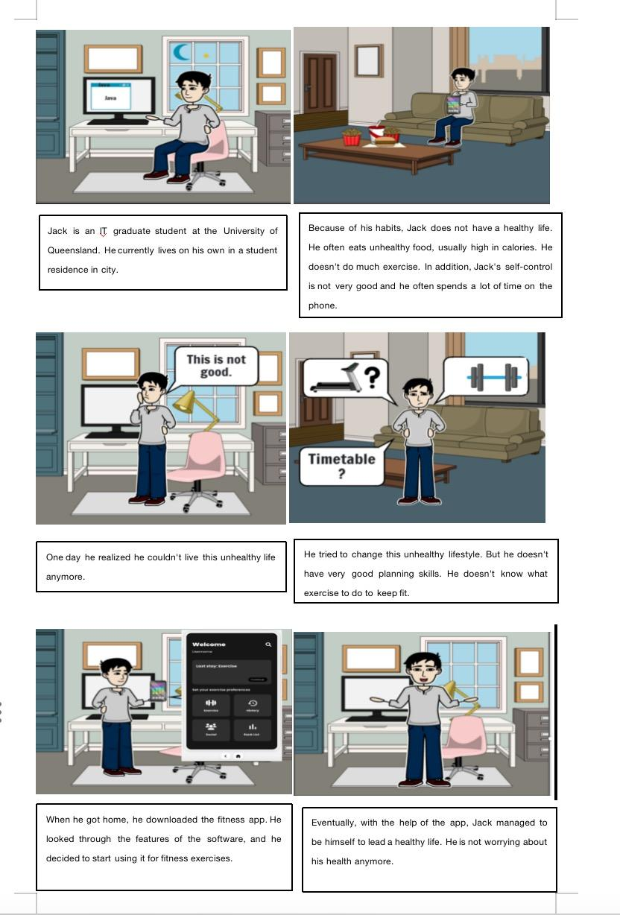

**Cultural Investigation:**

Cultural Background: People generally have the habit of using smart devices, especially smartphones. They are particularly accustomed to using smart devices before and after exercising. If they use smartphones during exercise, it might disrupt the workout (except for smart devices like Bluetooth headphones).

Social Interaction: People interact with their workout partners, especially in group fitness activities (e.g., yoga). However, most people prefer to interact through virtual social networks, even interacting with followers on social media.

Technology Acceptance: Ordinary users are not averse to online fitness courses and online fitness coaches. They have a high acceptance of new technologies.(对科技接受度高）

Challenges and Barriers: An overload of fitness information can confuse users. For instance, there are many ways people can work out their abdominal muscles. However, some methods cause significant wear and tear on the knees. Some fitness coaches advise users not to exercise in this way, but other coaches believe the level of damage to the body is acceptable, so they encourage users to do so.

Target user: Young people who lack motivation to work out

**Target user:**

Our first target users is Fitness enthusiasts:

1. This is the most obvious target user group. They are those who are active in various sports, gym memberships, or outdoor fitness enthusiasts. They seek to be fitness partners, participate in team challenges, or share exercise experiences.

2. Beginner Fitness: This group may be new to fitness or may not have a lot of fitness experience. They seek guidance, build confidence, and motivate other beginners.

3. Social fitters: They want to make more friends. They are not necessarily professional bodybuilders but appreciate the opportunity to work out with others.

4. Postpartum recovery groups: Women recovering from childbirth may seek a support system to help them regain their physical health, improve their physical fitness, and share their experiences with other mothers who are going through similar situations.

*All in all, our products are aimed at people who have a strong interest in health and exercise, seek social interaction, build relationships, improve fitness, or help others achieve these goals. So we designed this product*

Through the above survey

I designed the sketch, first of all, I think every user must review and agree to our app Privacy policy before using it. Because our design themes are fitness and socializing, there are privacy issues involved. That's what many people were worried about when we interviewed them.

My second design is that users can fill in their own information when entering, and the application system will automatically calculate their BMR so that they can better understand themselves.

In our app, users can view professional fitness training instructions according to the parts they want to exercise. I wanted the user to be able to see his movement history, so I designed the movement history view.

And another idea is that users can locate through the map, and add friends to each other, friends can help and encourage each other. However, our group thinks that this step is still to be discussed, and is not very good.  *and some problems may arise.*

Then our new idea is that users complete daily tasks, users complete tasks published by the system to get coins, and finally [i]exchange coins to buy things, but this feature is also controversial. I also designed leaderboards to motivate users to exercise.

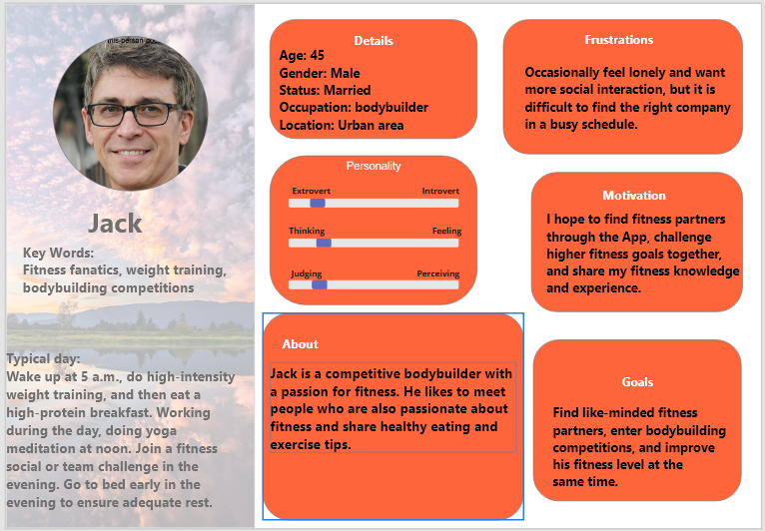

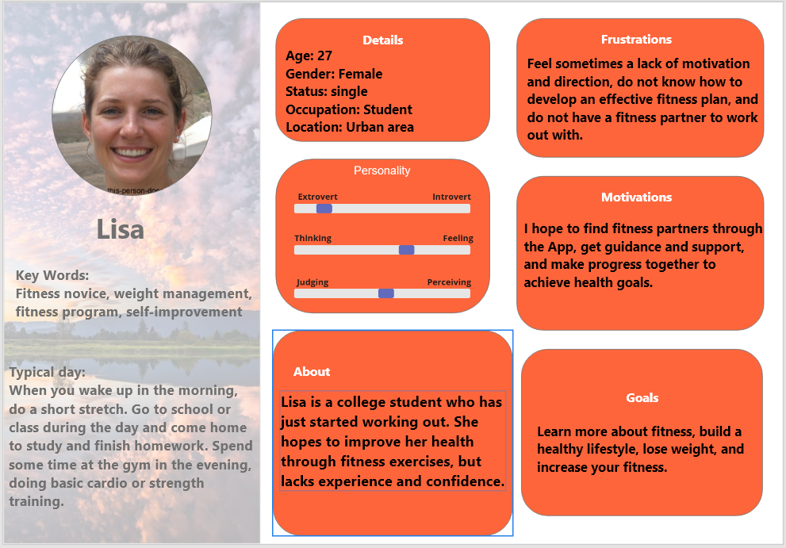

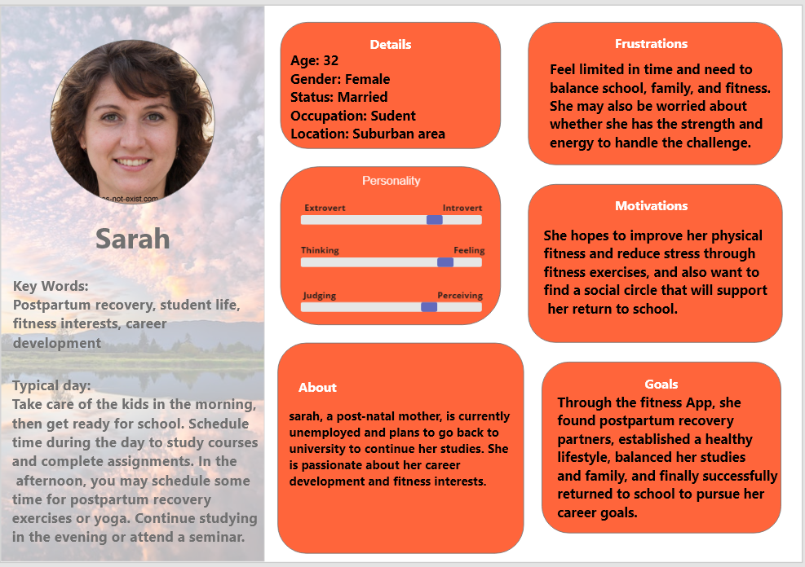

**Link to our non-functional prototype：**

<https://app.uizard.io/p/7863fefd>