Mp02SQL_Styles

**PART I**

1. Selects all tuples from the invoices table that has matching vendor_ids in the vendors table

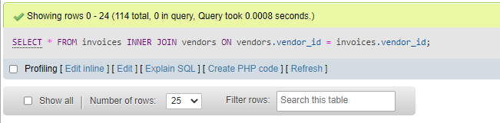

1. Selects vendor_name, invoice_number, and balance_due (calculated attribute using data from invoices table) attributes from vendors and invoices tables that have joined tuples based on vendor_id and only shows the balance_due amount that’s greater than 0 and is sorted in ascending order by the vendor_name attribute.

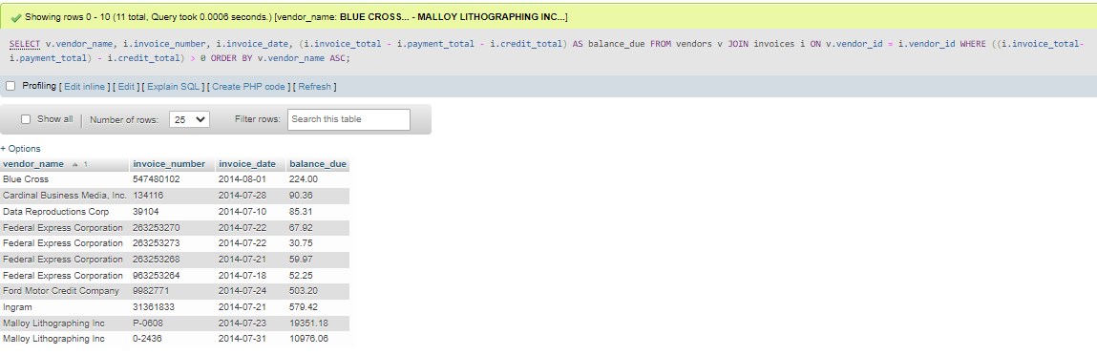

1. Selects vendor_name, default_account_number, account_description attributes from the vendors and general_ledger_accounts table that have joined based on the vendor’s default_account_number and general_ledger_accounts’ account_number attributes; finally it is ordered by account_description, and then by vendor_name.

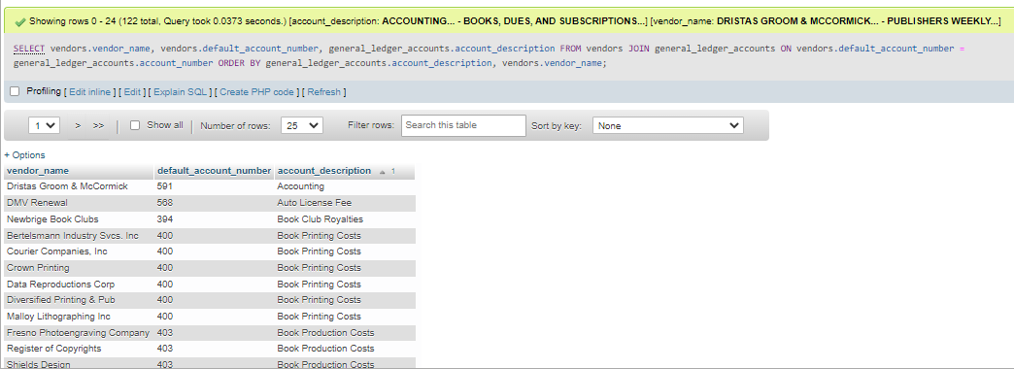

1. Selects vendor_name, invoice_date, invoice_number, invoice_sequence, line_item_amount attributes from the vendors table (with the given alias v), the invoices table (with the given alias i), and the invoice_line_items table (with the given alias li). The vendors and invoices tables are joined together based on vendor_id, afterwards the newly joined table is joined by invoices_line_items based on invoice_id. Finally, the result table is ordered by the vendor_name attribute, then the invoice_date attribute, followed by the invoice_number attribute, and then the invoice_sequence attribute.

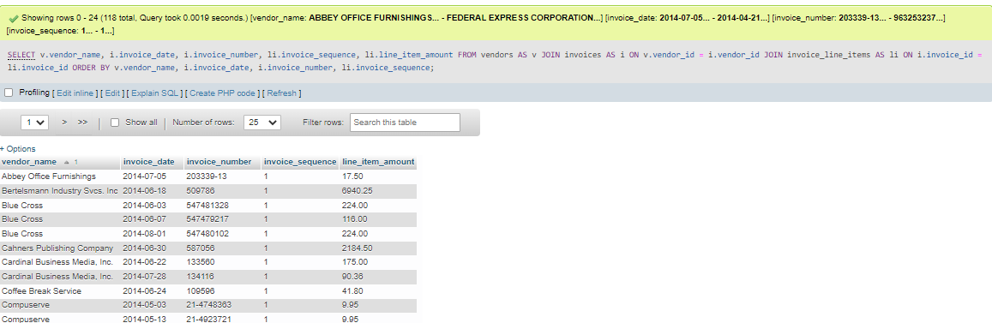

1. Selects only the unique tuples with the attributes vendor_id, vendor_name, and a created attribute with the alias contact_name using concatenated vendor_contact_first_name and vendor_contact_last_name; all of which comes from the vendors table. The vendors table is joined with itself (both instances of vendors table is given an alias to help better differentiate it) based on the vendors table1 vendor_id attribute not being equal to vendors table2 vendor_id attribute and where vendors table1 last_name attribute is equal to vendors table2 last_name attribute. Finally, the result table is ordered by vendor_contact_last_name attribute.

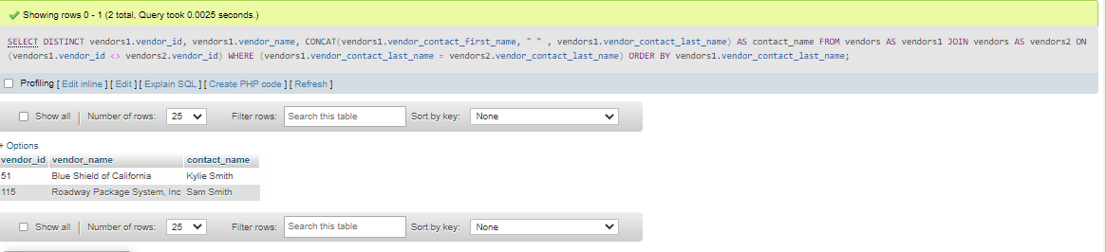

1. Selects account_number and account_description attributes from general_ledger_accounts table that joins with invoice_line_items table (returns all tuples from general_ledger_accounts and any matching records from invoice_line_items table) based on account_number attribute. Afterward it only returns tuples where the invoice_line_items account_number is null. Finally, the result table is ordered by account_number attribute.

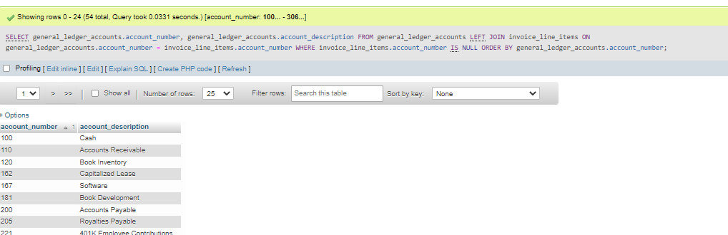

1. Selects vendor_name and vendor_state attributes from vendors table and returns only tuples where vendor_state = “CA”. Skipping ahead a little bit, we also select vendor_name and vendor_state attribute which sets all tuples to “Outside CA”, unless the vendor is not equal to “CA”. We then use a union to combine both selection statements and order the result table by vendor_name.

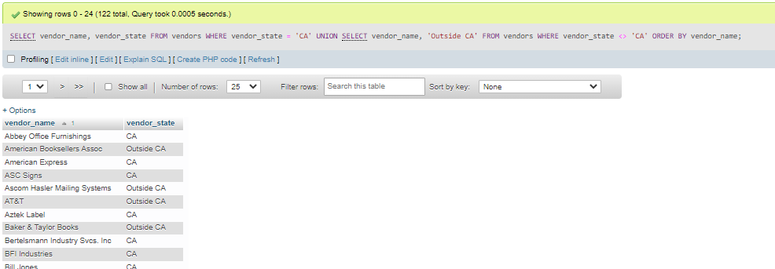

**PART II**

1. Selects category_name, product_name, list_price attributes from categories table which has been joined with the products table based on *matching* category_id attributes, which is then sorted in ascending order by category_name attribute, then by product_name attribute.

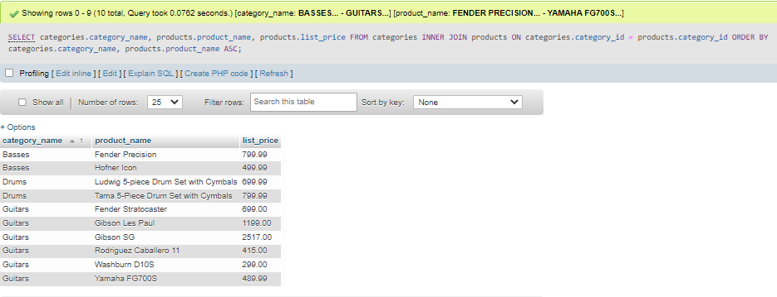

1. Selects first_name, last_name, line1, city, state, and zip_code attributes from the customers table that has joined with addresses table based on *matching* customer_id attributes from both the addresses and customer tables. Only returns the tuples where the email_address attribute equals “allan.sherwood@yahoo.com”

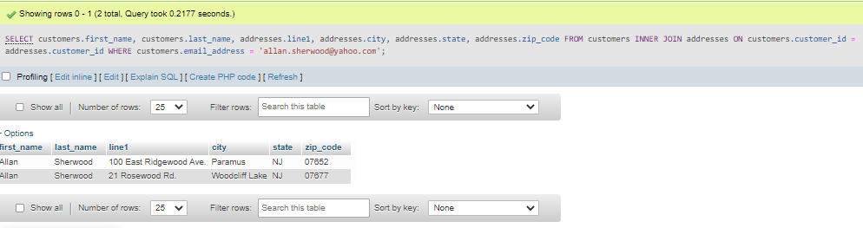

1. Selects first_name, last_name, line1, city, state, and zip_code attributes from the customers table that has joined with addresses table based on *matching* customer_id attributes from both the addresses and customer tables. Only returns tuples where customers and addresses customer_id attributes are equal AND the customers shipping_address_id attribute and addresses address_id attribute are equal.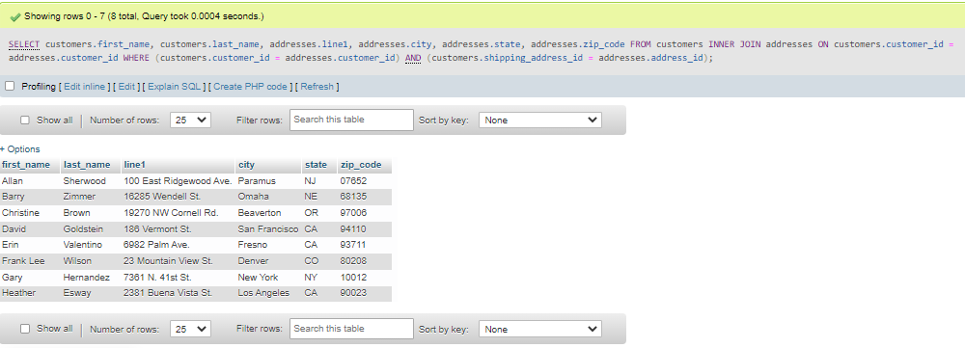
2. Selects last_name, first_name, order_date, product_name, item_price, discount_amount, and quanity attributes from the customer table and orders table which is joined on *matching* customer_id attributes from both the orders and customer tables; all of which is joined on *matching* order_id attributes with the order_items table; which in turn gets joined again on *matching* product_id attributes with the products table. Finally the result table gets ordered by last_name attribute, followed by the order_date attribute, and lastly the product_name attribute.

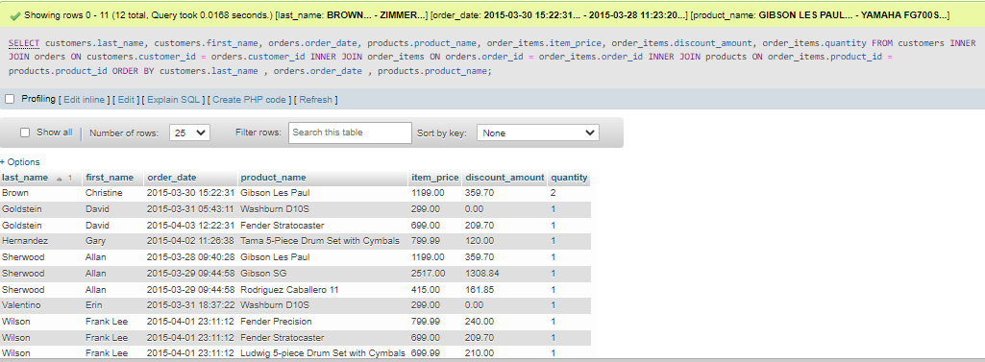

1. Select product_name and list_price from products which is joined with itself (first products table is assigned the alias products1 with the second products table being assigned the alias products2 to help differentiate them) based on product1 product_id attribute not equal to product2 product_id attribute AND product2 list_price attribute being equal to product1 list_price attribute

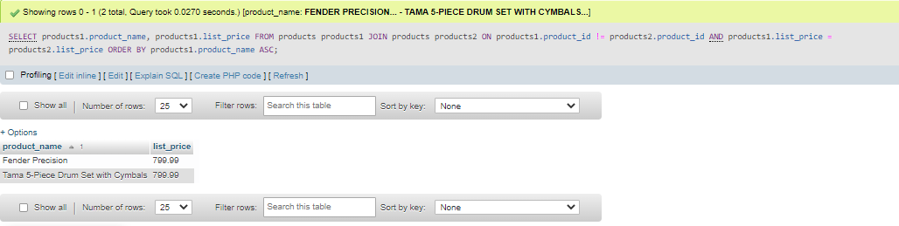

1. Selects category_name and product_id attributes from the categories and products tables, both of which have joined returning all tuples from the categories table and any matching tuples from the products table based on both tables category_id attribute. Only returns tuples where the product_id attribute from the products table is equal to NULL.

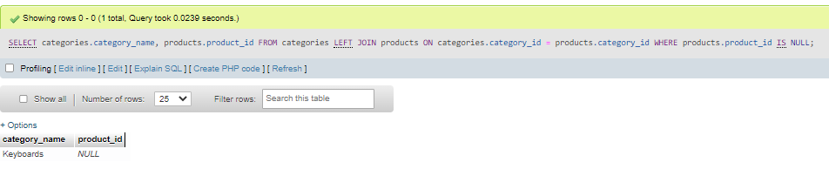

1. Selects the string “Shipped” and the order_id attribute as newly created attributes for the results table as well as the order_date attribute, all of which from the orders table where the ship_date attribute IS NOT NULL. Skipping ahead, another selection is made with the string “Not shipped” and the order_id attribute for a newly created attribute for the second result table as well as the order_date from the orders table where the ship date is NULL. Both selection statements are combined so any null statements within the created ship_status attribute is changed to “Not Shipped" and any statements that are not null are then changed to “Shipped”. Finally the result table is ordered by the order_date attribute.

