Mp3SQL_Styles

PART I

1).Inserts a new tuple into the terms table with the values of 6 for the terms_id attribute, “Net due in 120 days” in the terms_description attribute, and ’120’ for the term_due_days attribute.

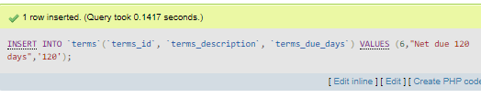

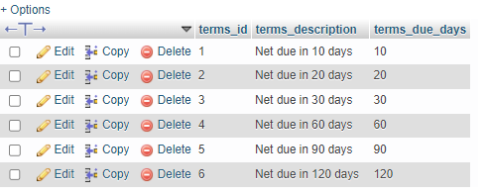

2). Updates the previously created tuple in the terms table with the values of “Net due in 125 days” in the terms_description attribute, and ’125’ for the term_due_days attribute where the term_id value equals 6.

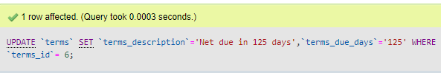

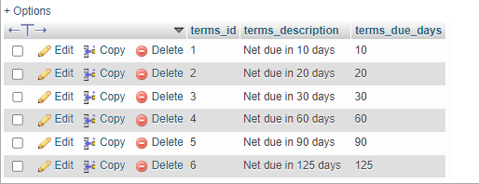

3). Deletes the previously created/updated tuple (whose terms_id = 6) from the table but only that tuple and nothing else.

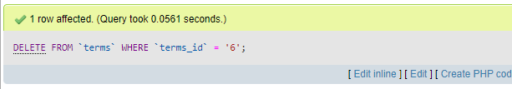

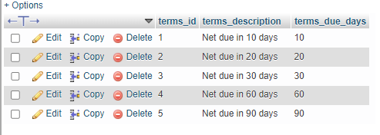

4). Creates a new tuple into the invoices table with the values “124” for the invoice_id, “32” for vendor_id, “AX-014-027” for invoice_number, “2018-08-01” for invoice_date, “434.58” for the invoice_total, “0.00” for both the payment and credit total, 2 for the term_id, “2018-08-31” for invoice_due_date, and finally NULL for the payment_date.

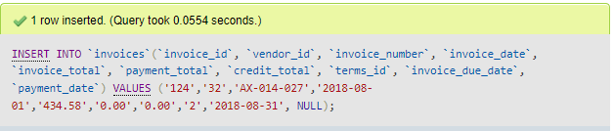

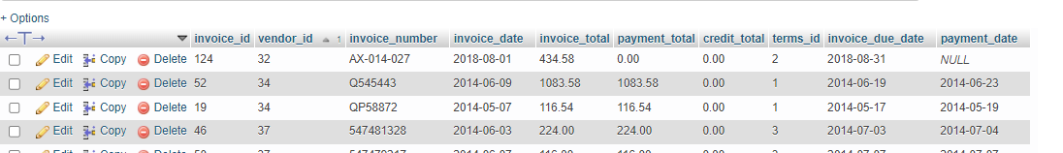

5). Creates two new tuples in the invoice_line_items table with the first’s values being “124” for invoice_id, “1” for the invoice_sequence, “160” for the account_number, “180.23” for line_item_amount, and “Hard drive” for the line_item_description attribute. As for the second tuple the new values are “124” for invoice_id, “2” for the invoice_sequence, “527” for the account_number, “254.35” for line_item_amount, and “Exchange server update” for the line_item_description attribute.

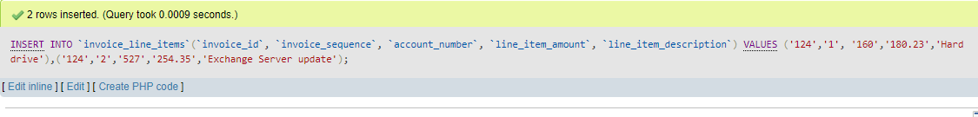

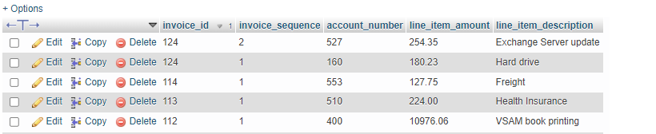

6). Updates any tuples in the invoices table where the invoice_id id equal to 124, with the new values being invoice_total multiplied by 0.1 for the credit_score attribute, and the difference between invoice_total and credit_total for the payment_total attribute.



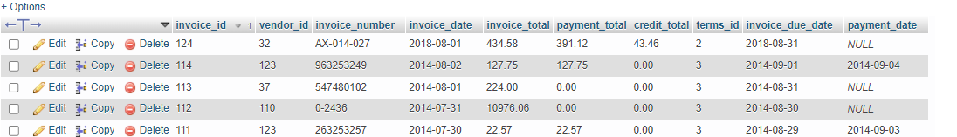

7). Updates any tuples in the vendors where the vendor_id equals 44, and sets the default_account_number tp 403.

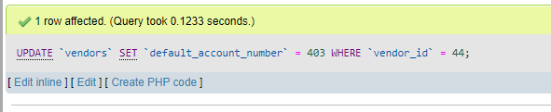



8). Honestly, this one confused me, all my results would equal zero and wasn’t sure why. Don’t feel like spending another 30 minutes to an hour on it so hopefully this picture of a crab with a cigarette will suffice



9). Deletes any tuple from invoice_line_items where the invoice_id equals 124

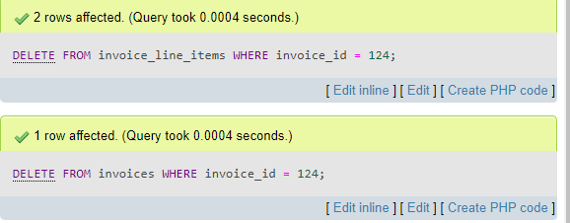

PART II

1). Selects non-duplicate vendor_id and invoice_total attributes from the vendors table that has joined with the invoices table where vendors’ vendor_id matches invoices’ vendor_id. The result set is then grouped by the invoices’ vendor_id. 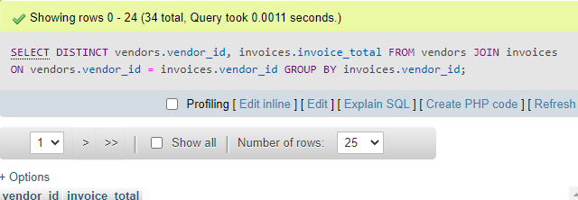

2).Selects vendor_name and the sum of payment_total attribute from the vendors table joined with the invoices table where vendors’ vendor_id matches with invoices’ vendor_id. Which is then grouped by the vendors’ vendor_id and the ordered by the sum of invoices’ payment_total attribute in descending order.

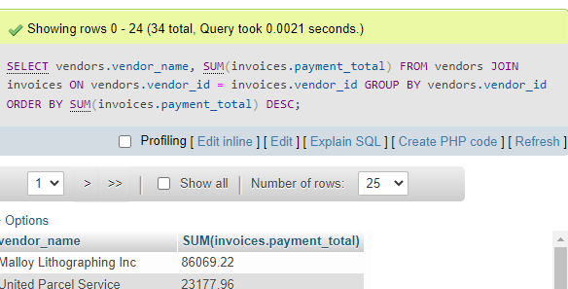

3). Selects vendor_name attribute, the count of the invoices’ vendor_id tuples, the sum of the invoice_total attribute’s tuples in the invoice table from the vendors table joined with the invoices table where vendors’ vendor_id matches with invoices’ vendor_id. Which is then grouped by the vendors’ vendor_id and then ordered by the count of the vendor_id attribute’s tuples from the invoice table in descending order.

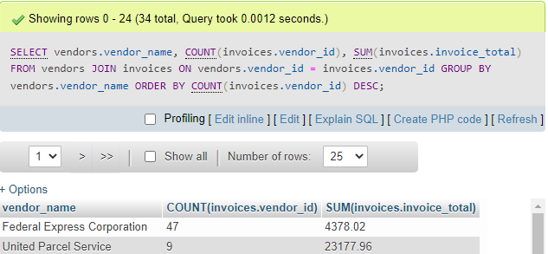

4). Selects the account_description attribute, the count of tuples in the account_number attribute, the sum of the tuples in the line_item_amount attribute from the general_ledger_accounts table joined with the invoice_line_items table where general_ledger_accounts’ account_number matches with invoice_line_items’ account_number. Then the result set is grouped by general_ledger_accounts’ account_description attribute, of those whose count of tuples for invoice_line_items’ account_number attribute is greater than 1. The result set is then ordered by the sum of tuples for the invoice_line_items’ line_item_amount attribute in descending order.

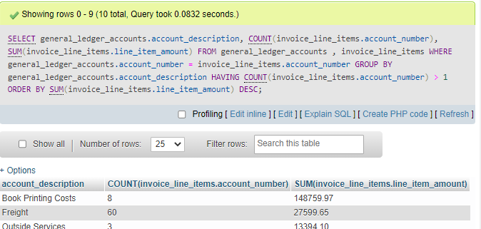

5). Selects the account_description attribute, the count of tuples in the account_number attribute, the sum of the tuples in the line_item_amount attribute from the general_ledger_accounts table, and the invoice date attribute joined with the invoice_line_items table where general_ledger_accounts’ account_number matches with invoice_line_items’ account_number, which is then joined with the invoices table where the invoice_line_items’ invoice_id attribute matches invoices’ invoice_id attribute. Then the result set is grouped by general_ledger_accounts’ account_description attribute, of those whose count of tuples for invoice_line_items’ account_number attribute is greater than 1 and invoice_date attribute from the invoices table is greater than or equal to ‘2014-04-01’ and lesser than or equal to ‘2014-06-30’. The result set is then ordered by the sum of tuples for the invoice_line_items’ line_item_amount attribute in descending order.

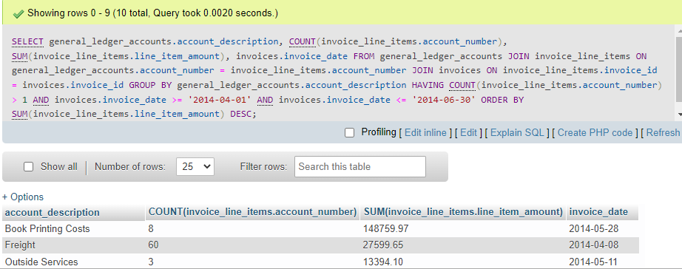

6).Selects the account_number attribute, the sum of line_item_amount from the invoice_line_items table with the result set grouped by account_number with rollup enabled (adds cool total/subtotal row at the VERY BOTTOM OF THE STUPID TABLE AND YOU CANT SORT IT DESCENDING TO SHOW THE STUPID MESSAGE WITH THE RESULT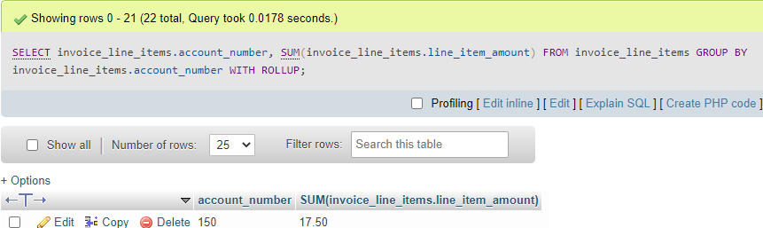



7).Selects the non-duplicate vendor_name, the count of non-duplicate account_numbers tuples from the general_ledger_accounts joined with invoice_line_items where the account_number matches on both the tables which is then joined with the vendors table where the vendor_id matches on both vendors and invoices tables. The result set is then grouped by vendors’ vendor_id having a non duplicate count of general_ledger_accounts’ account_number that is greater than 1.

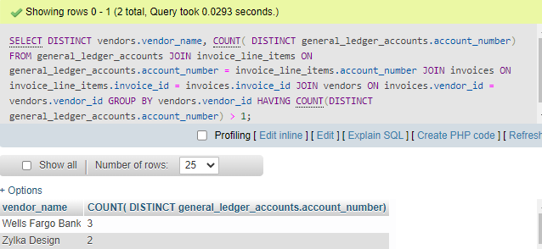

PART III

1. Selects town attribute from players table where the result set is grouped by the town attribute having the count greater than 4.

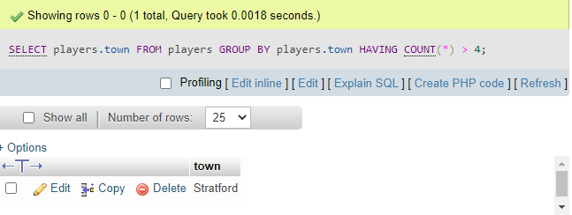

2).Selects the player_no from penalties table in which the result set is grouped by player_no having the sum of the amount attribute greater than 150.

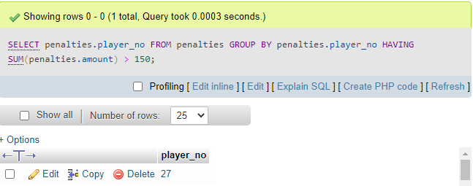

3). Selects name, initals, and count all attribute from the players table joined with penalties table on matching player_no attributes. The result set is grouped by players’ player_no, name, and initals having the count all > 1;

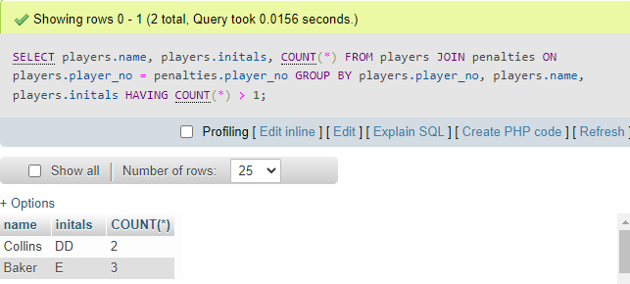

4). Select team_no, count all attributes from matches grouped by the team_no attribute having the count all attribute greater than or equal to all subqueried to select count all from the matches table and grouped by the team_no attribute.

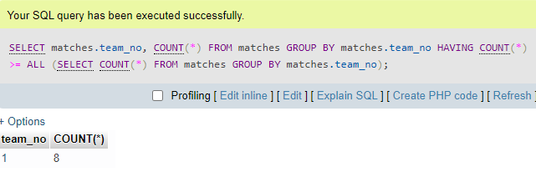

5).Select team_no and division from the teams table where the team_no from subquery joining matches is grouped by team_no having non-duplicate tuple count of player_no greater than 4.

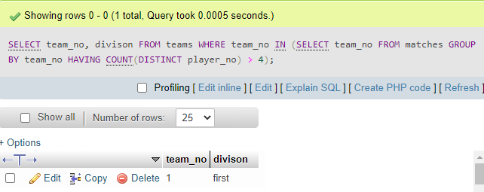

6).Select name and initals from the players table where player_no in subquery joining penalities where the penalties’ amount is greater than 40, which is then grouped by player_no having the count all greater than or equal to 2.

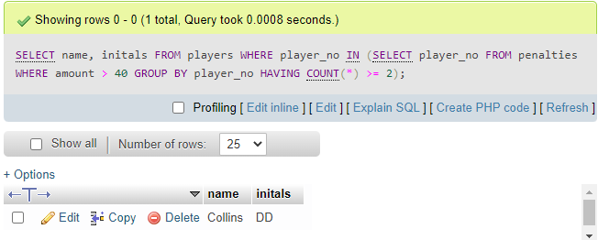

7).Select name and initals from the players table where player_no in subquery penalties is grouped by player_no having the sum of penalties’ amount greater than or equal to all with another subquery selecting sum of penalties amount from the penalities table grouped by player_no

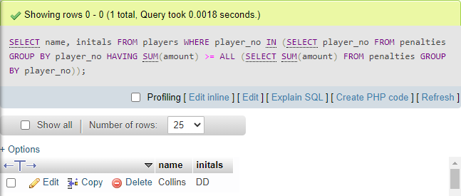

8). Selects player_no from the penalties table where player_no does NOT equal to 104, which is then grouped by player_no having the sum of amount equal to the subquery select of the sum of amount which is then multiplied by 2 from the penalties table where the player_no attribute equals 104.

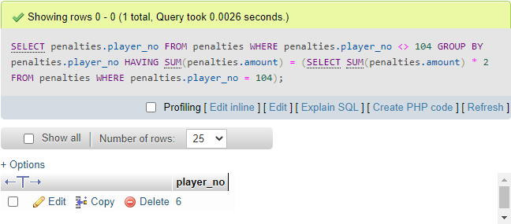

9). Select player_no from the penalties table where player_no does NOT equal 6 which is then grouped by player_no having count all equal to subquery of select count all from the penalties table where the player_no equal 6.

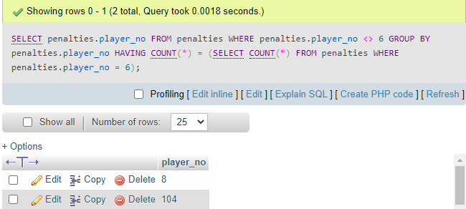

10). Selects player_no and name attributes from the players table joined with matches on matching player_no attributes which is then grouped by player_no and name having the sum of the won attribute greater than the subquery where the selected sum of lost attribute from matches where the second matches table player_no equals players’ player_no group by second matches table player_no.

