Lab3SQL_Styles

1). 4 tuples from the product_code, product_name, list_price, discount_percent attributes. Second screenshot orders the table by the list_price attribute in descending order.

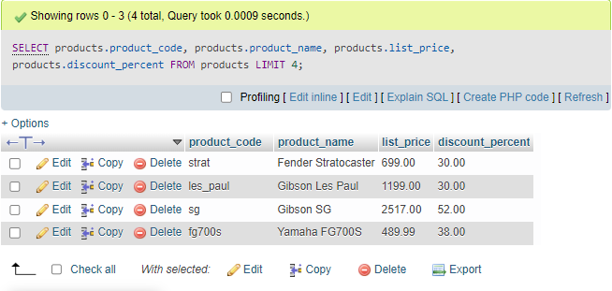

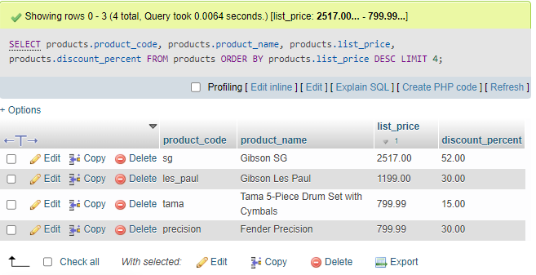

2).Displays an attribute with the alias “full_name” that is the result of concatenating the last_name attribute with the first name attribute from the customers table, with a comma string added in between. It is then ordered by the last_name attribute in ascending order.

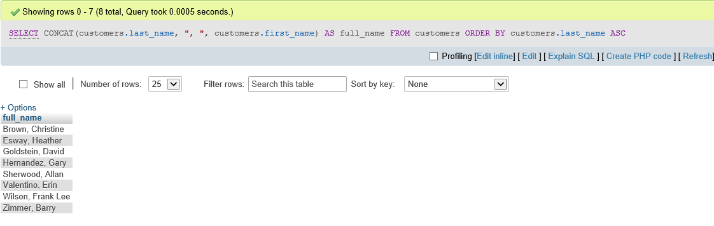

3).Displays all tuples with the attribute list_price from the products table that is greater than 500 and lower than 2000.The product_name , date_added attributes are both included; with the former being used to order the table in descending order.

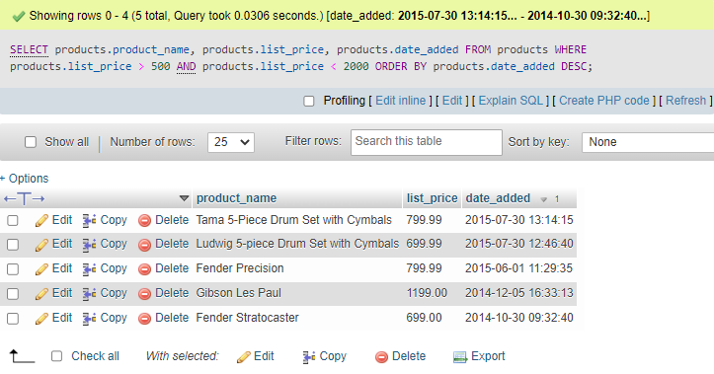

4).Displays 5 tuples with the attributes product_name, list_price, and discount_percent from the product table; with the last two attributes being used to calculate values for two newly created attributes “discount_amount” and “discount_price” (both rounded to two decimal places) where “discount_price is then used to order the table in descending order.

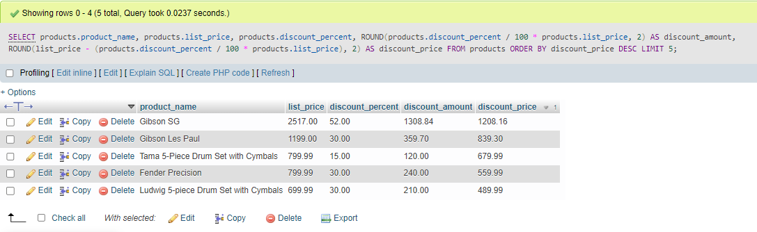

5). Displays a table with the attributes item_id, item_price, discount_amount, and quantity from the order_items table; with the last three attributes being used to calculate values for three newly created attributes “price_total”, “discount_total”, and “item_total”. The tuples in which the attribute “item_total” is greater than 500 is shown and sorted in descending order.

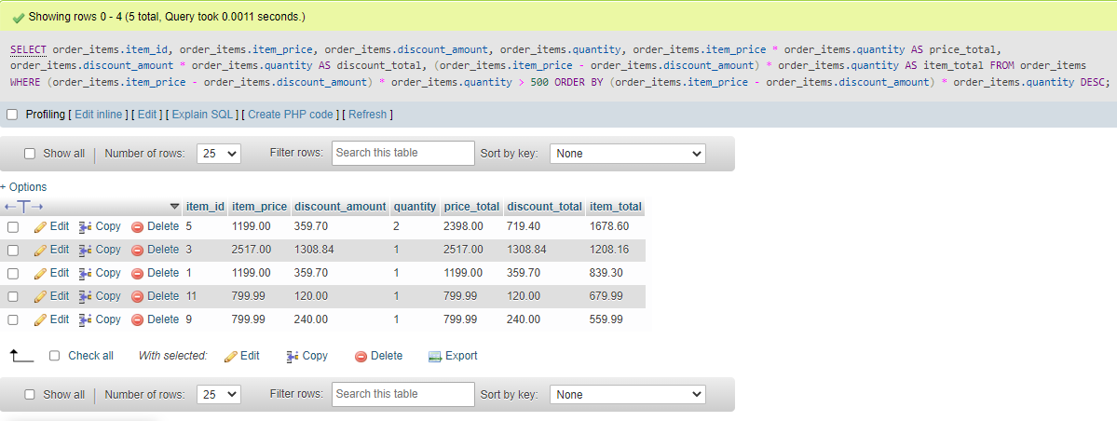

6).Displays a table with the attributes order_id, order_date, and ship_date from the orders table where the only the tuples in which the ship_date is null is shown.

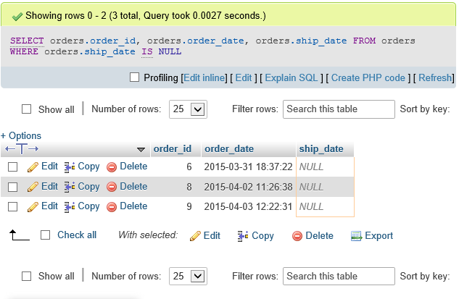

7). Displays a table using two newly created attributes using the now() function to display the current date, with the second attribute being formatted as DD-Mon-YY.

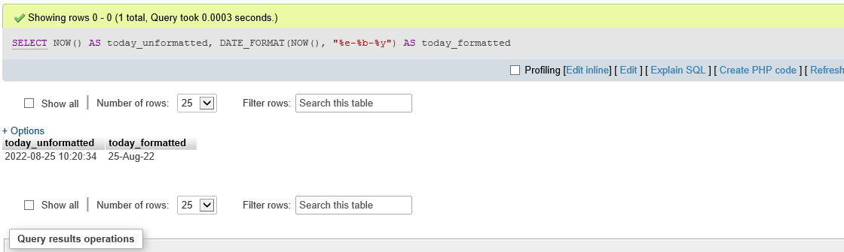

8). Displays a table with newly created attributes “price”, “tax_rate”, “tax_amount”, and “total”, in which the “price” attribute is formatted to two decimal spaces, the “tax_amount” attribute calculates the “price” attribute multiplied by the “tax_rate” attribute, and the “total” attribute calculates the “price” attribute with the “tax_amount” added.

