**User Interface and Color Style Reference**

1. **Logo usage rules**
   * Color Logo: System UI, Print out PDF file.



* + Black and White Logo: Print out paper.



1. **According to following reference to use similar color, Font Type.**

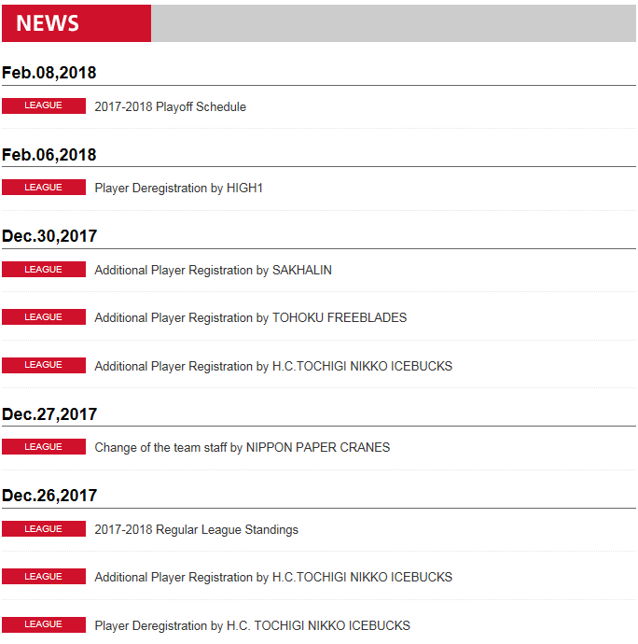

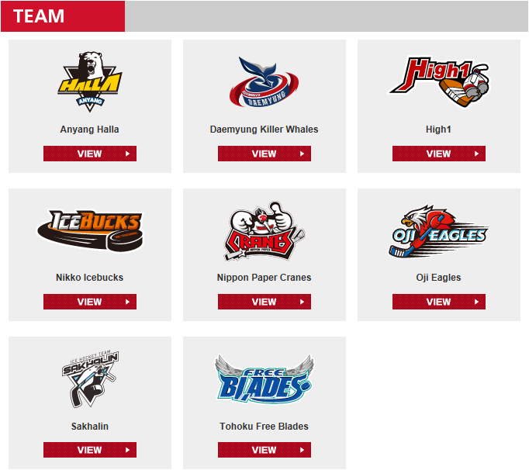

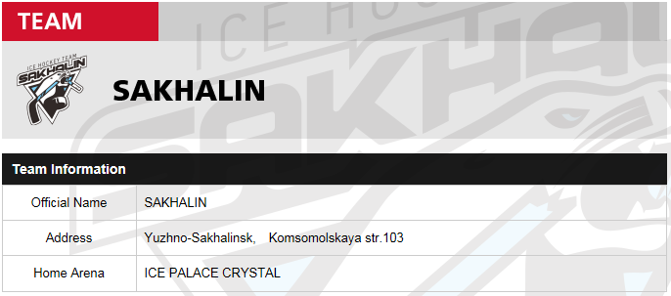

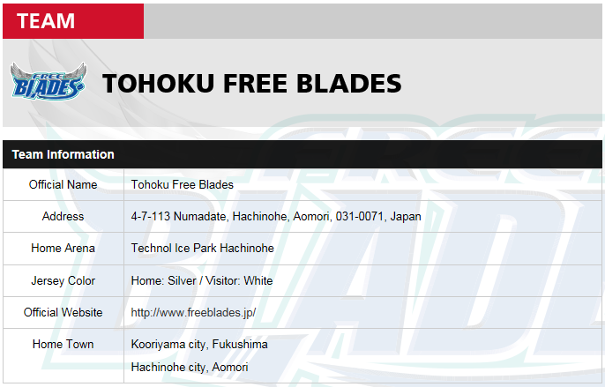

1. **If no related photo of Staff, Goal Keeper,** **Forward, and** **Defender, please use their Team photo “Team Logo.jpg”.**

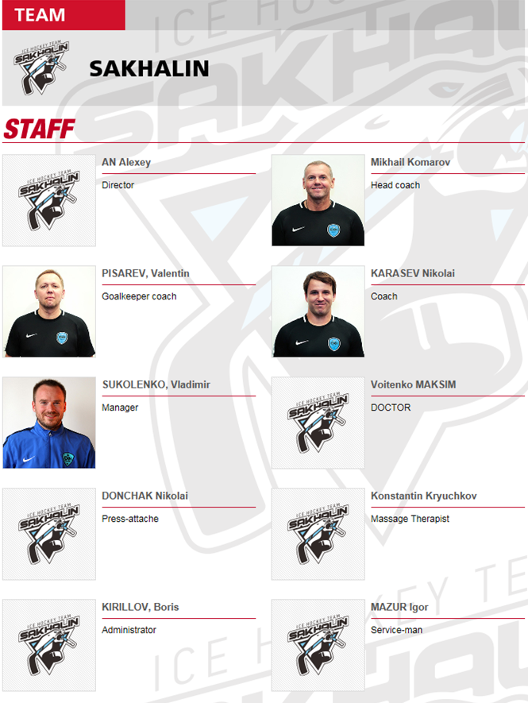

1. **Instruction for User Interface Layout.**



