JSPM NARHE TECHNICAL CAMPUS, NARHE, PUNE 411041



PCC-207-COM
DISCRETE MATHEMATICS
DEPARTMENT OF COMPUTER ENGINEEERING
SE (2024 Course)

Discrete Mathematics Report
On

Digital Cataloging System Using Binary Search Trees

SUBMITTED TO THE SAVITRIBAI PHULE PUNE UNIVERSITY, PUNE

IN THE PARTIAL FULFILLMENT OF THE REQUIREMENTS

FOR

SE COMPUTER ENGINEERING

Semester – IV

Subject Code- PCC-207-COM

Submitted By :-

2172 RAJPUT DNYANESHWAR BAHADURSING

2173 TANPURE TEJAS ANIL

2177 THOMBARE VIKAS RATAN

2141 JADHAV ADITI DATTATRAY

2143 JADHAV PRANJAL SAMBHAJII

2152 KHILARI APEKSHA RAJENDRA

2169 SHINGADE VAISHNAVI OMPRAKASH

2104 BAGAD SUJAL YOGENDRA

2107 BHOSALE TANMAY SURESH

Guided By :- Prof. B. K. Doshi

Prof. S. Y. Chitare Head Of Department

Case Study : Digital Cataloging System Using Binary Search Trees

ABSTRACT
This case study presents the design and implementation of a digital cataloging system using Binary Search Trees (BST). The project demonstrates how discrete mathematics concepts can be applied to real-world problems such as organizing and searching books in a library. A comparison between linear search and BST-based search is conducted to analyze efficiency. The study also includes physical modeling, manual tree construction, and documentation.

1. INTRODUCTION
In modern information systems, efficient data organization and retrieval are crucial. Libraries traditionally rely on classification systems, but digital methods improve speed and scalability. Binary Search Trees provide a structured way to store and search data efficiently.
This project focuses on building a mini library system and applying BST concepts for cataloging and searching books.

catalog few physical books with their details.

Case Study Description

We created a Discrete Mathematics Group Library consisting of academic books used by students of Computer Engineering.

The purpose of this library is to:

Maintain a systematic record of books

Help students quickly find required books

Apply discrete concepts like classification and ordering

Each book is uniquely identified using a Book ID, which helps in organizing and searching.

Book Catalog

Book ID | Title | Author | Publisher | Year | Category | Copies
101 | Discrete Mathematics and Its Applications | Kenneth Rosen | McGraw Hill | 2017 | Mathematics | 3
102 | Higher Engineering Mathematics | B.S. Grewal | Khanna Publishers | 2018 | Mathematics | 4
103 | Data Structures Using C | Reema Thareja | Oxford | 2016 | DSA | 5
104 | Let Us C | Yashavant Kanetkar | BPB Publications | 2018 | Programming | 6
105 | Computer Networks | Andrew Tanenbaum | Pearson | 2019 | Networking | 2

Library Organization Method

Books are organized based on:

1. Book ID (Primary Key Concept)

Each book has a unique ID

Helps in identification and searching

2. Category-Based Classification

Mathematics

Programming

DSA

Networking

Discrete Mathematics Concepts Used

Sets → Books grouped by category

Relations → Book linked with author, publisher

Functions → Book ID uniquely identifies a book

Ordering → Books arranged using ID (can be used for BST later)

2. BST insertion process on large chart paper to visualize tree balance.

BST Concept

A Binary Search Tree (BST) is a tree where:

Left child < Root

Right child > Root

This property helps in fast searching

Data Used (Book IDs)

We use Book IDs from our library:

10, 25, 5, 15, 30, 20

Step-by-Step BST Insertion (Draw this on Chart)

Visual Reference

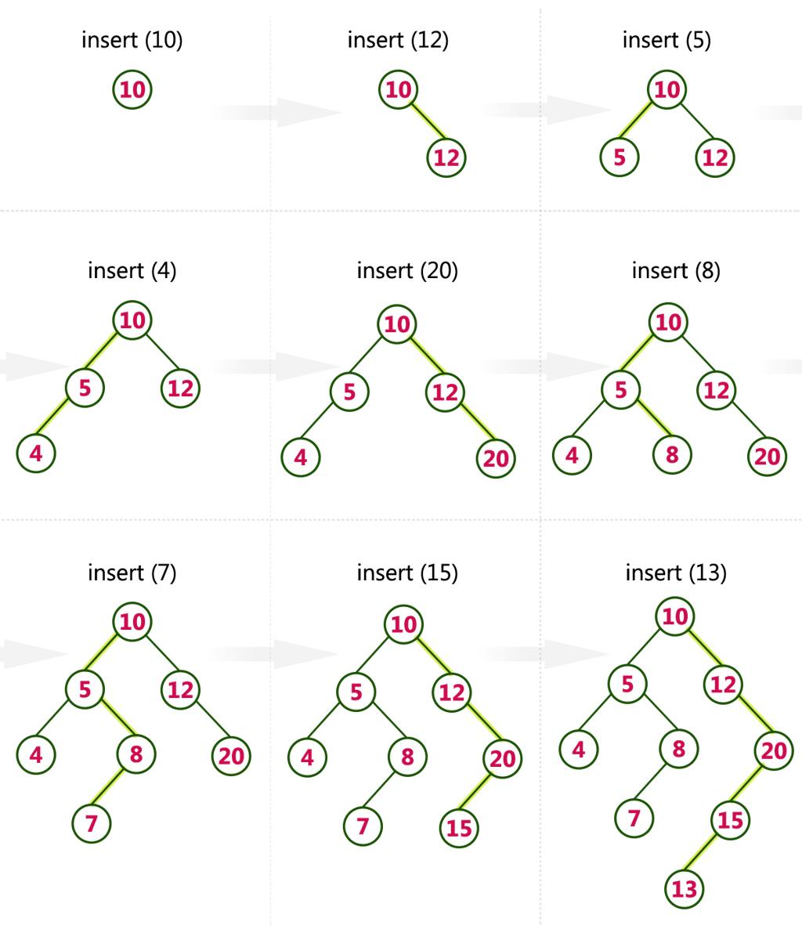

Insertion Steps

Step 1: Insert 10

Tree is empty → 10 becomes Root

10

Step 2: Insert 25

25 > 10 → goes to right

10
\
25

Step 3: Insert 5

5 < 10 → goes to left

10
/ \
5 25

Step 4: Insert 15

15 > 10 → right

15 < 25 → left

10
/ \
5 25
/
15

Step 5: Insert 30

30 > 10 → right

30 > 25 → right

10
/ \
5 25
/ \
15 30

Step 6: Insert 20

20 > 10 → right

20 < 25 → left

20 > 15 → right

10
/ \
5 25
/ \
15 30
\
20

Physically organize a subset of books according to BST properties.

Concept Used

A Binary Search Tree (BST) follows:

Left side → Smaller values

Right side → Greater values

Here, we use Book ID to organize books physically.

🔢 Selected Books (Subset)
Book ID | Title
10 | Discrete Mathematics
25 | Data Structures
5 | Let Us C
15 | Operating System
30 | Computer Networks
20 | DBMS

🌳 BST Structure

10
/ \
5 25
/ \
15 30
\
20

Steps to Physically Arrange Books

Step 1: Choose a Central Position

Place Book ID 10 in the center of the table/shelf
This acts as the root node

Step 2: Place Smaller Values (Left Side)

Place Book ID 5 on the left side of 10

Rule: Smaller → Left

Step 3: Place Greater Values (Right Side)

Place Book ID 25 on the right side of 10

Step 4: Continue BST Logic

Book ID 15 → left of 25

Book ID 30 → right of 25

Step 5: Final Placement

Book ID 20 → right of 15

Visual Understanding

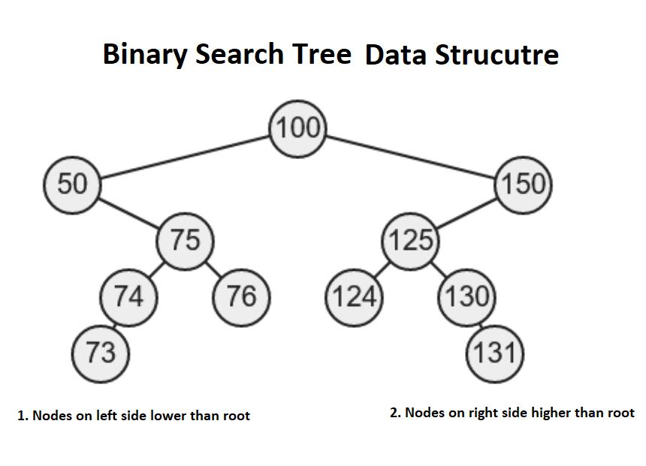

Final Physical Layout
Position | Book ID
Center | 10
Left | 5
Right | 25
Left of 25 | 15
Right of 25 | 30
Right of 15 | 20

Comparison of Search Time: Linear Search vs BST

Concept Overview

Linear Search (Shelf Scanning)

Books are checked one by one

No specific order required

Time Complexity: O(n)

BST Search

Books arranged using Binary Search Tree rules

Search follows left/right decisions

Time Complexity: O(log n) (if balanced)

Experiment Setup

Total Books: 6

Target Book: Book ID = 20

Tools used: Stopwatch (mobile)

⏳ Procedure

🔹 Linear Search:

Start from first book

Check each book sequentially

Stop when Book ID 20 is found

🔹 BST Search:

Start at root (10)

20 > 10 → go right

20 < 25 → go left

20 > 15 → go right → Found

Observation Table
Method | Steps Taken | Time Taken (Approx)
Linear Search | 6 steps | 10–15 seconds
BST Search | 4 steps | 3–5 seconds

📈 Visual Comparison

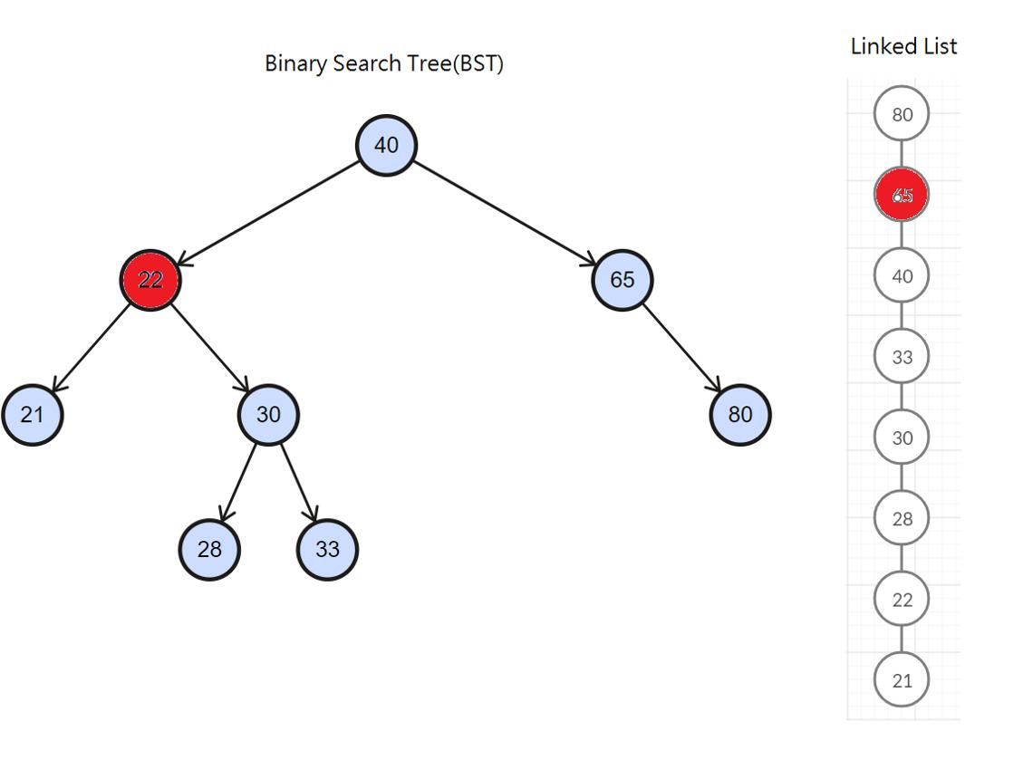

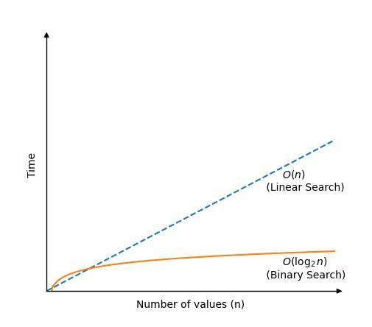

Analysis

Linear search checks every element → slow

BST reduces search space → faster

Fewer comparisons → less time

Result

BST is more efficient than linear search
because it reduces unnecessary comparisons.

Document of the case study group library's current classification system.

The case study group library uses a structured classification system to organize books efficiently.
Each book is categorized based on multiple attributes such as subject, Book ID, and author.

This system ensures:

Easy access to books

Logical arrangement

Efficient searching

Current Classification System

1. Primary Classification (Subject-Based)

Books are grouped into categories (like sets):
Category | Example Books
Mathematics | Discrete Mathematics, Engineering Mathematics
Programming | Let Us C
DSA | Data Structures Using C
DBMS | Database Concepts
Networking | Computer Networks

This is based on Set Theory in Discrete Mathematics
(Each category = one set)

2. Secondary Classification (Book ID Based Ordering)

Each book is assigned a unique Book ID

Books are arranged using ascending order / BST logic

Example:
5 → 10 → 15 → 20 → 25 → 30

This supports:

Fast searching

Structured storage

3. Tertiary Classification (Author-Based)

Books can also be grouped by author name

Helps in finding all books written by a specific author

BST-Based Classification

The library also uses Binary Search Tree (BST) logic for arrangement:

Left side → Smaller Book ID

Right side → Greater Book ID

This improves:

Search efficiency

Logical navigation

Discrete Mathematics Concepts Applied
Concept | Application in Library
Sets | Grouping books by category
Relations | Book ↔ Author ↔ Publisher
Functions | Book ID uniquely identifies a book
Ordering | Sorting books by ID
Trees (BST) | Efficient searching and arrangement

Example: Library Book Catalog
Let’s take 5 books:
ISBN | Title | Author
50 | Data Structures | A. Sharma
30 | C Programming | B. Kumar
70 | Algorithms | C. Rao
20 | Discrete Mathematics | D. Singh
40 | Operating Systems | E. Mehta

Step 1: Build the BST
Insert books using ISBN:
50
/ \
30 70
/ \
20 40

Step 2: Searching a Book (Example)

Find ISBN = 40
Steps:
- Start at root (50) → 40 < 50 → go left
- At 30 → 40 > 30 → go right
- Found 40
Found in 3 steps

Step 3: Traversals (Reports)

1. Inorder Traversal (Sorted Books)
Output:
20 → 30 → 40 → 50 → 70
➡ Gives sorted catalog

2. Preorder Traversal
50 → 30 → 20 → 40 → 70
➡ Used to recreate tree

3. Postorder Traversal
20 → 40 → 30 → 70 → 50
Used for deletion

Comparison with Linear Search

Linear Search:
- Check one by one
- Time = O(n)

BST Search:
- Divide and search
- Time = O(log n)

Example:
Method | Steps Needed
Linear Search | 4 steps
BST Search | 3 steps
BST is faster

7. ALGORITHMS & PSEUDOCODE

7.1 BST Insertion Algorithm
Logic:
- If tree is empty → create root
- Compare ISBN
- Insert left or right recursively
Pseudocode:
INSERT(root, key):
IF root == NULL:
RETURN new Node(key)
IF key < root.key:
root.left = INSERT(root.left, key)
ELSE:
root.right = INSERT(root.right, key)
RETURN root

7.2 BST Search Algorithm
Pseudocode:
SEARCH(root, key):
IF root == NULL OR root.key == key:
RETURN root
IF key < root.key:
RETURN SEARCH(root.left, key)
ELSE:
RETURN SEARCH(root.right, key)

7.3 Traversal Algorithms
Inorder (Sorted Output):
INORDER(root):
IF root != NULL:
INORDER(root.left)
PRINT root.key
INORDER(root.right)
Preorder:
PREORDER(root):
IF root != NULL:
PRINT root.key
PREORDER(root.left)
PREORDER(root.right)
Postorder:
POSTORDER(root):
IF root != NULL:
POSTORDER(root.left)
POSTORDER(root.right)
PRINT root.key

C++ IMPLEMENTATION
#include <iostream>
using namespace std;

struct Node {
long long isbn;
string title, author;
Node *left, *right;
};

Node* createNode(long long isbn, string title, string author) {
Node* n = new Node();
n->isbn = isbn;
n->title = title;
n->author = author;
n->left = n->right = NULL;
return n;
}

Node* insert(Node* root, long long isbn, string title, string author) {
if (root == NULL) return createNode(isbn, title, author);
if (isbn < root->isbn)
root->left = insert(root->left, isbn, title, author);
else
root->right = insert(root->right, isbn, title, author);
return root;
}

Node* search(Node* root, long long isbn) {
if (root == NULL || root->isbn == isbn) return root;
if (isbn < root->isbn)
return search(root->left, isbn);
return search(root->right, isbn);
}

void inorder(Node* root) {
if (root) {
inorder(root->left);
cout << root->isbn << " - " << root->title << endl;
inorder(root->right);
}
}

int main() {
Node* root = NULL;
root = insert(root, 9780131103627, "C Programming", "Ritchie");
root = insert(root, 9780262033848, "Algorithms", "Cormen");
root = insert(root, 9780132350884, "Clean Code", "Martin");

inorder(root);

Node* found = search(root, 9780132350884);
if (found) cout << "Found: " << found->title;
}

Conclusion
This case study successfully demonstrates how concepts from discrete mathematics, particularly Binary Search Trees (BST), can be applied to solve real-world problems such as organizing and searching library data. By creating a mini library and implementing BST both manually and programmatically, we gained a deeper understanding of hierarchical data structures.

