Clandestine Information Distribution

Throughout our time, there were simple things that Amy would, initially, be fine with, bring it up with me, show me, then when I ask about it as curiosity, have a profound and over the top reaction that would last – possibly up to an hour. The times that that was the case:

The DUI Defense Advert as “Friend Meme”. This was genuinely odd. Obviously, it contained a phone number to an individual, that number 206-278-7133, I called, a woman answered, it was a Foot Massage Facility. Clearly, this was a way to send a number of a contact to call for an action that they did not want to identify. However, the target of her anxiety, was photos of a supposed wreck that first happened to her car in February causing it to be in a body shop. Then, she insisted on showing me photos of it again, this time on, I believe December 22nd however, the picture of the ticket that she was taking at the time of the incident, said 12/21. Additionally, the ticket was “Driving too fast for conditions” which in WA is usually for Snow, not rain. However, the lawyer that I called, both of them because they now work separately (the meme is old) only do criminal issues of Misdemeanor or Felony charges and in no way do traffic infractions and have never done them. The issue was solidified at that point. It’s a meme, it’s a clandestine form of information distribution in a – fairly unsophisticated posture (a DUI ad for Traffic Infraction that when you call, they refuse to do traffic law). Nevertheless, she went on for an hour when I first showed her the following image and asked how she used them for an infraction when they only do criminal issues. This brought on an ongoing series of events were she would come and show me new photos of videos of her traffic accident.
This was the photo Amy sent me, as it was on her phone. It is a screen shot of a web-page where the number has been replaced with a photo editor.
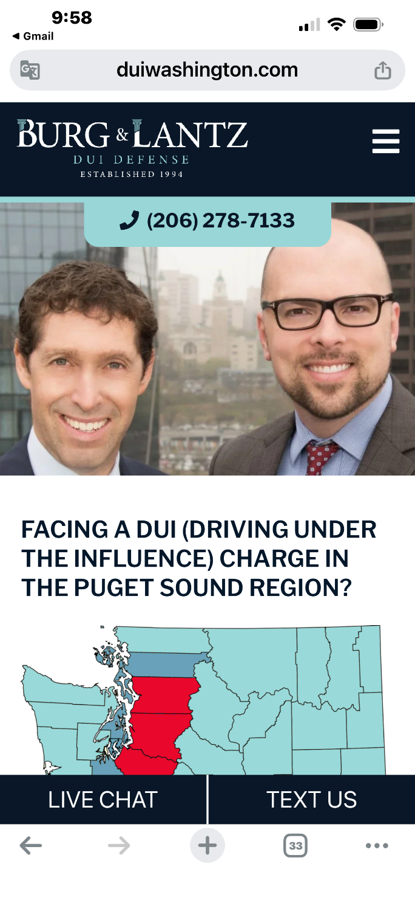
The actual correct number is seen in this image:
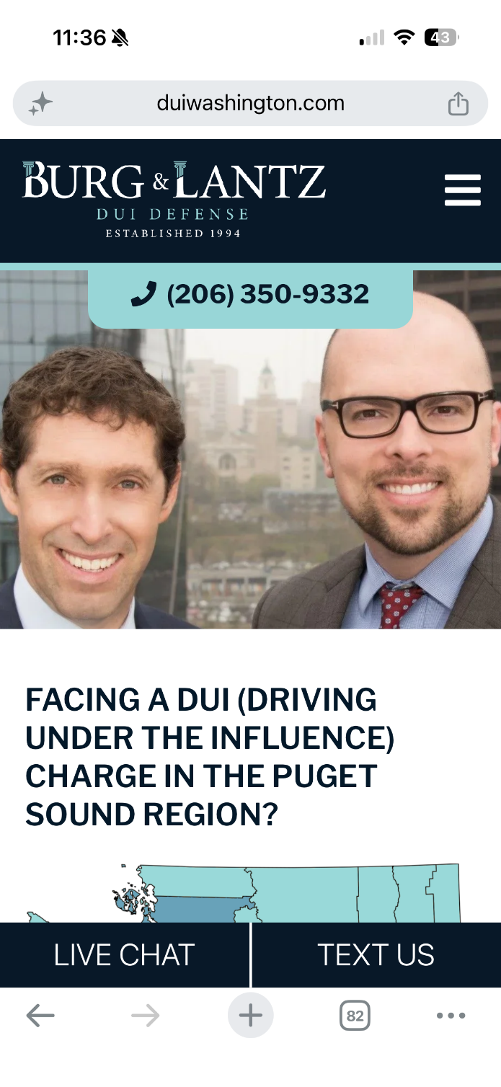

Even yesterday (6/13/2026) she came back with another video of this traffic accident on 12/22, this time with her in it inspecting the car. All the ones she insisted to show me previous to that were taken by her and therefore failed to include her. It indicates that this is a sensitive issue. The lawyers do not practice that law. 4 months for a car to be in a body shop that was originally 2, is ridiculous and, they give you a loaner car. It seems that there is another issue that was not fully present to me in her trying to produce more and more information without prompting about a traffic accident. It started with the DUI-Ad. It has a number that goes to an individual and not the massage place. My assumption was that this was the root of the issue but, perhaps there is another layer. I’m not sure why they keep generating more and more botched images of a “wreck” that produced a 4 month duration in a body shop on a 220k car that refuses to provide a loaner. Payment, clearly, once she decided to perform the hit, the number was I am assuming the one to contact and this individual contacted someone else who performed the actual paper work of taking a car that had been sitting for a year, 4/17/2025 (ten days after our pitch). Obviously the date became an issue as originally it was, I believe 2/7 (sometime in February) but, it had to be back-dated I am assuming to get into sales records and licensing that was forgotten to be submitted within the same calendar year. Not sure but, the fixation on the incident itself was entertaining. I believe three times she came back to show me more photos of a blatantly falsified event.

“Economics Report”
She has virtually zero financial prowess, engagement, consideration, etc. When she transmitted the funds she received on approximately 4/17/2026, she hadn’t logged in to her TD-Ameritrade in so long she had to call them, make transactions, and confirm the amounts to gain access to the account. But, every now and then, she mentions Economics Reports that she regularly gets and that she is so concerned for her situation because the economy in China is so bad.
On 6/13/2026, I was overlooking her shoulder as she pulled it up and she mentioned again: “Chinese Economy so Bad”. I looked at the field values and recognized none of them so, I was interested in what these represented. She got slightly mad about why do I need to be so curious. That night, I took her to a comedy show and, when we sat down, again she brought it up and started scrolling through it. I recorded it as she looked through it and used ChatGPT Pro to produce a translated document. The output was apparently about a small hotel that she supposedly owned. But, when I asked her about it, she got incredibly upset, and went on for – through the first act upsetting the people around us. I do not comprehend in a clandestine sense what these numbers would possibly mean however, it seems that she has concerns of me bringing this up even though, initially it is just a general economics document and, in closer detail is a hotel interest. It is out of her character to be in this mode and even more so, when she continuously returns to original statements of curiosity, etc. it suggests that something is there.
RE: Why it translated to a hotel but, she told me just general economics for her financial situation in China. Her original cover is as a wealthy individual who owns part of a Cleaning Products franchise from her ex-husband however, it was apparent on the first time I was in her condo that that was not the case and she confirmed it was her son’s allowance. As mentioned in previous documents, he also confirmed this when he chastised her for taking advantage of men.

See: Economics-Report-06.13.2026.MOV

Here are screen shots of the ChatGPT-Pro translation. The translation also is saved as a PDF document.

