**React**

**1. ReactJS-HOL**

**Code:**

**//App.js**

import React from 'react';

function App() {

  return (

    <div>

      <h1>Welcome to the first session of React</h1>

    </div>

  );

}

export default App;

**Output:**

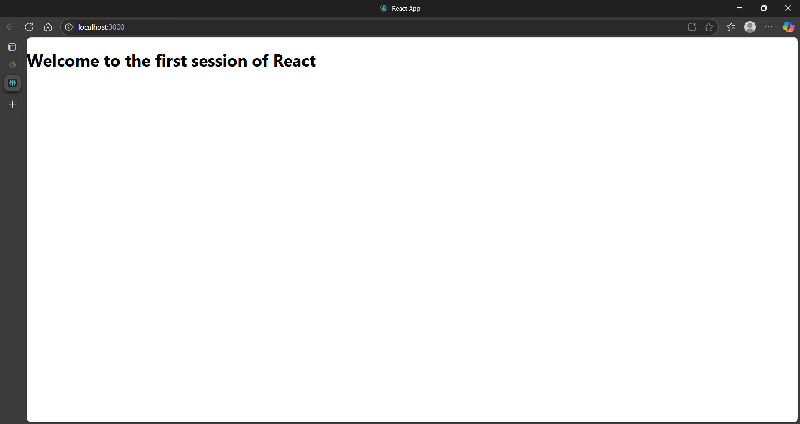

**2. ReactJS-HOL**

**Code:**

**//Home.js**

class Home extends Component {

  render() {

    return (

      <div>

        <h3>Welcome to the Home Page of Student Management Portal</h3>

      </div>

    );

  }

}

export default Home;

**//About.js**

import React,{Component} from "react";

class About extends Component{

render(){

return(

<div>

<h3>Welcome to the About Page of Student Management Portal</h3>

</div>)

}

}

export default About;

**//Contact.js**

import React,{Component} from "react";

class About extends Component{

render(){

return(

<div>

<h3>Welcome to the About Page of Student Management Portal</h3>

</div>)

}

}

export default About;

**//App.js**

import React from 'react';

import './App.css';

import Home from './Components/Home';

import About from './Components/About';

import Contact from './Components/Contact';

function App() {

  return (

    <div className="container">

      <Home />

      <About />

      <Contact />

    </div>

  );

}

export default App;

**Output:**

**3. ReactJS-HOL**

**Code:**

**//CalculateScore.js**

import './mystyle.css'

const percentToDecimal = (decimal) => {

return (decimal.toFixed(2) + '%')

}

const calcScore = (total, goal) => {

return percentToDecimal(total / goal)

}

export const CalculateScore = ({ Name, School, total, goal }) => (

<div className="formatstyle">

<h1 style={{ color: "Brown" }}>Student Details:</h1>

<div className="Name">

<b><span>Name: </span></b>

<span>{Name}</span>

</div>

<div className="School">

<b><span>School: </span></b>

<span>{School}</span>

</div>

<div className="Total">

<b><span>Total: </span></b>

<span>{total}</span>

<span>Marks</span>

</div>

<div className="Score">

<b>Score: </b>

<span>

{calcScore(

total,

goal

)}

</span>

</div>

</div>

)

**/* mystyle.css */**

.Name {

font-weight: 300;

color: blue;

}

.School {

color: crimson;

}

.Total {

color: darkmagenta;

}

.formatstyle {

text-align: center;

font-size: large;

}

.Score {

color: forestgreen;

}

**//App.js**

import logo from './logo.svg';

import './App.css';

import { CalculateScore } from './components/CalculateScore';

function App() {

return (

<div className="App">

<CalculateScore Name={"Steeve"} School={"DNV Public School"} total={284} goal={3}/>

</div>

);

}

export default App;

**Output:**

**4. ReactJS-HOL**

**Code:**

**//Post.js**

import React from 'react';

class Posts extends React.Component {

constructor(props) {

super(props);

this.state = {

posts: [],

error: null,

};

}

loadPosts() {

fetch('https://jsonplaceholder.typicode.com/posts')

.then(response => response.json())

.then(data => this.setState({ posts: data }))

.catch(error => this.setState({ error }));

}

componentDidMount() {

this.loadPosts();

}

componentDidCatch(error, errorInfo) {

alert(`Error: ${error.toString()}`);

console.error(error, errorInfo);

}

render() {

const { posts, error } = this.state;

if (error) {

return <div>Error: {error.message}</div>;

}

return (

<div>

{posts.map(post => (

<div key={post.id}>

<h1>{post.title}</h1>

<p>{post.body}</p>

</div>

))}

</div>

);

}

}

export default Posts;

**//App.js**

import logo from './logo.svg';

import './App.css';

import Posts from './Post';

function App() {

return (

<div className="App">

<Posts />

</div>

);

}

export default App;

**Output:**

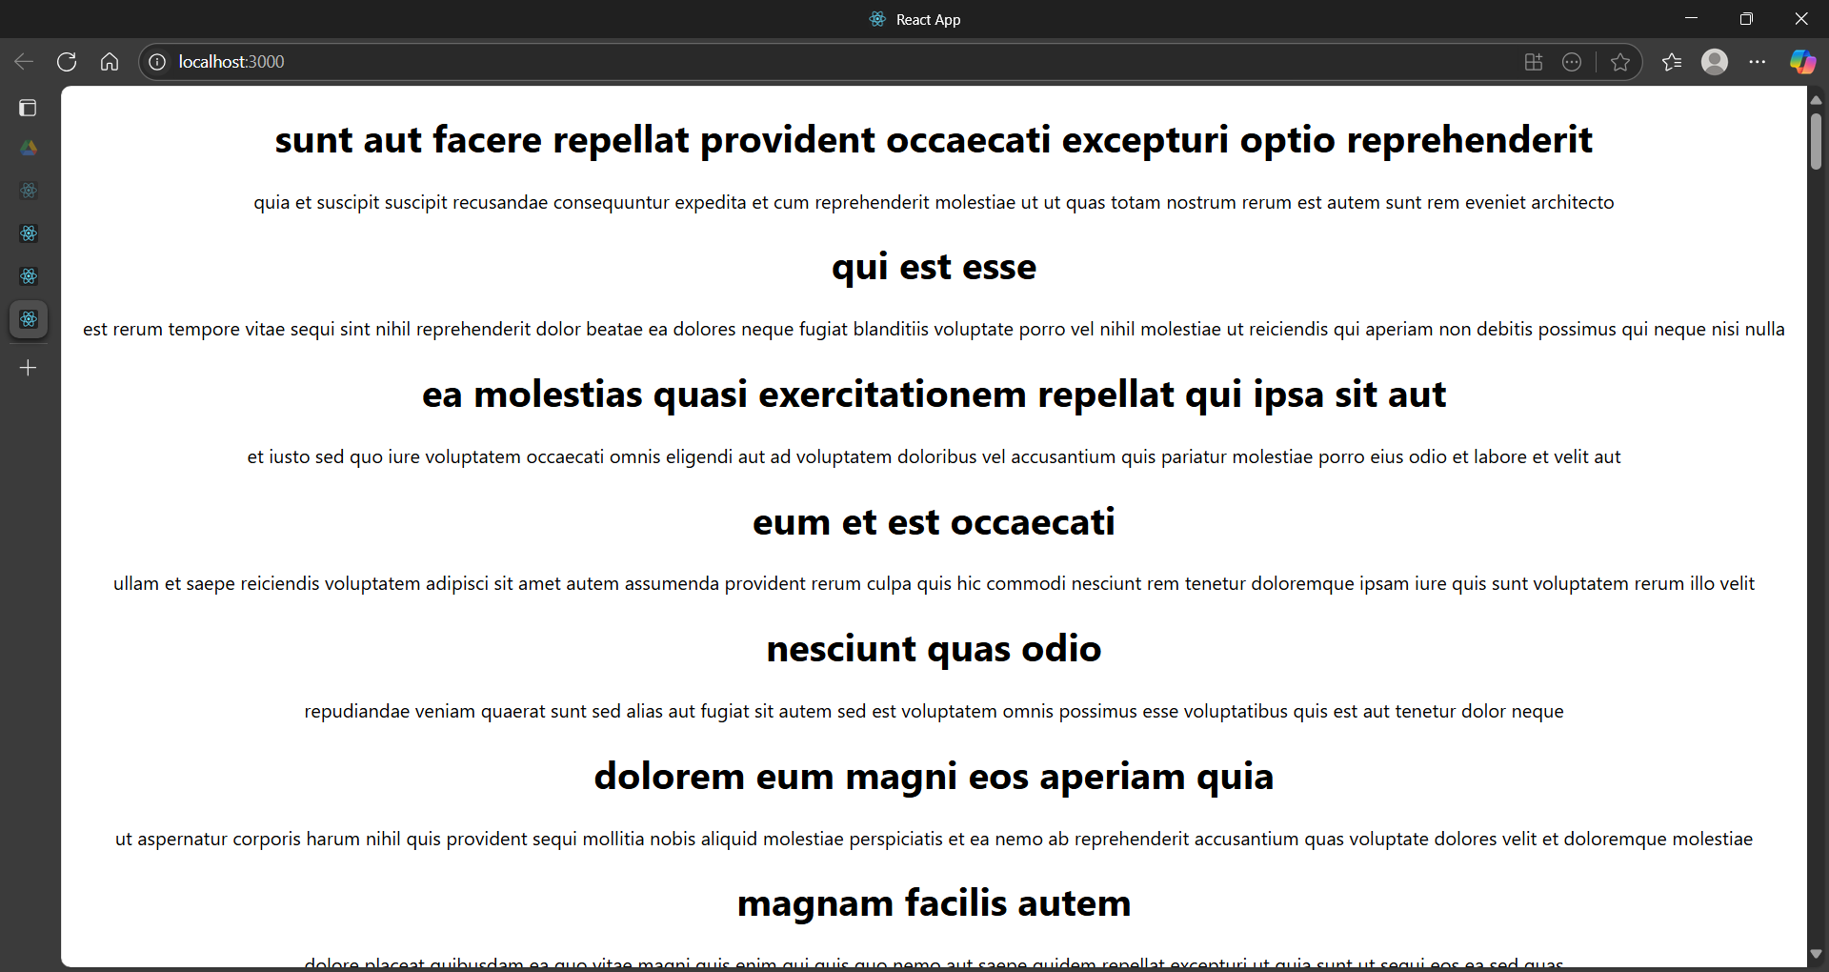

**5. ReactJS-HOL**

**Code:**

**/\*** **CohortDetails.module.css */**

.box {

width: 300px;

display: inline-block;

margin: 10px;

padding: 10px 20px;

border: 1px solid black;

border-radius: 10px;

}

dt {

font-weight: 500;

}

.greenText {

color: green;

}

.blueText {

color: blue;

}

**//CohortDetails.js**

import React from 'react';

import styles from './CohortDetails.module.css';

function CohortDetails(props) {

const h3ClassName = props.cohort.currentStatus === 'ongoing'

? styles.greenText

: styles.blueText;

return (

<div className={styles.box}>

<h3 className={h3ClassName}>

{props.cohort.cohortCode} -

<span>{props.cohort.technology}</span>

</h3>

<dl>

<dt>Started On</dt>

<dd>{props.cohort.startDate}</dd>

<dt>Current Status</dt>

<dd>{props.cohort.currentStatus}</dd>

<dt>Coach</dt>

<dd>{props.cohort.coachName}</dd>

<dt>Trainer</dt>

<dd>{props.cohort.trainerName}</dd>

</dl>

</div>

);

}

export default CohortDetails;

**//App.js**

import logo from './logo.svg';

import './App.css';

import { CohortsData} from './Cohort'

import CohortDetails from './CohortDetails';

function App() {

return (

<div>

<h1>Cohorts Details</h1>

{CohortsData.map(cohort => <CohortDetails cohort={cohort}/>)}

</div>

);

}

export default App;

**Output:**

