**GIT**

1. **Git - HOL**

**Code:**

uspra@USPRASATH MINGW64 ~

$ git version

git version 2.46.0.windows.1

uspra@USPRASATH MINGW64 ~

$ git config --global --list

user.email=usprasath2004159@gmail.com

user.name=U.S.Prasath

filter.lfs.clean=git-lfs clean -- %f

filter.lfs.smudge=git-lfs smudge -- %f

filter.lfs.process=git-lfs filter-process

filter.lfs.required=true

core.editor='C:\Program Files\Notepad++\notepad++.exe' -multiInst -notabbar -nosession -noPlugin

uspra@USPRASATH MINGW64 ~

$ git config --global user.name "U.S.Prasath"

uspra@USPRASATH MINGW64 ~

$ git config --global user.email "usprasath2004159@gmail.com"

uspra@USPRASATH MINGW64 ~

$ git config --global --list

user.email=usprasath2004159@gmail.com

user.name=U.S.Prasath

filter.lfs.clean=git-lfs clean -- %f

filter.lfs.smudge=git-lfs smudge -- %f

filter.lfs.process=git-lfs filter-process

filter.lfs.required=true

core.editor='C:\Program Files\Notepad++\notepad++.exe' -multiInst -notabbar -nosession -noPlugin

uspra@USPRASATH MINGW64 ~

$ cd ..

uspra@USPRASATH MINGW64 /c/Users

$ cd ..

uspra@USPRASATH MINGW64 /c

$ cd ..

uspra@USPRASATH MINGW64 /

$ cd d

uspra@USPRASATH MINGW64 /d

$ git init GitDemo

Initialized empty Git repository in D:/GitDemo/.git/

uspra@USPRASATH MINGW64 /d

$ cd GitDemo

uspra@USPRASATH MINGW64 /d/GitDemo (master)

$ ls -al

total 8

drwxr-xr-x 1 uspra 197609 0 Aug 10 19:05 ./

drwxr-xr-x 1 uspra 197609 0 Aug 10 19:05 ../

drwxr-xr-x 1 uspra 197609 0 Aug 10 19:05 .git/

uspra@USPRASATH MINGW64 /d/GitDemo (master)

$ echo "Welcome to the version control" >> welcome.txt

uspra@USPRASATH MINGW64 /d/GitDemo (master)

$ ls -al

total 9

drwxr-xr-x 1 uspra 197609 0 Aug 10 19:06 ./

drwxr-xr-x 1 uspra 197609 0 Aug 10 19:05 ../

drwxr-xr-x 1 uspra 197609 0 Aug 10 19:05 .git/

-rw-r--r-- 1 uspra 197609 31 Aug 10 19:06 welcome.txt

uspra@USPRASATH MINGW64 /d/GitDemo (master)

$ cat welcome.txt

Welcome to the version control

uspra@USPRASATH MINGW64 /d/GitDemo (master)

$ git status

On branch master

No commits yet

Untracked files:

(use "git add <file>..." to include in what will be committed)

welcome.txt

nothing added to commit but untracked files present (use "git add" to track)

uspra@USPRASATH MINGW64 /d/GitDemo (master)

$ git add welcome.txt

warning: in the working copy of 'welcome.txt', LF will be replaced by CRLF the next time Git touches it

uspra@USPRASATH MINGW64 /d/GitDemo (master)

$ git commit

[master (root-commit) b7035df] Initial Commit - Created GitDemo Repository for Cognizant Digital Nurture DeepSkilling Program

1 file changed, 1 insertion(+)

create mode 100644 welcome.txt

uspra@USPRASATH MINGW64 /d/GitDemo (master)

$ git status

On branch master

nothing to commit, working tree clean

uspra@USPRASATH MINGW64 /d/GitDemo (master)

$ git pull origin master

fatal: 'origin' does not appear to be a git repository

fatal: Could not read from remote repository.

Please make sure you have the correct access rights

and the repository exists.

uspra@USPRASATH MINGW64 /d/GitDemo (master)

$ git pull origin master https://gitlab.com/usprasath-group/GitDemo

fatal: invalid refspec 'https://gitlab.com/usprasath-group/GitDemo'

uspra@USPRASATH MINGW64 /d/GitDemo (master)

$ git pull origin master https://github.com/US-PRASATH/GitDemo

fatal: invalid refspec 'https://github.com/US-PRASATH/GitDemo'

uspra@USPRASATH MINGW64 /d/GitDemo (master)

$ git remote add origin https://gitlab.com/usprasath-group/GitDemo

uspra@USPRASATH MINGW64 /d/GitDemo (master)

$ git pull origin master

warning: redirecting to https://gitlab.com/usprasath-group/GitDemo.git/

fatal: couldn't find remote ref master

uspra@USPRASATH MINGW64 /d/GitDemo (master)

$ git pull origin main

warning: redirecting to https://gitlab.com/usprasath-group/GitDemo.git/

remote: Enumerating objects: 3, done.

remote: Counting objects: 100% (3/3), done.

remote: Compressing objects: 100% (2/2), done.

remote: Total 3 (delta 0), reused 0 (delta 0), pack-reused 0 (from 0)

Unpacking objects: 100% (3/3), 2.74 KiB | 77.00 KiB/s, done.

From https://gitlab.com/usprasath-group/GitDemo

* branch main -> FETCH_HEAD

* [new branch] main -> origin/main

fatal: refusing to merge unrelated histories

uspra@USPRASATH MINGW64 /d/GitDemo (master)

$ git push origin main

error: src refspec main does not match any

error: failed to push some refs to 'https://gitlab.com/usprasath-group/GitDemo'

uspra@USPRASATH MINGW64 /d/GitDemo (master)

$ git push origin master

warning: redirecting to https://gitlab.com/usprasath-group/GitDemo.git/

Enumerating objects: 3, done.

Counting objects: 100% (3/3), done.

Writing objects: 100% (3/3), 317 bytes | 317.00 KiB/s, done.

Total 3 (delta 0), reused 0 (delta 0), pack-reused 0 (from 0)

remote:

remote: To create a merge request for master, visit:

remote: https://gitlab.com/usprasath-group/GitDemo/-/merge_requests/new?merge_request%5Bsource_branch%5D=master

remote:

To https://gitlab.com/usprasath-group/GitDemo

* [new branch] master -> master

uspra@USPRASATH MINGW64 /d/GitDemo (master)

$

**Output:**

**2.Git-HOL**

**Code:**

uspra@USPRASATH MINGW64 /d

$ cd GitDemo

uspra@USPRASATH MINGW64 /d/GitDemo (master)

$ ls

debug.log log/ welcome.txt

uspra@USPRASATH MINGW64 /d/GitDemo (master)

$ rm debug.log

uspra@USPRASATH MINGW64 /d/GitDemo (master)

$ rm -r log

uspra@USPRASATH MINGW64 /d/GitDemo (master)

$ ls

welcome.txt

uspra@USPRASATH MINGW64 /d/GitDemo (master)

$ echo "This is a log file" > debug.log

uspra@USPRASATH MINGW64 /d/GitDemo (master)

$ echo "Log data inside folder" > log/app.log

bash: log/app.log: No such file or directory

uspra@USPRASATH MINGW64 /d/GitDemo (master)

$ mkdir log

uspra@USPRASATH MINGW64 /d/GitDemo (master)

$ echo "Log data inside folder" > log/app.log

uspra@USPRASATH MINGW64 /d/GitDemo (master)

$ notepad++ .gitignore

uspra@USPRASATH MINGW64 /d/GitDemo (master)

$ git add .gitignore

git commit -m "Add .gitignore to ignore .log files and log folder"

[master 0f2d52b] Add .gitignore to ignore .log files and log folder

1 file changed, 5 insertions(+)

create mode 100644 .gitignore

uspra@USPRASATH MINGW64 /d/GitDemo (master)

$ git status

On branch master

nothing to commit, working tree clean

uspra@USPRASATH MINGW64 /d/GitDemo (master)

$

**Output:**

**3.Git-HOL**

**Code:**

uspra@USPRASATH MINGW64 /d/GitDemo (master)

$ git branch GitNewBranch

uspra@USPRASATH MINGW64 /d/GitDemo (master)

$ git branch -a

GitNewBranch

* master

remotes/origin/main

remotes/origin/master

uspra@USPRASATH MINGW64 /d/GitDemo (master)

$ git checkout GitNewBranch

Switched to branch 'GitNewBranch'

uspra@USPRASATH MINGW64 /d/GitDemo (GitNewBranch)

$ echo "This is content for the new branch" > branchfile.txt

echo "Another file in the branch" > secondfile.txt

uspra@USPRASATH MINGW64 /d/GitDemo (GitNewBranch)

$ git add branchfile.txt secondfile.txt

git commit -m "Add files in GitNewBranch"

warning: in the working copy of 'branchfile.txt', LF will be replaced by CRLF the next time Git touches it

warning: in the working copy of 'secondfile.txt', LF will be replaced by CRLF the next time Git touches it

[GitNewBranch bb07c8d] Add files in GitNewBranch

2 files changed, 2 insertions(+)

create mode 100644 branchfile.txt

create mode 100644 secondfile.txt

uspra@USPRASATH MINGW64 /d/GitDemo (GitNewBranch)

$ git status

On branch GitNewBranch

Untracked files:

(use "git add <file>..." to include in what will be committed)

sh.exe.stackdump

nothing added to commit but untracked files present (use "git add" to track)

uspra@USPRASATH MINGW64 /d/GitDemo (GitNewBranch)

$ git checkout master

Switched to branch 'master'

uspra@USPRASATH MINGW64 /d/GitDemo (master)

$ git diff master GitNewBranch

diff --git a/branchfile.txt b/branchfile.txt

new file mode 100644

index 0000000..4942c00

--- /dev/null

+++ b/branchfile.txt

@@ -0,0 +1 @@

+This is content for the new branch

diff --git a/secondfile.txt b/secondfile.txt

new file mode 100644

index 0000000..b015c15

--- /dev/null

+++ b/secondfile.txt

@@ -0,0 +1 @@

+Another file in the branch

uspra@USPRASATH MINGW64 /d/GitDemo (master)

$ p4merge --version

bash: p4merge: command not found

uspra@USPRASATH MINGW64 /d/GitDemo (master)

$ "C:\Program Files\Perforce\p4merge.exe"

uspra@USPRASATH MINGW64 /d/GitDemo (master)

$ git config --global diff.tool p4merge

uspra@USPRASATH MINGW64 /d/GitDemo (master)

$ git config --global difftool.p4merge.path "/c/Program Files/Perforce/p4merge.exe"

uspra@USPRASATH MINGW64 /d/GitDemo (master)

$ git difftool master GitNewBranch

Viewing (1/2): 'branchfile.txt'

Launch 'p4merge' [Y/n]? y

Viewing (2/2): 'secondfile.txt'

Launch 'p4merge' [Y/n]? y

uspra@USPRASATH MINGW64 /d/GitDemo (master)

$ git log --oneline --graph --decorate

* 0f2d52b (HEAD -> master) Add .gitignore to ignore .log files and log folder

* b7035df (origin/master) Initial Commit - Created GitDemo Repository for Cognizant Digital Nurture DeepSkilling Program

uspra@USPRASATH MINGW64 /d/GitDemo (master)

$ git log --oneline --graph --decorate

* 0f2d52b (HEAD -> master) Add .gitignore to ignore .log files and log folder

* b7035df (origin/master) Initial Commit - Created GitDemo Repository for Cognizant Digital Nurture DeepSkilling Program

uspra@USPRASATH MINGW64 /d/GitDemo (master)

$ git merge GitNewBranch

Updating 0f2d52b..bb07c8d

Fast-forward

branchfile.txt | 1 +

secondfile.txt | 1 +

2 files changed, 2 insertions(+)

create mode 100644 branchfile.txt

create mode 100644 secondfile.txt

uspra@USPRASATH MINGW64 /d/GitDemo (master)

$ git log --oneline --graph --decorate

* bb07c8d (HEAD -> master, GitNewBranch) Add files in GitNewBranch

* 0f2d52b Add .gitignore to ignore .log files and log folder

* b7035df (origin/master) Initial Commit - Created GitDemo Repository for Cognizant Digital Nurture DeepSkilling Program

uspra@USPRASATH MINGW64 /d/GitDemo (master)

$ git branch -d GitNewBranch

Deleted branch GitNewBranch (was bb07c8d).

uspra@USPRASATH MINGW64 /d/GitDemo (master)

$ git status

On branch master

Untracked files:

(use "git add <file>..." to include in what will be committed)

sh.exe.stackdump

nothing added to commit but untracked files present (use "git add" to track)

uspra@USPRASATH MINGW64 /d/GitDemo (master)

$

**Output:**

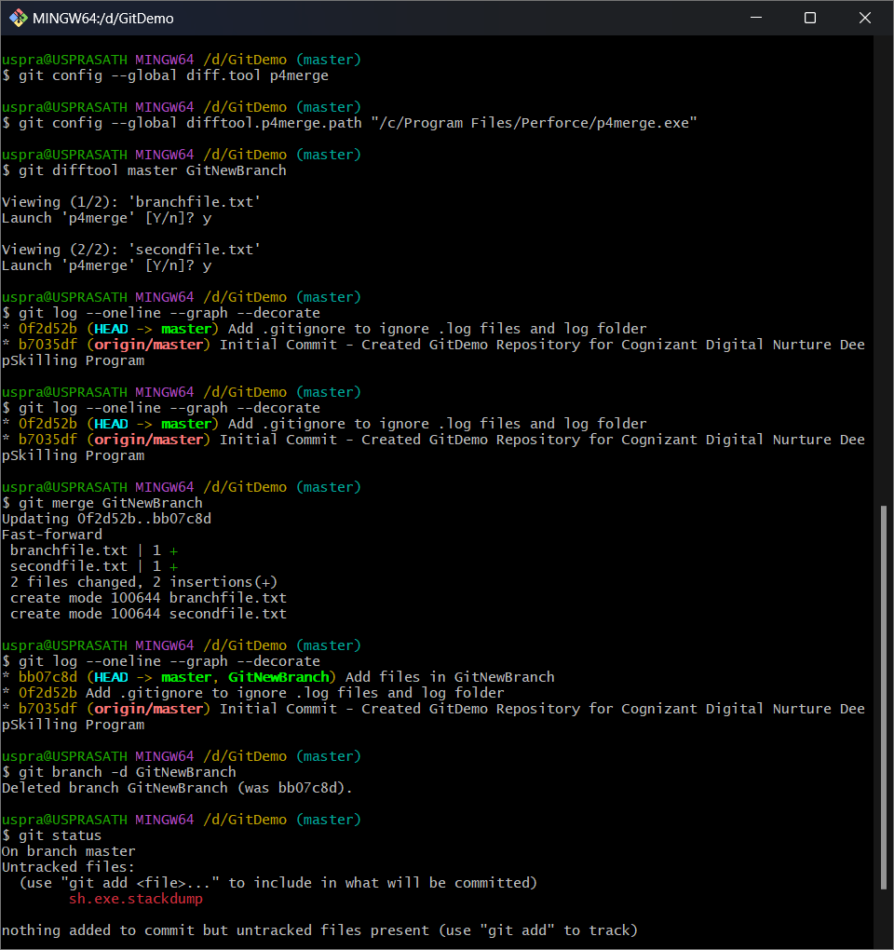

**4.Git-HOL**

**Code:**

uspra@USPRASATH MINGW64 /d/GitDemo (master)

$ git checkout master

git status

Already on 'master'

On branch master

nothing to commit, working tree clean

uspra@USPRASATH MINGW64 /d/GitDemo (master)

$ git checkout -b GitWork

echo "<message>Hello from GitWork branch</message>" > hello.xml

Switched to a new branch 'GitWork'

uspra@USPRASATH MINGW64 /d/GitDemo (GitWork)

$ echo "<update>Second line from GitWork</update>" >> hello.xml

git status

On branch GitWork

Untracked files:

(use "git add <file>..." to include in what will be committed)

hello.xml

nothing added to commit but untracked files present (use "git add" to track)

uspra@USPRASATH MINGW64 /d/GitDemo (GitWork)

$ git add hello.xml

git commit -m "Add and update hello.xml in GitWork branch"

warning: in the working copy of 'hello.xml', LF will be replaced by CRLF the next time Git touches it

[GitWork 73067e2] Add and update hello.xml in GitWork branch

1 file changed, 2 insertions(+)

create mode 100644 hello.xml

uspra@USPRASATH MINGW64 /d/GitDemo (GitWork)

$ git checkout master

Switched to branch 'master'

uspra@USPRASATH MINGW64 /d/GitDemo (master)

$ echo "<message>Hello from Master branch</message>" > hello.xml

uspra@USPRASATH MINGW64 /d/GitDemo (master)

$ git add hello.xml

git commit -m "Add hello.xml in Master branch with different content"

warning: in the working copy of 'hello.xml', LF will be replaced by CRLF the next time Git touches it

[master 21439e9] Add hello.xml in Master branch with different content

1 file changed, 1 insertion(+)

create mode 100644 hello.xml

uspra@USPRASATH MINGW64 /d/GitDemo (master)

$ git log --oneline --graph --decorate --all

* 21439e9 (HEAD -> master) Add hello.xml in Master branch with different content

| * 73067e2 (GitWork) Add and update hello.xml in GitWork branch

|/

* 2048f95 Merged GitNewBranch to master

* bb07c8d Add files in GitNewBranch

* 0f2d52b Add .gitignore to ignore .log files and log folder

* b7035df (origin/master) Initial Commit - Created GitDemo Repository for Cognizant Digital Nurture DeepSkilling Program

* b2ea0de (origin/main) Initial commit

uspra@USPRASATH MINGW64 /d/GitDemo (master)

$ git diff master GitWork

diff --git a/hello.xml b/hello.xml

index 7feff86..a8c7b97 100644

--- a/hello.xml

+++ b/hello.xml

@@ -1 +1,2 @@

-<message>Hello from Master branch</message>

+<message>Hello from GitWork branch</message>

+<update>Second line from GitWork</update>

uspra@USPRASATH MINGW64 /d/GitDemo (master)

$ git config --global diff.tool p4merge

git config --global difftool.p4merge.path "/c/Program Files/Perforce/p4merge.exe"

git difftool master GitWork

Viewing (1/1): 'hello.xml'

Launch 'p4merge' [Y/n]? y

uspra@USPRASATH MINGW64 /d/GitDemo (master)

$ git merge GitWork

Auto-merging hello.xml

CONFLICT (add/add): Merge conflict in hello.xml

Automatic merge failed; fix conflicts and then commit the result.

uspra@USPRASATH MINGW64 /d/GitDemo (master|MERGING)

$ git difftool master GitWork

Viewing (1/1): 'hello.xml'

Launch 'p4merge' [Y/n]? y

uspra@USPRASATH MINGW64 /d/GitDemo (master|MERGING)

$ git merge GitWork

error: Merging is not possible because you have unmerged files.

hint: Fix them up in the work tree, and then use 'git add/rm <file>'

hint: as appropriate to mark resolution and make a commit.

fatal: Exiting because of an unresolved conflict.

uspra@USPRASATH MINGW64 /d/GitDemo (master|MERGING)

$ git difftool master GitWork

Viewing (1/1): 'hello.xml'

Launch 'p4merge' [Y/n]? y

uspra@USPRASATH MINGW64 /d/GitDemo (master|MERGING)

$ git merge GitWork

error: Merging is not possible because you have unmerged files.

hint: Fix them up in the work tree, and then use 'git add/rm <file>'

hint: as appropriate to mark resolution and make a commit.

fatal: Exiting because of an unresolved conflict.

uspra@USPRASATH MINGW64 /d/GitDemo (master|MERGING)

$ git difftool master GitWork

Viewing (1/1): 'hello.xml'

Launch 'p4merge' [Y/n]? y

uspra@USPRASATH MINGW64 /d/GitDemo (master|MERGING)

$ ^C

uspra@USPRASATH MINGW64 /d/GitDemo (master|MERGING)

$ git status

On branch master

You have unmerged paths.

(fix conflicts and run "git commit")

(use "git merge --abort" to abort the merge)

Unmerged paths:

(use "git add <file>..." to mark resolution)

both added: hello.xml

no changes added to commit (use "git add" and/or "git commit -a")

uspra@USPRASATH MINGW64 /d/GitDemo (master|MERGING)

$ git merge GitWork

error: Merging is not possible because you have unmerged files.

hint: Fix them up in the work tree, and then use 'git add/rm <file>'

hint: as appropriate to mark resolution and make a commit.

fatal: Exiting because of an unresolved conflict.

uspra@USPRASATH MINGW64 /d/GitDemo (master|MERGING)

$ git add hello.xml

uspra@USPRASATH MINGW64 /d/GitDemo (master|MERGING)

$ git commit

[master 0b706a1] Merge branch 'GitWork'

uspra@USPRASATH MINGW64 /d/GitDemo (master)

$ git status

On branch master

nothing to commit, working tree clean

uspra@USPRASATH MINGW64 /d/GitDemo (master)

$ git merge GitWork

Already up to date.

uspra@USPRASATH MINGW64 /d/GitDemo (master)

$ echo "*.bak" >> .gitignore

git status

On branch master

Changes not staged for commit:

(use "git add <file>..." to update what will be committed)

(use "git restore <file>..." to discard changes in working directory)

modified: .gitignore

no changes added to commit (use "git add" and/or "git commit -a")

uspra@USPRASATH MINGW64 /d/GitDemo (master)

$ git add .gitignore

git commit -m "Add .bak files to .gitignore"

warning: in the working copy of '.gitignore', LF will be replaced by CRLF the next time Git touches it

[master cf8ad1f] Add .bak files to .gitignore

1 file changed, 1 insertion(+)

uspra@USPRASATH MINGW64 /d/GitDemo (master)

$ git branch

GitWork

* master

uspra@USPRASATH MINGW64 /d/GitDemo (master)

$ git branch -d GitWork

Deleted branch GitWork (was 73067e2).

uspra@USPRASATH MINGW64 /d/GitDemo (master)

$ git log --oneline --graph --decorate

* cf8ad1f (HEAD -> master) Add .bak files to .gitignore

* 0b706a1 Merge branch 'GitWork'

|\

| * 73067e2 Add and update hello.xml in GitWork branch

* | 21439e9 Add hello.xml in Master branch with different content

|/

* 2048f95 Merged GitNewBranch to master

* bb07c8d Add files in GitNewBranch

* 0f2d52b Add .gitignore to ignore .log files and log folder

* b7035df (origin/master) Initial Commit - Created GitDemo Repository for Cognizant Digital Nurture DeepSkilling Program

uspra@USPRASATH MINGW64 /d/GitDemo (master)

$

**Output:**

**5.Git-HOL**

**Code:**

uspra@USPRASATH MINGW64 /d/GitDemo (master)

$ git checkout master

git status

Already on 'master'

On branch master

nothing to commit, working tree clean

uspra@USPRASATH MINGW64 /d/GitDemo (master)

$ git branch -a

* master

remotes/origin/main

remotes/origin/master

uspra@USPRASATH MINGW64 /d/GitDemo (master)

$ git pull origin master

warning: redirecting to https://gitlab.com/usprasath-group/GitDemo.git/

From https://gitlab.com/usprasath-group/GitDemo

* branch master -> FETCH_HEAD

Already up to date.

uspra@USPRASATH MINGW64 /d/GitDemo (master)

$ git checkout Git-T03-HOL_002

git push origin Git-T03-HOL_002

error: pathspec 'Git-T03-HOL_002' did not match any file(s) known to git

error: src refspec Git-T03-HOL_002 does not match any

error: failed to push some refs to 'https://gitlab.com/usprasath-group/GitDemo'

uspra@USPRASATH MINGW64 /d/GitDemo (master)

$ git push

fatal: The current branch master has no upstream branch.

To push the current branch and set the remote as upstream, use

git push --set-upstream origin master

To have this happen automatically for branches without a tracking

upstream, see 'push.autoSetupRemote' in 'git help config'.

uspra@USPRASATH MINGW64 /d/GitDemo (master)

$ git push origin master

warning: redirecting to https://gitlab.com/usprasath-group/GitDemo.git/

Everything up-to-date

uspra@USPRASATH MINGW64 /d/GitDemo (master)

$

**Output:**

