How to Setup a SoftRock RXTXv6.x with PowerSDR-sr40
By Guido, PE1NNZ

Abstract
This document describes how to setup the Softrock40 transceiver RXTX [50, 51, 52, 53] in combination with modified PowerSDR software. The software may also be used in conjunction with other QSD/QSE based hardware or SoftRock receivers such as Lite+Xtall, Lite+USB Xtall [40, 41, 42, 43, 44, 45].

Introduction
PowerSDR is a Software Defined Radio application that is originally developed to work with FlexRadio System’s SDR-1000 Transceiver [2]. However, the Open Source nature of this software has led to the support of other radios such as the SoftRock40 receiver. The support for this radio as of today is limited to a receiver use only.

With the birth of the SoftRock RXTX, software was required to enable the transmitter path. This has led to the development of various SDR software by the Softrock40 community [1] such as ROCKY [5], KGKSDR [6], DG8SAQ [7] and PowerSDR/KD5TFD [4], and the PowerSDR-sr40 extensions by me, PE1NNZ [3].

PowerSDR-sr40 is based on a (beta) version of FlexRadio´s PowerSDR SVN baseline. Extensions are especially added to let PowerSDR work with cheap soundcards, such as your integrated soundcard and other 2 channel soundcards.

Features include:
- IQ Sample Correction;
This is required to correct the left-right sample in the event when an Audio Device introduces a delay in one of the left or right channel. This applies for sound chips like PCM290x, WM8775ED5 (as used in Creative SoundBlaster Live! 24 bit internal sound card).

- IQ Output when transmitting;
The SoftRock40 model can only Receive Only. However, to enable experimentation with a SoftRock40-alike transmitter, now it is possible to generate IQ signals when a PTT/MOX button is pressed. Like in RX, the IQ signals uses a variable IF frequency which is the VFO frequency relative to the "Center Freq".

- Dual soundcard support;
One soundcard is dedicated for the I/Q processing only, while the other soundcard is dedicated for Audio processing (Microphone input and Speaker output to the human).

- Hardware controls;
To control the transceiver in their operation, such as TX/RX support, PTT switch input to the application. Both COM Port, Parallel Port and USB interfaces are supported.

- Si570 support

Setup
Download the latest PowerSDR-sr40 Setup from [3]:

http://prdownloads.sourceforge.net/powersdr-sr40

Run the Setup and after installation, startup PowerSDR by clicking PowerSDR sr40 Shortcut. You may choose to cancel the fttw_wisdom optimization by closing the window, since the FFT optimization might not be noticeable.

Go through but reject the steps in the PowerSDR Setup Wizard by pressing next. The wizard will not help us setting up Soft Rock hardware in detail.

To use SoftRock hardware, choose Setup and select as Radio Model the Soft Rock 40. Set the Center Freq; this is the frequency selected crystal in your RXTXv6.2 divided by 4 (or 8 depending on the jumper setting). In case a Radio Model of Softrock-40 is selected, the center Frequency may also be changed by entering a valid Frequency in the VFO-A control of the console, followed by a Enter-key press. Check Extended Freq to be able to enable PTT in out of band frequencies. Ensure that Receive Only is disabled. Set LPT Address to 0, if you are not intended to connected your SoftRock to the Parallel Port (this will disable the sense logic via the Parallel port).

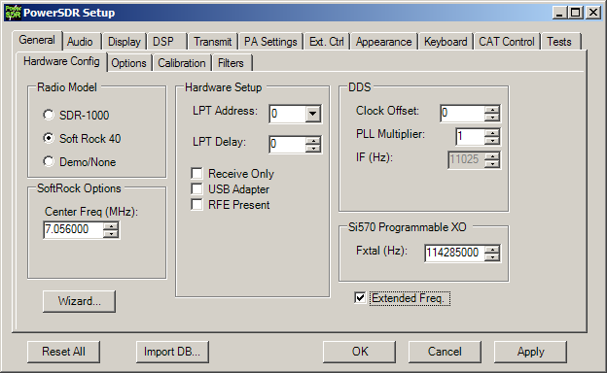
Figure 1 Hardware Config Settings that require attention
Ensure that Update Notifications is disabled, since new releases issued by FlexRadio Systems overwrite these PowerSDR sr40 extensions. Ensure that Spur Reduction is disabled, since no DDS (Direct Digital Synthesis) is used by the SoftRock, but a fixed crystal oscillator. The increment of Process Priority to Above Normal, will make the software less suspicious to interrupts in the signal processing in case other applications are busy. Ensure that Disable PTT is disabled, since we would like to use a VOX or external PTT input to enable the transmitter.
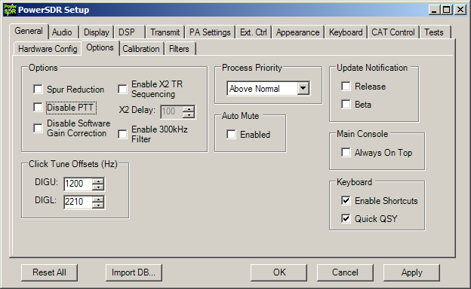
Figure 2 Options Settings that require attention

Single Soundcard Audio Setup
The SoftRock RXTX may use a single soundcard. In this configuration, it is required to connect your phones to the Phones output of the SoftRock RXTX, a microphone may be connected directly to the soundcard. Please see Dual soundcard setup section if you do not like this setup.

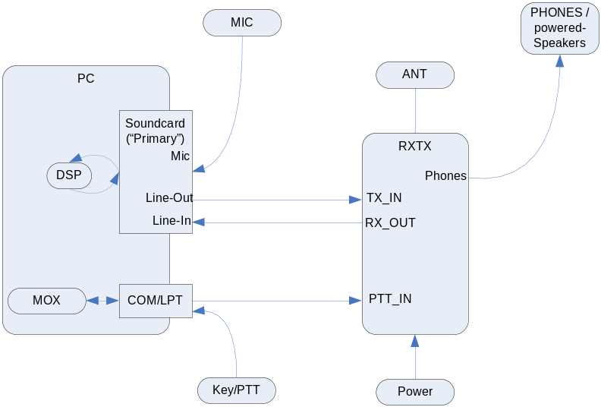
Figure 3 Interconnections for Single Soundcard Setup

The tab Sound Card, configures the Audio Device that is connected to the SoftRock RXTX and to the Phones and Microphone.

Select in the Sound Card Selection your device. If you an Unsupported Card, continue, else your Soundcard setup is finished.

Ensure Unsupported Card is selected. Set Channels to 2, to indicate that there is input and output channel.

Select MME Driver, or experiment with Windows WDM-KS Driver if you like to reduce latency by directly interface with the Audio driver.

Select the Soundcard for both input and output that is connected to the SoftRock.
Select the highest supported Sample Rate.

Set a Buffer Size (such as 1024), try what works well.
Set Latency to an acceptable value (80 might be a good value for MME Driver; 1 for Windows WDM-KS Driver, try a value that works well)

Some Soundcards delays the left or right channel stream. To correct this, apply an IQ correction. The correction is the number of samples shifted in time applied on the left channel. This Soundcards base on a chipset PCM290x, WM8775ED5 (such as Creative SoundBlaster Live! 24 bit Internal) should apply an IQ Correction of 1.

Select the Mixer of the selected Soundcard. The mixer will switch microphone and receiver input. Select in Receive, the Line-In input that will be used for I/Q Processing during RX. Select in Transmit the Microphone that will be used for Audio Processing during TX.

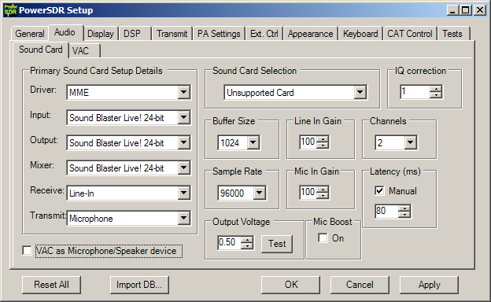
Figure 4 Sound Card Settings that require attention
Set Output Voltage to the value that appears on the line, when you press Test. For most soundcard this will be in the around 0.4 - 0.9V. Adjust it near the maximum output (not more than that since this would results in distortion).

Dual Soundcard Audio Setup
This section describes how to setup audio in case you choose to use two soundcards; one dedicated for I/Q processing, the other dedicated for Audio processing.
In this case, you may connect the microphone and speaker directly to the soundcard that is dedicated for Audio processing.

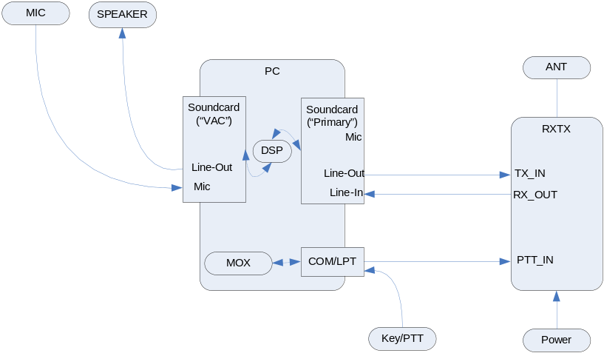
Figure 5 Interconnections for Dual Soundcard Setup

To achieve Dual Soundcard support, the VAC functionality within PowerSDR will be re-used as a secondary Audio Device. This might be misleading, but you do not require installing the VAC driver.

The tab Sound Card, configures the Audio Device that is connected to the SoftRock RXTX.

Ensure Unsupported Card is selected. Set Channels to 2, to indicate that there is input and output channel.

Select MME Driver, or experiment with Windows WDM-KS / ASIO Driver if you like to reduce latency by directly interface with the Audio driver.

Select the Soundcard for both input and output that is connected to the SoftRock.
Select the highest supported Sample Rate to see the largest portion of the band.

Set a Buffer Size (such as 1024), try what works well.
Set Latency to an acceptable value (80 might be a good value for MME Driver; 1 for Windows WDM-KS Driver, try a value that works well)

Some Soundcards delays the left or right channel stream. To correct this, apply an IQ correction. The correction is the number of samples shifted in time applied on the left channel. This Soundcards base on a chipset PCM290x, WM8775ED5 (such as Creative SoundBlaster Live! 24 bit Internal) should apply an IQ Correction of 1.

Optionally, do not select a Mixer, but ensure that the Input and Output signals are selected in the Windows Audio Mixer.
Set Output Voltage to the value that appears on the line, when you press Test. For most soundcard this will be in the around 0.4 - 0.9V. Adjust it near the maximum output (not more than that since this would results in distortion).

Enable VAC as Mic/Speaker device, this will mute VAC output when transmitting, and will mute Sound Card output when receiving (use this in combination with VAC Enabled).

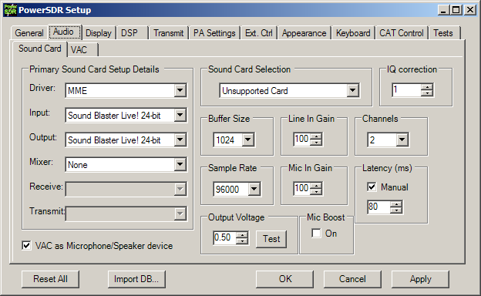
Figure 6 Sound Card Setting dedicated to I/Q Processing

The tab VAC, configures the Audio Device that is connected to the Microphone and Speaker.

Ensure VAC enabled, this will redirect audio to/from the selected device.

Select MME Driver, or experiment with Windows WDM-KS Driver if you like to reduce latency by directly interface with the Audio driver.

Select the Soundcard for both input and output that is connected to a speaker and microphone. This will normally be your default device Microsoft Sound Mapper.
Select the lowest acceptable Sample Rate for audio processing, such as 12000 Samples/s; please ensure to select a value so that the Sample Rate for the Primary Sound Card is an integer multiple. Note that using the same Sample Rate as for the Primary Sound Card may reduce latency.

Disable Stereo, to save performance loss.

Set a Buffer Size (such as 1024), try what works well.
Set Latency to an acceptable value (80 might be a good value for MME Driver; 1 for Windows WDM-KS Driver, try a value that works well)

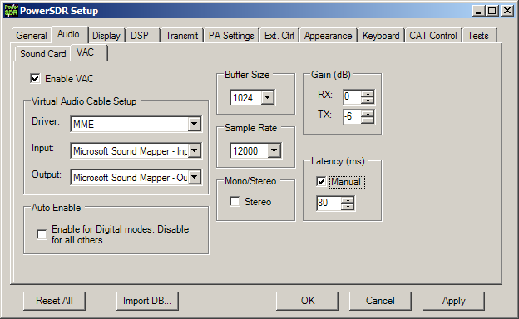
Figure 7 Sound Card (VAC) Settings dedicated to Audio Processing

Hardware Setup

Serial Interface
PowerSDR can be used with SoftRock RXTX, via the serial port. It is important to connect your SoftRock as in the table below or see schematic [10]. PowerSDR should be Setup as:
You must open a COM port as the Primary port using Setup > DSP > Keyer. If you have trouble opening the COM port, go to Setup > CAT control and disable CAT Control, which could be contending for the COM port.
Ensure High Res. is not checked.

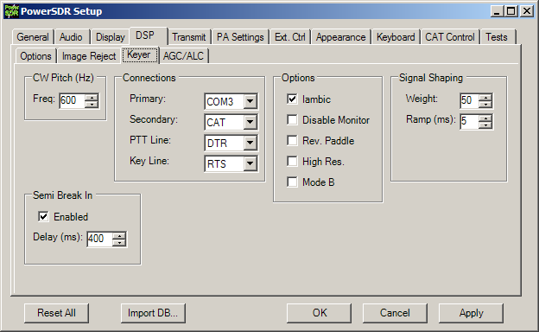
Figure 8 Hardware Config Settings that require attention

After doing this you should be able to get PowerSDR to switch the RXTX from RX to RX mode when you press the MOX button.
Attach SoftRock RXTX as:
SR T/R Line | RTS (pin 7) | This will go HIGH when in XMIT, LOW for receive
GND to SR | GND (pin 5)

There is also support for attaching a keyer and the Soft Rock T/R line to the same serial
port. To do this:
Attach Key as:
Common Ouput  to keyer paddles | DTR (pin 4 on a 9 pin D shell serial port) | This is NOT ground, it will be sitting at +9-12V or so when PowerSDR is running
Dot | DSR (pin 6)
Dash | CTS (pin 8)
Note:
Dot and Dash also function as PTT when the mode is not CW

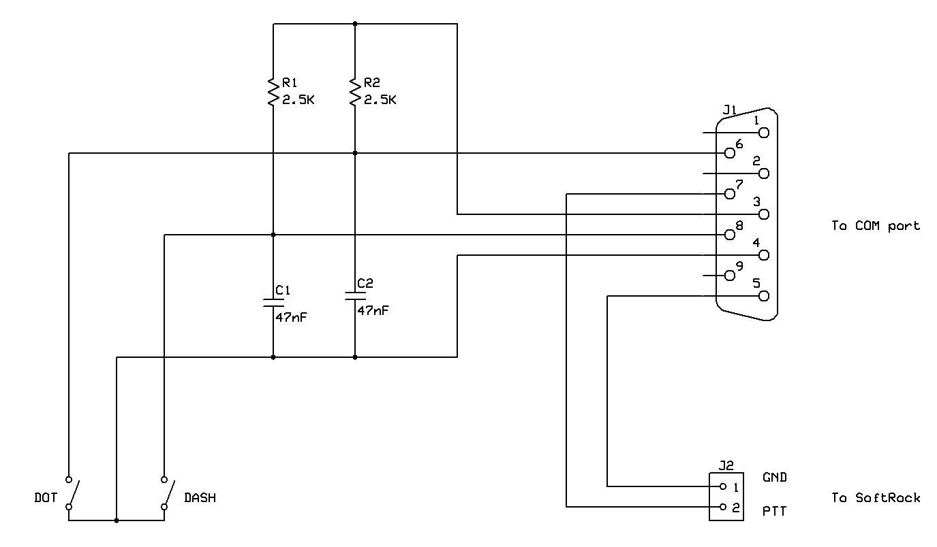
Figure 9 Schematic of Paddle/PTT and RXTXv6.2 interconnection at (9 pin) serial port

The common output, dot and dash work nicely this way with just a couple resistors and capacitors at the serial connector.

Parallel Interface
If you do not have a serial port, you may alternatively use the Parallel Port for interfacing with your SoftRock RXTX. The original SDR-1000 hardware is using to PC Parallel Port to interface the radio. Although it is believed that the commonly accepted way to interconnect your SoftRock RXTX is via a serial interface, you still may choose to interface SoftRock via the Parallel Port. To do so;
Set the LPT Address to the Parallel port that interconnects the radio. Generally 378 is used for LPT1. Ensure that RFE Present is enabled, in this way you do not need a clocked T/R signal.

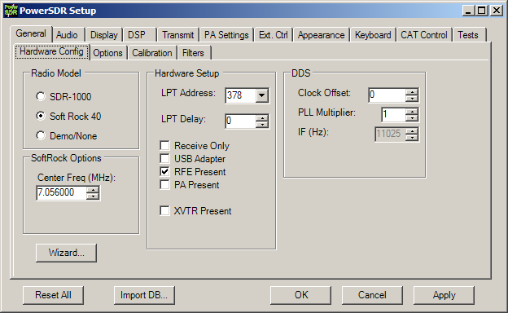
Figure 10 Hardware Config Settings that require attention

The following signals on the Parallel Port are used:
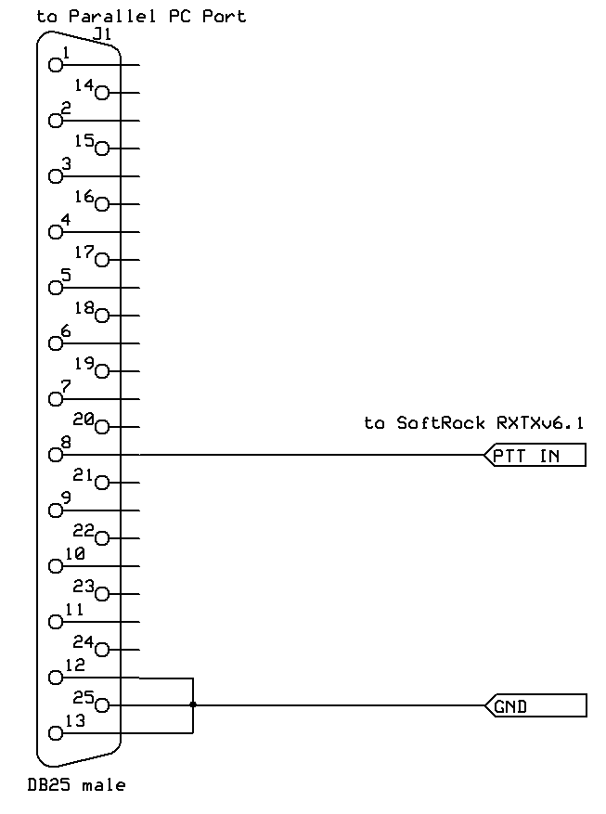
Figure 11 Schematic for interconnecting RXTXv6.2 to LPT
Attach SoftRock RXTX as:
D6 (pin 8) | SR T/R Line | In XMIT this is HIGH
GND (pin 18-25)
Note: Connect pin 12, 13 (dot, dash) to pin 25 (GND), otherwise PowerSDR will keyed
Note2: C1- (pin 14) may optionally used as clock for T/R data (pull up)

Optionally, attach Key as:
S5+ (pin 12) | keyer (dot) or PTT switch | Inverted, pull down to GND
S4+ (pin 13) | keyer (dash) | Inverted, pull down to GND

Using VAC with third party applications
You may also use VAC to interface with an external third party application such as MixW. Install the Virtual Audio Cable loopback driver [8], and N8VB vCOM Virtual Serial Ports Driver [9].

Setup the N8VB vCOM Virtual Serial Ports Driver. Connect COM6 to COM16, COM7 to COM17.

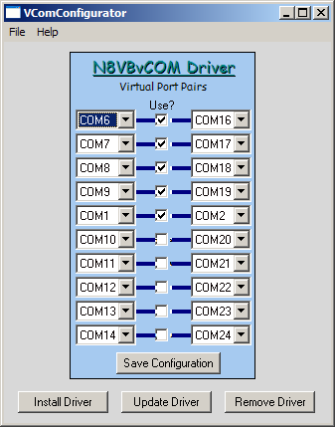
Figure 12 N8VB vCOM Virtual Serial Ports Driver Settings

Setup the N8VB vCOM Virtual Serial Ports Driver. Add two cables.

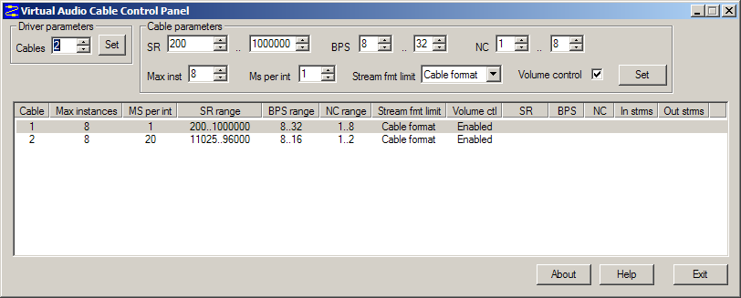
Figure 13 Virtual Audio Cable Settings

Set CAT Control Setting to COM16. Enable CAT. Set ID to TS-2000.
Set PTT Control Setting to COM17. Enable RTS. Enable DTR. Enable PTT.

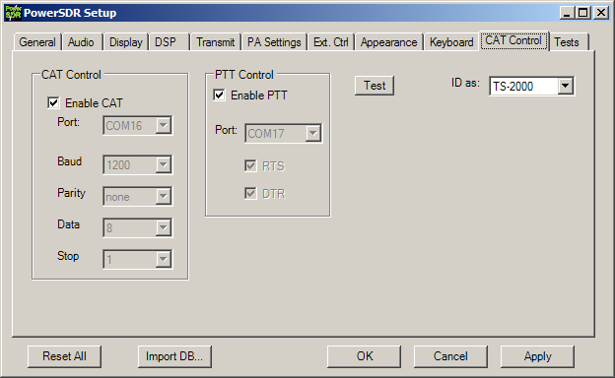
Figure 14 CAT Control Settings that require attention

Set Secondary connection to CAT.
Set PTT line to DTR. Set Key line to RTS.
Disable Semi-Break-In, since MOX switching is slow and may break the first signs.
Disable Monitor (and also when MOX is pressed disable MON), since the monitor function is broken since it does output I/Q signal.

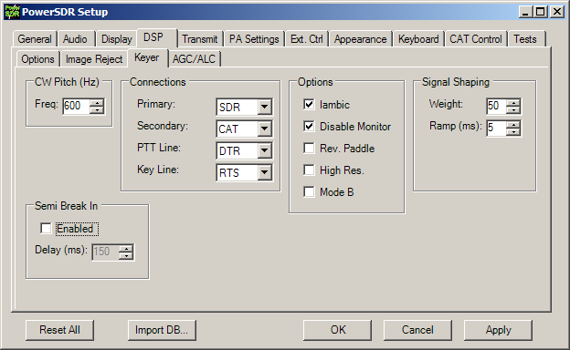
Figure 15 DSP Keyer Settings that require attention

In the Audio VAC Setup, choose the Virtual Cable 2 as Input, Virtual Cable 1 as Output. Ensure that the lowest acceptable Sample Rate for audio processing is select, such as 11025 Samples/s; it is important not to overload the third party application.

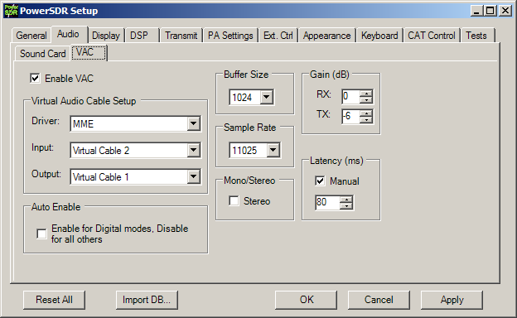
Figure 16 VAC Audio Settings that require attention

In the third party application (such as MixW, DigiPan) the following devices are available:
CAT Control | COM6 | use RTS as CW, DTR as PTT.
PTT Control | COM7 | use RTS or DTR as PTT.
Sound Input | Virtual Cable 1
Sound Output | Virtual Cable 2
Note: Use a sample rate that is same as defined in VAC Audio Settings in PowerSDR.

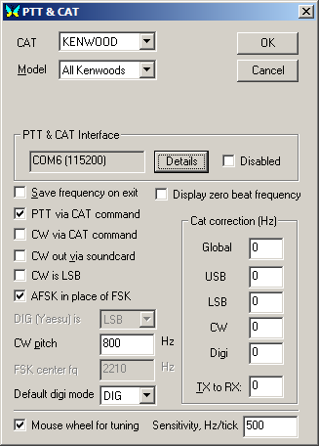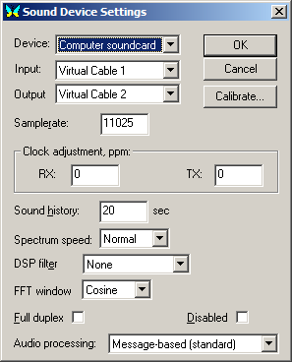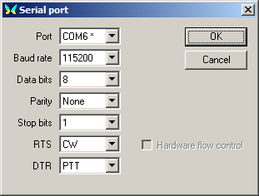
Figure 17 Example of MixW Settings: CAT Control interface is used

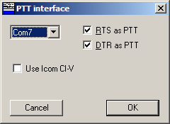
Figure 18 Example of DigiPan Settings: PTT Control interface is used

With the usage of a Third Party application, you may monitor the Audio by using the Audio Repeater simultaneously. Select as Wave in: Virtual Cable 1 , Wave out: Microsoft Sound Mapper and select a Sample Rate of 11025 (same as in PowerSDR VAC Setting).

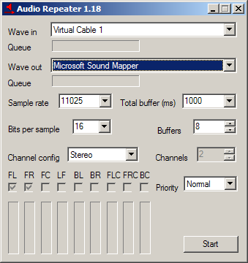
Figure 19 Audio Repeater as used for monitoring

Digital modes
It is important to set appropriate TX and RX filters; use a filter bandwidth that is equal or less than half the Sample Rate as is set in Audio VAC Settings tab. Thus use a bandwidth of 150-5150 Hz (~ 11025/2 Hz).
In the Transmit tab, set the bandwidth in the Transmit Filter, and store the settings in a new profile named DIG.

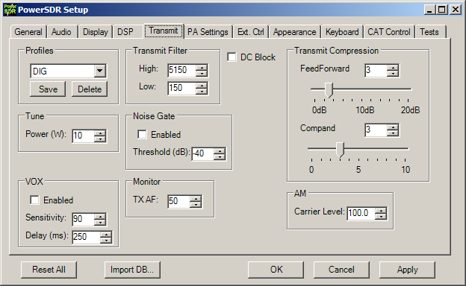
Figure 20 Transmit Settings that require attention

In the Console, choose Mode DIGL or DIGH and set the receive Filter bandwidth of 5.0k. Select the TX Profile DIG.

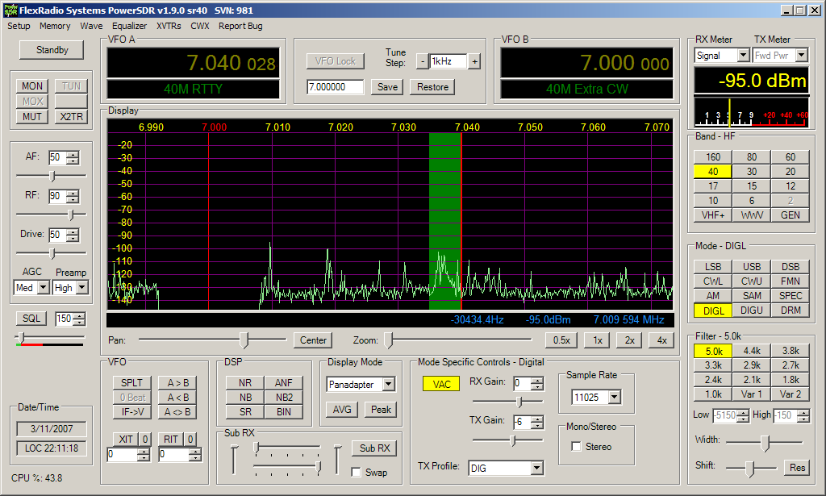
Figure 21 Console Settings that require attention

CW
Ensure that PTT is ON in advance of keying, and ensure that PTT goes OFF after at least a space duration in CW, this to deal with and prevent slow MOX switching.

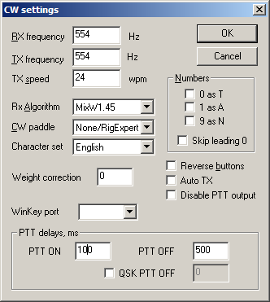
Figure 22 Example of MixW Settings: Setting up CW

Controlling an External Oscillator

Interfacing with a Si570 XO attached to Parallel Port
The SoftRock RXTX may be used in conjunction with an I²C programmable crystal oscillator Si570 [12]. With this device, a SoftRock RXTX is tunable in the range of about 0.872 to 40 MHz.

The Si570 device consists of a PLL followed by programmable dividers. A digitally-controlled oscillator (DCO) that is part of the PLL, is numerically controlled by a fixed internal crystal reference Fxtal with a nominal crystal frequency of ~ 114.285 MHz.
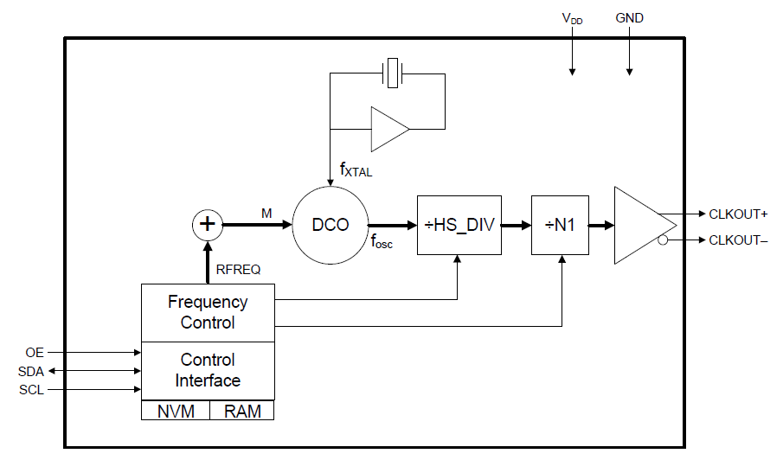
Figure 23 Si570 Detailed Block Diagram
To tune the Si570 device in the range 10 to 160 MHz, the registers RFREQ, HS_DIV, N1 must be chosen such that Fdco is within the range 4850 to 5670 MHz and Fout=Fxtal*RFREQ/(HS_DIV* N1). This is calculated on demand by PowerSDR and consequently PowerSDR writes these registers over I²C interface. As the nominal reference frequency Fxtal is known and does not deviate much over several devices, it is not required to read-out the registers of the device to determine it (as is mentioned in the Si570 Programming Instructions [12]).

PowerSDR interfaces directly with Si570 device by implementing the (write-only) I²C protocol over the following Parallel Port pins. Choose either the inverted or non-inverted lines depending on your needs:
D0 (pin 2) | /SDA | Inverted I²C Serial Data
D1 (pin 3) | /SCL | Inverted I²C Clock
D2 (pin 4) | SDA | Non-inverted I²C Serial Data
D3 (pin 5) | SCL | Non-inverted I²C Clock
Note: Only a PC Parallel Port is supported (no USB Parallel port)

The following schematic shows a practical (and pragmatic) way of interconnecting the Si570 device:

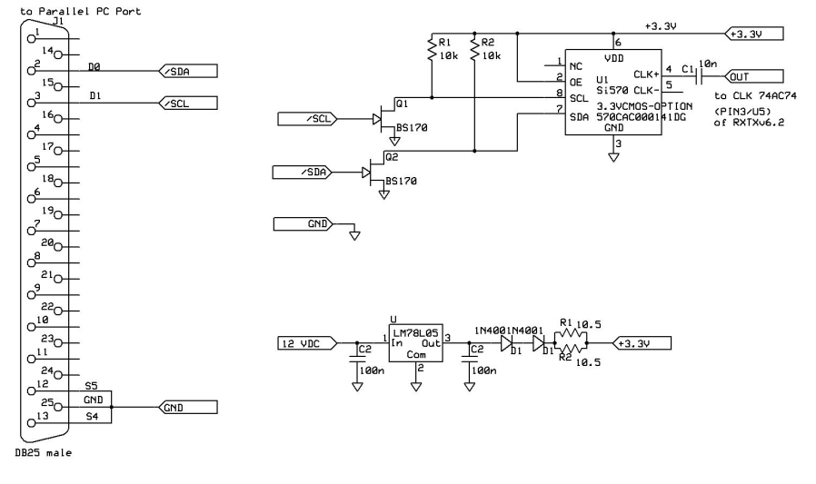
Figure 24 Schematic of Si570/Parallel port/Softrock interfacing
Note: The schematic is only valid for 3.3V/CMOS option of Si570.

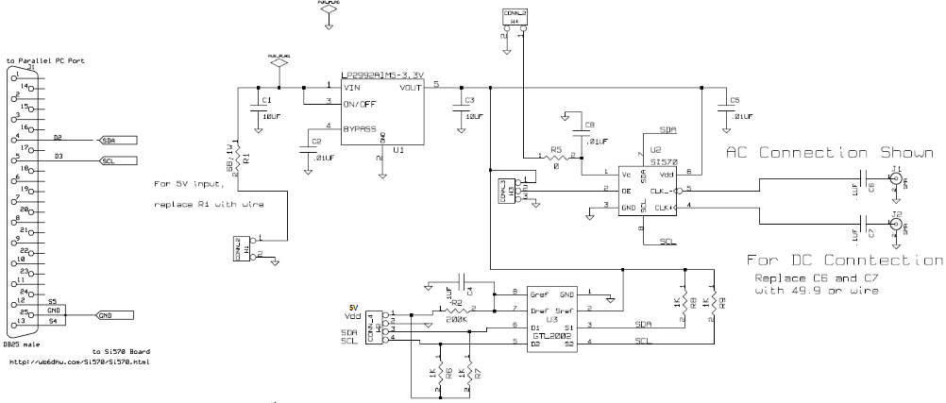
Figure 25 Schematic of Parallel Port Interfacing with WB6DHW Si570 Board [13]

Ensure that the LPT Address of the Parallel port is set that interconnects the Si570. Generally 378 is used for LPT1. Ensure that Fxtal is set to a nominal crystal frequency of about 114.285000.

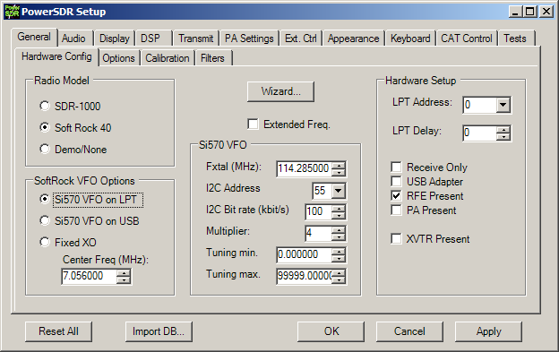
Figure 26 Hardware Config Settings that may be changed
The Si570 may be calibrated by tuning to a known reference, and change Fxtal until the frequency read-out of the reference is in agreement. In practically, the value of Fxtal shall be in range 114.285000 ± 35000.

Interfacing with a microcontroller attached to serial Port
When PowerSDR is tuned, it announces the frequency change over the serial port that is selected as Primary Keyer. Ensure that COM port is configured as Primary Keyer. A microcontroller may be attached to the serial in order to tune an external oscillator or select filter banks.

The microcontroller must be attached to:
RXD of µC | TXD (pin 3) | Serial Communication BaudRate=4800, Parity=n, DataBits=8, StopBits=1
GND | GND (pin 5)

On a frequency PowerSDR sends; a byte with the length of next message {$0a}.
It is directly followed by {$66 or ASCII "f") to indicate it is a frequency change, followed by nine ASCII characters aligned right and filled-up with zeros to the left, expressing the frequency in Hz (example: $30 $30 $37 $30 $35 $36 $31 $32 $33 or 007056123 in string-form for a frequency of 7.056123 MHz).

Interfacing with a micro-controlled Si570 attached to serial Port
The microcontroller may be used to forward I2C commands from PC to Si570 part. An example of this interface that uses the PIC12F683 of a Softrock RXTXv6.3 is realized by Cesco HB9TLK and Francis F6HSI [14]. A stand-alone implementation based on a PICAXE microcontroller [13] is realized by Mike KF4BQ.

When tuned, in addition to the frequency change message, it will issue I2C commands over the serial port to program the Si570. Each I2C command is preceded with a byte that expresses the length of subsequent I2C command.

On a frequency PowerSDR sends:
Length of next I2C message {$03}, I2C Write: Si570 Freeze {$aa, 137, $10},
Length of next I2C message {$08}, I2C Write: Si570 Divider Reg. {$aa, 7, reg7, reg8, reg9, reg10, reg11, reg12},
Length of next I2C message {$03}, I2C Write: Si570 UnFreeze {0xaa, 137, 0x00},
Length of next I2C message {$03}, I2C Write: Si570 Newfreq {0xaa, 135, 0x40}.

Interfacing with a Si570 USB interface
This interface connects via USB to the PC and controls the Si570 and GPIO as CW Dash/Dot inputs and PTT. Tom DG8SAQ published the idea to use a Atmel ATTiny (AVR) as a low-cost USB interface to control a DDS and other things [20] by using ObDev’s USB open-source firmware. This firmware and hardware was extended with Si570 support [21]. The schematic is depicted in Figure 27, and the USB software interface is documented here [23]. As the software USB interface may be implemented by any microcontroller, there exists other implementations like for the UBW target [27] as realized by Alex 9V1AL. The Si570 USB is supported by other software than PowerSDR-sr40, such as Rocky.

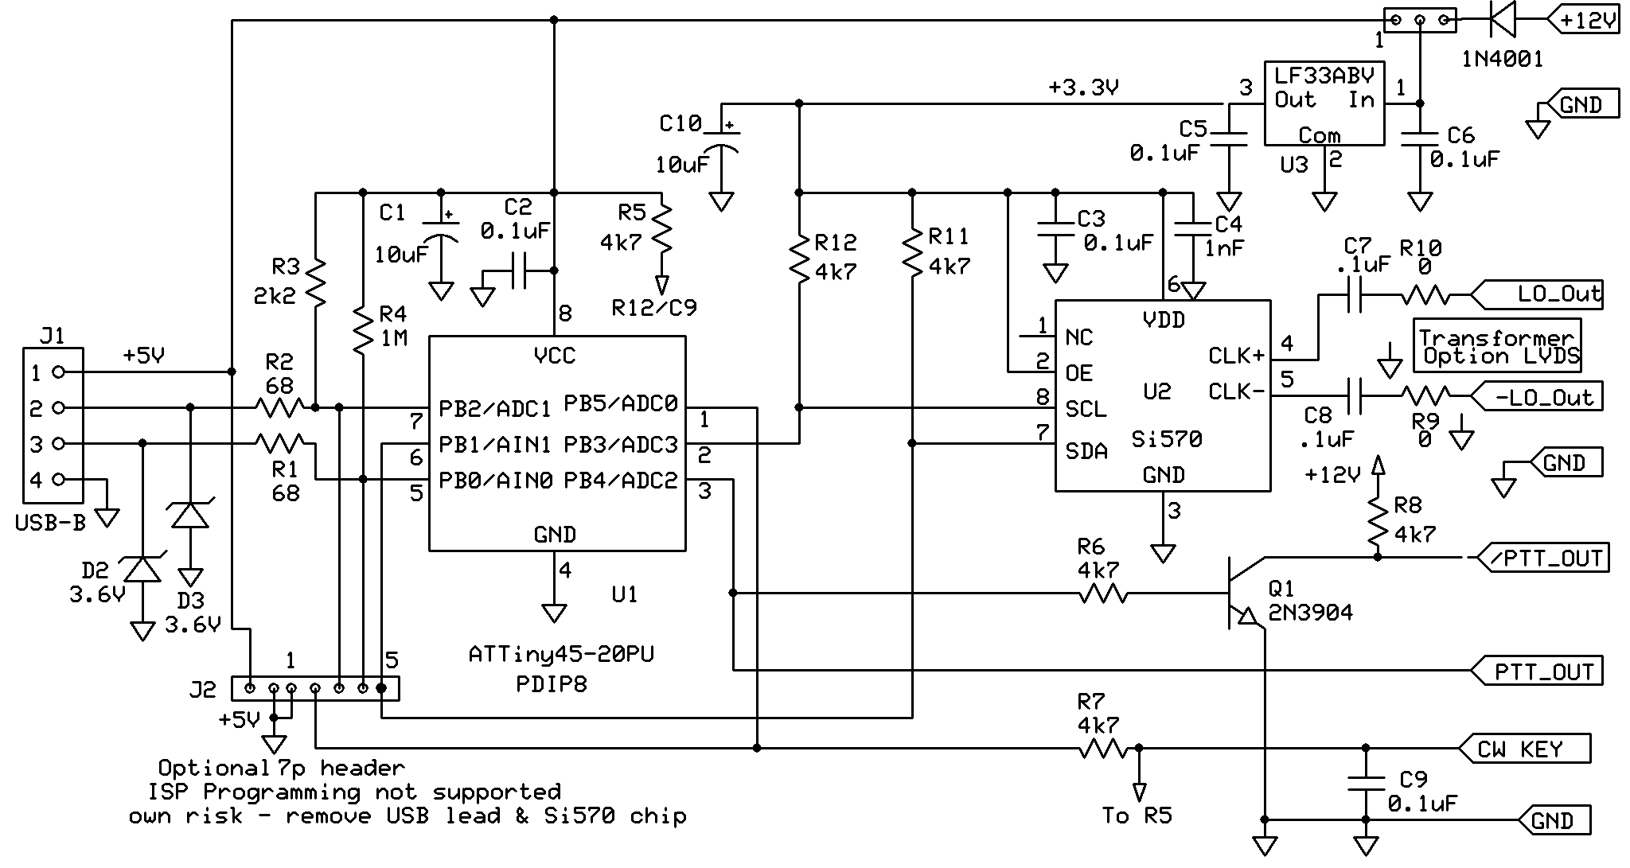
Figure 27 Schematic of USB Si570 interface Board [30]
A stand-alone synthesizer board of this schematic is made available by Jan G0BBL and Tom KM5H as a kit [24] and may be used in conjunction with a SoftRock. Tony KB9YIG also offers a SoftRock Lite+USB Xtall v8.4 receiver based on this principle [45], and offers a USB I2C Interface Board [25] that fits with the latest SoftRock RXTXv6.3 board. Funkamateur has a temperature controller synthesizer FA-SA based on this principle [26].

The following settings below may be of relevance when using the Si570 USB Interface. Note that in general a I2C Address of 55 (hex) is used, however for the FA-SA a address 50 (hex) may apply (depends on the Si570 part).
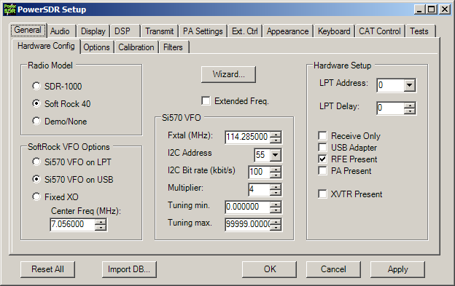
Figure 28 Hardware Config Settings that may be changed
Note that the Fxtal setting must be used for manual calibration, i.e. the calibration data in the Si570 or AVR is not used. The SI570 in PowerSDR can be calibrated against an external reference (such as WWV at 10MHz) as follows:
a. tune PowerSDR at the reference;
b. in Setup, set Fxtal parameter to the nominal frequency of 114.285MHz;
c. change Fxtal parameter, until the reference is exactly zero beat.
When done, Fxtal then represents the exact internal Xtal reference of the Si570.

Final words
Please consult PowerSDR Operation Manual [11] regarding the use of the software.
A word of thank to all contributors who made this all possible: FlexRadio Company (open-source initiative of PowerSDR), Tony Parks KB9YIG (SoftRock release), Tom Hoflich KM5H (Si570) and many others.

Good DX,
73, Guido PE1NNZ

References
[1] Yahoo Softrock40 Group,
http://groups.yahoo.com/group/softrock40

[2] FlexRadio Systems,
http://www.flex-radio.com

[3] Guido PE1NNZ, PowerSDR-sr40; PowerSDR Softrock40 Extensions,
http://powersdr-sr40.sourceforge.net

[4] Bill Tracey KD5TFD, SR and HPSDR modifications PowerSDR,
http://www.tracey.org/wjt/sdr1k/SoftRock40/PowerSDR-KD5TFD-srxmit-20061012.zip and svn://206.216.146.154/svn/repos_sdr_hpsdr/trunk/KD5TFD/PowerSDR/3in4out-48khz

[5] Alex VE3NEA, Rocky 3.0; SDR Software for SoftRock40,
http://www.dxatlas.com/rocky

[6] Duncan M0KGK, SDR Decoder Software "KGKSDR",
http://www.m0kgk.co.uk/sdr/index.php

[7] Tom DG8SAQ, SSB TX Software,
http://groups.yahoo.com/group/softrock40/files/DG8SAQ/DG8SAQ_SSB.zip

[8] Muzychenko, Virtual Audio Cable,
http://software.muzychenko.net/eng/vac.html

[9] Phil Covington, N8VB vCOM Virtual Serial Ports Driver,
http://www.philcovington.com/SDR.html

[10] Hidehiko Komachi JA9MAT, SoftRock RXTX Transceiver Connections,
http://groups.yahoo.com/group/softrock40/files/RXTXv6.1%20files/Softrockv6b_Configuration_revised.BMP

[11] FlexRadio Systems, SDR-1000 Operating Manual,
http://powersdr-sr40.svn.sourceforge.net/viewvc/*checkout*/powersdr-sr40/trunk/Documentation/SDR-1000_Operating_Manual.pdf

[12] Silicon Laboratories, Si570/Si571 Preliminary Data Sheet, Any-Rate I²C Programmable XO/VCXO, Rev. 0.31 8/07,
http://www.silabs.com/public/documents/tpub_doc/dsheet/Timing/Frequency_Control/en/si570.pdf

[13] David A Brainerd WB6DHW, Si570 Interface Board, http://wb6dhw.com/Si570/Si570.html

[14] Cesco, Si570 - 12F683 PowerSDR-sr40 RS232 connection,
http://hammap.smallcpu.org/softrock/rs232_683.html

[15] Mike KF4BQ, PICAXE 18X code for Guido PowerSDR-sr40,
http://groups.yahoo.com/group/softrock40/files/KF4BQ/Si570%20Testing/GUIDO%20TEST%205.BAS

[20] Tom DG8SAQ, A low-cost, flexible USB interface,
http://www.mydarc.de/dg8saq/AVR-USB/Baier_USB_QEX.pdf

[21] Tom DG8SAQ, Minimum Complexity Wideband RF Synthesizer from 10MHz...1400MHz with USB Control based on SiLabs SI570 and Atmel AVR,
http://www.mydarc.de/dg8saq/SI570/index.shtml

[22] Tom DG8SAQ, Troubleshooting AVR USB SI570 devices,
http://groups.yahoo.com/group/softrock40/files/DG8SAQ/AVR-SI570-Troubleshooting.pdf

[23] Tom DG8SAQ, Description of firmware commands for the DG8SAQ USB-SI570 Interface,
http://groups.yahoo.com/group/softrock40/files/Description%20of%20firmware%20commands%20for%20SI570.pdf

[24] Jan G0BBL, SDR-Kits.net: USB-Controlled Synthesizer for Softrock RXTX and Local Oscillator Applications,
http://www.sdr-kits.net

[25] Tony KB9YIG, USB I2C Interface board, http://groups.yahoo.com/group/softrock40/files/USB%20I2C%20Interface%20board

[26] Norbert DL1SNG, Funk Amateur BX-026, BX-029: FA-Synthesizer 'FA-SY'
http://www.box73.de/catalog/index.php?cPath=112_113&osCsid=28f90a03d53b9e6f9de459f525220322

[27] Alex 9V1AL, UBW Emulator,
http://groups.yahoo.com/group/softrock40/files/9V1AL/UBW%20Emulator

[40] Tony KB9YIG, SoftRock-40 rev. v4.0,
http://www.amqrp.org/kits/softrock40

[41] Tony KB9YIG, SoftRock v5.0,
http://groups.yahoo.com/group/softrock40/files/SoftRock%20v5.0%20docs

[42] Tony KB9YIG, SoftRock v7.0,
http://groups.yahoo.com/group/softrock40/files/SoftRock%20v7.0%20docs

[43] Tony KB9YIG, SoftRock Lite v6.2,
http://groups.yahoo.com/group/softrock40/files/SoftRock%20v6.0%20docs/SoftRock%20Lite%20docs

[44] Tony KB9YIG, SoftRock Lite+Xtall v8.3,
http://groups.yahoo.com/group/softrock40/files/Lite%2BXtall%20v8.3

[45] Tony KB9YIG, SoftRock Lite+USB Xtall v8.4, http://groups.yahoo.com/group/softrock40/files/Lite%2BUSB%20Xtall%20v8.4

[50] Tony KB9YIG, SoftRock Receiver-Exciter v6.0,
http://groups.yahoo.com/group/softrock40/files/SoftRock%20v6.0%20docs

[51] Tony KB9YIG, SoftRock RXTXv6.1,
http://groups.yahoo.com/group/softrock40/files/RXTXv6.1%20files

[52] Tony KB9YIG, SoftRock RXTXv6.2,
http://groups.yahoo.com/group/softrock40/files/RXTXv6.2%20files

[53] Tony KB9YIG, SoftRock RXTX+Xtall v6.3,
http://groups.yahoo.com/group/softrock40/files/RXTX%2BXtall%20v6.3%20files

