This document is a very simple explanation of Api.

Step 1:

As the following graph shows, first step is to send a ‘get’ request with parameter ‘username’ and parameter ‘password’. If they are legal, there will be a token generated by server, which finally response to client side.

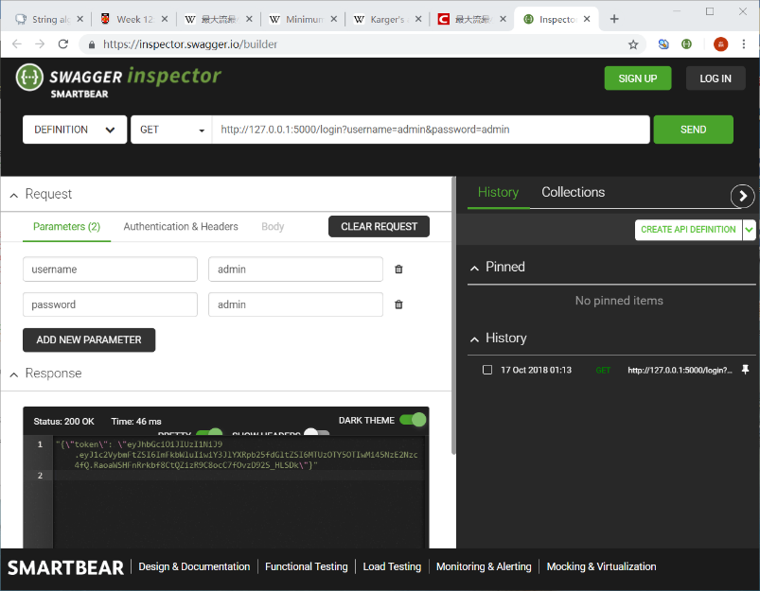

Step 2:

Client side should change their webpage from “/login” to “/predict”. Then, client side should send a ‘get’ request will all of features that “ML model” needed. Particularly, this request should add a header which is {“AUTH-TOKEN”: GIVEN TOKEN}.

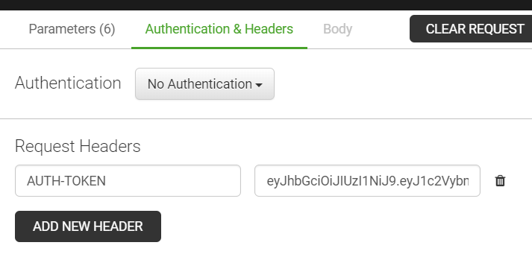

If every thing are correct, server will return the result.

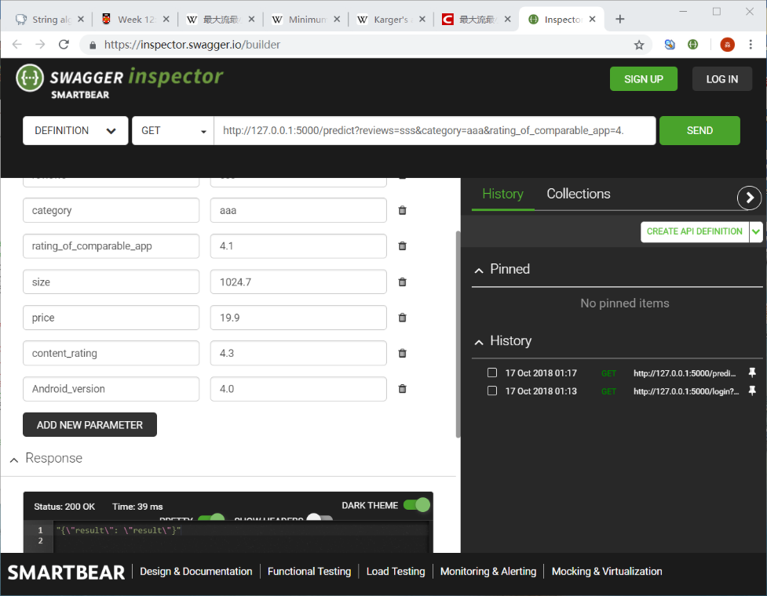

If there are not enough parameters, it will return 400 Bad requests.

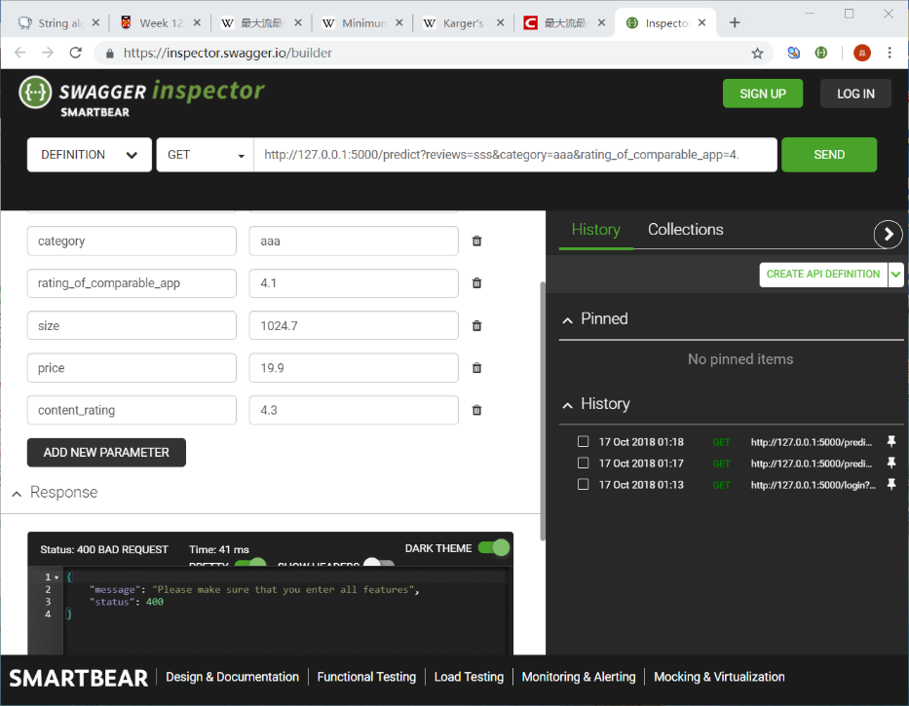

If you send ‘get’ request without “token”, it will return Non-Authentication, 401.

For program:

As the following graph shows, I add same structure where you add in “token”. So there should not be any problem with ['No Access-Control-Allow-Origin header is present'](https://stackoverflow.com/questions/20518653/jsonp-cross-origin-error-no-access-control-allow-origin-header-is-present). If it is, please tell me and I will try to modify it.

