**Recommender system using collaborative filtering**

COMP9417 Assignment

|  |  |
| --- | --- |
| Peiguo Guan | z5143964 |
| Taoran Sun | z5150998 |
| Wanze Liu | z5137189 |
| Yunhe Hu | Z3351805 |

1. **Introduction**

In the era of internet, individuals are overwhelmed with huge amount of information online. This common situation has brought an obvious problem that internet users have difficult to choose the most appropriate services or contents. Nowadays, individuals are seeking more personalized services and experiences from service and content providers. Amazon, widely known as an online book reseller, deployed a recommender system in 1998 which can recommend books to its customers based on purchasing history, past preference and demographic information. As at today, recommendation systems are used not only for books, but also almost all types of internet entertainment services including movie, music and news.

The purpose of this assignment is to implement a collaborate filter recommender system based on a movie rating dataset and predict the highest rated movies for users. More specifically, the 1k dataset from MovieLens will be used to implement and test the method.

1. **Related Work**

The MovieLens dataset has been used by a large number of researchers to develop collaborate filtering system since 1999. Herlocker, Konstan, Borchers and Riedl (1999) conducted a study to solve the collaborate filtering problem by using similarity analysis and neighborhoods selection. Herlocker et al. also introduced two different methods to compute similarity, namely Pearson correlation coefficient and Spearman rank correlation. In addition, the effective of parameter normalization methods has been examined. The result indicates that average z-score normalization method is the best method for personalized recommender system. However, the average deviation from mean normalization method performs similar to the average z-score normalization method and performs much better for non-personalized recommender system.

Howe and Forbes (2008) conducted a further examination on the parameter normalization based on Herlocker et al.’s study. The result indicates that parameter normalization has a significant role when applying collaborate filtering algorithm and cosine vector similarity could be better than Pearson correlation coefficient similarity in some cases. The study also mentioned that different datasets favor different parameter normalization methods.

1. **Implementation**

The dataset used in this assignment is the ML-100K one downloaded from MovieLens website at <https://grouplens.org/datasets/movielens/>. There are several different data files in this dataset including user rating, user demographic information, user occupation and movie information.

In the first step, only the rates given by each individual user are considered. The extra date about user demographic information and movie specific information are ignored. The user id, movie id and rating are extracted from u.data file and the movie id and movie title are extracted from u.item data file. A M×N matrix is created by combing user and movie data where each row represents a user, each column represents a movie and the value represent user’s ratings against a movie.

To implement the prediction model, similarity among users and movies have to be calculated. In this implementation, Cosine Similarity method is chosen to calculate the similarity. The formula is given by:

Cosine Similarity: Sim(ui, uk) = =

To recommend a list of movies to a target user, the main process is to calculate the similarity between the target user and all other users, select the top N (an arbitrary number) similar users and choose highest rated movies from those N users. The formula is given by:

rij =

Because different users have different rating baseline when given rating, an absolute rating is not appropriate in this implementation. A method is used to normalize the individual rating. The overall formula to calculate rating is given by:

rij = +

To coupe with the problem with cold start (new user with no previous ratings), a content-based similarity among all the movies is also calculated using the Cosine Similarity method. The result shows similarities between each pair of movies.

The predicted rating for a specific movie is compared with the actual rating given by a user to show the error. The Root-Mean-Square Error method is used to illustrate the overall error for the test dataset.

------To be edited below--------

In the second step, Singular Value Decomposition is also tested to show the movie rating prediction. In this implementation, k values from 1 to 50 are used to demonstrate the impact of different k values. k is the number of singular values and vectors to be computed here. More information will be saved with larger k value.

------To be edited above--------

In the third step, additional information is considered when calculating user-based similarity matrix and content-based similarity matrix.

For user-based similarity matrix, another user similarity matrix is calculated based on user demographic information including gender and occupation using Cosine Similarity method. Combining the similarity matrixes from step one and the new user similarity matrix, a new movie rating prediction matrix is calculated. And the error is calculated with Root-Mean-Square Error method. In this implementation, weight vd (weight for user demographic information similarity matrix) in range (0, 1, 0.1) has been tested to demonstrate the impact of adding user demographic information into similarity matrix.

For content-based similarity matrix, another movie similarity matrix is calculated based on only the movie genres information using Cosine Similarity method. Combing this matrix with the content-based movie similarity matrix from step one. A weight vg representing the weight of this new matrix in range (0, 1, 0.1) is assigned when combining the matrix to demonstrate the impact of addition movie genres information.

1. **Result**

The goal of the implemented prediction model is to recommend a list of movies to a user. For this model, three methods are used to predict the movie ratings given by a specific user and the difference between the predicted ratings and the actual ratings for the same movie is noted as the error. The result is the overall Root-Mean-Square Error for all users and related movie ratings in the test dataset. The results for user-based, content-based and Singular Value Decomposition methods are shown below:

|  |  |
| --- | --- |
|  | Root-Mean-Square Error |
| User-based similarity | 3.1406 |
| Content-based similarity | 3.4865 |
| Singular Value Decomposition  (best result when k = 12) | 2.7885 |

Singular Value Decomposition method provides the best result comparing to user-based similarity method and content-based similarity method.

For different k value used in the Singular Value Decomposition method, the result is shown as:

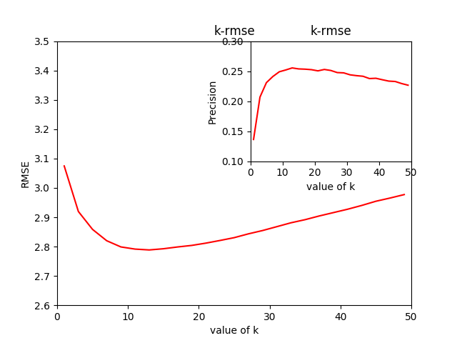

Increasing the k value has positive effect at the beginning of this simulation. However, when k reaches 12, futher increasing of the value brings negative effect. This model gives the worst result when k is 1 where most of the information in the similarity matrix are ignored. When comparing the result of this method again user-based similarity method and content-based similarity method, Singular Value Decomposition method always give better result in terms of Root-Mean-Square Error.

When user demographic information is added into the user-based similarity matrix, the result is shown in the following graph:

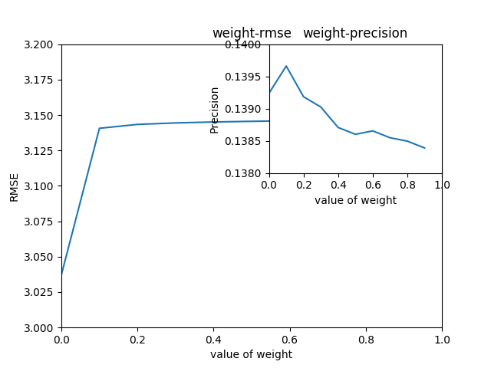

The model gives the best result when the weight of user-based similarity for movie rating is 0 and the weight of user-based similarity for demographic information is 1. However, the results difference between different weights settings are not significant. Once the weight of user-based similarity for movie rating reaches 0.1, this matrix will become the dominant component of the model.

On another hand, the model precision gives the bets result when the weight of user-based similarity for movie rating is 0.1 and the weight of user-based similarity for demographic information is 0.9. Increasing the weight of weight of user-based similarity for movie rating will significantly decrease the model precision.

The inclusion of user demographic information provides much better result in term of precision without significantly affecting the result in term of Root-Mean-Square Error.

When movie genres information is added into the content-based similarity matrix, the result is shown in the following graph:

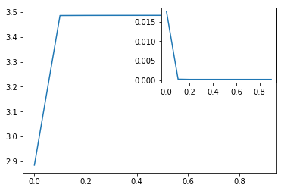

The model gives the best result when the weight of content-based similarity for movie rating is 0 and the weight of content-based similarity for movie genres information is 1. This result implies that the content-based similarity model performs the best when considering only the movie genres. Once the weight of content-based similarity for movie rating reaches 0.1, the movie genres information becomes redundant and the movie rating information will dominant the overall performance of this prediction model. In addition, the overall result will be much worse comparing the result using only movie genres information.

The model precision shows exactly the same pattern as Root-Mean-Square Error. The model is most accurate when using only the movie genres information.

1. **Conclusion**

This prediction model is designed to recommend a list of movies to a user based on user rating information, user demographic information and movie information. Three different methods are tested including user-based similarity method, content-based similarity method and Singular Value Decomposition method. In conclusion, Singular Value Decomposition method is more suitable to construct a prediction model for movie recommendation. This model provides better results in terms of both model Root-Mean-Square Error and model precision. The user-based similarity method provides the second-best result in terms of both model Root-Mean-Square Error and model precision. The content-based similarity method provides the worst result for this prediction model and this specific dataset.

1. **Future Work**

**TO BE EDITED**

**Reference**

Herlocker, J. L., Konstan, J. A., Borchers, A. & Riedl, J. 1999, ‘An algorithmic framework for performing collaborative filtering’, in *Proceedings of the 22nd Annual International ACM SIGIR Conference on Research and Development in Information Retrieval*, New York, NY, USA, 1999, pp. 230-237.

Howe, A. E. & Forbes, R. D. 2008, ‘Re-considering neighborhood-based collaborative filtering parameters in the context of new data’, in *Proceedings of the 17th ACM conference on Information and Knowledge management*, Napa Valley, California, USA, October 26-30, 2008, pp. 1481-1482.