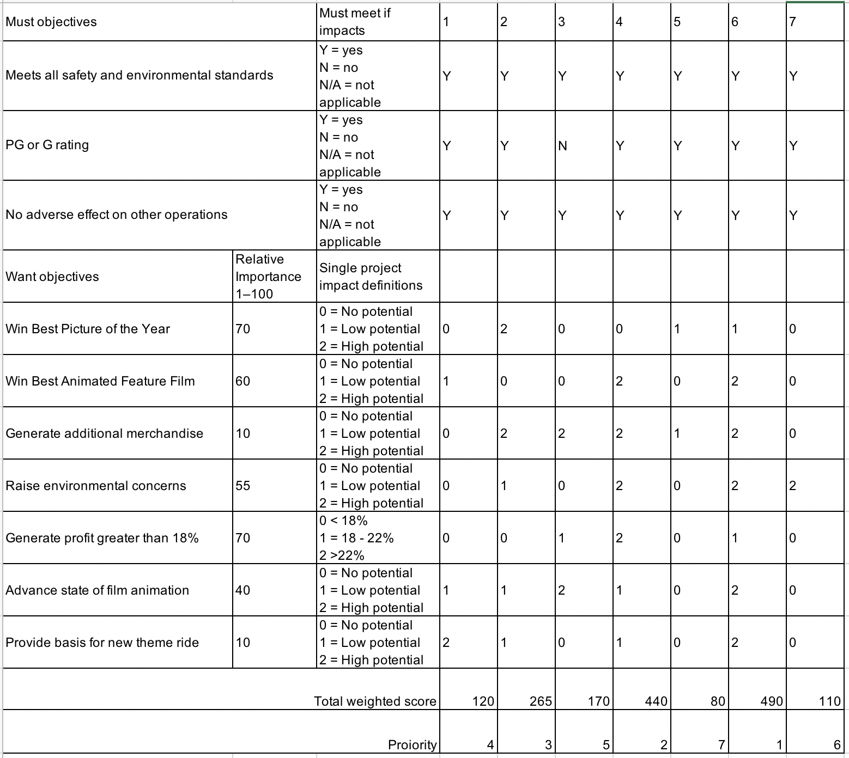

Hi, everyone

Here is my filled Project Priority Evaluation Form.

For the must objectives ,I gave Yes for the almost all of them, except the 3rd moive, I gave No for the part of PG and G rating , because in 3rd movie’s proposal it mentioned that the film will focus on the death of one of the founding members from a heroin overdose and reveal the underworld of sex, lies, and drugs in the music industry. so it will contain many violence images which may have adverse impact on children.

For the want objectives, I will analyse every movies and list below

The 2rd movie has big-budget and breathtaking view of the Swiss Alps hence it has high potential for being nominated the Best Picture of Year, for the 5th and 6th movie, the plots of these two movies are extremely attractive, so I think it is likely to win this trophy, but for the rest of 4 movies, they are documentary, so I do not think this type of movie can win this prize.

There are only three animation movies 1st ,4th,6th movies, for the last two of three, the drama is very in details and attractive, especially for the 6th one, so I gave high potential for this two, and low potential for 1st one, because this is a carton of Dalai Lama’s childhood the characters of this movie may only attractive for younger child.

In terms of additional added value of movie, the 2re movie have superstar which could generate celebrity effect ,so it has high potential, as the 4th and 6th all have animated characters , it can be used for making dolls or toys which could have large market among the young children, although the 5th movie is not carton or with top-name stars, it is could activate people’s desires for sports, and people are likely spend more money on sports.

The 2rd ,4th ,6th ,7th are all related to environment , so it is no doubt that could raise people ‘s awareness about environment.

For the profit , I just choose it depend on the survey.

As proposal mentioned ,the 2rd and 6th movie have big-budget, hence the quality of animation should not bad, however , even without big-budget , the carton also need to show the high quality of animation and also most of budget will spend on it because there are no need for actors’ expense.

For the 3rd, 5th ,7th movie, they are all documentary kind of movies , so it are not likely to provide theme ride, however ,the rest of movies not only include breathtaking view ,but also special story of  Protagonist.