#### Exercise 1: nslookup

1.Name: www.google.com

Server: 129.94.242.2

Address: 129.94.242.2#53

Non-authoritative answer:

Name: www.google.com

Address: 216.58.196.132

Different servers can be access through different IP addresses. some website like google, there are a lot of DNS requests daily ,therefore, using more servers makes website load balancing.

2.name = localhost.

The [IP address](https://www.lifewire.com/what-is-an-ip-address-2625920) 127.0.0.1 is a special-purpose IPv4 address called localhost or loopback address. All computers use this address as their own but it doesn't let them communicate with other devices like a real IP address does.

Exercise 2: Use ping to test host reachability

* [www.cse.unsw.edu.au](http://www.cse.unsw.edu.au/) yes

* [www.getfittest.com.au](http://www.getfittest.com.au/) no
* the remote host or network may be down, or the domain name does not exist.
* [www.mit.edu](http://www.mit.edu/) yes

* [www.intel.com.au](http://www.intel.com.au/) yes

* [www.tpg.com.au](http://www.tpg.com.au/) yes
* [www.hola.hp](http://www.hola.hp/) no
* the remote host or network may be down, or the domain name does not exist.

* [www.amazon.com](http://www.amazon.com/) yes

* [www.tsinghua.edu.cn](http://www.tsinghua.edu.cn/) yes

* [www.kremlin.ru](http://www.kremlin.ru/) no
* when I ping it, it shown time out ,but I can open it by using web browser, some reasons that cause this problem maybe is that the remote host is not in the same network segment as the user, and the host cannot be found though the route ,and another reason is that the IP address was blocked by some security reason.
* [8.8.8.8](https://webcms3.cse.unsw.edu.au/COMP3331/18s2/resources/8.8.8.8) yes

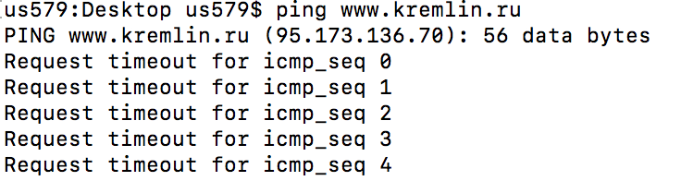

#### Exercise 3: Use traceroute to understand network topology

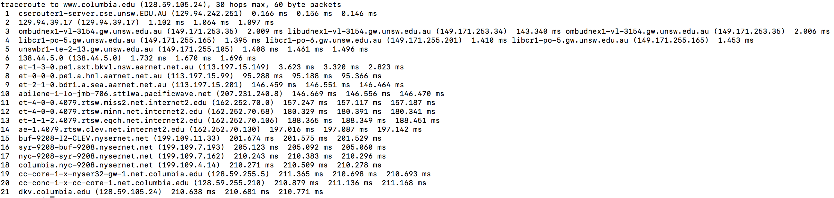

1. There are 21 routers between workstation and www.columbia.edu

There are 5 routers belong to UNSW network(the first five).

I noticed that the response time of router 7 and router 8 has increased dramatically, which means the distance could be very long between this two routers, so we can know that they cross the Pacific Ocean .

2.

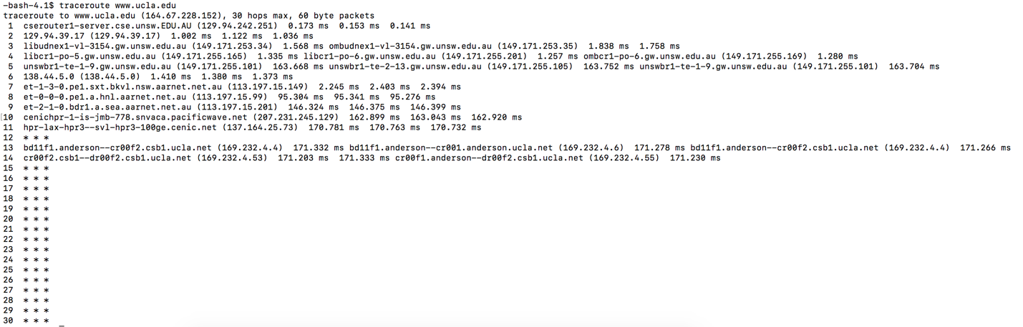

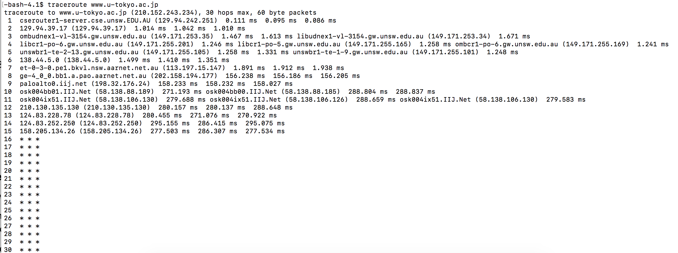

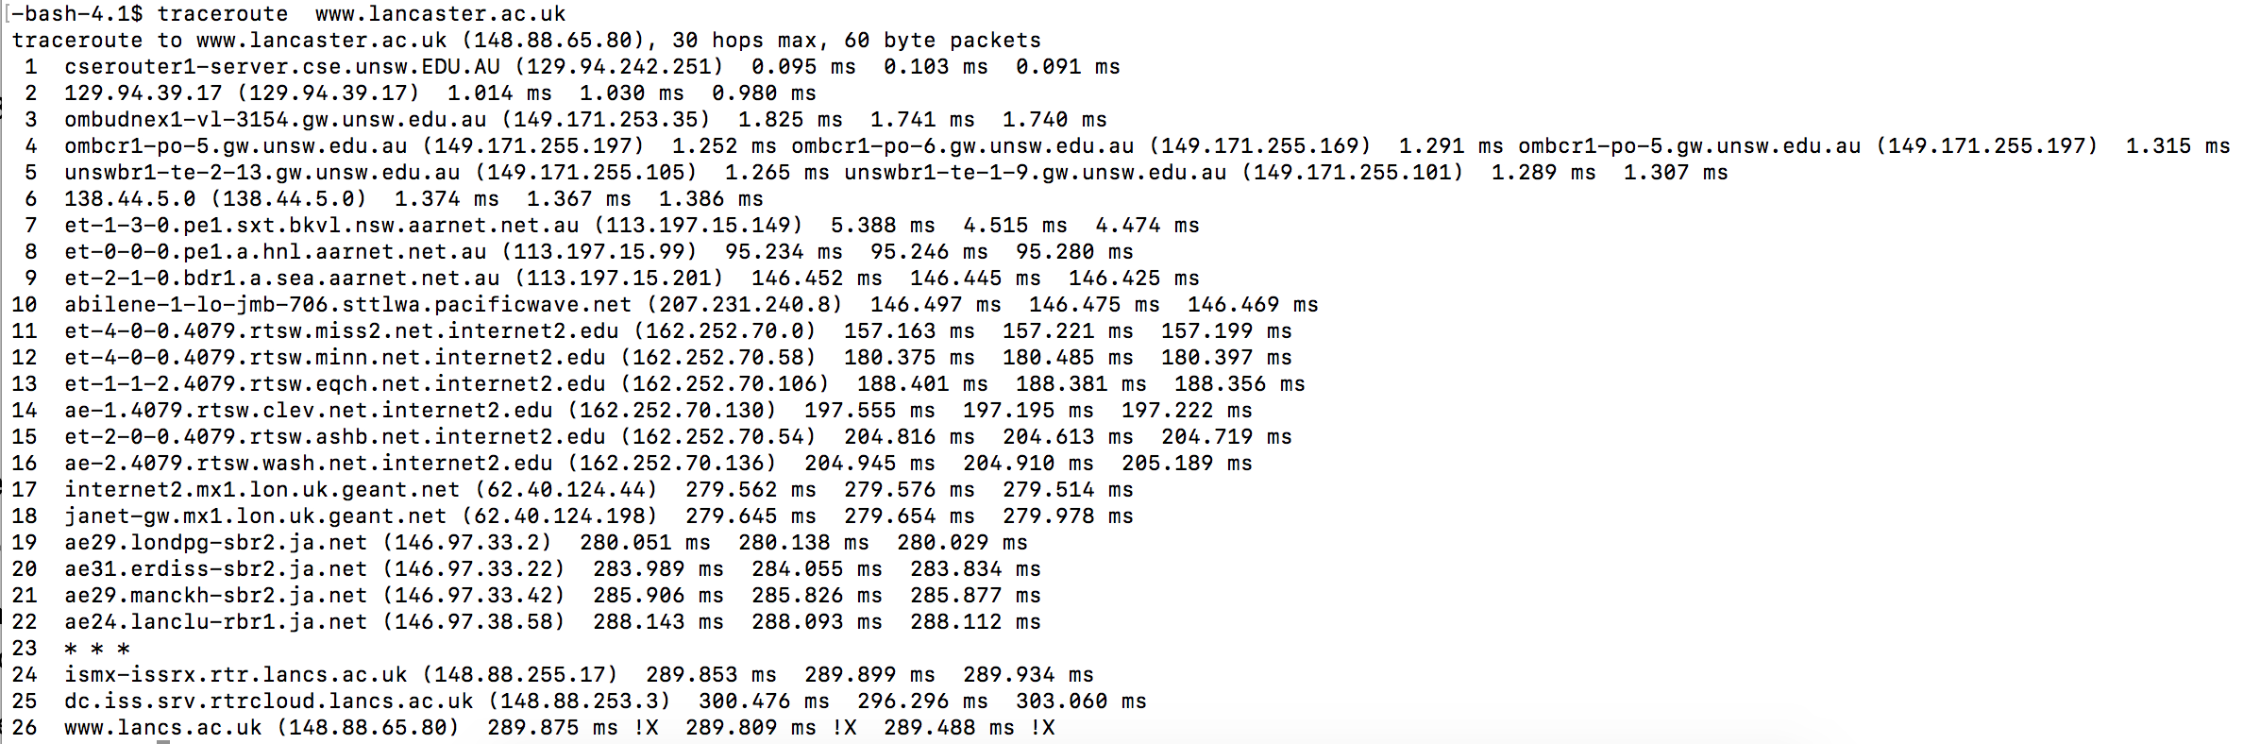

So the path diverge at no.6 router which IP address is 138.44.5.0

According to geographical location tool, we can obtain the information below

14 routers----7499.0 miles

15 routers----4908.7 miles

26 routers----10569.8 miles

So as we can see ,we can conclude that the number of hops is not proportional to the physical distance.

3. From my machine to speedtest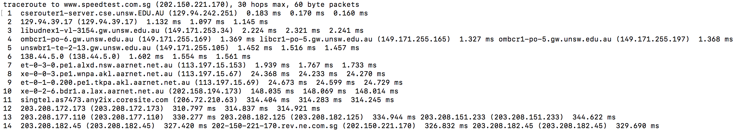

From speedtest To my machine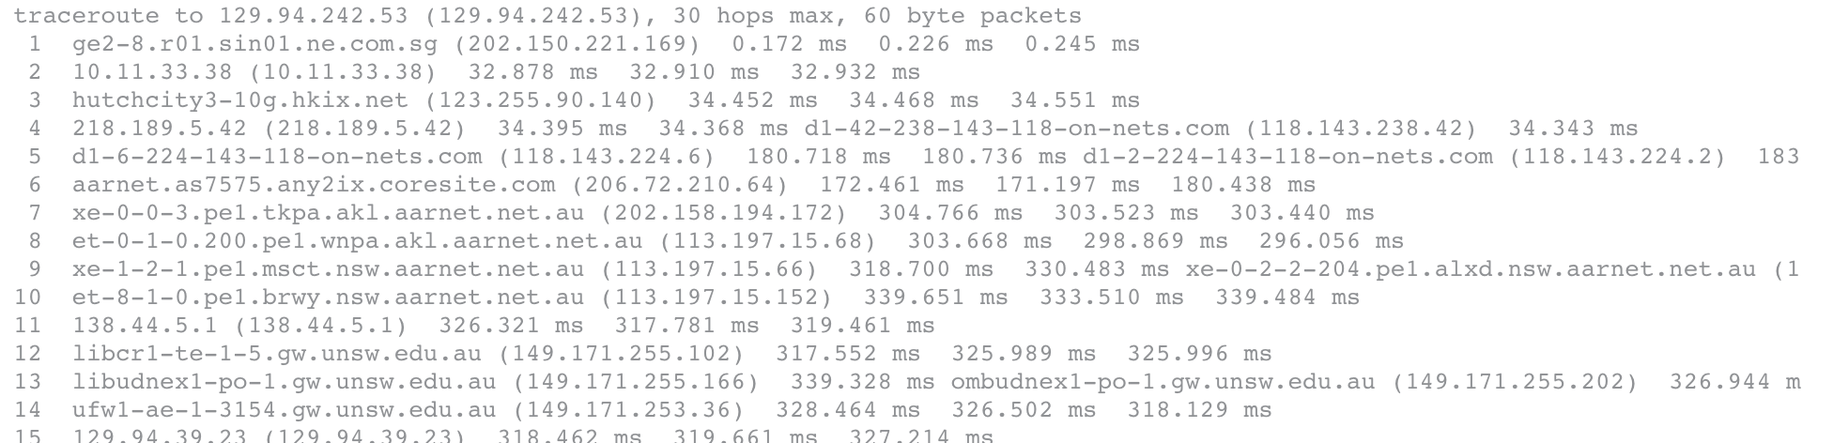

 From my machine to telstra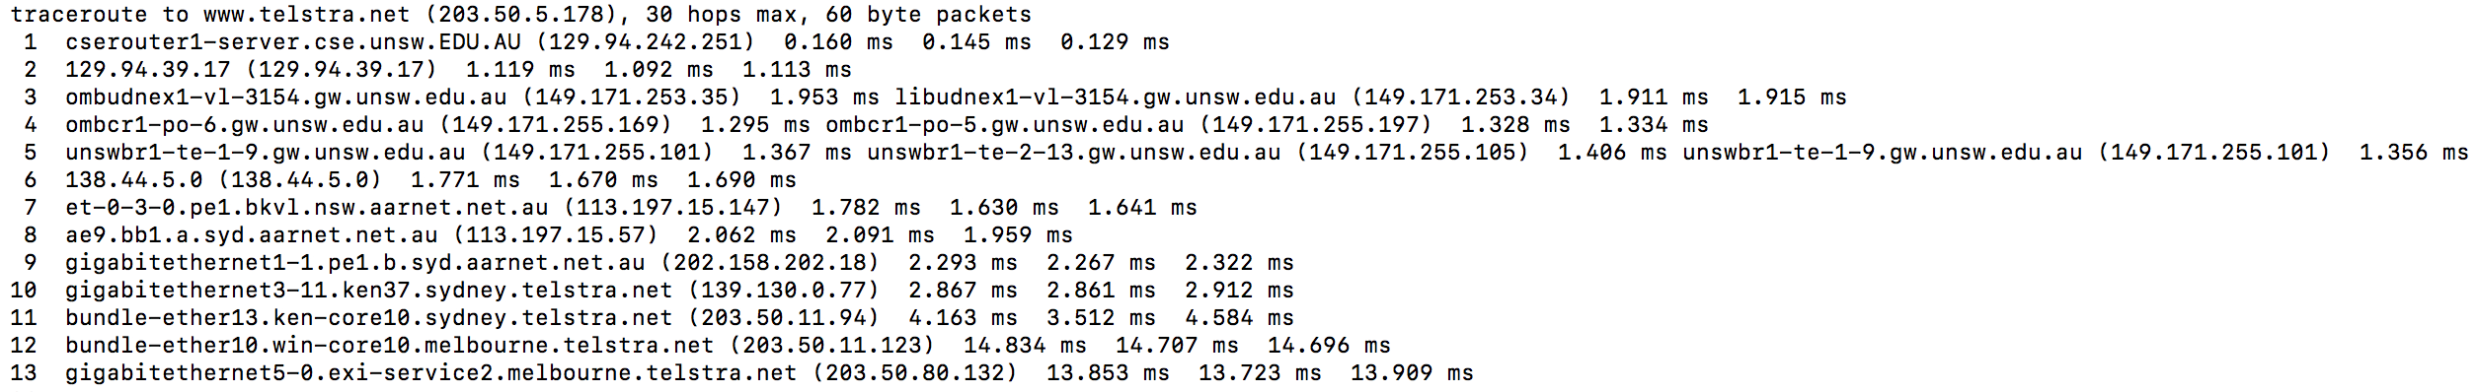

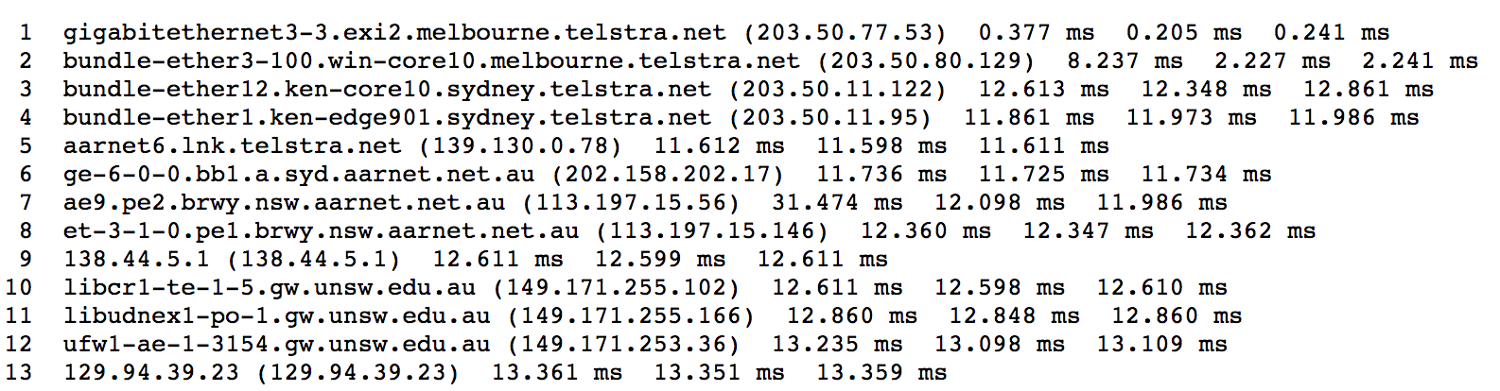

From telstra To my machine

The IP that i chosen are : www.speedtest.com.sg and www.telstra.net

As we can see, The reverse path is different form the forward path. So the answer is No ,because it is random to choose paths. they do not use the same path. Eventhough they use the same router ,the IP address is different.

Exercise 4: Use ping to gain insights into network performance

Compute the shortest possible time T using speed of light as propagation speed:

Approximate physical distance from UNSW to Brisbane:

T = 745km/speed of light = 2.48 ms

Approximate physical distance from UNSW to Singapore

T = 6310km/speed of light = 21 ms

Approximate physical distance from UNSW to Berlin

16100km/speed of light = 53.7 ms

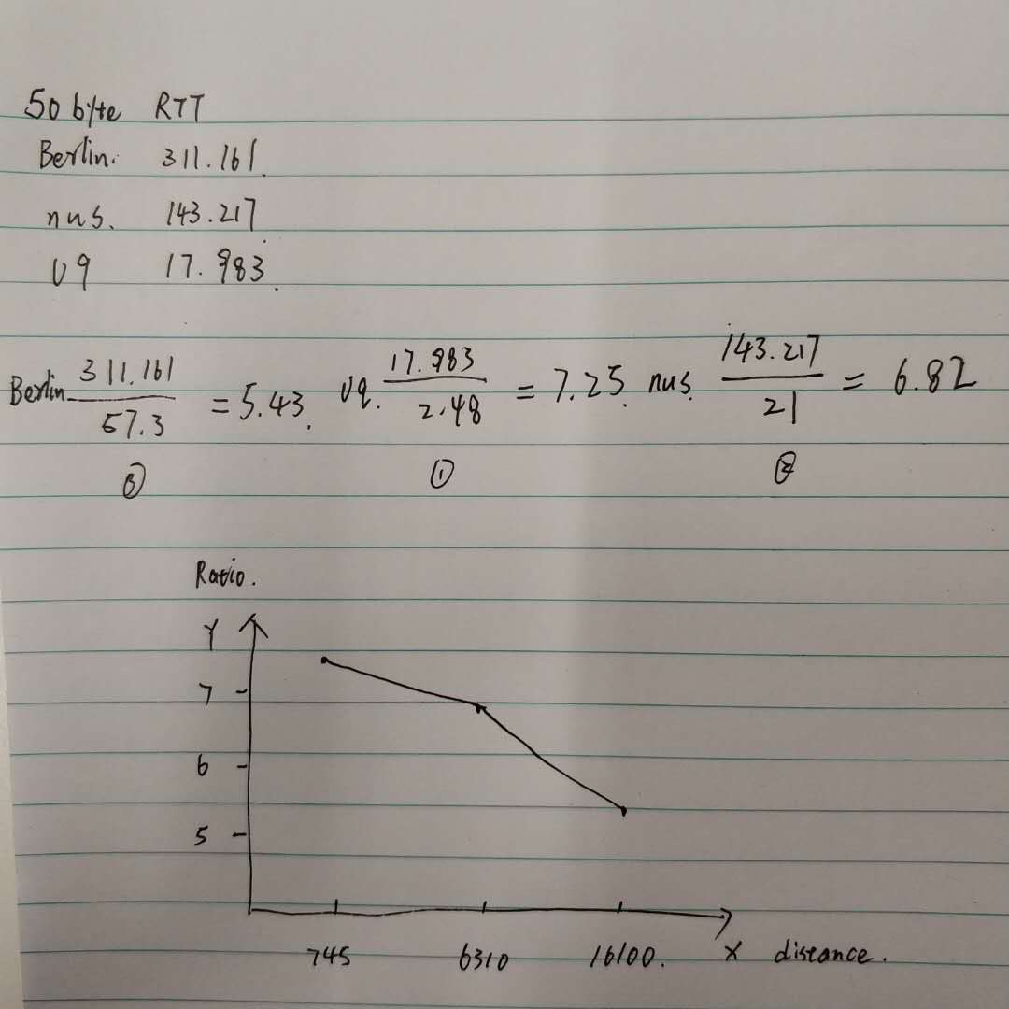

Can you think of at least two reasons why the y-axis values that you plot are greater than 2?

three kinds of delay. Processing delay, queue delay, transmission delay.

Packets don’t travel at speed of light through any physical medium.

Packets travel along cables and go through multiple hops rather than travel directly .

Q2: Is the delay to the destinations constant or does it vary over time? Explain why.

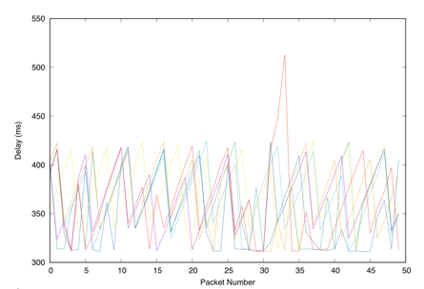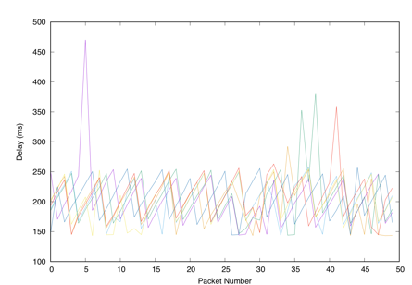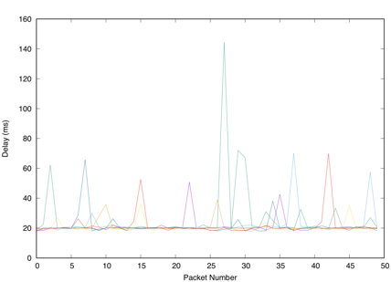

The delay varies over the time. Because it related to the current network condition. If the traffic is busy, the queue delay would be longer.

Q3:The measured delay (i.e., the delay you can see in the graphs) is composed of propagation delay, transmission delay, processing delay and queuing delay. Which of these delays depend on the packet size and which do not?

Only Transmission delay depend on the packet size. its definition is the rate of which bits are pushed out of the queue.

Propagation Delay is the amount of time it takes for the head of the signal to travel from the sender to the receiver. It can be computed as the ratio between the link length and the propagation speed over the specific medium.it depends on the distance and specific medium.

Processing Delay can be generated on many places ,like checking the head of packet and determining the direction of packets’ transmission. and its influence is very tiny.

Queuing delay is the time a job waits in a [queue](https://en.wikipedia.org/wiki/Queue_(data_structure)) until it can be executed. it depends on the congestion of network.