N.I.N.A. - Nighttime Imaging 'N' Astronomy

What’s new in Version 1.4.0.0

# Blind Solving

## What is it?

Blind Solving is basically the same as solving, with the difference that there are no reference coordinates to start the search. The plate solver will try to go through all plates to find a match for the current image.

## Why do we need it?

When initially setting up the telescope, the scope could be off by a fair amount. A solver like Platesolve2 is very slow to solve, when the starting coordinates are off by a large amount, as this type of solver starts at the reference coordinates to find a match and then circles around it. For this task a fully blind solver will be faster.  
Additionally for a failed solve a blind solve attempt can be made to get the correct coordinates. This will be also used during a plate solve of a meridian flip if the initial one fails.  
And lastly for the framing assistant when we want to load an image from a file, which does not have any reference coordinates to start with, we need to blind solve the image to know where the image is located, how the image is rotated and what the image scale is, to determine the exact coordinates during framing.

## How do we set it up?

For the blind solving feature the Plate Solving options interface changed slightly. There will now be two new combo boxes which determine which type of solver for each task should be used. Additionally to this a generic interface to set up each solver on their own is added.

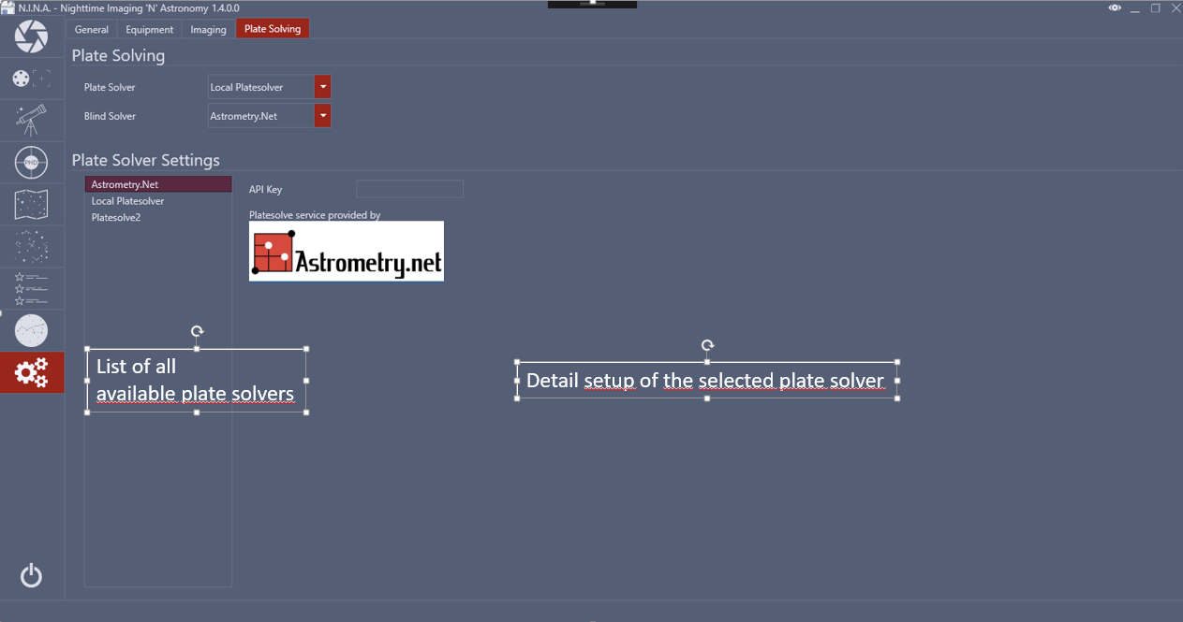

## How to use?

When a plate solve fails a prompt will be shown, if the user wants to start a blind solve. If yes is selected, the blind solve will start with the selected plate solver.  
For a meridian flip the prompt will not be shown on a failed plate solve. Instead a blind solve will automatically triggered, so the automation process won’t be interrupted.  
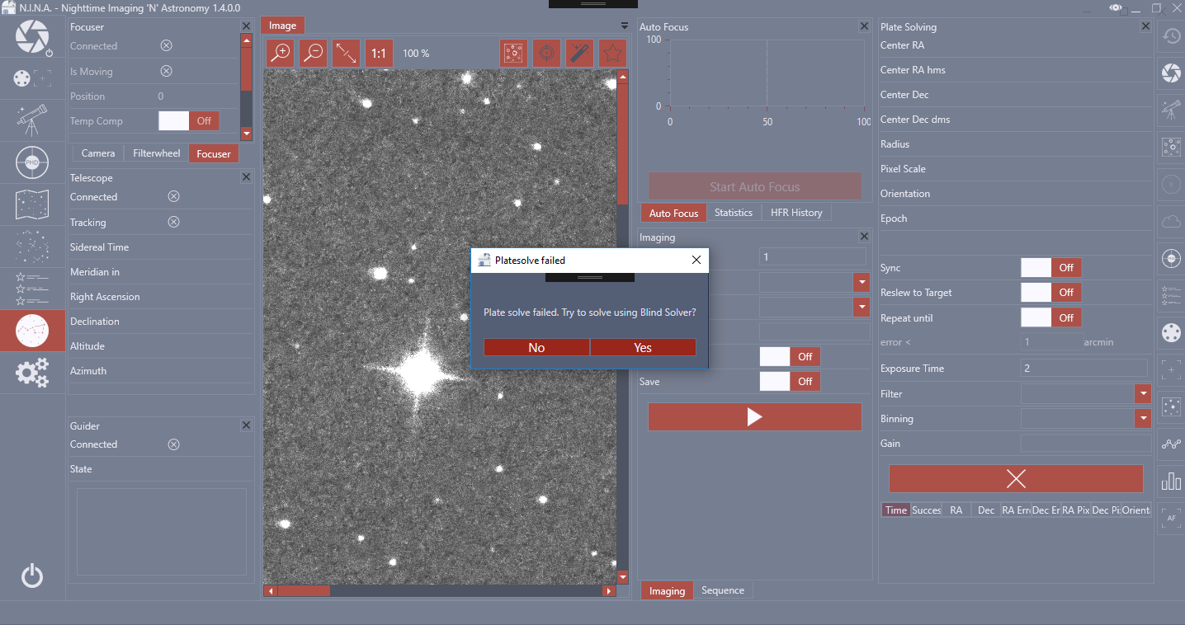  
A dedicated button to directly initiate a blind solve instead of a plate solve is not yet implemented, but planned.

# Framing Assistant

## What is it and why do we need it?

One of the most critical task for planning an imaging run is getting the framing right. NINA already offered the sky atlas to select a dedicated target for an imaging run. For this to work, the target has to be inside the center of the image. But what if the coordinates do not match the desired framing? This was not possible prior to this version. But now a new tool has been introduced, where a perfect framing can be achieved

## How do we set it up?

There is no setup required for the framing itself. The blind solver should be set up as explained above, when trying to load an image from a file instead of the digital sky survey however.

## How to use?

There are three ways to load an image into the Framing Assistant

### Digital Sky Survey

(requires internect connection)

For a given set of coordinates and Field of View NINA will establish a connection to the NASA Sky Survey webpage and download an image for the given coordinates. The larger the field of view, the more time this may take.  
There are two ways to get coordinates for the Sky Survey

* Select an object via the sky atlas and select “Set for framing assistant”
* Manually enter coordinates and click “Load image”

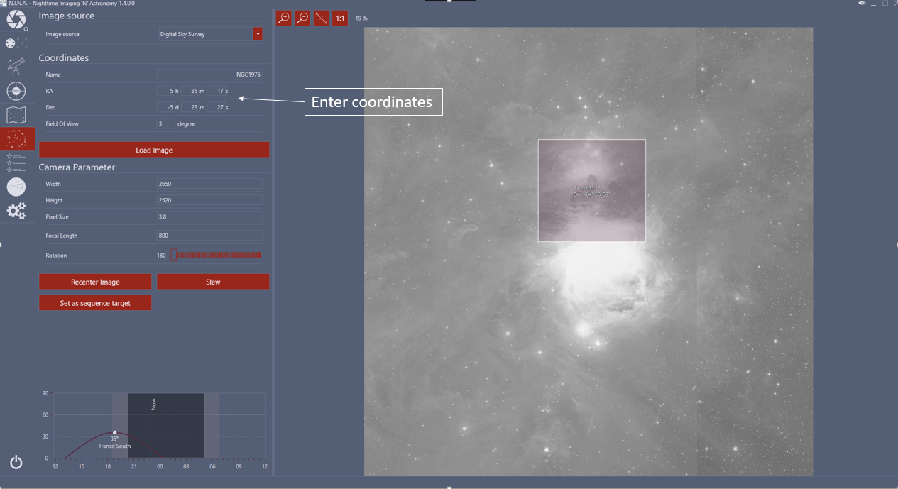

### Local Image File

(currently supported formats: tif, jpg, png)

When loading an image from disk select the image source “File” and click on “load image”. Select the desired file and submit. NINA will then ask to plate solve the image. If the plate solve worked, the image will be displayed together with the coordinates and field of view.

### File Cache

Each time an image is downloaded via Digital Sky Survey or loaded via a local image file, the image will be cached for later use. This will enable the user to use images from the digital sky survey in the field without having an active internet connection.

To use the cache, select “Cache” as image source. A new list will appear with all available cached entries and their coordinates.

In order to load an image into the application, just select the desired entry inside the list and click on “load image”.

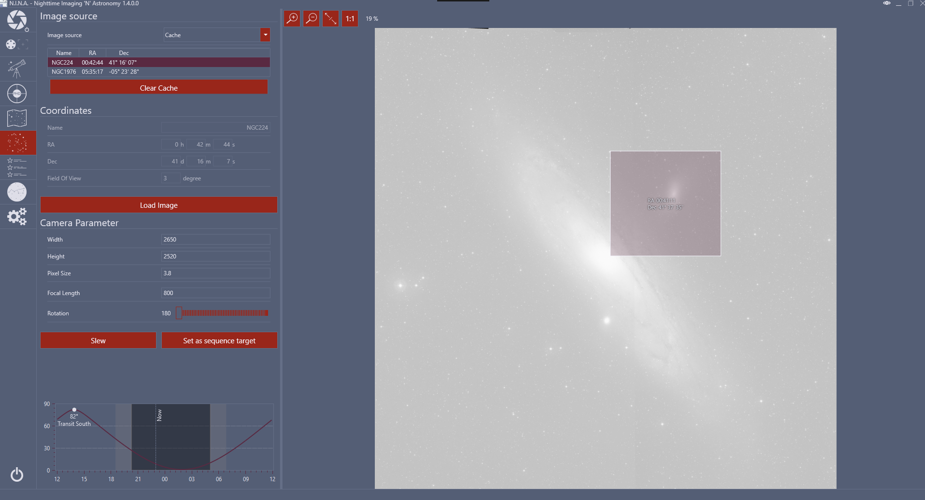

### Camera Parameter

To get a correct camera indicator inside the image area, there are some parameter which should be set. Those will be automatically populated when connecting the camera and telescope and from the application settings. Ideally nothing has to be set up at all.

When everything worked correctly, the application renders the target image and also a camera indicator as a draggable rectangle with the center coordinates of the rectacangle inside.

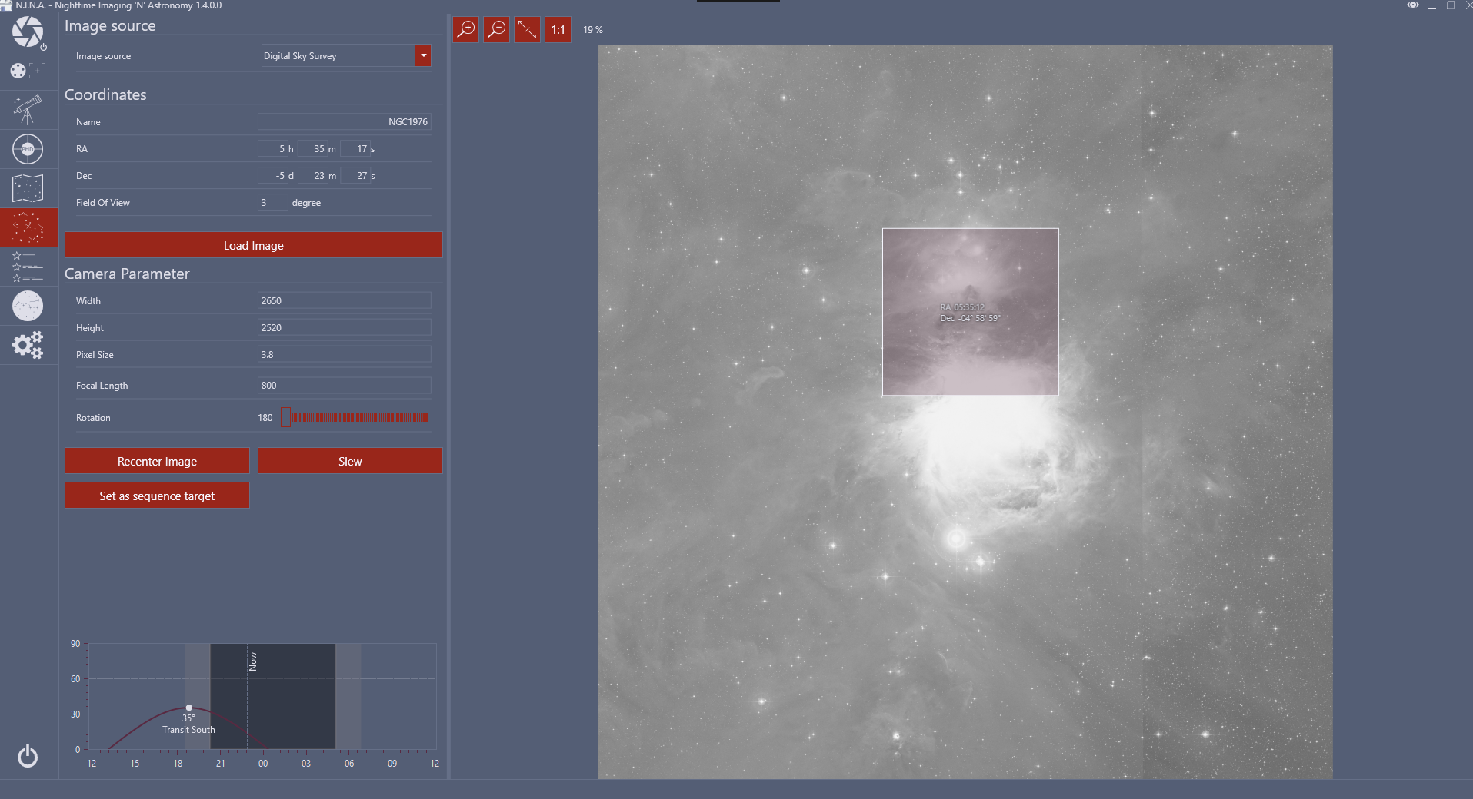

When satisfied with the location of the rectangle, the user can set the coordinates for the sequence target by clicking on the button “set as sequence target”. The sequence window will then be automatically populated by the correct coordinates.

## What is planned for future?

* Support for file types: FITS, XISF
* Readout header info for FITS and XISF that are already solved to not have them be solved again by the application
* An export feature like for sequences for a “manual” cache instead of the built in cache, to import it to a different pc
* Use the rotation for rotators or manual rotation via platesolving on sequence start