- Preface
LifeSim is the life loss and direct damage estimation software used by the U.S. Army Corps of Engineers. LifeSim is designed to simulate the entire warning and evacuation process for estimating potential life loss and direct economic damages resulting from floods. The following is a description of the major capabilities of LifeSim:
- Graphical User Interface
- Agent Based Modeling
- Evacuation Simulation
- Uncertainty
- Graphics and Reporting
The user interacts with LifeSim through a graphical user interface (GUI). The interface is designed to make it easy to use the software, while still maintaining a high level of efficiency for the user.
LifeSim uses an agent-based approach to track individuals throughout the warning and evacuation process. During an evacuation, agents are interacting with the roads, other vehicles, and the incoming hazard. After the warning and evacuation process has been simulated, LifeSim calculates lethality for those people who are exposed to the hazard and the associated direct damages. By tracking individual people and their movements, LifeSim can help identify where people are most at risk of losing their lives, whether it is on roads or in structures.
Three modes of evacuation are included in LifeSim: cars, sports utility vehicles (SUVs), and pedestrians. For vehicular evacuation, a dual regime modified Greenshields model (USDOT) in conjunction with spillback enforcement is used for traffic propagation to represent the effects of traffic density and road capacity on vehicle speed. Each road is assigned default values for the number of lanes, free flow speed, traffic jam densities, and minimum stop-and-go speeds based on the Highway Capacity Manual (HCM) (TRB 2000).
To define the routes people use to evacuate, a road network is provided where each segment of the network contains information such as road category, directionality, ground offset (for bridges), and interconnectivity. The road network can be imported from an existing GIS polyline shapefile or from OpenStreetMap. OpenStreetMap is a collaborative project to create a free editable map of the world. During each timestep at the user defined interval Δt, evacuating groups (PAR evacuating from a structure in a single vehicle) move as far as the model allows until the group reaches a destination point, gets caught, or becomes stranded. More information on the evacuation simulation can be found in the LifeSim 2.0 Technical Reference Manual (RMC 2021).
LifeSim applies both natural variability and knowledge uncertainty through Monte Carlo analysis. Multiple parameters can be entered with uncertainty including those that influence the warning and evacuation timeline. Each iteration in a simulation represents a scenario that could occur given the data uncertainties in the model. The results of the analysis provide a distribution of estimated consequences from a given hazard.
- Introduction
Welcome to the U.S. Army Corps of Engineers LifeSim Applications Guide. LifeSim uses an agent-based methodology for estimating life loss with the fundamental intent to simulate population redistribution during an evacuation. Direct life loss, direct economic damages, and direct agriculture damages are then determined by the hazard (e.g., flooding). Direct consequences, the primary focus of LifeSim, are those incurred when people, structures, or agricultural resources interact with the hazard.
LifeSim is designed to simulate the entire warning and evacuation process for estimating potential life loss and direct economic damages resulting from catastrophic floods (e.g., riverine flooding, coastal flooding, dam breach, and levee breach). LifeSim applies both natural variability and knowledge uncertainty (i.e., naturally occurring change in models’ parameters and outputs and gaps in what can be known by the modelers at the time) through Monte Carlo simulation. Many parameters can be entered with uncertainty including those that influence the warning and evacuation timeline (see the LifeSim 2.0 Technical Reference Manual, Warning and Evacuation Timeline Section for a more detailed overview). LifeSim is a multifaceted consequence estimation tool that can be utilized for various types of studies and analyses, including dam safety, levee safety, coastal storm risk management, flood risk management, risk communication, and more.
  - Overview of this Guide
The LifeSim Applications Guide contains written descriptions of seven examples that demonstrate the main features of the LifeSim software. The discussions in this manual contain detailed descriptions for the data inputs and analysis of the output for each example. The examples show and describe various input and output screens used to enter the data and view the output. The examples are intended as a guide for performing similar analyses in LifeSim. The manual is organized as follows:
- Summary of LifeSim Inputs, details the required inputs for all LifeSim studies. This section also defines and explains the inputs. Finally, some recommended data pre-processing is discussed. Reference back to this section for additional information on Hydraulic Data, emergency planning zones, Structure Inventories, Alternatives, and Simulations.
- Example 1, Estimating Consequence for Levees and Floodwalls, demonstrates the data required to estimate consequences (life loss and direct economic damages) for a levee or floodwall breach. The example details required inputs, ways to acquire emergency preparedness information for populations at risk (PAR) and emergency management agencies (EMAs), how to simulate evacuation, and how to analyze your modeling results.
- Example 2, Estimating Consequences for Dams, demonstrates the data required to estimate consequences for a dam breach model. The example details potential Geospatial Information System (GIS) pre-processing needed for data inputs, editing your structure inventory for accuracy, and inputting warning and evacuation data specific to dams.
- Example 3, Estimating Consequences for Cascading Dam Breaches, demonstrates various ways to model cascading dam breaches. The example highlights the modeling differences if there is a downstream dam that breaches due to an upstream dam breaching. This example primarily focuses on differences in (1) selecting the hazard occurrence time (i.e., the date and time breach or overtopping occurs in the study area) and (2) the delineation and parameter selection of the emergency planning zones (i.e., zones in LifeSim that can uniquely sample uncertainty parameters).
- Example 4, Estimating Consequences for Coastal Infrastructure, illustrates how LifeSim modeling differs for coastal structures (e.g., floodwalls, seawalls, dunes, and levees) compared to riverine infrastructure (e.g., floodwalls and levees), including differences in hydraulic data, warning times, and other consequence nuances specific to coastal infrastructure.
- Example 5, Estimating Life Loss in Flood Risk Management Planning, details how to compare life loss across an array of Planning alternatives in LifeSim. This example shows how to use typical Planning hydraulic outputs (e.g., eight flow-frequency events typically used in Hydrologic Engineering Center’s Flood Damage Reduction Analysis [ HEC-FDA]) in LifeSim to estimate expected annual life loss and how to utilize these results in the Planning process.
- Example 6, Estimating Direct Economic Damages for Flood Risk Management Planning, focuses solely on generating accurate direct economic damages with more uncertainty than the default parameters. The chapter details how to edit and create structure occupancy types, adjust stage-damage curve uncertainty, adjust foundation height uncertainty, and adjust structure value uncertainty.
- Example 7, Estimating Consequences Using Summary Grids, demonstrates how to estimate life loss and economic damages using summary grid output which differs from using Hierarchical Data Format (HDF) files from Hydrologic Engineering Center’s River Analysis System (HEC-RAS). This example will be helpful for individuals attempting to estimate consequences for a smaller Planning study, a study that did not utilize unsteady flow in HEC-RAS, or a study with limited output or information from the hydraulic model.
- Summary of LifeSim Inputs
  - Purpose
LifeSim requires an array of inputs in order to calculate life loss and/or economic consequences. This section details the general requirements to run a LifeSim model and some of the recommended pre-processing that should take place outside of LifeSim. The major inputs that require pre-processing are the emergency planning zones (EPZ), structure inventory, and the summary output polygon(s) used in the simulations. Inputs required to simulate evacuation (i.e., road network and destinations) are discussed in the Estimating Consequences for Levees and Floodwalls Chapter.
  - Hydraulic Data
Each of the applications in this guide details how to import hydraulic data from Hydrologic Engineering Center’s River Analysis System (HEC-RAS), including various import sources (e.g., summary grids and Hierarchical Data Format files) from HEC-RAS. There are nuances in selecting the correct hazard occurrence time for dams, levees, cascading dam failures, etc. The hazard occurrence time is defined as the point in time in which the hazard (e.g., dam breach, levee overtopping) occurs. It is the anchor point for all other time-dependent warning and evacuation parameters within the simulation.
It is recommended to reference the Hydraulic Data section for your specific application. There are other hydraulic data sources that can be imported into LifeSim that are not discussed in the Applications Guide (e.g. FLO2D). However, they are discussed in the LifeSim 2.0 Technical Reference Manual.
  - Structure Inventory
To use LifeSim to calculate direct life loss and/or economic damages, a structure inventory must be imported into the study. LifeSim will not simulate if any structure points are located outside of the EPZ.
For LifeSim users located in the U.S., the best available structure inventory data is the most recent version of the National Structure Inventory (NSI). The NSI is now public facing and can be leveraged by all U.S. LifeSim users from the NSI website. See the NSI User Guide for additional information. This dataset includes each of the LifeSim required attributes except for Ground Floor Height, Above Ground Floor Height, and Attic Height, which typically use the default values shown above. An alternative approach to the base NSI dataset can include various county and state data including local tax assessor, parcel, or footprint data that could help inform building location as well as some of the other attributes. Conducting a survey (direct observation or virtually using a tool like Google Earth) within the study area could also inform the structure inventory.
Occasionally, there may be a local dataset (e.g., from a local university, municipality, or some other study unrelated to your own) that has been calibrated specifically for the area of interest and surpasses the precision of some of the NSI’s more general assumptions. If a local dataset is available, either using GIS software to incorporate the localized data into your inventory or choosing to only use the localized data is often preferred.
The NSI was developed using parcel data, building footprints, and several other data sources to create a comprehensive statistical structure inventory. LifeSim has the capability of downloading a base NSI inventory based on a provided study area polygon, and other methods for accessing NSI data will likely become available in the future. If using an alternative to the NSI, a point structure inventory must be created with the following data fields for each structure:
- Occupancy Type
- Number of Stories
- Construction Type
- Foundation Height
- Population Under 65 (Night)
- Population Over 65 (Night)
- Population Under 65 (Day)
- Population Over 65 (Day)
- Structure Value
- Content Value
- Vehicle Value
The first four fields listed above define the structure types and directly impact the life loss calculations. The occupancy type and construction type fields help to define the structure stability criteria in LifeSim (discussed in more detail in the following sections). Construction type specifically denotes outer wall materials such as wood, steel, manufactured, or concrete. The number of stories and foundation height fields help define the potential for vertical evacuation and the first-floor elevation of the structure. Population values are required to calculate life loss.
By default, LifeSim uses the 40 occupancy types from HAZUS listed and described below, although they can be customized. The user can also add new occupancy types in LifeSim.

Table 1 HAZUS Occupancy Types Used in LifeSim
Occupancy Type | Description
RES1-1SNB | Single Family, 1 Story no Basement
RES1-1SWB | Single Family, 1 Story w/ Basement
RES1-2SNB | Single Family, 2 Story no Basement
RES1-2SWB | Single Family, 2 Story w/ Basement
RES1-3SNB | Single Family, 3 Story no Basement
RES1-3SWB | Single Family, 3 Story w/ Basement
RES1-SLNB | Single Family, Split Level no Basement
RES1-SLWB | Single Family, Split Level w/ Basement
RES2 | Mobile home
RES3A | Multi Family Dwelling, Duplex
RES3B | Multi Family Dwelling, 3-4 Units
RES3C | Multi Family Dwelling, 5-9 Units
RES3D | Multi Family Dwelling, 10-19 Units
RES3E | Multi Family Dwelling, 20-49 Units
RES3F | Multi Family Dwelling, 50+ Units
RES4 | Average Hotel, & Motel
RES5 | Institutional Dormitory
RES6 | Nursing Home
COM1 | Average Retail
COM2 | Average wholesale
COM3 | Average Personal & Repair Services
COM4 | Average Prof/Tech Services
COM5 | Bank
COM6 | Hospital
COM7 | Average Medical Office
COM8 | Average Entertainment/Recreation
COM9 | Average Theatre
COM10 | Parking Garage
IND1 | Average heavy industrial
IND2 | Average light industrial
IND3 | Average Food/Drug/Chem
IND4 | Average Metals/Minerals processing
IND5 | Average High Technology
IND6 | Average Construction
AGR1 | Average Agriculture
REL1 | Church
GOV1 | Average government services
GOV2 | Average emergency response
EDU1 | Average school
EDU2 | Average college/university

When importing a structure inventory into LifeSim, if structure, content, and/or vehicle values are not readily available, you can check the “Missing” box and enter a default value. In the example below, all structures in the structure inventory have a value of $200,000. If the purpose of the study is only to evaluate life loss and not monetary damages, it is appropriate to set these values to $0.
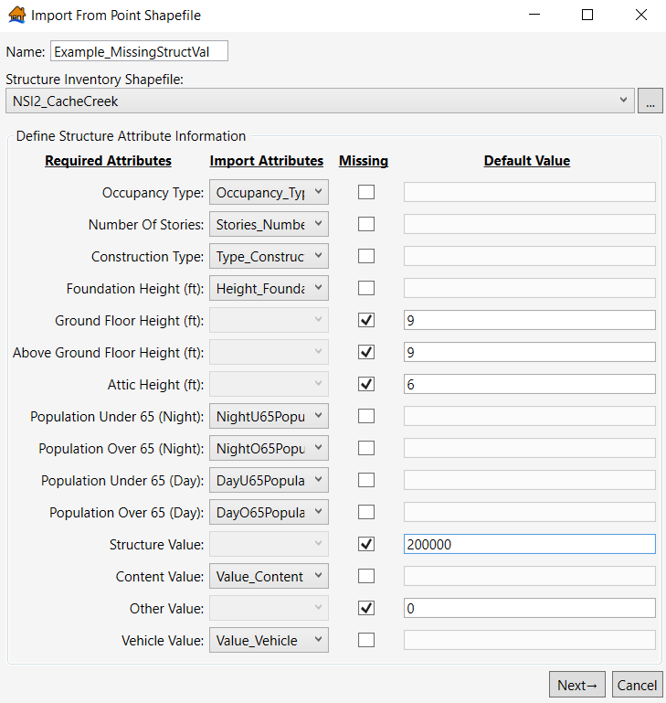
Figure 1 Importing a structure inventory with missing values
  - Emergency Planning Zones
An EPZ is a geospatial area where the warning and evacuation characteristics are homogeneous; the Emergency Management Agency responsible for evacuating people within the EPZ will have the same evacuation planning and preparedness, community participation and awareness, and types of flood warning systems available. EPZs also allow LifeSim to have different warning and mobilization parameters for areas that experience different flooding characteristics (e.g., breach flows and non-breach flows). Depending on the study’s purpose and level of detail there could be different parameters for different areas, communities, or counties. Refer to the LifeSim 2.0 Technical Reference Manual for additional information regarding EPZs.
  - Alternatives
Each of the applications in this guide include specific details regarding creating alternatives, including selecting imminent hazard identification times (i.e., warning times), simulating evacuation, and how many alternatives to include per hydraulic scenario. There are nuances to creating alternatives for different types of LifeSim models.
It is recommended to reference the Alternatives section for each application.
  - Simulations
There are limited options to select in the Simulations window. However, a key part of LifeSim Simulations is the summary output polygon. A summary output polygon is required when creating a simulation. The user may enter multiple summary output polygons in a single simulation. Similar to the EPZs, the summary output polygon is a geospatial area and LifeSim will generate results based on the areas in the summary output polygon. The summary output polygon can be a shapefile that is not an input for LifeSim. An example of this is using the U.S. Census city boundaries shapefiles to receive LifeSim results by city. Another example is simply using the study’s EPZ as the summary output polygon if the results do not need to be specifically delineated by area.

(Page is intentionally left blank)

- Estimating Consequences for Levees and Floodwalls
  - Purpose
This example demonstrates the process for estimating consequences for levees or floodwalls in LifeSim. The general process is similar to estimating consequences for dams, but there are modeling nuances specific to levees or floodwalls. This chapter focuses on the Cache Creek Levee located in Yolo County, CA. This levee system was originally modeled in 2021 by the U.S. Army Corps of Engineers’ (USACE) Modeling, Mapping and Consequences (MMC) Production Center. This chapter includes step-by-step instructions for importing the required data into LifeSim for a levee or floodwall breach model, how to choose appropriate warning and evacuation data for a study area, how to simulate evacuation, and how to interpret model results.
  - Input Data
The subsequent sections discuss the input data required to calculate direct damages and life loss for a levee or floodwall in LifeSim. The input data sections include hydraulic data, emergency planning zones (EPZ), structure inventories, road networks, destinations, creating alternatives, and simulating alternatives.
  - Hydraulic Data
The Cache Creek Levee utilized output from the Hydrologic Engineering Center’s River Analysis System (HEC-RAS). When using HEC-RAS data in LifeSim, the hydraulic data should be in the form of Hierarchical Data Format (HDF) files. HDF files are essentially a file package of depths, velocities, and hydraulic timing. Using HDF files allows you to simulate evacuation in LifeSim easily and with greater detail. For most levees/floodwalls, it is recommended to simulate evacuation to accurately capture potential life loss in structures and on roads. The HEC-RAS plan HDF file and the HEC-RAS terrain HDF file are needed for each hydraulic scenario.
To import the hydraulic data from HEC-RAS, right click on Hydraulic Data in the study pane, and select Import from HEC-RAS.
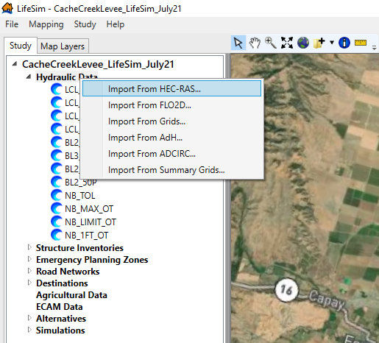
Figure 2 Importing hydraulic data from HEC-RAS
From the Import from HEC-RAS window, map to the project’s HEC-RAS Plan(s) Directory by clicking on the button with the three dots. The file directory selected should contain plan HDF files from HEC-RAS (e.g., p01.hdf). Then, map to the project’s HEC-RAS Terrain File (e.g., terrain.hdf) by clicking on the button with three dots. Note, you will also need all terrain Tagged Image Format (TIF) files. Then, you will select the specific HEC-RAS plan you want to import by using the dropdown next to HEC-RAS Plan. Once selected, the Name of the hydraulic scenario automatically populates, but the user can alter the Name. Once you have the hydraulic data selected in the Import from HEC-RAS window, you can either select Import from RAS or Import from Map.
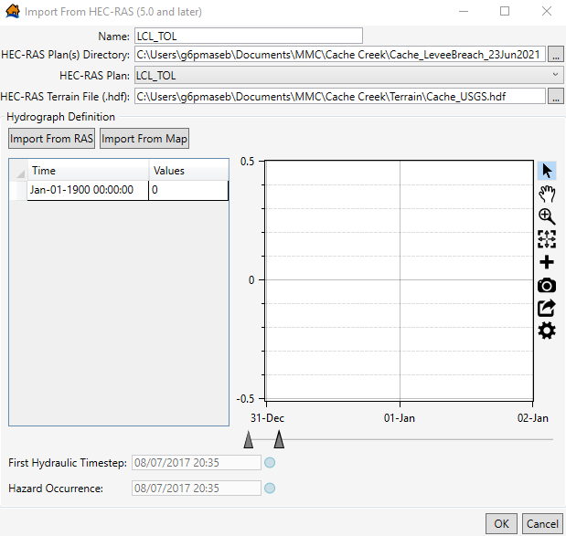
Figure 3 Import from HEC-RAS window
    - Import HEC-RAS Data – Import from RAS
If you select Import from RAS, select the cross section where the hazard (e.g., overtopping or breach) occurs within the study area. The hydraulic engineer should supply you with the project’s breach locations, which correspond to a cross section. After selecting the correct cross section, click OK.
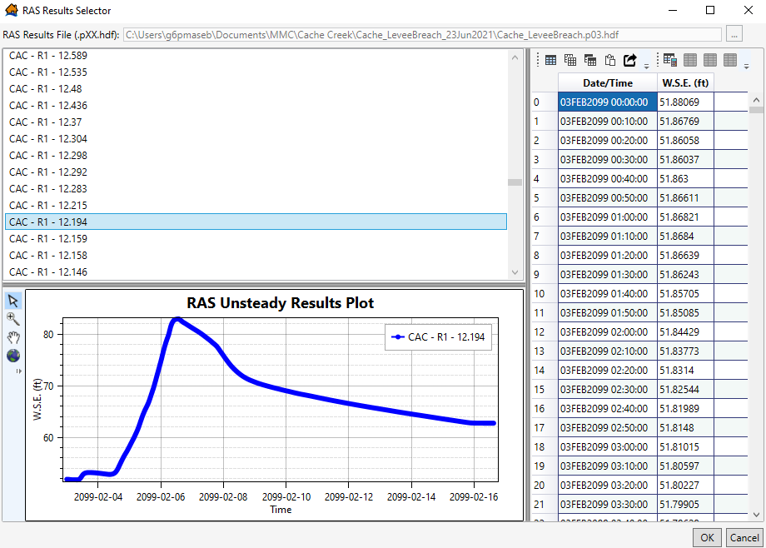
Figure 4 Import from RAS – RAS Results Selector window
You automatically return to the Import from HEC-RAS window. A representative hydrograph is now shown in the window along with hydraulic timing information and corresponding depths at each timestep. Within this window, enter the Hazard Occurrence date and time. The Hazard Occurrence date and time should match the time that breach or overtopping (if applicable) begins within the study area. This information can be found in the HEC-RAS model or provided to you by the hydraulic engineer. Press OK; the hydraulic scenario is processed and imported into LifeSim.

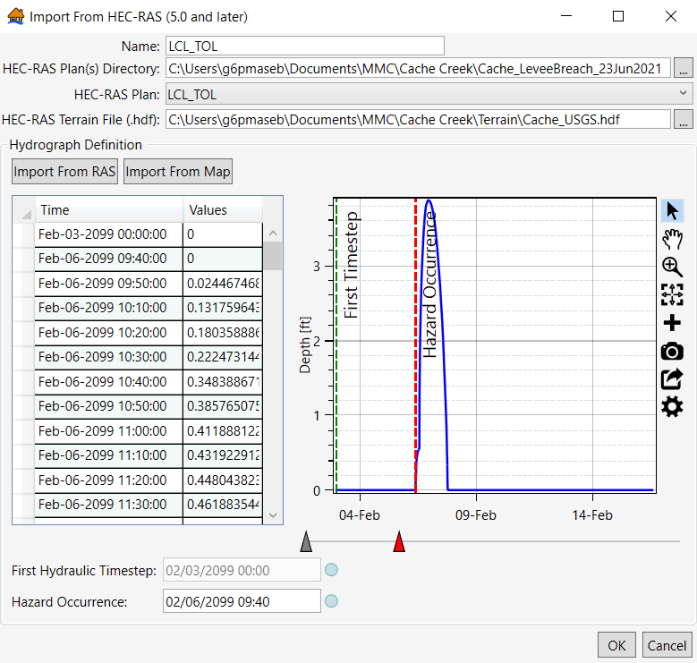
Figure 5 Import from HEC-RAS window after selecting a cross section from the RAS Results Selector
    - Import HEC-RAS Data – Import from Map
Alternatively, if you select Import from Map, the RAS Map Data Selector window opens.
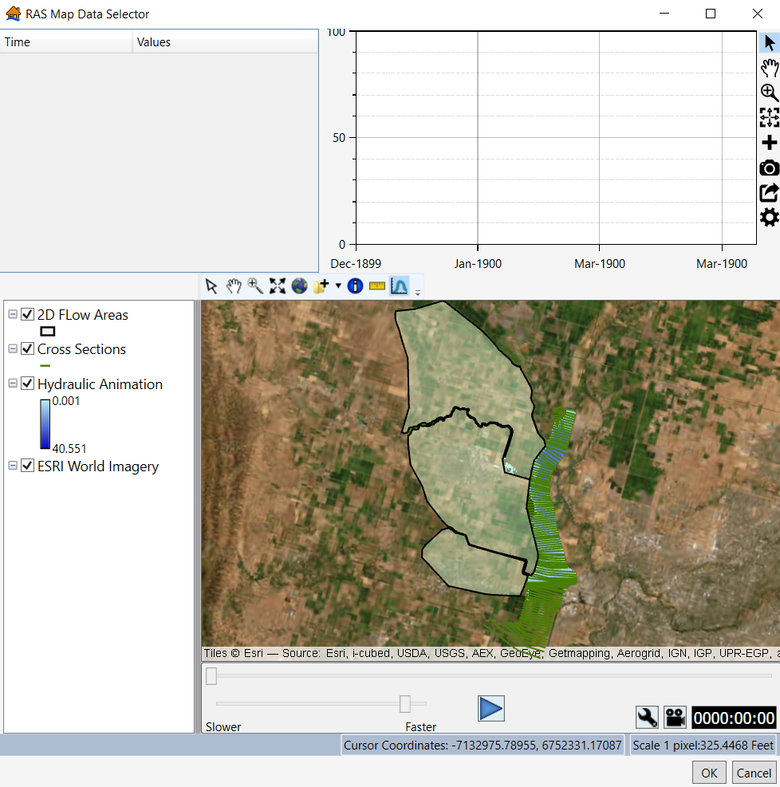
Figure 6 RAS Map Data Selector window
To view a hydrograph along with its hydraulic timing and depths, use the Select Hydrograph Tool in the toolbar (shown below).
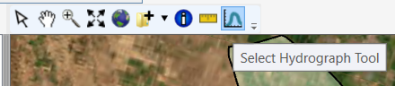
Figure 7 Select Hydrograph Tool in the RAS Map Data Selector
The RAS Map Data Selector map window automatically displays the 2D areas used in the RAS modeling, the cross sections, the hydraulic animation, and a base map. The user can change the base map and add data to the map window (e.g., breach locations shapefile, leveed area shapefile, structure inventory, etc.) by clicking on the Add Data button (see below).
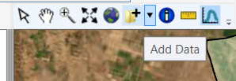
Figure 8 Add Data feature in the RAS Map Data Selector
For the Cache Creek Levee, adding the breach location shapefile (“LCL” in the layers shown in the figure below) and the leveed area shapefile (“POLYGON” in the layers shown in the figure below) to the map window was useful in finding the where the hazard first occurs near the breach location.
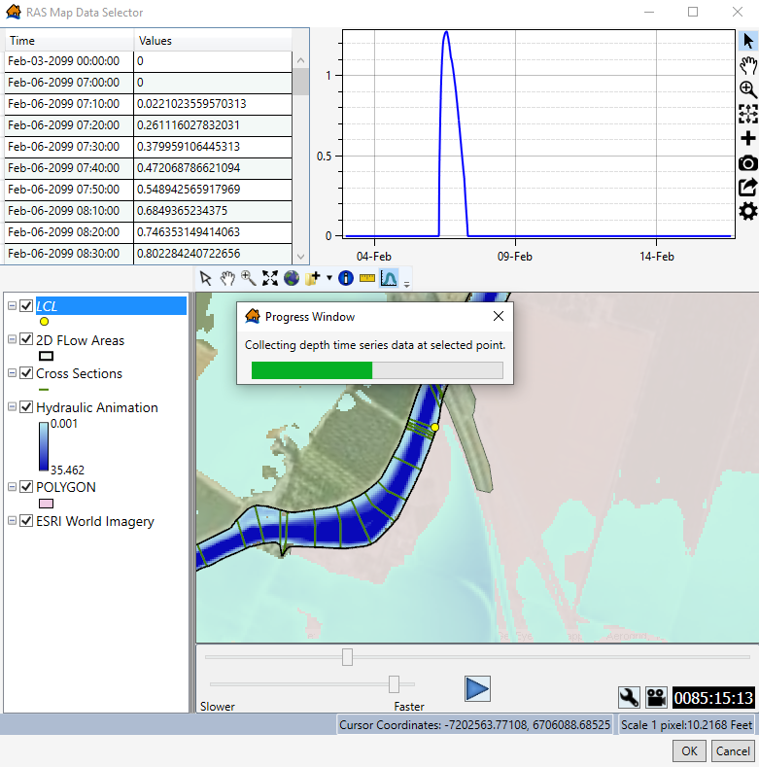
Figure 9 Progress Window in the RAS Map Data Selector after clicking on an area with the Select Hydrograph Tool
Once you find a representative hydrograph for the hydraulic scenario, click OK. The Import from HEC-RAS window is now shown. The new window displays hydraulic timing information as well as the same representative hydrograph. Again, the Hazard Occurrence date and time should match the time that breach or overtopping (if applicable) begins within the study area. Press OK; the hydraulic scenario will be processed and imported into LifeSim.
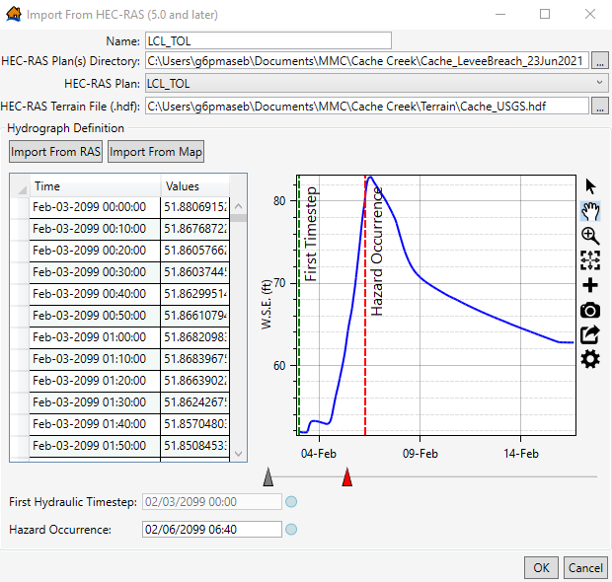
Figure 10 Import from HEC-RAS window after selecting a representative hydrograph from RAS Map Data Selector
Repeat this process for each of the study’s hydraulic scenarios.
  - Emergency Planning Zones
As discussed in the Data Inputs and Pre-Processing section, EPZs are polygons that allow LifeSim to have different warning and mobilization parameters for different geographic areas and/or for areas that experience different flooding characteristics. For most levees and floodwalls, the shapefile used for the EPZ should represent the estimated leveed area. Otherwise, it is likely that both economic damages and life loss estimates would be inflated due to including consequences that are outside of the leveed area. Presumably you are estimating the risk of a levee or floodwall; therefore, you need to understand where the incremental risk (i.e., “levee risk” or the risk associated with the levee) is, which is within the leveed area.
For most levees and floodwalls, the shapefile used for the EPZ should represent the estimated leveed area. The National Levee Database (NLD) is a resource that includes most floodwalls and levees within the U.S. (https://levees.sec.usace.army.mil/). The NLD shows the leveed area for each project and allows you to download the leveed area as a shapefile, which should be used as the EPZ for the entire study.
If the project is not included in the NLD or you are unable to access the NLD, it is recommended to obtain the HEC-RAS model’s 2D mesh area and use this shapefile as the EPZ. It’s also recommended to discuss what should be considered the leveed area with your hydraulic engineer and any other team members on the study.
    - EPZ Warning and Protective Action Parameters
Once you have a representative shapefile for the EPZ, the next step is to assign the Warning and Protective Action Data, including the Warning Issuance Delay, Warning Diffusion (First Alert Curves), and Protective Action Initiation (PAI) parameters.
There are a few types of resources to consider when gathering information about the area’s warning and evacuation procedures: (1) any expert opinion consequence elicitation conducted in the city or county in question within 5 years of the current analysis, (2) the USACE Levee Screening Tool (LST), and (3) local, county, and/or state Emergency Management Agency (EMA) websites and social media. Reaching out to communities directly, or the responsible USACE districts, and asking questions to gauge the need for a more formal consequence elicitation is perfectly acceptable if the data available is in question.
If these resources are not available for your project, you should select LifeSim’s preset Unknown parameters for Warning Issuance Delay, Hazard Communication Delay, and Protective Action Initiation curves within the EPZ editor.
The subsequent sections discuss the three resources that should be considered when developing your warning and evacuation parameters.
      - Using Existing Consequence Elicitation Data to Inform LifeSim Parameters
Over recent years, many consequence elicitations have been conducted within the U.S. to support risk assessments. The consequence elicitations are generally conducted for various high-risk cities and/or counties. When starting a new LifeSim model or risk assessment, check if an elicitation was already conducted within your study area. The current consequence elicitation directory is stored on a USACE shared drive and is for internal use only. Reaching out to the responsible USACE district is a perfectly acceptable way to assess whether or not an elicitation has been or needs to be conducted for your study. If an elicitation was completed, you can likely use most of these same parameters for your LifeSim model. It is recommended to review the elicitation results, including the meeting notes and elicited LifeSim parameters, to ensure the parameters are logical for your levee project. If the elicitation was conducted for a dam, review the notes to ensure that the elicitation could be applied to a levee. There may be instances in which you do not feel confident that the previous elicitation results directly apply to your project, which could cause you to gather other resources to make an informed decision.
      - Using the Levee Screening Tool to Inform LifeSim Parameters
The Levee Screening Tool (LST) (https://lst2.sec.usace.army.mil/) can contain helpful information regarding expected emergency action plans, community awareness, and warning systems to inform the EPZ’s warning and evacuation data. Within the LST, a levee may have several segments with individual screenings. It is recommended to look at the segment with the most screenings, or to identify the screening that was completed most recently; this screening will have the most up-to-date information. Generally, all levee units are rescreened as a system, but there can be special instances in which this is not the case.
If you attempt to login to the LST and are unable, there are instructions on the login page to request/create an account.
The figure below shows the screenings for the segments of Cache Creek Levee available in the LST.
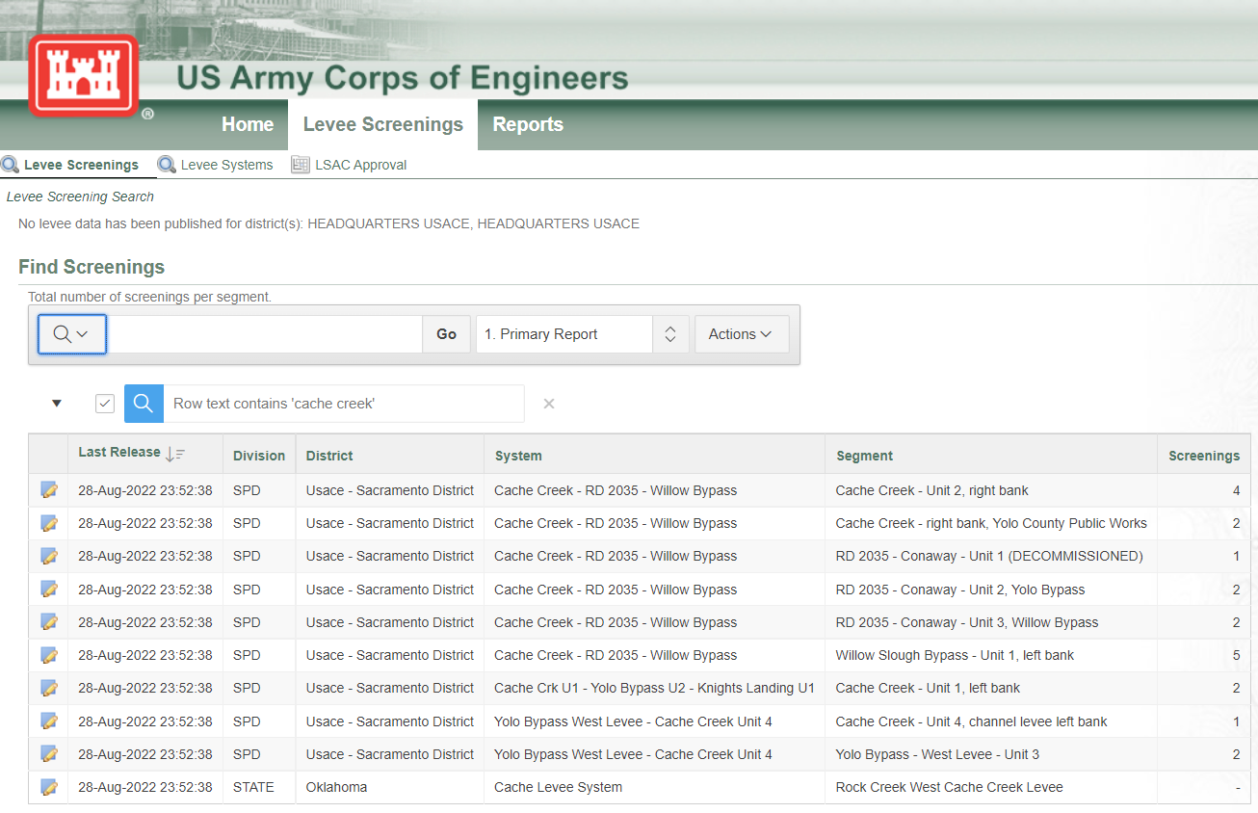
Figure 11 Levee Screening Tool - Cache Creek levee screenings
As shown in the figure below, Cache Creek Levee was last screened several years ago in 2015. The user may find that this information is not recent enough to use in the LifeSim study. Since the 6 levee segments were all screened at the same, I selected the segment that has the most screenings: Willow Slough Bypass – Unit 1, left bank.
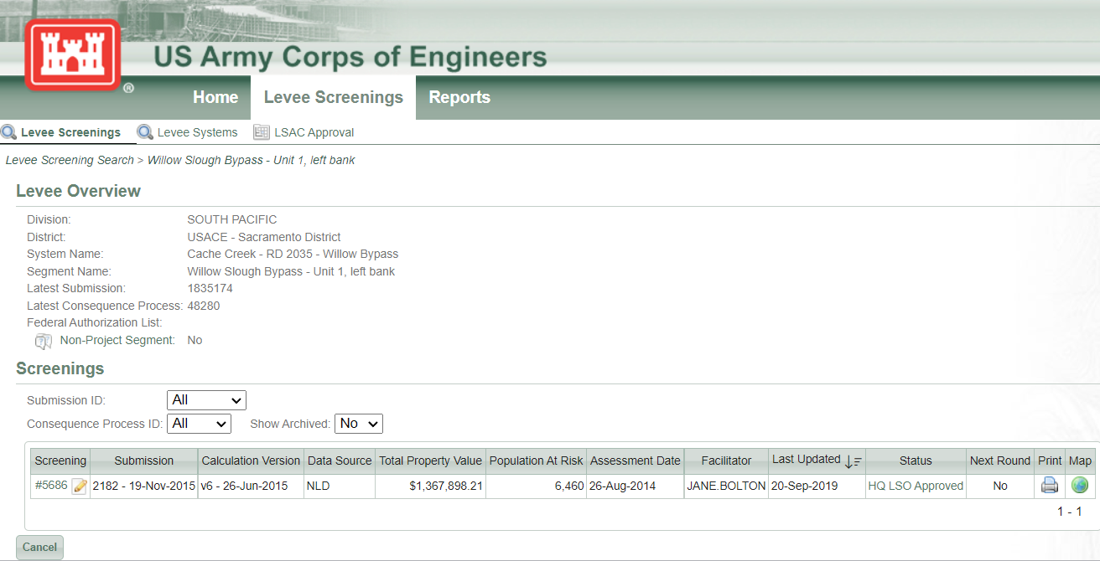
Figure 12 Willow Slough Bypass - Unit 1, Left Bank levee screening
After selecting a levee unit screening, navigate to the Consequences section of the LST.
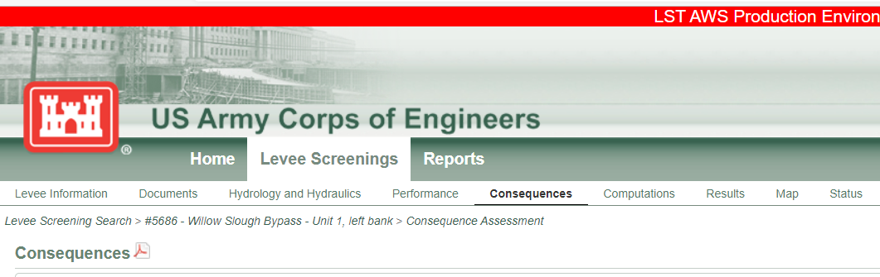
Figure 13 Willow Slough Bypass's LST Consequences section
This Consequences section of the LST shows key consequences information such as Evacuation Planning, Community Awareness, and Flood Warning Effectiveness. Each of these elements can be helpful in determining preset LifeSim curves if the explanations of the scores are detailed, recent, and logical. The details for Cache Creek Levee’s Evacuation Effectiveness Information are shown below.
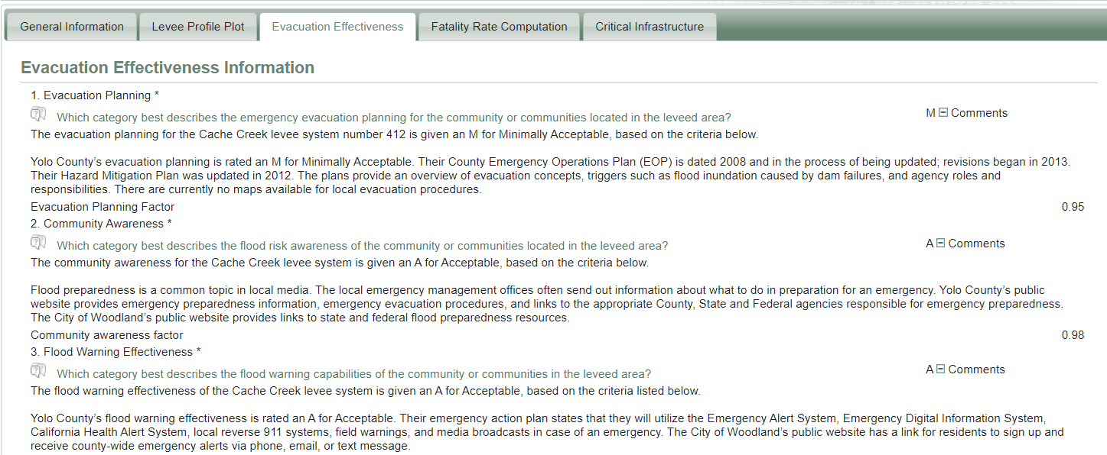
Figure 14 Evacuation Effectiveness Information for the Cache Creek levee system
The Evacuation Planning factor may help determine the Warning Issuance Delay. As shown above, the latest Evacuation Planning information is from 2012 and 2013. This may not be the most up-to-date information; it is recommended to confirm the information by looking into the Emergency Management Agency’s website (see next section for details). If the Evacuation Planning factor was given an Acceptable rating (with quality reasoning) you would select an optimistic Warning Issuance Delay curve, such as Well Prepared.
The Community Awareness factor can be used to inform the Protective Action Initiation curve. If the rating is Acceptable and the explanation includes information about recent flood events/evacuations, public education campaigns, and flood preparedness as a topic in the media, then an optimistic PAI curve could be warranted, such as the Perception: High / Preparedness: High. However, if the rating is Unacceptable and none of the previously stated factors are included in the explanation, a more pessimistic PAI curve may be warranted, such as the Perception: Low / Preparedness: Low.
The Flood Warning Effectiveness factor can be used to inform the Warning Diffusion/First Alert curves. If this factor received an Acceptable rating and the explanation details several different types of warning channels (e.g., radio, media, reverse 911, and texts), then an optimistic Warning Diffusion curve should be used, such as the Moderately Fast or the Fast curves.
If the ratings and explanations could defend a variety of LifeSim parameters, it is recommended performing sensitivity runs using a variety of parameters to determine if life loss changes significantly and then seek additional information from the local sponsor and/or the project’s district office. The local personnel should be able to provide more information to determine final LifeSim parameters if necessary. Additionally, you can provide a variety of results in your study and clearly state the differences between the sets of alternatives and simulations. The variety of scenarios provide uncertainty to the life loss estimates, especially if there is some uncertainty regarding some of the warning and evacuation parameters. Ensure there is defensible reasoning for each uncertainty parameter.
      - Using Emergency Management Agency Websites to Inform LifeSim Parameters
Looking through the county’s Emergency Management Agency’s (EMA) website or social media provides insight on the area’s emergency procedures, recent updates to emergency action plans or hazard mitigation plans (if applicable), and what warning channels are available, which can inform the EPZ’s warning and evacuation data.
The Cache Creek Levee is in Yolo County, CA. This section discusses the emergency procedures and resources from Yolo County Emergency Management and demonstrates how to use this type of information to select appropriate warning and evacuation parameters. As shown in the screenshot below, Yolo County’s website links to Current Emergencies and Incidents (listed in both English and Spanish), Flooding Resources, and the county’s relatively recent updates to emergency preparedness and resources.
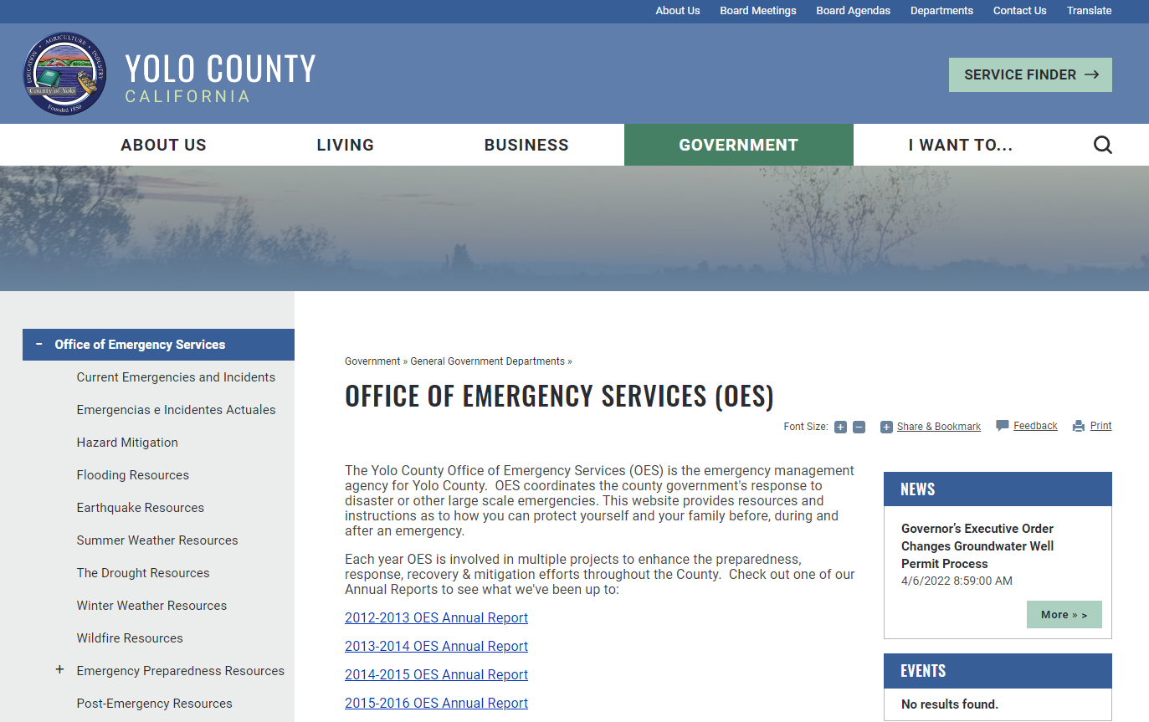
Figure 15 Yolo County, California, Office of Emergency Services website
As you scroll down this webpage, there are additional links about how to prepare for an emergency, signing up for Yolo Alert, and contact information for the Office of Emergency Services. After clicking on the link to sign up for emergency alerts, you are sent to a webpage to sign up for Yolo County’s warning system, Everbridge, which is an advanced public warning system.
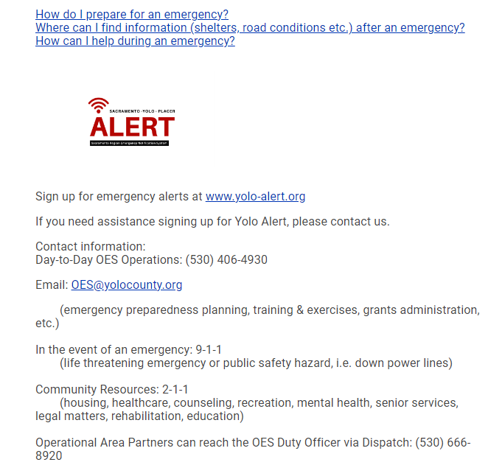
Figure 16 Yolo County, California, Office of Emergency Services: Sign up for emergency alerts
While selecting uncertainty parameters for your EPZ, consider if the area experienced flooding recently, especially large flood events that resulted in evacuations. This information helps select warning and evacuation data in LifeSim (e.g., heightened community awareness, recent experience writing and sending out warnings, etc.). Regardless of the curves you select for your study, defensible reasoning for each warning and evacuation parameter is needed.
    - Importing an Emergency Planning Zone
This section discusses importing an EPZ into LifeSim and how to use the information discussed in the previous sections to determine the final parameters used in the study. For Cache Creek Levee, the readily available warning and evacuation data, the local EMA website, and recent flood warnings and evacuations are heavily relied upon to determine appropriate warning and evacuation parameters.
Once you determine the EPZ shapefile and gather information on the area’s warning and evacuation data, import the EPZ shapefile into LifeSim. Right click on Emergency Planning Zones in the study tree and select Import EPZs from Shapefile.
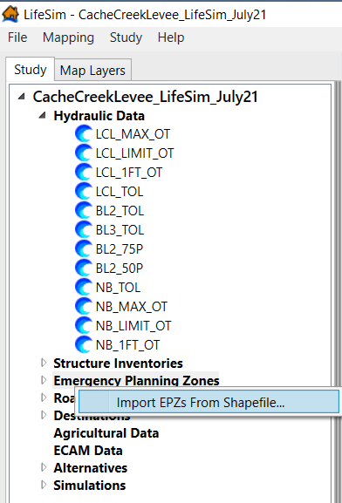
Figure 17 How to Import an emergency planning zone from the LifeSim study tree
The Import Emergency Planning Zones window opens. First, map to the EPZ shapefile. You can do this by either utilizing the Emergency Planning Zone Polygon Shapefile dropdown, which displays the polygon shapefiles that are currently in your Map Layers, or you can map to the shapefile by clicking on the button with the three dots next to dropdown.
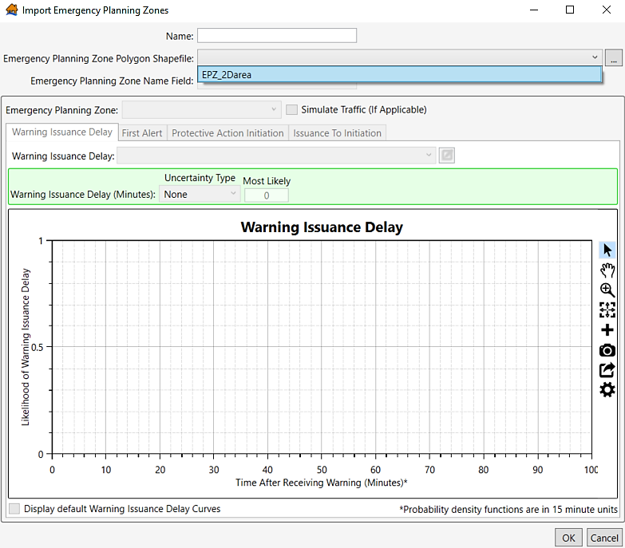
Figure 18 Selecting an emergency planning zone Polygon Shapefile from the dropdown
Then, designate one of the shapefile’s fields as the Emergency Planning Zone Name Field. If you are importing a shapefile composed of multiple areas, or EPZs (e.g., two counties), the Emergency Planning Zone Name Field needs to have unique values. After selecting the Name Field, select the warning and evacuation data for the EPZ(s). For the Cache Creek Levee, the National Levee Database named the leveed area “Sugarfield – Woodland NE”.
As stated previously, information from the Yolo County Office of Emergency Services website is heavily utilized to select warning and evacuation data. To accurately select the Warning Issuance Delay curve to be used in the study, consider if there are message templates, if the county has recently (within the past 10 years) sent out an evacuation warning, especially within the leveed area, and if there are trainings or standard operating procedures for writing warning messages.
When utilizing only the local emergency management website, some of this information may be difficult to find. It is recommended to do additional research about the leveed area and any flooding that may have occurred in this area. For example, after a brief internet search, there multiple articles reporting that the Cache Creek Levee was overtopped in 2019. Yolo County Sheriff’s Office released evacuation notices via Twitter (see screenshot below) and through Yolo County AlertSense (Everbridge). Yolo County emergency managers have recently sent out warning and evacuation messages directly related to a levee safety emergency occurring at Cache Creek Levee.
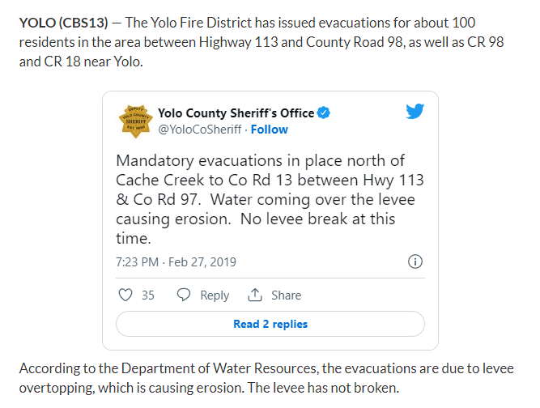
Figure 19 Evacuation order from Yolo County Sheriff’s Office via Twitter during the 2019 Cache Creek Levee overtopping event
Because we don’t fully understand how quickly the warning was sent out relative to when Yolo County was notified of the emergency, the Moderately Prepared warning issuance delay curve was selected to allow for more uncertainty in the delay time. The most likely sampled warning issuance delay time is 16 minutes (about 21% likelihood), but there is still probability that the delay is longer or shorter (e.g., there is a 12% likelihood that the delay is 50 minutes; there is a 15% likelihood the delay is 10 minutes.)

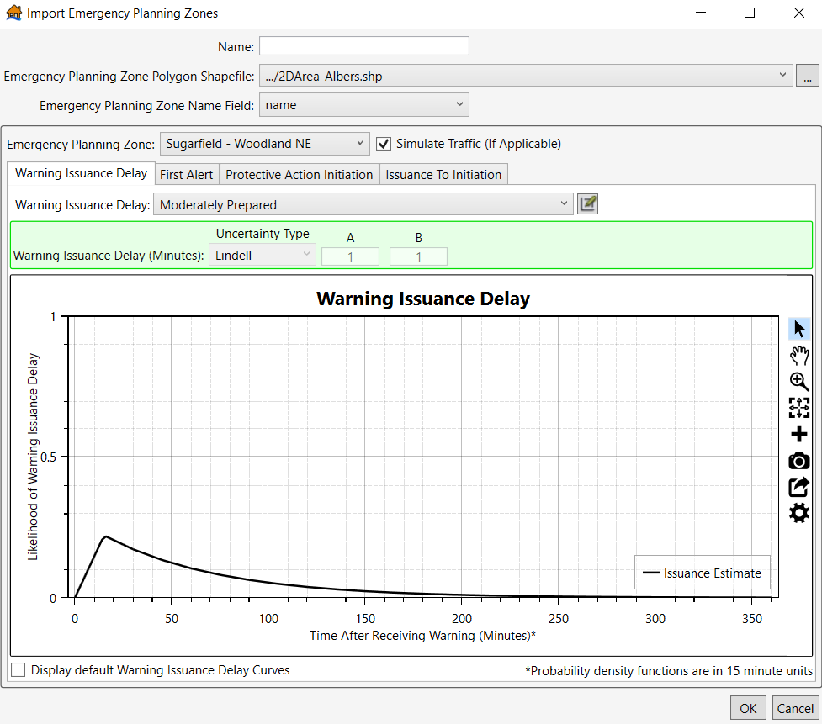
Figure 20 Moderately Prepared Warning Issuance Delay curve
Next, select First Alert Diffusion curves for the EPZ. This parameter is heavily influenced by the amount of communication channels the county would use during a levee safety emergency. As shown in the Using Emergency Management Agency Websites to Inform LifeSim Parameters section above, Yolo County has an opt-in alert system. The website also shows Yolo County uses Everbridge, which is a robust mass alert system. Everbridge distributes messages via phone calls, texts, and emails. Additionally, following the 2019 Cache Creek Levee overtopping, it’s likely that several people signed up for alert messages through AlertSense. It is known that Yolo County utilizes social media, radio, and news to distribute a warning message.
Given what we do know about the available communication channels, the warning message would likely be distributed to the relatively small leveed area quickly. However, since AlertSense (Everbridge) is an opt-in system, and it is unclear what percentage of the population protected by Cache Creek has signed up for this system, it is not recommended to assume the most optimistic First Alert curve. With our baseline understanding of Yolo County’s available warning channels, the Moderately Fast First Alert Diffusion curve was selected.
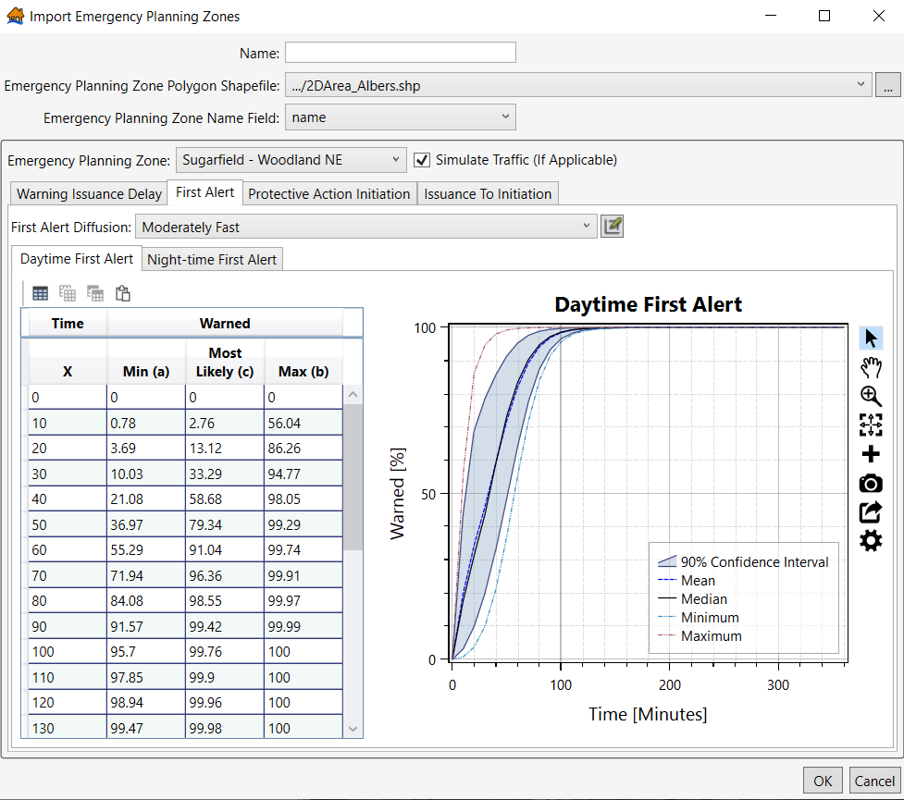
Figure 21 Moderately Fast Daytime First Alert Diffusion curve
Finally, select the PAI curve. Recent experiences (within the past decade) with flooding and/or evacuation are reason to assume more optimistic PAI curves; conversely, if the community doesn’t have a history of flooding, the selected PAI curves should be more pessimistic. The residents protected by Cache Creek Levee experienced flooding due to levee overtopping in 2019. As shown in the evacuation order posted by the Yolo County’s Sheriff Office on Twitter, approximately 100 people were asked to evacuate from the Cache Creek leveed area. However, because the effectiveness of the evacuation order is unknown, it is recommended to allow for more uncertainty in the PAI curve. The Perception: High / Preparedness: Low PAI curve was selected for Cache Creek Levee to both account for the area’s recent experience with flooding and witnessing the potential consequences (Perception: High) and uncertainty regarding the population’s readiness to mobilize (Preparedness: Low) since there is limited knowledge on preparedness.
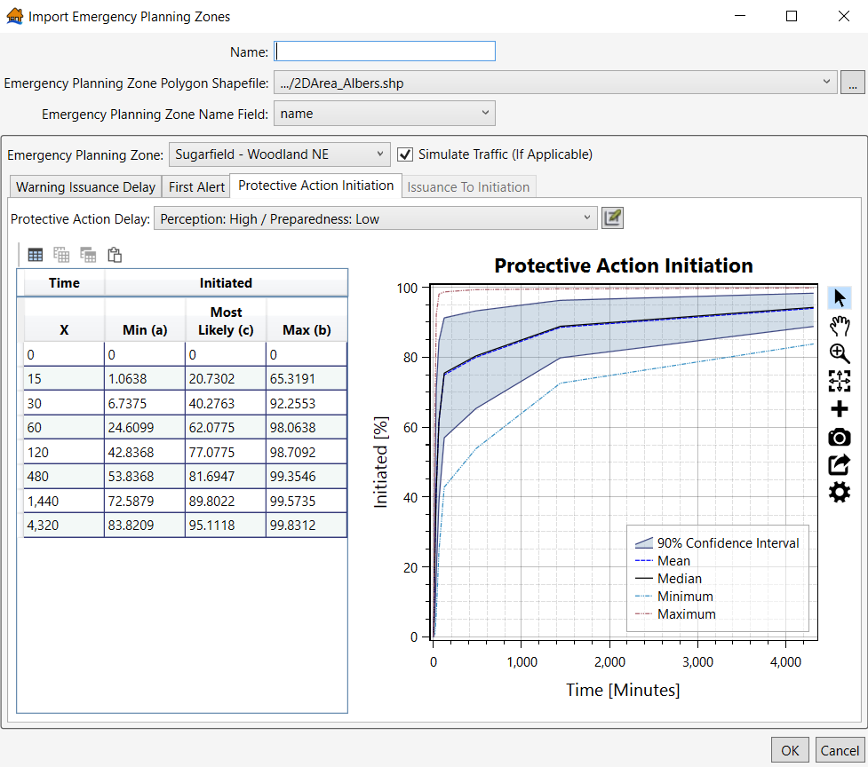
Figure 22 Perception: High / Preparedness: Low Protective Action Delay Curve
The user is encouraged to perform additional sensitivity tests on parameters that have significant knowledge uncertainty. In this example, there is limited information on the community’s preparedness during a flood emergency. Therefore, the user should run simulations with the Perception: High / Preparedness: Low PAI curve as well as the Perception: High / Preparedness: Moderate PAI curve to better understand the model’s sensitivity to the selected PAI curve. Then, the user may want to run the Perception: Unknown / Preparedness: Unknown curve as an additional sensitivity test. Regardless of your final model parameters, ensure there is ample justification for the selected warning evacuation parameters and that they accurately represent the impacted areas.
Ensure the warning and evacuation parameter assumptions are clearly documented.
After selecting your uncertainty parameters, enter a name for the EPZ, press OK, and the EPZ is imported into the LifeSim study.
  - Structure Inventory
    - Importing a Structure Inventory
To import a structure inventory from an existing point shapefile, navigate to the Study pane in your model, right click on Structure Inventories, and select Import from Point Shapefile.
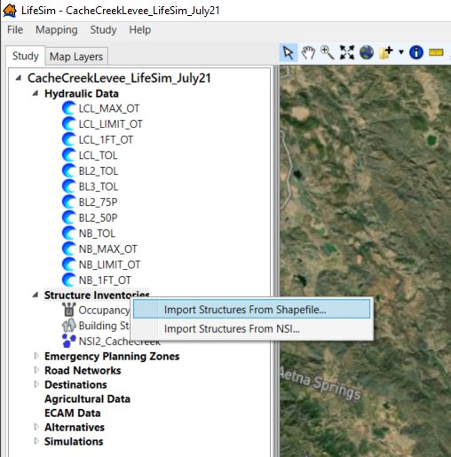
Figure 23 Importing Structures from Shapefile from the Study Pane
Then, either select the Structure Inventory Shapefile from the dropdown, which is available if the shapefile is in the Map Layers pane of the LifeSim model, or map to the shapefile by clicking on the button with the three dots next to the dropdown. Notably, there are several required attributes in order for LifeSim to properly calculate economic damages and life loss. The list of required attributes from the Import from Point Shapefile window is shown below.
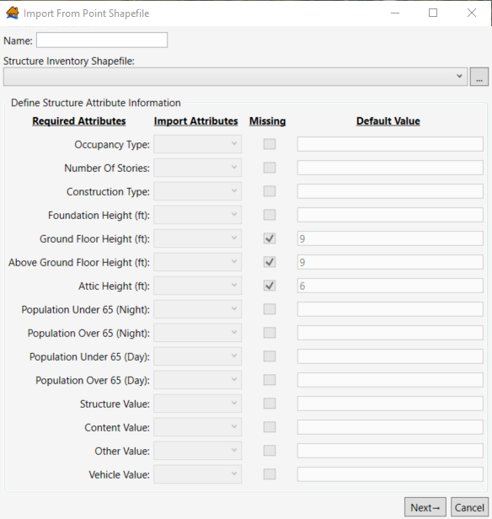
Figure 24 Import from Point Shapefile window
Once you match up your shapefile’s attributes (Import Attributes) with the corresponding LifeSim Required Attributes (an example of matched up attributes using the NSI is shown in the figure below), click Next at the bottom right. If the shapefile is missing certain attributes (e.g., Other Value in the figure below), you can check the “Missing” checkbox and enter a default value. This value will be the same for each structure in the inventory.
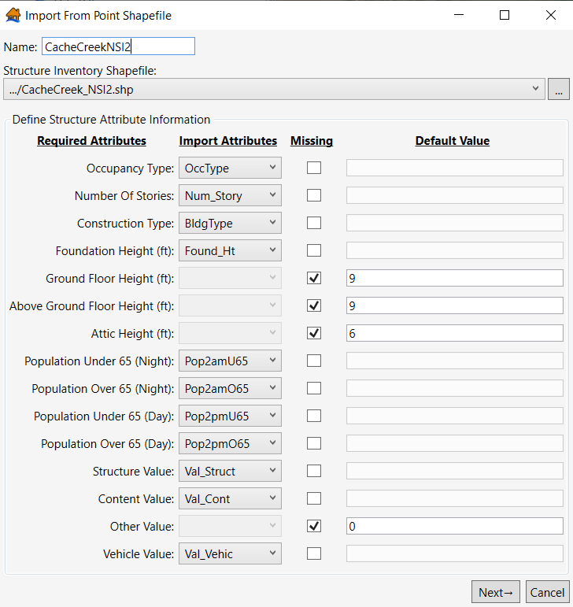
Figure 25 Importing National Structure Inventory 2.0 into LifeSim – Defining structure attributes
Then, match the occupancy types in LifeSim with the occupancy types included in your structure inventory shapefile. If using the NSI, typically the occupancy types exactly match the occupancy type names in LifeSim, but the user should scan through the list to ensure everything is matched up correctly. If these are mismatched, the depth-damage functions, evacuation parameters, and submergence criteria will not be correct for that structure type, which impacts the accuracy of your economic damages and life loss results.
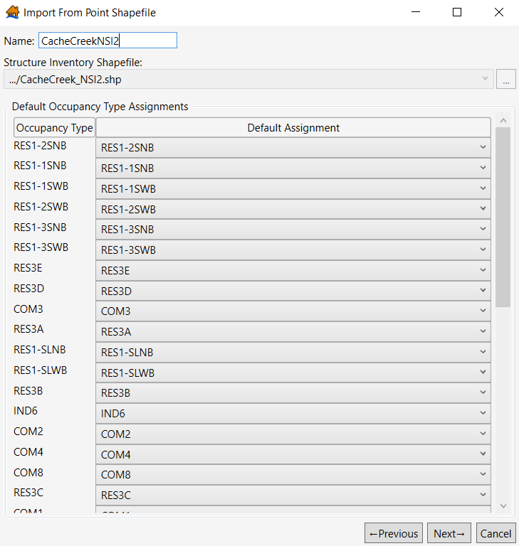
Figure 26 Importing National Structure Inventory 2.0 – assigning occupancy types
After the occupancy types are assigned and reviewed, click Next. The final step for importing the inventory is the Stability Criteria Assignment. LifeSim has default stability criteria assignments for wood unanchored structures (e.g., mobile homes), wood anchored structures, masonry structures, and steel structures. For NSI users, you should use the default stability criteria shown below.
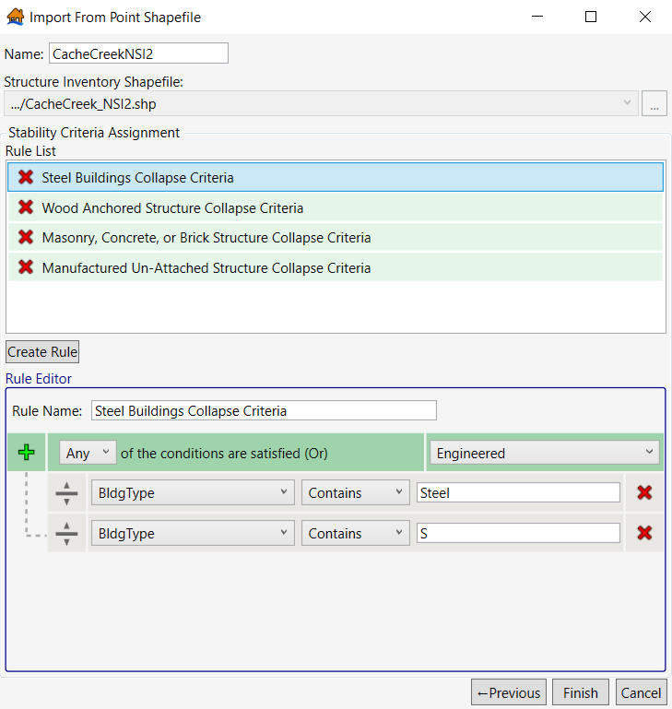
Figure 27 Importing National Structure Inventory 2.0 – assigning stability criteria
You can create additional criteria rules by clicking Create Rule. A new rule appears in the Rule List; enter a Rule Name and set the logic for the new stability criteria. For example, if you want to adjust the criteria for Wood 2-story structures to use the USACE – Wood 2-story stability criteria, select the following information:
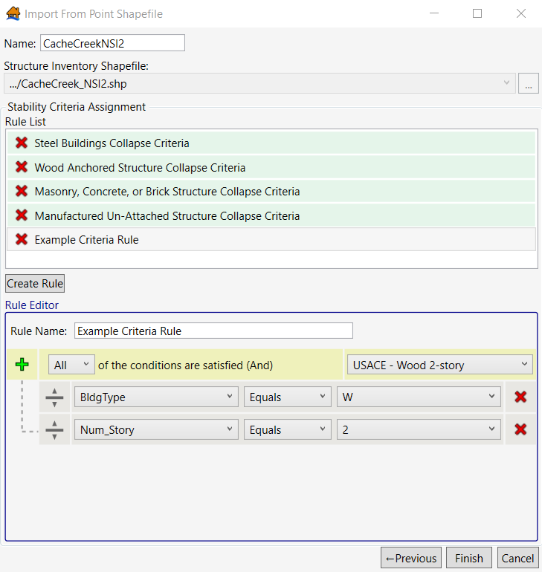
Figure 28 Example of creating a new stability criteria rule
Once all structures have been assigned a stability criterion, click Finish. The structure inventory is then imported into LifeSim.
    - Editing the Structure Inventory
After importing a structure inventory into LifeSim, edits to the attribute table and/or structure placement are likely needed. To edit the imported structure inventory, right click on the study’s structure inventory and click Show in Map Window.
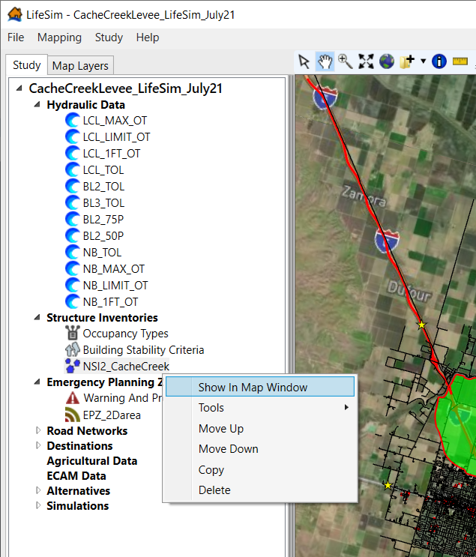
Figure 29 How to show a study’s structure inventory in the Map Layers pane
Navigate to the Map Layers pane. Right click on the structure inventory (NSI2_CacheCreek below) and select Edit. You can now edit the placement of structure points in the map window and edit structure attributes in the attribute table.
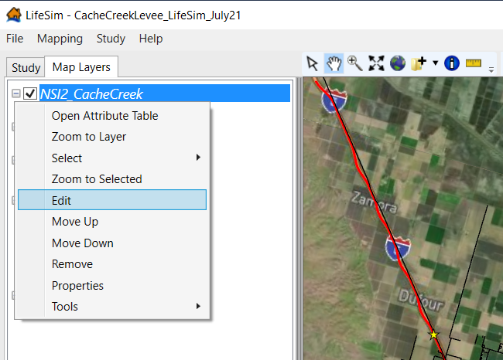
Figure 30 How to edit an existing structure inventory via the Map Layers pane
Once you are done editing the structure inventory, right click on the structure inventory in the Map Layers pane (NSI2_CacheCreek in the figure below) and select Stop Editing.
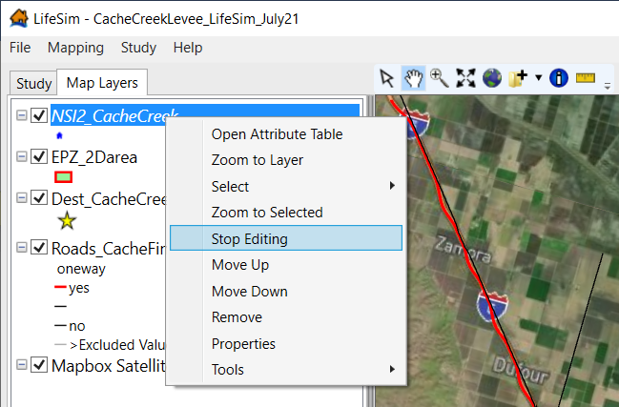
Figure 31 How to stop editing a layer in LifeSim
A pop-up window then asks if you want to save your changes to the study’s structure inventory file. Select Yes and the changes are reflected in the structure inventory both in the Study pane and Map Layers pane.
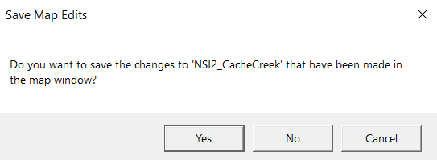
Figure 32 Save Map Edits dialog box
  - Simulating Evacuation
For most levee/floodwall projects, evacuation is simulated in LifeSim. In addition to the hydraulic data, EPZs, and structure inventory, you need to import (1) a road network and (2) destination points to simulate evacuation in LifeSim. The recommended workflow is to begin with importing a road network and then create destination points.
    - Road Network
There are two ways to import a road network: (1) download and import a road network from OpenStreetMap (OSM) within LifeSim and (2) import a polyline shapefile. Unless you have detailed data from a previous study or from local stakeholders, you will download and import a road network from OpenStreetMap.
      - Downloading a Road Network in LifeSim
To download and import a road network, navigate to the Study Pane, right click on Road Networks, and select Import Road Network From OpenStreetMap.
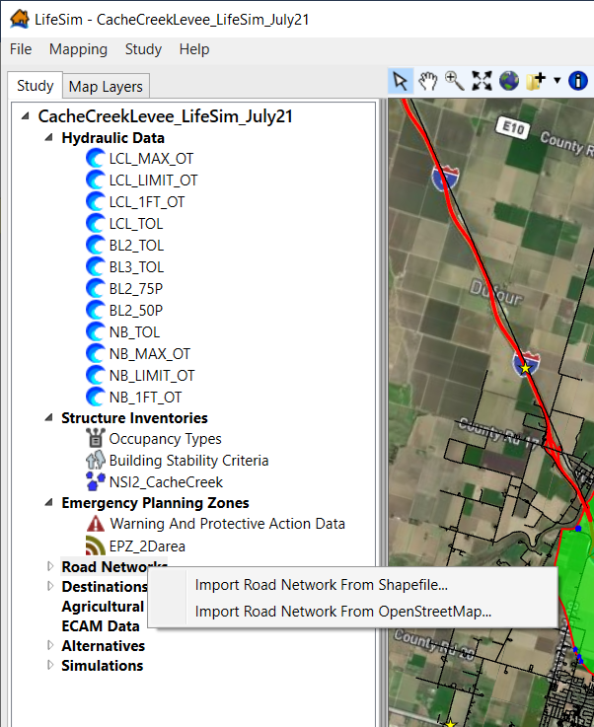
Figure 33 Import a Road Network from Study pane
The Import Road Network From OpenStreetMap window opens. The primary data needed to import a road network is a bounding polygon shapefile. The bounding polygon determines what roads are downloaded from OpenStreetMap. The easiest bounding polygon to use for import is the shapefile used for the EPZ; additionally, the bounding polygon needs to be in the same projection as the LifeSim study Once you select the polygon, type in a bounding polygon buffer (the value represents miles).
As shown below, the Cache Creek EPZ shapefile is being used for import. The Bounding Polygon Buffer is set to 1 mile. The additional mile of road network allows for more realistic traffic congestion in the simulation and increases the accuracy of potential evacuation routes. There should be some amount of buffer included on the bounding polygon for import, unless the selected shapefile is already buffered or larger than the leveed area. Selecting an appropriate buffer size depends on the size of the study area, inundation extents, the density of the population, and known evacuation routes. Do not make the buffer too large as this imports many additional road segments that (1) may not improve the evacuation accuracy and (2) can significantly increase simulation run times as depths and velocities on each road segment are calculated (i.e., more road segments lead to longer simulation times).
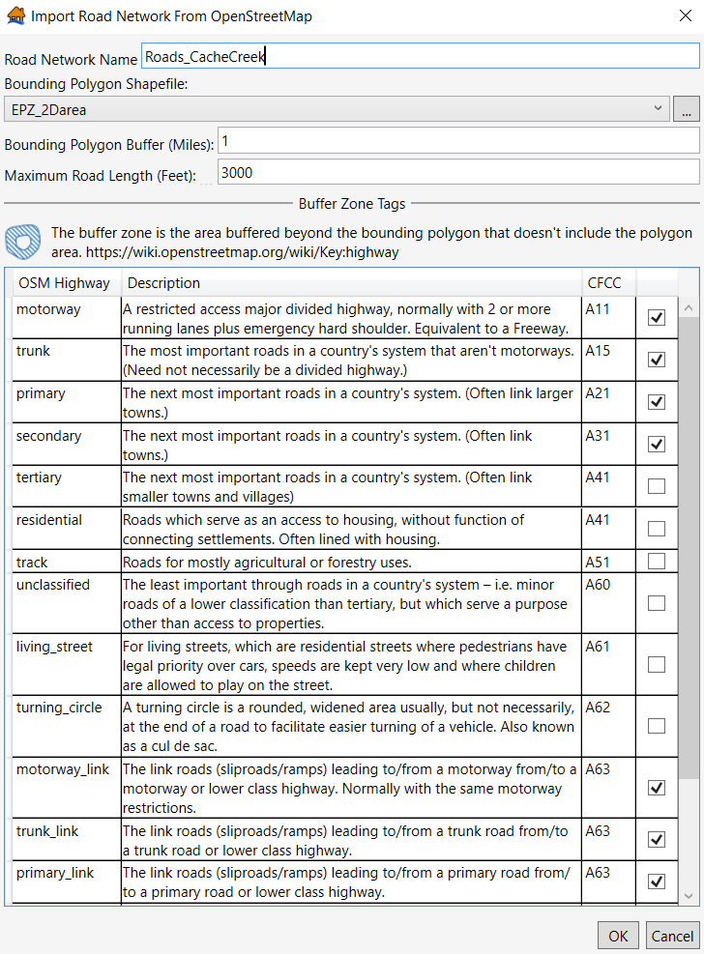
Figure 34 Import Road Network from OpenStreetMap – Selecting Census Feature Class Codes (CFCC)
As shown above, there are several types of road segments included in OpenStreetMap road networks. LifeSim has certain road types automatically selected and deselected for import. However, depending on the study area, you may need to include additional road segment types. For example, if the study area is primarily rural or farmland, you would want to select tertiary (“The next most important roads in a country’s system”), residential (“Roads which serve as an access to housing without function connecting settlements. Often lined with housing”), and track (“Roads for mostly agricultural or forestry uses”) for import. For larger or primarily urban study areas, it is recommended to import only the default, or baseline road types to reduce simulation run times. Once you have selected or deselected the road segment types that should be included in your road network, select OK, and the road network downloads and imports into the study.
      - Import Road Network from Shapefile
The other method of importing a road network is to use an existing polyline shapefile. Navigate to the study pane, right click on Road Networks, and select Import Road Network from Shapefile.
Figure 35 Import a Road Network from Study pane
The Import Road Network window opens. Map to the Road Network Shapefile by either using the dropdown (only polyline shapefiles that are in the map window are shown) or by clicking the button with the three dots next to the dropdown. Then, match the CFCC Name Field to the corresponding attribute from the polyline shapefile, which should be an already existing attribute if you are importing a road network from a previous study. Then, match the One-Way Field (with an identifier) and the Vertical Offset attribute. These fields are optional but increase the accuracy of the road network. Once you match up the field(s) with your shapefile’s attribute(s), select OK and the road network imports.
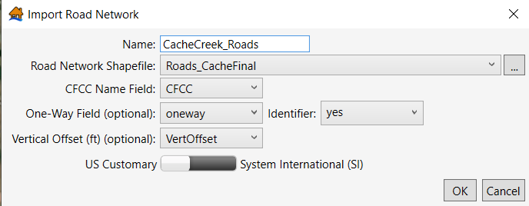
Figure 36 Import Road Network from Existing Shapefile window
      - Editing a Road Network
After importing a road network into LifeSim, edits to the polygon and/or the road network’s attributes are likely needed. OSM provides a base for an accurate road network. However, there are aspects to the data that may need to be edited and confirmed. One of the key components of a road network is the “Vertical Offset” field, which is found in the road network attribute table. This field accounts for if a road segment should have some amount of vertical offset relative to the terrain elevation, such as a bridge or highway overpass. The default vertical offset for all road segments in OSM is 0. Vertical offsets should be confirmed and edited throughout the study area. Focus on areas you can visibly see road segments over waterways (i.e., bridges) and areas where highways are most concentrated (there may be overpasses). To view the attribute table and the Vertical Offset field, right click on the imported road network from the Study pane and select Show in Map Window. Navigate to the Map Layers pane, right click on the road network, and select Open Attribute Table.
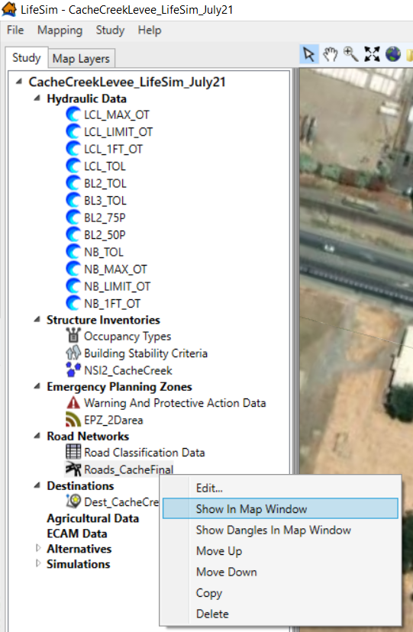
Figure 37 Showing a road network in the map window
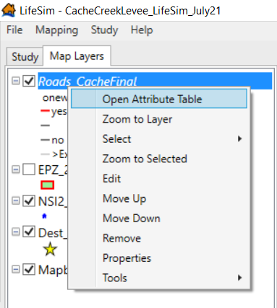
Figure 38 Opening a road network’s attribute table
For Cache Creek Levee, there are several highway overpasses in the study’s road network. Many of these overpasses lead to destination points and need to have accurate vertical offsets. The highlighted road segments shown below are parts of highways located over a different highway. A vertical offset of 40 feet was given to both segments. Without accounting for the 40 feet of vertical offset within the attribute table, LifeSim may wrongly show this overpass as inundated. This could negatively and incorrectly impact evacuation to the south, potentially affecting estimated direct life loss. Use best available data to determine accurate vertical offsets (e.g., Google Street View).
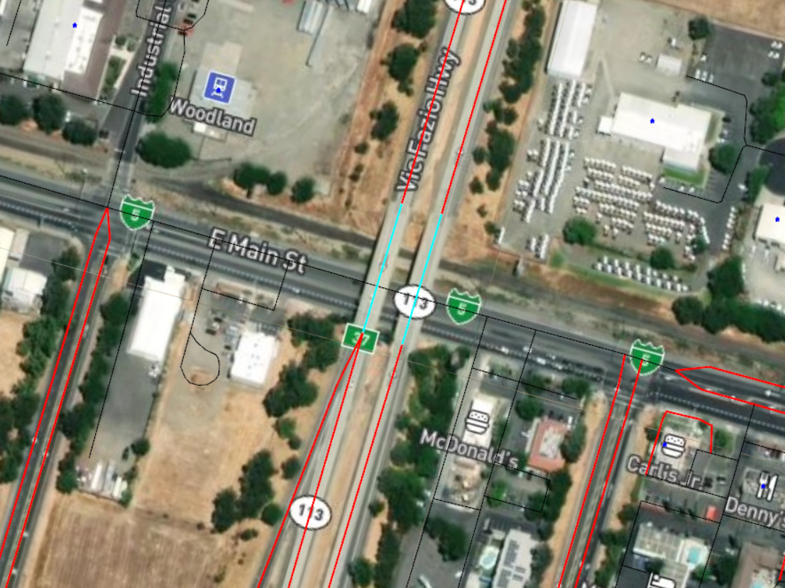
Figure 39 Cache Creek Levee road network – highway overpasses on Route 113
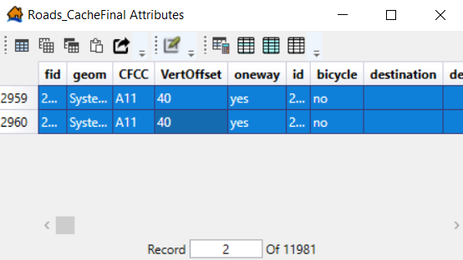
Figure 40 Updating vertical offsets in the Cache Creek Levee road network
It is recommended to save the road network edits as you progress. For example, save the road network and the LifeSim study after making a few road network edits, then make additional edits to the road network and save again. Several edits to one shapefile can overload LifeSim’s memory and may crash the program prior to saving your edits.
    - Destination Points
The other key element for simulating evacuation is destination points, which represent where the evacuating population should/will go to reach safety. To import destinations, a point shapefile is needed. You can create the required point shapefile in LifeSim or in another geospatial software (e.g., ArcGIS Pro or QGIS).
      - Creating a Point Shapefile in LifeSim
Locate the toolbar at the top of the map window. Click on the down arrow next to the folder with a plus sign (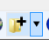) and select Create New.
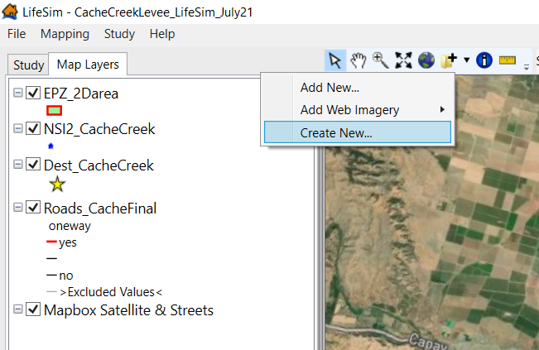
Figure 41 Create new vector features file in LifeSim
The Create New Vector Features File window opens. Click on the button with three dots to select the file output location.
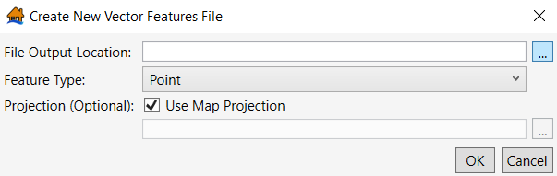
Figure 42 Create New Vector Features File window
A new window opens that allows you to map to your desired file location. Name the shapefile and click Save.
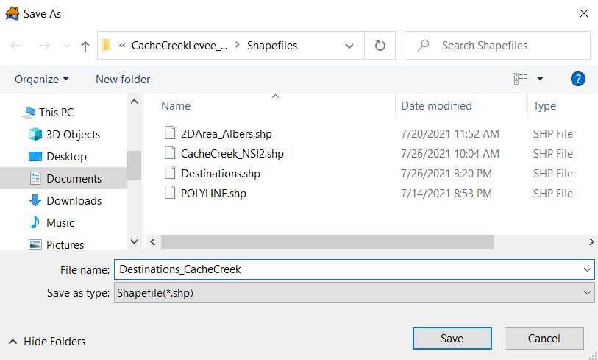
Figure 43 Saving new vector features file
Select the appropriate Feature Type from the dropdown (Point for a Destinations file) and either use the map projection (recommended) or map to another project file. Press OK and your new point shapefile is added to the map window.
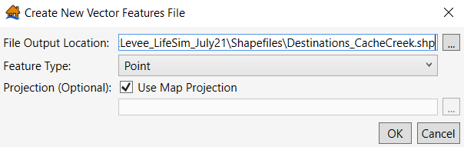
Figure 44 Example of new vector file
To add features within the point shapefile, navigate to the map pane, right click on the point shapefile you created, and select Edit. Navigate to the toolbar at the top of the map window and click the Add New Features button. This now allows you to create new points, which represent evacuation destinations.
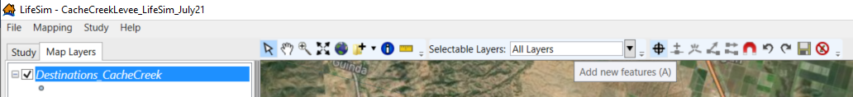
Figure 45 Newly created destinations point shapefile in the Map Layers pane
It is best to place destination points directly on road segments, so it is recommended to also have your road network in the map window. If the point is not placed directly on a road segment, the closest road segment is assumed to be the destination point. When creating destination points, most of the points should be on major highways and roadways. The destination points should generally not be shelters or large buildings because there is no way to set a limit on how many people can evacuate to each destination point. This would lead to inaccuracies in your evacuation simulation.
In general, attempt to place each of the destination points an equal distance away from the study area. If one destination is significantly closer to the study area, LifeSim will direct most of the population to this destination point since it is the closest distance and most likely the quickest evacuation route. The group evacuating selects which destination point to evacuate based on the shortest travel time (i.e., accounting for traffic congestion), not the shortest travel distance. Depending on the study area and available information, you may want to place some destination points closer or farther away from the study area (e.g., If you want more people to evacuate east rather than north, place the destination points to the east closer to the study area than the northern destination points).
For Cache Creek, the study area is most densely populated in the western portion of the leveed area. The flooding source is along the eastern portion of the leveed area, so the destination points located to the west are the preferred destination routes, therefore the northern and western destination points are closer to the population center compared to the destination points to the east of the leveed area.
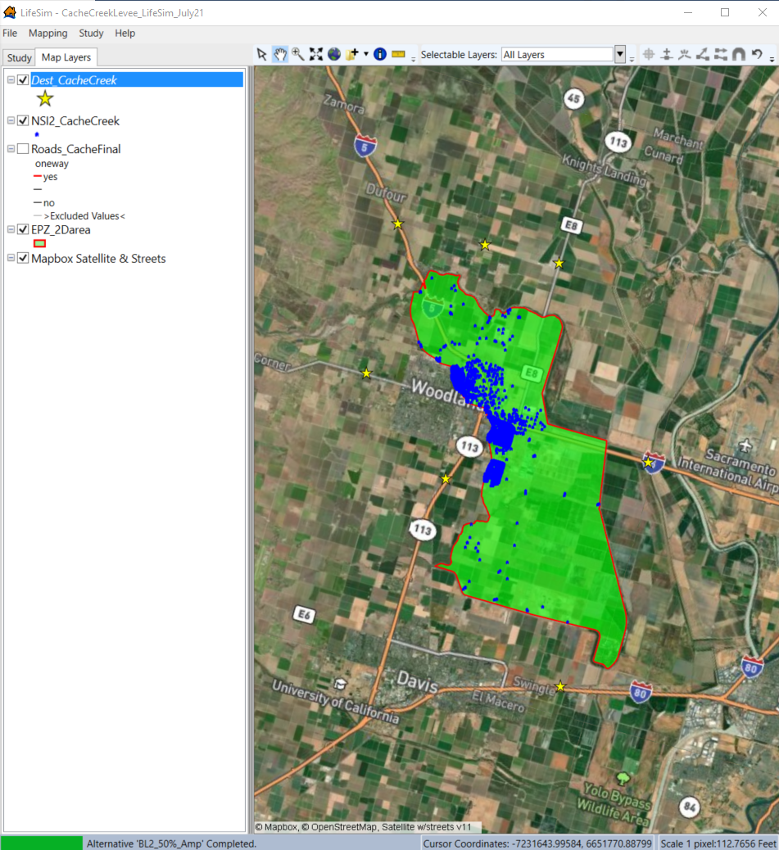
Figure 46 Destination point shapefile for Cache Creek Levee
Once you have placed all your initial destination points in the map window, edit the attribute table to give each feature unique attributes. As you place destinations, new rows are automatically created in the point shapefile’s attribute table. The figure below shows that as two new points are placed in the map window, two new rows are created. The attribute shown in the attribute table (“Id”) automatically populates as a blank attribute; each point needs a unique “Id” value.
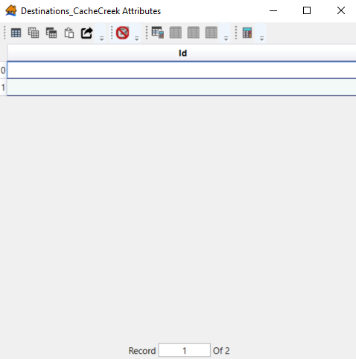
Figure 47 Destinations_CacheCreek Shapefile Attribute Table
To import a destinations file, at least one of the fields in the attribute table needs to have unique naming (Destinations Naming Identifier). The Id field could be used, but it’s recommended to create a new field in the shapefile’s attribute table. To create a new field, click Open Field Calculator.
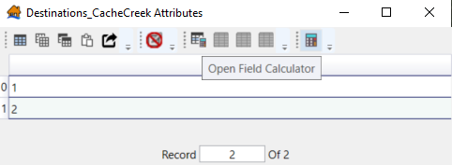
Figure 48 Open Field Calculator tool within shapefile attribute table
The Field Calculator window opens. Select Create New Column and type a field title (e.g., Name). Within the Expression box, type “=” with some text, which automatically sets the field type to be text rather than an integer (e.g., type “=RoadName”). Then press Execute.
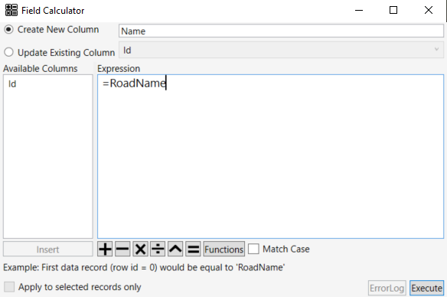
Figure 49 Field Calculator window – Creating a new field
The attribute table should now include a new field with placeholder text. You are now able to edit each attribute’s name.
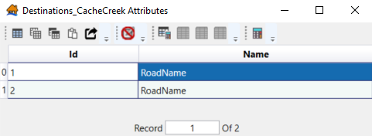
Figure 50 Attributes Table following field calculator edits
For clarity and ease of use, each destination point should be named based on the road it’s placed on.
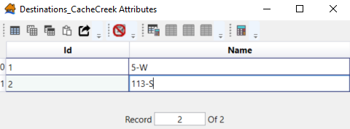
Figure 51 Attributes Table following entering unique names
Press the Stop Editing Feature Session button () and click Yes after the Save Map Edit dialog box pops up.
      - Importing and Editing Destinations File(s)
After creating a point shapefile that represents the study area’s destination points, you can import the shapefile into LifeSim as a destinations file. Navigate to the Study pane, right click on Destinations, click Import Destinations from Shapefile.
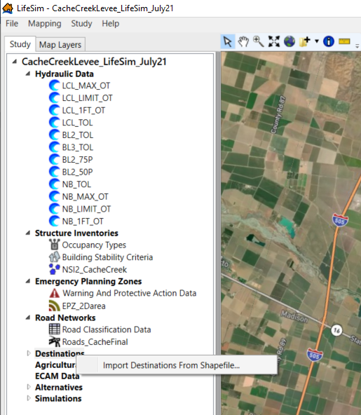
Figure 52 Importing Destinations from Shapefile
The Import Destinations from Point Shapefile window opens. Enter a name for the destinations file. Then, select the point shapefile you want to import. If the shapefile is in the Map Layers pane, it will be available via the dropdown. Otherwise, click on the three dots next to the dropdown to map to the destinations shapefile file location.
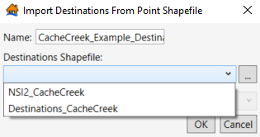
Figure 53 Import Destinations from Point Shapefile window
Then, select the Destination Identifier Field. For the destinations to import into LifeSim, each destination must have a unique name (i.e., the field cannot contain blank attributes and the selected field cannot contain duplicate names). Press OK and the destinations import into the study.
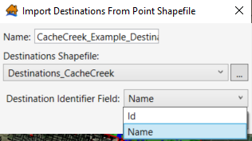
Figure 54 Import Destinations from Point Shapefile - Destination Identifier Field dropdown
Once the destinations file is imported, ensure you edit the study’s destination file, not the original shapefile created in the Map Layer pane. Like editing the study’s structure inventory, add the newly imported destination file to the map window, right click on the file (in the Map Layers pane), and select Edit. You can now add destinations, edit the destination placement, and edit the attribute table. After saving any edits, these changes are reflected in the study’s destinations file.
  - Creating Alternatives
Once you have all the input data imported in the LifeSim study, you can begin creating alternatives. To create an alternative, navigate to the Study pane, right click on Alternatives, and click Create New Alternative.
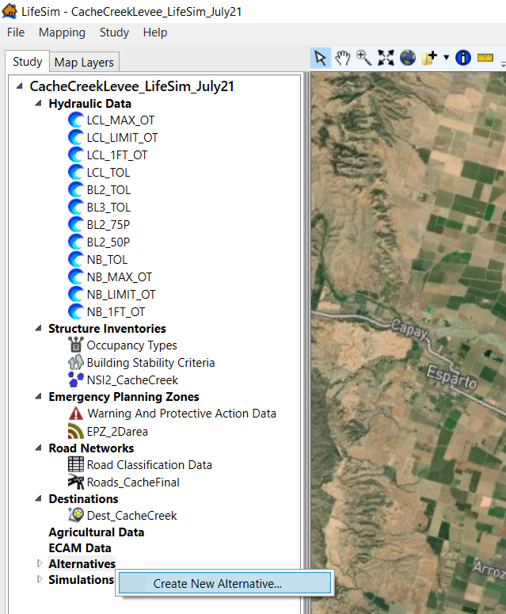
Figure 55 Create New Alternatives from Study pane
To create an alternative for a levee, include all input data required to calculate life loss and simulate evacuation. For most levee studies, this includes hydraulic data, a structure inventory, an EPZ, a road network, and destinations. Select the input data through the dropdown menus within the Create New Alternative window. In addition to the input data, other warning and evacuation parameters need to be entered for each alternative. Two other inputs required to create an alternative are the Imminent Hazard Identification Time and the Hazard Communication Delay. Input values (in hour units) for both parameters. If you have multiple EPZs, enter the information for these parameters for each EPZ.
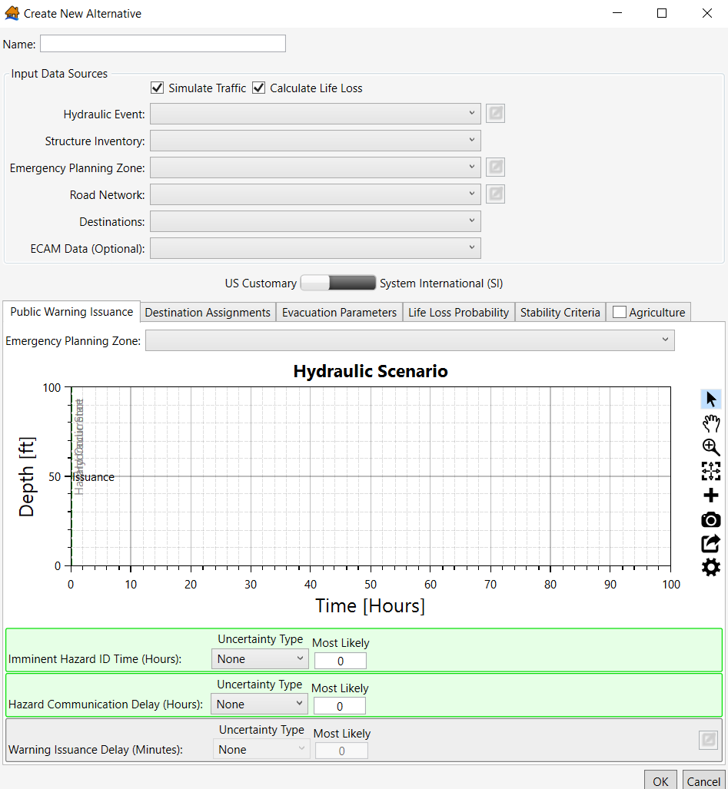
Figure 56 Create New Alternative window
The example alternative below (LCL_TOL_Min; i.e., a minimal warning scenario for a hazard occurrence at the Levee Control Location during a Top of Levee hydraulic loading) shows the selected data inputs required to simulate traffic and calculate life loss for the LCL TOL hydraulic scenario as well as the entries for the relative hazard identification time and hazard communication delay. The relative hazard identification time should be reflective of the community’s ability to monitor the project, how early the event could be forecasted in advance, and the type of failure mode. For example, if the emergency managers would have little time to identify a rapidly developing breach, the relative hazard identification time would be close to the time the hazard occurs. The example alternative (LCL_TOL_Min) is representative of a situation in which the breach occurs relatively quickly. You can create multiple alternatives for each hydraulic scenario with various warning times if there is uncertainty surrounding the relative hazard identification time. This provides a range of possible life loss outcomes.
Additionally, determining the hazard communication delay depends on how quickly the hazard would be communicated from the project personnel to local emergency managers. A smaller delay (or no delay) would occur if the local emergency managers were onsite with other project personnel while the situation develops. A longer delay would occur if the local emergency managers were unaware of the hazard, there are power and electricity outages, and there are no redundant technologies available to maintain communication with project personnel. The project’s emergency action plan provides insight regarding the potential hazard communication delay. The hazard communication delay in the example alternative represents a situation in which the project personnel are able to contact the local emergency managers relatively quickly, but there is still a slight delay.

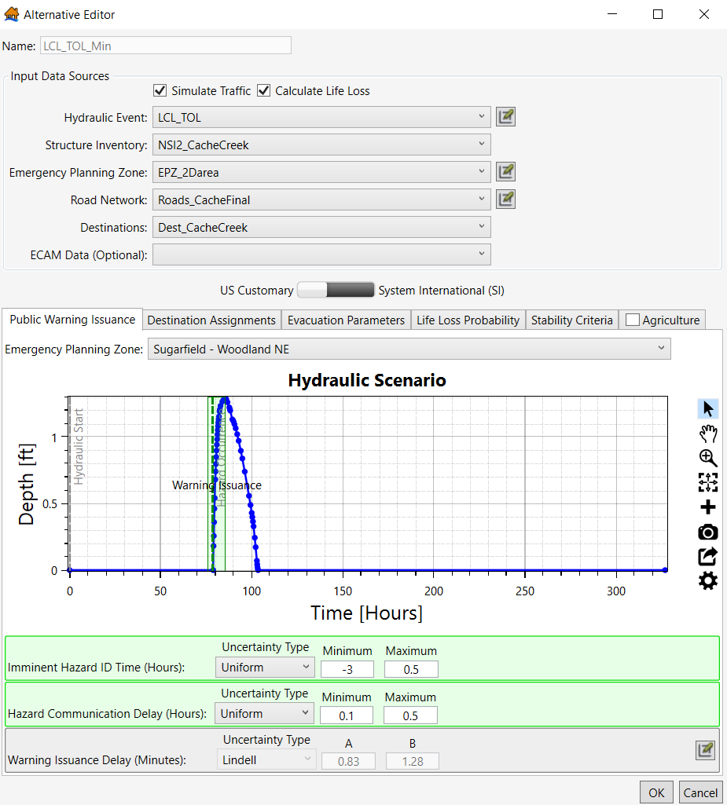
Figure 57 LCL_TOL_Min Alternative for Cache Creek
  - Creating Simulations
Once you have created alternatives, you need to simulate the alternatives to compute life loss and economic damages results. To create a simulation, navigate to the Study Pane, scroll to the bottom, right click on Simulations, and select Create New Simulation.
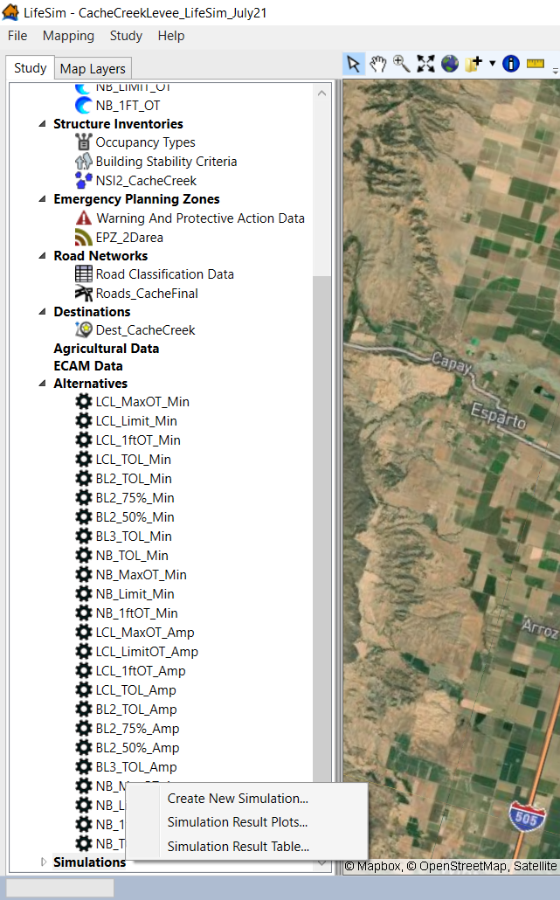
Figure 58 Creating a New Simulation
The Create New Simulation window will open. From this window, you can simulate at various hazard occurrence times of day to account for interpolating population estimates within structures. Additionally, you can specify the number of iterations, select summary polygons for result aggregation, and select which alternatives to run.
Below is an example of a simulation for breach location 2 (BL2) alternatives, including a daytime (2pm) and a nighttime (2am) hazard occurrence, that simulates each hazard occurrence time with 1,000 iterations. LifeSim simulates the alternatives assuming the hazard occurrence time is at 2am and then again assuming the hazard occurrence time is at 2pm. These times are generally selected because there is no interpolation of daytime and nighttime population at these times in the model. If other times are selected, LifeSim will interpolate between the daytime and nighttime population values included in the structure inventory.
In the example, only one summary polygon is included, which is the EPZ shapefile. You can include multiple summary polygons if you want to see results by county, city, census tract, arrival time, depth, etc. You can include any shapefile as a summary polygon, but the Summary Name Field must include a unique name for each attribute.
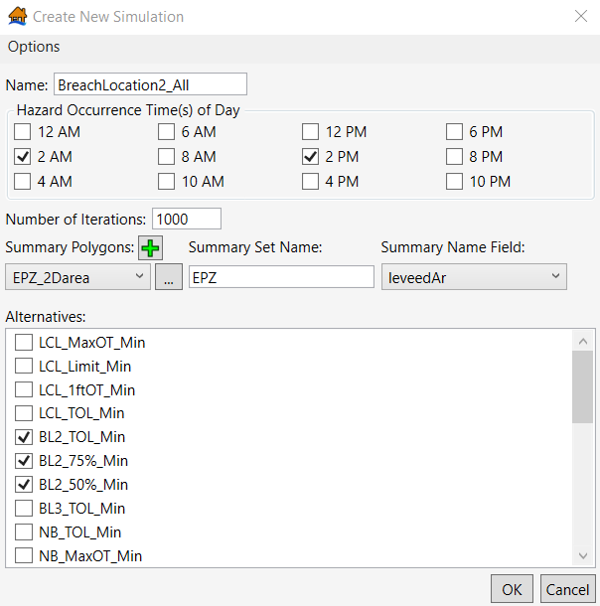
Figure 59 Creating Breach Location 2 simulation for day (2 PM) and night (2 AM) hazard occurrence times
Within the Create New Simulation window, there are an array of options that the user can customize for each simulation. Click on Options (located in the top left corner) and select Computation Engine Options.
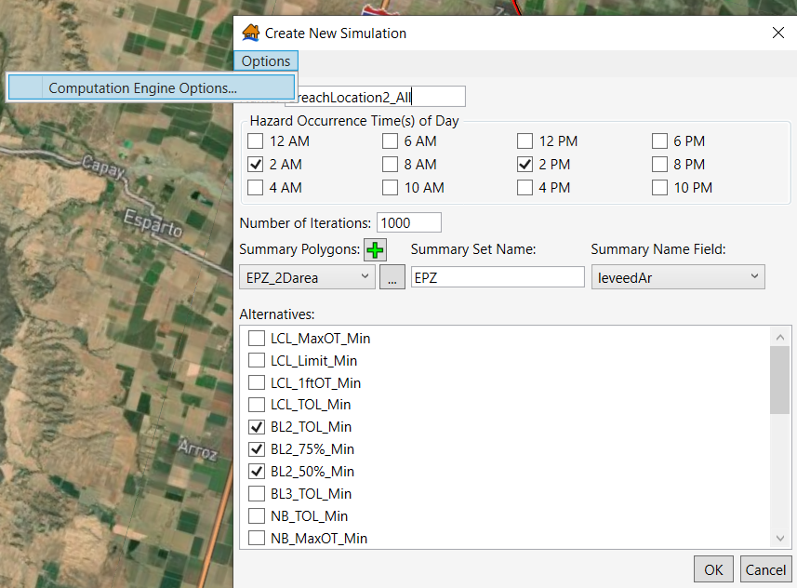
Figure 60 Locating Computation Engine Options in the Create New Simulation window
The Computation Engine Options window opens, and you can customize (1) the number of threads for the simulation (the higher the number of threads, the faster the simulation runs), (2) whether the simulation generates structure summary results, (3) whether the simulation generates road summary results, and (4) whether you want to enforce vehicular spillback. More information about the appropriate times to uncheck these boxes is discussed in the LifeSim 2.0 User Manual (See the Simulation – Computation Engine Options section).
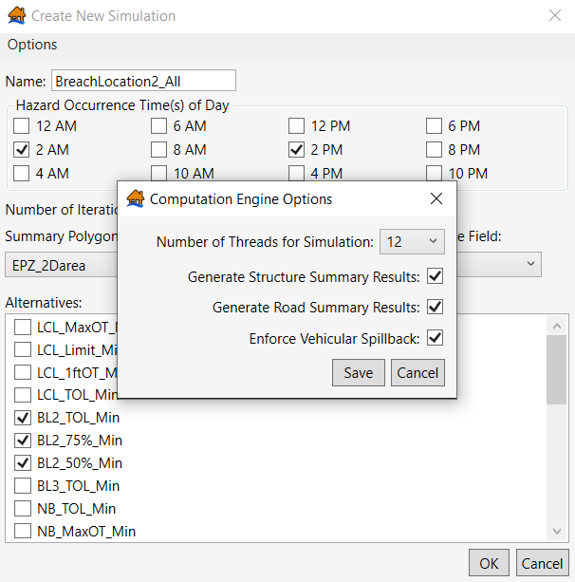
Figure 61 Editing Computation Engine Options
Click Save in the Computation Engine Options window after you make changes. Press OK in the Create New Simulation window after selecting the hazard occurrence times, entering the number of iterations, selecting a summary polygon, and checking the alternatives to be included in the simulation. The simulation you created is now located under Simulations in the study pane. Right click on the new simulation’s name and select Run Simulation.
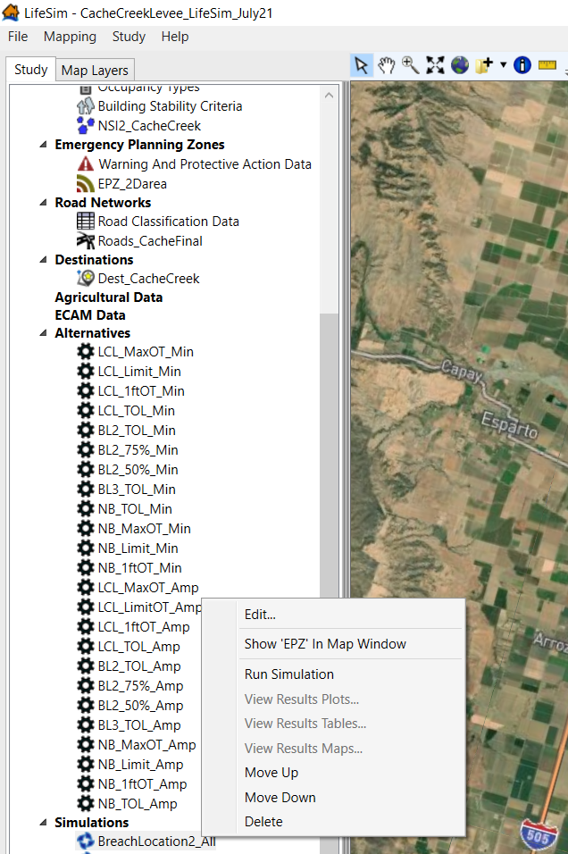
Figure 62 Running a simulation
  - Understanding and Interpreting Results
After running simulations, you can view your results by result plots, result tables, and result maps. Each way to view results is uniquely beneficial in (1) understanding your life loss and economic damage estimates and (2) quality checking your results. It is unlikely that your first simulation will be your last simulation—edits to the structure inventory, EPZs, road network and/or destination points may be needed to obtain accurate and representative results.
    - Result Plots
The first way to view results is by result plots. Right click on the already run simulation and select View Results Plots. The Simulation Results Plots window opens. The first tab of the window display is the Box and Whisker – Time of Day. The user can toggle which alternative results are displayed in the whisker plot and what data is shown in the plot (Plot Summary Data By dropdown in the bottom right corner). You can also view results across various summary polygons or summary zones.
This tab is helpful in seeing if the results fall within the expected order of life loss magnitude. As an example (from the figure below), the BL2 TOL breach scenario should result in more life loss than the BL2 75% breach due to the higher water surface elevation and because they use the same data inputs and warning time. If the BL2 75% breach resulted in more life loss than the BL2 TOL breach, the alternatives may include the wrong hydraulic scenarios, or the user would need to confer with the hydraulic engineer about the issue. Additionally, this tab helps the user understand if life loss is likely to be higher at various times of day (e.g., daytime versus nighttime life loss).
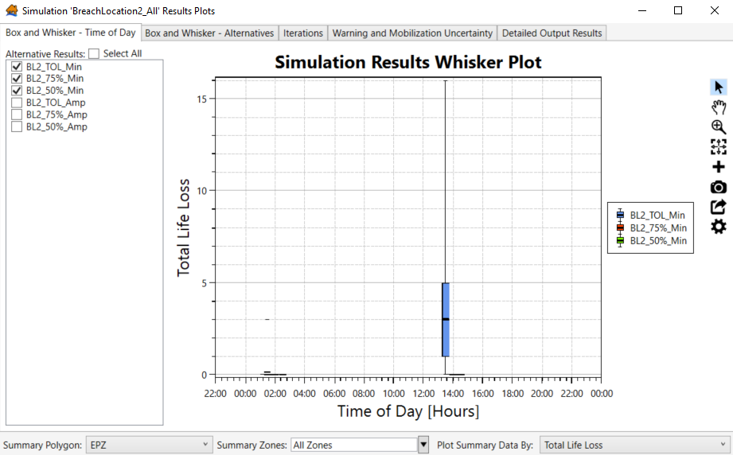
Figure 63 Simulation Results Plots: Box and Whisker – Time of Day
The next tab is the Box and Whisker – Alternatives. This tab is similar to the Box and Whisker – Time of Day plot in terms of the data displayed, but the data is displayed differently. The key difference between the two tabs is you can toggle which Time of Day results are displayed in the Box and Whisker – Alternatives tab. You can view just the 02:00 or 14:00 results. In the example below, only the 14:00 results are shown.
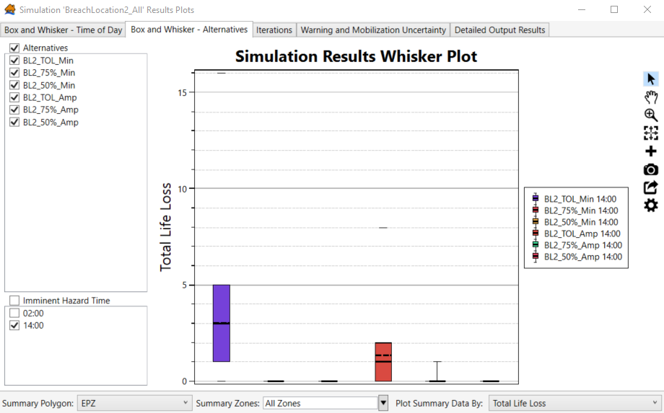
Figure 64 Simulation Results Plots: Box and Whisker – Alternatives
Another key result to analyze and review is the Life Loss on Roads, which is shown in the figure below. Overall, there is little estimated life loss on roads within the BL2 results. If the life loss on roads makes up most of the total life loss, the user should review the road network and destinations to ensure the simulated evacuations are logical, that there is not high life loss on particular road segments, and that all the road segments are connected properly. For example, ensure most of the life loss on roads is not incorrectly occurring on a single bridge that should have a vertical offset.,
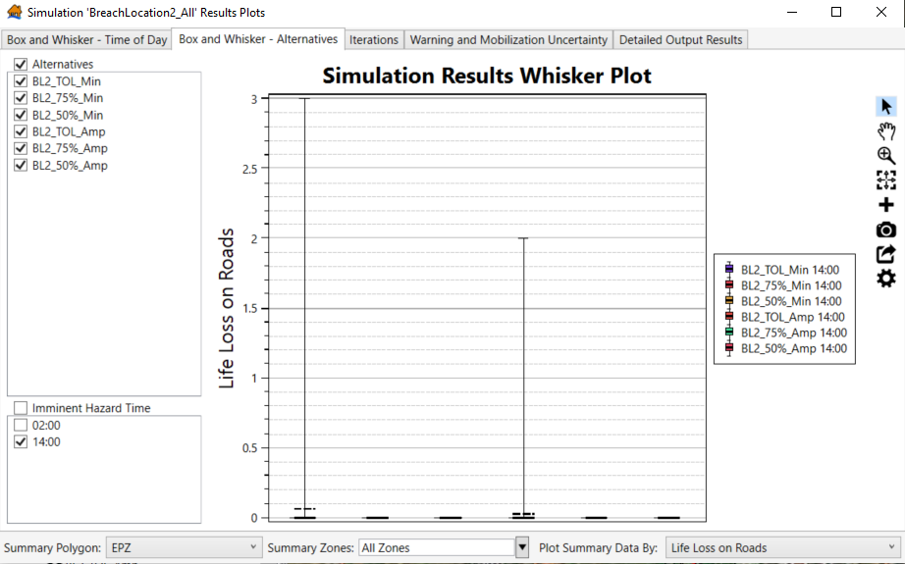
Figure 65 Simulation Results Plots: Box and Whisker – Time of Day Life Loss on Roads
      - Generating and Viewing Detailed Output in Results Plots
The best ways to identify whether there are issues with the evacuation data are to (1) animate the simulated evacuation and observe if there are traffic issues of any kind and (2) understand which destinations were utilized the most by evacuees and ensure the most used destinations make sense given the study area. To view both the evacuation animation and the cumulation destination arrivals, you’ll need to generate detailed output. To get this output, go to the Iterations tab from the Results Plot window, left click on the iteration that you want more detailed information for, such as animating evacuation, and click Generate Detailed Output in the bottom right corner.
As you can see in the example below, I selected an iteration that has the highest life loss on roads to better understand potential evacuation issues. If there are several iterations with high life loss on roads, it may be best to select an iteration that is representative of the average life loss on roads. Sometimes high life loss on roads in some iterations is solely due to a timing issue rather than a traffic issue; the highest life loss on roads results may occur when there is little warning and many people are on the road minutes prior of the floodwaters arriving.
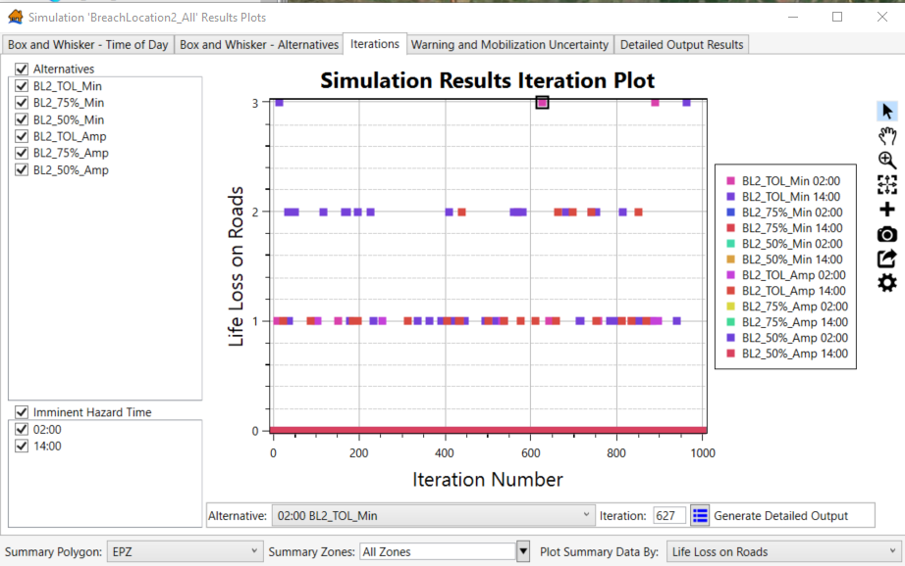
Figure 66 Simulation Results Plots: Iterations
Within the Results Plots window, go to the Detailed Output Results to see additional information specific to the iteration you generated detailed output for. Within this tab, there are three sub-tabs (Time Evacuating Histogram, Cumulative Evacuation Outflow, and Cumulative Destination Arrivals). Each iteration you create detailed output for is included as an option for viewing on the left side of the tab. The first sub-tab you can view is the Time Evacuating Histogram, which shows you how long it takes for people to evacuate safely to a destination point. This histogram can be very informative, especially if you think traffic would be an issue in your study area. For example, if the study area is very populated and everyone evacuates within 5 minutes, this may indicate that your destination points should be placed farther away from the EPZ to allow more realistic traffic conditions to occur in the model.
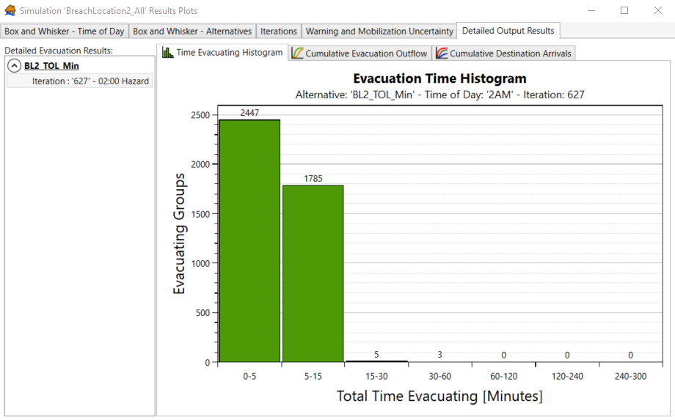
Figure 67 Simulation Results Plots: Detailed Output Results – Time Evacuating Histogram
The second sub-tab is the Cumulative Evacuation Outflow, which shows the relationship between the number of evacuees and the duration of the evacuation and compares the number of mobilized individuals to the number of people who reach safety. This provides additional information on how long it generally takes the Population at Risk (PAR) to initiate protective action and when the hazard begins to disrupt evacuation.
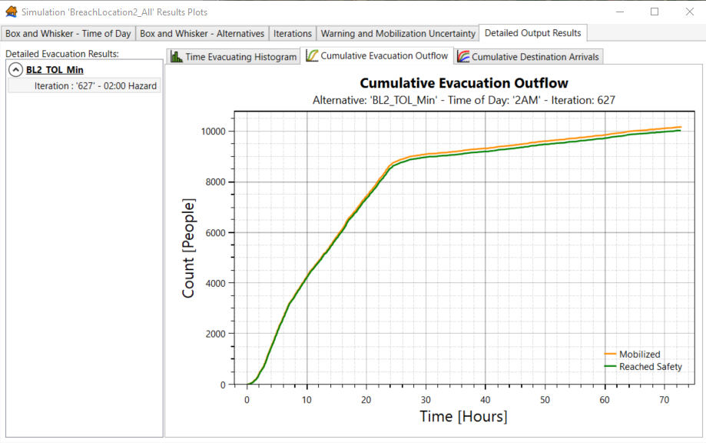
Figure 68 Simulation Results Plots: Detailed Output Results – Cumulative Evacuation Outflow
The third and final sub-tab is the Cumulative Destination Arrivals. This shows how many vehicles traveled to each destination point. This plot can be very useful when conducting a quality control review of the evacuation results and life loss on roads. As you can see in the example plot below, the 113-S destination point was overwhelmingly utilized compared to the other destination points. To understand if the destination arrivals are logical, you need to understand your study area. Depending on the project, the terrain of the area, the location of the hazard, and the availability of egress routes dictates if there are viable destination points in all directions. In many situations, only a couple of directions are likely to offer favorable destination points. For Cache Creek Levee, the inundation extents cut off egress routes to the north, east, and west. Therefore, most of the vehicles were expected to evacuate to the south, which is exactly what is shown in the plot.
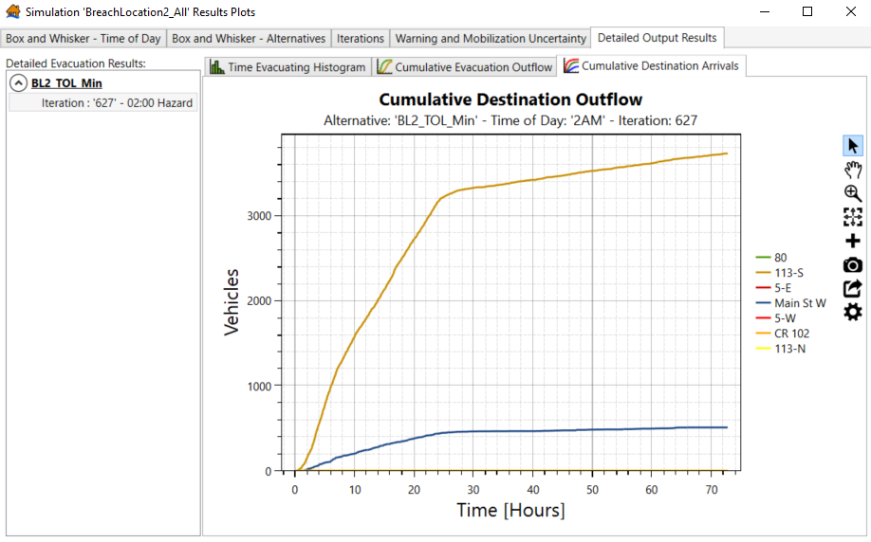
Figure 69 Simulation Results Plots: Detailed Output Results – Cumulative Destinations Arrivals
      - Animating Evacuation
The other key data available following generating detailed output is Evacuation Animation. To view the animation, right click on the already run simulation, select View Results Maps, and the Result Map Selector window opens. Scroll to the alternative that you generated detailed output for, check the box that includes “Evacuation Animation” in the title, and select the corresponding hydraulic scenario (02:00 BL2 TOL scenario in this example). Then click Send Selected To Map Window.
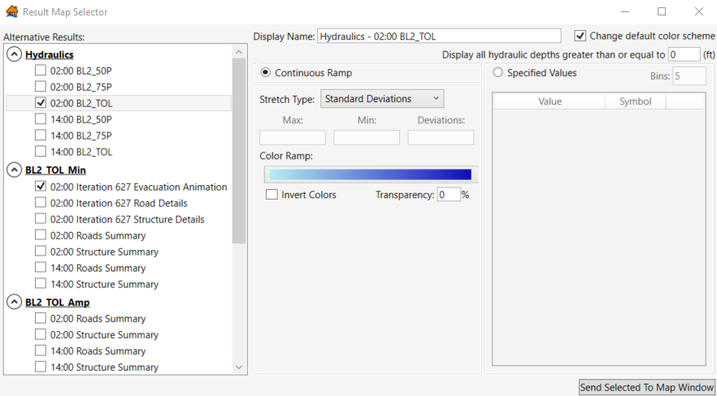
Figure 70 Results Map Selector: What to select to animate evacuation
You can then view the evacuation for this specific iteration. You can play and pause the animation by utilizing the button in the middle. You can make the animation speed up or slow down by using the Slower to Faster scroller bar; you can also manually speed up and slow down the animation by using the top scroller bar. The animation shows when structures are warned (yellow structures by default), when structures are inundated (red structures), when vehicles evacuate (blue cars), and when vehicles are caught (red cars). This is a useful tool for understanding if your road network and destinations are set up appropriately. When animating evacuation, you can zoom into specific areas to see if there is significant traffic or significant life loss on roads and confirm if the life loss results are valid or if there are potential issues with the road network. Examples of potential issues are disconnected road segments, road segments that may be too long and are showing vehicles as caught that are not actually inundated, and vertical offsets that have not been appropriately added.
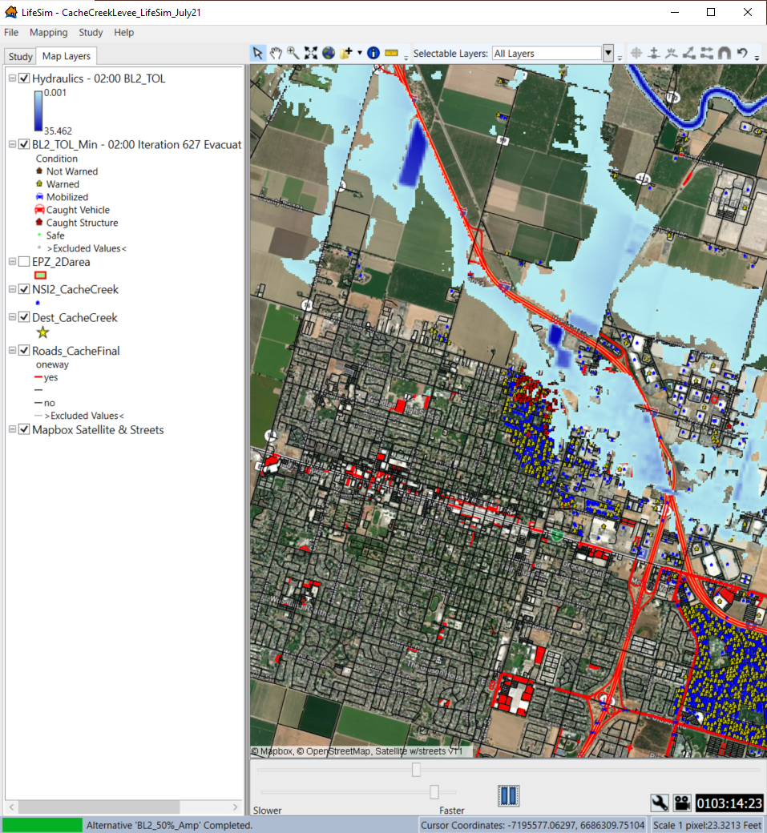
Figure 71 Animating evacuation
    - Result Maps
Another way to view if life loss on roads appears reasonable is to view various Roads Summary maps. These layers are accessible in the Result Maps Selector.
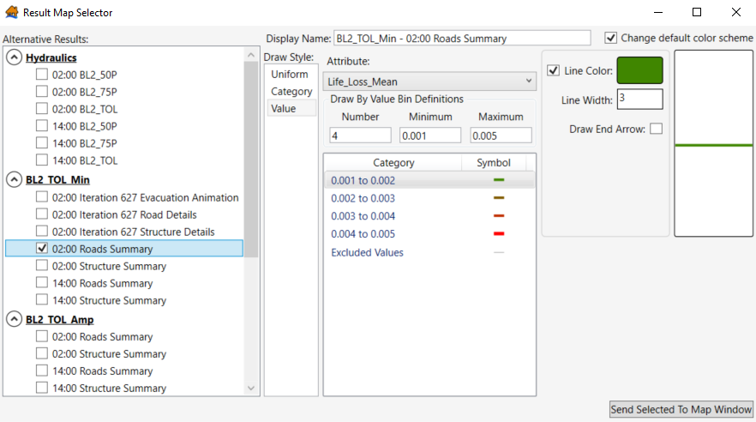
Figure 72 Simulation Results Maps – Sending Roads Summary maps to the Map window
Select the alternative results you want to add to the map window, adjust the value bins and corresponding symbols as needed (these can also be adjusted later in the Map Layer pane) and click Send Selected to Map Window. The Roads Summary polyline shapefile should now be in the Map Layers pane. You can see in the map window if there are roads with high average life loss. Additionally, it’s helpful to look through Roads Summary attribute table (right click on the shapefile; click Open Attribute Table).
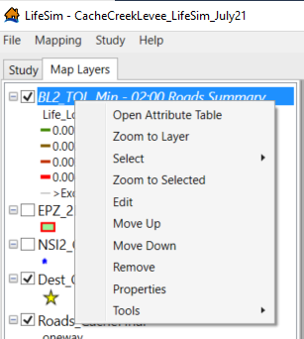
Figure 73 Opening the Roads Summary Attribute Table
Within the Roads Summary Attribute table, scroll to the right and find the field titled Life_Loss_Mean. Double click on this field name to sort from the lowest life loss to the highest life loss; double click on the field name again to sort from the highest life loss to the lowest life loss (you can also right click on the field’s header and select ascending or descending). As shown in the example below, life loss occurs on only five road segments for Cache Creek Levee. If the mean life loss for one of these segments was high relative to the total mean life loss, this would indicate that there may be a road network connectivity issue or an unwanted traffic build-up. You would then look at the evacuation animation again, focusing on those high life loss road segments to identify the potential issue.
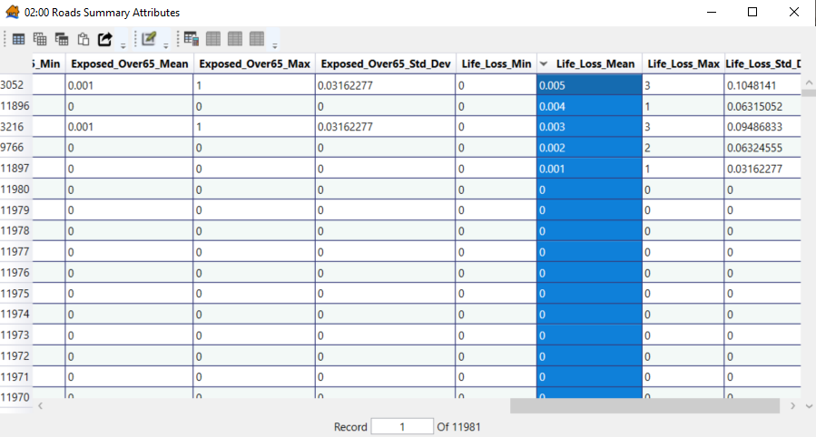
Figure 74 Roads Summary Attribute Table – sorting mean life loss in descending order
In addition to performing a quality check on the life loss on roads and evacuation data inputs, you should always review the life loss in structures results. Common issues or errors that can be caught when looking through the results is (1) a high amount of population within structures that should have a relatively small population (e.g., a RES1 structure containing a total population of 25), (2) the structure stability was not linked to the correct structure types (e.g., a RES2 structure having an engineered structure stability assignment), (3) a field was not linked properly when importing a structure inventory (e.g., absence of values assigned to vehicles, resulting in all values being populated as $0), or (4) structure points are not placed accurately.
An efficient way of reviewing the life loss in structures results is to look through various results maps. To add these layers to the map window, right click on the already run simulation, and select View Results Maps. The Result Map Selector window opens. Select the structure summaries from the scenarios you want to add to the Map Layers pane and click Send Selected to Map Window. To conduct a full quality check on the structures, add structure summaries for all times of day. If you only analyze the daytime Structure Summary (14:00), you could miss any errors occurring with the nighttime population (02:00).
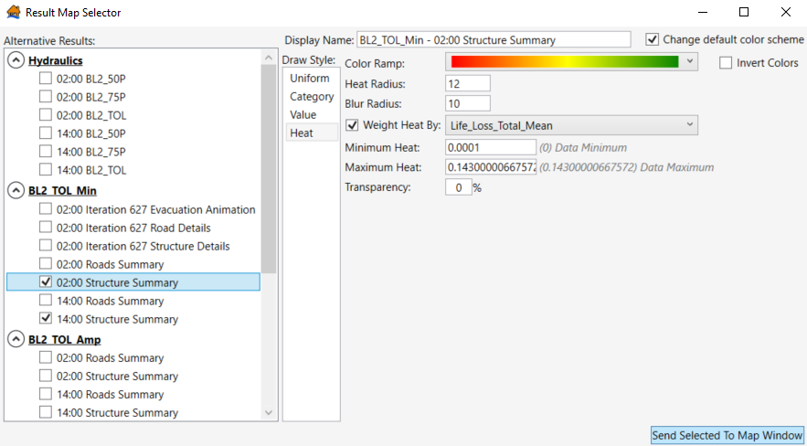
Figure 75 Simulation Results Maps – Sending Structure Summary maps to the Map window
Once the Structure Summary shapefile(s) have been added to the Map Layers pane, right click on the shapefile, and select Open Attribute Table.
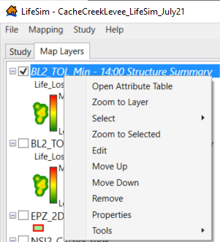
Figure 76 Opening the Structure Summary Attribute Table
Similar to viewing the Road Summary results, scroll to the Life_Loss_Total_Mean field. Double click on the field name to sort from the lowest to the highest life loss; double click on the field name again to sort from the highest to the lowest life loss. Then, confirm that the life loss results align with the structure type and that the structure point placement for the structures with relatively high average life loss is accurate.
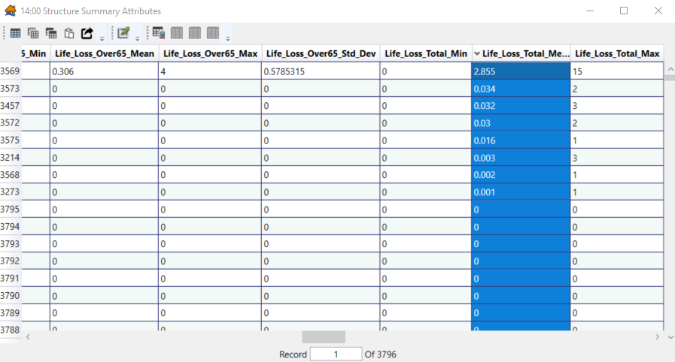
Figure 77 Structure Summary Attribute Table – sorting mean life loss in descending order
Begin confirming the placement of structure points by selecting the first structure while the life loss is sorted from highest to lowest. Right click on the row number (3569 in the example below) and select Zoom to Selected.
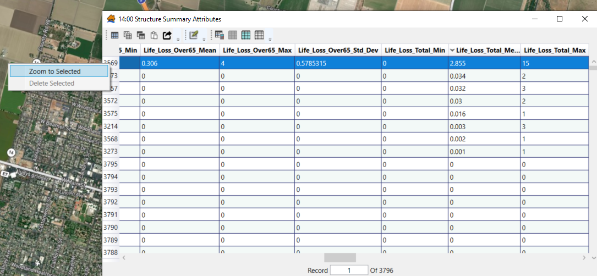
Figure 78 Zooming to the structure with highest mean life loss at 2 PM
LifeSim then zooms to the selected structure, and you can confirm the point placement of the structure with the highest life loss. For Cache Creek Levee, the highest life loss occurs in a commercial building as shown in the figure below. The structure placement is in the middle of the building footprint, which confirms that the life loss estimate for this structure is valid in terms of its location. This process should be repeated as often as necessary to confirm that the life loss estimates in structures are reasonable for the various hydraulic scenarios.
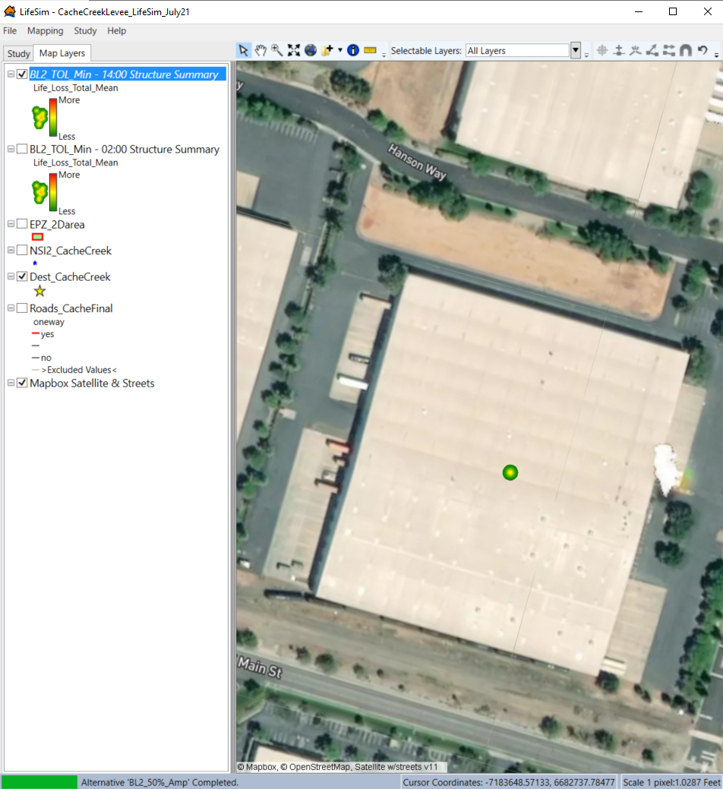
Figure 79 Zoomed in to the highest mean life loss structure
    - Result Tables
The final way to view results is by table. This is most helpful to clearly see results for various alternatives at once and is the easiest way to export results for report writing. To see the results table, right click on the already run simulation and select View Results Table. The Results Table window opens.
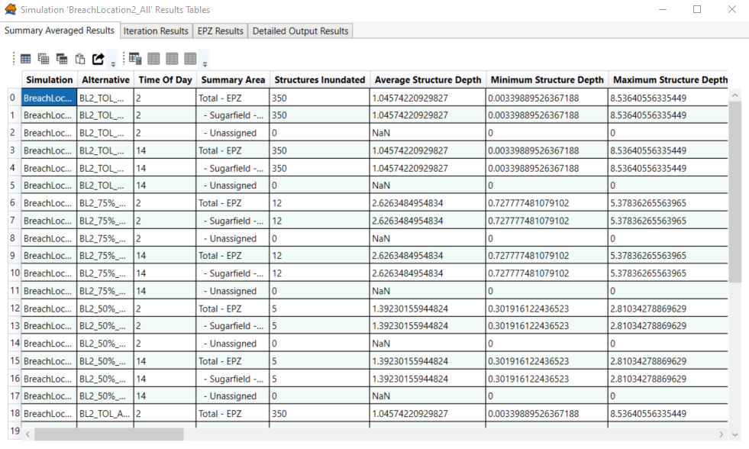
Figure 80 Simulation Results Tables – Summary Averaged Results
There are four tabs that each show results in a different way. The first tab shows average results for each alternative and each time of day that was included in the simulation. This table is most useful when reporting out PAR estimates, the number of structures inundated, average structure depth, average mobilization rates, and average life loss.
The Iteration Results table shows you the life loss and economic results for each specific iteration of each alternative and time of day. You can also generate detailed output from this tab by right clicking on the row you want to obtain detailed output for and clicking Generate Detailed Output.
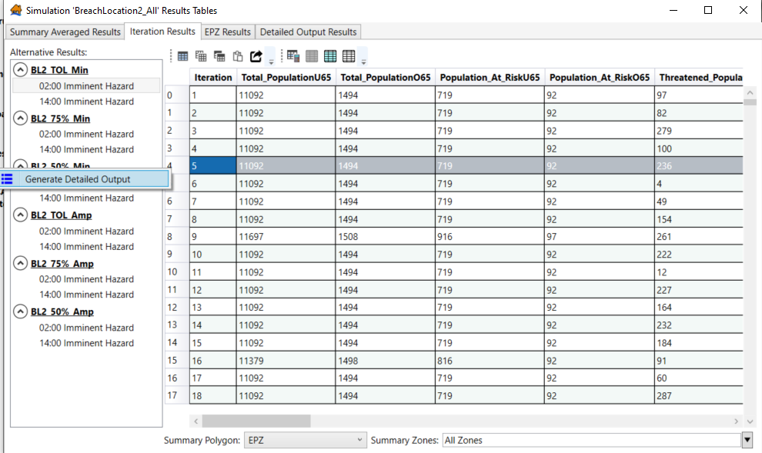
Figure 81 Simulation Results Tables – Iteration Results – Generate Detailed Output
The EPZ Results table shows iteration results as well but highlights the parameter sampling results (in hours) in addition to the total life loss results. As you scroll through this table, you can see the sampled relative warning issuance time, sampled hazard communication delay, sampled warning issuance delay, sampled warning curve, and sampled mobilization curve for each iteration. This provides insight into which parameters drive life loss.
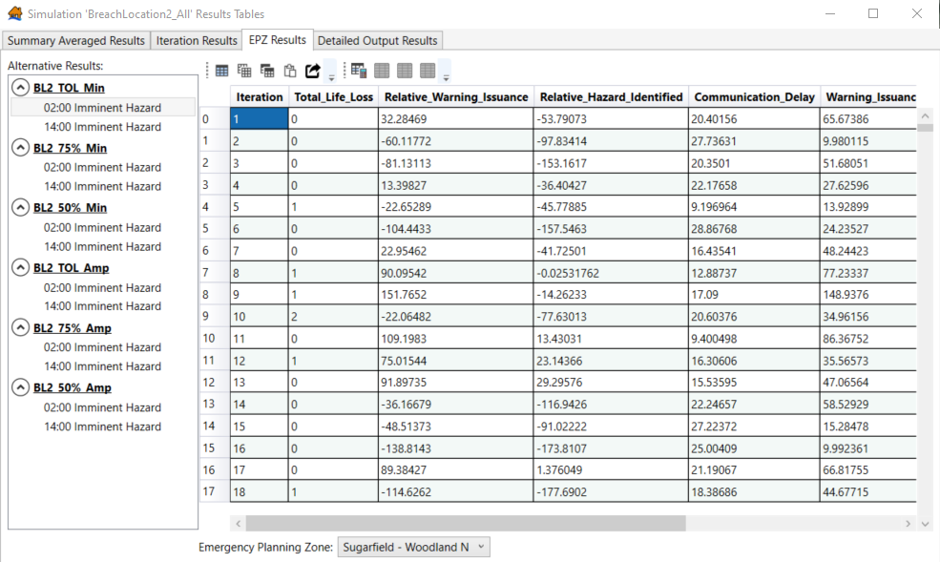
Figure 82 Simulation Results Tables – EPZ Results
Finally, the Detailed Output Results table shows detailed output results by evacuation group for specific iterations. This table details if a group received warning, if they mobilized, if they mobilized safely, how quickly they mobilized, which life loss probability zone (low hazard or high hazard) was used for sampling, what kind of vehicle was used during evacuation, and the various stability thresholds. This provides significant detail surrounding evacuation and the life loss probability zones, which allows the user to understand why life loss occurred (or why there is little life loss) for that specific iteration.
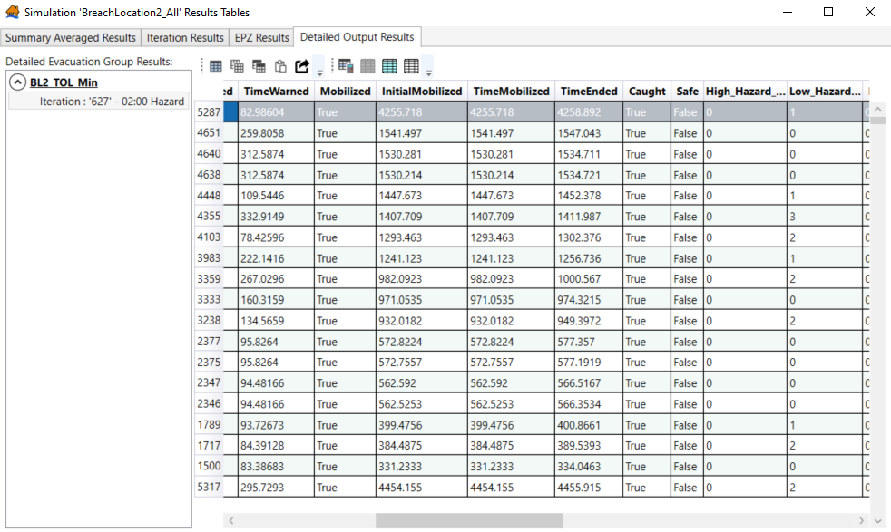
Figure 83 Simulation Results Tables – Detailed Output Results
You can export any of the four tabulated tables into various formats by clicking on the Export Table button (see below). After clicking on this button, name the file and select the file format. Then click Save.
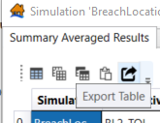
Figure 84 Export Table tool within the Results Table window
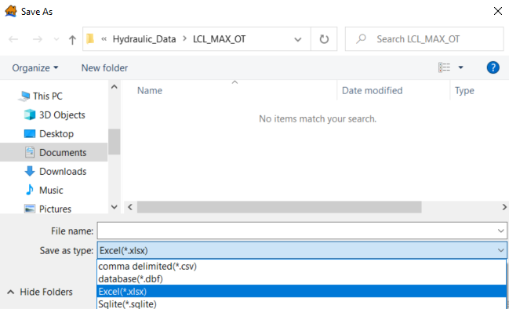
Figure 85 Simulation Summary Average Results table as an Excel file
Following any edits made during the quality control check, you need to rerun all simulations. Once you confirm the new life loss and economic results, your levee/floodwall LifeSim model is complete.

(Page is intentionally left blank)

- Estimating Consequences for Dams
  - Purpose
This example demonstrates the process for estimating consequences for dam breaches in LifeSim. This chapter focuses on Curwensville Dam located in Clearfield County, PA. This was originally modeled by the Modeling, Mapping and Consequences (MMC) Production Center of Expertise of the U.S. Army Corps of Engineers (USACE) in 2022. This chapter walks through developing and importing the needed data and how to choose appropriate warning and evacuation data for a LifeSim study.
  - Data Requirements
To take full advantage of LifeSim capabilities, an unsteady Hydrologic Engineering Center’s River Analysis System (HEC-RAS) dam breach model with a range of breach and corresponding non-breach events is required. Non-breach events are needed to identify any areas flooded prior to the breach, which allows you to understand incremental life loss and incremental risk of the dam. Alternatively, the inundation footprint from a breach model time step just before the breach occurs can be used to identify areas flooded prior to the breach, but for this example the non-breach inundation footprint is used to identify pre-breach flooding. This example also assumes that both maximum depth grids and inundation boundary polygons for each event have been created in the HEC-RAS model directory using RAS Mapper.
The hydraulic events used in the example are shown in the table below.

Table 2 Hydraulic Events in Curwensville Dam LifeSim Model
Short Name | Long Name | Description
MHP | Maximum High Pool | Inflow design flood at project
IHP | Intermediate High Pool | Pool elevation where spillway is at 50% capacity
TAS | Top of Active Storage | Highest elevation which can be obtained under normal regulated operating conditions (flood control pool)
SS | Security Scenario | The 1% exceedance duration pool elevation
NH | Normal High Pool | The 10% exceedance duration pool elevation
LifeSim requires a structure inventory that includes the following characteristics at a minimum, (1) a structure occupancy type, (2) a construction type, (3) the number of stories, and (4) the population within the structure. This example uses the USACE National Structure Inventory (NSI) as the base dataset for the structure inventory.
  - Input Data and Pre-Processing
    - Study Area Polygon
The first step in modeling a dam breach in LifeSim is to identify a study area polygon that can be used as a basis for emergency planning zones (EPZ), the structure inventory boundary, and output polygons. There are several ways to do this, but the most common methods include buffering the maximum inundation, manually drawing a polygon boundary in GIS software (e.g., ArcGIS Pro or QGIS), or exporting a Geometry Bounding Polygon from RAS Mapper within HEC-RAS. The RAS Mapper geometry polygon method does not always produce an acceptable study area when there are complex geometries. When using this method, the output must be checked for areas where inundation is not covered and for gaps within the polygon requiring vertex edits. This example uses a method of buffering and then simplifying the maximum inundation polygon in ArcGIS Pro.
Create a map in ArcGIS Pro and use the Add Data button to add the inundation polygon of the maximum breach event. In the Geoprocessing tools pane, navigate to Analysis Tools > Pairwise Overlay > Pairwise Buffer. Select the maximum inundation polygon as the Input Features and designate an output shapefile name (it is not recommended to save into the default geodatabase location). The buffer will be set at 1,500 feet. This allows for (1) a reasonable number of structure points outside the inundation for use in calibration of the inventory and (2) the case that a larger breach event might be added in the future. The Dissolve Type is set to “Dissolve all output features into a single feature”. Reference the ArcGIS Pro technical documents for additional information on tool inputs. The tool setup is shown in Figure 85.
Once the dissolve is complete, the Simplify Polygon tool is used to reduce the complexity and file size of the buffered polygon for a final study area, which allows follow-on GIS processes and the LifeSim modeling to run more efficiently. The tool is found by navigating to Cartography Tools > Generalization in the default Geoprocessing toolboxes. The output of this tool should be your final study area polygon. The simplification tolerance determines how far the new simplified line can move. A larger number will make a simpler polygon. Make sure this number is less than the original buffer distance. The inundation boundary can be used as an Input Barrier to ensure than the study area is larger than the inundation. The tool setup is shown in Figure 86.
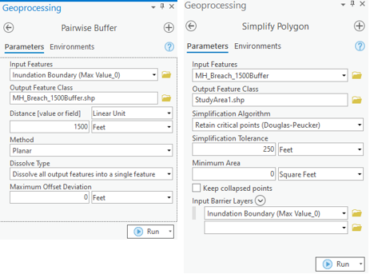
Figure 86 Pairwise Buffer and Simplify Polygon tools
Once the simplify polygon tool has been run, the study area is visually checked to look for areas that need to be cleaned up. Several spots had open areas near the center of the polygon. Those vertices were removed using the Edit ribbon and the Edit Vertices tool. Vertices can be selected and deleted by right clicking on the selected group and using the option to delete the selected vertices. This is shown in Figure 3. There were also several disconnected polygons caused by very small spots of disconnected inundation which were deleted from the final study area. The edits were saved. Figure 87 shows some of the vertices that were removed.
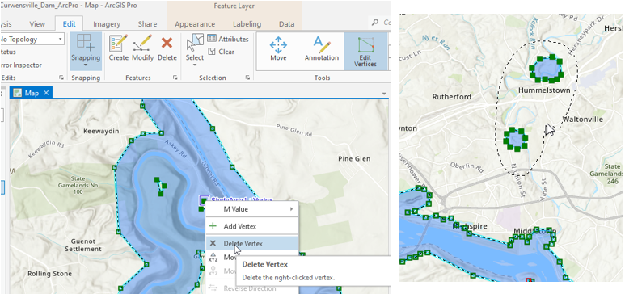
Figure 87 Deleting Vertices for the final Study Area polygon
Alternative Methods to Get a Study Area:
Create a new shapefile and draw a polygon around the maximum inundation. This can be accomplished in the LifeSim map viewer or in ArcGIS, QGIS, or another GIS software.
Export the Geometry Bounding Polygon from HEC-RAS/RAS-Mapper. Check and edit the polygon for completeness).
    - Emergency Planning Zones
EPZs are polygons that allow LifeSim to have different warning and mobilization parameters for different geographic areas and/or for areas that experience different flooding characteristics (e.g., breach flows and non-breach flows). Depending on the study’s purpose and level of detail there could be different parameters for different communities or counties. For this example, we will focus our geographic areas on the flood characteristics only and assume that parameters influenced by emergency response capability and demographic characteristics can be captured by using the default “unknown” curves in LifeSim. Reference the LifeSim 2.0 Technical Manual for additional information regarding the software’s default parameters.
In a standard dam breach scenario where no detailed information about the communities is known, there are three primary areas that may have different warning and mobilization characteristics: (1) the area upstream of the dam (or the reservoir), (2) the area that experiences flooding downstream of the dam prior to (or regardless of) a breach, and (3) the area that is only flooded in the event of a breach. People living near the pool of a reservoir would typically be more aware of the flood risk than areas downstream and would have more time to mobilize as the reservoir rises, so their perception of risk is higher. Downstream areas subject to flooding prior to a breach (i.e., spillway flow or non-breach flows from dam releases) may not necessarily have a higher risk perception, but they would receive flood warnings relative to when spillway flow begins. The non-breach flows rate of rise would also be more gradual than a breach, meaning they would have more warning time and a higher likelihood of mobilization than areas only flooded in the event of a breach.
To simulate this effect in LifeSim, each unique event with different levels of spillway flow needs a unique EPZ polygon because the areas flooded prior to a breach are different—this is why you need corresponding non-breach events for each of your breach events. If an event has no flooding prior to the breach, the EPZ only needs two areas: (1) the area upstream in the reservoir and (2) the area downstream. However, this requires the hydraulic modeling and structure inventory to be adequately calibrated so that no structures are flooded in the corresponding non-breach event (e.g., For the Top of Active Storage breach scenario to only have two zones, there should be zero inundated damages during the Top of Active Storage non-breach scenario. Otherwise, the EPZ would need to include the 3 zones identified above.).
The first step in creating the two zone EPZ is to make a copy of the Study Area and call it “EPZ_NoDoubleWarning”. This is done by right clicking on the layer name, selecting Data menu near the bottom, and clicking on Export Features. Save the file in a folder, not in the default geodatabase. The resulting polygon can be split at the dam to create an “In Pool” polygon feature and a “Downstream” polygon feature. On the Edit ribbon, click on the Split tool, select the polygon, and make a split across the polygon at the dam. Save the edits.
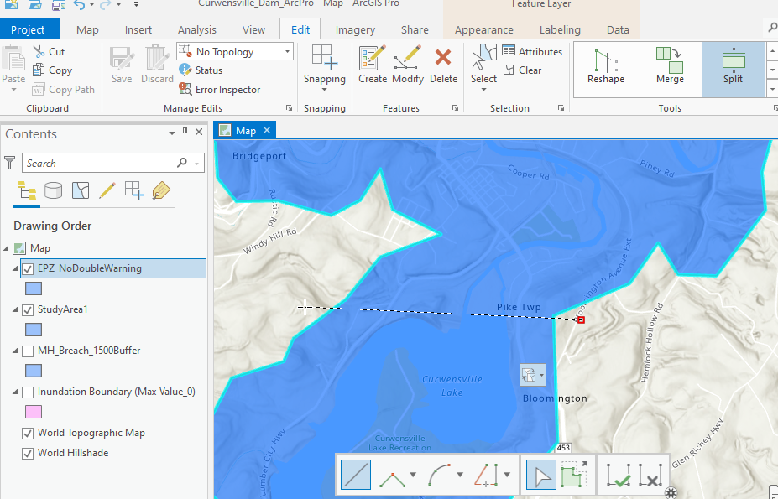
Figure 88 Splitting the In-Pool Area and Downstream areas for the EPZ_NoDoubleWarning shapefile
A name field is added so that each polygon can be named appropriately. Right click on the layer name to open the Attribute Table, then select Add Field to bring up the Add Field dialog. Set the field name to Name and the Data Type to Text. When finished, hit the Save button in the upper right on the Fields ribbon.
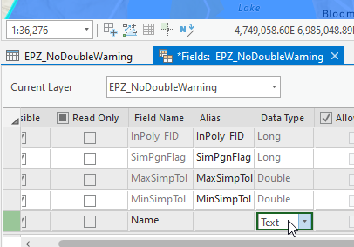
Figure 89 Adding a Name Field to the EPZ_NoDoubleWarning shapefile
Next, type in the names of each EPZ.
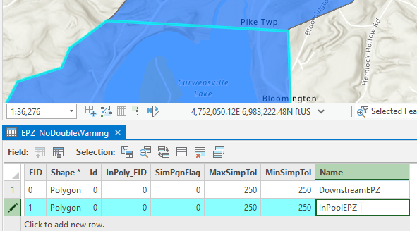
Figure 90 Naming the Downstream and In-Pool areas
This results in an EPZ that can be used for any events without flooding prior to a breach (in this example, these events are Top of Active Storage Pool, Security Scenario Pool, and Normal High Pool).
To make the EPZ shapefiles for the events with flooding prior to breach, the non-breach polygons must be joined with the “EPZ_NoDoubleWarning” file using the Union tool (not the Merge tool, as that will create overlapping polygons in the process). First, make sure the selections are cleared out. Navigate to the Union tool in the Geoprocessing toolbox in Analysis Tools > Overlay > Union. Select the “EPZ_NoDoubleWarning” file and the Inundation Boundary shapefile of the Maximum High Pool Non-Breach scenario as inputs, and name the output feature “EPZ_MHP_DoubleWarning.shp” (again, do not save in the geodatabase).
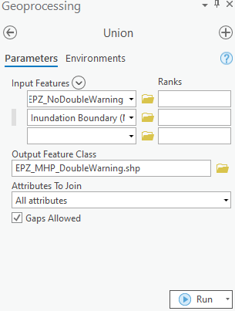
Figure 91 Union Tool in ArcGIS Pro
Once the EPZ has been created, it needs to be modified by merging some areas together and ensuring the EPZ names are correct. Open the attribute table and zoom the map close to the dam where all three areas come together. Select Polygons to identify which one should be the Non-Breach EPZ and change the name (“NonBreachEPZ” in the figure below).
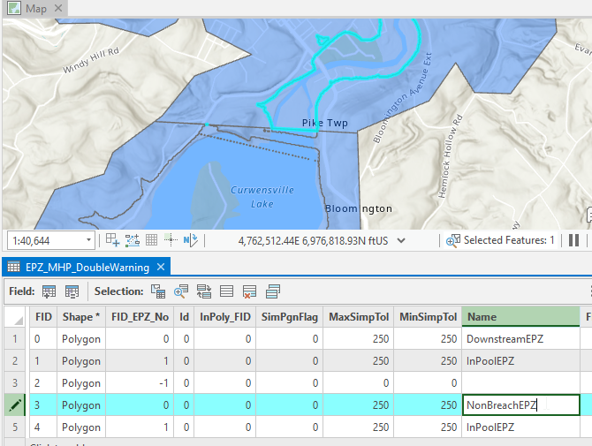
Figure 92 Naming Conventions for the EPZ_MHP_DoubleWarning shapefile
The rest of the Downstream area can be changed to the Breach EPZ (“BreachEPZ” in the figure below). Next, the two “InPoolEPZs” can be merged together to make a single in-pool polygon (“InPoolEPZ” in the figure below). Hold control to select both and find the Merge tool in the Edit ribbon.
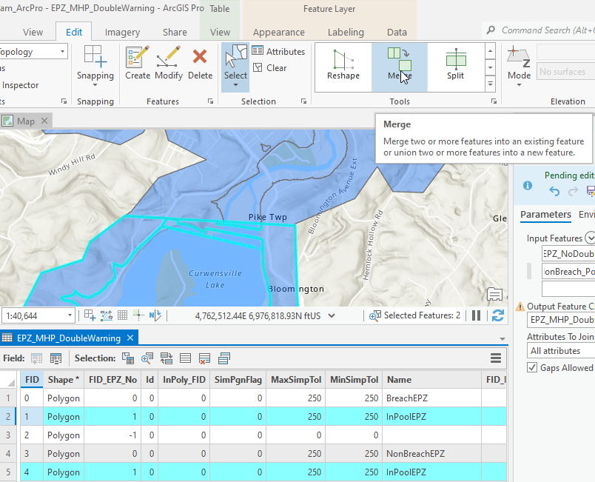
Figure 93 Merging the two In-Pool areas in ArcGIS Pro
This will leave a single unnamed feature. Right clicking on that feature and selecting Zoom To will identify this feature as two small, disconnected inundation areas. If needed they could be merged as part of the appropriate breach or non-breach area, but in this example, they appear to be unrelated to the breach modeling so they can be completely deleted by selecting that row and hitting the Delete button near the top middle of the Edit ribbon (or by right clicking the row and selecting delete). Once the edits are saved, this should complete the MHP Double Warning EPZ. The same steps, starting with the Union, must be repeated with the Intermediate High Pool (IHP) non-breach area using “EPZ_IHP_DoubleWarning” as the Union output file name.
    - Simulation Output Polygons
LifeSim has the capability to output results aggregated to multiple polygon shapefiles. At a minimum the EPZ polygons can be selected as output polygons, but for comprehensive understanding and reporting of the results additional polygons are needed. For this example, a polygon will be created that has the downstream area broken out by milage zones relative to the dam. The zones are 0 to 3 miles, 3 to 7 miles, 7 to 15 miles, 15 to 60 miles, and over 60 miles. A separate polygon shapefile will be created by selecting and exporting city boundary polygons that are significantly impacted by the inundation.
To make the milage reach polygon, start by exporting the “EPZ_NoDoubleWarning” layer as a new shapefile by right clicking on it in the Layers Pane and navigating to Data > Export Features. Save to a folder and name it “Milage_Reaches.shp”. Next, identify a point along the river three miles downstream of the dam. This can be done by looking at cross section stations from the RAS geometry, creating points along a river centerline every mile, or simply by using the measure a path tool in ArcGIS Pro or Google Earth. For this example, the cross sections were exported from RAS Mapper and included in a Geometry folder in the RAS model data. These are added to the ArcGIS Pro map and labeled with the “River Stat” field. Since the dam is at river station 185.7, the downstream polygon needs to be split close to 182.7 (3 miles), 178.7 (7 miles), 170.7 (15 miles) and 125.7 (60 miles). There are no cross sections with these exact river station values, but they are close enough to visually estimate a location to split the polygon. The cross sections also provide a guide for splitting the polygons perpendicular to the river inundation. To split the polygon, use the Split tool in the Edit ribbon, select the polygon, and draw the split between stations 182.63 and 182.79 to delineate the first reach three miles downstream of the dam.
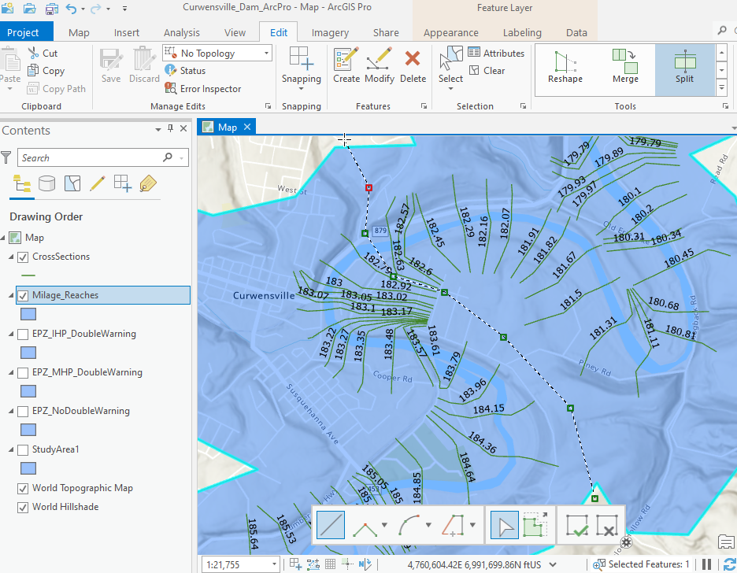
Figure 94 Creating a Mileage Reach polygon Based on cross sections
Repeat the split at the remaining river stations, then save the edits. Right click on the layer and open the attribute table to assign the correct names. A first and important step in naming is to rename the “InPoolEPZ” polygon to just say “InPool”. This will become important later in the study, because if both the Milage Reaches and the EPZ shapefiles are used as output polygons, having two areas with the same name could cause double counting of results if Excel pivot tables are used to analyze results. Select each row to identify what the name should be. Do not use only numbers and dashes because most spreadsheets will attempt to convert “3-7” into a date format. Save the edits when complete.
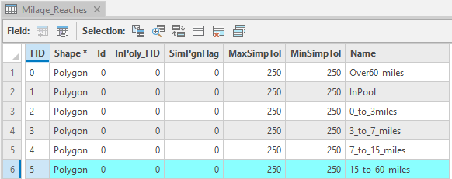
Figure 95 Naming conventions for the Mileage Reach polygon
The second results output polygon set is a city boundary polygon. A comprehensive set of U.S. city boundaries, or Places as they are called on the Census.gov website, can be obtained by navigating to the link below and finding the Places 1:500,000 (national) shapefile a little more than halfway down the page.
https://www.census.gov/geographies/mapping-files/time-series/geo/cartographic-boundary.html
Once the file is downloaded and unzipped, load it into the ArcGIS Pro map using the Add Data button. Use the Select by Location tool in the Map ribbon to select the cities that intersect with the maximum inundation polygon (the MHP Breach in this example). You could intersect it with the study area, but since that was buffered, it could result in some cities that would have no consequences.
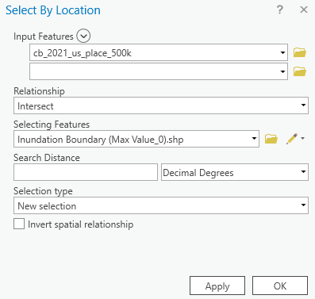
Figure 96 Select by location window
Once the selection is complete, right click on the city layer and navigate to Data > Export Features to export the selected features into a new shapefile called “City_Boundaries.shp”. This results in 79 individual cities, which is more than we want in our simulation outputs since many of them do not have significant impacts and sorting through that many rows of results creates difficulties in interpreting results. Smaller cities farther downstream can be removed, as well as cities that are barely touched by the inundation, by selecting individual polygons and using the Delete button in the Edit ribbon. Another method of removing cities is to run a test simulation in LifeSim, view the results table, and identify any cities that do not have any life loss. The latter was done for this example and based on those results and user judgement the following nine cities were retained for the city boundary results output polygon:
- Clearfield, PA
- Curwensville, PA
- Hyde, PA
- Jersey Shore, PA
- Lock Haven, PA
- Milton, PA
- Muncy, PA
- Plymptonville, PA
- South Renevo, PA
    - Structure Inventory
The Curwensville Dam structure inventory is developed using the USACE NSI dataset. Reference the Estimating Consequences for Levees and Floodwalls Chapter for additional information on the NSI and/or importing structure inventories into LifeSim.
  - LifeSim Model Setup
The subsequent sections will discuss setting up a LifeSim model by importing data and setting EPZ parameters and alternatives. The sections will cover hydraulic data import, EPZs, structure inventories, creating alternatives, and simulating alternatives.
    - Hydraulic Data
For estimating life safety consequences, LifeSim requires depths, velocities, and arrival times from unsteady hydraulic modeling. The most common method of delivering this information into the LifeSim model is through HEC-RAS Hierarchical Data Format (HDF) plan files (Note: Only HEC-RAS versions 5+ produce the HDF files required by LifeSim). For each hydraulic scenario, the user will need the plan file from HEC-RAS and the terrain files (both the HDF and the associated Tagged Image Format (TIF) files) so that LifeSim can calculate depths and arrival times.
Prior to importing data, create a new study by specifying a name and location to save to study data. To import the hydraulic data from HEC-RAS, right click on Hydraulic Data in the study pane, and select Import from HEC-RAS.
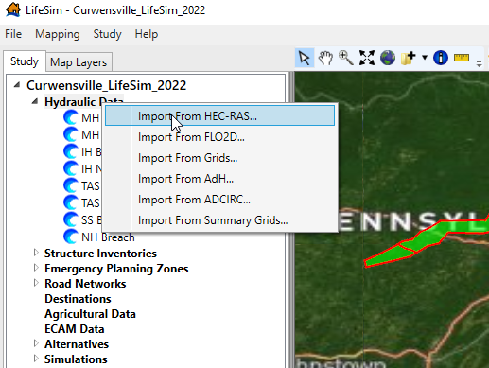
Figure 97 Importing hydraulic data from HEC-RAS
From the Import from HEC-RAS window, map to the project’s HEC-RAS Plan(s) Directory by clicking on the button with the three dots. The file directory selected should contain plan HDF files from HEC-RAS (e.g., PA00003_Curwensvill.p01.hdf). Select the specific HEC-RAS plan you want to import by using the dropdown next to HEC-RAS Plan. Once selected, the Name of the hydraulic scenario will automatically populate, but the user is able to alter the Name. If the terrain is inside the HEC-RAS directory Terrain folder it usually auto populates the terrain. If not, map to the project’s HEC-RAS Terrain File (HDF) by clicking on the button with three dots. Once you have the hydraulic data mapped and selected in the Import from HEC-RAS window, you can either select Import from RAS or Import from Map.
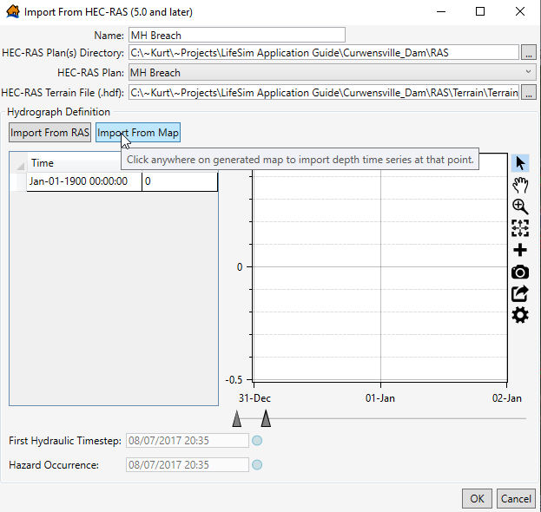
Figure 98 Import from HEC-RAS window
To specify the timing of the hazard being evaluated, in this case dam breach, the user can either import a hydrograph from a specific cross section or a storage area using the Import from RAS option or select a point on the map to generate a hydrograph using the Import from Map option. This example uses the Import from Map option for simplicity. Refer to the Estimating Consequences for Levees and Floodwalls Chapter for guidance on utilizing the Import from RAS option.
When you select Import from Map, the RAS Map Data Selector window will open.
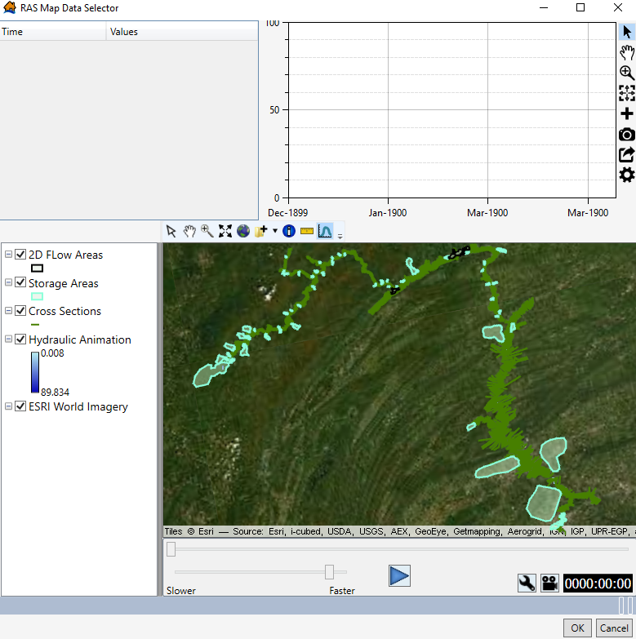
Figure 99 RAS Map Data Selector window
To view a hydrograph along with its hydraulic timing and depths, use the Select Hydrograph Tool in the toolbar (shown below).
Figure 100 Select Hydrograph Tool in the RAS Map Data Selector
The RAS Map Data Selector map window will automatically display the 2D areas used in the RAS modeling, the cross sections, the hydraulic animation, and a base map. The user can change the base map and add data to the map window (e.g., breach locations shapefile, leveed area shapefile, structure inventory, etc.) by clicking on the Add Data button (see below).
Figure 101 Add Data feature in the RAS Map Data Selector
Zoom into the area just downstream of the dam and move the animation slider bar to get a clear picture of the inundation. Use the Select Hydrograph Tool and click in the center channel of the inundation just below the dam to get a hydrograph.
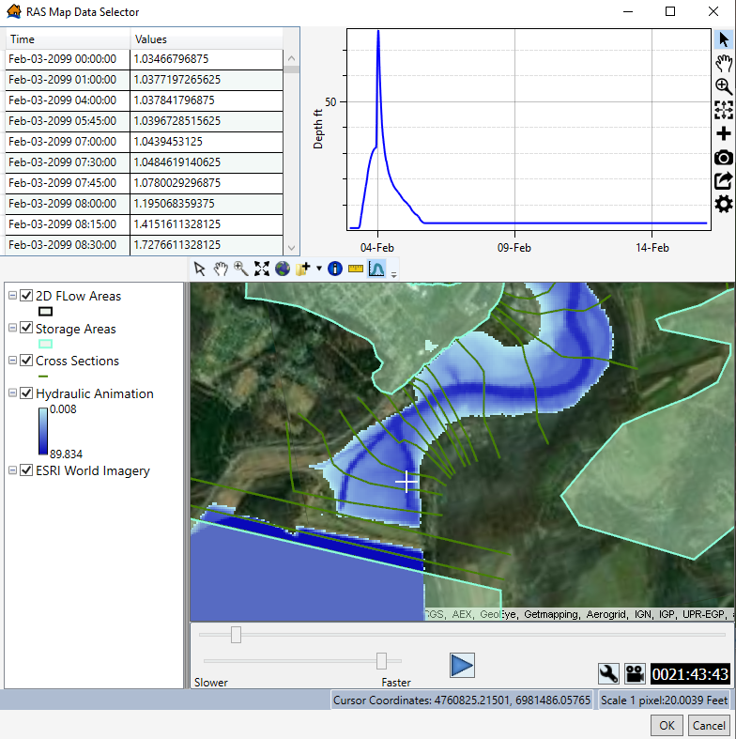
Figure 102 Progress Window in the RAS Map Data Selector after clicking on an area with the Select Hydrograph tool
Once a representative hydrograph for the hydraulic scenario is loaded, click OK and you will return to the Import from HEC-RAS window. The window will now display hydraulic timing information as well as the same representative hydrograph. The Hazard Occurrence date and time should match the time that breach or overtopping (if applicable) begins within the study area. This information can be found in HEC-RAS or the hydraulic engineer will provide this information. For the Curwensville MH Breach, the breach initiation time is 2/3/2099 at 23:00. The red line is the hazard occurrence time, and the first 31 feet of depth represents spillway flow. The hydrograph then increases steeply after the breach. Press OK and the hydraulic scenario will be processed and imported into LifeSim.
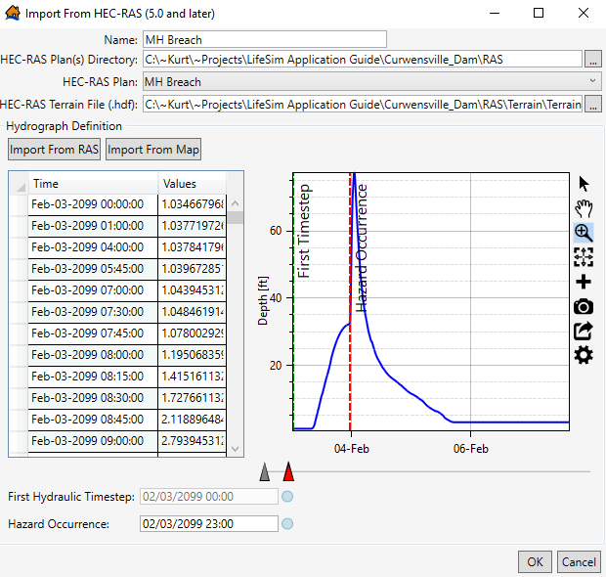
Figure 103 Import from HEC-RAS window following selection of a representative hydrograph from RAS Map Data Selector
The user will repeat this process for each of the study’s hydraulic scenarios. For non-breach scenarios, it is recommended to use the same imminent hazard time used for the corresponding breach scenario. LifeSim interpolates population between the 2am and 2pm time values. Therefore, using different imminent hazard times for breach and non-breach can cause inconsistencies when calculating incremental consequences by subtracting non-breach results from breach results.
    - Importing a Structure Inventory
To import a structure inventory from an existing point shapefile, the user will navigate to the Study pane in their model, right click on Structure Inventories, and select Import Structures from Shapefile.
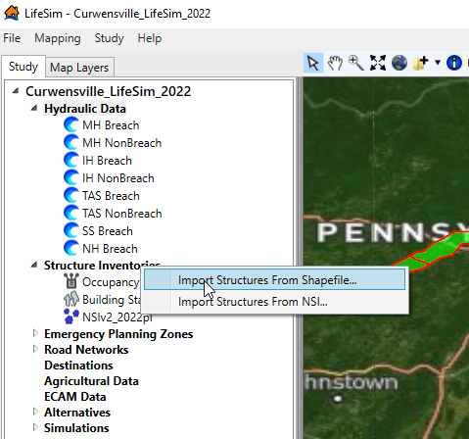
Figure 104 Importing Structures from Shapefile from the Study Pane
The user will then be able to either select the Structure Inventory Shapefile from the dropdown, which is available if the shapefile is in the Map Layers pane of the LifeSim model, or navigate to the shapefile by clicking on the button with the three dots next to the dropdown. Once you match up your shapefile’s attributes (Import Attributes) with the corresponding LifeSim Required Attributes (an example of matched up attributes using the NSI is shown in the figure below), click Next at the bottom right.
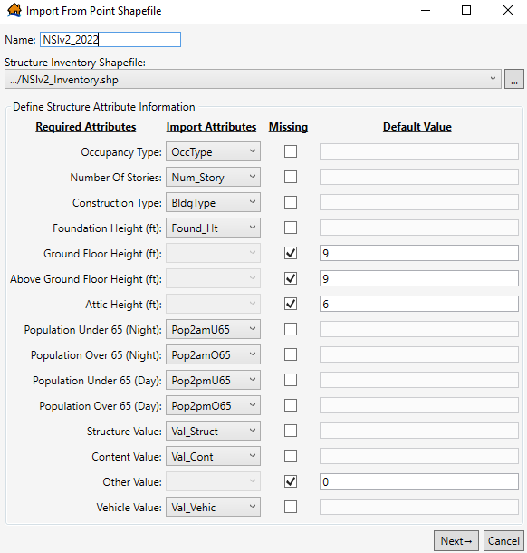
Figure 105 Importing National Structure Inventory 2.0 into LifeSim – Defining structure attributes
You will then need to match the occupancy types in LifeSim with the occupancy types included in your structure inventory shapefile. If using NSI 2019 or NSI 2022, the occupancy types will typically exactly match the occupancy type names in LifeSim, but the user should scan through the list to ensure everything is matched up correctly. If these are mismatched, the depth-damage functions, evacuation parameters, and submergence criteria will not be correct for that structure, which would impact the accuracy of your economic damages and life loss. If an occupancy type is missing, the user can add occupancy types or edit the existing occupancy types, which is discussed in the next subsection.
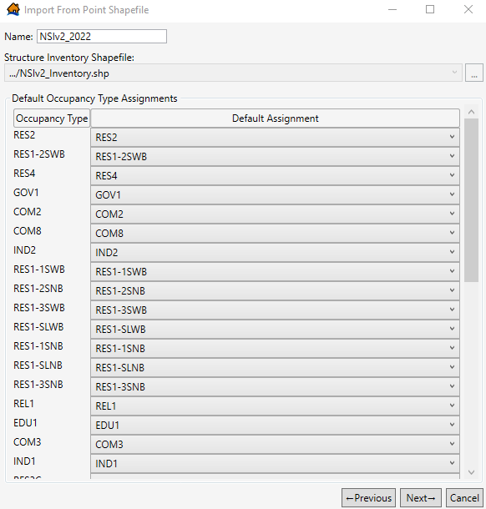
Figure 106 Importing National Structure Inventory 2019 – Assigning occupancy types
After the occupancy types are assigned and reviewed, click Next. The final step for importing the inventory is the Stability Criteria Assignment. LifeSim has default stability criteria assignments for wood unanchored structures (e.g., mobile homes), wood anchored structures, masonry structures, and steel structures. For NSI users, you should use the default stability criteria.
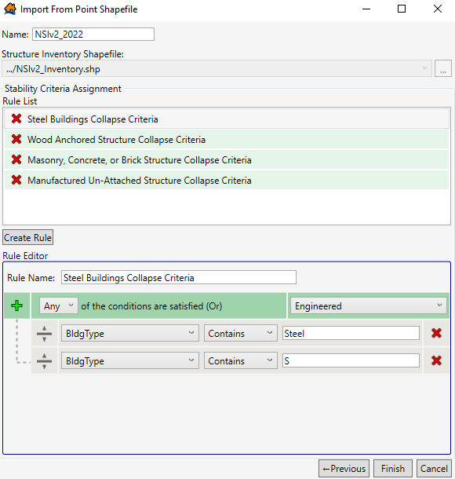
Figure 107 Importing National Structure Inventory 2.0 – Assigning stability criteria
Reference the Estimating Consequences for Levees and Floodwalls Chapter for creating new structure criteria rules. Once all structures have been assigned a stability criterion, click Finish. The inventory will then be imported into LifeSim.
    - Emergency Planning Zones
The three EPZ shapefiles created in ArcGIS are each imported to the EPZ section of LifeSim. Within a set of EPZs, each zone must be assigned a curve for Warning Issuance Delay, First Alert Diffusion during daytime and nighttime, and Protective Action Initiation (commonly called mobilization).
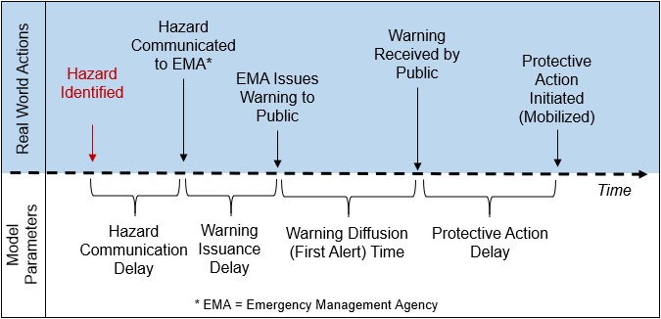
Figure 108 Warning and Mobilization Timeline
When conducting a detailed consequence analysis in LifeSim, the analyst would work with local emergency managers and other subject matter experts to determine the most appropriate curves to select for the entire study area or for specific areas with the study area. However, LifeSim contains generic “unknown” curves that represent a maximum amount of uncertainty (relative to the other preset curves) regarding EPZ parameters. The unknown warning diffusion and PAI curves are uniform distributions, so given enough iterations the range of results should provide reasonable upper and lower bounds of life loss. These unknown parameters are used for most MMC level LifeSim models and are used in this example. Reference the Estimating Consequences for Levees and Floodwalls Chapter and Estimating Consequences for Coastal Infrastructure Chapter for more information on how to develop Warning and Protective Action parameters for your specific impact areas.
To import an EPZ, right click on Emergency Planning Zones and select Import EPZs From Shapefile.
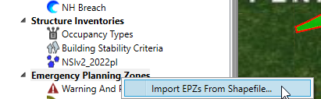
Figure 109 Import EPZs from Shapefile
In the Import Emergency Planning Zones window, use the three dots on the upper right to browse to the “EPZ_MHP_DoubleWarning.shp” shapefile that was created in the prior GIS section. Once selected, fill in the name field with the same name as the shapefile, and in the Emergency Planning Zone Name Field dropdown menu select the field “Name” which was added to the shapefile in the GIS section. Before proceeding, confirm that there are now three emergency planning zones named BreachEPZ, InPoolEPZ, and NonBreachEPZ.
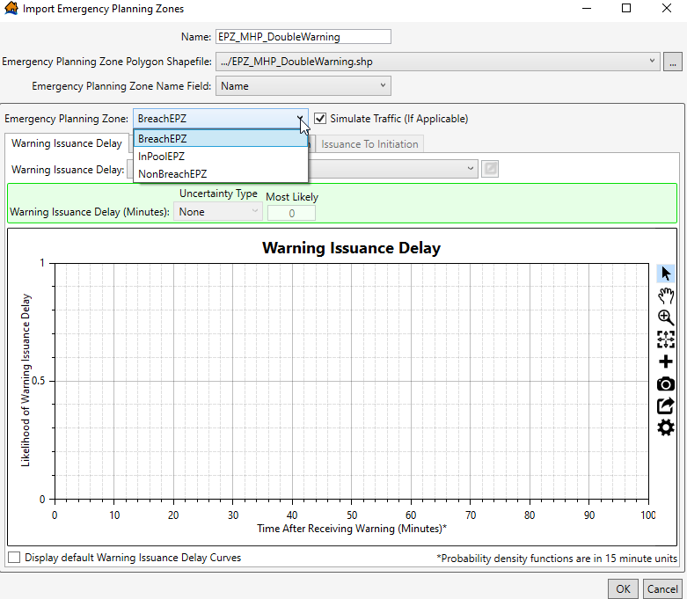
Figure 110 Showing the 3 Areas in the “EPZ_MHP_DoubleWarning” EPZ
Each of the three EPZs are now assigned a Warning Issuance Delay curve, a First Alert Curve, and a PAI curve. Each area will have the same assigned curves for each uncertainty parameter.
There is a check box for Simulate Traffic (If Applicable). The “if applicable” statement is here because there is also a checkbox in the Alternative window to either simulate traffic or not simulate traffic for each alternative. Regardless of whether this box in the EPZ editor is checked, the primary option for simulating evacuation is the one in the Alternative window.
However, if the Alternative specifies that traffic will be simulated, then the checkbox in the EPZ editor becomes applicable and allows the user to select specific EPZs in which traffic will be simulated. Traffic can either be simulated in all EPZs or only in certain selected EPZs. For example, in a dam breach with a very long inundation area traffic might only be a concern in areas close to the dam or in a few large cities. EPZ polygons could be created specifically for those areas so that the model runs efficiently while still simulating traffic in high-risk areas. Since this is meant to be a more base-level analysis, the Alternatives will specify that traffic will not be simulated, so the check box in the EPZ editor is not applicable and can be left checked.
      - Warning Issuance Delay
The Warning Issuance Delay is the time it takes from when the emergency managers receive the notification of the imminent hazard to when they issue the first evacuation order to the public. The preset “Preparedness Unknown” warning issuance delay curve is used in this analysis. Although the range of possible warning issuance delay possibilities is between 0 minutes and 360 minutes, the most likely outcome is warning issuance 30 minutes after officials are notified of the flood hazard.
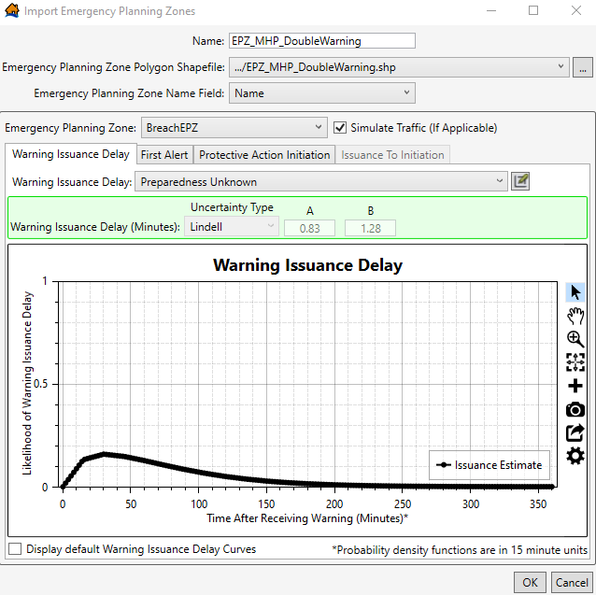
Figure 111 Unknown Warning Issuance Delay curve
      - First Alert Diffusion
The preset “Preparedness Unknown” warning diffusion curves were used in this analysis. The curves utilize a uniform distribution, and the warning diffusion curves are sampled during each Monte Carlo iteration in LifeSim. The upper bound of the curve reaches 100% diffusion after 100 minutes, and the lower bound reaches 100% diffusion after 360 minutes. Note that there is a different diffusion curve for daytime and nighttime.
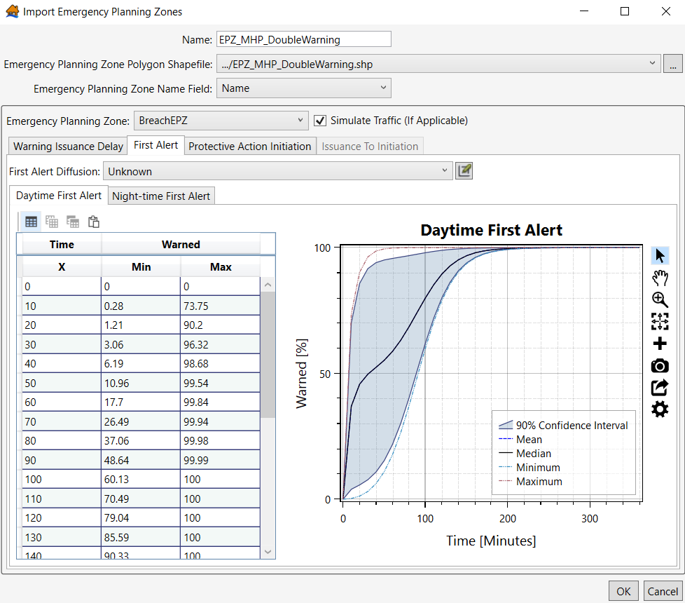
Figure 112 Unknown Daytime First Alert curve
      - Protective Action Initiation
Protective Action Initiation (PAI) is the rate at which PAR takes action after receiving an evacuation order (warning). Unlike the warning diffusion curves, the PAI “Preparedness Unknown” curve includes a perception element as well. The perception element describes the PAR as being aware of flood risk (Perception = High) or generally unaware that they are at risk of being flooded (Perception = Low). The “Preparedness Unknown, Perception Unknown” curve was used in this analysis for all areas.

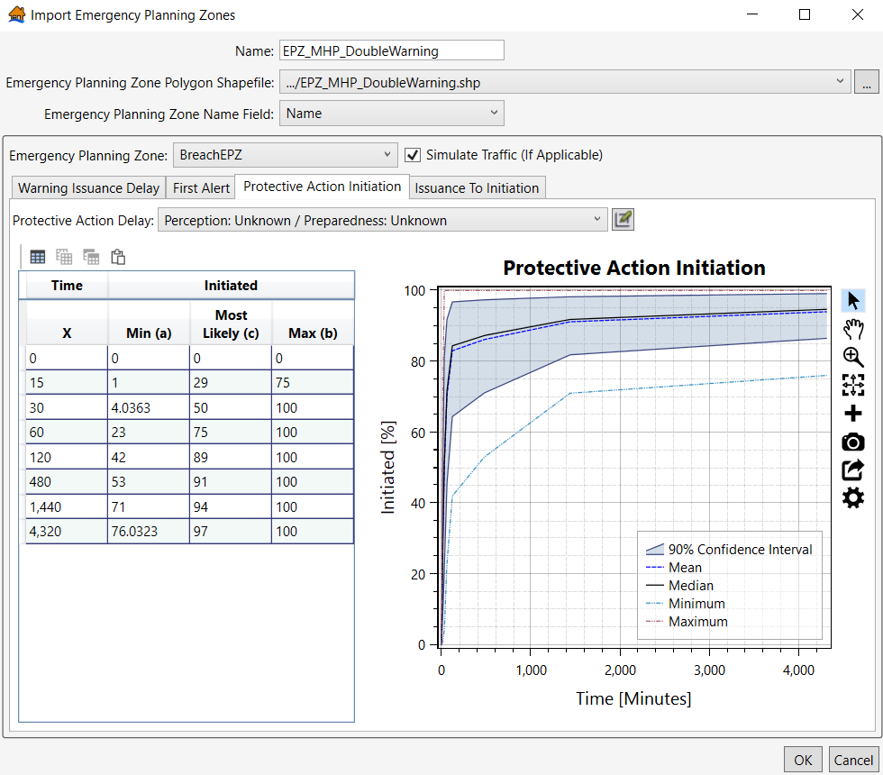
Figure 113 PAI Curve Preparedness Unknown, Perception Unknown
Switch the Emergency Planning Zone dropdown to the NonBreachEPZ and make the same selections that were made for the BreachEPZ; repeat for the InPoolEPZ, then click OK to close the EPZ editor window. Repeat the Import EPZs from Shapefile process with the “EPZ_IHP_DoubleWarning” shapefile and the “EPZ_NoDoubleWarning” shapefile using the same uncertainty parameters for each area in each EPZ.
    - Creating Alternatives in LifeSim
Below the EPZ section of the LifeSim study tree are Road Networks, Destinations, Agricultural Data, and ECAM Data. These sections will be skipped for this example of a base level study, as they are not utilized on most USACE projects that follow the MMC Standard Operating Procedure (SOP). Therefore, the next step will be to create alternatives.
For this study, each breach event will have two alternatives representing different warning ranges. These ranges are referred to as minimal warning and ample warning and they allow the results to be applied to different potential breach scenarios that may have different opportunity ranges for observation, development, and warning in relation to the breach initiation. The non-breach events will only have one alternative because only the areas impacted by breach flows will have different warning conditions. The table below shows the different warning times used in these alternatives.

Table 5 Warning Times used for Curwensville Dam Alternatives
Warning Scenario | Distribution Type | Minimum (hours) | Maximum (hours)
Minimal | Uniform | -2 | 0
Ample | Uniform | -6 | -2
Flooding prior to breach | None | -72 hours prior  (Upper end of mobilization potential)
To create the first alternative, right click on Alternatives and select Create New Alternative to bring up the alternative window.
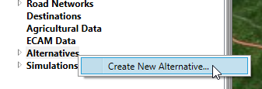
Figure 114 Creating New Alternatives in LifeSim
The name for this first alternative will be “MHP_Breach_MinWarn”. Under Input Data Sources, uncheck the box for Simulate Traffic but leave the Calculate Life Loss box checked. Fill in the remainder of the Input Data Sources box to match the following figure.
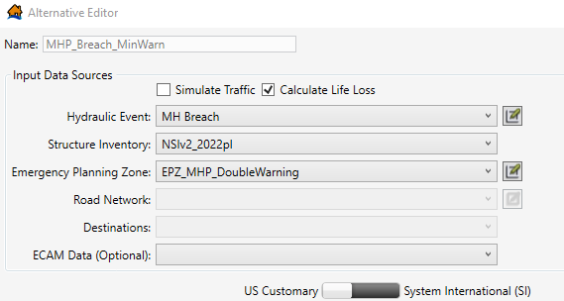
Figure 115 MHP Breach with Minimal Warning alternative
The lower section of the Alternative Editor allows the user to set different parameters for each EPZ area. For the BreachEPZ, the Imminent Hazard ID Time is set to a Uniform Distribution of -2 to 0 (i.e., between 2 hours prior to the hazard and the time of hazard occurrence) which represents the MMC SOP minimal warning case. This value is the time that a breach or other hazard would be identified by someone on site. The Hazard Communication Delay represents the time it takes for that person to alert local emergency managers or other officials of the hazard and this value is set to a uniform distribution between 0.1 and 0.5 hours.
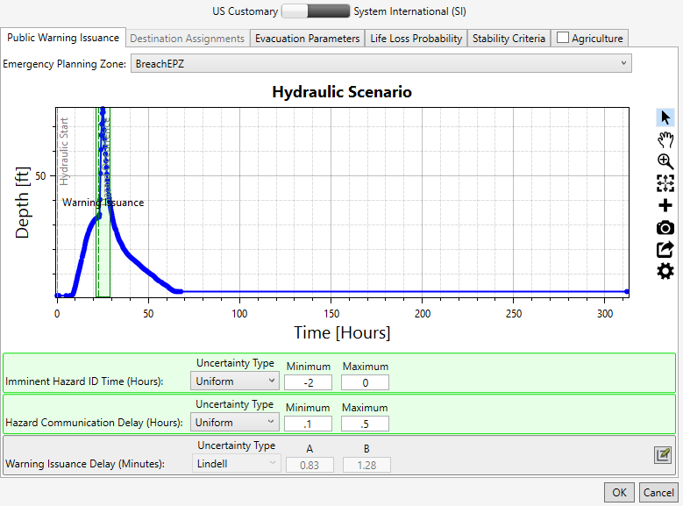
Figure 116 MHP BreachEPZ Imminent Hazard ID Time and Hazard Communication Delay
Note that the green column in the hydrograph represents the potential range of time that a warning could be issued. This not only reflects the two uniform distributions just entered, but it also reflects uncertainty on the EPZ parameter for the Warning Issuance Delay. This window also shows other tabs for Evacuation Parameters, Life Loss Probability, Stability Criteria, and Agriculture where additional parameters can be customized, but for a standard LifeSim model these can be left at the default values.
Once the BreachEPZ warning values have been entered, use the Emergency Planning Zone dropdown to switch to the InPoolEPZ. For the in-pool area a single most likely warning time of -72 hours will be used with no uncertainty. The reason for this is not necessarily that the population in this area will have that much warning, but that the characteristics of the flood caused by a rising reservoir pool are such that we assume the mobilization rate will be near the upper end of the PAI curve. The early warning time provides a model outcome reflecting that assumption. Also note that it is on a 24-hour increment, which prevents any potential issues in calculating incremental results caused by population interpolation between daytime and nighttime. If the warning was on a 12-hour increment, that interpolation could cause a negative incremental PAR result. With a warning that early the Hazard Communication delay is insignificant, so it is left at the default value of 0.
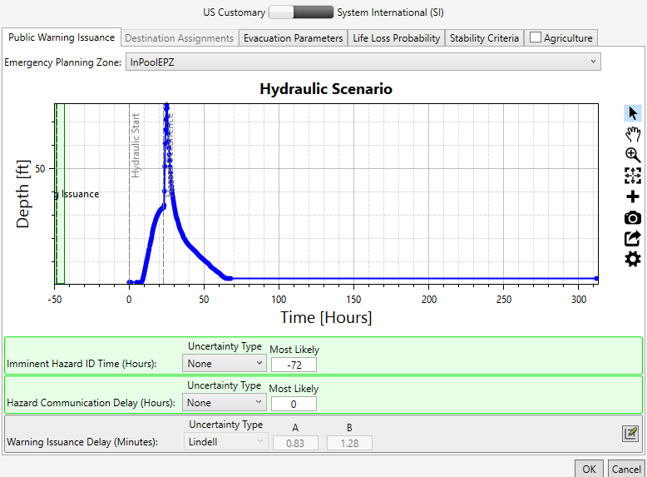
Figure 117 MHP InPoolEPZ Imminent Hazard ID Time and Hazard Communication Delay
Finally, switch to the NonBreach EPZ and set the same warning (-72 hours) that was used for the in-pool EPZ. A similar assumption of upper-end mobilization based on flood characteristics applies here; the non-breach flooding is a result of spillway flow from the dam which will typically be forecasted in advance based on rainfall and inflows and it will occur somewhat gradually as the pool rises above the spillway crest or spillway gates are incrementally opened. Once this final warning is set, click OK to close the Alternative Editor window.
To create the additional alternatives, an easy method is to right click on the alternative just created and click Copy. This brings up a window where the name of the new alternative can be changed. Change the name to “IHP_Breach_MinWarn” to create the next alternative. Right click on the new alternative and select Edit. Change the hydraulic event to IH Breach and change the EPZ to the “EPZ_IHP_DoubleWarning” file. Set the same hazard ID time and hazard communication delay for breach, non-breach, and in-pool areas to the same as they were on the MHP alternative (-2 to 0 hours for breach and -72 hours for non-breach and in-pool).
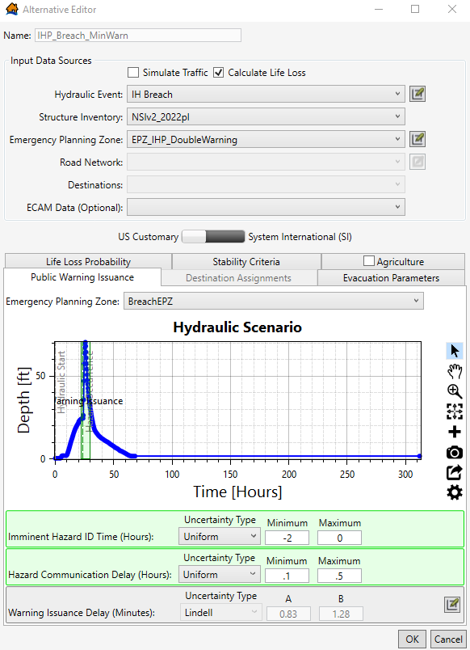
Figure 118 IHP BreachEPZ Minimal Warning Imminent Hazard ID Time and Hazard Communication Delay
Next, copy existing alternatives (e.g., “IHP_Breach_MinWarn”) to create alternatives for “TAS_Breach_MinWarn”, “SS_Breach_MinWarn”, and “NH_Breach_MinWarn”. In each alternative, change the hydraulic event to the appropriate breach event (i.e., TAS, SS, or NH) and for each of these three alternatives change the EPZ to the “EPZ_NoDoubleWarning” selection. There will be no non-breach zone for these runs because there is no out-of-bank flooding prior to the breach.
Once the minimal warning scenarios are complete, make copies of each one and replace the “MinWarn” in the name with “AmpleWarn”.
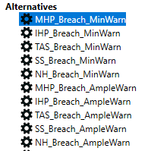
Figure 119 List of Curwensville Dam breach Alternatives
The only edit required for each alternative is the Hazard ID time for the breach zone, which is changed to -6 to -2 hours (minimal warning was -2 to 0 hours).
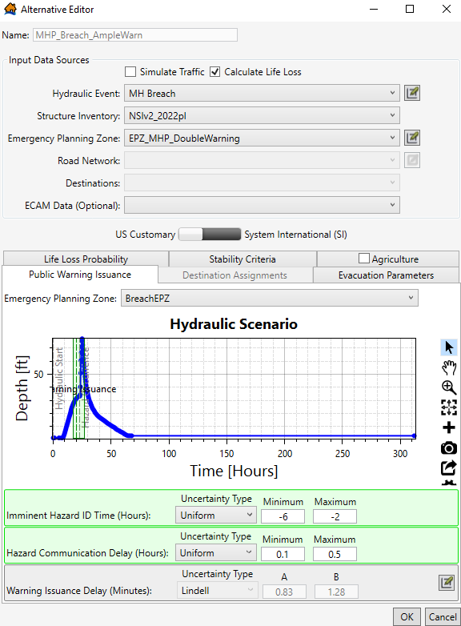
Figure 120 MHP_Breach_AmpleWarn Alternative
Finally, set up the non-breach alternatives. For this study we will have non-breach alternatives for only the (1) MH Pool, (2) IH Pool, and (3) TAS Pool. The TAS event should not have any damages as it should be within control levels, but it needs to be simulated to confirm that and identify any inaccuracies in the hydraulics or structure inventory that need to be corrected.
Once all the example alternatives are created it should match the figure below.
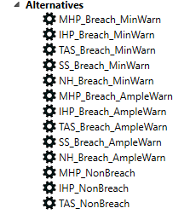
Figure 121 Complete List of Curwensville Dam Alternatives
    - Creating Simulations
Simulations are created for testing (e.g., “Test_Sim”) and for each grouping of alternatives (e.g., “MH_Sims”, “IH_Sims”, and “TAS_SS_NH_Sims”; TAS, SS, and NH alternatives can be run together since they will all use the two zone EPZ). The “TestSim” is created to run the TAS non-breach alternative and any other alternatives that might be run for testing (e.g., MHP Minimal Warning as the most structures will be inundated in this scenario). This simulation is helpful for calibrating the structure inventory. As discussed earlier, the TAS non-breach test simulation will help you identify any structures that are in the river or reservoir. The MHP scenario will help you identify if high life loss structures are accurately placed and/or if the structure attributes need updating (e.g., a high-rise apartment building only has one floor in the attribute table, which does not allow the PAR to vertically evacuate in the simulation and may be inflating life loss estimates).
The MH and IH alternatives get their own simulations so that the EPZ polygons can be used as a reporting polygon; remember the non-breach EPZ polygons for those events are unique to the MH and IH scenarios. Since the “TestSim” is not for final reporting, the Summary Polygons are less relevent and the number of iterations can be lower. Name the simulation “TestSim”, select the 2am and 2pm boxes, set the number of iterations to 100 and use the NoDoubleWarning EPZ as the Summary Polygon. Select the TAS_NonBreach alternative (and any other alternative needed to help with calibration) to run.
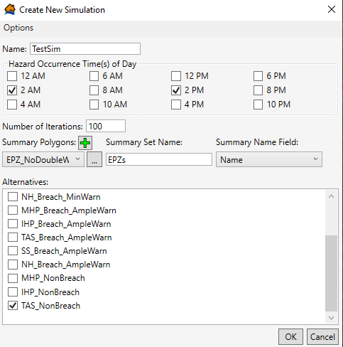
Figure 122 Creating the Test_Sim Simulation
Next create the “MH_Sims”, “IH_Sims”, and “TAS_SS_NH_Sims” simulations. For the “MH_Sims”, select 2am and 2pm, and use 1000 iterations (more iterations can be used depending on need and simulation times, 1,000 is a recommended minimum). For the Summary Polygons, select the MHP double warning EPZ, the Milage Reaches polygon that was created in ArcGIS previously, and the City Boundaries polygon. For Summary Set Name it is important to use the same names for each simulation (EPZs, Reaches, and Cities) to facilitate analysis of results in a spreadsheet.
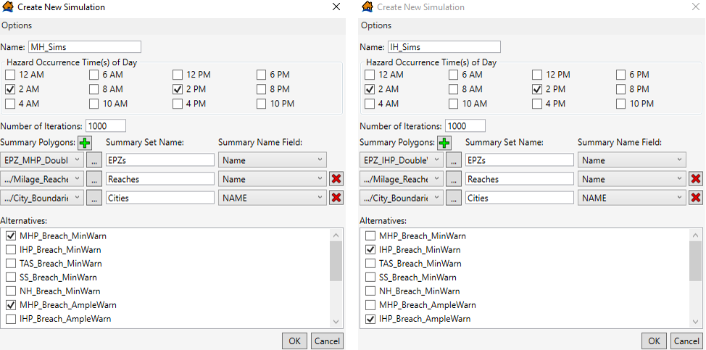
Figure 123 Creating the MH_Sims and IH_Sims simulations
Once all the example simulations are created, it should match the figure below.
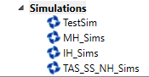
Figure 124 Curwensville Dam Simulation list
  - Running the TestSim
The first Simulation to be run is the TestSim, as this will assist in calibration of the inventory. In theory, the TAS non-breach scenario should be within channel and have no flood damages. If structures are flooded in this scenario, it means those structures would likely be flooded prior to the breach in the breach scenario and would not receive any warning within the model.
Right click on the TestSim and select Run Simulation to simulate the TAS non-breach alternative that was selected. This simulation may take about 20 minutes or more depending on the computer. Once the simulation is finished, right click on TestSim and select View Results Tables.
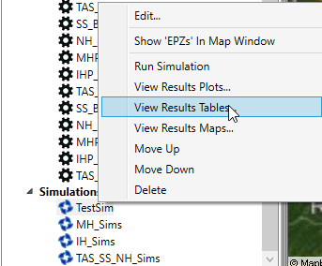
Figure 125 Viewing TestSim’s Results Table
The primary output table for the simulation has a row for each Summary area, including totals for the entire summary areas. There are also rows for each time of day. In this example 15 structures were inundated in the TAS non-breach event and these need to be checked and modified before running the final simulation sets.
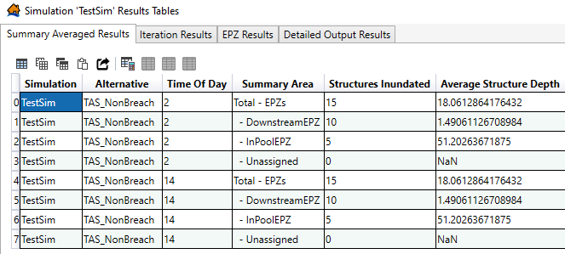
Figure 126 TestSim Results Tables – Summary Average Results tab
  - Editing the Structure Inventory Based on Simulation Results
To edit the structure inventory, right click the study’s structure inventory in the study tree and select Show in Map Window.
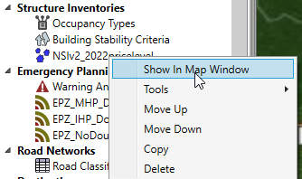
Figure 127 How to Show the Structure Inventory in the Map Window
Switch to the Map Layers tab and add a web imagery layer as shown below.
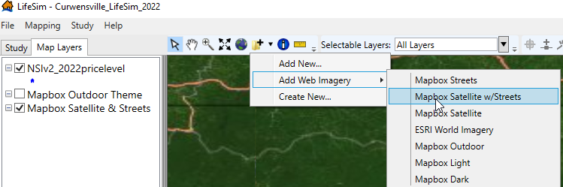
Figure 128 How to Add Web Imagery to the Map Window
Switch back to the study tree, right click on TestSim under Simulations and select View Results Maps.
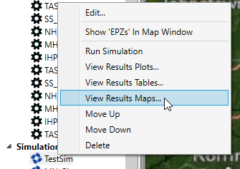
Figure 129 Viewing TestSim’s Results Maps
Check the box next to 14:00 Structure Summary and the rest of the window should populate as follows.
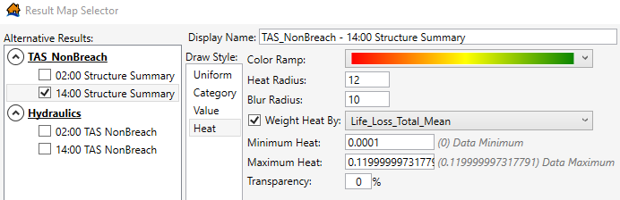
Figure 130 Results Map Selector window
Click Send Selected to Map Window in the bottom right to add the selection(s) to the map. In the Map Layers pane, select and move the structure inventory so it is at the top of the list. Next, right click on the TAS_NonBreach layer and select Properties. Change the Draw Style to Value, select the Attribute Max_Depth, change the number of bins to 1 and the Minimum to 0.001. Next change both the Line Color and Fill Color to yellow and change the size to 5. Next, select the Excluded Values category, and uncheck the boxes next to Line Color and Fill Color. When the changes are made hit Apply and then Close in the bottom right.
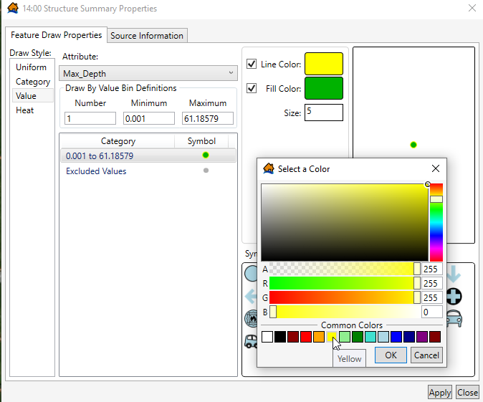
Figure 131 Structure Summary Properties – Editing the map properties
These map properties create an effect that highlights any structures that were inundated by more than 0.001 feet in the TAS Non-breach simulation. Four of the structures are on or just upstream of the dam itself. Zooming in it is apparent that these are not structure points that should be included in the LifeSim model.
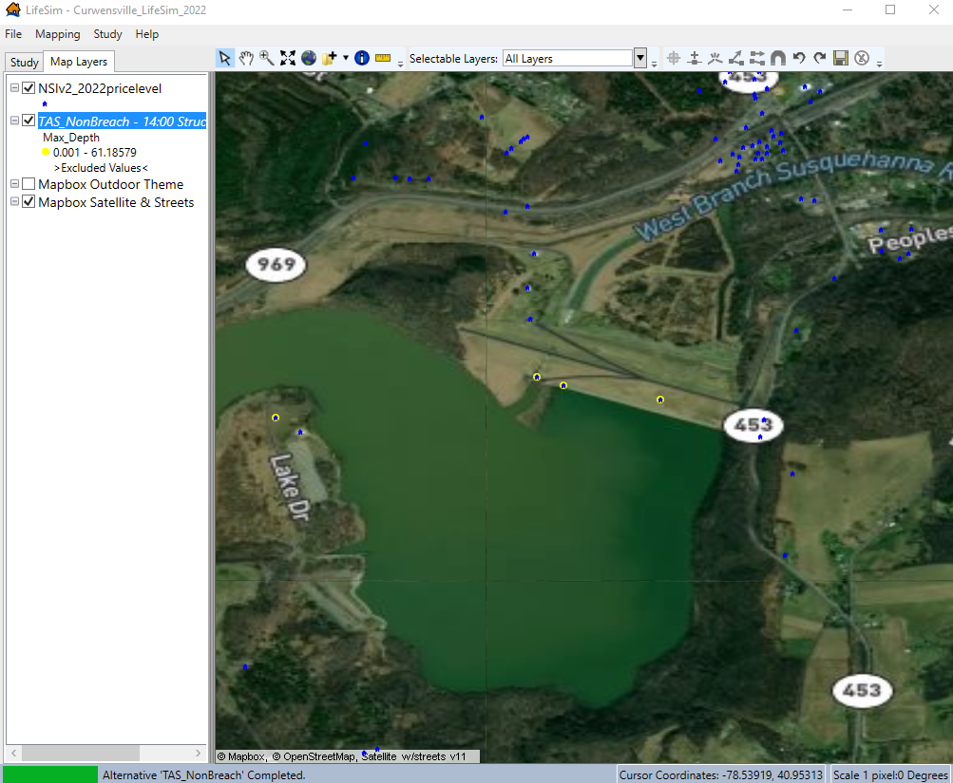
Figure 132 Map Window with the Structure Inventory and TAS_NonBreach Structure Summary shapefiles
The problem is addressed by editing the structure inventory. Right click on the inventory and select Edit.
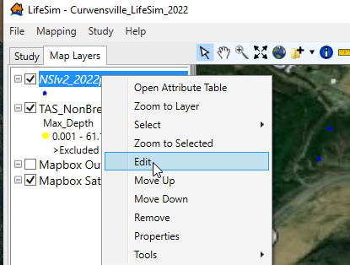
Figure 133 Editing the Structure Inventory from the Map Layers pane
Once edit is selected a new toolbar appears on the right side of the map buttons.
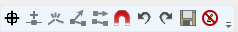
Figure 134 LifeSim Toolbar in the Map window
First the three points on the dam are selected by drawing a box around them.
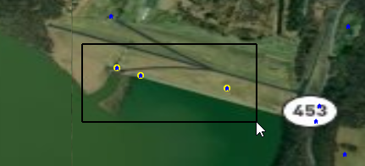
Figure 135 Selecting Multiple Structure Points in the LifeSim Map window
Hit the Delete key on your keyboard to delete the structure points. Directly west of these structure, across the lake, a highlighted structure point in an empty field can also be selected and deleted. The user can zoom out and scroll downstream to locate the other highlighted points that were damaged in the TAS non-breach, either deleting points if there are no apparent structures nearby without points or moving them to structures if possible. It can be helpful to uncheck the structure inventory layer display to help locate the yellow points. Structures can be moved by left clicking and holding down the button to drag the points to a new location as demonstrated in the figure below.
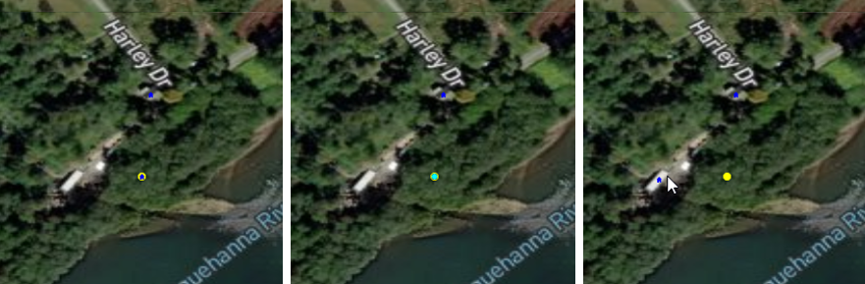
Figure 136 Deleting a Structure from your Structure Inventory
To finish editing, click on the Save button and then click on the Stop Editing button. Note that if saving results in an error about the number of records not matching, stop editing and remove the inventory from the map layer list, then add it to the display again from the study tree and verify and re-edit as necessary.
Figure 137 Saving your Structure Inventory Edits and How to Stop Editing
Editing the structure points impacted in the TAS Non-breach event represents a minimum level of structure inventory calibration that must be accomplished to avoid overestimating consequences due to structures not receiving a warning or structures being flooded deeper than they should be. There are some cases where a structure point is placed correctly but is still flooded due to either terrain inaccuracies or lack of low flow hydraulic model calibration. In these cases, the user must determine the most efficient and effective resolution which could include steps such as moving structures to compensate for the inaccuracies, using a double warning approach to ensure the structures get a warning in the model prior to inundation, or performing additional hydraulic model calibration. Some structure points may need to be moved outside of the structure footprint to compensate. Common examples of when this may be required are structures on a hillside where the uphill side is at ground level and the downhill side is raised on blocks or piers and floating structures attached to riverside docks (there are several examples of the latter along the Columbia River).
Once the TAS non-breach calibration is complete, edit the test simulation to select both the MH Breach Minimal Warning and the TAS Non-Breach alternatives, then run the simulation with those two alternatives and the inventory edits just completed. This second test will accomplish two important tasks: (1) it will verify that the TAS Non-breach event does not flood any structures and (2) it will provide the results needed to verify the attributes and locations of high consequence structures.
Once the simulation is complete, close the simulation then right click on TestSim and select View Results Tables. It should look like the figure below where the TAS_NonBreach alternative has zero structures inundated.
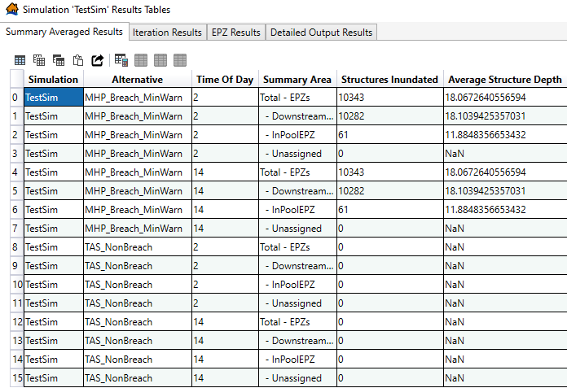
Figure 138 View Updated TestSim Results Tables
Close the table, right click on TestSim again, and select View Results Maps. Check the box next to the MHP Breach MinWarn 14:00 Structure Summary and click Send Selected to Map Window in the bottom right of the window. The map window will now contain a heat map of the daytime life loss for the MH MinWarn alternative.
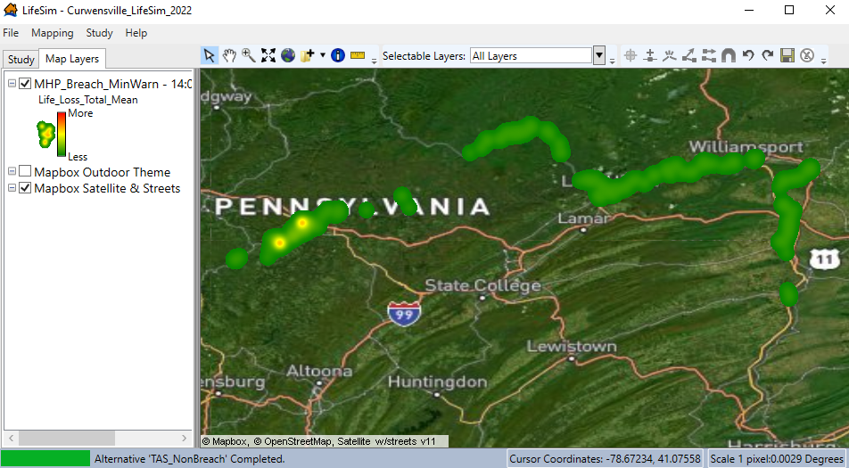
Figure 139 Mean Life Loss Heat Map
Life loss at individual structures can be checked by right clicking on the selection and opening the attribute table. Scroll the table halfway across to the field Life_Loss_Total_Mean, right click on the field name, and select Sort Descending. The first row will now be the structure with the highest mean life loss. Right click on the row number on the left and select Zoom to Selected to zoom to the structure area. Repeat the zoom a few more times to zoom to a close view of the structure.
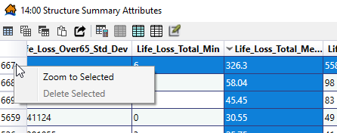
Figure 140 Zoom to Specific Structures from the Structure Summary Attribute Table
Now with the structure inventory displayed on top of the results map, right click on the inventory to open the attribute table. Move and organize both attribute windows to they can be seen, and then use the Select tool (white arrow) to select the structure with the high life loss. In the structure attribute table, click on the button to Show Selected Rows Only as shown in the figure below.
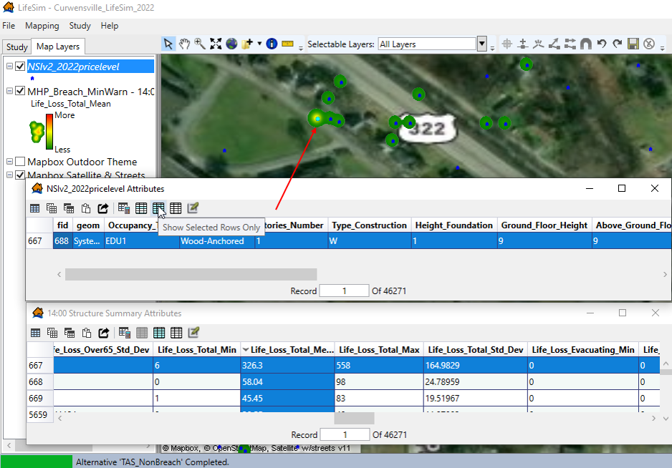
Figure 141 Identifying High Life Loss Structures in the Map Window
In this example, a significant portion of the life loss (22%) is occurring in a building with an occupancy type of EDU1, which is a school. The structure can now be investigated to determine whether the attributes and location are correct. The first obvious issues are that (1) the placement is incorrect based on the imagery and (2) the NSI lists the school as a single-story structure, while many schools are multiple stories.
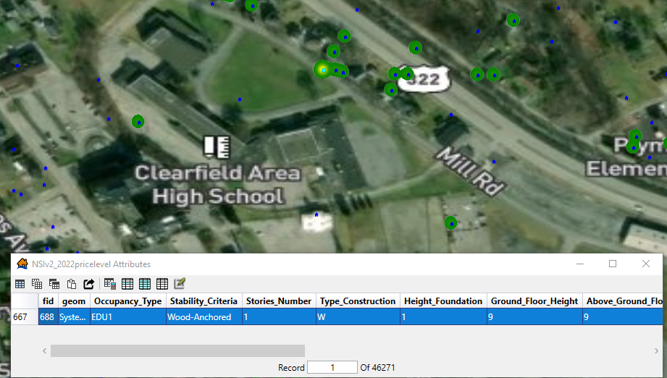
Figure 142 fid 688 (EDU1) structure attributes
Scrolling right on the inventory shows that there is a daytime under 65 population of 739, which should be the students and teachers combined. The structure can be moved based on the imagery, but to check the other attributes the school must be researched on the internet.
Google Maps and Streetview can typically be used to verify how many stories a building is if street view is available in the area. With a school, the school website also often has pictures which can be used to count stories. A Google Maps search for Clearfield Area High School will bring the user to a completely different school location than what is shown in the inventory and in the Mapbox satellite imagery in LifeSim, which poses a unique problem.
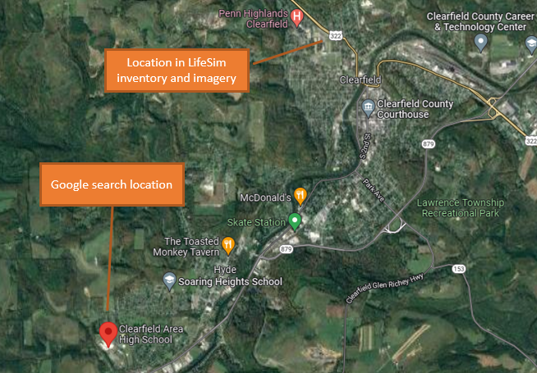
Figure 143 Google Maps Search Results for Clearfield Area High School
It’s helpful to crosscheck the stucture’s location by utilizing an alternate imagery source. LifeSim contains two streaming sources, MapBox and ESRI. The figure below shows the same area with Mapbox imagery on the left and ESRI imagery on the right.
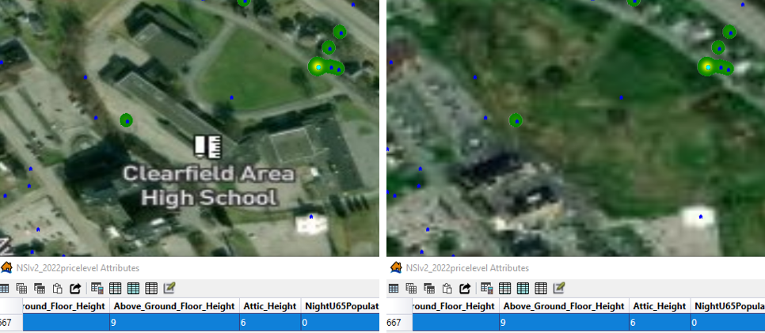
Figure 144 ESRI Imagery versus Mapbox Imagery
While the ESRI imagery is lower resolution, the school buildings are clearly not there, leading to the possibility that the school has been demolished. Additional news article searches verified that a new consolidated school was built and the school location in the structure inventory was the old school. The point can be moved to the new school location found in the Google Maps search, however, an inundation check shows that new location to be outside of the maximum inundation footprint, so the entire school point can be deleted instead of moved. Right click on the inventory layer in LifeSim and select Edit, then select the structure point, right click on it, and click Delete Selected Features. If the school was still operating in its original location, the point would be moved to the school structure and the number of stories would be changed to 3 stories.
Next look at the structures with the second highest mean life loss value by selecting that row in the MH_Breach_MinWarn attribute table (with the descending sort on the Life Loss Total Mean field). Right click on the row to zoom to the structure and it comes up as the Curwensville Area School District. Open the structure attribute table and select the structure and it will show two structures on the same point, both EDU1 schools.
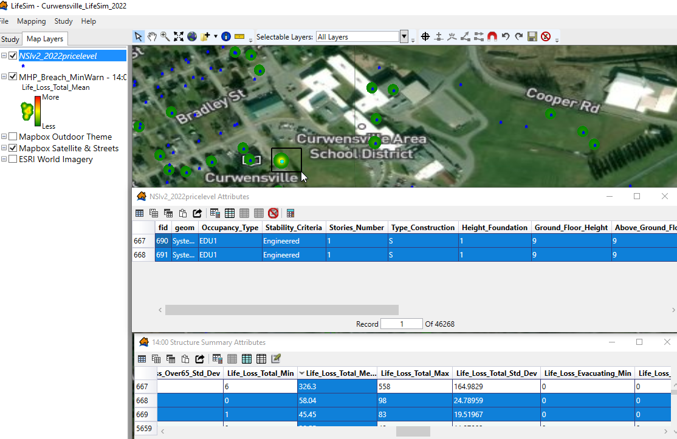
Figure 145 Investigating the second highest life loss structure for the MHP_Breach_MinWarn alternative
Right click on the inventory layer to edit. First, delete the residential structure points currently on the school or move them to any nearby residential structures that are missing points. Move the EDU points to the school (they can stay together because there is a high school and middle school in the same complex). Next perform an internet photo search to find pictures of the school to confirm the number of stories (this area did not have street view available). Photos show the school to be 2-stories, so change the number of stories.
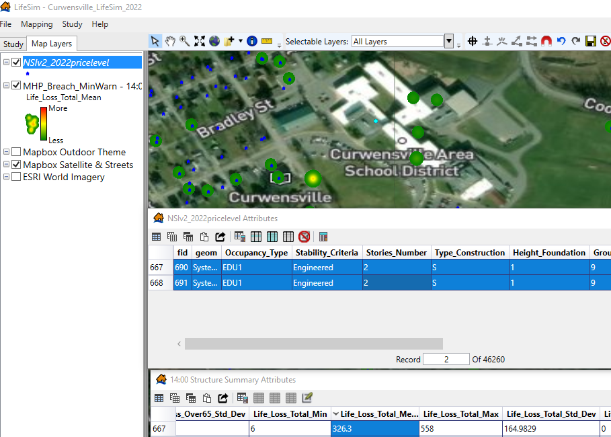
Figure 146 Updated structure attributes for the EDU1 structures (number of stories)
Save the edits and stop the editing session.
While further edits will not be detailed in this guide, additional calibration can be performed by scrolling along the inundated areas and looking for visual inventory issues such as misplacement in open fields or points too close to or inside the river itself. Attributes of selected structures can be edited by opening the attribute table of the structure inventory. Note that typically in dam breaches life loss is higher in areas closer to the dam due to the arrival time, and high consequence structures in both daytime and nighttime results should be checked and validated. The level of effort spent in calibrating the inventory depends on the scope and purpose of the study as well as the accuracy of the data used to create the structure inventory.
Once all structure edits have been completed, the three non-test simulations can be computed. Once complete, results can be viewed by right clicking on the simulations and selecting View Results Plots, Tables, or Maps. The results tables can be copied into Microsoft Excel and analyzed using pivot tables and formulas. Results can be displayed and compared by downstream reaches and city boundaries; additionally, the IHP and MHP results can be viewed by non-breach and breach EPZs.

(Page is intentionally left blank)

- Modeling Cascading Dam Breaches in LifeSim
  - Purpose
This chapter demonstrates the process for estimating consequences for a scenario in which multiple dams breach within the same modeling extents. An example of this is a dam breaching due to extreme inflow from an upstream dam breach. This chapter focuses on a breach at Oahe Dam, located along the Missouri River in South Dakota, and the other dams located downstream that could breach following a breach at Oahe Dam.
There are several dams downstream of Oahe Dam that are at risk of a cascading breach. The modeled cascading breaches (originally modeled by the Modeling, Mapping, and Consequences (MMC) Production Center of the U.S. Army Corps of Engineers’ (USACE) in 2022) include three other dams that could potentially breach: Big Bend Dam (85 miles downstream of Oahe Dam), Fort Randall Dam (192 miles downstream of Oahe Dam), and Gavins Point Dam (261 miles downstream of Oahe Dam). Since this example assumes there are three dams that breach following the initial Oahe Dam breach, there are multiple ways to model this scenario in LifeSim.
This chapter focuses on two options: (1) warning the entire downstream area relative to the Oahe Dam breach and (2) warning the in-pool area, areas downstream of Oahe Dam, and areas downstream of Big Bend Dam relative to the Oahe Dam breach, as well as warning areas downstream of Fort Randall Dam and Gavins Point Dam relative to the Fort Randall Dam breach. Another modeling option that is not detailed in this chapter is warning areas downstream of specific dams relative to specific dam breaches (e.g., Warn the population between Oahe Dam and Big Bend Dam relative to the Oahe Dam breach, warn the population between Big Bend Dam and Fort Randall Dam relative to the Big Bend Dam breach, etc.).
  - Input Data and Pre-Processing
The subsequent sections discuss the input data required to calculate damages and life loss for a cascading dam breach. Most of the input data remains similar to the non-cascading dam LifeSim modeling (see the Dam Applications Chapter for more information). The subsequent sections discuss hydraulic data, emergency planning zones (EPZ), structure inventories, creating alternatives, and simulating alternatives.
    - Hydraulic Data
Importing hydraulic data for a cascading dam breach follows the same process as importing hydraulic data for a standard dam breach. Although there are multiple hazard occurrence times (i.e., multiple dam breaches), LifeSim currently only allows the user to select one hazard occurrence time. For cascading dam breaches, the most upstream dam is often the focus of the dam safety study. To model cascading breaches, it is easiest to select the hazard occurrence time based on the upstream dam breach, which is Oahe Dam in this example.
Fort Randall Dam will have a separate breach time, but this will come into play when selecting warning times for the EPZs rather than the hazard occurrence time (if using Option 2 discussed in the Purpose section). Similarly, for all LifeSim models, the hazard occurrence time is the first step in the warning and evacuation timeline. The imminent hazard identification times in the alternatives are relative to the hazard occurrence time selected for each hydraulic scenario. This is discussed in more detail later in the Alternatives section.
    - Structure Inventory
The structure inventory for a cascading dam breach is the same inventory used for standard hydraulic scenarios (i.e., the breach of only Oahe Dam). However, if the cascading breaches scenarios are tacked on later in the study/modeling process, the structure inventory may need to be expanded as these inundation boundaries are larger than those from the Oahe Dam breach alone. If you have the cascading breach inundation boundaries from the start of the study, it is recommended to use the highest loading breach scenario with cascading breach to select the structure inventory. Including a buffer on this inundation boundary is recommended to accommodate any changes to the hydraulic model.
    - Emergency Planning Zones
EPZs are a key input that are likely to differ for a cascading dam breach scenario. There are two EPZ options for this type of event: (1) use the same double warning EPZ as the standard hydraulic scenario (see the Dam Applications Chapter) and (2) create a new double warning EPZ that includes a separate zone(s) for the area(s) downstream of a cascading dam breach(es).
Option 1 is recommended if you believe the entire downstream area would be warned relative to the upstream dam breaching. Option 2 is recommended if you believe portions of the downstream area would only receive an evacuation order following the breach of a downstream dam (i.e., the population and emergency managers view the risk of the downstream dam breaching as low; they also believe risk is low following the upstream dam breach).
For the Missouri River dams downstream of Oahe, it is possible that emergency managers believe Big Bend (85 miles downstream of Oahe Dam) is at higher risk for breaching since it is within 100 miles of the dam. However, emergency managers in areas downstream of Fort Randall Dam may initially believe the dam will not breach. They would then send out a warning much closer to when Fort Randall Dam breaches compared to when Oahe Dam breaches. The rest of this chapter focuses on modeling Option 2 and separating the EPZ at Fort Randall Dam.
      - Modeling Option 2: Creating a New Double Warning EPZ
To model the cascading breach following modeling Option 2, you need to first create a double warning EPZ that includes a separate zone for downstream of Fort Randall Dam. The base shapefile of any cascading breach EPZ is the non-cascading double warning EPZ; the non-breach flows remain the same between a cascading breach and non-cascading breach. The easiest way to do this is to duplicate the existing double warning EPZ / save the existing double warning polygon as a new shape. Then, begin an edit session in ArcGIS on the duplicate double warning shapefile, cut the polygon at Fort Randall Dam, edit the attribute table to include an appropriate name (e.g., FtRandall_Downstream), and save edits.

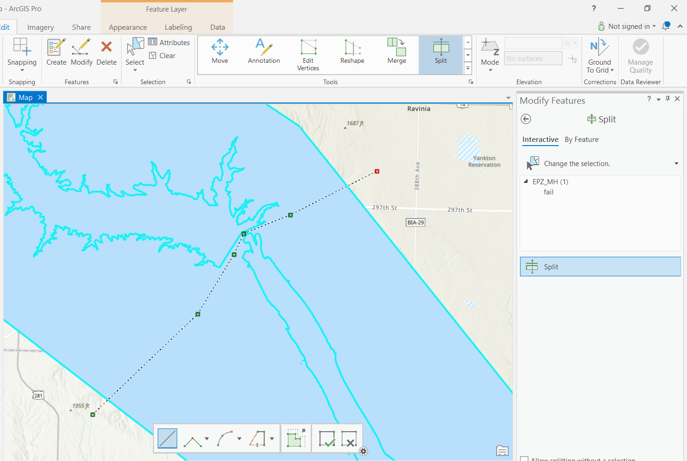
Figure 147 Splitting the existing MHP EPZ double warning shapefile at Ft. Randall Dam
Then, import the new shapefile into LifeSim with an appropriate name; Figure 148 exemplifies different EPZ names, including an EPZ specifically for modeling Option 2: MHP_breach_casc_FtRandall_Warn.
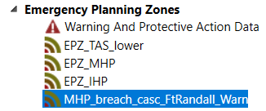
Figure 148 EPZ naming examples
    - Alternatives
Creating and setting up alternatives in LifeSim varies significantly depending on which modeling method you are using. Both modeling options are detailed in the subsequent sections.
      - Modeling Option 1: Warning Relative to Oahe Dam Breach
For Option 1, the cascading dam breach alternative is almost identical to the standard hydraulic scenario. As shown in the figures below, the only difference in the alternatives is which Hydraulic Event is selected (non-cascading breach, labeled “NC”, versus cascading, labeled “C”, breach). Both use the Maximum High Pool (MHP) double warning EPZ, the same structure inventory, and the same Imminent Hazard ID Times.
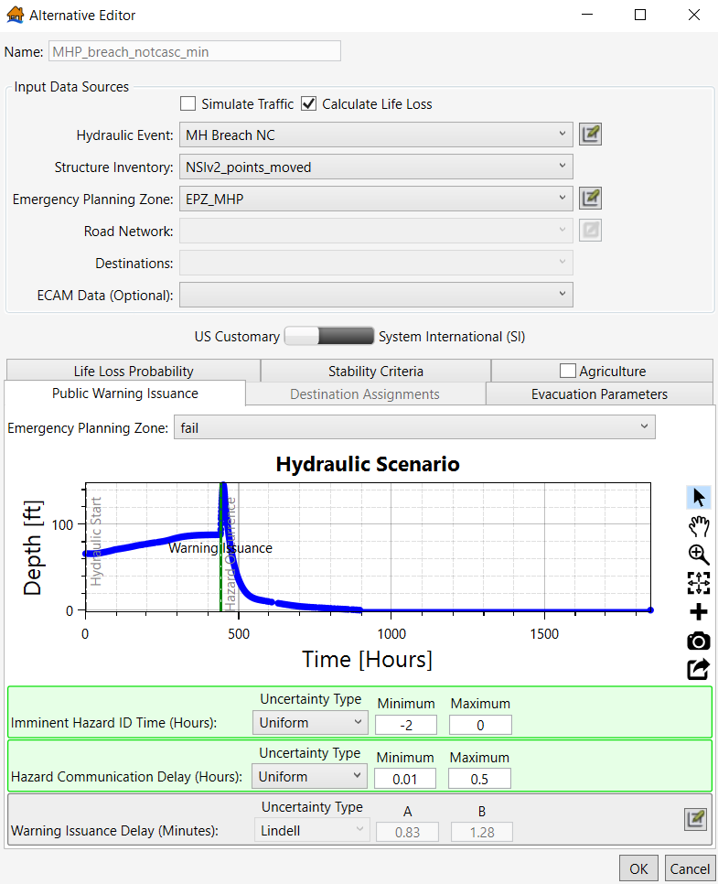
Figure 149 MHP NonCascading Breach Minimal Warning Alternative
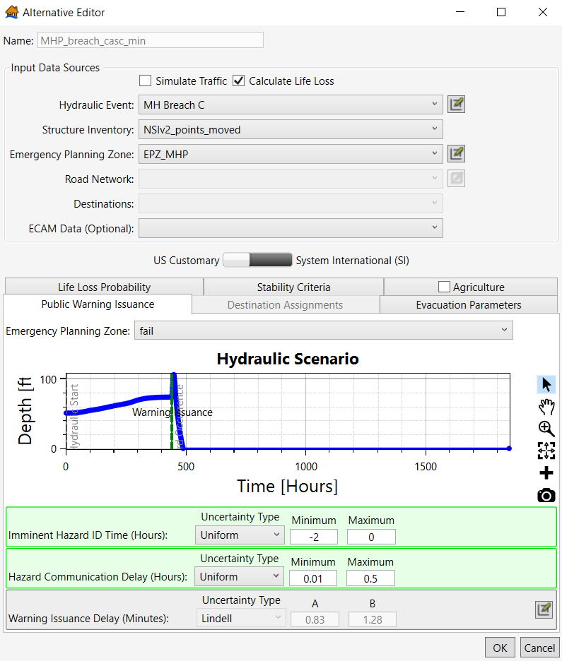
Figure 150 Modeling Option 1: MHP Cascading alternative for Option 1 Breach Minimal Warning alternative
      - Modeling Option 2: Warning Areas Relative to Specific Dam Breaches
For Option 2, first you need to use the new double warning polygon that was created for the cascading dam breaches. The only difference between the two EPZs will be that the polygon is cut at the cascading dam (i.e., Fort Randall Dam). The separate zones are necessary in order to include different Imminent Hazard ID Times relative to 1) Oahe Dam breaching and 2) Fort Randall Dam breaching.
For Option 2, the key difference is warning the areas downstream of the other dam breach (e.g., Fort Randall Dam) relative to its hazard occurrence time (i.e., overtopping or breach time). The hydraulic engineer can provide the downstream dam’s breach time and/or overtopping time. Recall, however, that LifeSim can only have one hazard occurrence time per hydraulic scenario. A cascading dam breach has multiple hazard occurrence times; one for each dam that overtops/breaches in the scenario. To account for the hazard occurrence time of Fort Randall Dam breaching, the Imminent Hazard ID Time needs to be calculated to warn areas downstream of Fort Randall Dam relative to when it breaches. To obtain this information, calculate the time difference (in hours) between the two dams breaching (shown in green in the following table).

Table 2 Hazard occurrence times for Oahe Dam and Fort Randall Dam
Hydraulic Timing Information
Event | Oahe Dam Breach Initiation |  | Fort Randall Dam Breach Initiation |  | Ft Randall Breach Time relative to Oahe Dam Breach Time (Hours)
Event | Date | Time | Date | Time
Maximum High Pool | 21 FEB 2099 | 8:00 | 22 FEB 2099 | 0:00 | 16.00
Intermediate High Pool | 20 FEB 2099 | 16:00 | 21 FEB 2099 | 8:00 | 16.00
Top of Active Storage | 21 FEB 2099 | 16:00 | 22 FEB 2099 | 12:30 | 20.50
Security Scenario Pool | 20 FEB 2099 | 2:00 | 21 FEB 2099 | 22:30 | 44.50
Normal High Pool | 04 FEB 2099 | 0:00 | 04 FEB 2099 | 22:00 | 22.00

From here, you can determine the Imminent Hazard ID Times for the various warning scenarios. The following table shows the calculated Imminent Hazard ID Times for the Downstream of Fort Randall EPZ. The warning times shown below warn the population downstream of Fort Randall Dam between 2 hours prior to breach and the time of breach (minimal warning) and 6 hours prior to breach to 2 hours prior to breach (ample warning) -- relative to the time of Fort Randall Dam’s breach initiation.

Table 3 Imminent hazard ID times for the Downstream area of Fort Randall Dam EPZ
Imminent Hazard ID Times for the Downstream of Fort Randall Dam EPZ
Event | Minimal Warning Time |  | Ample Warning Time
Event | Min | Max | Min | Max
Maximum High Pool | +14 | +16 | +10 | +14
Intermediate High Pool | +14 | +16 | +10 | +14
Top of Active Storage | +18.5 | +20.5 | +14.5 | +18.5
Security Scenario Pool | +42.5 | +44.5 | +38.5 | +42.5
Normal High Pool | +20 | +22 | +16 | +20

Implementing the warning times from Table 3 into your alternatives is shown in Figure 151 and Figure 152. The figures show the Maximum High Pool cascading breach. As shown in the figures, the “DS_Oahe_Fail” EPZ is assigned the standard time of -2 to 0 hours. The “DS_FtRandall_Fail” EPZ is assigned the calculated time of +14 to +16 hours. Again, the +14 to +16 hours is relative to the hazard occurrence, which is Oahe Dam’s breach initiation time.
If you are unsure of which modeling method to use, implement both methods in the study to understand how the different EPZs impact life loss results.
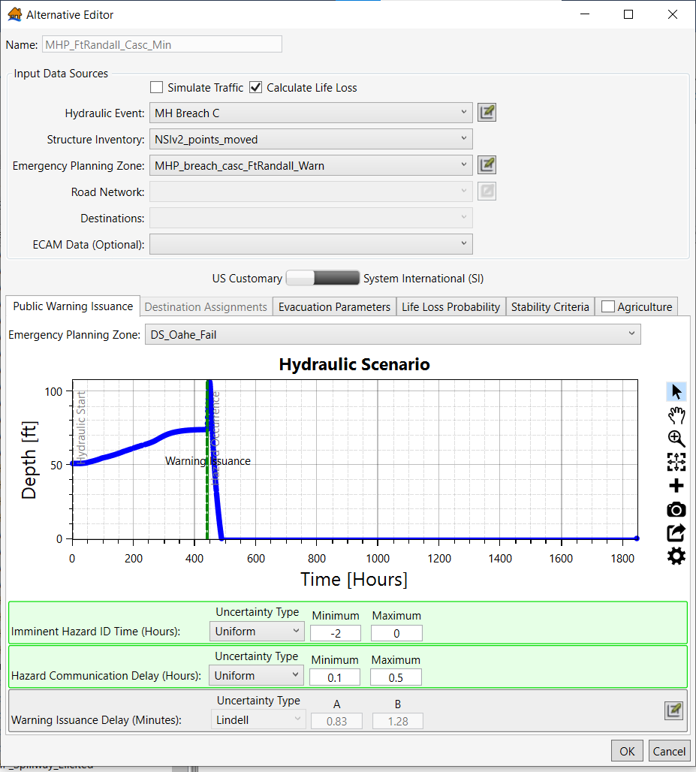
Figure 151 Modeling Option 2: MHP Cascading Breach Minimal Warning Alternative – Warning for areas between Oahe Dam and Ft Randall Dam

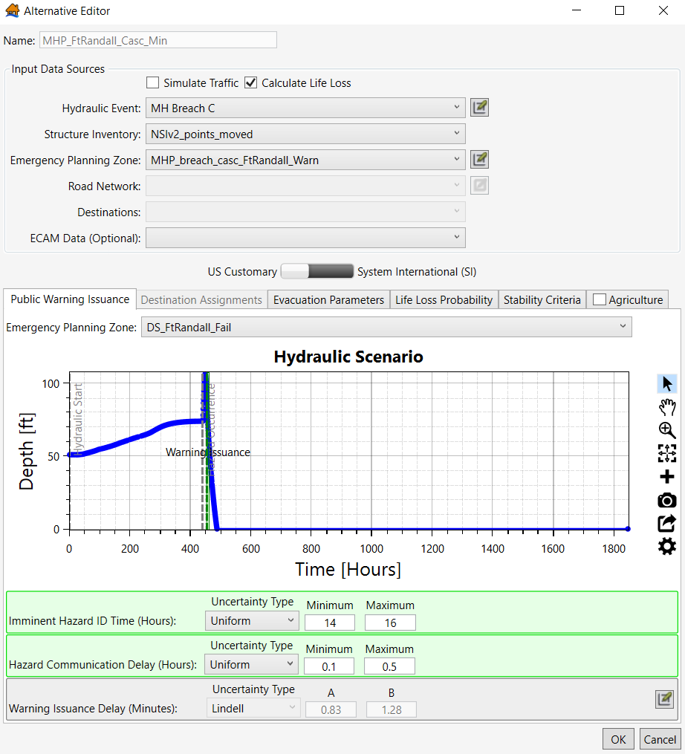
Figure 152 Modeling Option 2: MHP Cascading Breach Minimal Warning alternative – Warning for areas downstream of Ft Randall Dam relative to Ft Randall’s breach time
As previously mentioned, an additional modeling method is to warn the populations separately downstream of each dam (e.g., the EPZ would include a zone downstream of Oahe Dam, a zone downstream of Big Bend Dam, a zone downstream of Fort Randall Dam, and a zone downstream of Gavins Point dam—each with imminent hazard ID times calculated based on the respective dam’s breach initiation relative to the Oahe Dam’s breach initiation time.). The local emergency managers and dam operators may have a general understanding of how they would respond to a breach of an upstream dam, including if/when they would send out evacuation orders. This type of information can help inform which LifeSim modeling method is most appropriate for your study’s cascading dam breach scenarios.
    - Simulations
For both modeling options, creating a simulation and running it follows the same standard practice. Reference the Estimating Consequences for Dams Chapter for more detailed information on creating simulations. The only additional reporting consideration is if you want to include unique summary polygons. For example, it may be beneficial to summarize results by dam breach area (e.g., one area between Oahe Dam and Fort Randall Dam and another area for everything downstream of Fort Randall Dam, etc.) If you created new EPZs for the cascading dam breach, these shapefiles may be used as the summary polygon.

(Page intentionally left blank)

- Estimating Consequences for Coastal Infrastructure
  - Purpose
This example demonstrates the process for estimating consequences for coastal levees, floodwalls, dune and/or seawalls in LifeSim. The general process is similar to estimating consequences for riverine levees, but there are modeling nuances and warning and evacuation considerations specific to infrastructure in a coastal environment. This chapter includes step-by-step instructions (often referring to the Levee applications chapter) for importing the required data into LifeSim, choosing appropriate warning and evacuation data for a study area, and interpreting modeling results. The Coastal Infrastructure chapter focuses on South Shore Staten Island (SSSI) modeling that was conducted in 2020 by the Risk Management Center to support a risk-informed design (RID) risk assessment. This RID risk assessment took place after the planning process was complete for the SSSI Coastal Storm Risk Management planning study. The proposed SSSI Levee includes segments of buried seawalls, levees, and floodwalls.
  - Input Data
The subsequent sections discuss the input data required to calculate economic damages and life loss for coastal infrastructure in LifeSim. The input data sections, many of which simply refer to the Estimating Consequences for Levees and Floodwall Chapter, include hydraulic data, emergency planning zones (EPZ), structure inventories, road networks, destinations, creating alternatives, and simulating alternatives. For reference, Figure 153 through Figure 155 below show the SSSI levee and seawall breach locations, structure inventory, and road network and destinations, respectively. Refer to these figures for context regarding later sections in this chapter.
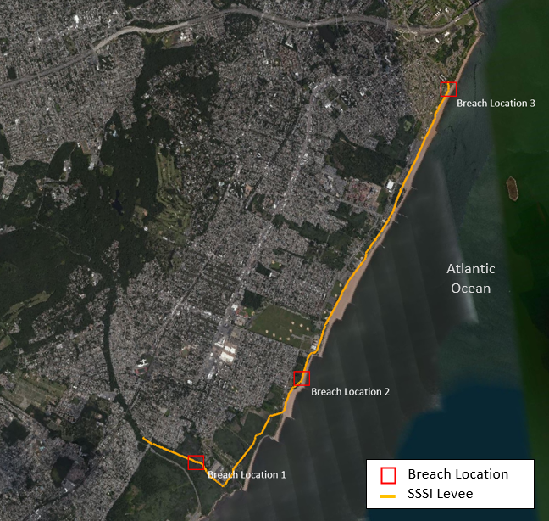
Figure 153 SSSI breach locations
Breach Location 1 in the above figure is the Levee Control Location (LCL). This is the lowest section of the proposed levee and will likely overtop first in most cases. Oceanic wind/wave patterns (discussed further in the ‘Importing HEC-RAS Data’ section), however, can sometimes lead to overtopping at a different location where levee elevations are higher. Breach Locations 2 and 3 which breach the proposed buried seawall were selected by the USACE New York District]. These sections of the proposed project were also analyzed for wind/wave-overtopping.
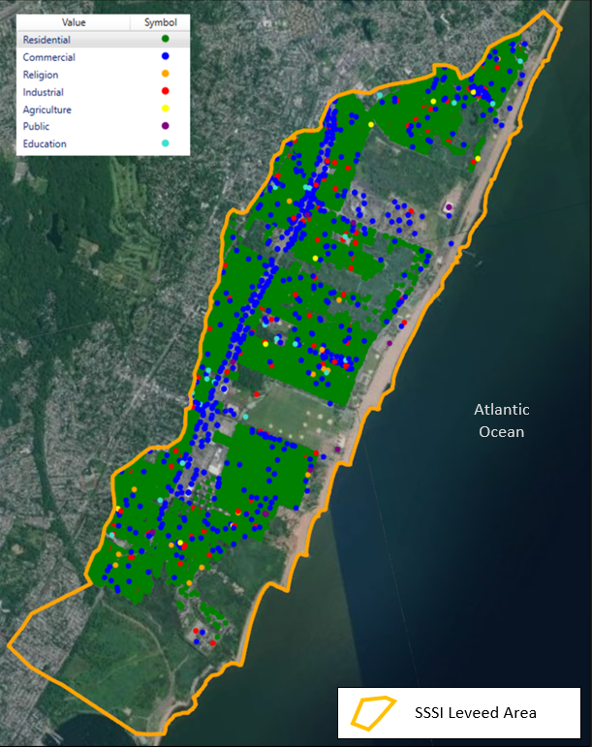
Figure 154 SSSI structure inventory
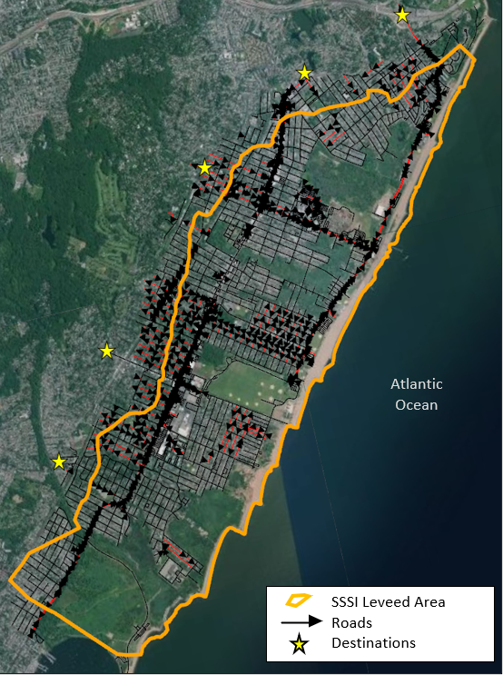
Figure 155 SSSI road network and destinations
With hurricanes being the assumed source of inundation to coastal levees in the form of storm surge, local emergency managers would likely recommend a shelter-in-place action to those who were unable to or decided not to evacuate well before this non-evacuation depth occurs. As there is no current mechanism to stop the evacuation process at a particular time step (i.e., when high wind speeds or significant rainfall prevent mobilization at a time preceding storm surge landfall), a LifeSim model utilizing evacuation on roads could simulate vehicles on roadways and exposed to inundation when these last-minute evacuations do not commonly occur.
    - Hydraulic Data
When using Hydrologic Engineering Center’s River Analysis System (HEC-RAS) data as LifeSim input, the hydraulic data should be in the form of Hierarchical Data Format (HDF) files so the user can easily simulate evacuation when necessary. Unlike riverine/inland levees or floodwalls, simulating evacuation in a coastal environment may not be a critical part of estimating direct life loss. In most cases, life loss on roads in a coastal context where the source of inundation is most associated with an infrequent storm event (e.g., hurricane) is not expected to be the primary risk driver. Lead times for these types of events are generally expected to be greater than 24 hours (e.g., hurricane tracking begins several days prior to the storm reaching landfall). For scenarios where lead times are expected to be relatively short, the option to simulate evacuation is still available to the user when HDF files are utilized. The HEC-RAS plan HDF file and the HEC-RAS terrain HDF file are needed for each hydraulic scenario where evacuation is simulated.
      - Import HEC-RAS Data
Importing HEC-RAS data for coastal levees or floodwalls is generally the same as described in the Levee applications chapter. It remains important to understand where and when water is entering the leveed area to best establish the Hazard Occurrence time in LifeSim. For levees in a coastal setting, the team must be able to distinguish the source of water (i.e., breach flow, rainfall, flanking, or wind/wave-overtopping). If, for example, wind/wave-overtopping during a storm surge leads to water entering the leveed area prior to a levee or floodwall breach, the time of wind/wave-overtopping will be set as the Hazard Occurrence time in LifeSim. This should be discussed at length with the team’s hydraulic engineer.
The figure below shows an example wind/wave-overtopping hydrograph from the SSSI LifeSim model. Note that the Hazard Occurrence time (red dashed line in Figure 156) aligns with the wind/wave combination that led to a peak depth capable of overtopping the levee at the selected location (red circle in the map window in Figure 156).

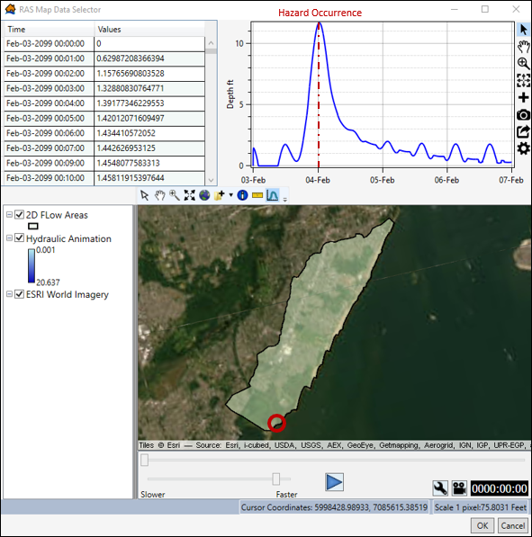
Figure 156 Example SSSI wave/wind-overtopping hydrograph
    - Emergency Planning Zones
Refer to the Estimating Consequences for Levees and Floodwalls Chapter for establishing the EPZ for your coastal infrastructure. It is again recommended to discuss what should be considered the leveed area with your hydraulic engineer and potentially other team members.
Multiple EPZs may be required to account for different evacuation assumptions related to hurricane events. For example, consider a situation where effective evacuation is unlikely and the affected population must shelter-in-place. This would mean the maximum mobilization rate parameter in LifeSim would be set to 0%, or some other static rate if some amount of shadow evacuation (evacuation without a direct order to do so) is assumed. A new EPZ will be generated each time the warning and protective action data is customized according to the assumed event (e.g., The user needs 3 EPZs to account for different mobilization assumptions: one EPZ to show 100% of the population shelters-in-place, one EPZ to show a 10% shadow evacuation, one EPZ with standard mobilization assumptions).
Figure 157 below shows the adjusted SSSI shelter-in-place EPZ parameters in the Warning and Protective Action Data Editor. To access this data editor, right-click the Warning and Protective Action Data subheading just below the ‘Emergency Planning Zones’ heading in the study tree. Select “Edit Warning and PAI Data”. Under the ‘Protective Action Initiation’ tab of the data editor, click the green plus sign to add a custom distribution.

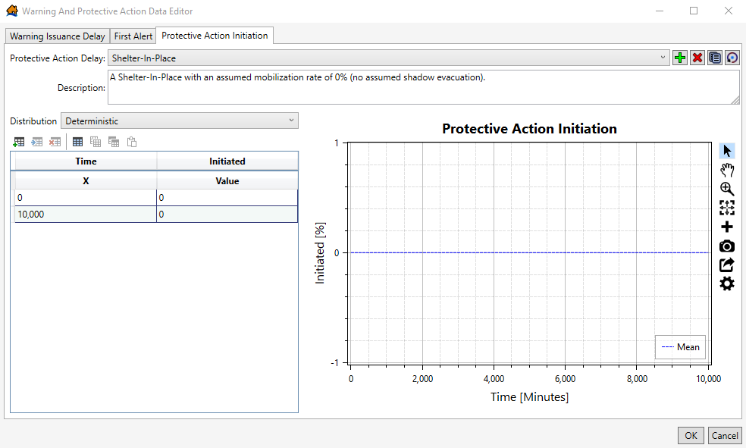
Figure 157 Shelter-In-Place Protective Action Initiation curve
In the above figure, a deterministic distribution was selected from the dropdown and the table just below.The Time and Initiated fields can be edited. According to Figure 157, after 10,000 minutes, 0% of the affected population will have initiated evacuation in the simulations where this new Shelter-In-Place EPZ is used. If, however, 10% of the affected population has evacuated in previous disasters despite a shelter-in-place order, change both ‘Initiated’ values to 10 instead of 0.
      - Using Existing Data to Inform LifeSim Parameters
Refer to the Estimating Consequences for Levees and Floodwalls Chapter if using existing consequences elicitation data, the Levee Safety Tool, or Emergency Management Agency Websites to inform LifeSim parameters. Many counties and major metropolitan areas along the coasts publish evacuation plans for large storm events on their own websites. These evacuation plans should be considered when selecting warning and evacuation parameters in the EPZ(s) and in the evacuation inputs (if applicable).
For example, in relation to the SSSI coastal storm study, the New York City official website (NYC.gov) is linked to the NYC Emergency Management Department site. Here, users can learn about specific disaster plans in their area. Figure 158 below shows the home page of the NYC Emergency Management website.

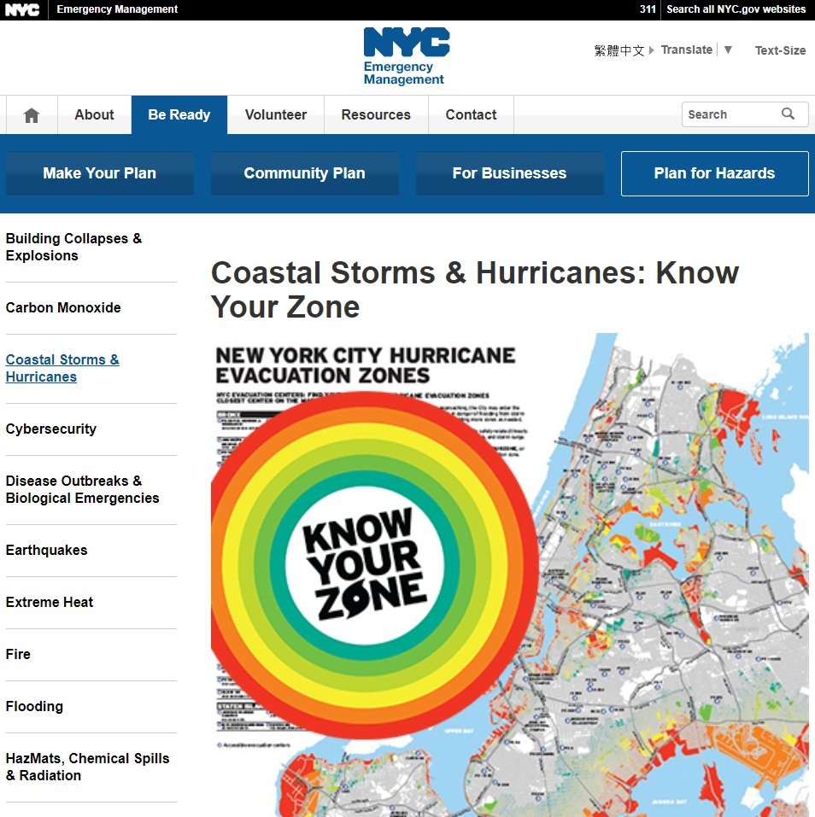
Figure 158 New York City Emergency Management website
After scrolling down within the ‘Coastal Storms and Hurricanes’ page depicted in Figure 158, website users have access to the information shown in Figure 159 below.
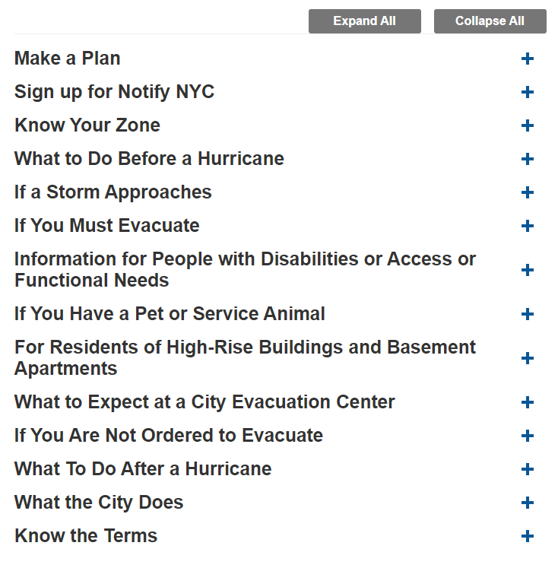
Figure 159 Available coastal preparedness information to site users
Many coastal emergency management websites are organized similarly to Figure 159. To inform the LifeSim model, it is important to understand who is receiving the order, what they are being told to do, and when they will be told to do it. ‘Know Your Zone’ (often called something similar across emergency management sites) is typically the best place to start. Coastal cities or counties usually evacuate by numbered and color-coded zones based on storm surge, forecasted storm conditions, or wind/wave patterns. Figure 160 below shows an overview of the Staten Island hurricane evacuation zones.
Notably, it is currently not recommended to include evacuation centers or shelters as Destination Points in LifeSim. As of 2024, there is no way to assign a maximum number of persons allowed at a destination point, so this type of assumption likely overestimates the amount of people that could evacuate to “shelter locations” in LifeSim. Generally, Destination Points are meant to represent egress routes, not final shelter locations.
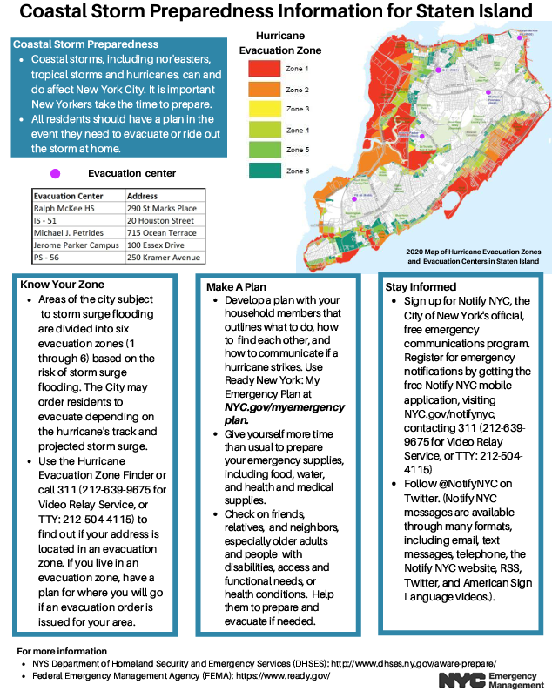
Figure 160 Coastal storm preparedness information for Staten Island (PDF)

An additional EPZ can be created in which the evacuation zones are delineated. Figure 161 below shows both the general EPZ in the SSSI LifeSim model map window and the hurricane evacuation zones from the NYC emergency management website. The latter will be used (visually) to split the general EPZ polygon in GIS software or the LifeSim model. Refer to the Estimating Consequences for Dams Chapter for creating and editing an EPZ in GIS software.
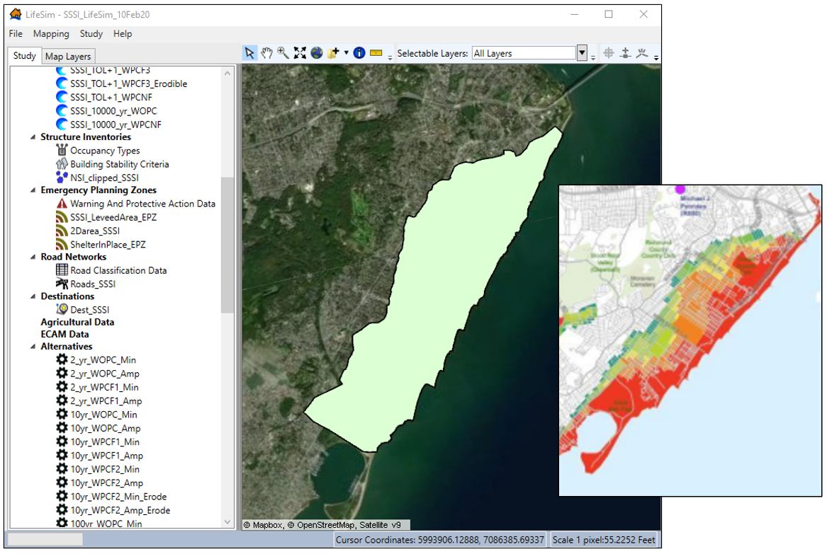
Figure 161 SSSI EPZ in LifeSim and evacuation zones
Understanding the thresholds used to evacuate each zone is the next piece of the puzzle. If, for example, a 2ft storm surge will lead to the evacuation of Zone 1 (red) nearest the coast, the LifeSim modeler will need to communicate with the team’s hydraulic engineer and decide when this threshold is reached in the model. The same process will be applied to each zone until the hazard occurs (e.g., breach or overtopping).
      - Importing an Emergency Planning Zone
Refer to the Estimating Consequences for Levees and Floodwalls Chapter for instructions to import an EPZ into LifeSim.
    - Structure Inventory
To use LifeSim to calculate life loss and/or economic damages, a structure inventory needs to be imported into the study. For levees and floodwalls, whether in a riverine or coastal setting, the structure inventory should be limited to including structures within the leveed area. Otherwise, it’s possible that both economic damages and life loss estimates would be inflated due to including structures that are outside of the leveed area. Additionally, LifeSim will not simulate if any structure points are located outside of the EPZ. The National Levee Database (https://levees.sec.usace.army.mil/) is a resource that often includes the estimated leveed area (including coastal structures), which can be downloaded as a shapefile and used in LifeSim. It’s also recommended to communicate with the hydraulic engineer when establishing a protected/leveed area.
      - Importing a Structure Inventory
Refer to the Estimating Consequences for Levees and Floodwalls Chapter to import a structure inventory into LifeSim.
      - Editing the Structure Inventory
Refer to the Estimating Consequences for Levees and Floodwalls Chapter to edit the structure inventory. Structures attributes, specifically foundation heights and construction types, may need additional adjustments in a coastal setting. General structure inventory assumptions may be less applicable in these areas. Figure 162 below shows three structures with foundation heights that needed to be edited in the SSSI LifeSim model.
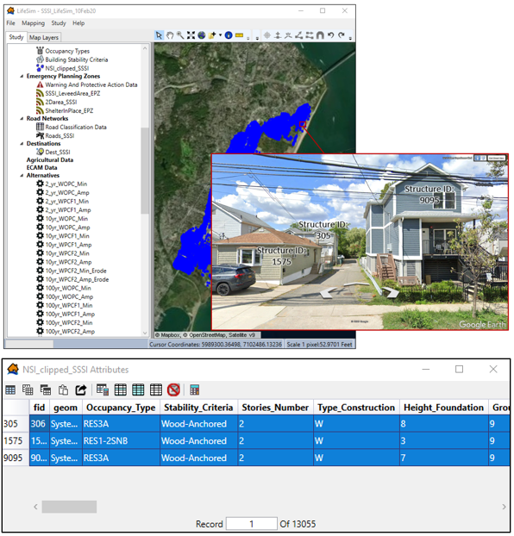
Figure 162 Adjusted foundation heights in the SSSI LifeSim model
If the NSI base level data lack structure-specific data sources, some values will be generalized across larger areas (e.g., census block or tract). In the above case, these three structures’ (structures 305, 1575, and 9095) foundation heights were increased from 1.5ft to show that the structures’ first floors are elevated. Moving inland, the terrain elevation increases in this area, leading to a lower assumed foundation height across the tract. If the general NSI foundation heights were 1-foot for all three structures where terrain elevation is lower, for example, much lower flood depths would result in the non-evacuated PAR getting “caught” in their structure and sampled for life loss. Because the structures shown in the figure above are elevated, it’s possible that the PAR in these structures could safely shelter-in-place and life loss would not be sampled. When foundation height errors like this example are aggregated across a shoreline, life loss estimates can potentially be inflated. It is important to spend adequate time adjusting structure attributes, especially in a coastal setting.
    - Simulating Evacuation
For most riverine or other inland levee projects, evacuation is simulated in LifeSim. In a coastal context, however, evacuation may not be a crucial element to the LifeSim model. Life loss on roads in a coastal environment where the source of inundation is most associated with a hurricane event is not expected to be the primary risk driver. Since forecasted lead times before hurricane landfall (or imminent hazard identification time) are expected to be no less than 24 hours, protective action initiation rates used in the LifeSim modeling are most likely to be the primary risk driver. This expected lead time prior to the hurricane landfall enables both the warning issuance delay and first alert parameters to sample approximately 100% (i.e., the entire population receives a warning), even when incorporating uncertainty distributions. The sampled protective action initiation parameter primarily drives the life loss estimates.
If it is decided for certain scenarios that simulating evacuation is necessary (most often for events with relatively short lead times), a road network and destination points will need to be imported. Without these two components, it is not possible to simulate evacuation. The recommended workflow is to begin with importing a road network and then create destination points.
      - Road Network
Refer to the Estimating Consequences for Levees and Floodwalls Chapter to import and edit a road network in LifeSim.
      - Destination Points
Refer to the Estimating Consequences for Levees and Floodwalls Chapter to create, import, and edit destination points in LifeSim. When simulating evacuation to look for potential choke points, reference the area’s evacuation plans (e.g., zones and routes) when placing destination points. As stated earlier in the chapter, the destination points should not reflect shelter locations; the points should represent major egress routes that lead to safety.
    - Creating Alternatives
Refer to the Estimating Consequences for Levees and Floodwalls Chapter for general information on creating alternatives in LifeSim. However, there are additional considerations when creating alternatives for a coastal model. Much like with riverine levees, there is a warning and delay continuum the PAR may be subjected to. Given limited time and resources, it is important to leverage LifeSim in a way that captures a range of possible outcomes.
Similar to inland levees and floodwalls, the relative hazard identification time should be reflective of the community’s ability to monitor the project (consider storm conditions), how early the event could be forecasted in advance (usually early for coastal storm events), and the type of failure mode (e.g., the emergency managers would have little time to identify a rapidly developing breach, so the relative hazard identification time would be close to the time the hazard occurs).
163 shows an example alternative representative of a situation in which either the hazard occurs relatively quickly, or emergency managers have waited to warn the impacted population (hazard identification between 3 hours prior to its occurrence and 30 minutes after). In the example below, this warning may be appropriate for a 0.5 Annual Exceedance Probability (AEP) event as this is a frequent event with potential to impact very few people. It’s possible the “warning” would only be based on the population self-warning relative to when they see floodwaters.
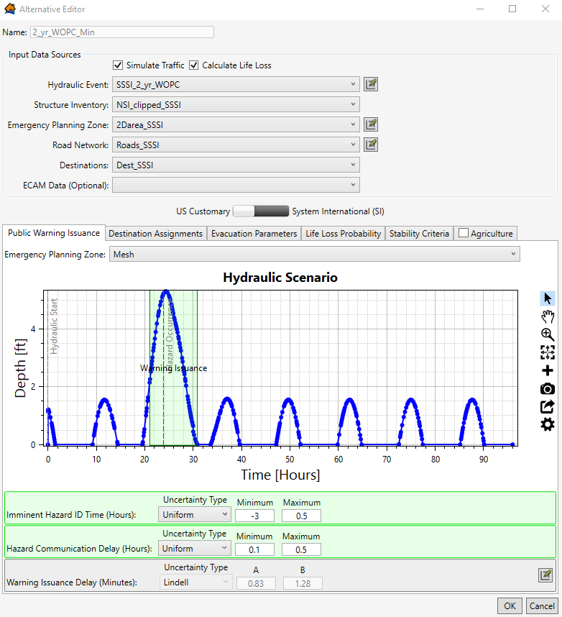
Figure 164 Example of a minimal warning alternative from the SSSI Study
You can create multiple alternatives for each hydraulic scenario with various warning times if there is uncertainty surrounding the relative hazard identification time. This provides a range of possible life loss outcomes. Figure 165 shows an example using the same hydraulic event but with more optimistic warning assumptions (hazard identification 24 hours prior to its occurrence). As shown in the hydrograph, the depths do exceed 4ft, which could result in life threatening flooding. It’s possible that even this frequent of an event would be forecasted in advance.
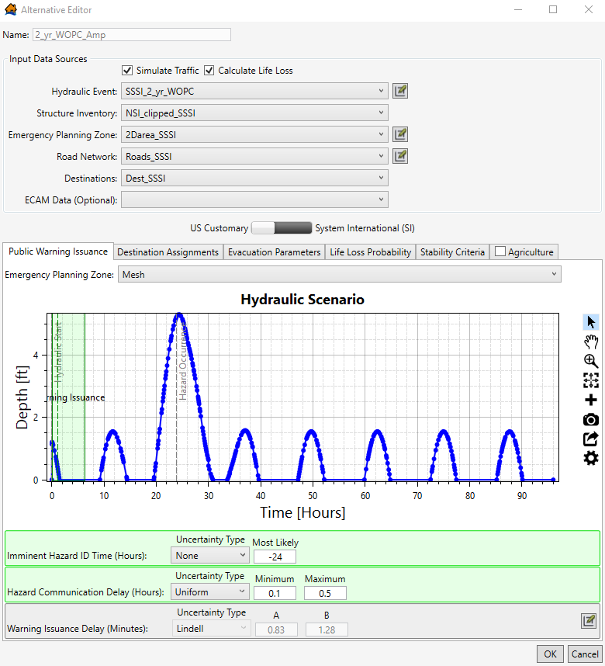
Figure 165 Example of an ample (somewhat optimistic) warning alternative from the SSSI Study
It is not uncommon for evacuation orders to be given days prior to the event in a coastal environment. Figure 166 shows a far more optimistic, or “optimal”, warning alternative for the same SSSI hydraulic event depicted in 163 and Figure 165.
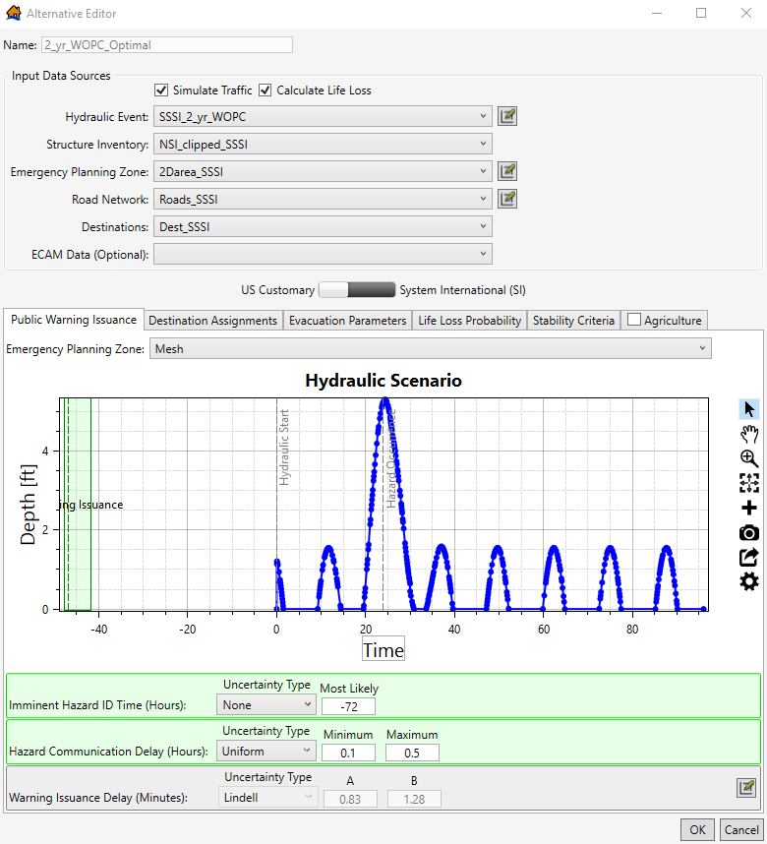
Figure 166 Example of an optimal warning alternative from the SSSI Study
If events like the ones being modeled have previously occurred, adjust the alternative parameters to reflect either what happened or what will likely happen based on lessons learned. After major storm events, city and/or county emergency managers may publish a report outlining specific recommendations for updates to existing emergency plans; check for these documents when adjusting alternative input parameters in LifeSim.
    - Creating Simulations
Once you have created alternatives, you need to simulate the alternatives to compute life loss and economic damages results. Refer to the Estimating Consequences for Levees and Floodwalls Chapter to create simulations in LifeSim.
  - Understanding and Interpreting Results
After running simulations, you can view your results in various ways, including by result plots, result tables, and result maps. Each way you view results is beneficial in understanding your life loss and economic damage results as well as conducting a quality check on your results. It is unlikely that your first simulation will be your last simulation—edits to the structure inventory, EPZs, road network, and/or destination points may be needed to obtain accurate and representative results.
Much like with riverine/inland levees, if multiple warning alternatives were created for a single hydraulic scenario, it is important to compare life loss estimates across those alternatives. However, when multiple sources of water are present in the model (e.g., breach flow, rainfall, flanking, or wind/wave-overtopping), as is common with coastal storm studies, life loss estimates may not align intuitively with the hydrologic events. For example, a 0.002 AEP event may result in higher incremental life loss estimates when compared to the 0.001 AEP event because much of the population was warned early due to overtopping and evacuated prior to breach. The 0.002 AEP event could also produce less rainfall in the leveed area relative to the 0.001 AEP again resulting in an earlier warning, ample time to evacuate prior to breach, and thus higher incremental life loss.
Similarly, when evacuation is being simulated, additional warning time does not always correspond to lower life loss estimates. For example, ample warning may lead to more people attempting evacuation during extreme conditions causing life loss to occur on roads that may have been avoided by sheltering-in-place at that point in time. On the other hand, if storm conditions (i.e., high depths and velocities) exceed stability criterion across many structures in the leveed area, sheltering-in-place may result in the highest life loss estimates. Before these narratives can be deduced and defended from the LifeSim model, it is important to double-check input parameters and quality check results at the structure level.
    - Post-Simulation Calibration
Gaining an understanding of how flood depths and flood arrival times interact with each other and structures within the leveed area is a good place to start. Figure 167 and Figure 168 below break up the SSSI LCL 1ft OT breach inundation area by depth and arrival time, respectively.
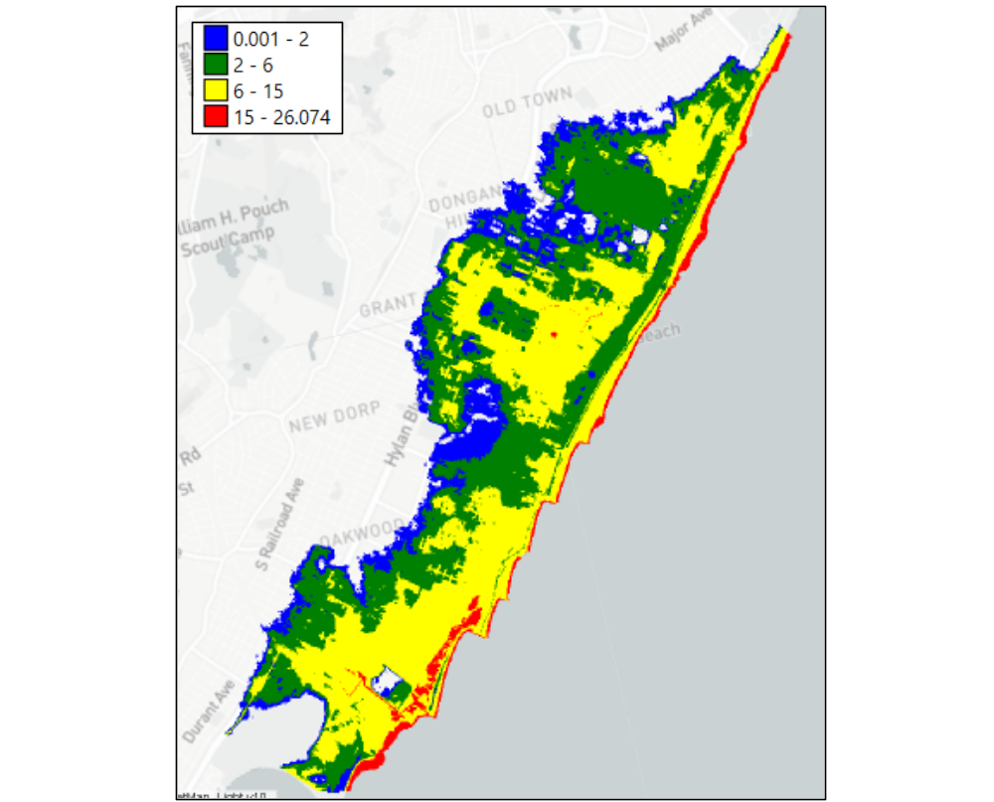
Figure 167 Example of inundation depth ranges (feet) for the SSSI Study (Levee Control Location 1ft OT Breach)

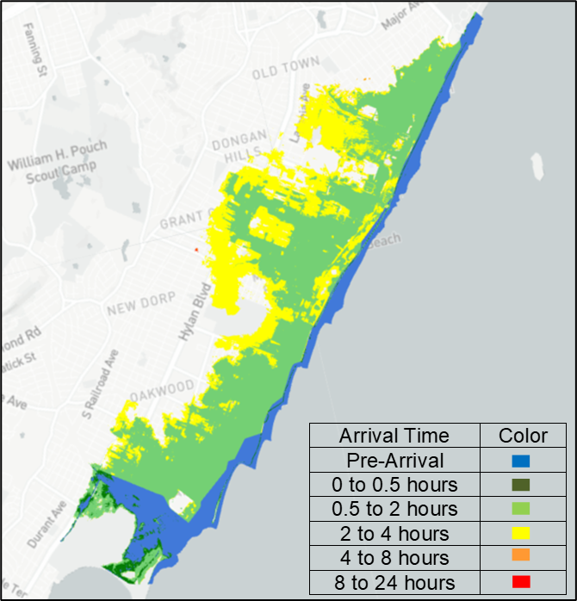
Figure 168 Example of 2 feet inundation arrival times for the SSSI study (Levee Control Location 1ft OT Breach)
The arrival of two feet of water within the leveed area happens relatively quickly for the event depicted in the figures above. In fact, most of the leveed area is inundated by at least two feet of water between 30 minutes to 4 hours relative to the hazard (i.e., initial overtopping). Furthermore, much of this area is inundated by depths exceeding 6 feet. These characteristics would suggest life loss could be spread across much of the leveed area depending on how the PAR is distributed. Figure 169 shows the spatial distribution of life loss for a minimal warning (hazard identification 3 hours prior to overtopping to 30 minutes after) LCL 1ft OT breach scenario.
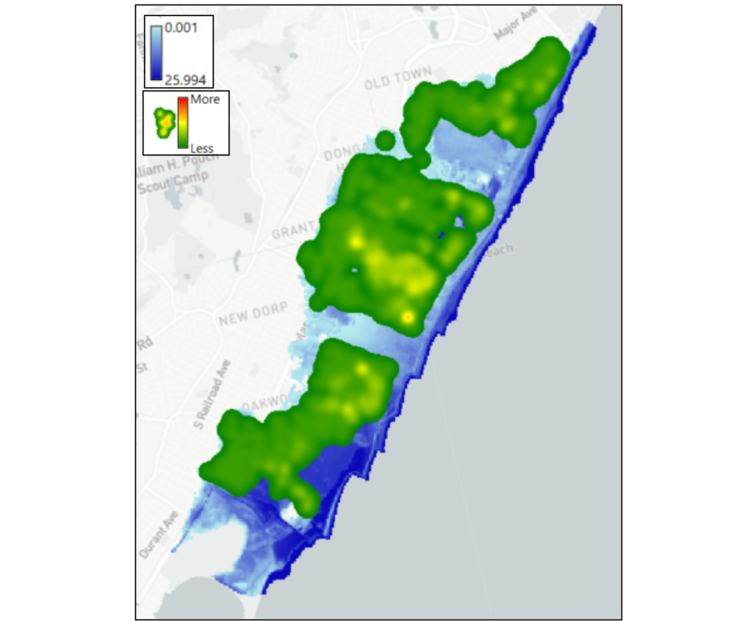
Figure 169 Spatial distribution of life loss for the SSSI study (Levee Control Location 1ft OT Breach/Minimal Warning)
In alignment with the depth grid and arrival time grid shown in Figure 165 and Figure 166, the estimated life loss is spread out with slightly higher estimates near the center of the leveed area. Now, with an understanding of depths, arrival times, and where life loss is generally occurring, the modeler should focus on structure specific results. Refer to the Estimating Consequences for Levees and Floodwalls Chapter for creating and editing Structure Summary files in LifeSim. Figure 170 shows the Structure Summary Attributes Table for the LCL 1ft OT minimal warning breach scenario. Many additional attributes were removed from this attributes table to focus on the fields presented in the figure.
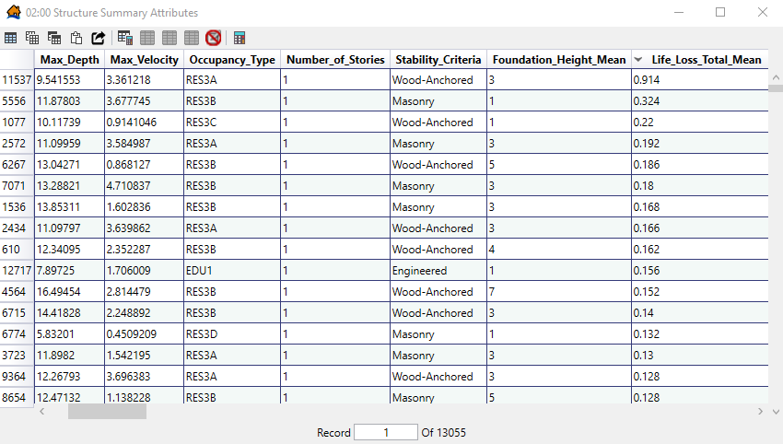
Figure 170 Structure summary attributes for the SSSI study (Levee Control Location 1ft OT Breach/Minimal Warning)
An understanding of the relationship between each structure’s maximum depth and total mean life loss estimate can help the modeler locate structures with characteristics (e.g., foundation height and number of stories) that may need manual calibration. Start by sorting ‘Life_Loss_Total_Mean’ from largest to smallest by double-clicking the header twice, or right-clicking and selecting descending order. Structure 11537 (the first entry of the table in Figure 170) has the highest estimated life loss for this scenario, a foundation height of 3 feet, 1 story, and experiences a maximum depth just below 10 feet. Figure 171 below shows structure 11537 in the LifeSim map window and Google Earth Street View.

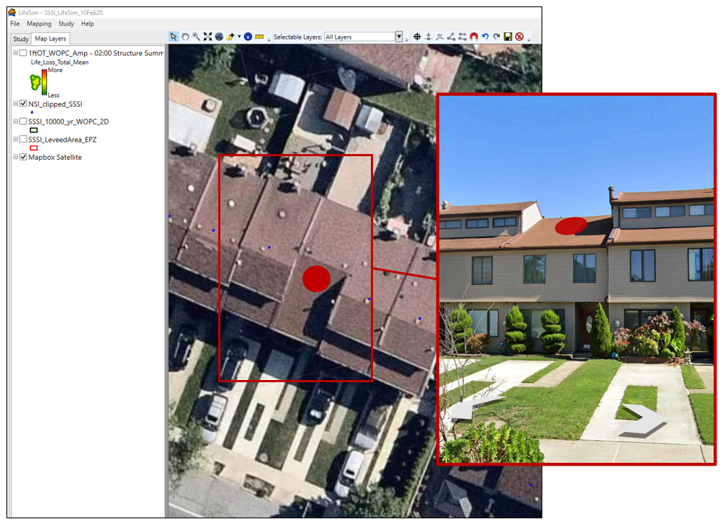
Figure 171 Structure 11537: example calibration process for the SSSI study
A closer look shows that this structure has a foundation height less than 3 feet and is actually 2 stories. In this case, life loss could potentially be overstated given the ability for PAR to vertically evacuate to the second story above the maximum flood depth experienced at this structure. In this example, if the structure had a foundation height closer to 8 feet due to its proximity to the coast, the number of stories would not significantly matter because of the maximum depth of 10 feet. PAR within the structure would experience a first-floor depth of about 2 feet and life loss would be unlikely. However, these types of discrepancies when aggregated throughout the leveed area can greatly impact the total estimated life loss.
If evaluating a shelter-in-place alternative, it is important to relate high life loss structures to the corresponding maximum velocities. Refer to Figure 170 and, again, sort by ‘Life_Loss_Total_Mean.’ Compare maximum depths and velocities to each structure’s stability criteria (e.g., wood-anchored, masonry, and manufactured). If a structure collapses in over half of the iterations with relatively low depths and velocities, zoom to the structure like shown in Figure 171 and ensure that the stability criteria match the structure type. Refer to the Estimating Consequences for Dams Chapter and Estimating Consequences for Levees and Floodwalls Chapter for additional information regarding post-simulation structure inventory calibration.
The SSSI road network was calibrated in a similar fashion. For more detailed coastal levee risk assessments, LifeSim can be used to estimate evacuation travel time or potential traffic chokepoints of mobilized PAR. Figure 172 shows the spatial distribution of estimated life loss on roads for the SSSI study.
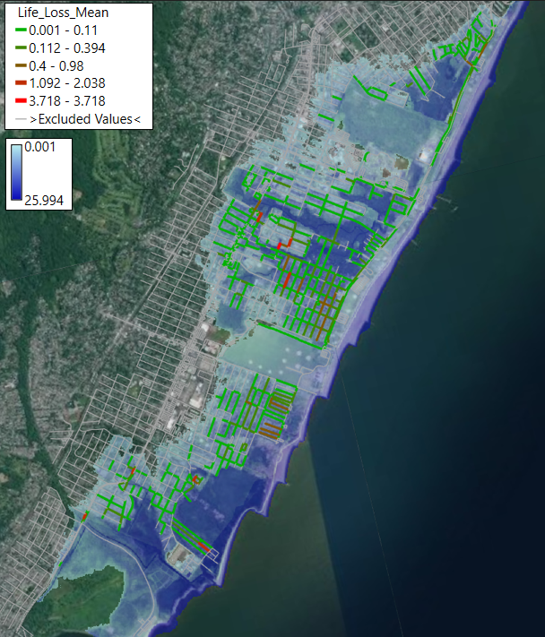
Figure 172 Mean life loss on roads for the SSSI study (Levee Control Location 1ft OT Breach/Minimal Warning)
Refer to the Estimating Consequences for Levees and Floodwalls Chapter for quality checking the road network after the initial simulation. Once the road network has been calibrated, look for roads with high mean life loss estimates in relation to the nearest destination points. For the SSSI study, destinations were placed inland just beyond the inundation (see Figure 155). Life loss on roads occurs mostly on smaller access roads located relatively close to the SSSI alignment; several vehicles are caught evacuating as they attempt to reach freeways and interstates that can handle more traffic on their way to destination points.
    - Applying Results to Risk Assessments
Life loss estimates can vary greatly across warning alternatives (e.g., a standard hurricane warning of 24 hours prior to the event, an optimal hurricane warning of at least 3 days prior to the event, and a shelter-in-place scenario with a maximum mobilization rate of 0.) Depending on your project and your risk assessment, consider which warning scenarios most align with the expected forecasting and monitoring that would occur. Additionally, it’s possible that you will need to include additional warning alternatives to better understand potential life loss for various potential failure modes.
Refer to the Estimating Consequences for Levees and Floodwalls Chapter for additional information on performing quality control checks of LifeSim results.
Following any edits made during the quality control check, rerun all simulations. Once you confirm the new life loss and economic results, your coastal levee or floodwall LifeSim model is complete.

(Page intentionally left blank)
- Estimating Life Loss in Planning: Comparing Alternatives for Riverine & Coastal Flooding
  - Purpose
This example demonstrates the process for estimating consequences and comparing expected life loss across alternatives for planning studies in LifeSim. This chapter focuses on the Ala Wai Flood Risk Management General Investigations Study, which is an ongoing Planning study in the U.S. Army Corps of Engineers (USACE) Honolulu District. The LifeSim model was completed in 2023 by the USACE Omaha District. The Ala Wai LifeSim model compares life loss results across four different alternatives. Notably, there is no existing infrastructure in the study area.
For each of the alternatives, the eight flow-frequency events used in the study’s other flood risk management model were imported into LifeSim. The alternatives included the Future Without-Project (FWOP) condition and three structural alternatives. The structural alternatives’ hydraulic scenarios represent the Future With-Project (FWP) and do not include breaches in the proposed flood protection infrastructure.
Reference USACE’s Planning Bulletin 2019-04, Comprehensive Documentation of Benefits in Decision Documents Memorandum, and Engineering Regulation 1105-2-103 for more information on including life loss estimates in USACE planning studies.
This LifeSim model was built prior to the Tentatively Selected Plan (TSP) milestone to compare the change in expected life loss and how flood risk changes. Eventually incremental risk of the TSP will need to be understood, but this phase of the planning study focuses on changes in flood risk across the final array of alternatives.
This chapter includes instructions for importing the required data into LifeSim, how to choose appropriate warning and evacuation data for a study area, and how to interpret modeling results. Additional considerations for LifeSim modeling for planning studies are identified throughout the chapter.
  - Input Data
The subsequent sections discuss the input data required to calculate damages and life loss across various alternatives for planning studies. The input data sections include hydraulic data, emergency planning zones (EPZ), structure inventories, road networks, destinations, creating alternatives, and simulating alternatives.
    - Hydraulic Data
The Ala Wai LifeSim model utilized output from the Hydrologic Engineering Center’s River Analysis System (HEC-RAS). Ideally, the HEC-RAS inputs should be in the form of Hierarchical Data Format (HDF) files so the user can easily simulate evacuation in LifeSim. However, summary grids or other output from other hydraulic models could be utilized in LifeSim (reference the LifeSim 2.0 User Manual and Technical Reference Manual). For planning studies, simulating evacuation can help address other planning objectives or opportunities, such as improving emergency action planning and identifying safe evacuation routes. Including evacuation more accurately captures potential life loss in structures and life loss on roads. The HEC-RAS plan HDF file and the HEC-RAS terrain HDF file (and terrain TIF files) are needed for each hydraulic scenario. Reference the Estimating Consequences for Levees and Floodwalls Chapter for step-by-step instructions on importing hydraulic data from HEC-RAS.
It is recommended to include all the hydraulic events used in the economic modeling (most likely 8 different flow-frequency events) in the LifeSim model. Similar to the economic damage modeling typically completed in HEC-FDA, it is critical to understand the potential life loss for events of varying frequency and magnitude. Eventually, the life loss ranges computed in LifeSim will be used to estimate Expected Annual Life Loss (EALL), similar to how Expected Annual Damages are computed, either in a spreadsheet or a tool like TotalRisk 1.0 (link to TotalRisk here). The more events included in the EALL calculation in TotalRisk, the more accurate the EALL is. The resulting EALL is another metric by which planning alternatives can be compared. Refer to the TotalRisk Application Guide to set up the EALL calculation (link to TR app guide here)
Below are some of the hydraulic events included in the Ala Wai LifeSim model (FWOP, Alternative 2B, and Alternative A5). As shown in the figure, the 0.5 Annual Exceedance Probability (AEP), 0.2 AEP, 0.1 AEP, 0.05 AEP, 0.02 AEP, 0.01 AEP, 0.005 AEP, and 0.002 AEP events are included for each alternative.
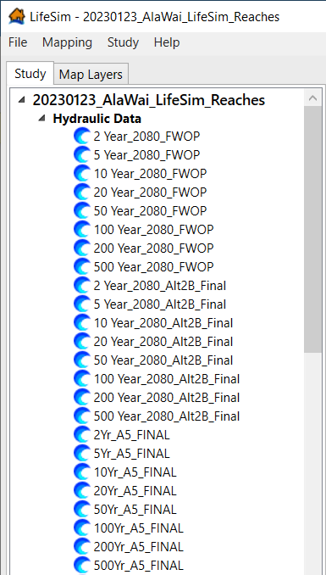
Figure 173 Ala Wai LifeSim model - hydrualic events
      - Other Considerations for Hydraulic Data
For the Ala Wai study area, there are multiple flood sources that flood various areas at different times. It is important to understand the various timings involved in the flooding when selecting the Hazard Occurrence time. Be consistent in where you select the hydrograph (i.e., For all hydraulic scenarios, the Hazard Occurrence time represents when out-of-bank flooding begins for the same flood source). Separating your EPZ is further discussed in the Emergency Planning Zones section below.
    - Emergency Planning Zones
If your planning study includes levees, coastal structures, and/or dams, reference the EPZ Section in the other Application Guide chapters. For planning studies, the EPZ shapefile should represent the entire study area. Coordinate with other Project Delivery Team members, especially the hydraulic engineer and lead planner to ensure your EPZ matches the study area. The LifeSim model should account for the same flooding and structures as other economic models used in the study, such as Hydraulic Engineering Centers’ Flood Damage Reduction Analysis (HEC-FDA) or Generation II Coastal Risk Model (G2CRM).
Otherwise, the shapefile used for the EPZ should represent the entire study area. Coordinate with other Project Delivery Team members, especially the hydraulic engineer and lead planner to ensure your EPZ matches the study area. The LifeSim model should account for the same flooding and structures as other economic models used in the study, such as Hydraulic Engineering Centers’ Flood Damage Reduction Analysis (HEC-FDA) or Generation II Coastal Risk Model (G2CRM).
Refer to the Estimating Consequences for Levees and Floodwalls Chapter for examples of what to consider when assigning warning and evacuation parameters in your EPZ(s).
      - Delineating EPZs
As mentioned in the Hydraulic Data section, oftentimes there are various flooding sources in planning studies. The various flooding sources may flood different areas and the flooding may begin at different times. Therefore, each of these areas would have differing hazard occurrence times (i.e., flooding begins at different times in various parts of the study area.) In LifeSim, each hydraulic scenario can technically only have one Hazard Occurrence time identified in the Hydraulic Data. However, you can account for various Hazard Occurrence times in the EPZs. By delineating the EPZs based on flood timing/flood sources, you can warn various areas relative to when specific hazards occur. It is recommended to work with the Project Delivery Team’s (PDT) hydraulic engineer to better understand the flooding sources and flooding timing across the study area (see the Cascading Dam Breaches Chapter for additional information).
        - Ala Wai EPZs
In the Ala Wai Planning Study there are several flood sources including tidal surge, riverine flooding from the Mānoa Stream, Makiki Stream, Palolo Streams, and flooding along the Mānoa-Palolo and Ala Wai Canals. Following an analysis of the hydraulic timing and flow, the EPZ was delineated into 4 zones (see Figure 174). This decision was made by both the LifeSim modeler and the PDT’s hydraulic engineer. The delineation of EPZs is critical for study areas with various flood timings and/or flood sources. Delineating EPZs is the best way to model various warning times for various impact areas and should generally be done with the team’s hydraulic engineer.
As shown in the figure below, there are 4 EPZs in the Ala Wai LifeSim model; this EPZ polygon is used for all hydraulic scenarios, including both FWOP and FWP conditions. They are divided by flood source and hydraulic timing:
- The main flood source in EPZ 1 is the Makiki Stream
- The main flood source in EPZ 2 is tidal surge
- The main flood source in EPZ 3 is the Mānoa Stream
- The main flood source in EPZ 4 is the Palolo Streams
The difference in hydraulic timing between the four EPZs is generally less than an hour, which may not seem like a large difference, but the flooding in the study area is quite flashy. Advanced forecasting and early warning are unlikely. The life loss estimates are highly sensitive to the hazard identification time (i.e., early hazard identification is correlated with lower life loss and late hazard identification is correlated with higher life loss), which is why delineating the EPZs for Ala Wai based on flood source and flood timing is important. The warning times for each EPZ are discussed more in the Creating Alternatives section below.
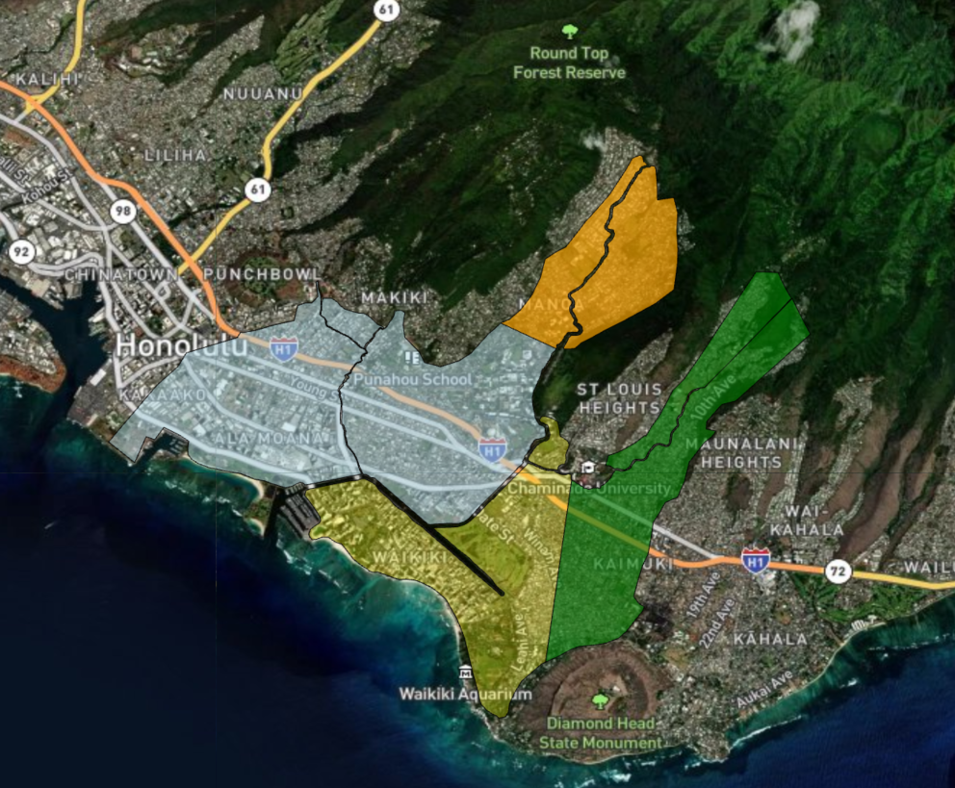
EPZ 1
EPZ 3
EPZ 4
EPZ 2
Figure 174 Ala Wai EPZs
      - Importing an Emergency Planning Zone
Refer to the Estimating Consequences for Levees and Floodwalls Chapter and/or the Estimating Consequences for Dams Chapter for information on importing EPZs into LifeSim.
    - Structure Inventory
To use LifeSim to calculate life loss and/or economic damages, a structure inventory needs to be imported into the study. LifeSim will not compute if any structure points are located outside of the EPZ.
      - Importing a Structure Inventory
Refer to the Estimating Consequences for Levees and Floodwalls Chapter and the Estimating Consequences for Dams Chapter for information on importing a structure inventory into LifeSim and editing it.
    - Simulating Evacuation
Refer to the Estimating Consequences for Levees and Floodwalls Chapter for how to simulate evacuation. The Simulating Evacuation section covers (1) importing and editing the road network and (2) creating, importing, and editing the destinations.
    - Creating Alternatives
Refer to the Estimating Consequences for Levees and Floodwalls Chapter, the Estimating Consequences for Coastal Infrastructure Chapter, and/or the Estimating Consequences for Dams Chapter for how to create alternatives.
      - Ala Wai EPZ Imminent Hazard Identification Times
As discussed in the Ala Wai EPZ section, the LifeSim model utilized 4 different EPZs—all with unique hazard occurrence times (i.e., flooding begins at different times in each zone) in the alternatives. Since only one hazard occurrence time can be identified for each hydraulic scenario, you need to utilize various imminent hazard identification times for each zone while creating alternatives.
To find the various zones’ hazard occurrence times, add your EPZ polygon to the RAS Map Data Selector Map Window. Then, find each zone’s hazard occurrence times by finding where/when flooding first begins in each EPZ. Then, identify which EPZ’s hazard occurrence time will be the hydraulic scenario’s hazard occurrence time identified in the hydraulic data. For Ala Wai, EPZ 1 (shown in the following figure) was selected as the “control” hazard occurrence time for every hydraulic scenario, which means the imminent hazard ID times for EPZs 2, 3, and 4 were relative to EPZ 1’s hazard occurrence time. The figure below shows the hazard occurrence times for each EPZ and each event for Alternative 2B; the figure also shows where the Hydrograph Tool pulled the hazard occurrence times for each EPZ (red circles in the figure below).
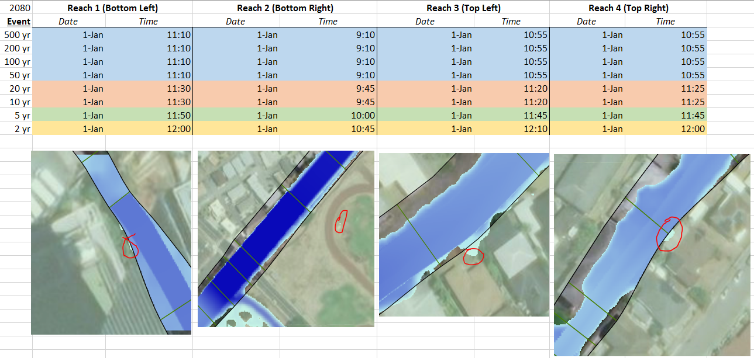
Figure 175 Hazard occurrence times by reach and event – Alternative 2B
Table 4 below highlights the various hazard occurrence times in each EPZ for Alternative 2B for the 0.02 AEP, 0.05 AEP, and 0.01 AEP events. Table 5 highlights the calculated imminent hazard identification times.
For the 0.02 AEP and 0.05 AEP events in EPZ 1, a relatively small amount of warning time was given to the public; a uniform distribution of -2 to 0 hours was used. For the 0.01 AEP event in EPZ 1, the warning time distribution was expanded to potentially give the population more warning; -4 to 0 hours was used. The same amount of warning time was used for all zones, but zones 2 through 4 were warned relative to EPZ 1’s hazard occurrence time.
For example, for the 0.05 AEP event, EPZ 2’s hazard occurrence time occurs 1.83 hours prior to EPZ 1’s hazard occurrence time. This indicates that EPZ 2 needs to be warned 1.83 hours earlier than EPZ 1. The final Imminent Hazard Identification Times (i.e., warning times) used in the alternatives reflect the difference in hazard occurrence times to ensure each EPZ receives the same amount of warning relative to each zone’s unique hazard.

Table 4 Sample of Alternative 2B’s hazard occurrence times
Event | EPZ 1 Hazard Occurrence Time* | EPZ 2 Hazard Occurrence Time | EPZ 3 Hazard Occurrence Time | EPZ 4 Hazard Occurrence Time
0.02 AEP | 11:50 | 10:00 | 11:45 | 11:45
0.05 AEP | 11:30 | 09:45 | 11:20 | 11:25
0.01 AEP | 11:10 | 09:10 | 10:55 | 10:55
*All Hazard Occurrence Times occur on the same date in HEC-RAS

Table 5 Sample of Alternative 2B’s imminent hazard identification time
Example Imminent Hazard Identification Times for Alternative 1
Event | EPZ 1 |  | EPZ 2 |  | EPZ 3 |  | EPZ 4
Event | Min | Max | Min | Max | Min | Max | Min | Max
0.02 AEP | -2 | 0 | -3.83 | -1.83 | -2.08 | -0.8 | -2.08 | -0.08
0.05 AEP | -2 | 0 | -3.75 | -1.75 | -2.17 | -0.17 | -2.08 | -0.08
0.01 AEP | -4 | 0 | -6 | -2 | -4.25 | -0.25 | -4.25 | -0.25

    - Creating Simulations
Refer to the Estimating Consequences for Levees and Floodwalls Chapter for creating simulations, selecting the appropriate options, and running simulations.
  - Understanding and Interpreting Results
After running simulations, you can view your results in various ways, including by result plots, result tables, and result maps. Each way you view results helps understand your life loss and economic damage results and quality check your results. It is unlikely that your first simulation will be your last simulation—edits to the structure inventory, EPZs, road network and/or destination points are frequently needed to obtain accurate and representative results.
Refer to the Estimating Consequences for Levees and Floodwalls Chapter, the Estimating Consequences for Coastal Infrastructure Chapter, and/or the Estimating Consequences for Dams Chapter for understanding results and finalizing the LifeSim model.
LifeSim utilizes an event-based approach, so there is no annualization across the various flow-frequency events. Use a tool like TotalRisk 1.0 or another certified annualization tool to produce expected annual life loss values for each alternative.

(Page intentionally left blank)

- Estimating Direct Economic Damages
  - Purpose
This example demonstrates the process for estimating economic consequences in LifeSim. This chapter applies to dam and levee safety, planning studies, and other analyses that focus on economic consequences. This chapter focuses on the Ala Wai Flood Risk Management General Investigations Study, which is an ongoing Planning study in the U.S. Army Corps of Engineers Honolulu District. The LifeSim model was modeled in 2023 by the USACE Omaha District. The Ala Wai LifeSim model compares economic damage results across four different alternatives.
For each of the alternatives, the eight flow-frequency events used in the study’s economic damage modeling were imported into LifeSim. The alternatives included the Future Without-Project (FWOP) condition and three structural alternatives. The structural alternatives’ hydraulic scenarios utilized in LifeSim represent the Future With-Project (FWP) and do not include breaches in the proposed flood protection infrastructure.
This chapter includes instructions on importing the required data into LifeSim, how to edit structures and occupancy types, and how to interpret modeling results. Additional considerations for LifeSim modeling for planning studies are identified throughout the chapter.
  - Input Data
The subsequent sections discuss the input data required to calculate direct economic damages across various alternatives for planning studies. The input data sections include hydraulic data, structure inventories, creating alternatives, and simulating alternatives. The structure inventory section includes significant detail on editing and creating structure occupancy types in LifeSim.
    - Hydraulic Data
The Ala Wai LifeSim model utilized output from the Hydrologic Engineering Center’s River Analysis System (HEC-RAS). Ideally, the HEC-RAS inputs should be in the form of Hierarchical Data Format (HDF) to streamline the process; this is the easiest way to calculate both direct economic damages and life loss in one LifeSim model. However, summary grids (Reference the Estimating Consequences Using Summary Grids Chapter), and other hydraulic models could be utilized in LifeSim (reference the LifeSim 2.0 User Manual and Technical Reference Manual). The HEC-RAS plan HDF file and the HEC-RAS terrain HDF file are needed for each hydraulic scenario. Reference the Estimating Consequences for Levees and Floodwalls Chapter for step-by-step instructions on importing hydraulic data from HEC-RAS.
It is recommended to include several hydraulic events (greater than 6 different flow-frequency events) in the LifeSim model. Eventually, the life loss estimates will be used to estimate Expected Annual Damages (EAD) in a tool like TotalRisk 1.0, and the more hydraulic events included in that calculation, the more accurate the EAD is. Below are some of the hydraulic events included in the Ala Wai LifeSim model (for the FWOP, Alternative 2B, and Alternative A5). As shown in the figure, the 0.5 Annual Exceedance Probability (AEP), 0.2 AEP, 0.1 AEP, 0.05 AEP, 0.02 AEP, 0.01 AEP, 0.005 AEP, and 0.002 AEP events are included for each alternative.

Figure 176 Ala Wai hydrualic events and alternatives
    - Emergency Planning Zones
For calculating only economic damages, an emergency planning zone (EPZ) is not required in the LifeSim model.
    - Structure Inventory
To calculate economic damages in LifeSim, a structure inventory needs to be imported into the study. There are key additionall things to consider and edit in the structure inventory to accurately calculate economic damages. The follow sections focus on viewing, editing, and creating occupancy types. For information on importing a structure inventory, refer to the Estimating Consequences for Levees and Floodwalls Chapter and Estimating Consequences for Dams Chapter.
      - Creating and Editing Occupancy Types
When estimating direct economic damages in LifeSim, additional edits to the structure inventory and occupancy types may be needed to allow for more uncertainty in the economic damage computation. The following sections describe the editable aspects of occupancy types in LifeSim, including the Depth-Damage Functions (Structure, Content, and Vehicle), Foundation Height Offset, Value Uncertainty (Structure, Content, and Vehicle), Evacuation Parameters, and Submergence Criteria. Additionally, you can create new occupancy types (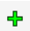), copy occupancy types (), and delete occupancy types ().
To view, edit, and create occupancy types, right click on Occupancy Types under Structure Inventories in the Study Pane. Select Edit Occupancy Type Data from the options.
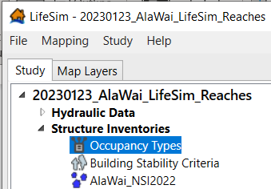
Figure 177 Occupancy types in the Study pane
The Occupancy Type Editor window opens (shown in the figure below) and displays the various attributes associated with the selected occupancy type. The figure below shows the RES1-1SNB (Residential Structure with 1-Story, No Basement) occupancy type.
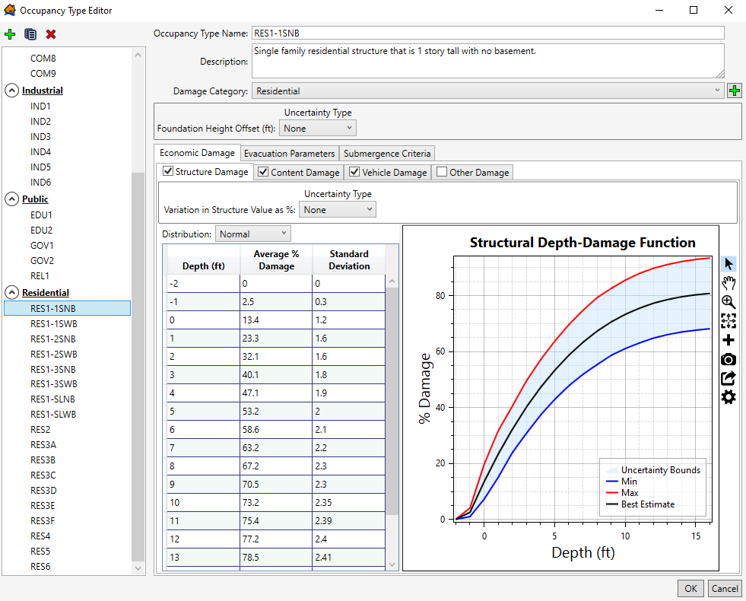
Figure 178 RES1-1SNB default depth-damage function from EGM 04-01
        - Occupancy Type Depth-Damage Function Uncertainty
Notably, most of the default structure occupancy types do not include uncertainty in the depth-damage function. The only occupancy types that include uncertainty are the RES1 occupancy types (as seen in the figure above). The RES1 depth-damage functions (structure and content) are the default depth-damage functions defined in Economic Guidance Memorandum (EGM) 04-01. All commercial, public, industrial, and the other residential occupancy types (e.g., manufactured homes, apartment buildings, etc.) do not have uncertainty in the depth-damage functions. However, all existing occupancy types can be edited to include uncertainty and new occupancy types can be added by the user.
This example will step through adding uncertainty to the existing EDU1 occupancy type. Figure 179 shows the default occupancy type for an educational structure with 1-story (EDU1). Although the default depth-damage functions for EDU1 do not include uncertainty, an uncertainty distribution can be defined by the user for each of the depth-damage functions (Structure, Content, and Vehicle).
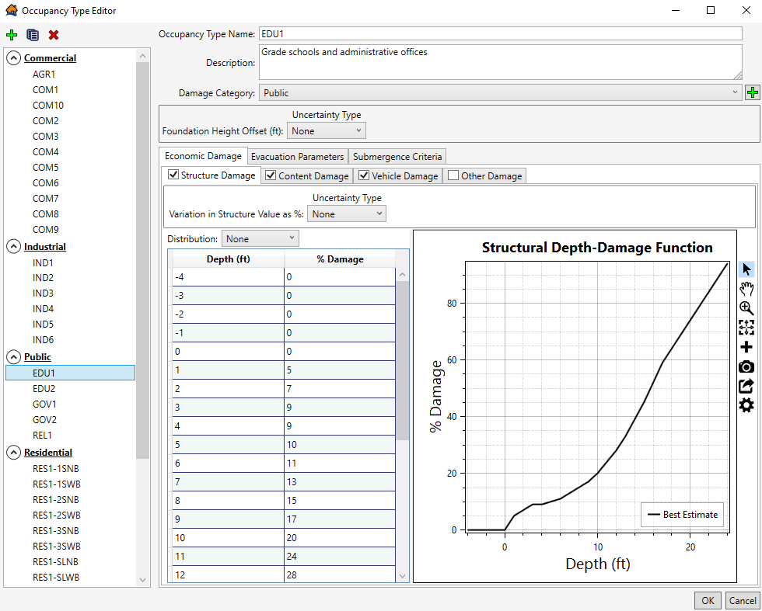
Figure 179 EDU1 default depth-damage function from HAZUS
Figure 180 shows the variety of uncertainty distributions for the depth-damage functions. You can choose from a triangular, uniform, normal, and lognormal distribution.
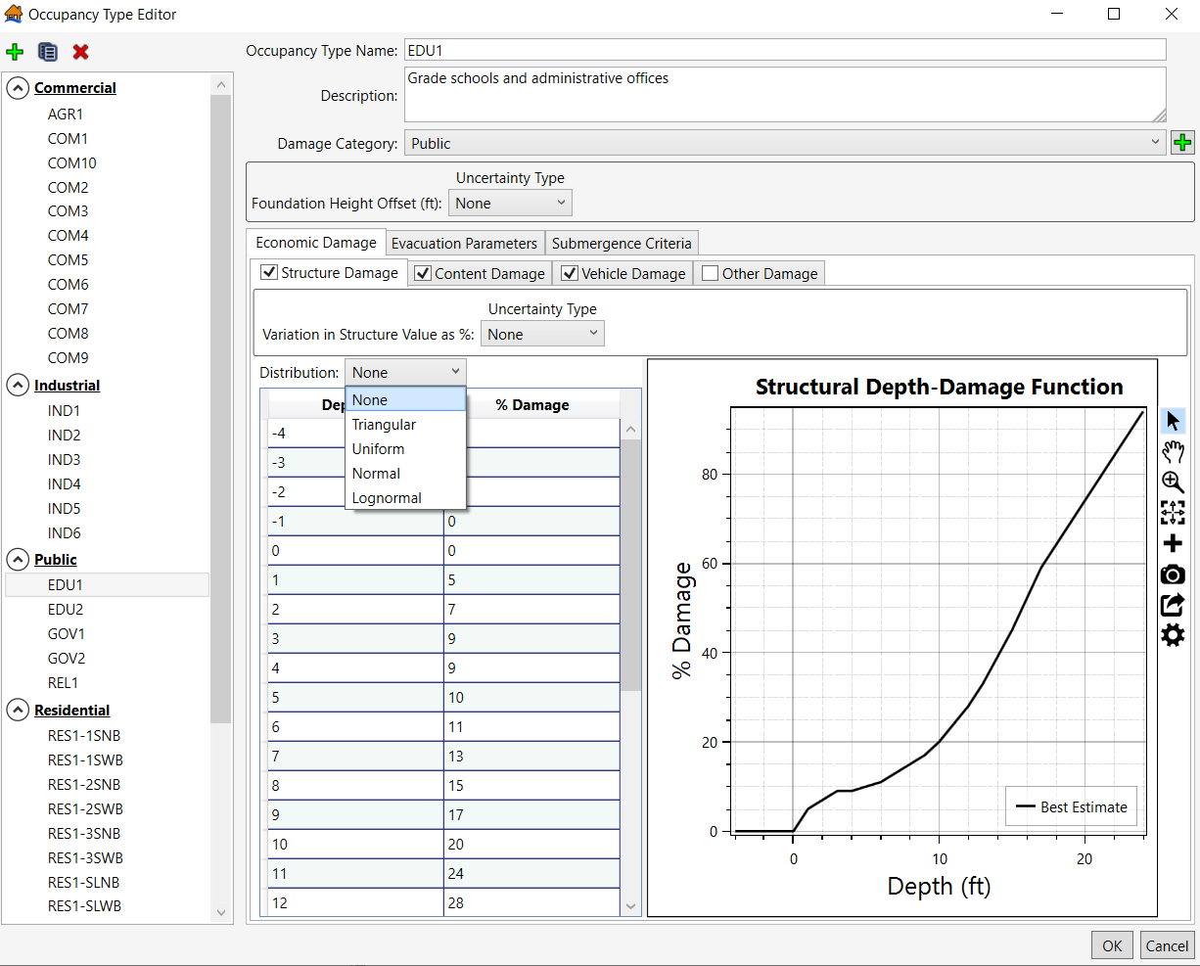
Figure 180 EDU1 default depth-damage function – uncertainty distribution options
Figure 179 shows an example of a uniform distribution (minimum % damage and maximum % damage). As shown in the function plot, there is more uncertainty included in shallower flood depths (the 0ft to 10ft range), with less uncertainty included in the higher depths. It’s recommended to coordinate with other economists, your reviewers, and/or technical experts on representative uncertainty in the depth-damage functions. Alternatively, you could utilize other developed depth-damage functions (e.g., from other Corps studies, FEMA curves, or other published depth-damage functions) and enter the values into LifeSim.
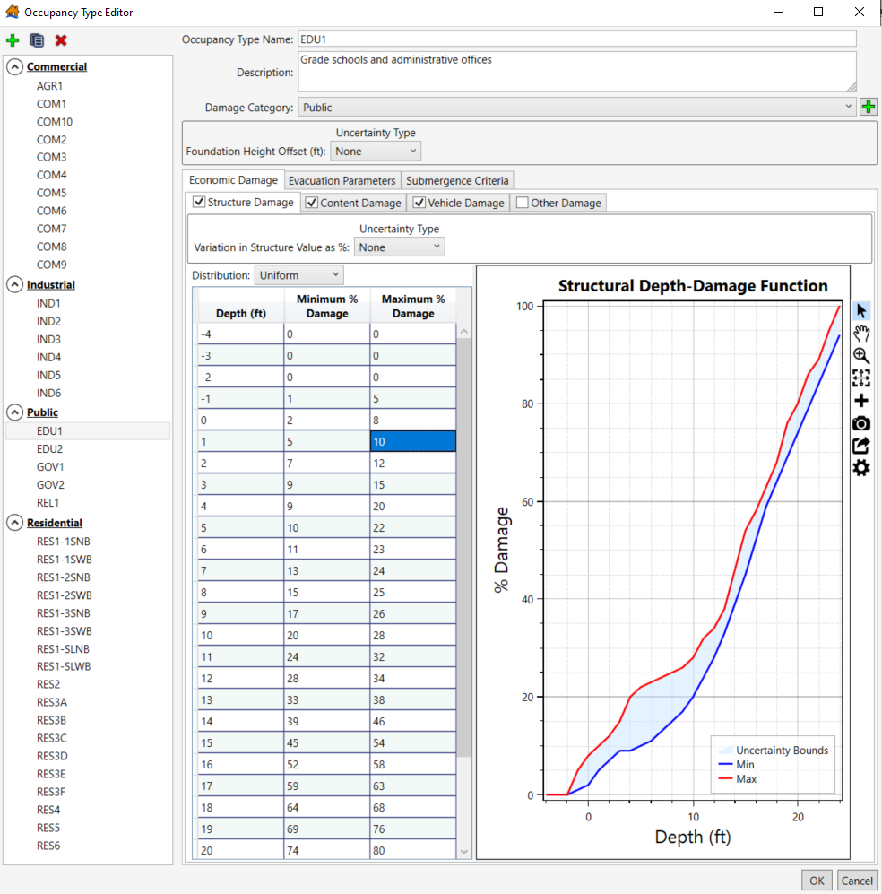
Figure 181 EDU1 depth-damage function with uniform uncertainty distribution
      - Variation in Structure Values
In addition to including an uncertainty distribution to the depth-damage function, uncertainty can be added to the values of each of the damage categories (Structure, Damage, and Vehicle). As shown in the figure below, you can select the Uncertainty Type for the Structure Value. Note the variation is a percentage, not a dollar value. This variation percentage will be applied to each structure with the same occupancy type.

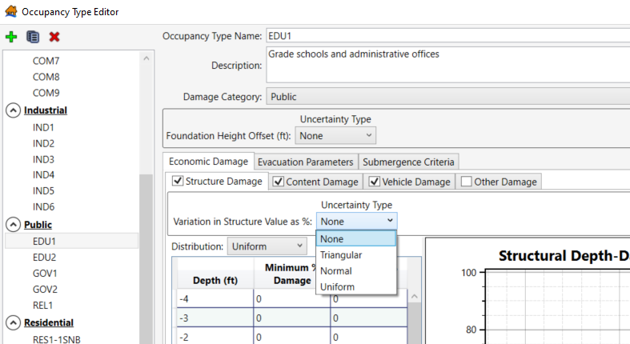
Figure 182 EDU1 default depth-damage function – variation in structure value as % uncertainty distribution options
In this example, the user wants to include uncertainty regarding the structure values of all EDU1 structures. A triangular distribution is selected, and the uncertainty distribution is as follows: -15% as the lower bounds, 0% (no change) as the most likely, and 20% as the upper bounds. For example, if an EDU1 structure has a defined structure value of $100K, the structure value will be randomly sampled between $85K and $120K—with $100K being the most likely sampled value. This triangular uncertainty distribution is applied to all EDU1 structure values.
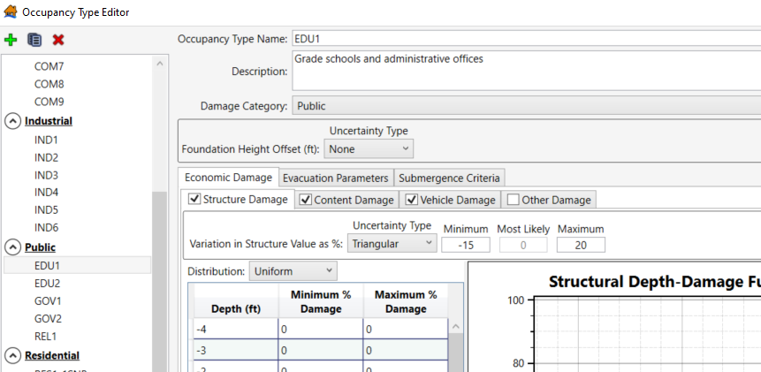
Figure 183 EDU1 variation in structure value as % – triangular distribution
      - Foundation Height Offset Uncertainty
The final uncertainty parameter that can be defined at the occupancy type level is the Foundation Height Offset. Similar to the Variation in Structure Value uncertainty, you can choose a triangular, normal, or uniform uncertainty distribution (shown in Figure 184). Notably, the defined uncertainty bounds are based on feet, not a percentage of the foundation height. The example uniform distribution below is a range of -1ft to 1.5ft, which indicates the defined foundation height for each EDU1 structure will sample that offset relative to the defined foundation height. For example, if an EDU1 structure has a defined foundation height of 2ft, in each iteration, the foundation height would be sampled as a number between 1ft and 3.5ft. The uncertainty distribution should be informed by either a foundation height sample or by information from real estate. Justification of the selected distribution and uncertainty bounds needs to be included in any documentation.
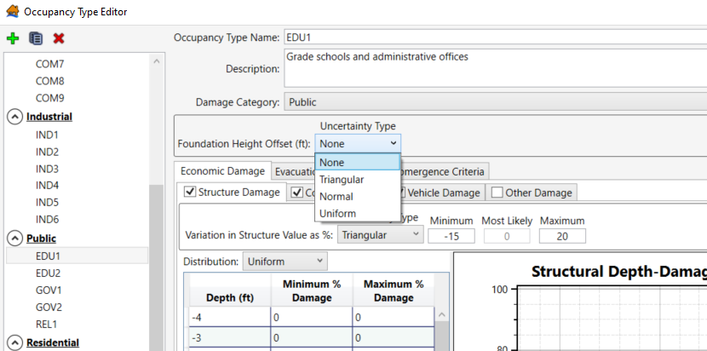
Figure 184 EDU1 depth-damage function – foundation height offset uncertainty type options

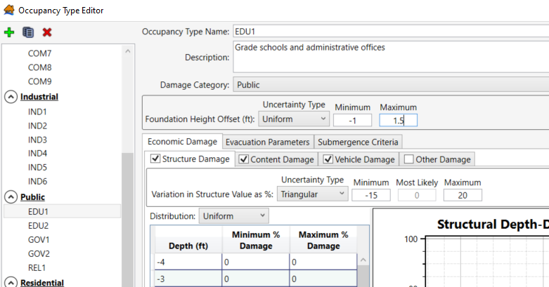
Figure 185 EDU1 depth-damage function with a defined foundation height offset uncertainty
An additional consideration: If there are several variations in a single occupancy type, the user may want to create copies of that same occupancy type, with each having the variable attribute(s) defined . For example, you may need multiple occupancy types for schools. If you have sampled foundation heights for EDU1 buildings built on slab and sampled foundation heights for EDU1 buildings with basements, this may prompt the user to create two EDU1 occupancy types (e.g., EDU1-SLAB and EDU1-WithBSNT) to accurately account for the two foundation height samples and include two different depth-damage functions (i.e., the EDU1-WithBSNT would incur damage at lower flood depths).
    - Creating Alternatives
After editing your occupancy types and structure inventory, you will create alternatives for each scenario for which you want to calculate economic damages. For computing only economic damages, relatively simple alternatives are required. As shown in Figure 186 below, you only need to link the structure inventory and correct hydraulic scenario in the Alternative Editor window. Ensure both the Simulate Traffic and Calculate Life Loss boxes are unchecked.
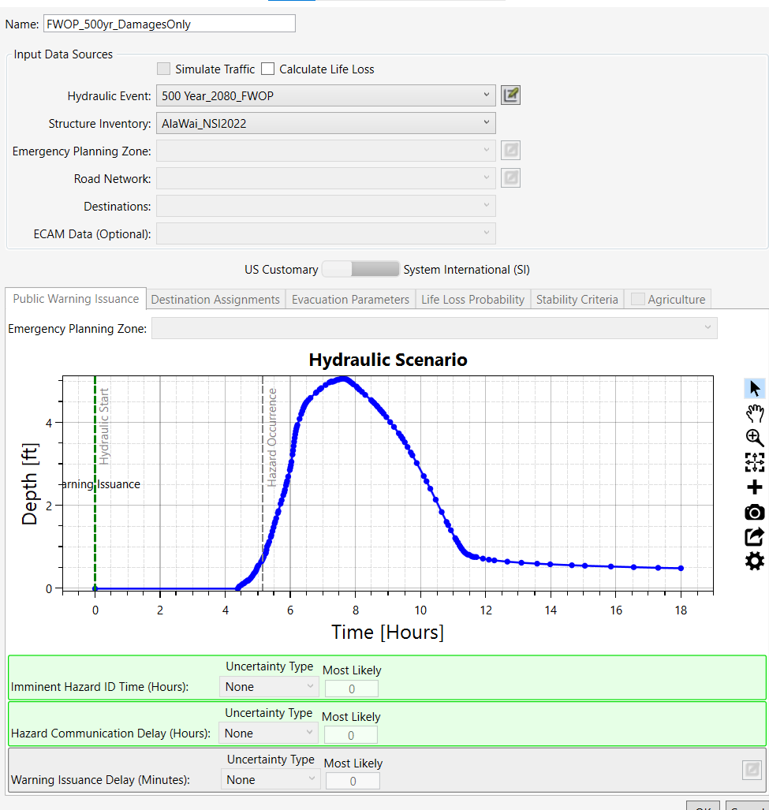
Figure 186 LifeSim alternative to compute economic damages
    - Creating Simulations
Refer to the Estimating Consequences for Levees and Floodwalls Chapter for creating simulations, selecting the appropriate options, and running simulations. An additional consideration for estimating direct economic damages is selecting an appropriate Output Summary Polygon. Similar to how HEC-FDA requires a delineation of reaches to accurately account for uncertainty in the hydraulic data, this should be a consideration in calculating economic damages in LifeSim—especially if the user is going to use TotalRisk following the LifeSim modeling. The damage reaches polygon should be incorporated into the Simulations by selecting it as the Output Summary Polygon.
      - Delineating Reaches
As stated in EM 1110-2-1619, delineating damage reaches is part of the overall study strategy and is an integral part of computing expected annual damages. This is a step that the user must consider and it is highly recommended to coordinate with the team’s hydraulic engineer. There are several factors to consider when delineating damage reaches including, but not limited to, the following:
- Existing levees and proposed levees (i.e., existing and proposed levees should have separate damage reaches)
- Flooding sources (i.e., coastal, streams, rivers, etc.)
- Flooding characteristics (i.e., higher depths vs shallow depths; fast velocities vs slow velocities)
- Population centers (i.e., urban vs rural areas)
- Inundation Boundaries (i.e., 0.04 Annual Exceedance Probability (AEP) floodplain and 0.01 AEP floodplain)
The Hydrologic Engineering Center-Flood Damage Reduction Analysis (HEC-FDA) software manual includes additional information on delineating damage reaches in Section 3.3. The TotalRisk application guide chapter xx discusses how to use the LifeSim results by damage reach to accurately incorporate hydraulic uncertainty by reach.
      - Ala Wai Damage Reaches
In the Ala Wai Planning Study there are several flood sources including tidal surge; riverine flooding from the Mānoa Stream, Makiki Stream, and the Palolo Streams; and flooding along the Mānoa-Palolo and Ala Wai Canals. The flooding sources alone indicate several damage reaches are needed for this study. An additional consideration is if a reach represents the right bank, left bank, or both. The figure below shows each of the Ala Wai reaches and is color coded to show which bank(s) the reach includes. With all hydraulic, economic, engineering, and planning considerations, the study has a total of 13 damage reaches. The reaches shown in Figure 185 would then be used as your Summary Output Polygon in all LifeSim simulations, which allows LifeSim to show results by reach and can be easily used in TotalRisk to estimate expected annual damages (see TotalRisk Application Guide).
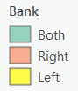
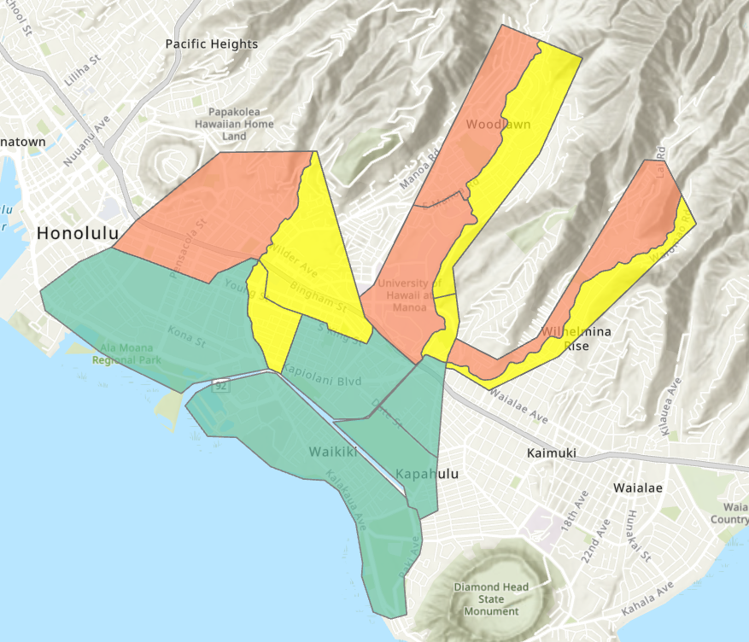
Figure 187 Ala Wai economic damage reaches
  - Understanding and Interpreting Results
After running simulations, you can view your results in various ways, including by result plots, result tables, and result maps. Each way you view results is beneficial to understanding your economic damage results as well as conducting a quality check on your results. It is unlikely that your first simulation will be your last simulation—edits to the structure inventory are often needed to obtain accurate and representative results. Reference the Estimating Consequences for Levees and Floodwalls Chapter for additional information on understanding and interpreting your results.
The results provided by the LifeSim model are event-based and include uncertainty in the economic damages. However, hydraulic data uncertainty is not accounted for. To calculate Expected Annual Damages with uncertainty in the hydraulic data, a tool like TotalRisk 1.0 should be utilized. Reference the TotalRisk Applications Guide for more information; the Flood Risk Management Chapter uses the Ala Wai LifeSim results. This specific chapter of the TotalRisk Applications Guide discusses how to interpret Expected Annual Damage when using LifeSim economic damage results.

(Page intentionally left blank)

- Using Summary Grids in LifeSim
  - Purpose
This chapter demonstrates the process of using summary grids in LifeSim. Importing summary grids allows LifeSim to bypass the need to calculate, or pre-process, hydraulic characteristics. The necessary raster files are instead imported directly into the software. This chapter walks through an example using Clearwater Dam in Piedmont, MO (Little Rock District) and includes step-by-step instructions for importing the required data and making runs in LifeSim using summary grids where life loss was a necessary consideration. Additional information will be provided throughout the chapter for cases where only structural or agricultural damages are being considered.
  - Summary Grids Import Overview
Summary grids can be created using post-processing tools for several different hydraulic modeling programs, not just Hydrologic Engineering Center’s River Analysis System (HEC-RAS). Therefore, this approach can be useful for many LifeSim users. Allowable file types include:
- .tif (tag image file format; an image format used for containing high quality graphics),
- .flt (floating-point grid; holds values for a single numeric measure, a value for each cell in the rectangular grid),
- ESRI Grid (format native to ESRI for storing raster data that defines geographic space as an array of equally sized square cells)
- .vrt (virtual format; use of this format is to group a series of grids that should be associated together)
See the following table for an overview of hydraulic characteristics represented by different summary grids and their associated LifeSim computes.

Table 6 Hydraulic characteristics represented by summary grids
Hydraulic Summary Grid | Economic Damages | Life Loss | Agricultural Damages
Maximum Depth | Required | Required | N/A
Maximum Velocity | Optional | Required | N/A
Maximum Depth*Velocity (D*V) | Optional | Required | N/A
Non-Evacuation Depth Arrival Time | N/A | Required | N/A
Agricultural Arrival Time | N/A | N/A | Required
Agricultural Duration | N/A | N/A | Required

Note that the maximum depth and maximum velocity grids do not account for hydraulic timing, they simply capture the maximum of the two metrics for any grid cell over the span of the hydraulic simulation. The approach assumes depth and velocity reach their respective maximums at the same time--which is not always true--leading to more conservative sampling of the assumed stability criteria for structures in the same cell. If the user were to use hierarchal data files (.hdf), where the hydraulic output is broken out into specified timesteps, it is possible that depth and velocity for any given cell may not reach their maximums at the same time. It is likely, however, that differences in life loss due to structure stability outcomes between the two approaches will be minimal for most studies.
  - Importing Summary Grids for Clearwater Dam
As shown in Table 6, to use summary grids in LifeSim for a consequences analysis where time and evacuation are being considered (i.e., for life loss computes), you will need a minimum of four summary grids – a maximum depth grid, a maximum velocity grid, an arrival time grid with a depth threshold of zero feet (i.e., the first arrival of water), and an arrival time grid with an assumed depth threshold that no longer allows for evacuation (i.e., a non-evacuation depth).
To start the import process, first right-click on Hydraulic Data in the study pane and select Import from Summary Grids, as shown in the following figure.
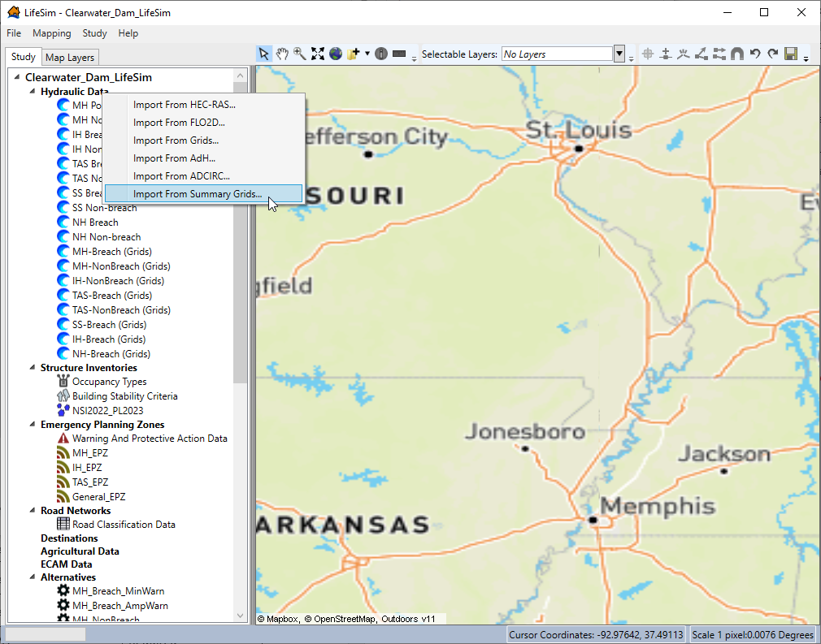
Figure 188 Import from Summary Grids option
The following pop-up window will appear.
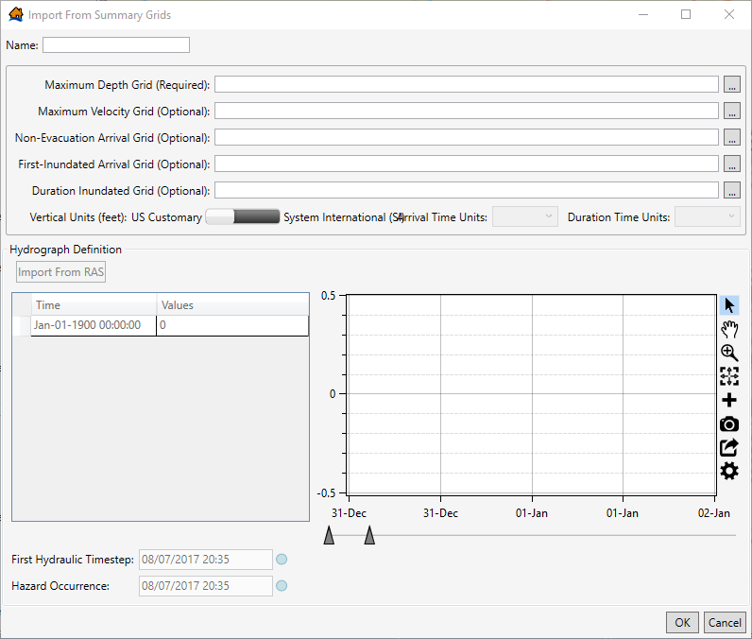
Figure 189 Import from Summary Grids window
A maximum depth grid (the first input in Figure 189) represents the maximum that occurs in each grid cell over the course of a hydraulic simulation. Like maximum depth, maximum velocity and maximum D*V represent the greatest velocity and instantaneous D*V that occurred in each grid cell. Maximum D*V is an important variable for stability criteria. More detailed discussion on this topic can be found in Section 4.3 of the LifeSim 2.0 Technical Reference Manual. As previously mentioned, because the maximum depth, maximum velocity, and maximum D*V grids are not time dependent, LifeSim cannot simulate evacuation on roads when utilizing only this style of hydraulic data.
From the Import from Summary Grids window, map to the project’s grids by clicking on the button with the three dots () next to the Maximum Depth Grid (Required) line. The file directory selected should contain one of the file formats outlined in the Summary Grids Import Overview section (e.g., .tif, .flt, .vrt,) earlier in the chapter. Repeat this process for the Maximum Velocity Grid, a required import for life loss estimation. See Figure 190 to view these completed steps for the Clearwater Dam Maximum High Pool (MHP) breach scenario. Note: When multiple .tif files are used to make up a larger area, a .vrt must be used in LifeSim unless the user is only interested in a smaller subsection of the study area made up of only the single .tif.
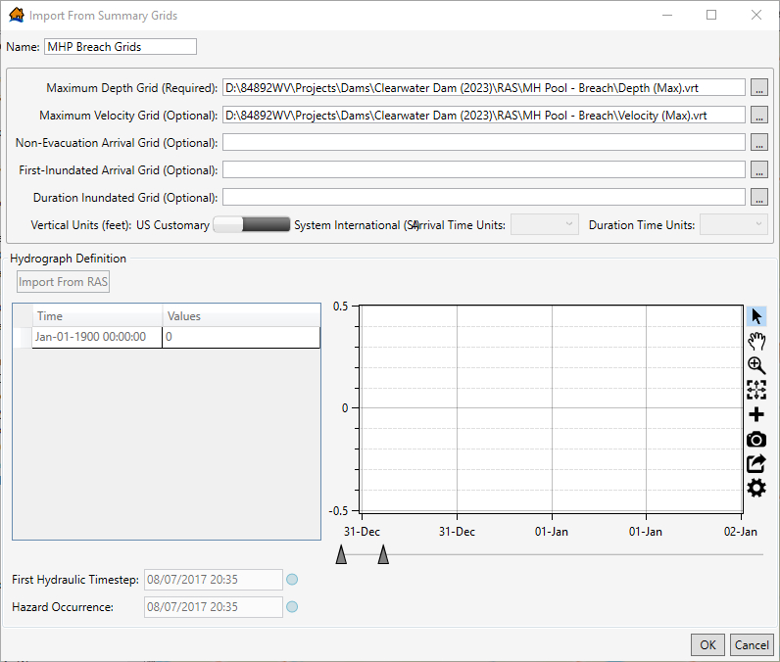
Figure 190 Interim MHP breach grids import (1)
The next required input is the Non-Evacuation Arrival Grid. An arrival time grid represents the point in time that flood water of a given depth reaches each cell. When modeling the evacuation process for life loss, LifeSim assumes that after a given flood depth is reached, individuals remaining in a structure will no longer be able to evacuate on roads, thus they will remain in the structure and vertically evacuate. In the Clearwater Dam example, a non-evacuation depth of two feet (this is the standard for USACE) was used in the LifeSim model.
The last required summary grid input for life loss calculations is the First-Inundated Arrival Grid (i.e., the first arrival of water, or an arrival grid with a flood depth threshold of zero). Figure 191 shows the selection of all four grids. Note: Set the Arrival Time Units to match specified output from the post-processing tools. In the case of Clearwater dam, grids were generated using hour-long timesteps.

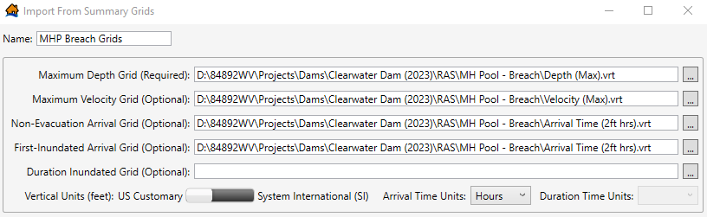
Figure 191 Interim MHP breach grids import (2)
For agricultural computations, duration grids are required to determine damage to crops and replanting potential. Duration grids contain information about the duration of time that a cell is inundated. Agricultural damage was not considered for Clearwater Dam.
Before clicking OK and completing the import for the first hydraulic scenario, the user must define the hydrograph. Figure 192 below shows this section of the Import from Summary Grids window.
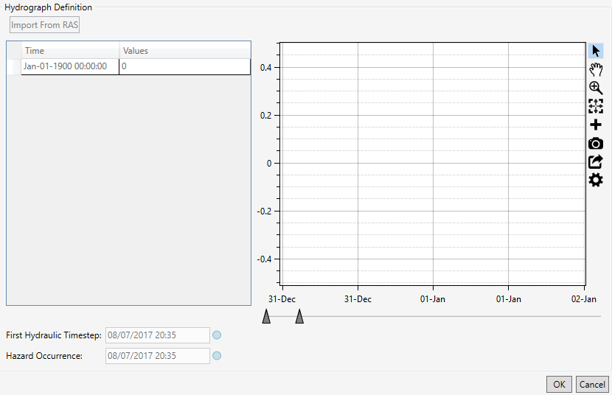
Figure 192 Hydrograph definition
For analysis scenarios where a hydraulic time series is used, the first hydraulic timestep marks the beginning of the hydraulic input. It has no bearing on other simulations within LifeSim. For example, warnings and evacuations could begin prior to the first hydraulic timestep, or well after. The first hydraulic timestep marks the first instance in which the hydraulic inputs interact with other model inputs (i.e., structure inventory) and subsequently leads to consequences. When importing from HEC-RAS, as described in the dam and levee application chapters, the first hydraulic timestep will automatically populate. When importing from grids or summary grids, however, the user must define the First Hydraulic Timestep field shown in Figure 193. This value can be found in the hydraulic model.
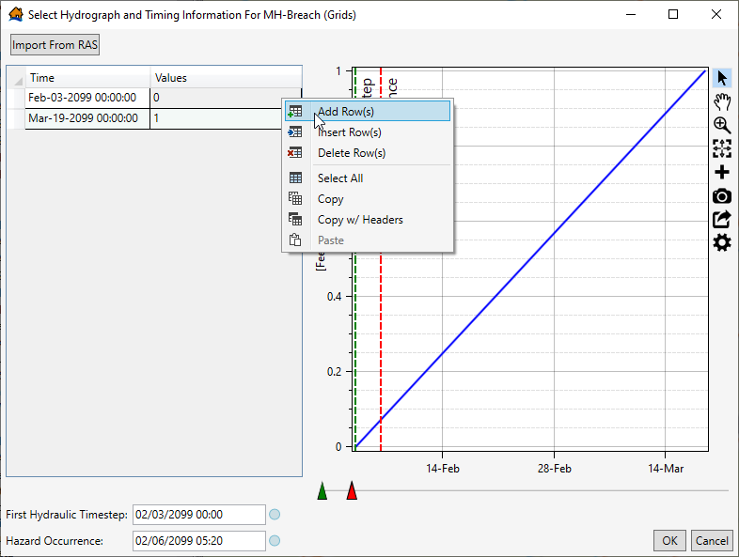
Figure 193 Selecting Hydrograph and Timing Information for the Clearwater Dam MHP breach scenario
The user must also define the hazard occurrence time, as is the case when importing from HEC-RAS. See either the dam and levee application chapters or Section 5.4 of the LifeSim 2.0 Technical Reference Manual for a more detailed discussion on hazard occurrence. Figure 194 below shows an example graph demonstrating the hazard occurrence time in terms of a downstream flood hydrograph.
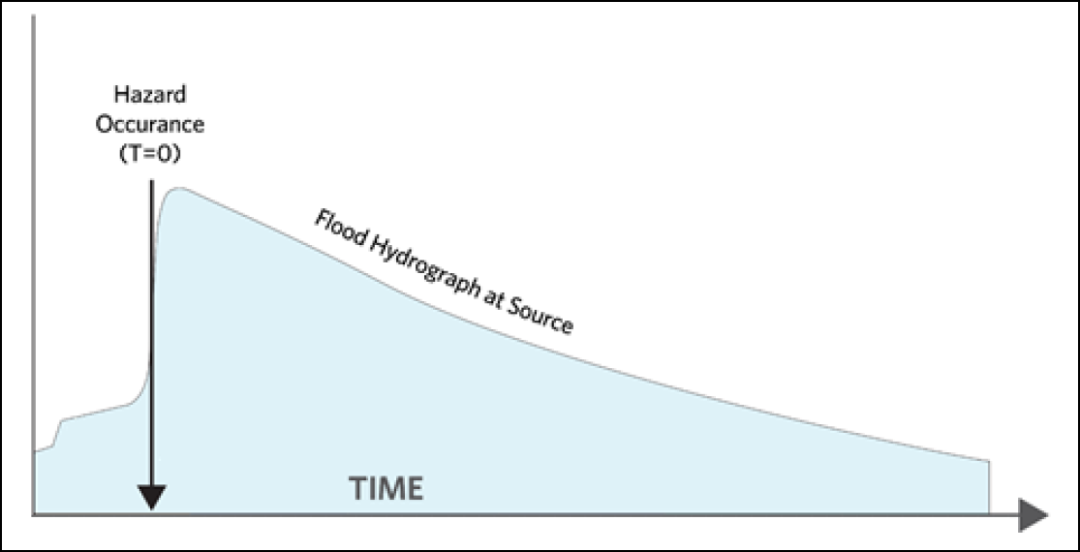
Figure 194 Example graph showing the point (Hazard Occurrence Time) at which the hazard occurs (e.g., dam breach)
The hydrograph, or the visual representation of the hydrograph, in the Import from Summary Grids window will have no impact on the LifeSim calculations. (Note: The hazard occurrence time must be set correctly and will directly impact LifeSim calculations.) A rough hydrograph must be loosely defined for LifeSim to accept the inputs. This can be achieved by simply creating a second row in the hydrograph table, specifying a time later in the hydraulic simulation, and adding a value higher than zero as defined in the initial timestep. See Figure 193 for reference. Again, this artificial hydrograph will not impact the software’s calculations.
Note that unless a more realistic hydrograph can be defined using output from the original hydraulic model, the artificially defined hydrograph (like that in Figure 193) cannot be used as visual representation of the model output.
Repeat the above steps for each hydraulic scenario. Figure 195 shows a LifeSim study pane with all imported hydraulic scenarios for the Clearwater dam study.
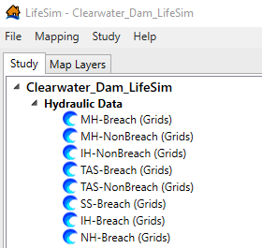
Figure 195 Clearwater Dam Study pane with all imported hydraulic scenarios
The remaining model inputs will follow the instructions of the Estimating Consequences for Levees and Floodwalls Chapter or Estimating Consequences for Dams Chapter. Refer to these chapters for information on importing structure inventories, emergency planning zones (EPZs), creating alternatives and simulations, and understanding your results.

(Page intentionally left blank)

The term Pairwise denotes that the tool will use multiple processing threads to accomplish the task, meaning that a Pairwise tool runs faster than the non-Pairwise version of that tool.

